Employee Manager plugin Docs

**Step -1**

Login to admin

**Step -2**

Click -> employee Category menu add details

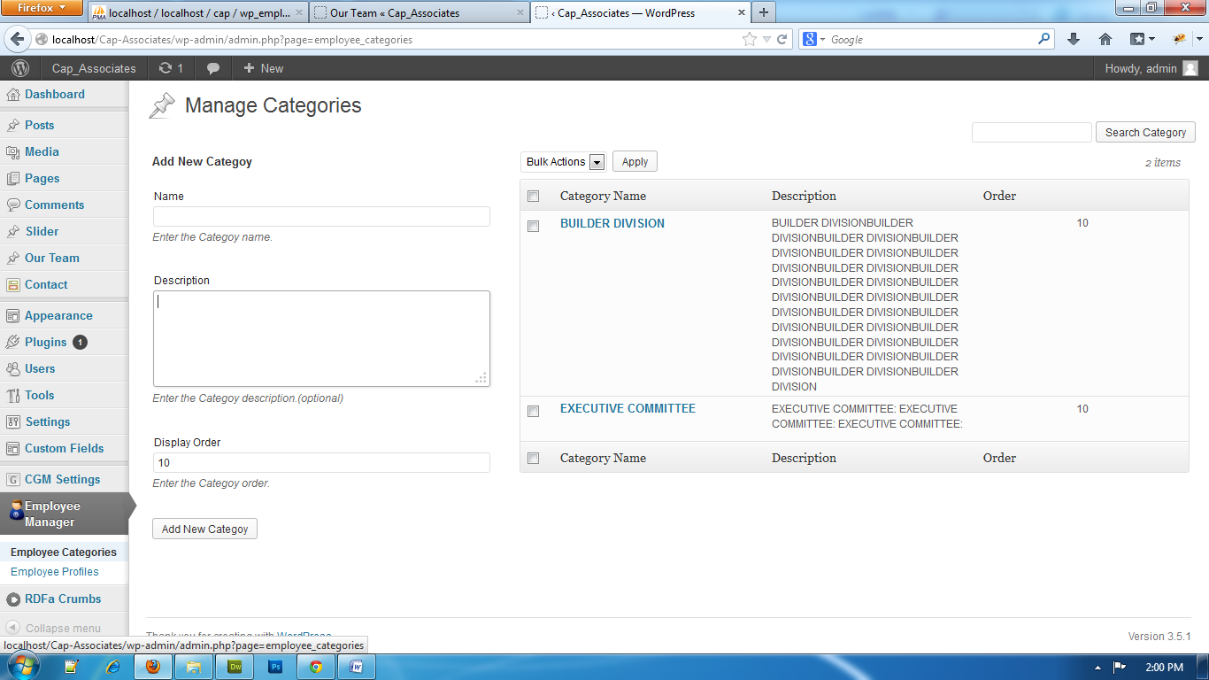

**Step- 3**

Click -> Employee Profile Menu and add details

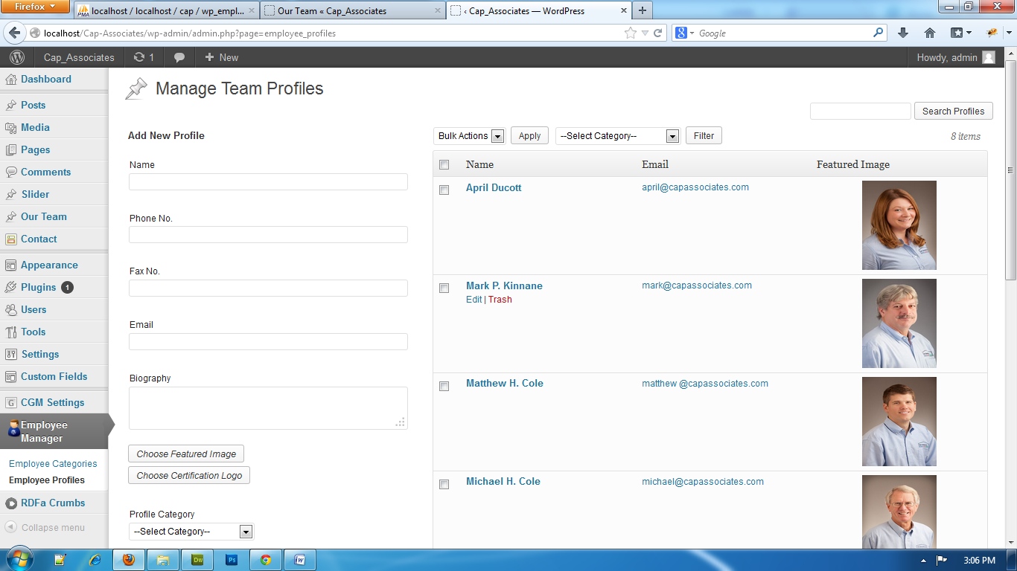

Click to add new profiles.

**Short Code for this plugin**

[employee_manager]

<?php echo do_shortcode("[employee_manager]"); ?>