**SQL Assignment:01**

**Database:**

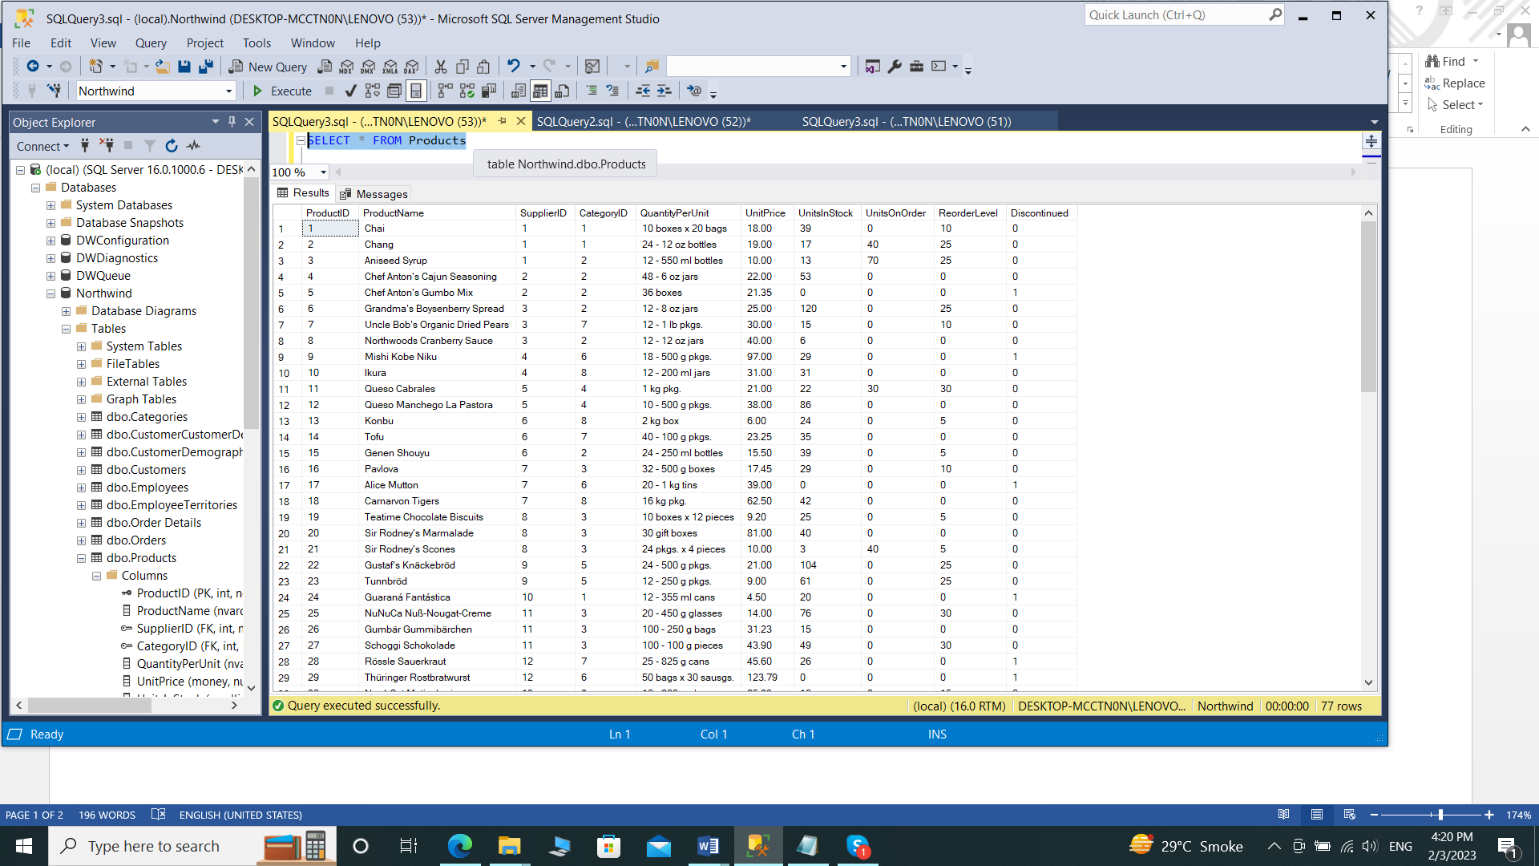

**1. Write a query to get a Product list (id, name, unit price) where current products cost**

**less than $20.**

SELECT ProductID, ProductName, UnitPrice

FROM Products

WHERE (((UnitPrice)<20) AND ((Discontinued)=0))

ORDER BY UnitPrice DESC;

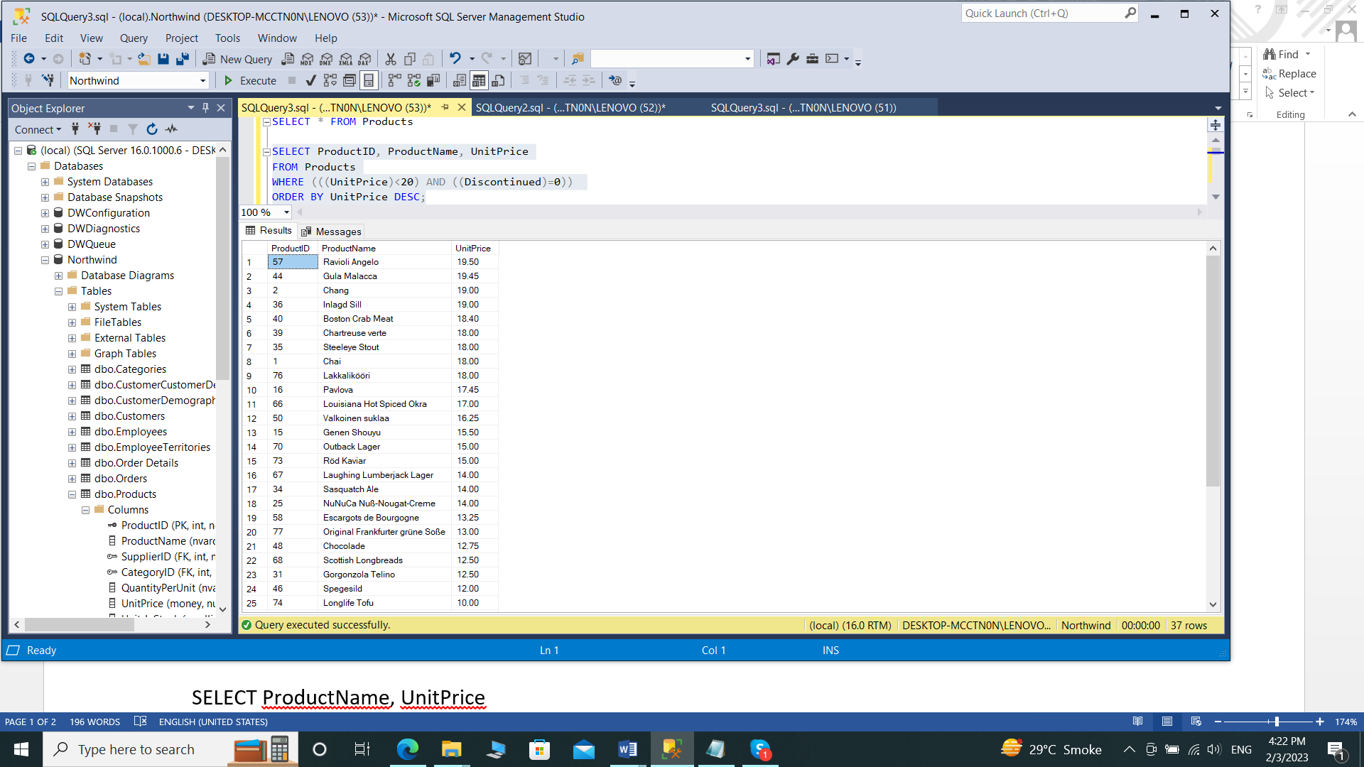

**2. Write a query to get Product list (id, name, unit price) where products cost between**

**$15 and $25**

SELECT ProductName, UnitPrice

FROM Products

WHERE (((UnitPrice)>=15 And (UnitPrice)<=25)

AND ((Products.Discontinued)=0))

ORDER BY Products.UnitPrice DESC;

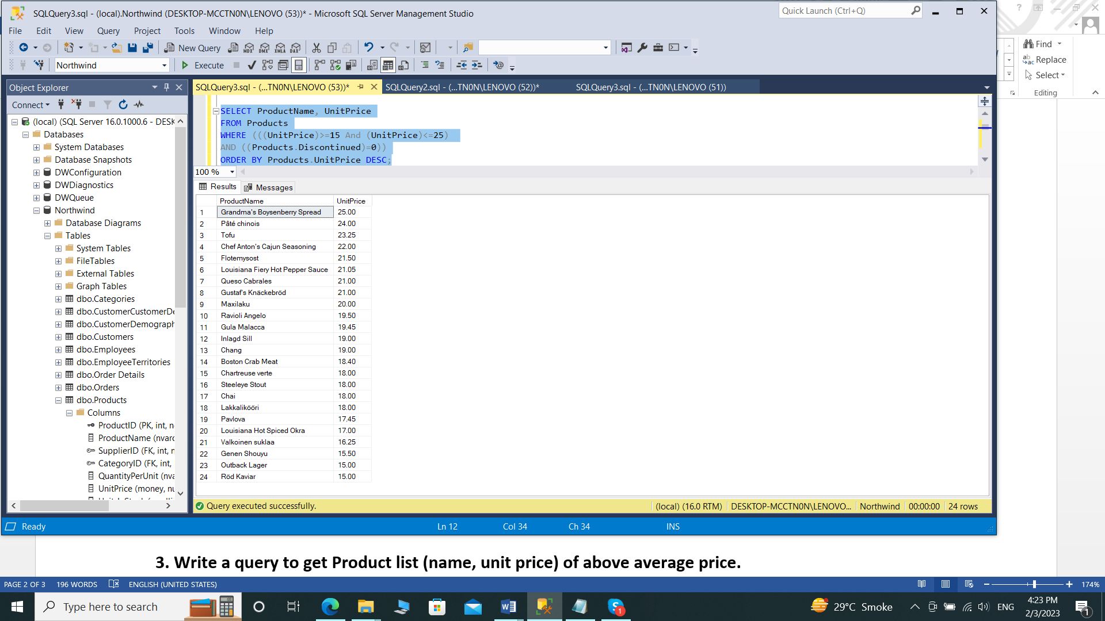

**3. Write a query to get Product list (name, unit price) of above average price.**

SELECT DISTINCT ProductName, UnitPrice

FROM Products

WHERE UnitPrice > (SELECT avg(UnitPrice) FROM Products)

ORDER BY UnitPrice;

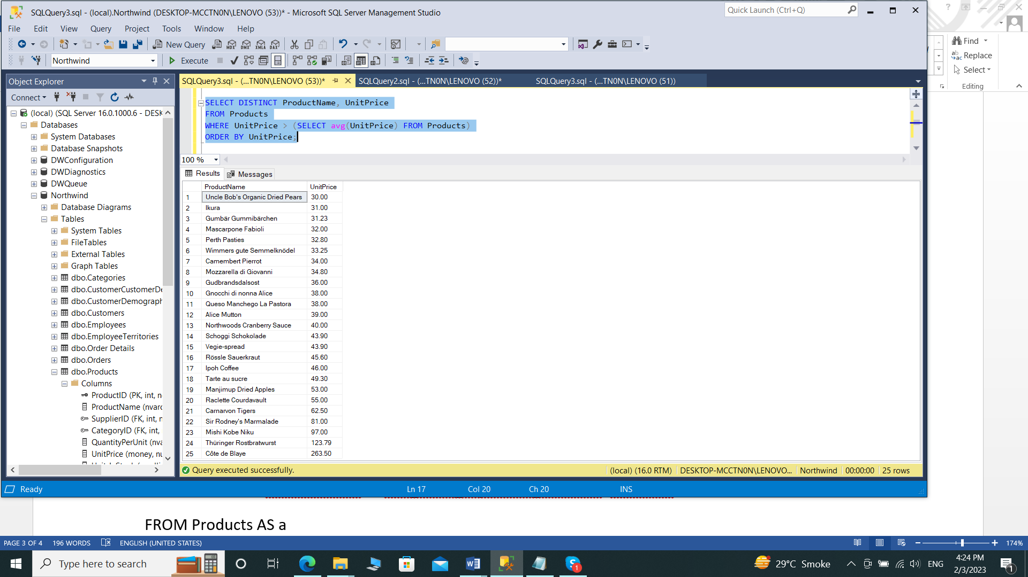

**4. Write a query to get Product list (name, unit price) of ten most expensive products**

SELECT DISTINCT ProductName as Ten_Most_Expensive_Products, UnitPrice

FROM Products AS a

WHERE 10 >= (SELECT COUNT(DISTINCT UnitPrice)

FROM Products AS b

WHERE b.UnitPrice >= a.UnitPrice)

ORDER BY UnitPrice desc;

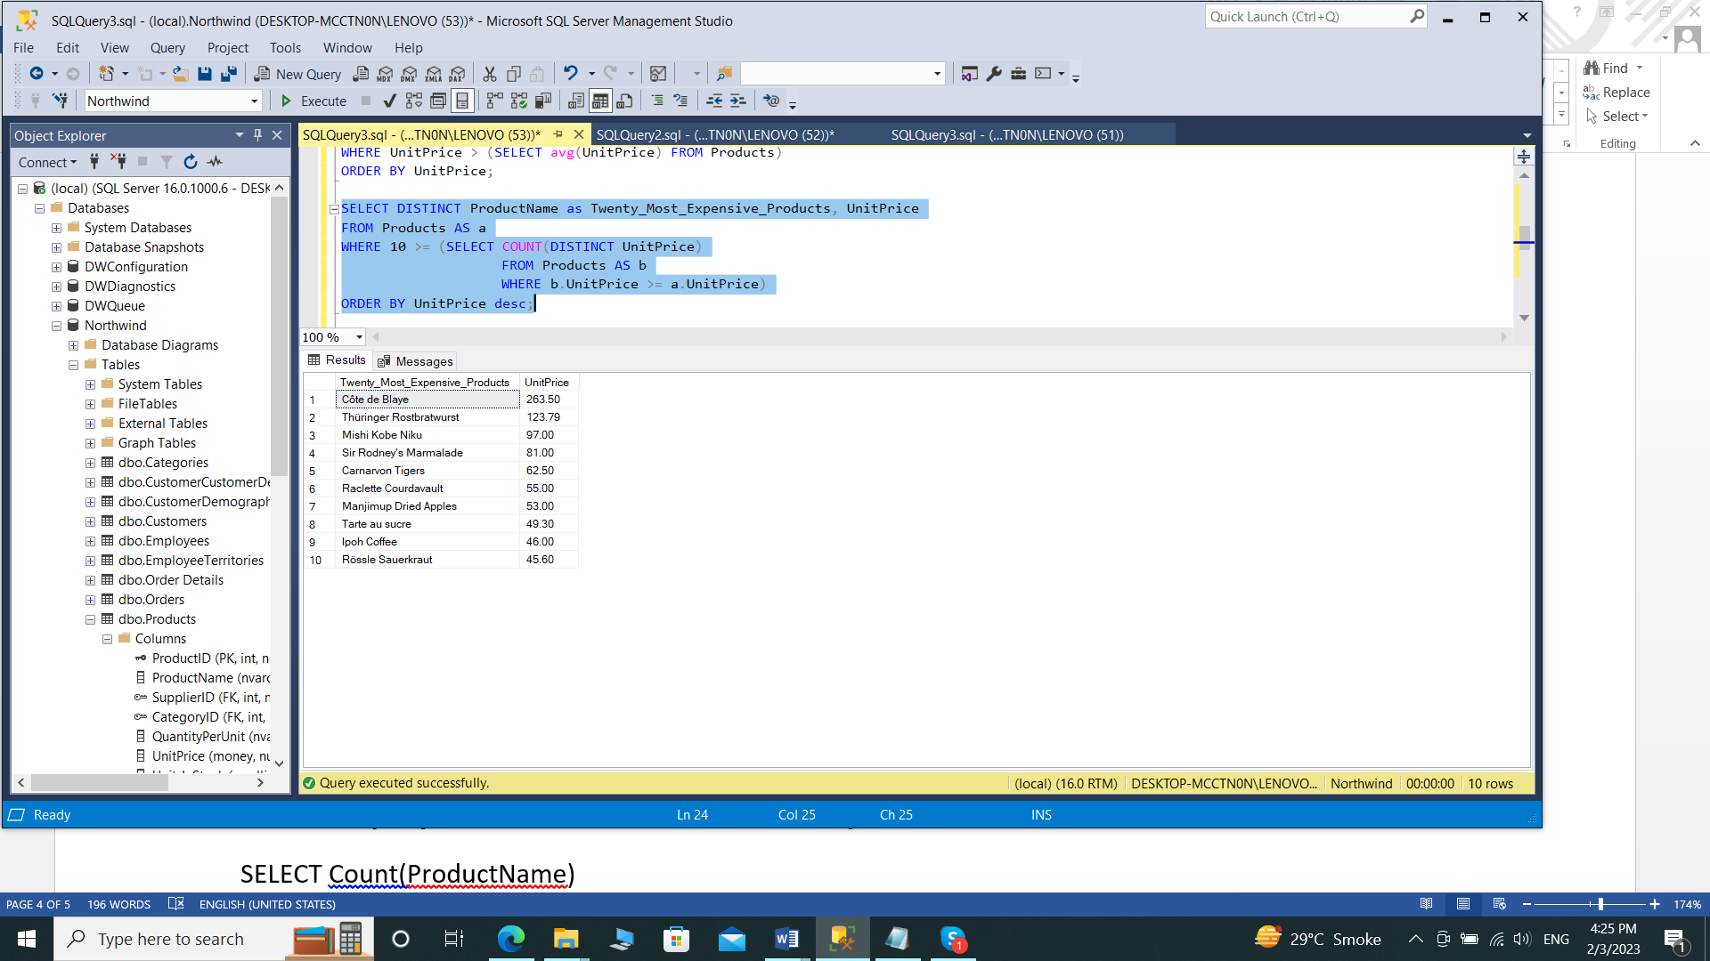

**5. Write a query to count current and discontinued products**

SELECT Count(ProductName)

FROM Products

GROUP BY Discontinued;

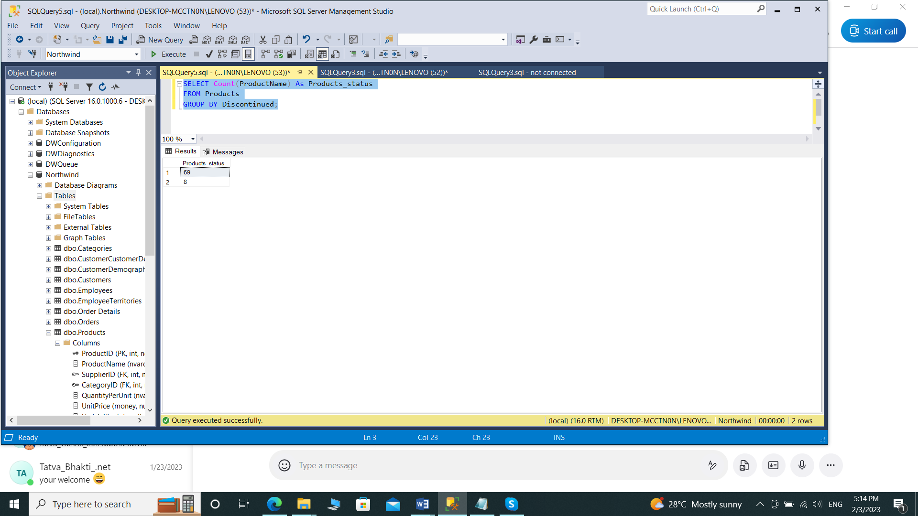

**6. Write a query to get Product list (name, units on order , units in stock) of stock is less**

**than the quantity on order**

SELECT ProductName, UnitsOnOrder , UnitsInStock

FROM Products

WHERE (((Discontinued)=0) AND ((UnitsInStock)<UnitsOnOrder));

