**SQL Assignment-3**

**Database:**

create database EmployeeDb

use EmployeeDb

create table Department

(

dept_id int NOT NULL Primary Key,

dept_name varchar(50) NOT NULL

)

create table Employee

(

emp_id int NOT NULL Primary Key,

dept_id int NOT NULL,

mngr_id int NULL,

emp_name varchar(50) NOT NULL,

salary int NOT NULL

)

insert into Department values(1001, 'FINANCE')

insert into Department values(2001, 'AUDIT')

insert into Department values(3001, 'MARKETING')

insert into Department values(4001, 'PRODUCTION')

insert into Department values(5001, 'TECHNICAL')

select * from Department

insert into Employee values(68319, 1001, NULL, 'KAYLING', 6000)

insert into Employee values(66928, 3001, 68319, 'BLAZE', 2750)

insert into Employee values(67832, 1001, 68319, 'CLARE', 2550)

insert into Employee values(65646, 2001, 68319, 'JONAS', 2967)

insert into Employee values(67858, 2001, 65646, 'SCARLET', 3100)

insert into Employee values(69062, 2001, 65646, 'FRANK', 3100)

insert into Employee values(63679, 2001, 69062, 'SANDRINE', 900)

insert into Employee values(64989, 3001, 66928, 'ADELYN', 1700)

insert into Employee values(65271, 3001, 66928, 'WADE', 1350)

insert into Employee values(66564, 3001, 66928, 'MADDEN', 1350)

insert into Employee values(68454, 3001, 66928, 'TUCKER', 1600)

insert into Employee values(68736, 2001, 67858, 'ADNRES', 1200)

insert into Employee values(69000, 3001, 66928, 'JULIUS', 1050)

insert into Employee values(69324, 1001, 67832, 'MARKER', 1400)

insert into Employee values(69325, 5001, 67832, 'JHON', 5400)

select * from Employee

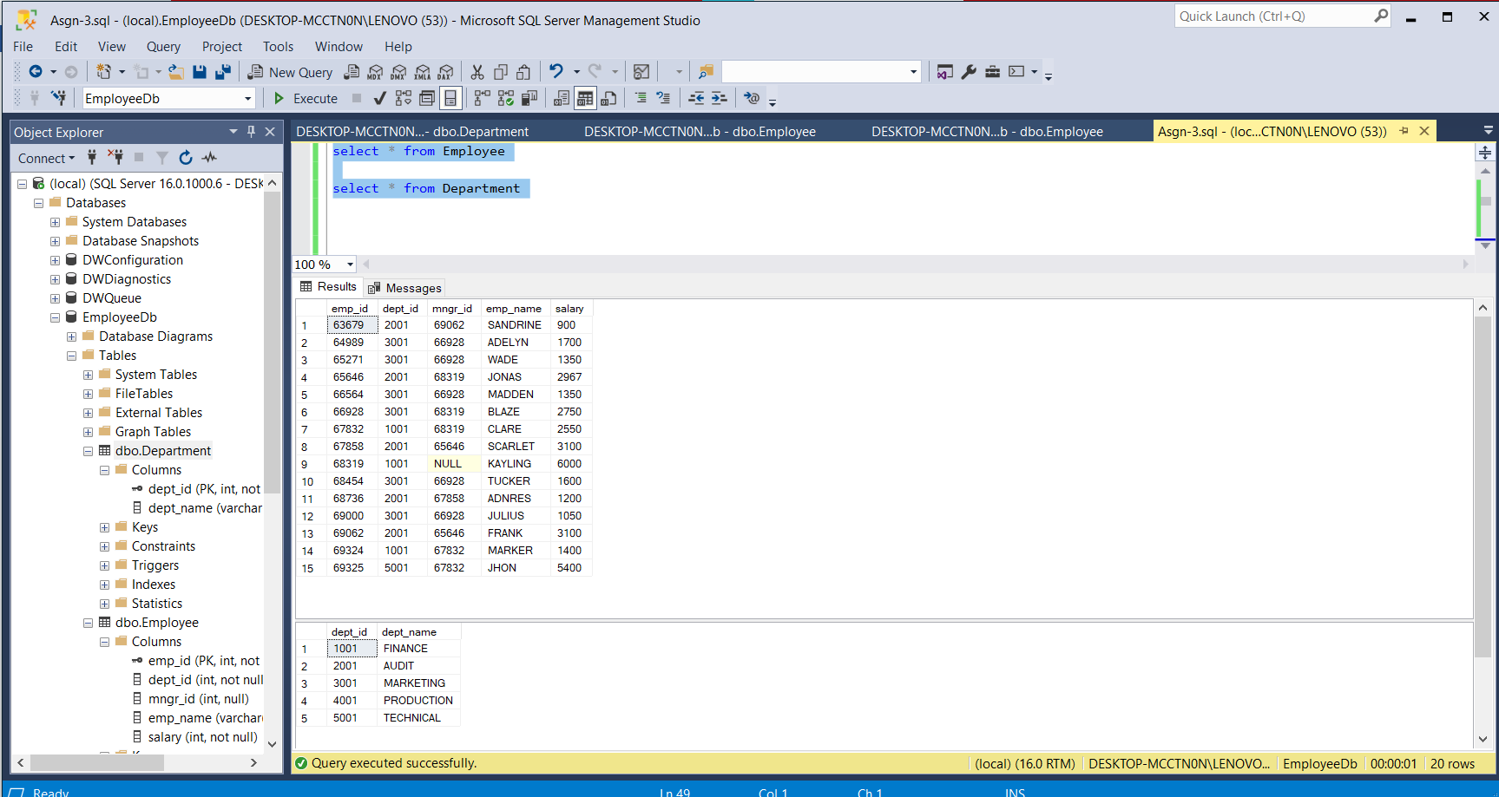

1. **write a SQL query to find Employees who have the biggest salary in their Department**

SELECT e.emp_name,

e.salary ,

e.dept_id,

Department.dept_name

FROM Employee e

RIGHT JOIN Department

ON e.dept_id=Department.dept_id

WHERE e.salary IN

(SELECT max(salary)

FROM Employee

GROUP BY dept_id) ;

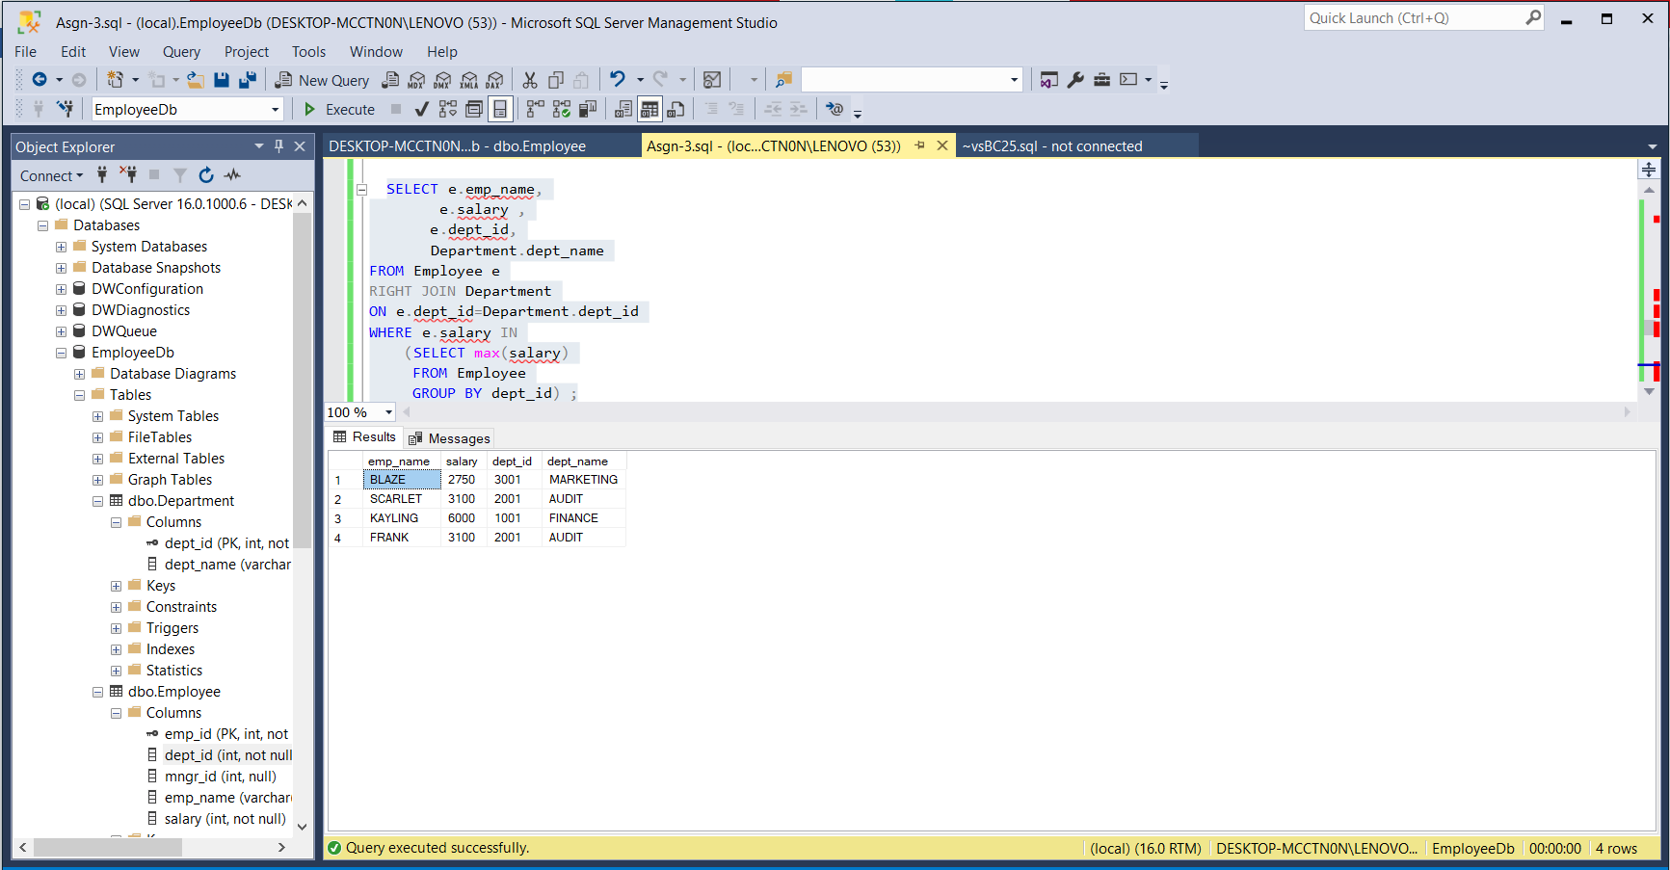

1. **write a SQL query to find Departments that have less than 3 people in it**

SELECT count(Employee.emp_id) AS Number_of_people , Department.dept_name

From Employee

RIGHT JOIN Department

ON Employee.dept_id=Department.dept_id

GROUP BY (Department.dept_name)

HAVING count(Employee.emp_id)<3;

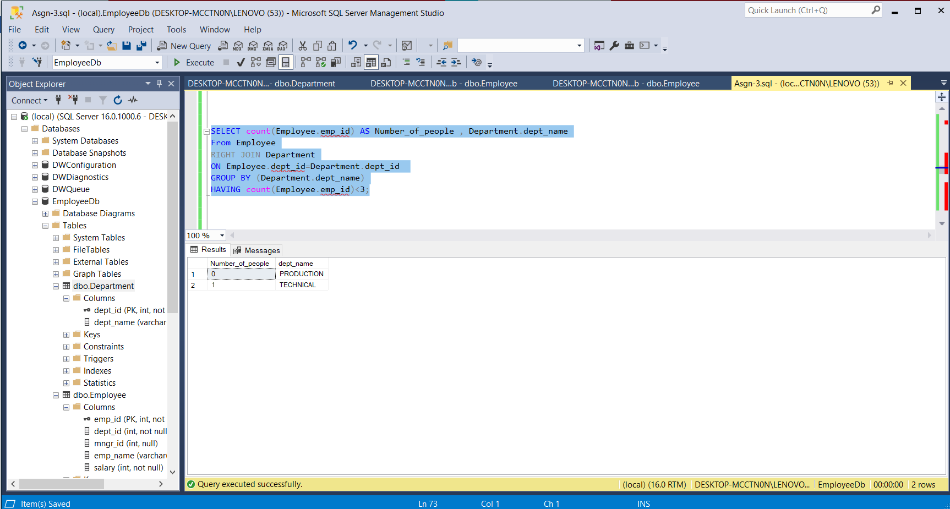

1. **write a SQL query to find All Department along with the number of people there**

SELECT Department.dept_name , count(Employee.emp_id) AS Number_of_people

From Employee

RIGHT JOIN Department

ON Employee.dept_id=Department.dept_id

GROUP BY (Department.dept_name);

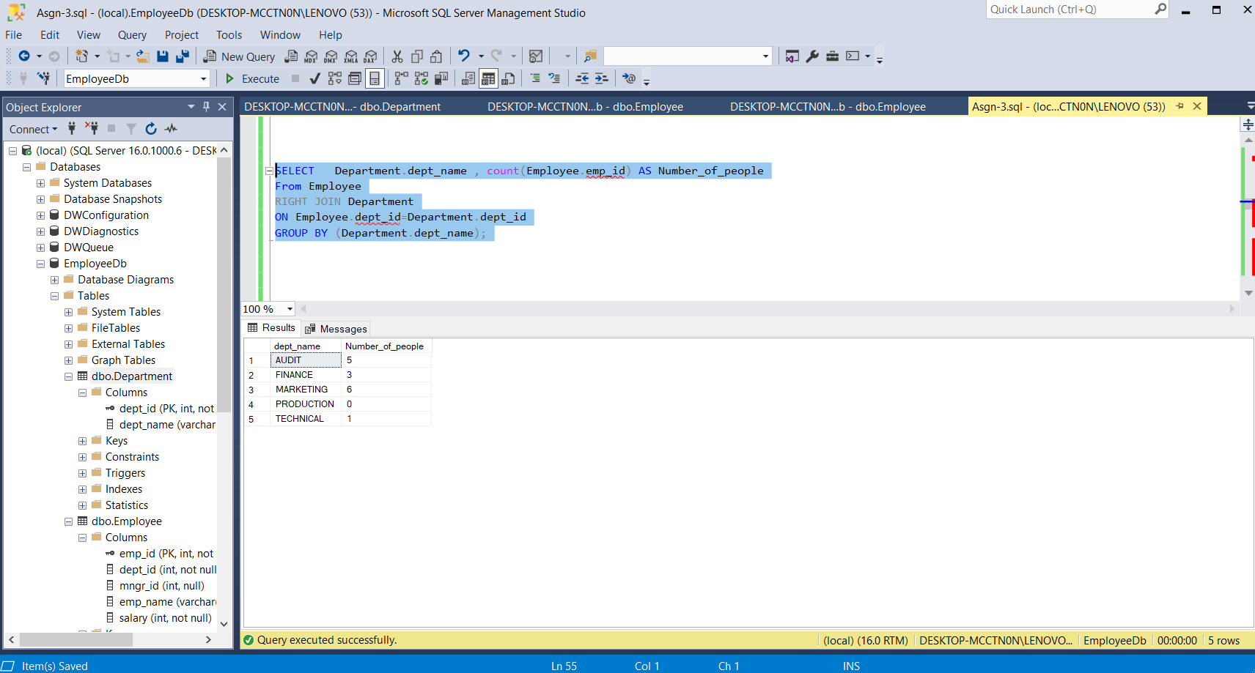

1. **write a SQL query to find All Department along with the total salary there**

SELECT Department.dept_name , SUM(Employee.salary) AS Salary

From Employee

RIGHT JOIN Department

ON Employee.dept_id=Department.dept_id

GROUP BY (Department.dept_name);

