**REPORT**

**UI-Sketches:**

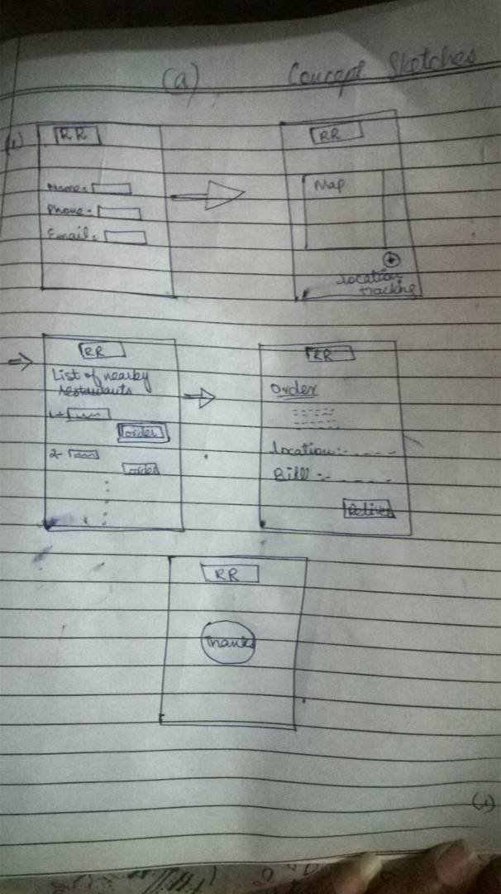

This is the first sketch we designed for the prototype but it seems vague so we develop a new one with modifications.mk;k

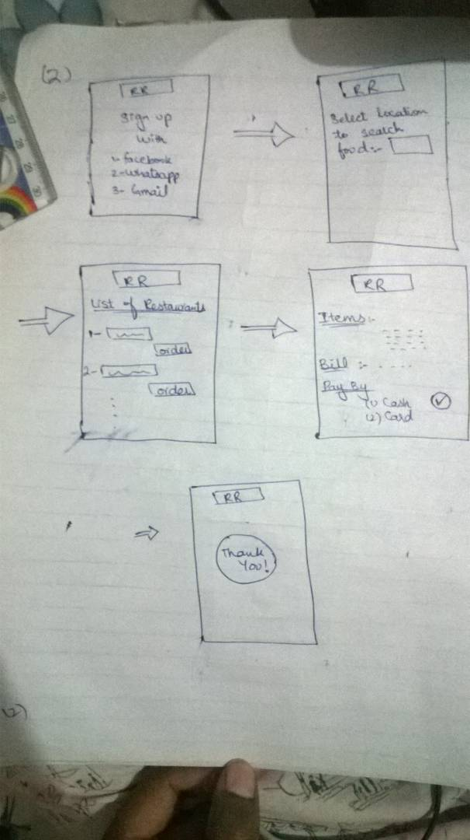

In this sketch we have added a feature that a customer can pay bill by cash as well as from credit card.

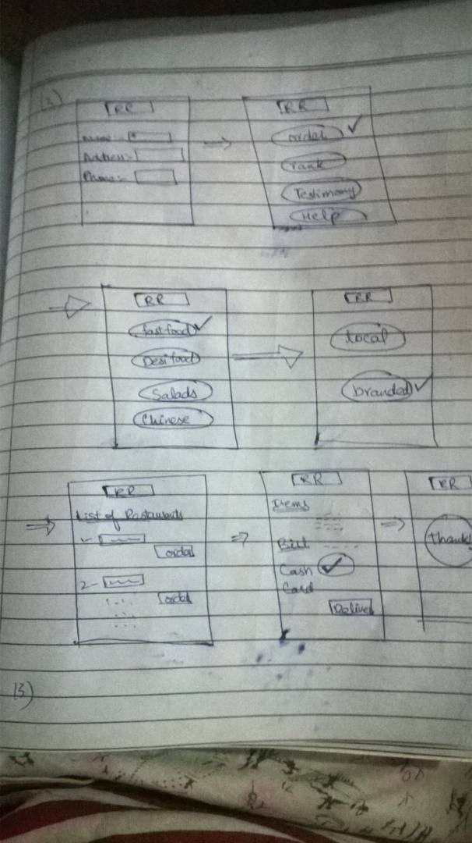

Here we tried to take this sketch work to next level by providing features asking customer that weather you want to order something, you want to give feedback or you want you give suggestions. We also categorized food in desi food, fast food or Chinese food and where you want to buy from local shops or you will like to go after brand.

In this attempt we tried that customer didn’t have to do the process from start if he wants to revise or alter his order. We have inculcate a feature that all restaurants can be sort out by their ranking or by considering their prices for the convenience of the customer that on one single click he may be able to see all the restaurants but in categorize.

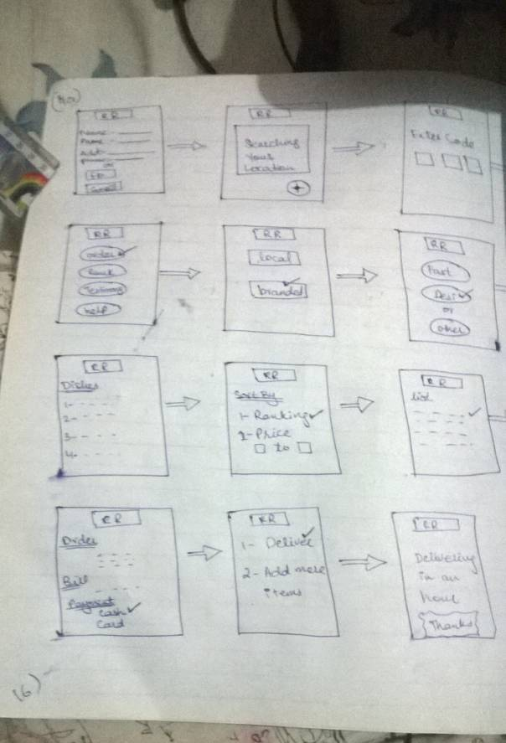

Here we have asked the customer to upload his photo for profile completion, he may leave this blank. A passcode to access restaurant ranking app will be given to every customer for security purpose.

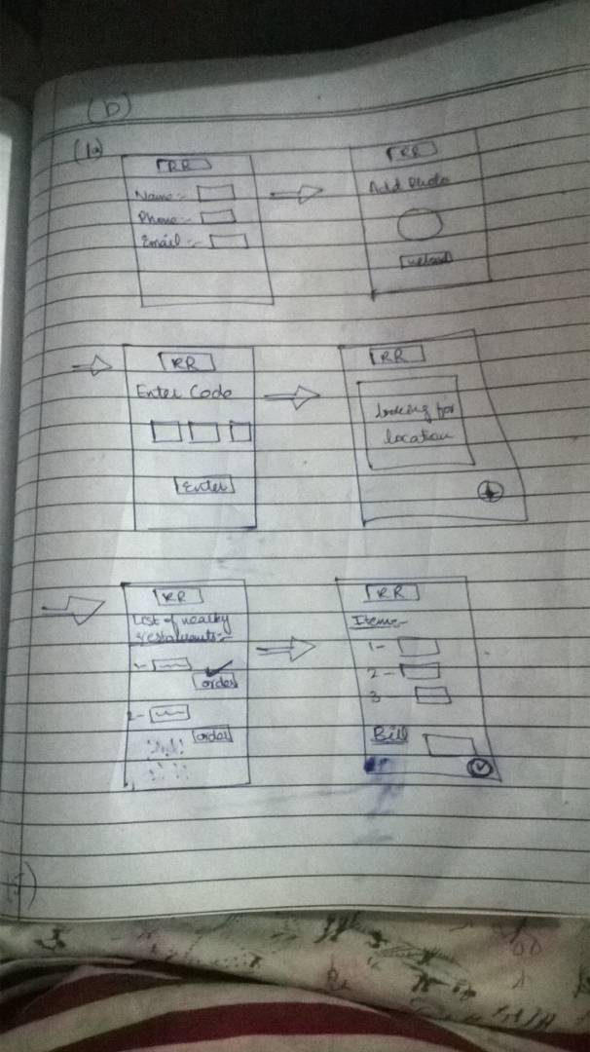

This is the final sketch upon we have reached after brainstorming so many times and creating so many initial sketches, we have refined and revisit the sketches to get on final stage. It have all the features but in very absolute and clean manners.

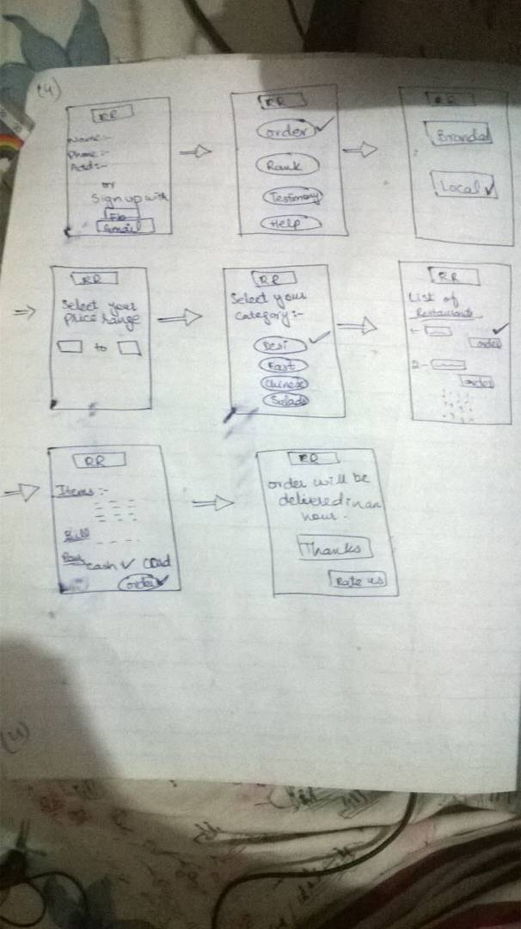

**Story-Boarding:**



Its 2 am Sam is feeling hungry, he don’t want to go outside so he tried restaurant ranking app.



Sam is our customer here, he is feeling hungry and want to know about nearby restaurants so he has checked into restaurant ranking app. He’s been given options to go with branded food or with local food. He selected local food and app has showed him local food restaurants.

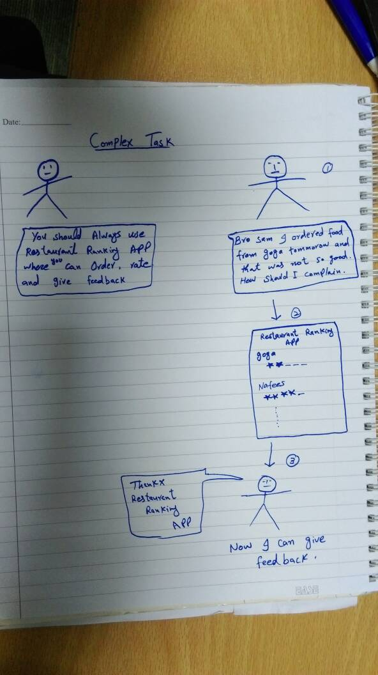

Now he is recommending his friends the same app because his experience with app so good. And he is ranking the restaurant for future reference.