**LAB#06**

**Object:** Introduction to FFT butterfly.

**TASK #01:**

Given a Sequence x(n),compute DFT of the sequence by DIT butterfly method on Simulink.

1. X(n)={4,-3,2,0,-1,-2,3,1}
2. X(n)={1,1,1,1,1,1,1,1}
3. X(n)={3,0,2,9}
4. X(n)={9,12,6,2}

**SIMULINK:**

1. 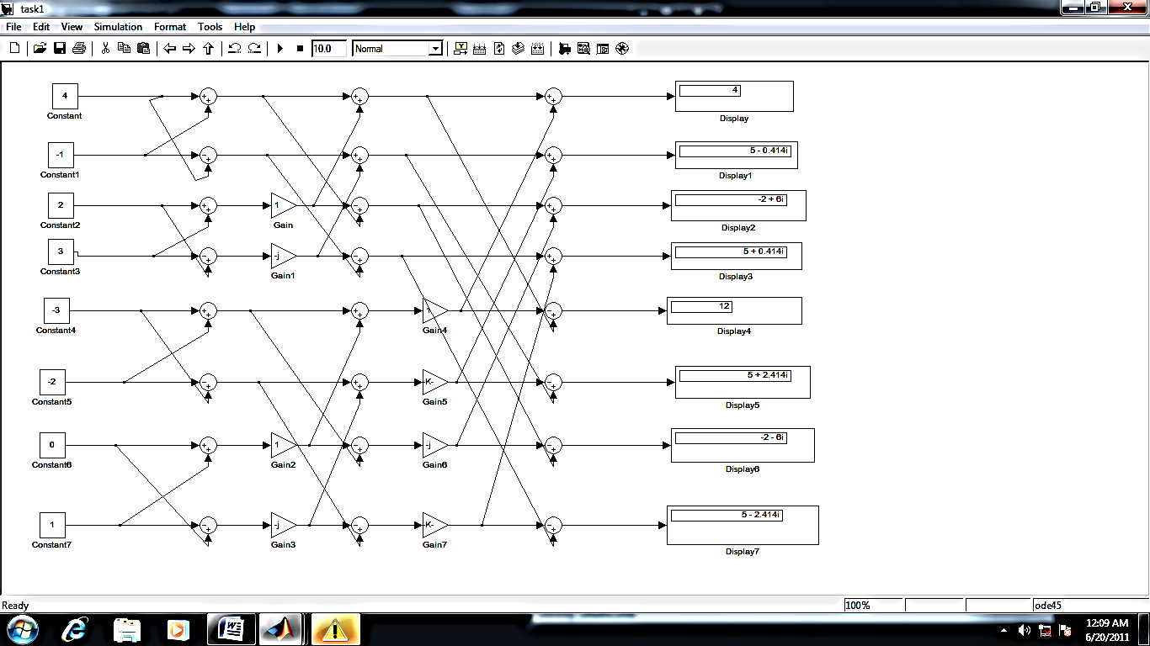**X(n)={4,-3,2,0,-1,-2,3,1}**
2. 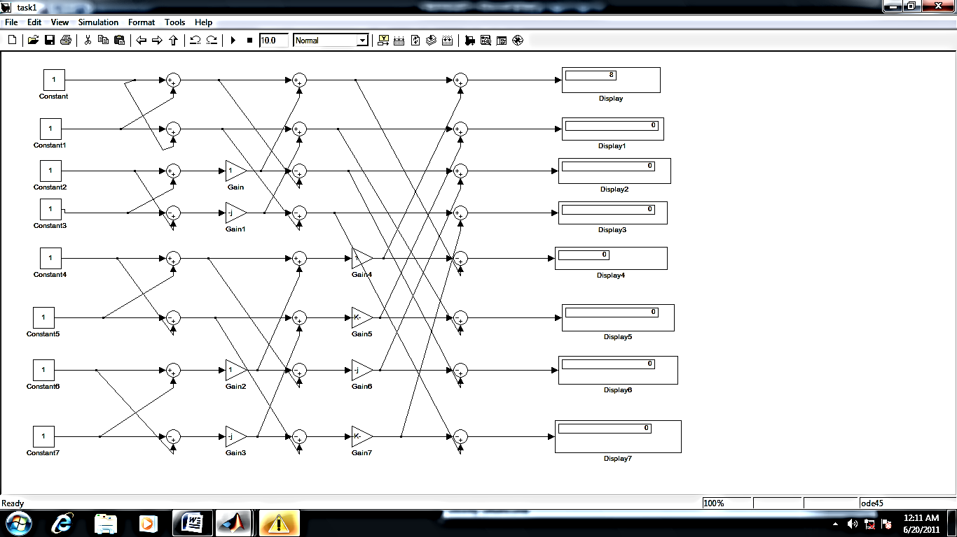**X(n)={1,1,1,1,1,1,1,1}**
3. **X(n)={3,0,2,9}**

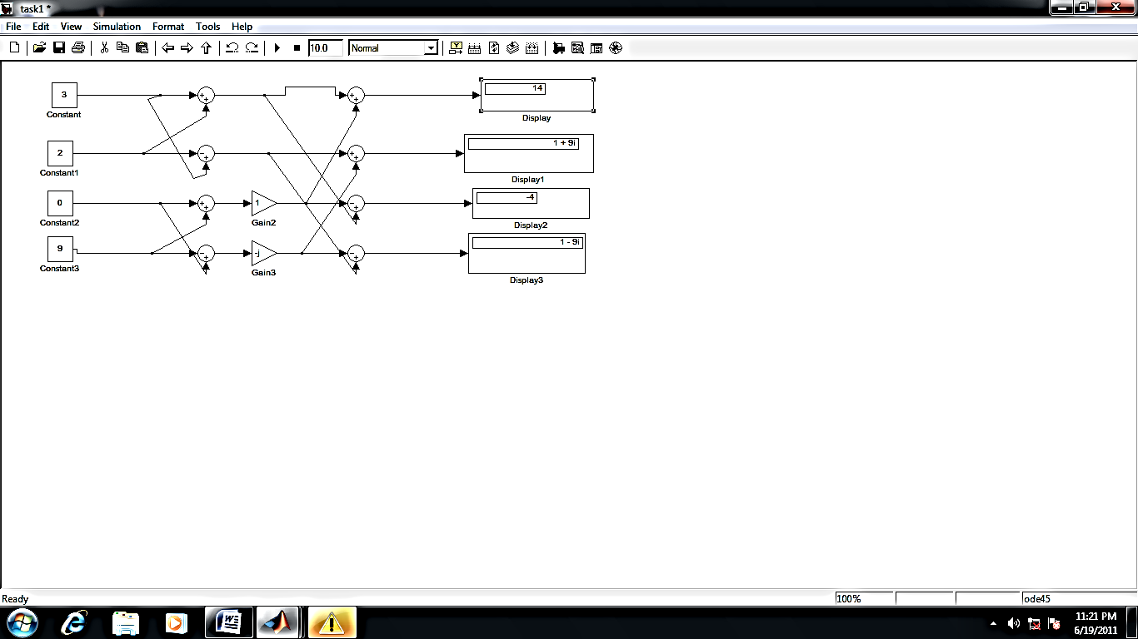

1. **X(n)={9,12,6,2}**

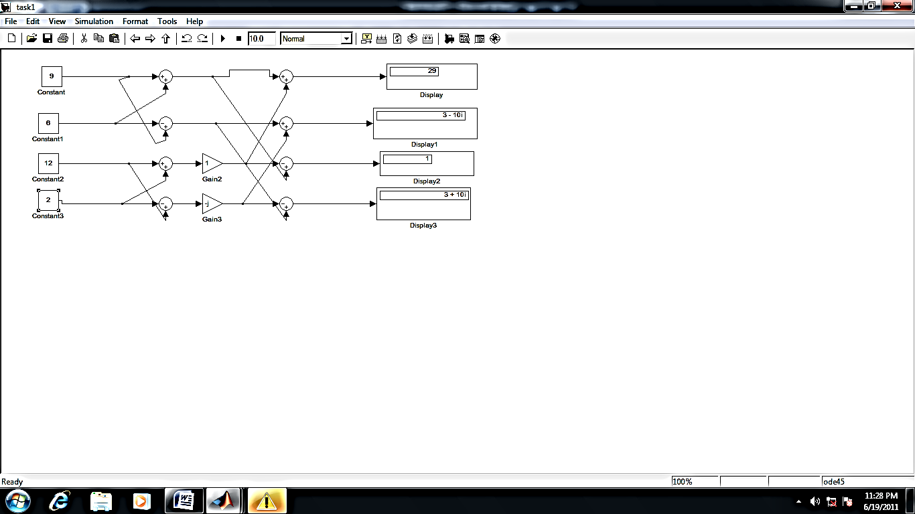

**TASK #02:** Prove above task on script file.

1. **X(n)={4,-3,2,0,-1,-2,3,1}**

**CODING:**

x=[4 -3 2 0 -1 -2 3 1]

y=fft(x)

**RESULT:**

y =

4.0000 5.0000 + 2.4142i -2.0000 + 6.0000i 5.0000 + 0.4142i 12.0000 5.0000 - 0.4142i -2.0000 - 6.0000i 5.0000 - 2.4142i

1. **X(n)={1,1,1,1,1,1,1,1}**

**CODING:**

x=[1 1 1 1 1 1 1 1]

y=fft(x)

**RESULT:**

y =

1. 0 0 0 0 0 0 0
2. **X(n)={3,0,2,9}**

**CODING:**

x=[3 0 2 9]

y=fft(x)

**RESULT:**

Y=

1. 1.0000 + 9.0000i -4.0000 1.0000 - 9.0000i
2. **X(n)={9,12,6,2}**

**CODING:**

x=[9 12 6 2]

y=fft(x)

**RESULT:**

y =

29.0000 3.0000 -10.0000i 1.0000 3.0000 +10.0000i

**TASK #03:**

Given a sequence X[k] , Compute IDFT by using DIT butterfly method.

1. X[k]={20 -4+6i -4 -4-6i}
2. X[k]={61 -2+5i -9 -2+5i}
3. X[k]={40 -6+I -10-2i 8-i -8+i -10+2i -6-i 60}

**SIMULINK:**

1. **X[k]={20 -4+6i -4 -4-6i}**

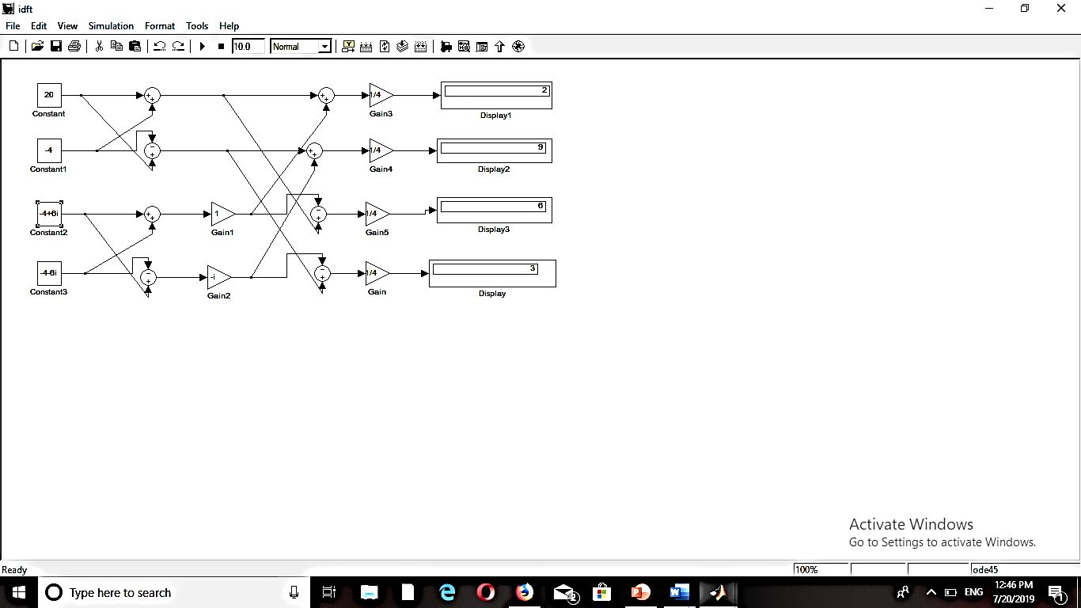

1. **X[k]={61 -2+5i -9 -2+5i}**

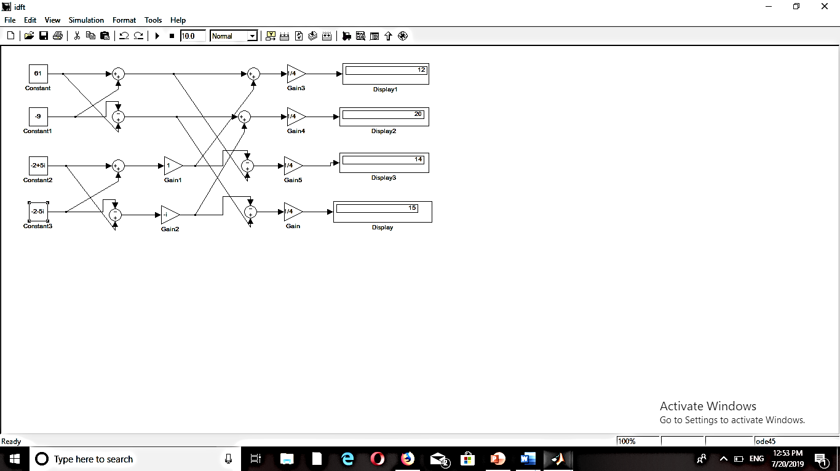

1. 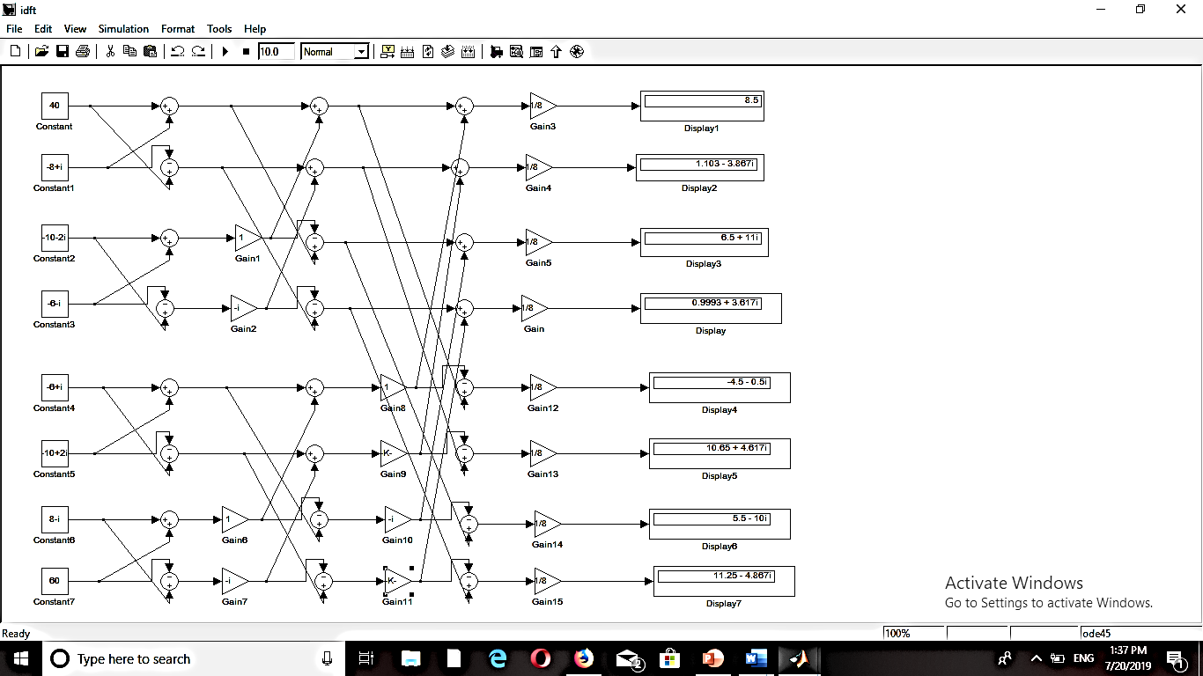**X[k]={40 -6+I -10-2i 8-i -8+i -10+2i -6-i 60}**

**TASK #04:**  Prove above task on script File .

1. **X[k]={20 -4+6i -4 -4-6i}**

**CODING:**

x=[20 -4+6i -4 -4-6i]

y=ifft(x)

**RESULT:**

y =

1. 3 6 9
2. **X[k]={61 -2+5i -9 -2+5i}**

**CODING:**

x=[61 -2+5i -9 -2-5i]

y=ifft(x)

**RESULT:**

y =

1. 15 14 20
2. **X[k]={40 -6+I -10-2i 8-i -8+i -10+2i -6-i 60}**

**CODING:**

x=[40 -6+i -10-2i 8-i -8+i -10+2i -6-i 60]

y=ifft(x)

**RESULT:**

y =

8.5000 11.2515 - 4.8676i 5.5000 -10.0000i 1.1020 - 3.8676i -4.5000 - 0.5000i 0.9985 + 3.6176i 6.5000 +11.0000i 10.6480 + 4.6176i