**LAB 13 (OPEN ENDED LAB)**

**Objective: Convert rgb image to hsv image by image processing in matlab.**

**Software Required:**

MatLab

**Block Diagram:**



**Methodology:**

First of all we have imported image by using imread command in matlab and than we have displayed that rgb by using imshow. The command used is rgb2hsv which converts RGB image to HSV in matlab. It is all part of image processing.

**Coding:**

img = imread('C:\Users\M. Aazib\Downloads\flower.jpg');

subplot(1,2,1);

imshow(img);

title('RGB Image');

hsv=rgb2hsv(img);

subplot(1,2,2)

imshow(hsv);

title('HSV Image');

**Observation:**

It is observed that image has been processed and converted from RGB to HSV. Result can be clearly seen on this picture.

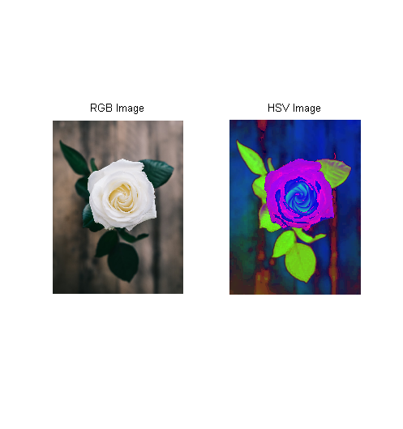

**Discussions And Results:**

We need HSV image because it separates image intensity from chroma. This is very useful in many applications. For example, if you want to do histogram equalization of a color image, you probably want to do that only on the intensity component, and leave the color components alone. Otherwise you will get very strange colors.

In computer vision you often want to separate color components from intensity for various reasons, such as robustness to lighting changes, or removing shadows.

**Conclusions:**

In this lab we have learnt how to convert image from RGB to HSV. It is a very useful tool as it removes image intensity from chroma. It is used in many real time applications, we just see the presentation layer while in back processes the same phenomena takes place.