**LAB # 10**

**Objective:** Introduction to Microwind.

**Task1:** Draw a layout of n-channel MOS transistor and simulate its transient characterstics.

**Layout:**

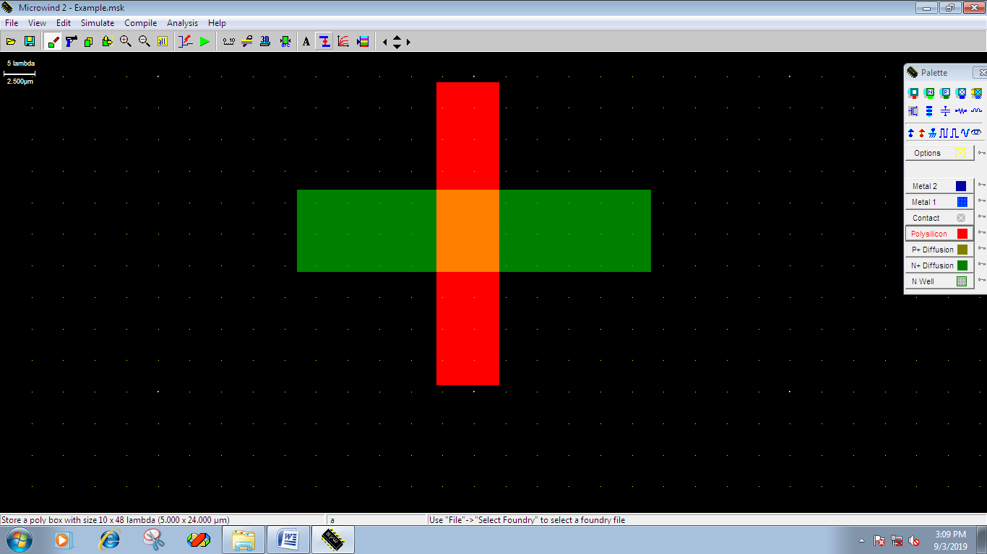

**Task2:** Draw a layout of n-channel MOS transistor and simulate its transient characterstics.

**Layout:**

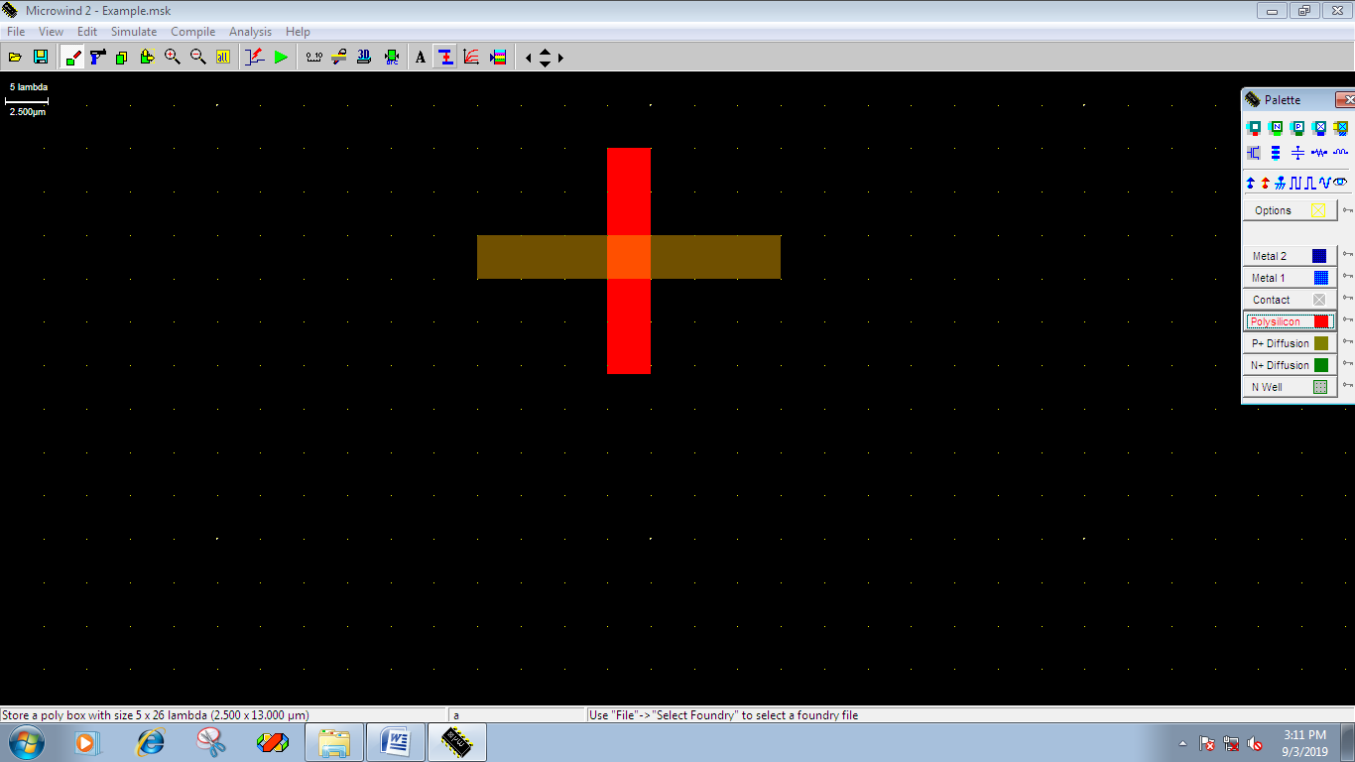

**Task3:** Draw a layout of inverter using PMOS and NMOS transistor and simulate its transient characterstics.

**Layout:**

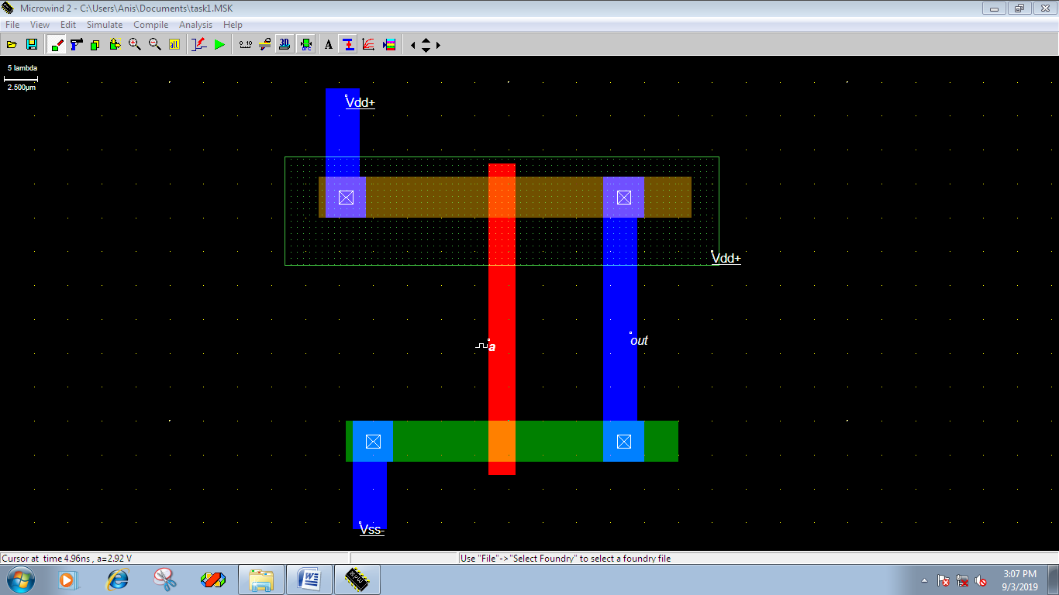

**Results (Timing diagram):**

