**LAB # 11**

**Objective:** Introduction to Microwind.

**Task1:** Draw the layout of Nand gate using CMOS technology and simulate its transient characteristics.

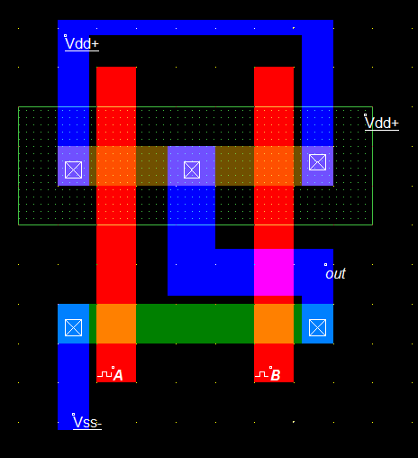**Layout:**

**Results (Timing diagram):**

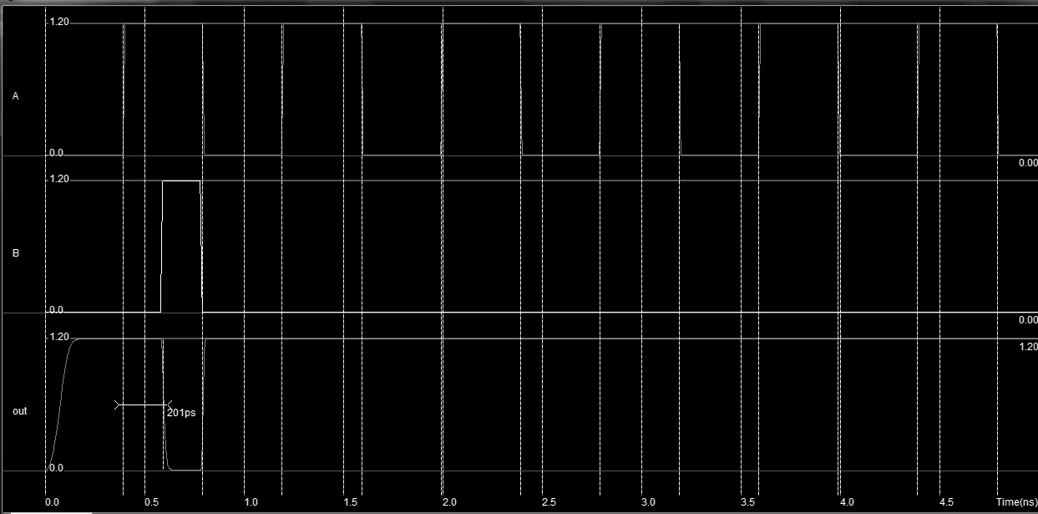

**Task2:**  Draw the layout of And gate using CMOS technology and simulate its transient characteristics.

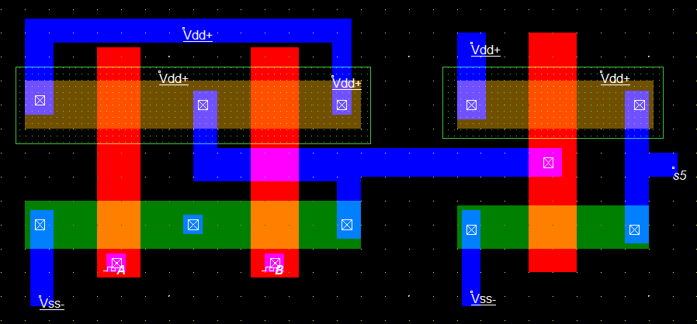**Layout:**

**Results (Timing diagram):**

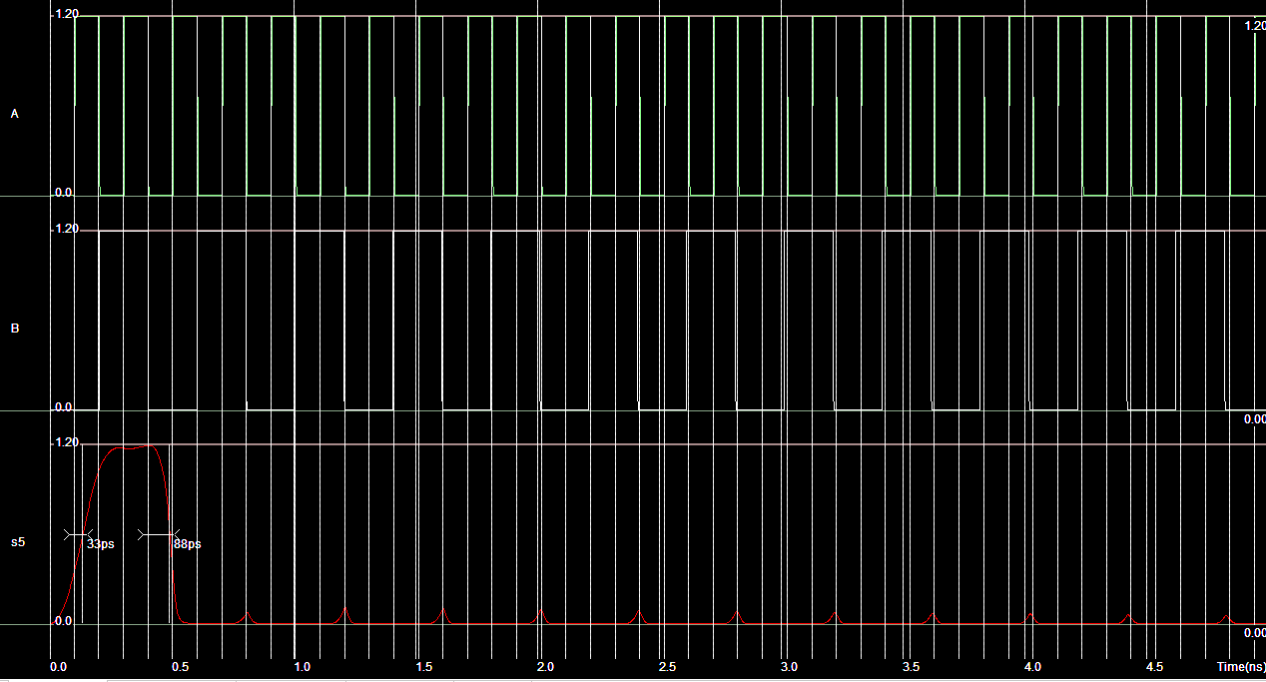

**Task3:**  Draw the layout of Or gate using CMOS technology and simulate its transient characteristics.

**Layout:**

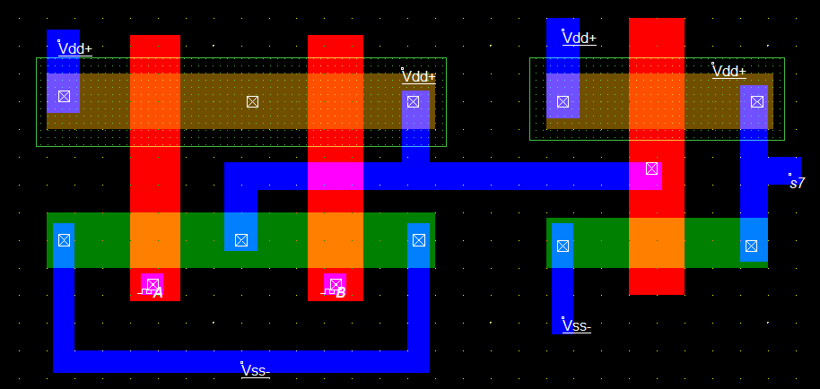

**Results (Timing diagram):**

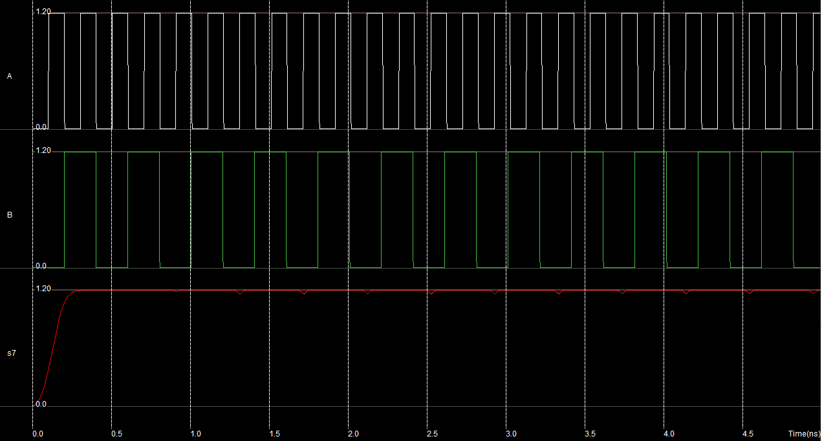

**Task4:** Draw the layout of Nor gate using CMOS technology and simulate its transient characteristics.

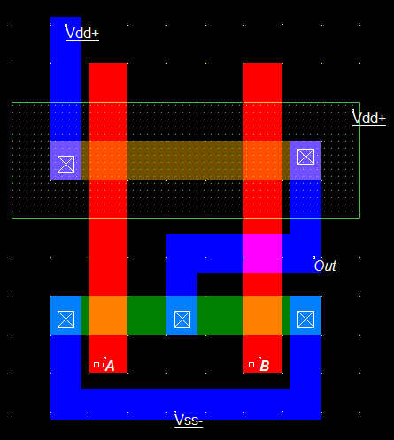**Layout:**

**Results (Timing diagram):**

