**LAB # 2**

**OBJECTIVE**

Generate a MatLab Code to reduce and solve the system’s block diagram by implementing the series, parallel, feedback and solve commands.

**THEORY**

* **Series**

If two or more systems are connected in series then they are multiplied into a single system.

* **Parallel**

If two or more systems are connected in parallel then they are added into a single system.

* **Feedback**

If a main system has a connection form right to left and is connected to the input of the main system.

* **Solve**

Solve command is used to make up the block diagram equations to solve out the system.

* **Syms**

Initializing symbols which are used in the block diagram.

* **Pretty**

It is used to discard the unnecessary calculations rather than the main solution.

* **Tf(‘s’)**

Initializing s-domain transfer function.

**EXERCISE:**

**Task 1(a):** Find the transfer function C/R in s-domain of the given block diagram by using series, parallel and feedback commands.

**G(s) = $\frac{2}{s+1}$ H(s) = $\frac{3}{s}$**

**CODING:**

s=tf('s')

g=2/(s+1)

h=3/s

a=series(g,h)

b=parallel(g,h)

c=feedback(g,h)

**RESULT:**

s = s

Continuous-time transfer function.

g =

2

-----

s + 1

Continuous-time transfer function.

h =

3

-

s

Continuous-time transfer function.

a =

6

-------

s^2 + s

Continuous-time transfer function.

b =

5 s + 3

-------

s^2 + s

Continuous-time transfer function.

c =

2 s

-----------

s^2 + s + 6

Continuous-time transfer function.

**Task 1(b):** Find the following by using solve command

## C/R (close loop transfer function)

## B/R (Primary feedback transfer function)

## E/R (error ratio)

**Coding:**

syms r e c b g h

v=solve('e=r-b','b=c*h','c=e*g',e,c,b)

a=v.c/r

pretty(a)

f=v.b/r

pretty(f)

t=v.e/r

pretty(t)

**Result:**

v =

b: [1x1 sym]

c: [1x1 sym]

e: [1x1 sym]

a =

g/(g*h + 1)

g

-------

g h + 1

f =

(g*h)/(g*h + 1)

g h

-------

g h + 1

t =

1/(g*h + 1)

1

-------

g h + 1

## Task 2: Find the transfer function C/R in s-domain of the given block diagram by using series, parallel and feedback commands.

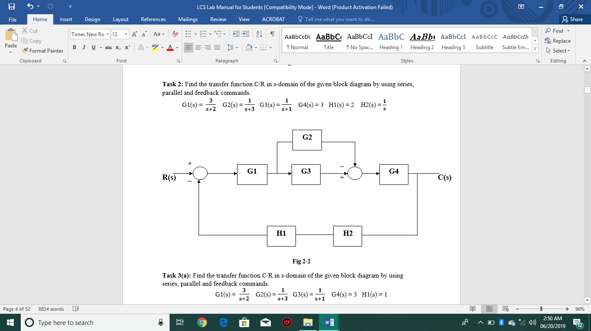G1(s) = $\frac{2}{s+1}$ $\frac{3}{s+2}$ G2(s) = $\frac{2}{s+1}$ $\frac{1}{s+3}$ G3(s) = $\frac{1}{s+1}$ G4(s) = 3 H1(s) = 2 H2(s) = $\frac{1}{s}$ $\frac{3}{s}$

**Coding:**

s=tf('s')

g1=3/(s+2)

g2=1/(s+3)

g3=1/(s+1)

g4=3

h1=2

h2=1/s

f1=parallel(-g2,g3)

f2=series(g1,f1)

f3=series(h1,h2)

f4=series(f2,g4)

f4=feedback(f4,f3)

**Result:**

s = s

Continuous-time transfer function.

g1 =

3

-----

s + 2

Continuous-time transfer function.

g2 =

1

-----

s + 3

Continuous-time transfer function.

g3 =

1

-----

s + 1

Continuous-time transfer function.

g4 = 3

h1 = 2

h2 =

1

-

s

Continuous-time transfer function.

f1 =

2

-------------

s^2 + 4 s + 3

Continuous-time transfer function.

f2 =

6

----------------------

s^3 + 6 s^2 + 11 s + 6

Continuous-time transfer function.

f3 =

2

-

s

Continuous-time transfer function.

f4 =

18

----------------------

s^3 + 6 s^2 + 11 s + 6

Continuous-time transfer function.

f4 =

18 s

-------------------------------

s^4 + 6 s^3 + 11 s^2 + 6 s + 36

Continuous-time transfer function.

**Task 3(a):** Find the transfer function C/R in s-domain of the given block diagram by using series, parallel and feedback commands.

G1(s) = $\frac{2}{s+1}$ $\frac{3}{s+2}$ G2(s) = $\frac{2}{s+1}$ $\frac{1}{s+3}$ G3(s) = $\frac{1}{s+1}$ G4(s) = 3 H1(s) = 1

**Coding:**

s=tf('s')

g1=3/(s+2)

g2=1/(s+3)

g3=1/(s+1)

g4=3

h1=1

f1=parallel(g2,-g3)

f2=feedback(g1,h1)

f3=series(f1,f2)

f4=series(f3,g4)

**Result:**

s = s

Continuous-time transfer function.

g1 =

3

-----

s + 2

Continuous-time transfer function.

g2 =

1

-----

s + 3

Continuous-time transfer function.

g3 =

1

-----

s + 1

Continuous-time transfer function.

g4 =

3

h1 =

1

f1 =

-2

-------------

s^2 + 4 s + 3

Continuous-time transfer function.

f2 =

3

-----

s + 5

Continuous-time transfer function.

f3 =

-6

-----------------------

s^3 + 9 s^2 + 23 s + 15

Continuous-time transfer function.

f4 =

-18

-----------------------

s^3 + 9 s^2 + 23 s + 15

Continuous-time transfer function.

**Task 3(b):** Find the following by using solve command

1. C/R (close loop transfer function)
2. B/R (Primary feedback transfer function)
3. 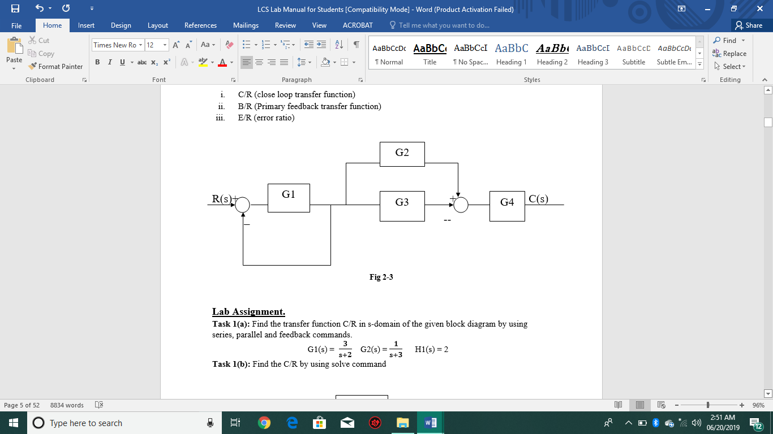E/R (error ratio)

**Coding:**

syms r e b g1 f h1 g2 g3 q c g4

v=solve('e=r-b','b=f*h1','f=g1*e','q=f*(g2-g3)','c=q*g4',e,b,f,q,c)

a=v.c/r

pretty(a)

i=v.e/r

pretty(i)

j=v.b/r

pretty(j)

**Result:**

v =

b: [1x1 sym]

c: [1x1 sym]

e: [1x1 sym]

f: [1x1 sym]

q: [1x1 sym]

a =

(g1*g4*(g2 - g3))/(g1*h1 + 1)

g1 g4 (g2 - g3)

---------------

g1 h1 + 1

i =

1/(g1*h1 + 1)

1

---------

g1 h1 + 1

j =

(g1*h1)/(g1*h1 + 1)

g1 h1

---------

g1 h1 + 1

**Lab Assignment.**

**Task 1(a):**Find the transfer function C/R in s-domain of the given block diagram by using series, parallel and feedback commands.

***G1(s) = $\frac{2}{s+1}$ $\frac{3}{s+2}$ G2(s) = $\frac{2}{s+1}$ $\frac{1}{s+3}$ H1(s) = 2***

**Block Diagram:**

G2

G1

+ C(s)

R(s) + +

_

H1

**Coding:**

S=tf('s')

G1=3/(s+2)

G2=1/(s+3)

H1=2

sys1=parallel(G1,G2)

Sys=feedback(sys1,H1)

**Result:**

Sys =

4 s + 11

---------------

s^2 + 13 s + 28

Continuous-time transfer function.

**Task 1(b):**Find the C/R by using solve command for figure task 1 (a).

**Coding:**

syms e r b c h g1 g2

v=solve('e=r-b','b=c*h','c=e*(g2+g1)',e,b,c);

x=v.c/r

pretty(x)

**Result:**

x =

(g1 + g2)/(g1*h + g2*h + 1)

s

g1 + g2

---------------

g1 h + g2 h + 1

**Task 2(a):** Find the transfer function C/R in s-domain of the given block diagram by using series, parallel and feedback commands.

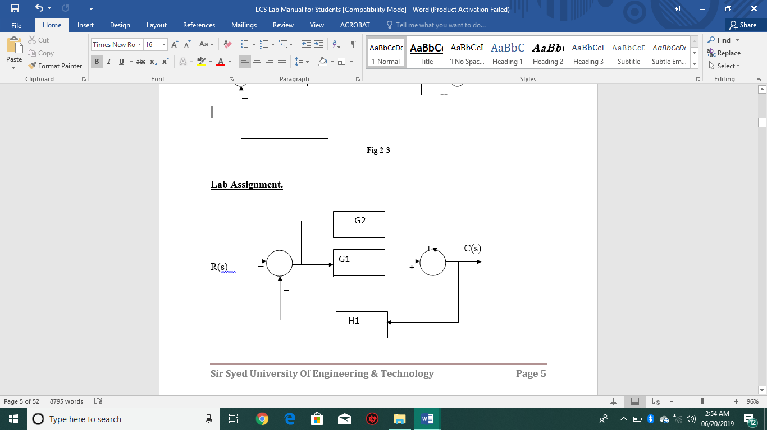 G1(s) = $\frac{2}{s+1}$ $\frac{3}{s+2}$ G2(s) = $\frac{2}{s+1}$ $\frac{1}{s+3}$ H1(s) = 2

**CODING:**

s=tf('s')

g1=3/(s+2)

g2=1/(s+3)

h1=2

f1=parallel(g1,g2)

f2=feedback(f1,h1)

**RESULT:**

s = s

Continuous-time transfer function.

g1 =

3

-----

s + 2

Continuous-time transfer function.

g2 =

1

-----

s + 3

Continuous-time transfer function.

h1 =

2

f1 =

4 s + 17

-------------

s^2 + 11 s + 24

Continuous-time transfer function.

**Task 2(b):** Find the C/R by using solve command

**Coding:**

syms r e b c h1 g1 g2 s d

v=solve('e=r-b','d=r*g2','s=g1*e',b=s*h1’,’c=d+s’,e,d,s,b,c)

a=v.c/r

pretty(a)

**Result:**

v =

b: [1x1 sym]

c: [1x1 sym]

d: [1x1 sym]

e: [1x1 sym]

s: [1x1 sym]

a =

(g1 + g2 + g1*g2*h1)/(g1*h1 + 1)

g1 + g2 + g1 g2 h1

------------------

g1 h1 + 1

**Task 3(a):** Find the transfer function C/R in s-domain of the given block diagram by using series, parallel and feedback commands.

G1(s) = $\frac{2}{s+1}$ $\frac{3}{s+2}$ G2(s) = $\frac{2}{s+1}$ $\frac{1}{s+3}$ G3(s) = $\frac{1}{s+1}$ G4(s) = 3 H1(s) = 2 H2(s) = $\frac{1}{s}$

**Coding:**

s=tf('s')

G1=3/(s+2)

G2=1/(s+3)

G3=1/(s+1)

G4=3

H1=2

H2=1/s

sys1=parallel(G2,G3)

sys2=series(G1,G4)

sys3=feedback(sys2,H1,+1)

sys4=series(sys1,sys3)

Sys=feedback(sys4,H2)

**Result:**

Sys =

18 s^2 + 36 s

---------------------------------

s^4 - 12 s^3 - 61 s^2 - 30 s + 36

Continuous-time transfer function.

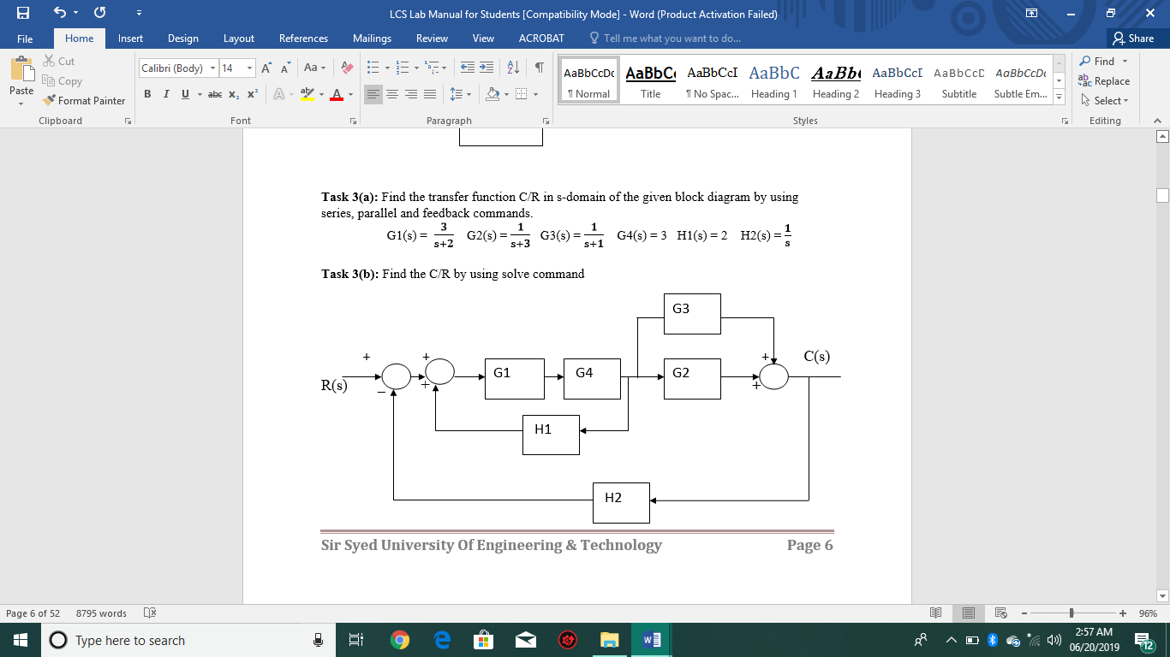**Task 3(b):** Find the C/R by using solve command

**Coding:**

Syms r e b f a g1 g4 h1 d g3 g2 h h2 c

v=solve('e=r-b','f=e+a','d=f*g1*g4','a=d*h1','h=d*(g3+g2)','c=h','b=c*h2',e,f,d,a,h,c,b)

a=v.c/r

pretty(a)

**Result:**

g1 g2 (g3 + g2)

----------------------------------------

h2 g1 g2 – h1 g1 g2 + 1 + g1 g2 g3 h2

**Conclusion:**

In this lab we find the closed loop transfer function C/R by using **series, parallel and feedback** command. And by using **solve** command we also find E/R and B/R.

Moreover, we use **syms, pretty & tf(‘s’)** also, accordingly.