**LAB # 09**

**OBJECTIVE:** Determine the step response of the 2nd order system by creating a model in SIMULINK and by generating a code in MATLAB.

**THEORY**

**2nd Order System:**

The standard 2nd order system transfer function is

**G(s) = $\frac{C(s)}{R(s)}$ = $\frac{{Wn}^{2}}{S^{2 }+2ξWnS+{Wn}^{2}}$**

ξ = Dimensionless Damping Ratio

Wn = Natural Frequency or Undamped Frequency

These two are the parameters of the 2nd order transfer function.

And its step response is

**C(t) = $1-{\frac{1}{β}e}^{-ξWnt}Sin\left(βWnt+ θ\right)$**

$β= \sqrt{1-ξ^{2}}$ $θ=\left(\frac{β}{ξ}\right)$

We cannot show typical step response for a second order system like in 1st order system because the step response of 2nd order system is a function of both ξ and Wn.

If we specify ξ , we still cannot plot C(t) without specifying Wn.

For ξ = 0, the step response is Un damped.

For ξ = 1, the step response is Critically damped.

For ξ >1, the step response is Over damped.

For 0<ξ <1, the step response is Under damped.

**Steady-State Response:**

The first term in the step response originates in the pole of the input R(s) and is called the forced response; since this term does not go to zero with increasing time, it is also called the steady state response.

**Transient Response:**

The second term of the step response originates in the pole of the transfer function G(s) and is called the natural response; since this goes to zero with increasing time, it is also called the transient response.

**Rise Time(Tr):**

The time required for the response to a unit step function to rise from 10 percent (0.1) of the final value to 90 percent (0.9) of the final value.

**Settling Time(Ts):**

It is the time required for the output to settle to within a certain percent of its final value (to reach the steady state).

**Peak Time(Tp):**

The time required to reach the peak value (Mpt) or it is the specified time to first peak.

**Maximum Point(Mpt):**

The peak value of the step response or the peak value of C(t) at peak time is Mpt.

**%overshoot:**

It is the maximum difference between the transient and steady state value.

To perform this lab we need the following commands:

* **tf**
* **feedback**
* **series**
* **plot**
* **subplot**
* **grid**
* **gtext**
* **step**
* **for**

**EXERCISE**

**Task 1: Find the step response of the following 2nd order open loop system by creating model in SIMULINK.**

**(a)G1(s) = $\frac{8}{ S^{2}+16S+8}$**

**Block Diagram: Output:**

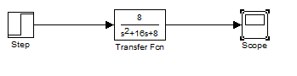 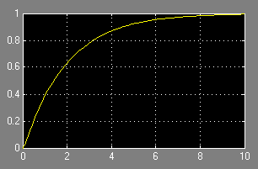

**(b)G2(s) = $\frac{4}{ S^{2}+4}$**

**Block Diagram: Output:**

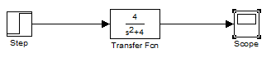 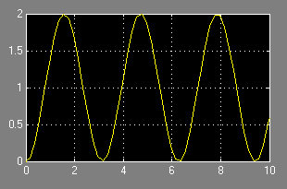

**(c)G3(s) = $\frac{1}{ S^{2}+2S+1}$**

**Block Diagram: Output:**

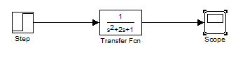 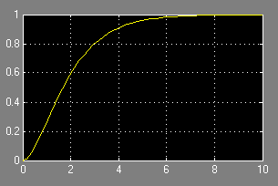

**(d)G4(s) = $\frac{16}{ S^{2}+16S+16}$**

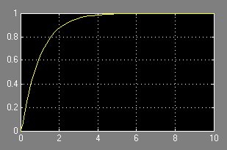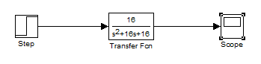**Block Diagram: Output:**

**Task 2: Find the step response of the following 2nd order closed loop system by creating model in SIMULINK.**

**(a)G1(s) = $\frac{8}{ S^{2}+16S+8}$, H1(s) = 1**

**Block Diagram: Output:**

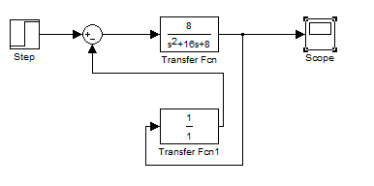 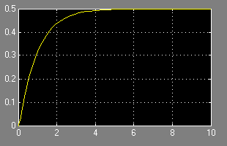

**(b)G2(s) = $\frac{4}{ S^{2}+4}$, H2(s) = $\frac{0.5}{S}$**

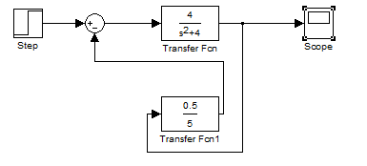**Block Diagram: Output:**

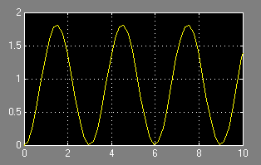

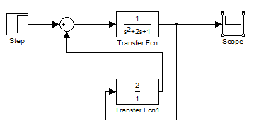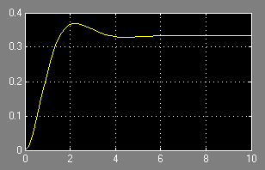**(c)G3(s) = $\frac{1}{ S^{2}+2S+1}$, H3(s) = 2 Output:**

**Task 3(a): For the given 2nd order open loop system identify the transient response, steady state response, settling time, rise time, peak time, maximum point(Mpt), overshoot in the step response graph.**

**G(s) = $\frac{8}{ S^{2}+S+6}$**

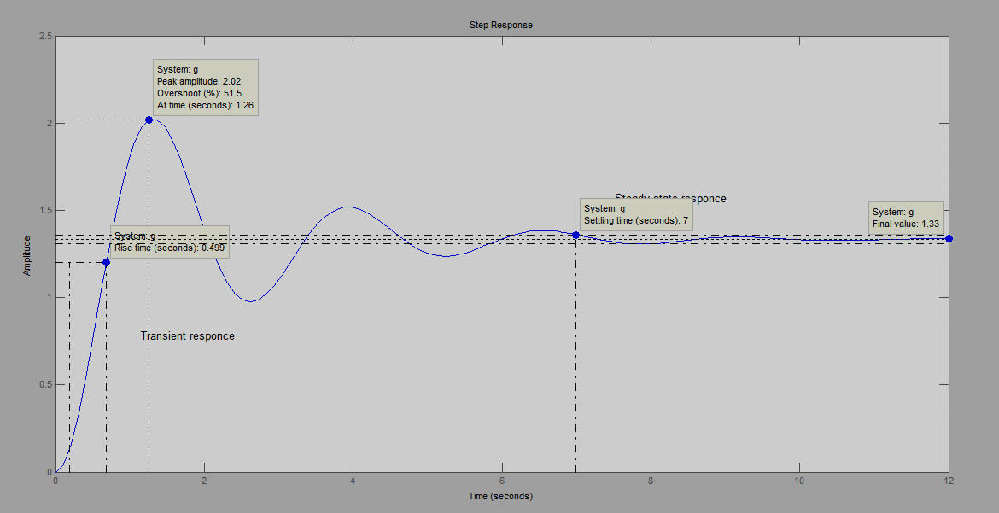**Coding:**

s=tf('s')

g=8/(s^2+s+6)

step(g)

gtext('Transient responce')

gtext('Steady state responce')

**Figure:**

**Task 3(b): For the given 2nd order closed loop system identify the transient response, steady state response, settling time, rise time, peak time, maximum point(Mpt), overshoot in the step response graph.**

**G(s) = $\frac{8}{ S^{2}+S+6}$, H(s) = 2**

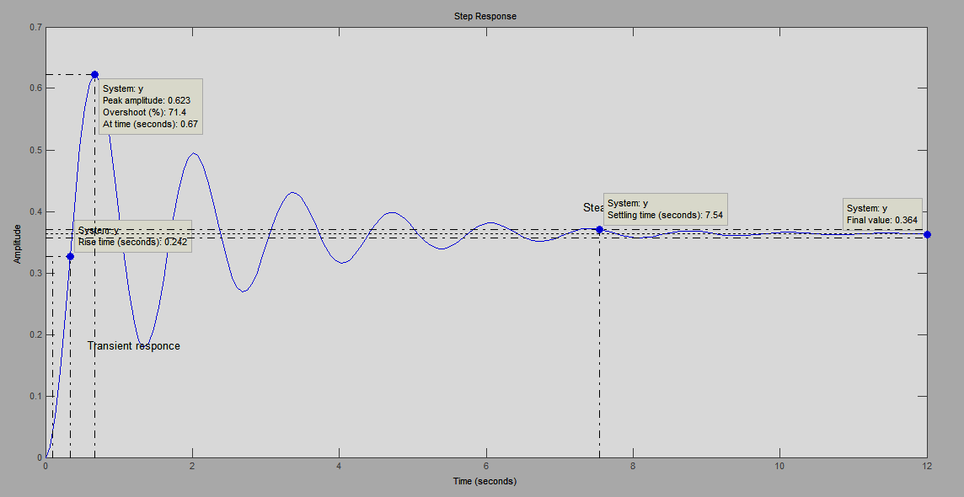**Coding:**

s=tf('s')

g=8/(s^2+s+6)

h=2

y=feedback(g,h)

step(y)

gtext('Transient responce')

gtext('Steady state responce')

**Figure:**

**Task 4: Plot the step response of standard 2nd order system G(s) = $\frac{C(s)}{R(s)}$ = $\frac{{Wn}^{2}}{S^{2 }+2ξWnS+{Wn}^{2}}$ with different values of $ξ$ = 0, 0.3, 0.5, 1, 2, 2.5 (take these values by using for loop) and fixed value of Wn = 4 without using plot command and show the results in one window of figure.**

**Coding:**

z=[0,0.3,0.5,1,2,2.5]

for i=1:6

t=0:0.001:5

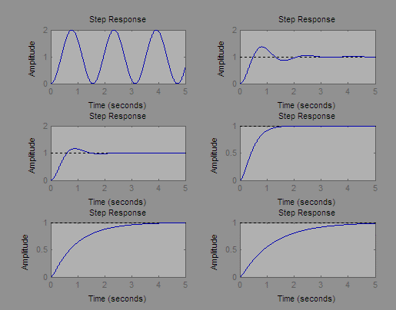 n=[16]

d=[1 8*z(i) 16]

g=tf(n,d)

subplot(3,2,i)

step(g,t)

end

**Figure:**

**Task 5(a): Generate a Matlab code to plot the step response of the given open loop 2nd order system by using the plot command.**

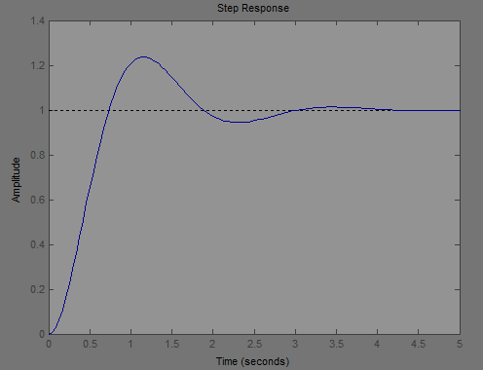**G(s) = $\frac{9}{ S^{2}+2.5S+9}$**

**Coding:**

s=tf('s')

g=9/(s^2+2.5*s+9)

step(g)

**Figure:**

**Task 5(b): Generate a Matlab code to plot the step response of the given closed loop 2nd order system by using the plot command.**

**G(s) = $\frac{9}{ S^{2}+2.5S+9}$, H(s) = $\frac{1}{S}$**

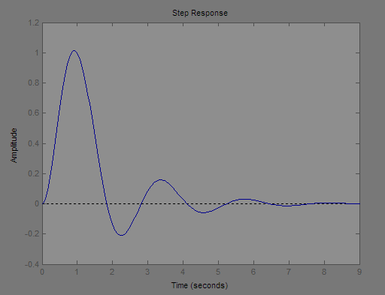**Coding:**

s=tf('s')

g=9/(s^2+2.5*s+9)

h=1/s

y=feedback(g,h)

step(y)

**Figure:**

**Task 6: For the given block diagram of the 2nd order closed loop system determine the step response for K = 10, 20, 50, 100 and show the result in one window figure. Find the measured and calculated values of Rise time, Peak time, Settling time, Mpt, %overshoot and steady state value.**

**K+11**

$$\frac{1}{ S^{2}+S+1}$$

**R(s) + C(s)**

**_**

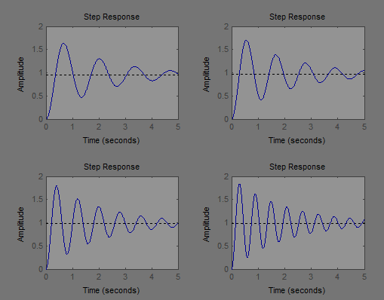**Coding:**

s=tf('s')

k=[10,20,50,100]

for i=1:4

t=0:0.001:5

g1=[k(i)+11]

g2=[1/(s^2+s+1)]

sys=series(g1,g2)

f=feedback(sys,1)

subplot(2,2,i)

step(f,t)

end

**Figure:**

**Lab Assignment**

**Task 1: Find the step response of the following 2nd order open loop system by creating model in SIMULINK.**

**(a)G1(s) = $\frac{3}{ S^{2}+2S+3}$**

**Block Diagram: Output:**

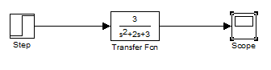 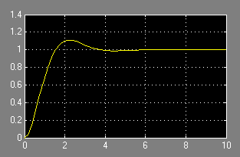

**(b)G2(s) = $\frac{4}{ S^{2}+4S+4}$**

**Block Diagram: Output:**

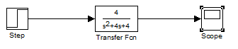 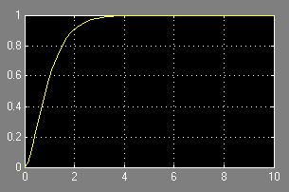

**(c)G3(s) = $\frac{36}{ S^{2}+24S+36}$**

**Block Diagram: Output:**

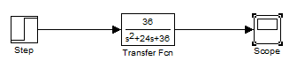 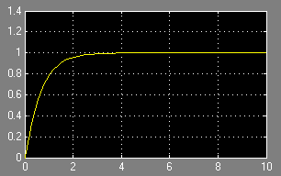

**Task 2: Find the step response of the following 2nd order closed loop system by creating model in SIMULINK.**

**(a)G1(s) = $\frac{3}{ S^{2}+2S+3}$, H1(s) = 1**

**Block Diagram: Output:**

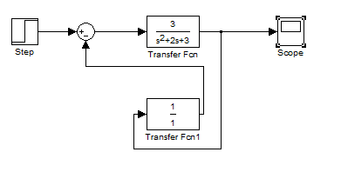 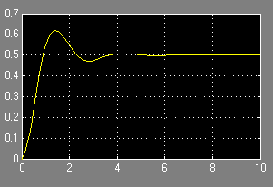

**(b)G2(s) = $\frac{5}{ S^{2}+5}$, H2(s) = 2**

**Block Diagram: Output:**

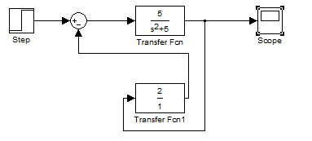 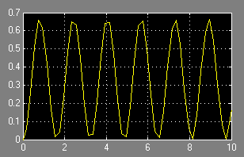

**(c)G3(s) = $\frac{4}{ S^{2}+4S+4}$, H3(s) = 3**

**Block Diagram: Output:**

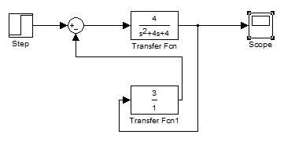 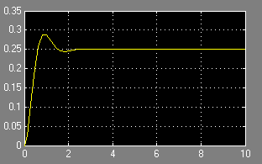

**(d)G4(s) = $\frac{36}{ S^{2}+24S+36}$, H4(s) = 4**

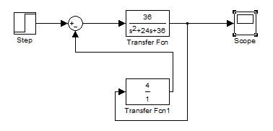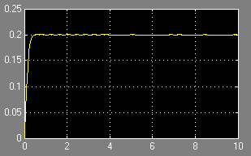**Block Diagram: Output:**

**Task 3(a): For the given 2nd order open loop system identify the transient response, steady state response, settling time, rise time, peak time, maximum point(Mpt), overshoot in the step response graph.**

**G(s) = $\frac{2}{ S^{2}+S+3}$**

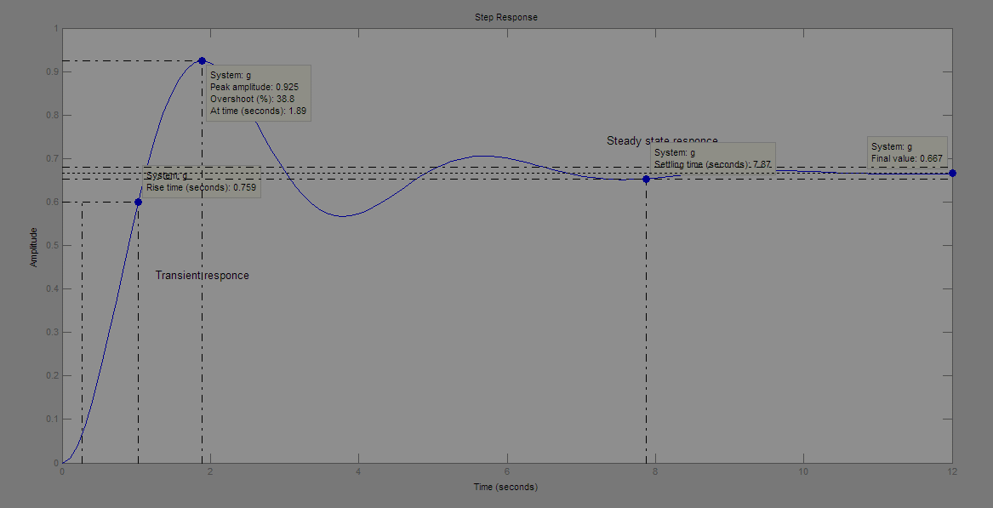**Coding:**

s=tf('s')

g=2/(s^2+s+3)

step(g)

gtext('Transient responce')

gtext('Steady state responce')

**Figure:**

**Task 3(b): For the given 2nd order closed loop system identify the transient response, steady state response, settling time, rise time, peak time, maximum point(Mpt), overshoot in the step response graph.**

**G(s) = $\frac{2}{ S^{2}+S+3}$, H(s) = 3**

**Coding:**

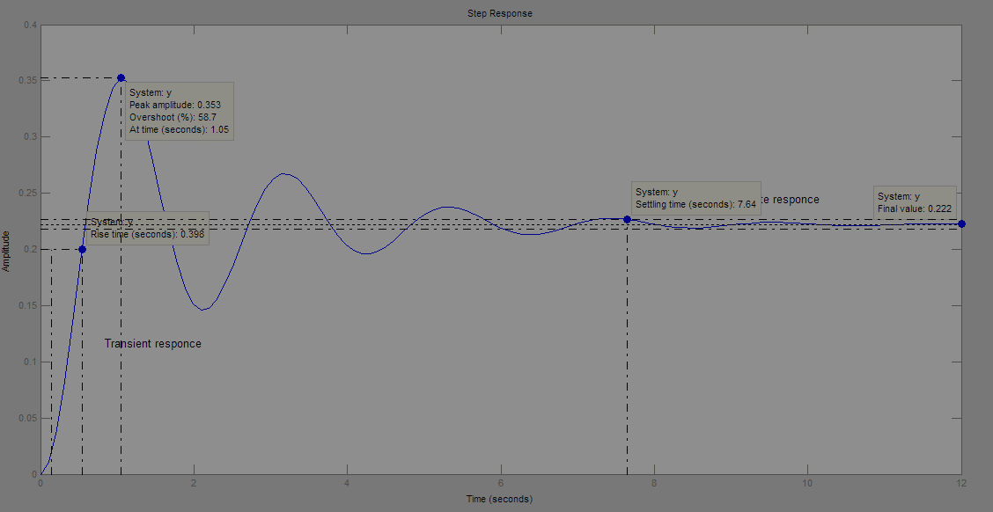s=tf('s')

g=2/(s^2+s+3)

h=3

y=feedback(g,h)

step(y)

gtext('Transient responce')

gtext('Steady state responce')

**Figure:**

**Task 4(a): Plot the step response of standard 2nd order system G(s) = $\frac{C(s)}{R(s)}$ = $\frac{{Wn}^{2}}{S^{2 }+2ξWnS+{Wn}^{2}}$ with different values of $ξ$ = 0, 0.2, 0.4, 1, 2, 2.8 (take these values by using for loop) and fixed value of Wn = 3 without using plot command and show the results in one window of figure.**

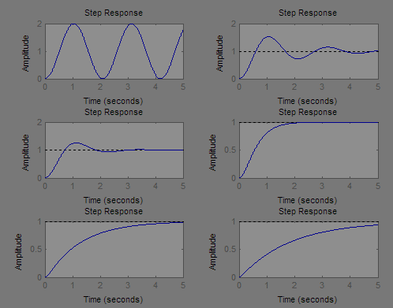**Coding:**

z=[0,0.2,0.4,1,2,2.8]

for i=1:6

t=0:0.001:5

n=[9]

d=[1 6*z(i) 9]

g=tf(n,d)

subplot(3,2,i)

step(g,t)

end

**Figure:**

**Task 4(b): Plot the step response of standard 2nd order system G(s) = $\frac{C(s)}{R(s)}$ = $\frac{{Wn}^{2}}{S^{2 }+2ξWnS+{Wn}^{2}}$ with different values of Wn = 2, 3, 4, 5, 6, 7 (take these values by using for loop) and fixed value of $ξ$ = 0.7 without using plot command and show the results in one window of figure.**

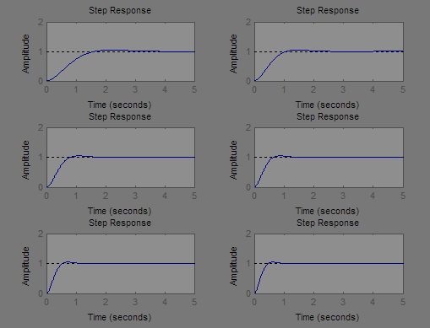**Coding:**

wn=[2,3,4,5,6,7]

for i=1:6

t=0:0.001:5

n=[wn(i).^2]

d=[1 2*0.7*wn(i) wn(i).^2]

g=tf(n,d)

subplot(3,2,i)

step(g,t)

end

**Figure:**

**Task 5(a): Generate a MATLAB code to plot the step response of the given open loop 2nd order system by using the plot command.**

**G(s) = $\frac{6}{ S^{2}+3.5S+6}$**

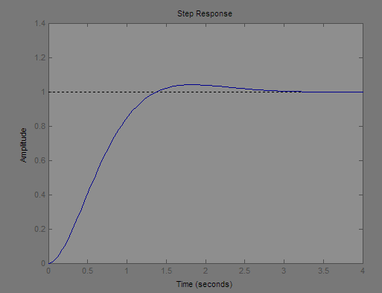**Coding:**

s=tf('s')

g=6/(s^2+3.5*s+6)

step(g)

**Figure:**

**Task 5(b): Generate a Matlab code to plot the step response of the given closed loop 2nd order system by using the plot command.**

**G(s) = $\frac{6}{ S^{2}+3.5S+6}$, H(s) = 5**

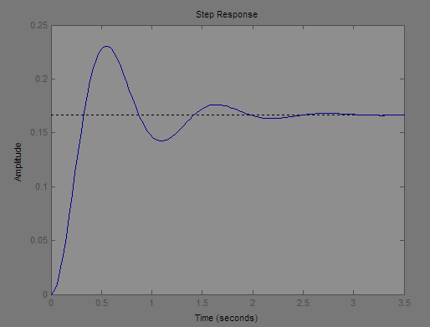**Coding:**

s=tf('s')

g=6/(s^2+3.5*s+6)

h=5

y=feedback(g,h)

step(y)

**Figure:**

**Task 6: For the given block diagram of the 2nd order closed loop system determine the step response for K = 5, 15, 45, 95 and show the result in one window figure. Find the measured and calculated values of Rise time, Peak time, Settling time, Mpt, %overshoot and steady state value.**

**K+10**

$$\frac{1}{ S^{2}+S+1}$$

**R(s) + C(s)**

**_**

**Coding:**

s=tf('s')

k=[5,15,45,95]

for i=1:4

t=0:0.001:5

g1=[k(i)+10]

g2=[1/(s^2+s+1)]

sys=series(g1,g2)

f=feedback(sys,1)

subplot(2,2,i)

step(f,t)

end

**Figure:**

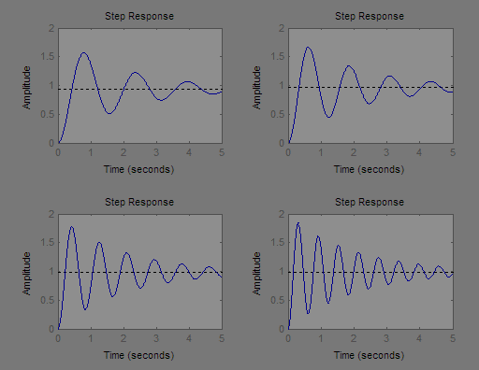

**Conclusion:**

In this lab I learnt how to determine the step response of the 1st order system by creating a model on SIMIULINK also by generating a MATLAB code.