**Business Requirement Document for Issue Tracking System**

# Use cases

## Analyst Use cases

* Login

The user provides username and password to get access to the system.

* See issues list

The user is able to view all issues recorded in the system

* Record new issue

The user is able to record a new issue in the system

* See issue details

The user is able to see the details of a specific issue

## Developer Use cases

* Login

The user provides username and password to get access to the system.

* See issues list

The developer sees all the issue he/she is currently assigned and working on.

* Record new issue

The user is able to record a new issue in the system.

* See issue details

The user is able to see the details of a specific issue.

* Open Issue

The user is able to open an issue to start working on.

* Reject Issue

The developer can reject an issue if they feel they can not work on it for some reason.

* Resolve Issue

The developer can mark an issue as resolved once they have worked on it.

## Manager Use cases

* Login

The manager provides the username and password to access the system.

* Add new user

The manager can add a new user to the system.

* See issues list

The manager can see all issues whose status is not closed.

* Record new issue

The user can report an issue to the system.

* See issue details

The user is able to see the details of a specific issue

* Assign Issue

The user is able to assign the issue to a particular developer to work on.

* Validate Issue

The manager can validate an issue that has been worked on by a developer.

* Fail Issue

The manager can fail an issue that has been worked on by a developer for whichever reason.

* Close Issue

The manager can close an issue if rejected by a developer or if it has already been resolved.

# Use case Diagrams

## Analyst Use case Diagram

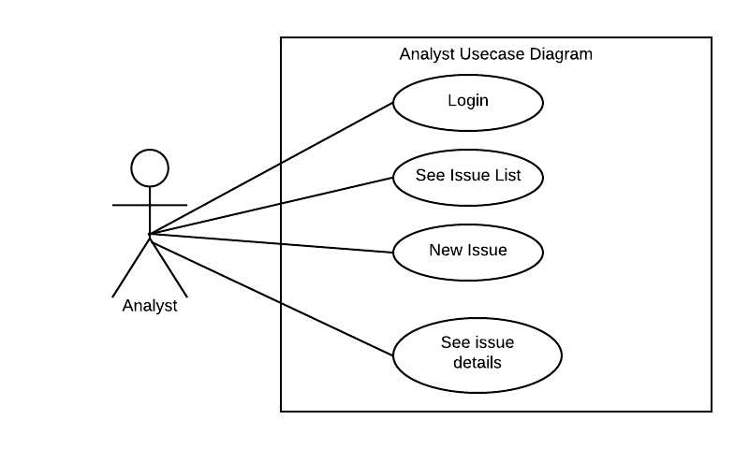

## Developer use case diagram

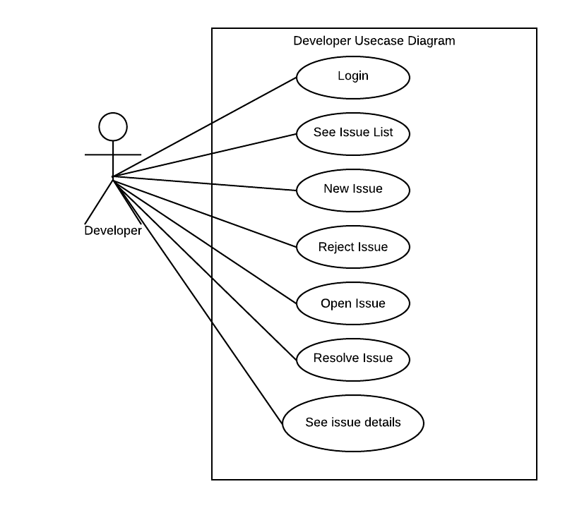

## Manager use case diagram

