BDD Cucumber

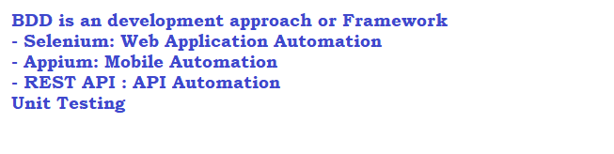

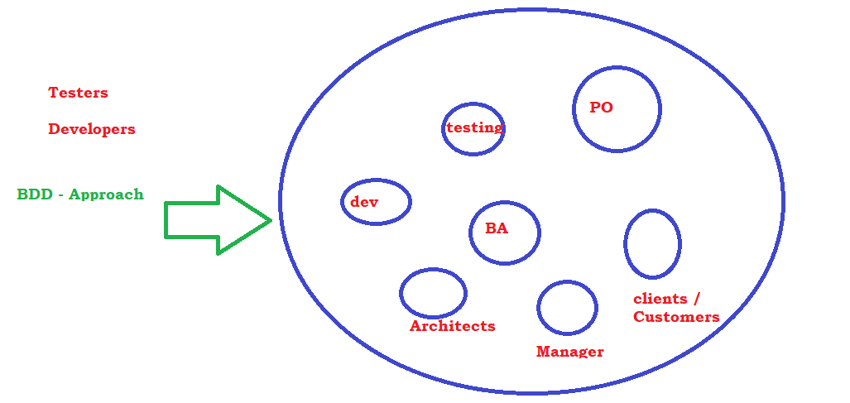

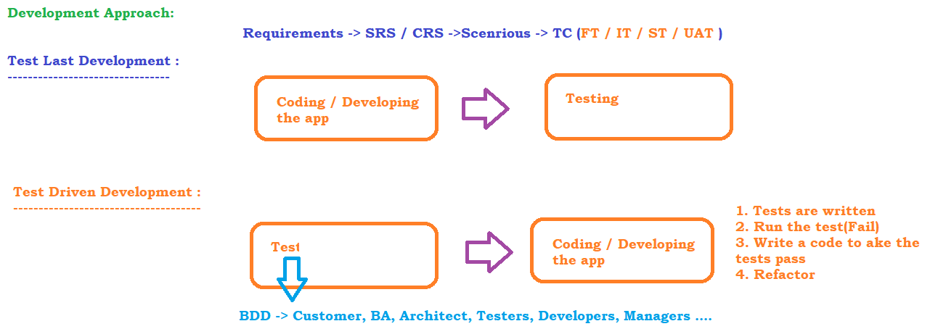

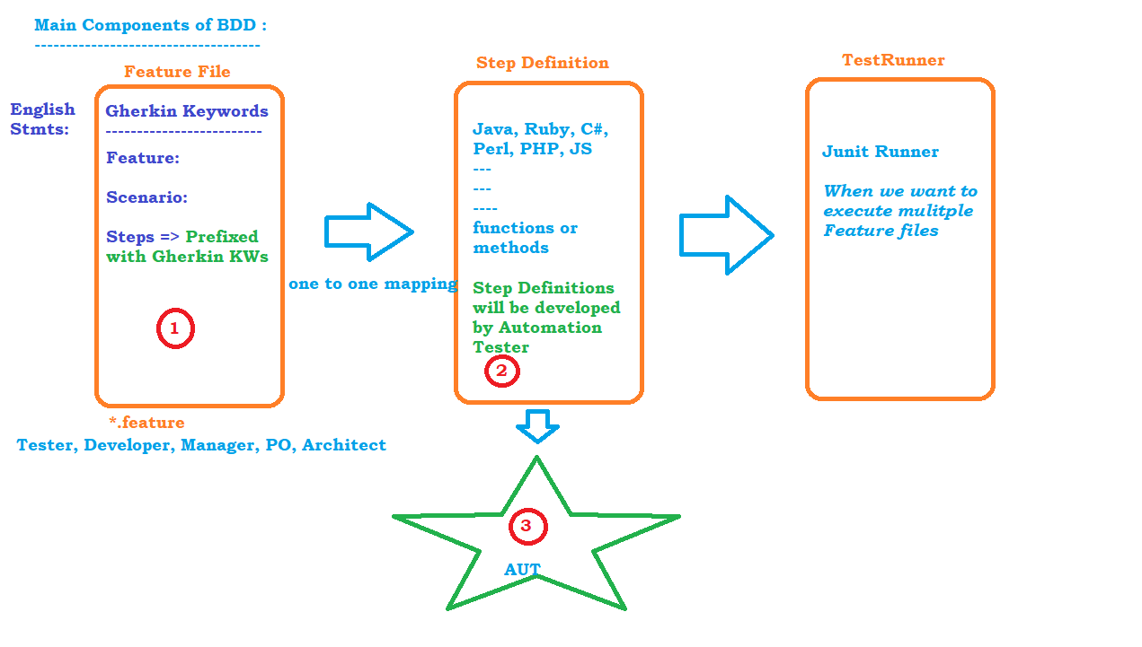

Sample Feature file

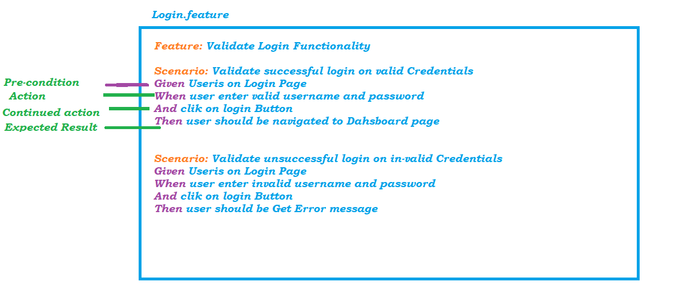

Eclipse Setup for Maven and BDD

1. Download maven <https://maven.apache.org/download.cgi>
2. Unzip the downloaded zip file
3. Update the Environment Variables
   1. MAVEN_HOME - D:\maven\apache-maven-3.6.1
   2. M2 - D:\maven\apache-maven-3.6.1\bin

OR %MAVEN_HOME%\bin

* 1. PATH - D:\maven\apache-maven-3.6.1\bin

1. Download Eclipse from <https://www.eclipse.org/downloads/packages/release/2022-03/r/eclipse-ide-java-developers>
2. Create a Maven Project in Eclipse

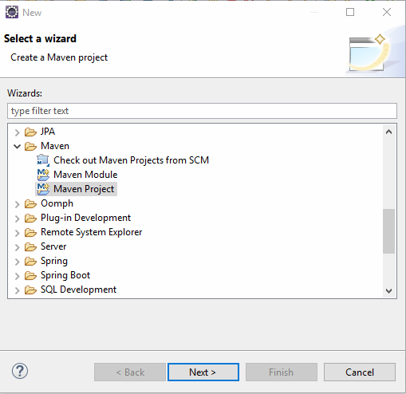

1. select the archetype
   1. 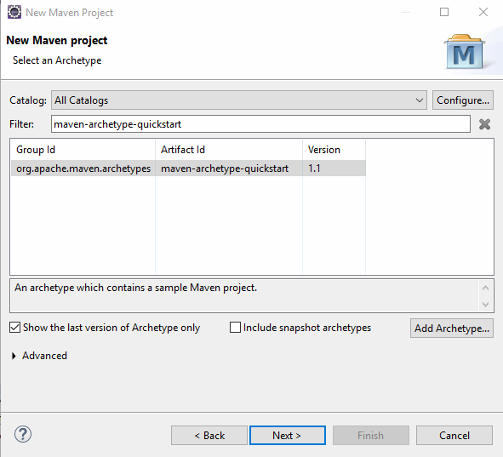
2. Update JDK And JRE
   1. Update JDK Version
      1. Right click on project -> select Java Compiler ->update the correct version
   2. Update JRE
      1. Remove the old JRE
      2. ADD JRE from JDK location
         1. Add library
         2. Click on JRE System library
         3. Alternate JRE
         4. Click on installed JRE
         5. Click on ADD -> Standard VM
         6. Browse and select JRE from JDK Location
         7. Click on apply and finish
   3. Update pom.xml for the dependencies
      1. cucumber-java : <https://mvnrepository.com/artifact/io.cucumber/cucumber-java>
      2. cucumber-junit : <https://mvnrepository.com/artifact/io.cucumber/cucumber-junit/7.3.4>
      3. junit: <https://mvnrepository.com/artifact/junit/junit/4.13.2>
   4. Install Cucumber Plugin
      1. go to Help ->marketplace
      2. 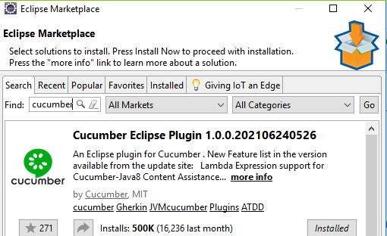
      3. Write your first feature file

Test Runner

features : location of the feature files

glue: location of the step definition

monochrome: to remove the junk characters

dryrun: to check all steps in the feature file has a step definition

plugin: to get the reports , cucumber supports junit, json and html reporting.

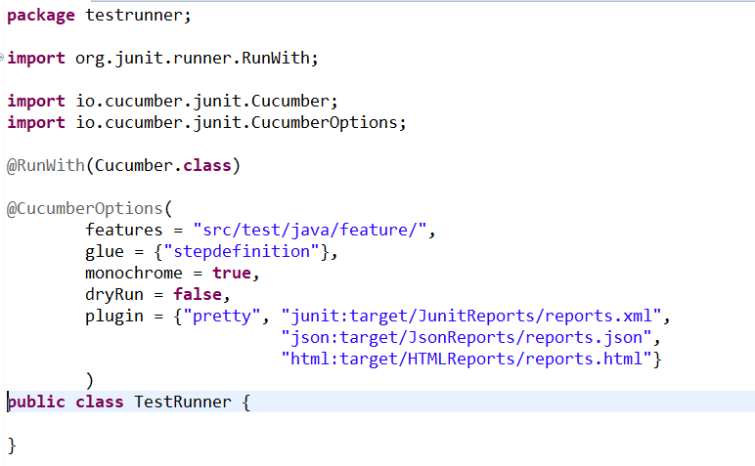

# Selenium Tests using BDD:

1. Update pom.xml with selenium dependencies
   1. WebdriverManager : is to automatically download the driver executable <https://mvnrepository.com/artifact/io.github.bonigarcia/webdrivermanager/5.2.0>