BDD Cucumber :

Pre req:

* Java
* Selenium – WebDriver
  + Object identification ->**xpath**
    - basic
      * Syntax - //htmltag[@attribute=’value’]
      * Ex - //input[@id='file-upload-field']
    - with Logical operations or / and / not
      * Syntax - //htmltag[@attribute1 =’value’ and @attribure2 = ‘value’]
      * //htmltag[@attribute1 =’value’ or @attribure2 = ‘value’]
      * Ex - //input[@type='text' or @type='password'] 🡪 2 elements
      * //input[@type='text' and @type='password'] 🡪 0 elements
      * //td[text()='15' and not (@class='past day')]

OR

* + - * //td[(@class='wd day' or @class='we day' or @class='current day') and text()='14']
    - functions -> Web Element which has **text** or which is **hyperlink**
      * text()
        + Syntax - //html[text()=’exact text’]
        + Example - //td[text()='15']
      * contains(arg1, arg2)
        + arg1 -> attribute or text()
        + arg2-> partial value corresponding to arg1
        + Syntax - //htmltag[contains(@attibure,’partialValue’)]
        + Ex - //img[contains(@src,'timer')]
        + //label[contains(text(),'Keep')]
      * starts-with(arg1, arg2)
        + arg1 -> attribute or text()
        + arg2-> partial value corresponding to arg1
        + Syntax - //htmltag[starts-with(@attribute,’startingvalue’)]
        + Example - //h3/span[starts-with(text(),'Synechron')]
        + //htmltag[starts-with(text(),’startingvalue’)]
        + //*[starts-with(@id,'ext-gen')]
    - Travers from parent to child
      * Immediate child - //h3**/**span[contains(text(),'Wiki')]
      * Not Immediate child - //div[@class='tF2Cxc']**//**span[contains(text(),'Wiki')]
    - Travers from child to parent – *whenever we have dependent and independent elements in the webpage*
      * 1. write xpath to the child element (independent ele)
      * 2. put the complete expression (excluding //) inside square bracket and specify parent html tag
      * Syntax - //parenttag[xpath_of_child]
      * //parent2[parenttag1[xpath_of_child]]
      * //div[div[div[h3[contains(text(),'Retreat to')]]]]//p[contains(@class,'blackText ')]
    - Axes Functions
      * traverse to following siblings
        + Syntax - //htmltag[@attribute=’value’]/following-sibling::SIBLINGTAG
        + //th[text()='Directed by']/following-sibling::td
      * traverse to preceding sibling
        + Ex - //li[a[text()='rPool ']]/preceding-sibling::li
      * till end of the page from any particular location
        + Ex - //span[contains(text(),'Wiki')]/following::a
      * till beginning of the page from any particular location
        + Ex - //span[contains(text(),'Wiki')]/preceding::a
      * traverse to parent
        + //th[text()='Directed by']/parent::tr//a
      * traverse to child
        + //h3/child::span
      * traverse to ancestor
        + //h3[contains(text(),'Retreat to')]/ancestor::div[contains(@class,'packageListing ')]//p[contains(@class,'blackText ')]
* BDD Cucumber
  + 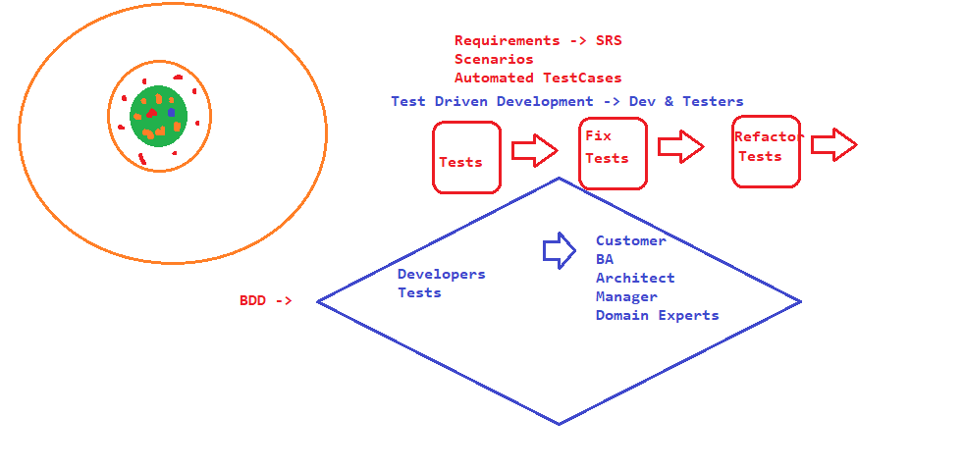
  + Frameworks
    - Cucumber
    - JBehave
    - BeanSpec
    - Esay B ..
* Components of BDD

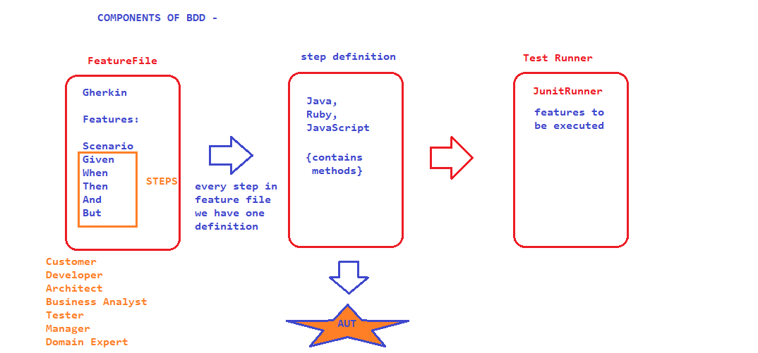

* Maven – BAT

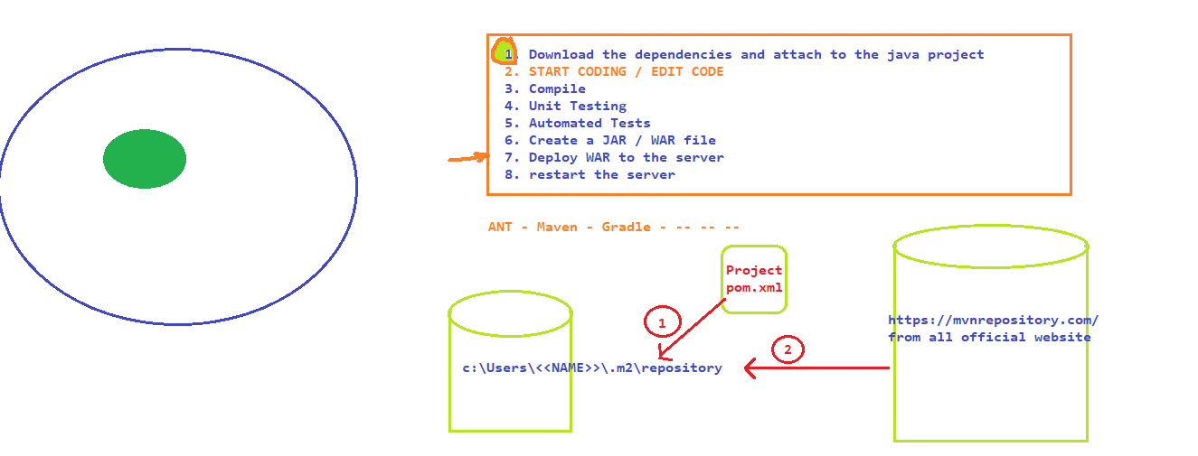

* Sample Feature file

