**Selenium Automation**

1. **Some intro to Testing**

* **What is Software Testing**
* **What are the different type of testing we do ???**
* **What are the drawbacks of manual testing**

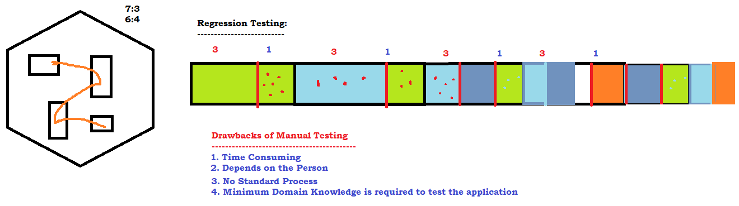

* **Why Automation is needed ?**
* **What are the Tools Available in Market ?**
  + **UFT**
  + **RFT**
  + **Selenium**
  + **Sahi**
  + **Eggplant**
  + **Auto IT**
  + **siquli .. .. .. .. .. ..**

1. **Why Selenium / Features Of Selenium**
   * **Open source freely available software**
   * **Only tool to support Multiple programming languages – java, c#, ruby, perl, python, js**
   * **OT – almost all the popular browsers**
   * **OT – Parallel Execution**
   * **No Dedicated machine is required**
   * **Headless browser execution**
   * **Distributed Execution**
2. **History**
3. **Versions**

* **Selenium IDE**
  + **Beginners – NOT much time**
  + 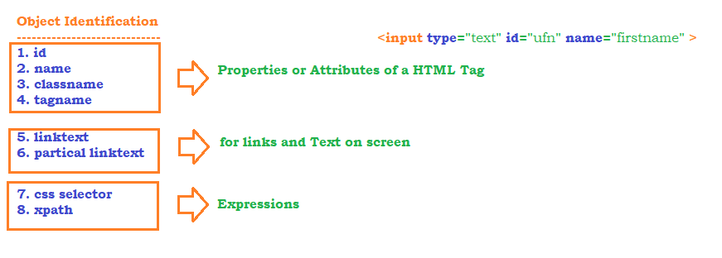
  + **Object Identification mechanism** 
    - **CSS**
    - **xpath (15)**
      * **basic**
      * **using function** 
        + **text()**
        + **contains()**
        + **starts-with()**
      * **using Regular expression** 
        + **AND**
        + **OR**
        + **NOT**
      * **Traversing from patent to child**
      * **Traversing from child to parent**
      * **using axes function**
        + **following**
        + **preceding**
        + **following-sibling**
        + **preceding-sibling**
        + **parent**
        + **child**
        + **ancestor**
* **~~Selenium RC~~**
* **Selenium WebDriver - 3.141.59**
  + **Operations**
    - **click – button, dropdown, image, hyperlink ...**
    - **type – textbox, text area..**
    - **dropdown elements**
    - **getting text from application**
    - **getting attribute value of a element**
  + **KB and Mouse operations**
  + **Automate –** 
    - **tooltip**
    - **suggestions**
    - **mouse hover**
  + **Browser operation**
  + **End to end tests**
  + **Popup**
    - **alert**
    - **confirmation popup**
    - **hidden division popup**
    - **file download**
    - **file upload**
    - **pageload popup**
  + **Sikuli / Auto IT**
  + **Data driven testing**
    - **Global Data – Common to all the tests**
    - **Local Data- specific to tests**
* **Selenium Grid**
  + **Distributed Execution**

**Frameworks**

* **TestNG**
  + **annotations**
  + **group**
  + **data driven testing**
  + **priority**
  + **parallel execution**
  + **HTML Reports**
  + **execute the failed tests**
  + **customized reports**
* **POM – Page Object Model**

**Maven – Build Automation Tool**

1. **Installation**
2. **Maven build life cycle**
3. **phases of maven**
4. **Create a Maven Project**
5. **batch run – without opening eclipse**

**BDD – Behavioural Driven Development**

1. **Developer, tester, manager, Business analyst, Customer, Architect**
2. **Gherkin language**
   1. **Feature File**
   2. **Step Definition**
   3. **Test Runner**

**GIT – Distributed Version Control Software**

1. **Installation**
2. **Adding roles to the users etc**
3. **Difference between local repository / Global Repository**
4. **Basic GIT Commands**
5. **stash / unstash**
6. **revert the commit**
7. **resolve conflicts**

**Jenkins – CI/CD/CT**

1. **Installation**
2. **Configuration**
3. **Plugin management**
4. **How to create Builds / Jobs**
5. **How to execute the tests**
6. **How to execute the tests Automatically**
7. **How to analyze logs / Reports**