JAVA –

**Strings**

**Type Casting (Wrapper Classes)**

***Threads(Optionally)***

**File Handling**

**Exceptions**

**Collections**

***Looping and conditional statements***

**SELENIUM *(Browser Automation Tool)* :**

1. **Open Source free available software**
2. **Almost all the popular browsers //QTP (HP) – IE, Mozilla, Chrome**
3. **Platform independed // QTP (HP) –Platform dependent**
4. **Supports multiple Programming languages // QTP (HP) – VBS**
   1. **Java**
   2. **C#**
   3. **Ruby**
   4. **Python**
   5. **Perl**
   6. **Javascript**
   7. **PHP**
5. **No dedicated machine is required for execution // QTP (HP) – Dedicated machine is must**
6. **Parallel Execution( 2-n ) // QTP (HP) – not supported**
7. **Distributed Execution**

***Versions :***

1. ***Selenium-IDE (Record and Playback) used by Beginners***
   1. ***Same origin Policy***

AUT

Script

1. ***~~Selenium-RC~~***
   1. ***~~Virtual Server~~***

VS

AUT

Script

* 1. ***~~Execution was very slow~~***
  2. ***~~Proxy settings, then RC will fail to perform~~***
  3. ***~~SSL, Security~~***
  4. ***~~Client and Server config was very difficult~~***
  5. ***~~JavaScript~~***

1. ***Selenium Webdriver (2.0 , 3.0, (3.141.59), Selenium 4.0 alpha)***
   1. ***JAVA***
2. ***Selenium Grid – Distributed Execution***

***TestNG, Maven, Jenkins:***

***Official WebSite :***

<https://www.seleniumhq.org/>

***Selenium IDE :***

***Addon with FF or Chrome***

***Script Generated by Selenium IDE is called Selenese***

***Selenese***

* ***Command - type of Action that we perform on WebElement (any component which you see on a Web Page)***
  + ***Command***
    - ***open – launch the application***
    - ***type***
    - ***click***
    - ***click at***
    - ***assert title***
    - ***assert text***
* ***Target- WebElement on we are performing action***
  + ***id***
  + ***name***
  + ***className***
  + ***tagName***
  + ***linkText***
  + ***partialLinkText***
  + ***css***
  + ***xpath***

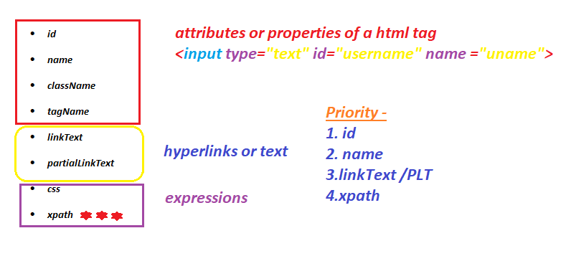

* ***Value***
  + ***Optional Section , text to be typed***

***Validations in Selenium IDE:***

* ***Verify - will make the step fail and continue the execution***
* ***Assert - will make the step fail and stop the execution***

***POC – Proof of Concept***

***Asusual***

***nd 6.30 AM IST 🡪(9.30 PM CST)***

***Expressions :***

***We find the exact location of a web Element in the web page or DOM.***

***CSS - we can traverse only from parent tag to child tag in HTML DOM***

1. ***css=htmlTag[propertyname = ‘propertyValue’]***
2. ***css=htmlTag#idValue or #idValue***
3. ***css=htmlTag. valueOfClassAttribute or .valueOfClassAttribute***

***Xpath - we can traverse from parent tag to child tag in HTML DOM or from child tag to parent tag***

***Xml path🡺 location of a element in DOM***

1. ***Absolute xpath***

***/html/child/superchild/child/../.../.../...***

1. ***Relative xpath***

***// 🡺 anywhere in the html page***

***Syntax :***

1. ***Basic Xpath***

***//htmlTag[@propertyname=’propertyValue’]***

1. ***Traversing from parent to child***

***//htmlTag[@propertyname=’propertyvalue’]/childTagName***

***Or***

***//htmlTag[@propertyname=’propertyvalue’]//childTagName***

***Or***

***//htmlTag[@propertyname=’propertyvalue’]//childTagName[@propertyname=’propertyvalue’]***

1. ***Using regular Expressions in Xpath***

***If one property is not sufficient to find the element then we can go with Regular Expressions***

***3.1 AND***

***- if both the properties are matched then we get the element***

***//htmltag[@property1=’value1’ and @property2=’value2’]***

***3.2 OR***

***- if any one property is matched then we get the element***

***//htmltag[@property1=’value1’ or @property2=’value2’]***

1. ***Xpath Using Functions:***
   1. ***text()***

***//htmltag[text()=’textToSearch’]***

* 1. ***contains(arg1,arg2)***
     1. ***arg1 - > text function or attribute***
     2. ***arg2 -> partial value (partial text or partial attibute value)***

***//htmltag[conatins(text(),’partialtext’)]***

***//htmltag[contains(@attriburename,’partialValueOfAttribute’)]***

* 1. ***starts-with(arg1,arg2)***
     1. ***arg1 - > text function or attribute***
     2. ***arg2 -> partial value (partial text or partial attibute value)***

1. ***Dependent and Independent Elements (Navigating from child to parent)***

When ever we are identifying or playing with dependent and independent elements always write a xpath to independent element from there navigate to dependent element

1. Xpath of child
2. //parentHtmlTAG[ Xpath of child ]
3. ***Using axes Functions :***

6.1 following-sibling🡪 Will search all the sibling tags which is next to the current tag

Xpath of independentElement/**following-sibling::**SiblingTag

6.2 preceding-sibling🡪 Will search all the sibling tags which are previous to the current tag

Xpath of independentElement/**preceding-sibling::**SiblingTag

6.3 following🡪 Will search all the tags which is next to the current tag till the end of the page

Xpath of independentElement/**following::**SiblingTag

6.4 preceding🡪 Will search all the tags which is next to the current tag till the start of the page

Xpath of independentElement/**preceding::**SiblingTag

6.5 parent🡪 will navigate to parent tag from the current tag

//th[text()='Directed by']/parent::tr

6.6 child 🡪 will navigate to child tag from the current tag

//th[text()='Directed by']/parent::tr/child::td

6.7 ancestor🡪 will navigate to parent -> super parent-> super most parent....

|  |  |  |  |
| --- | --- | --- | --- |
| ***Application*** | ***Type*** | ***Element Name*** | ***Xpath*** |
| ***ActiTime*** | ***basic*** | ***UserName Text Box*** | ***//input[@placeholder='Username']***  ***//input[@id='username']***  ***//input[@name='username']*** |
| ***ActiTime*** | ***basic*** | ***Password Text Box*** | ***//input[@placeholder='Password']*** |
| ***ActiTime*** | ***Traversing Parent to immediate child*** | ***Login Button*** | ***//a[@id='loginButton']/div***  ***Or***  ***//div[text()='Login ']*** |
| ***ActiTime*** | ***Traversing Parent to child present somewhere*** | ***Search all div under login button*** | ***//td[@id='loginButtonContainer']//div*** |
| ***ActiTime*** | ***Traversing Parent to child present somewhere*** | ***Print All Module Names*** | ***//table[@id='topnav']//div[@class='label']*** |
| ***ActiTime*** | ***Using Regular Expression*** | ***Search both username and password*** | ***//input[@id='username' or @name='pwd']*** |
| ***ActiTime*** | ***Using Regular Expression*** | ***Search none of un and pwd*** | ***//input[@id='username' and @name='pwd']*** |
| ***ActiTime*** | ***Using Function*** | ***logo*** | ***//img[contains(@src,'timer')]*** |
| ***Actitime*** | ***Using contains Function*** | ***Search all Log*** | ***//div[contains(text(),'Log')]*** |
| ***google*** | ***Using starts-with function*** | ***Search all elements with IBM*** | ***//h3[starts-with(text(),'IBM')]*** |
|  |  |  |  |
| ***Redbus.in*** | ***Using text() with Regular Expression*** | ***Selecting a Date*** | ***//div[@id='rb-calendar_onward_cal']//td[text()='29' and (@class='wd day' or @class='current day' or @class='we day')]*** |
|  |  |  | ***//label[@for='radio-button' and contains(text(),'Highest')]*** |
| ***wikipedia*** | ***Child to parent*** | ***Search Director Name*** | ***//tr[th[text()='Directed by']]/td*** |
| ***mmt*** | ***Child to parent*** | ***Price of a holiday*** | ***//div[div[div[h3[contains(text(),'Spanish Delight 2020')]]]]//p[contains(@class,'latoBold ')]*** |
|  | ***Using ancestor axes function*** | ***Price of a holiday*** | ***//h3[contains(text(),'Spanish Delight 2020')]/ancestor::div[@class='boxShadow bdr packageListing pointer packageDetailsBox']//p[contains(@class,'latoBold ')]*** |
| ***gsmarena*** | ***Child to parent*** | ***Display features of any given phone*** | ***//tbody[tr[th[text()='Display']]]//td[@class='nfo']*** |
| ***wikipedia*** | ***Axes function*** | ***Search Director Name*** | ***//th[text()='Directed by']/following-sibling::td*** |
|  |  | ***Print index Number*** | ***//span[text()='Awards and nominations']/preceding-sibling::span*** |
|  |  | ***Parent and child axes function*** | ***//th[text()='Directed by']/parent::tr/child::td*** |
|  |  |  |  |

***WebDriver***

|  |  |  |  |  |  |
| --- | --- | --- | --- | --- | --- |
| *Class / Interface* | *Method Name* | | *Return type* | *Arguments* | *Description* |
| WebDriver | **Get**() | | Void | String | Launch the browser |
| WebDriver | **findElement**() | | WebElement | By | To find the web element on web page. |
| WebElement | | **Sendkeys**() | Void | String | To perform type operation |
| WebElement | | **Click()** | Void | NA | To perform click operation |
| WebDriver | | **findElements** | List<WebElement> | By | To find the web element**s** on web page. |
| WebElement | | **getText()** | String | NA | Returns the text present out side the html tag |
| WebElement | | **getAttribute(String)** | String | String | Returns the Value present for a given attribute |
|  | |  |  |  |  |
|  | |  |  |  |  |
|  | |  |  |  |  |
|  | |  |  |  |  |
|  | |  |  |  |  |
|  | |  |  |  |  |

***Synchronization***

Sync Issue or Synchronization Issue ->

Selenium 🡪 findElement 🡪 250 ms / 0 sec 🡺 **NoSuchElementException**

**Implicit Wait (common for all elements)– Will not work for the elements generated due to**

* **Ajax call**
* **Java script execution**
* **Angular JS**

**Explicit Wait (for a single Element ) –**

* **Ajax Call**
* **JavaScript**
* **Angular JS**
* **Too much time a particular element is taking**

Sync Issues

FluentWait

-own method / own logic to wait

-polling time

- ignore exceptions

500ms

Static Waits – Thread.sleep(ms)

WebDriverWait

Implicit Wait

Explicit Wait

Dynamic Waits

Fluent Wait :

1. Create a Wait object
   1. *Specify what is the element*
   2. *What is the max time to wait*
   3. *What is the polling time*
   4. *Is there any exception to ignore*
2. Write your own wait logic
   1. Override apply method present in Function Interface
   2. Write you wait logic inside apply method
3. Call until function from wait object

DropDown:

1. Select tag
   1. Create an Object to Select class by passing dropdown WebElement as argument
      1. selectByIndex(int)
      2. selectByValue(Sting)
      3. selectByVisibleText(String)
      4. deSelectByIndex(int)
      5. deselectByValue(Sting)
      6. deselectByVisibleText(String)
      7. deselectAll()
      8. getAllSelectedOptions()
      9. getOptions()
      10. getFirstSelectedOption()
2. From any customized html tags -> div, table, td ...
   1. Click-> click will work

NOTE - > if we have any id starting with ext-gen<<NUMBER>> or auto-gen<<NUMBER>> don’t use

Actions in Selenium

Actions – used to perform exact keyboard and mouse operation(movment, leftclick , right click,drag and drop etc.,).

*If java script is disabled for any web Element we go with Actions. Or if we want to do some mouse movement operation.*

switchTo()

1. Alerts or confirmation popups – Java Script
2. Child browser (Parent and child Browsers) –
   1. getWindowHandle() - > String which is a unique ID for a Browser
   2. getWindowHandles() - > Set<String> which is a unique ID for a Browser

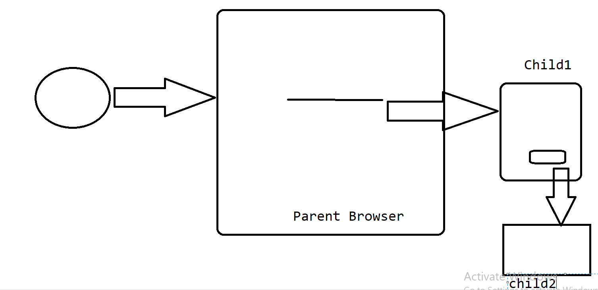

1. Frames
   1. Index
   2. String - name or id attribute of a iframe tag
   3. Webelement
   4. defaultContent() - > to switch the control from frame to parnet brower

NOTE - we can not switch from one frame to another directly.

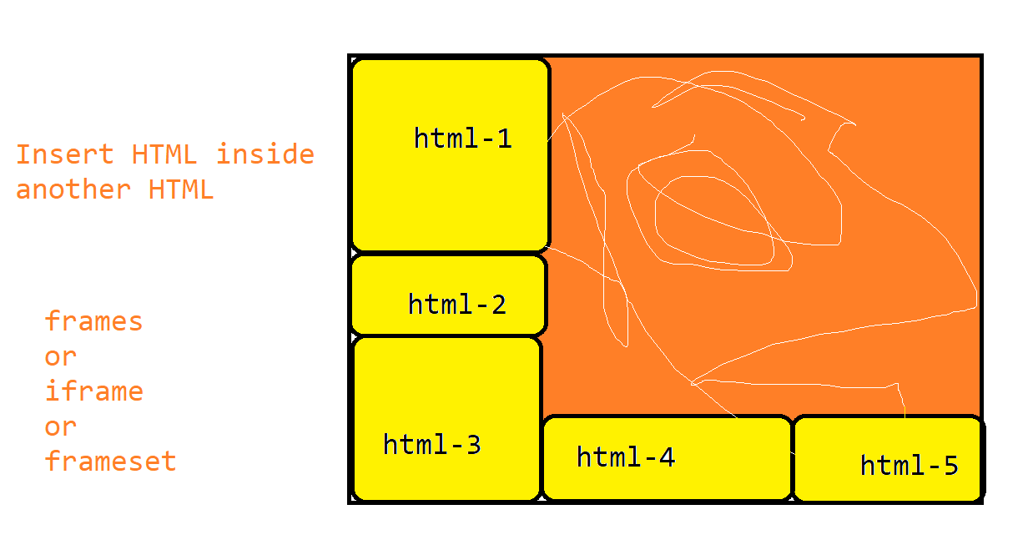

Data driven Testing :

1. Difficult to maintain the Automated Tests if we hardcode the data
2. Test can execute with Max one test data

Test Data - text file, properties file, excel file, csv file, database etc...

Test Data

Local Data – excel, textfile, db, csv ...etc...

Global Data

properties file

Url, Username, Password, Data specific to testcase

browser, maxTimeout