**Java**

1. Data types
   1. primitive data types
   2. derived data types
2. Variables
   1. local variables
   2. global variables
   3. constants
3. Methods
   1. methods with return type
   2. methods with-out return type
   3. methods with arguments
   4. methods with-out arguments
   5. variable number of Arguments
4. Classes
   1. Class
   2. Abstract class
   3. final class
5. Objects
6. Access Specifiers
   1. private
   2. default
   3. protected
   4. public
7. Access Modifiers
   1. static
   2. final
   3. synchronized
   4. abstract
8. Interfaces
9. Inheritance
   1. Simple Inheritance
   2. Multiple inheritance
   3. Multilevel Inheritance
10. Operators
11. Looping Statements
12. Conditional statements
13. ** ** ** Strings ** ** **
    1. Functions
    2. String Buffer
    3. String Builder
14. Exception ***
    1. Compile time exception
    2. Runtime exception
15. File Handling ***
    1. Read a file text file, properties, excel
    2. Write a file text file, properties, excel
16. Collections ****
    1. Set
    2. List
    3. Map
17. Generics

**Selenium :**

1. Selenium – IDE ( record and play back )

2. ~~Selenium –RC~~

3. Selenium WebDriver

1. Identification Mechanism ** ** **
   1. id
   2. name
   3. classname
   4. tagname
   5. linktext
   6. partial linktext
   7. css
   8. xpath
2. Work with WebElements
   1. text box
   2. radio button
   3. check box
   4. buttons
   5. links
   6. web table
   7. dropdowns ....
3. Handling Sync issues
   1. static waits
   2. dynamic waits ** ** **
4. Validations
5. Actions – Keyboard and mouse operations
6. Select – Automate dropdowns
7. SwithTo
8. Browser actions
9. Handling Alerts or POP up in selenium
10. Data driven testing

4. Selenium GRID

5. Framework

1. TestNG
2. POM

6. Build Automation Tool

* Maven

7. Interview Question

JAVA

* Default installation location :C:\Program Files\Java
  + Set environment variables
  + JAVA_HOME - C:\Program Files\Java\jdk1.8.0_201
  + PATH - C:\Program Files\Java\jdk1.8.0_201\bin
* IDE : <https://www.eclipse.org/downloads/>
* <https://www.eclipse.org/downloads/download.php?file=/technology/epp/downloads/release/2021-12/R/eclipse-java-2021-12-R-win32-x86_64.zip>

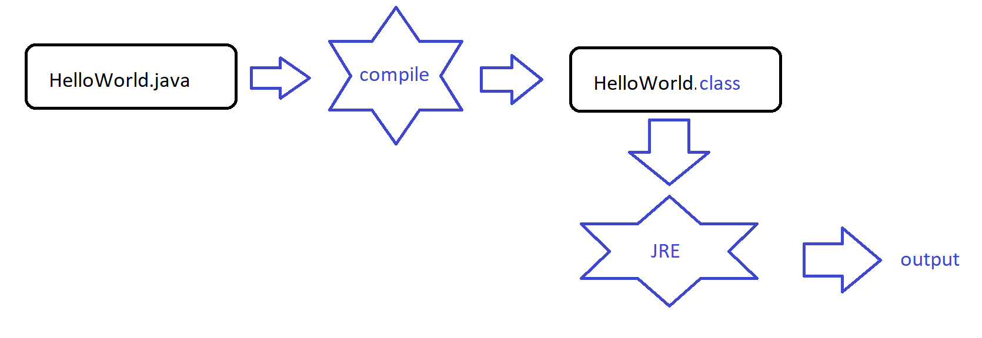

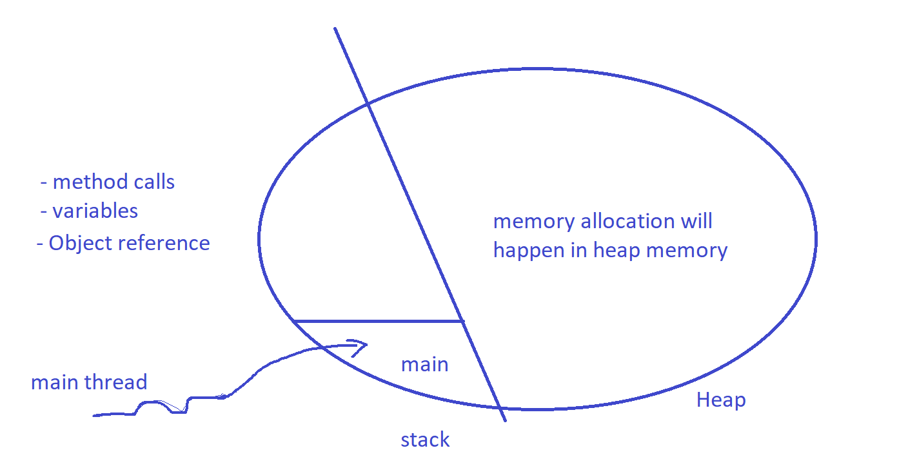

Data type :

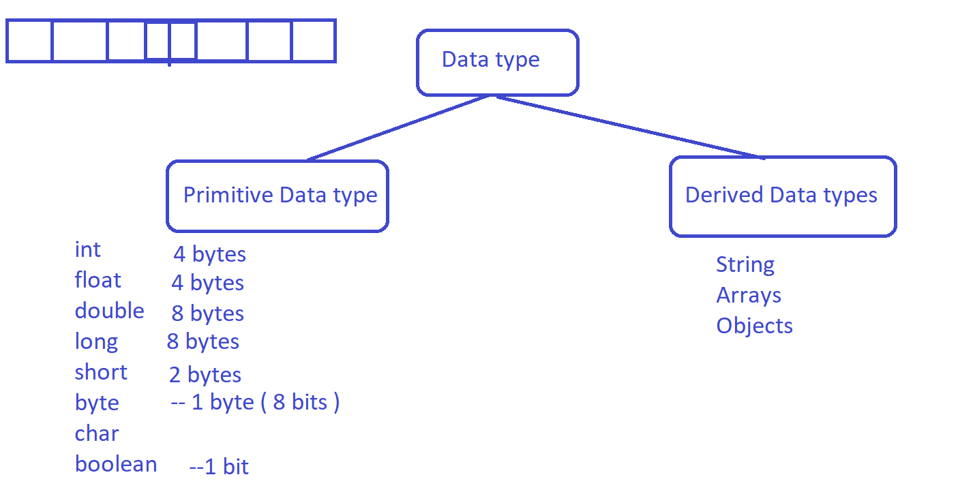

typeofDATA

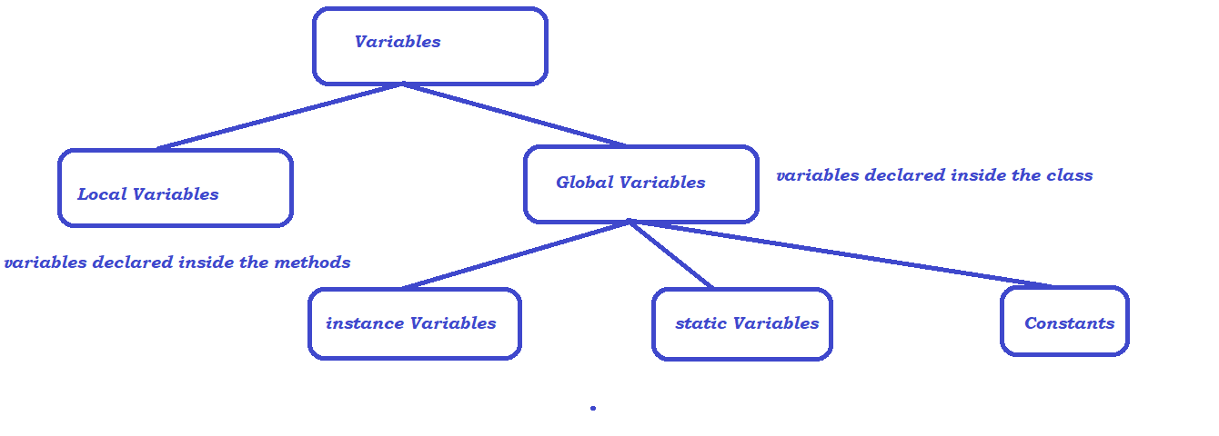

Methods

Describe the behaviour , write once and use as many times as you need is the behaviour of method

* methods without return type
* methods with return type
* static methods

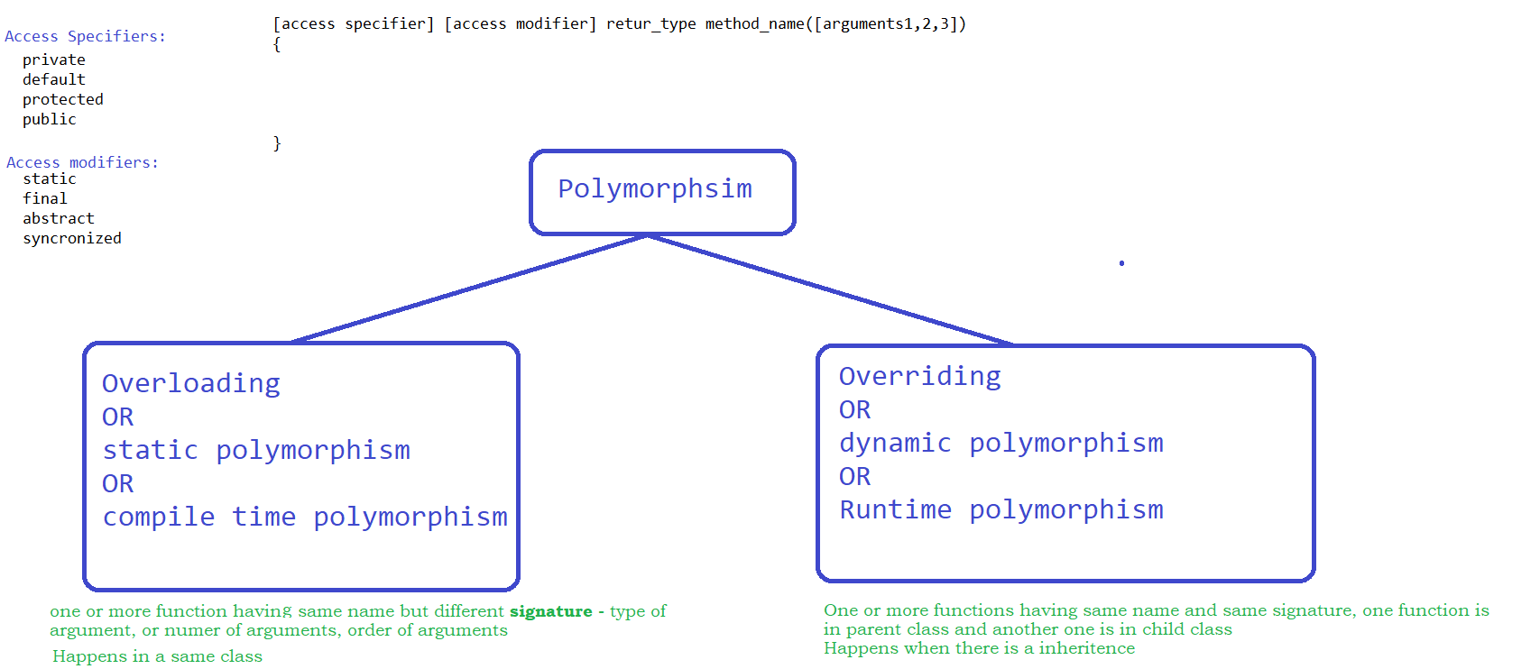

Inheritance in JAVA :

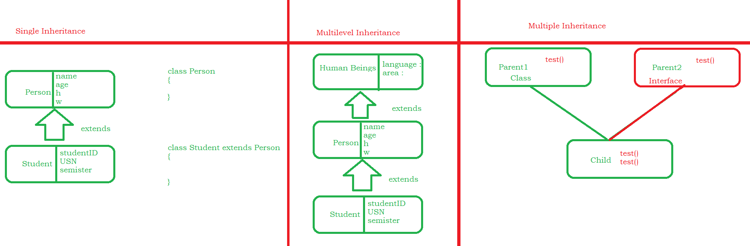

Abstract classes :

Constructors:

