JAVA : (50/50)

**Java** ,C#, Ruby, Python,Perl, Php,js

* Basic Syntax - class, variables, methods, return types
* Looping and Conditional Statements in java
* Types of variables – local variables, global variables, static variables, constants
* Difference between **classes** and **interfaces**
* **String –** String functions (atleast one program)
* **Exception Handling –** try, catch, throw, throws, finally
* **Treads ( Optional )**
* **Collections –** List , Set, Map
* **File Handling –** Read a file, Write a file. ( text, properties )
* **Generics - Must**

Selenium – Browser Automation Tool

* Selenium IDE (record and playback option)
* Selenium RC ( Selenium 1.0 )
* Selenium WebDriver ( Selenium 2.0, 3.0 (3.141.59), 4.0 )
* Selenium Gird (Distributed Execution)

Frameworks

* Function Driven Automation Framework
* Data Driven Automation Framework
* Keyword Driven Automation Framework
* Hybrid Driven Automation Framework
* TestNG
  + Annotations
  + How to generate test execution reports
  + Control test annotation execution
  + Execute the tests in parallel ( 2 or n )
  + How to achieve data driven testing in testNG
  + How to use xml file for test execution
  + How to create batch file
  + How to create groups in testNG
* Page Object Model
* BDD ( if time permits )

Maven

* What is maven
* Why it is required
* How to create a maven project
* How to add dependencies
* Life cycle of maven
* How to execute maven using command prompt

Jenkins – High level (CI \ CD)

Selenium :

* Free ,open source
* Supports multiple programming languages (**Java** , C#, Ruby, Python, Perl, php, js )
* Platform independent - (linux, Windows, MAC.. )
* Multiple Browsers ( almost all popular browsers )
* No Dedicated machine is required ******* ***
* Parallel Execution ( at a time you can open more than one browser )
* Distributed Execution
* 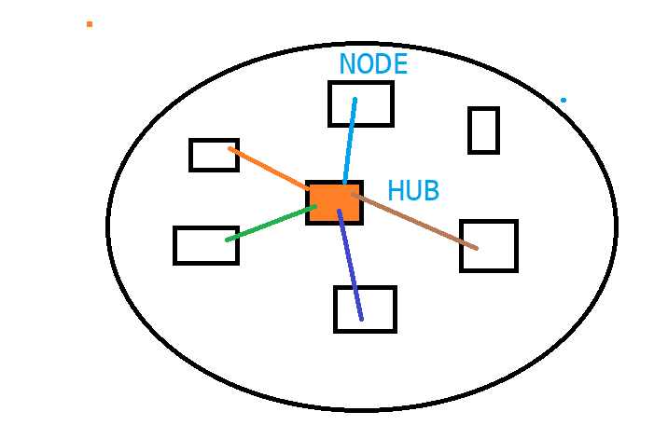

Testing –

Why Automation –

What are the Different Tools –

Why Selenium :

Selenium IDE :

Demo Application :

**actiTime**

---------------------