# Java Training

Installation: download java-17

[Java Downloads | Oracle](https://www.oracle.com/java/technologies/downloads/#java17-windows)

Eclipse Software :

[Eclipse IDE for Java Developers | Eclipse Packages](https://www.eclipse.org/downloads/packages/release/2025-06/r/eclipse-ide-java-developers)

# Package

Is a name space used to store the program in an organized way.

Java process :

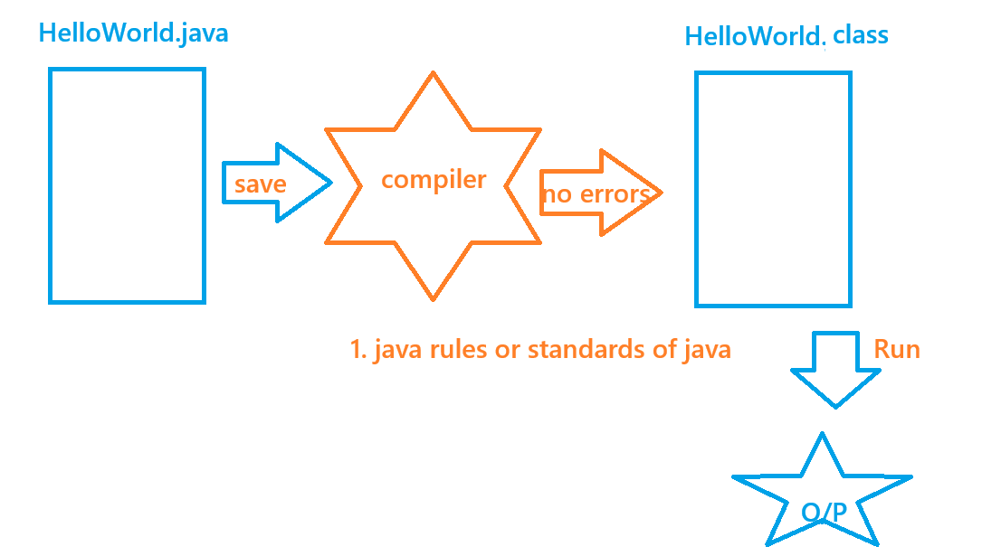

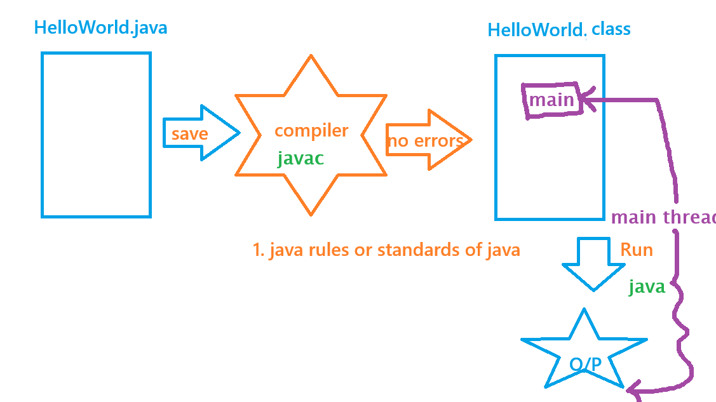

Data types in java

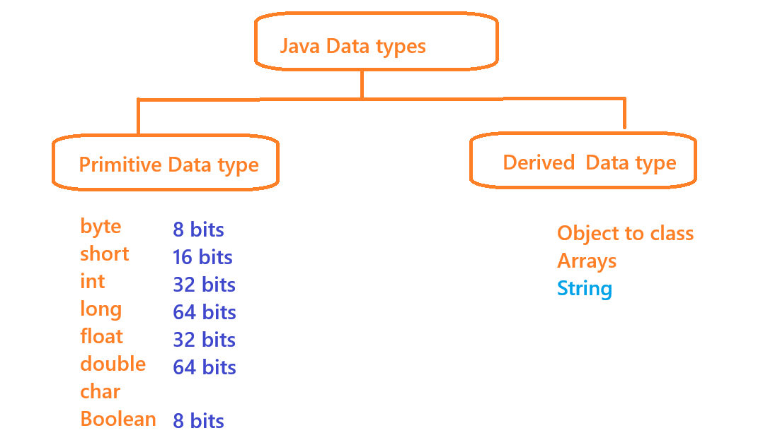

Variables in java

Variables are the names which hold the values

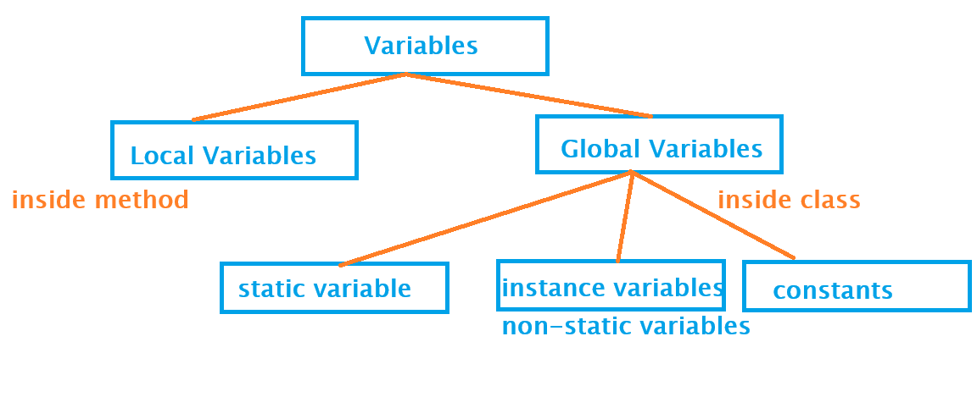

Memory allocation in Java

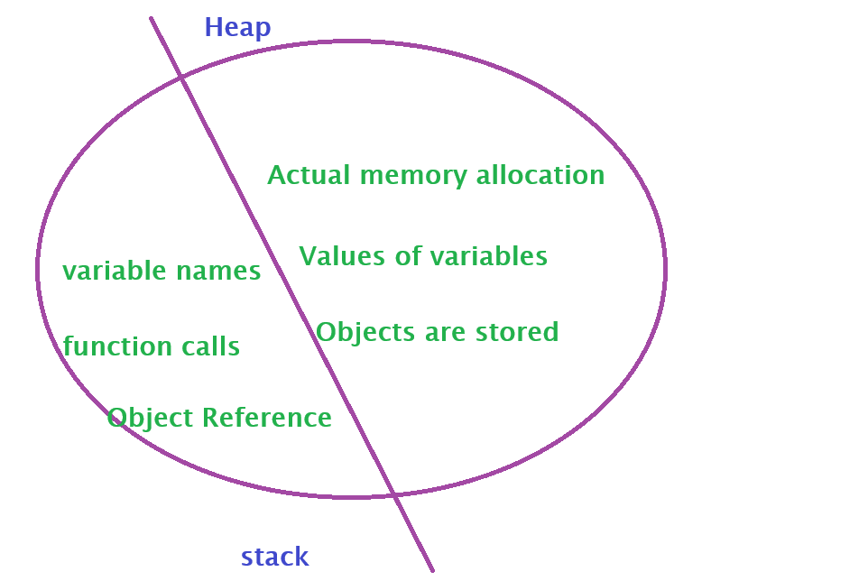

Access SPECIFIERS or functional access specifiers:

Are given only to global variables or methods/ functions. These specify the accessibility of a member.

1. **private –** only inside class
2. **default –** only inside package, except private member
3. **protected –** inside and outside package only on inherited classes, no private
4. **public -** anywhere

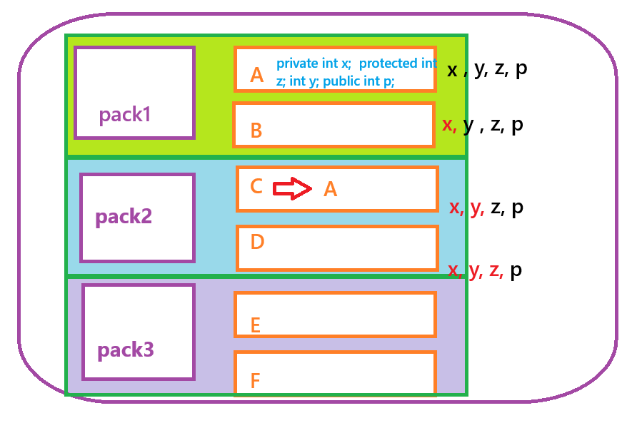

access modifiers or non- functional access specifiers

1. **static** – no need of an object
2. **final** – we cannot override the method
3. **abstract** – when the implementation changes from object to object instead of defining a method we can just keep the declaration of the method using abstract keyword.
4. **Synchronized** – is used to restrict multiple thread entering the method at a same time.

Methods in Java

Methods describes the behaviour of an object

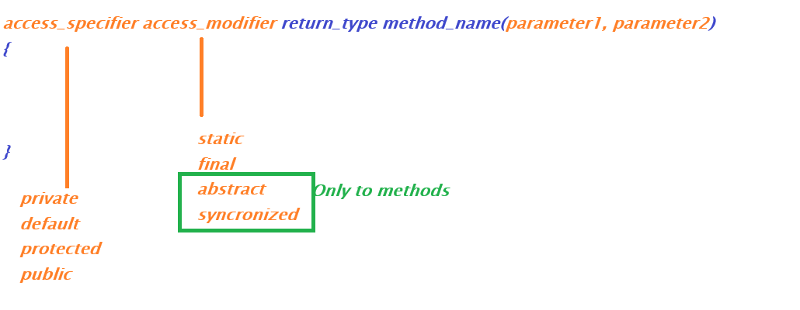

polymorphism :

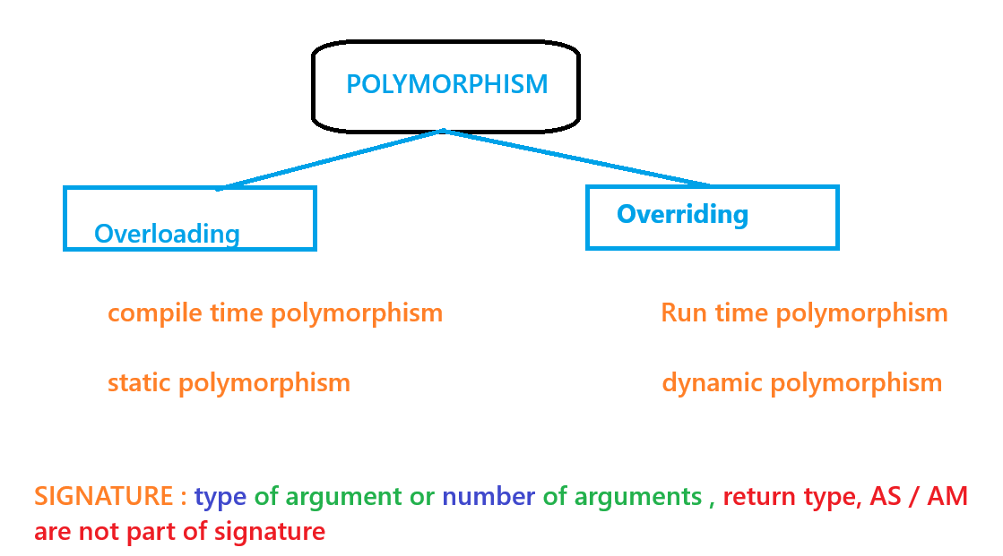

constructor

Constructors are used to assign default values to all the instance members of the class during object creation

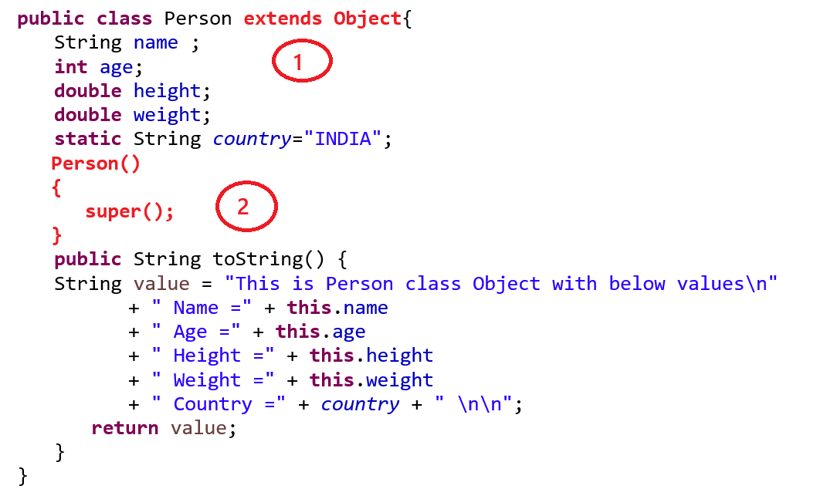

inheritance

* Single inheritance
* multilevel inheritance
* Multiple inheritance -> Interfaces

interfaces

100% pure abstract classes. it is used to achieve multiple inheritance in java

Strings

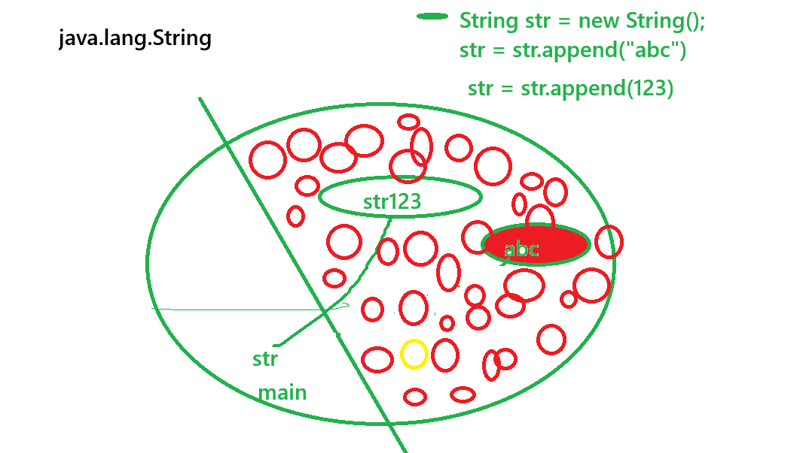

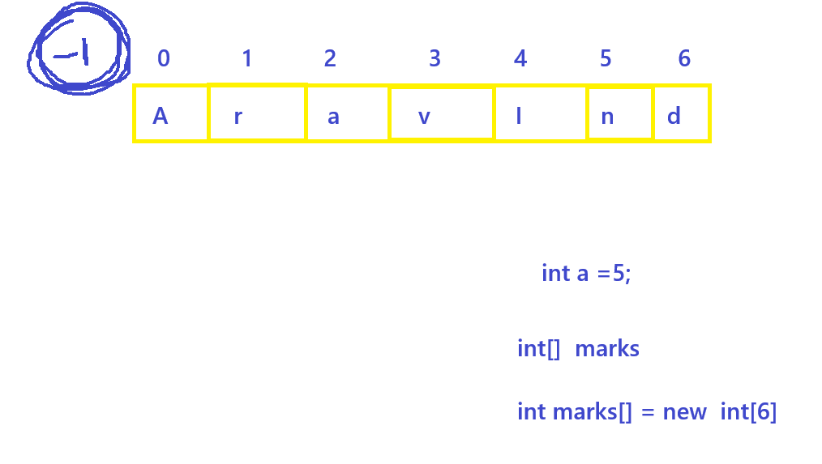

exception handling in java

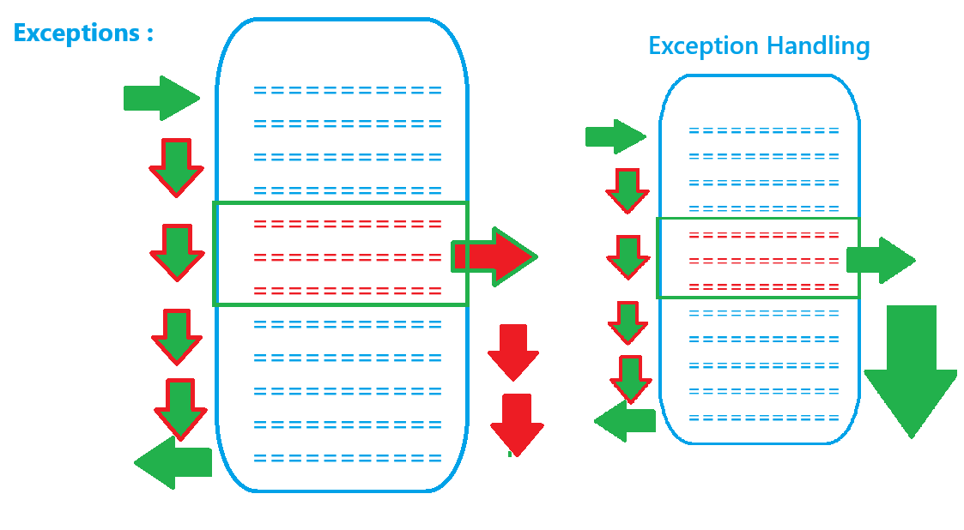

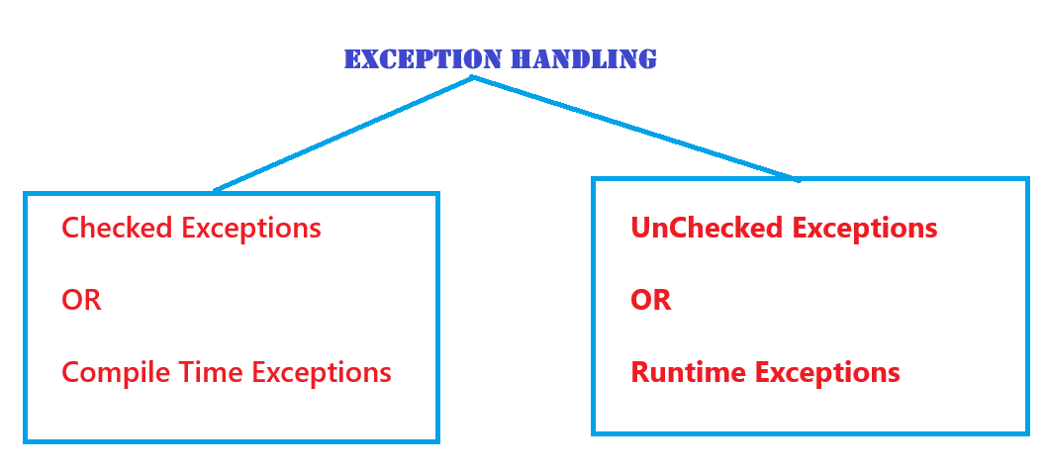

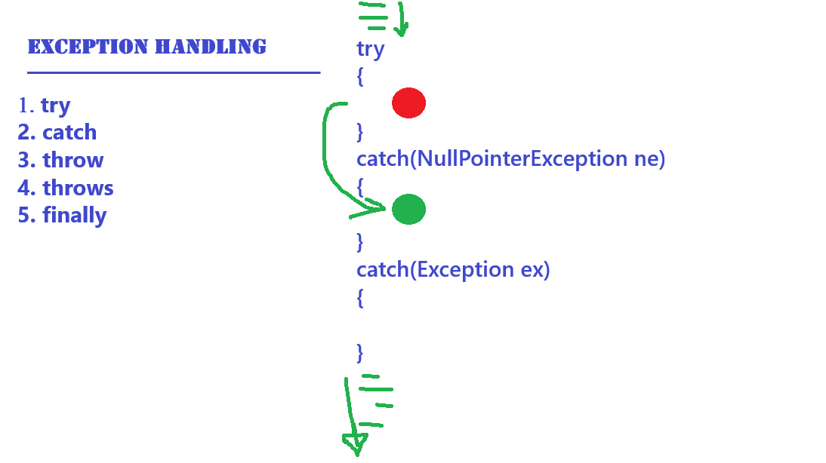

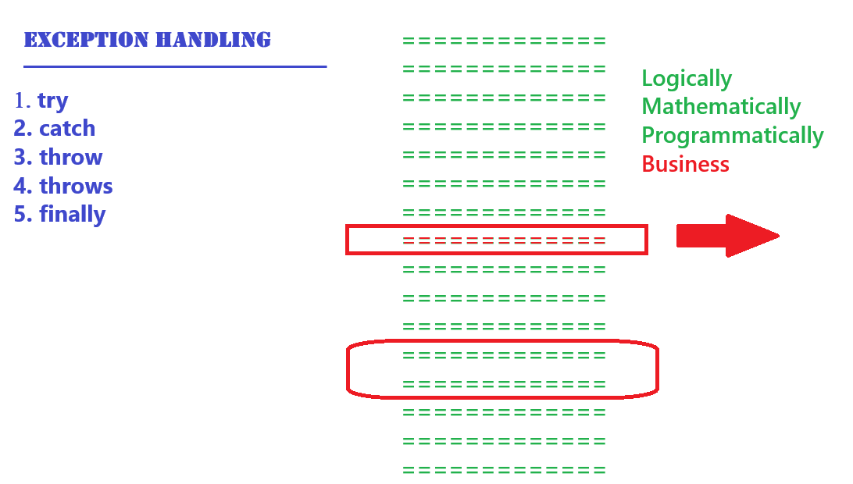

collections in java

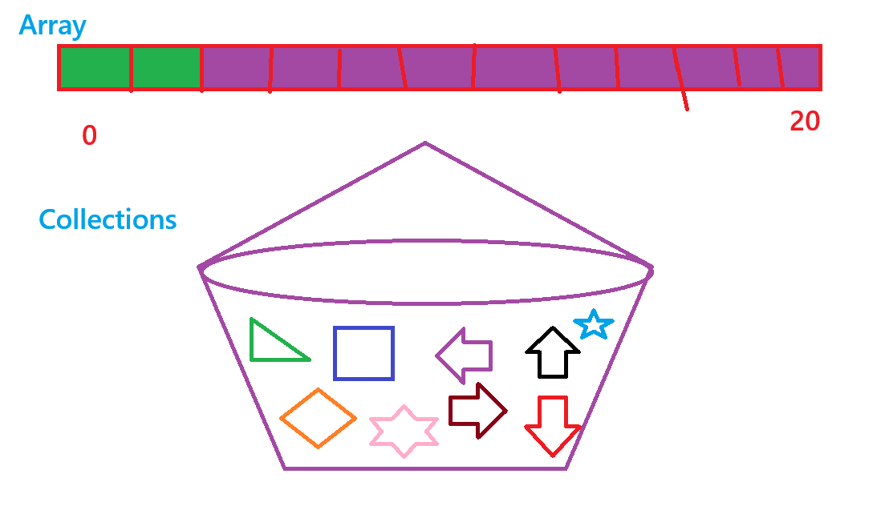

Architecture of collection API

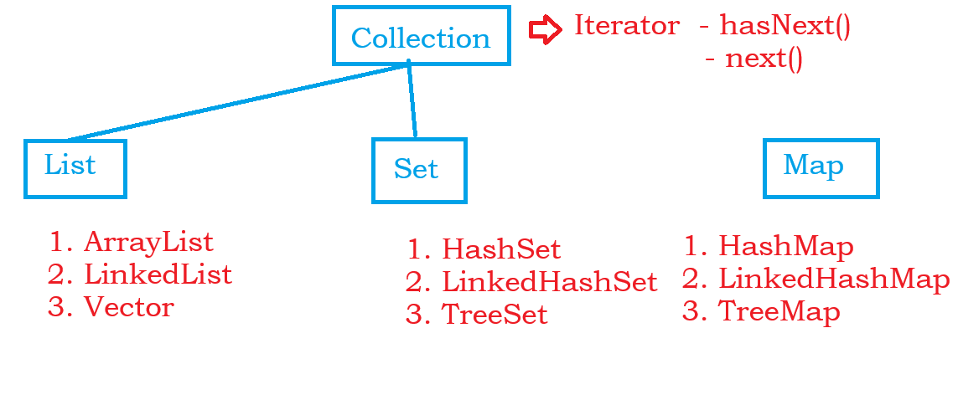

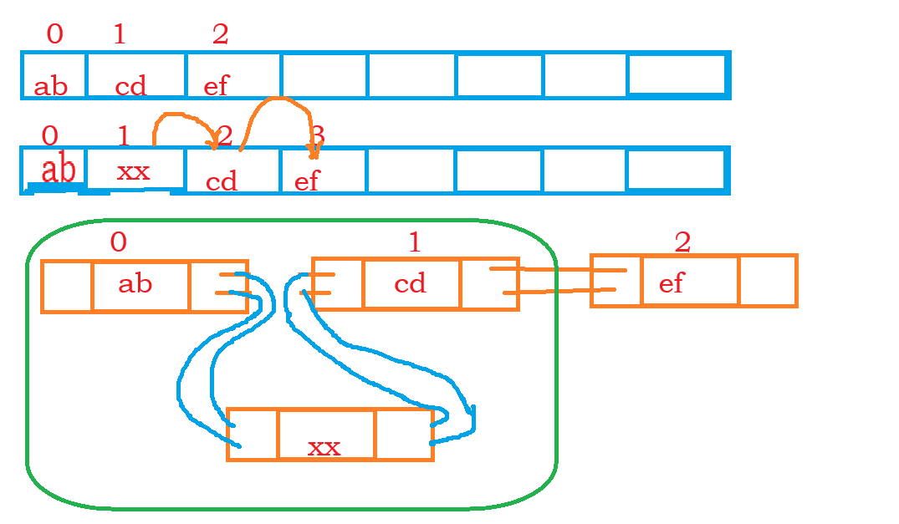

Reading and writing to file in java

