Java Selenium :

* Why Java
* Features of Java
* JDK / JRE / JVM
* Basic Syntax of writing a Class
* Data types
* Variables
* Methods
* Access Specifiers
* Access Modifiers
* String
  + String Buffer
  + String Builder
* Inheritance
* Interfaces
* Looping and conditional Statements
* Threads
* File Handling in java
* Exceptions
* Collections
* Generics

**Selenium**

* Why Selenium
* Versions of Selenium
* Architecture of Selenium
* Features of Selenium
* Object (Web Element) identification
* Operations – Web Elements
* Actions
* Drop Down
* Web Tables
* Dynamic Elements
* switchTo
  + alert
  + different browser
  + frame
* JavaScriptExecutor
* Popup handling
  + Alert
  + Confirmation popup
  + Hidden division popup
  + Pageload popup
  + Windows popup – sikuli / Roboat / AutoIT
* Reusable functions
* Automate end-to-end
* Data driven Testing
* Selenium GRID
* FrameWork
  + TestNG
  + POM
  + Cucumber
* Jenkins
  + Configure Jenkins
  + Trigger the build automatically
* Batch file

# JAVA :

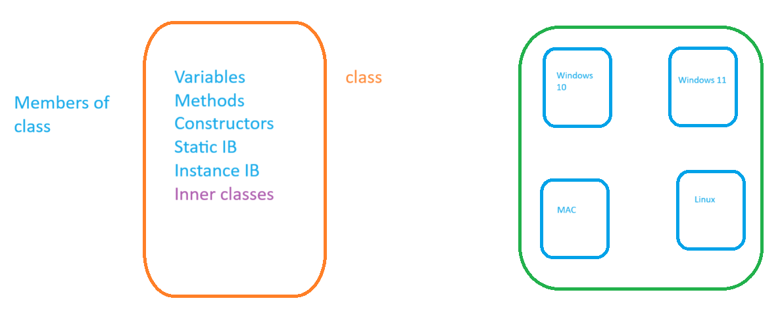

# Installation of Java :

1. **Download java from** [Java Archive Downloads - Java SE 17 (oracle.com)](https://www.oracle.com/java/technologies/javase/jdk17-archive-downloads.html)
2. **Double click and follow the instructions to install the software**
3. **Set Environment variable** 
   1. **JAVA_HOME :** C:\Program Files\Java\jdk-17
4. **Open new command prompt and execute** java **–**version
5. **If you get version of java installed on your machine then installation is successful**

# Eclipse Editor Installation

1. Goto [Eclipse Downloads | The Eclipse Foundation](https://www.eclipse.org/downloads/)
2. Download the zip
3. Extract the file and double click on eclipse application

# Hello World Java

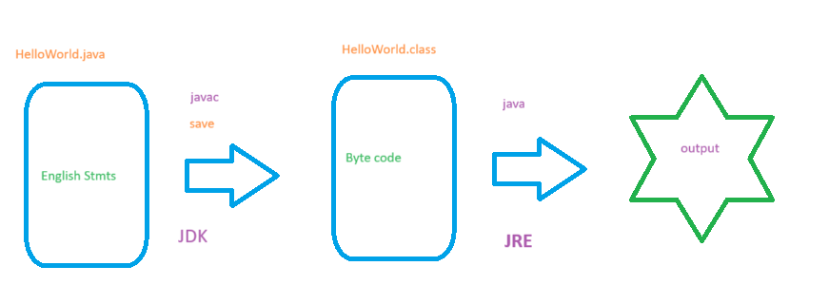

# JDK / JRE / JVM

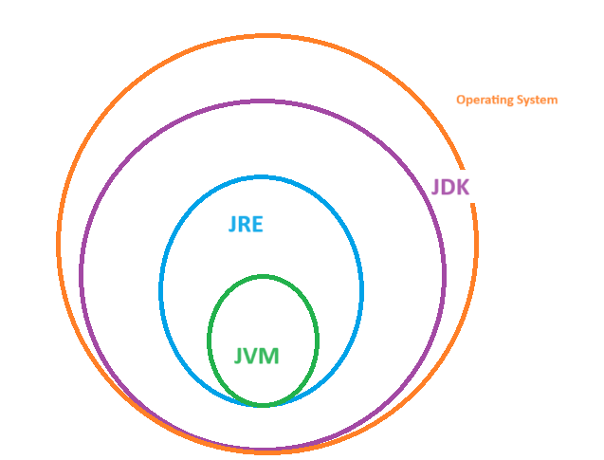

# Execution

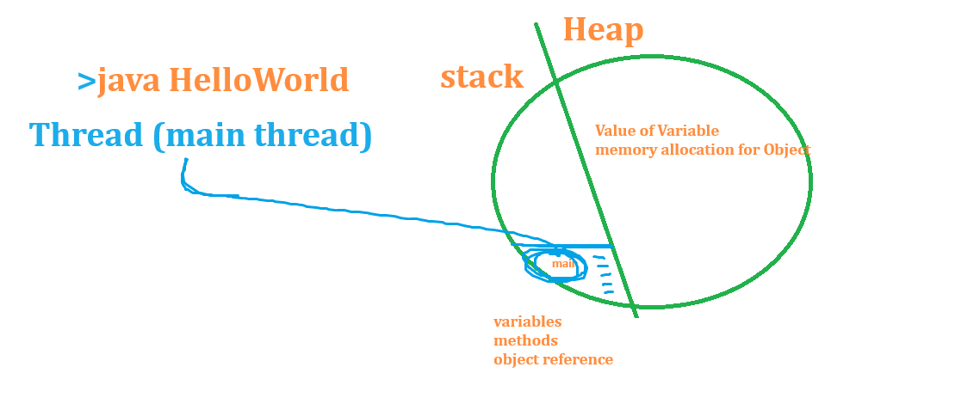

# Data types :

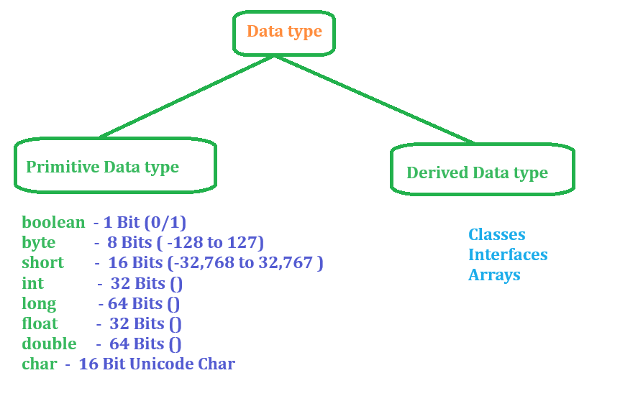

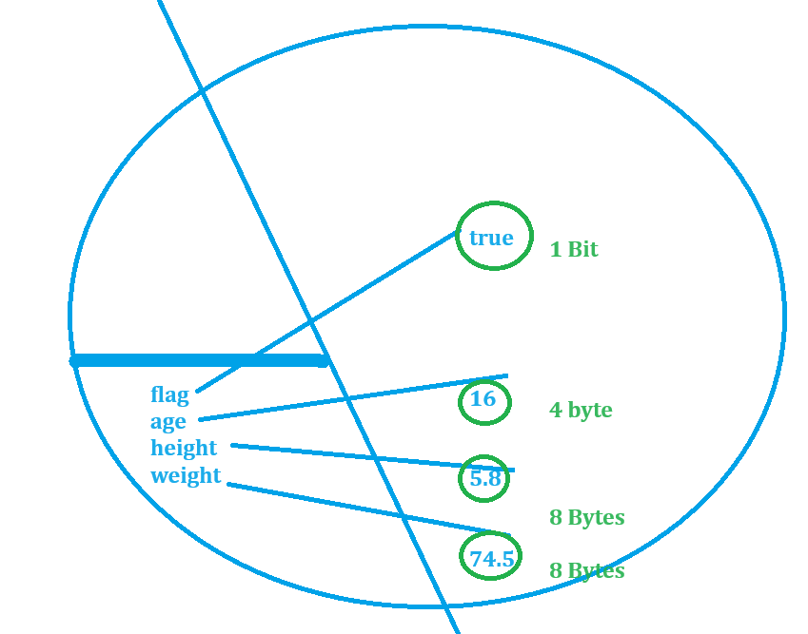

# Arrays

Arrays are derived data types which will hold multiple values of same data type.

# Object Class

Directly or indirectly Object class is the super class for all the classes in JAVA, which has below methods inherited automatically to all the classes

* Clone
* equals
* hascode
* finalize
* toString

# Variables

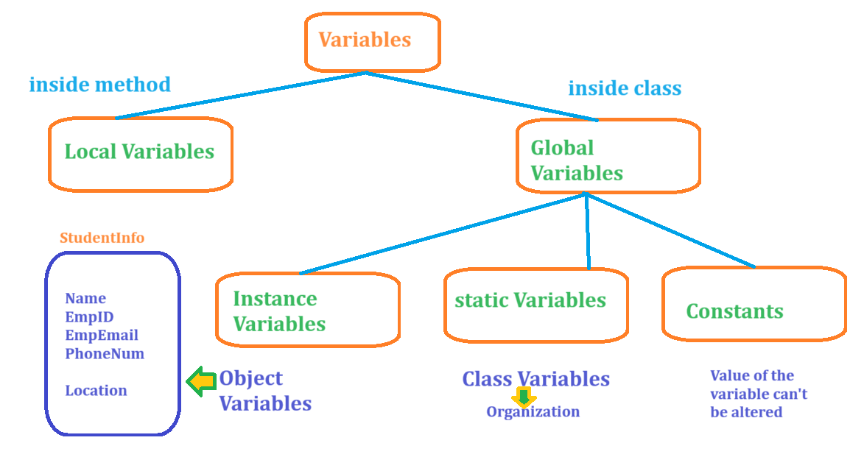

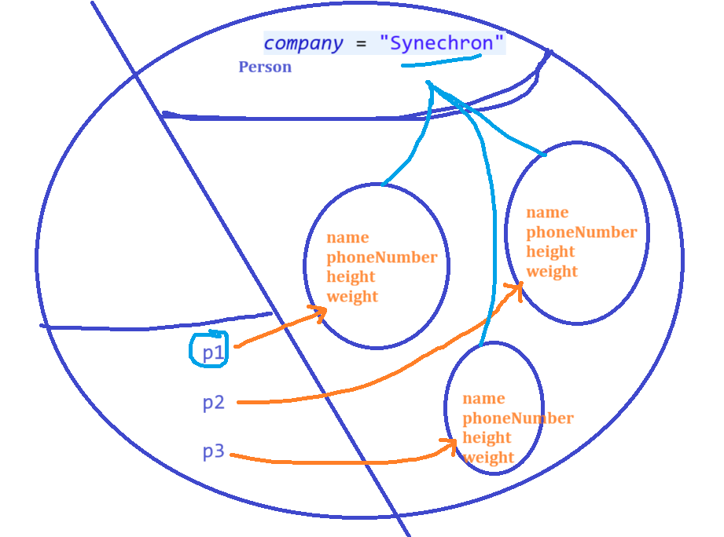

# Methods or Functions

Describe the behaviour of an object, these are the reusable entities we can write once and execute many times.

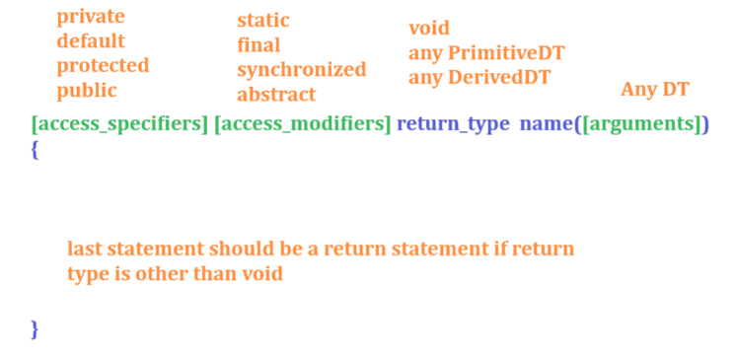

Types:

1. static methods
2. Non-static methods
3. Final methods
4. Methods with argument
5. Methods with-out argument
6. Methods with return type
7. Methods with-out return type
8. Overloading
9. Overriding

## Polymorphism

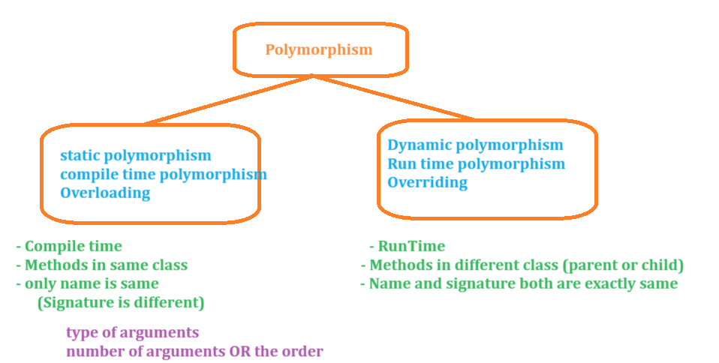

# Abstract class

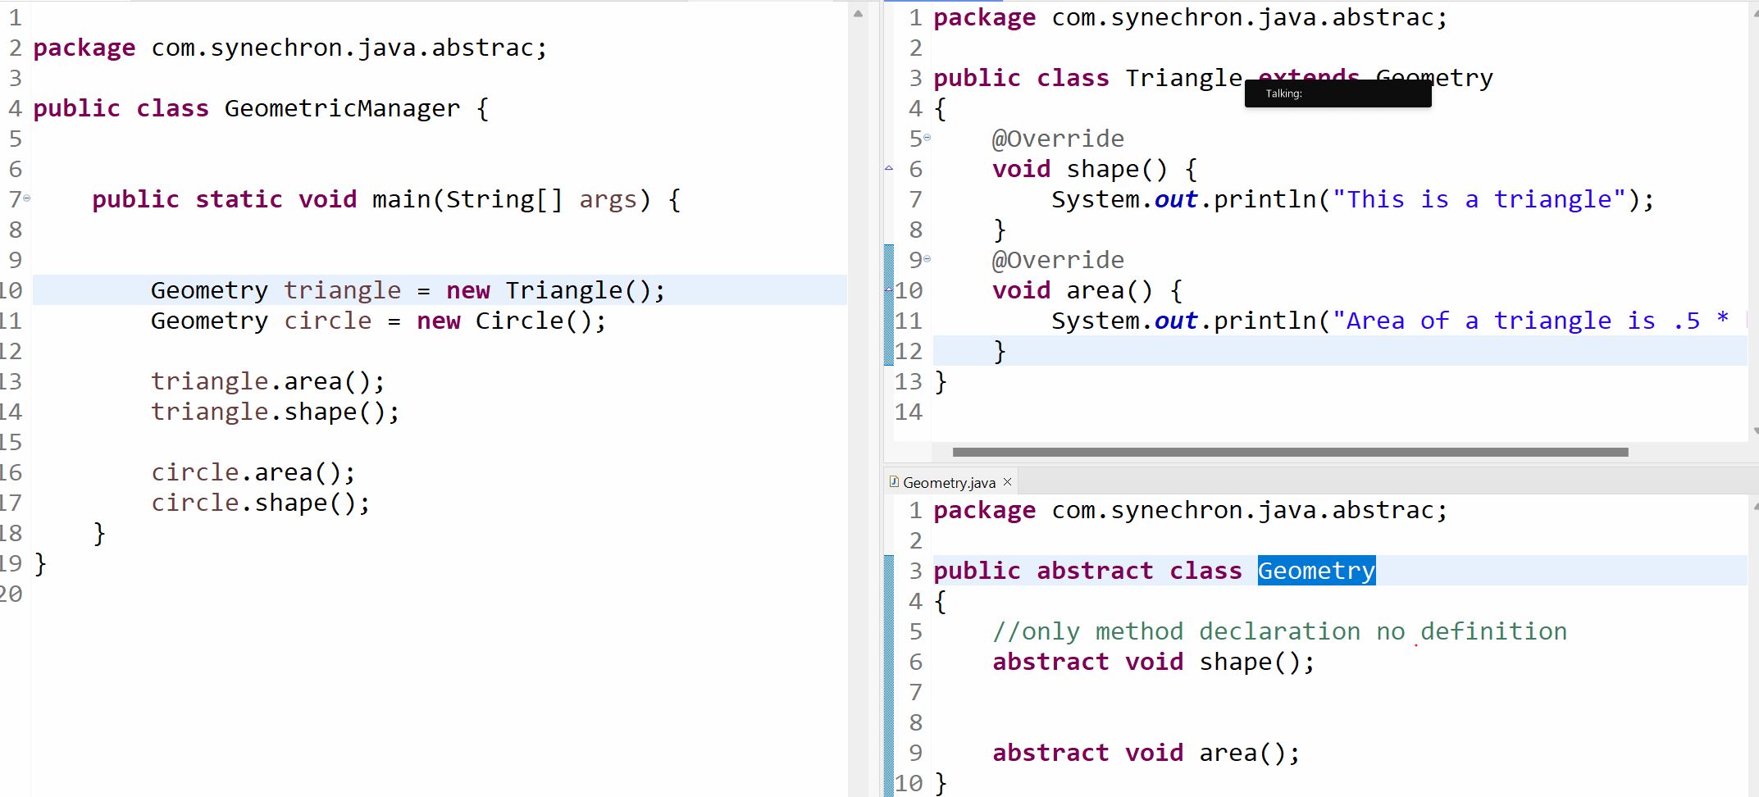

# Constructors :

Constructor is a block of code which has same name as the class name, Constructors will be called automatically at the time of object creation to initialize the instance variables with the default values.

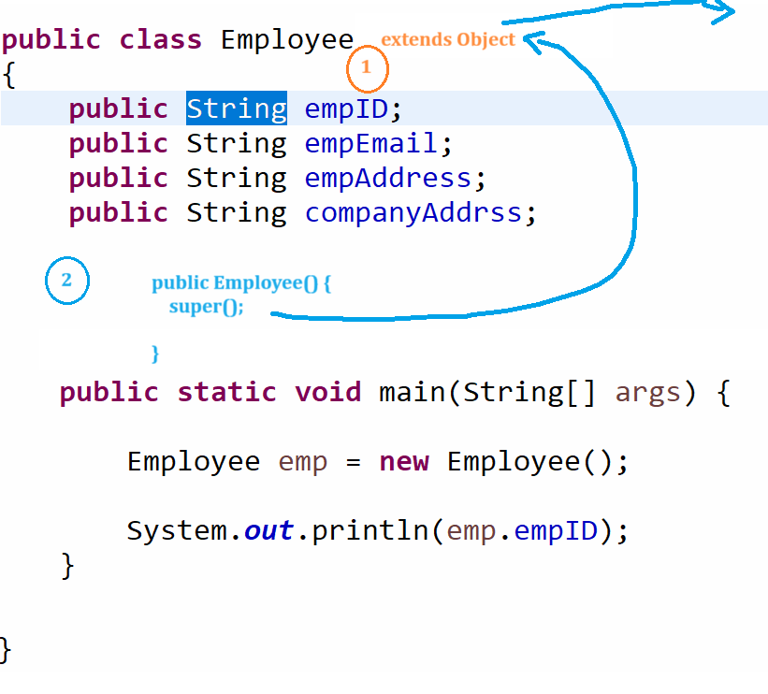

# Strings

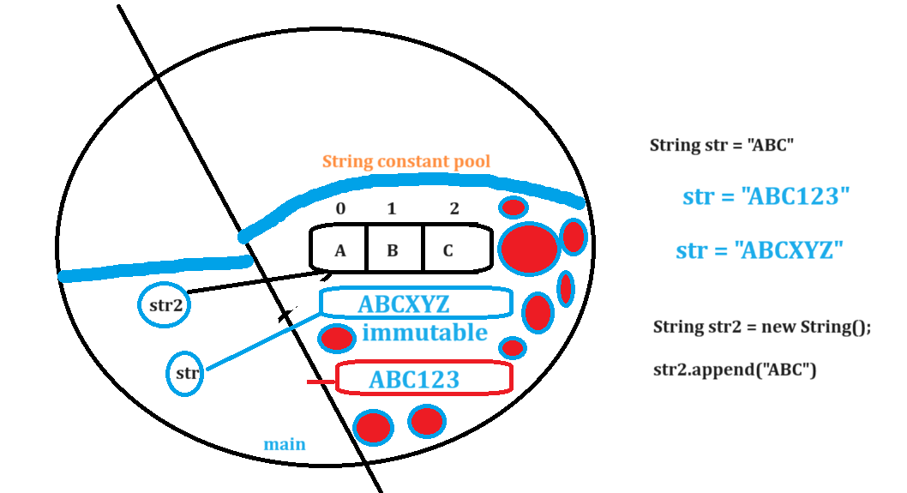

# Typecasting

Converting variable of one data type to another

# File Handling

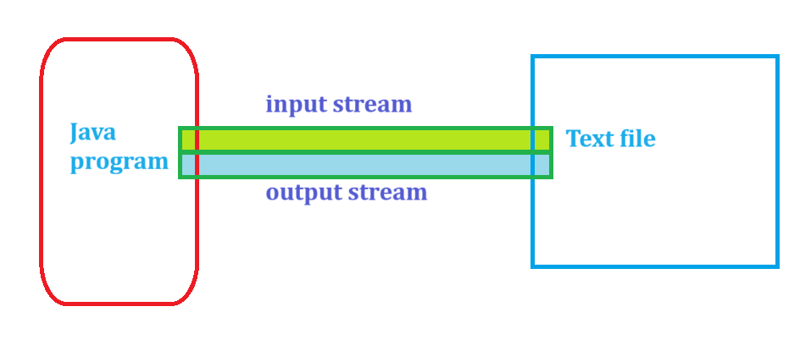

## Create a File

## Write to a File

## Read from a file

# Inheritance

1. Single / Simple inheritance
2. Multilevel inheritance
3. Multiple inheritance, java will not support multiple inheritance to achieve multiple inheritance we have to relay on Interfaces in java

# Exception handling in JAVA

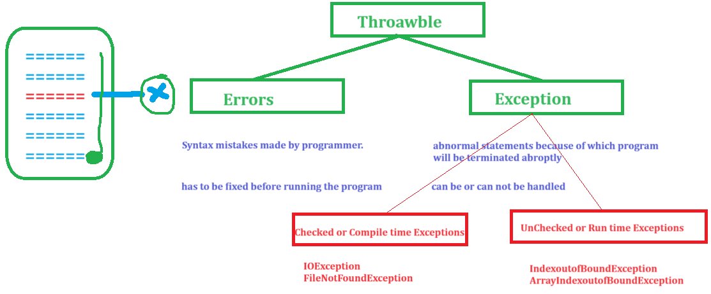

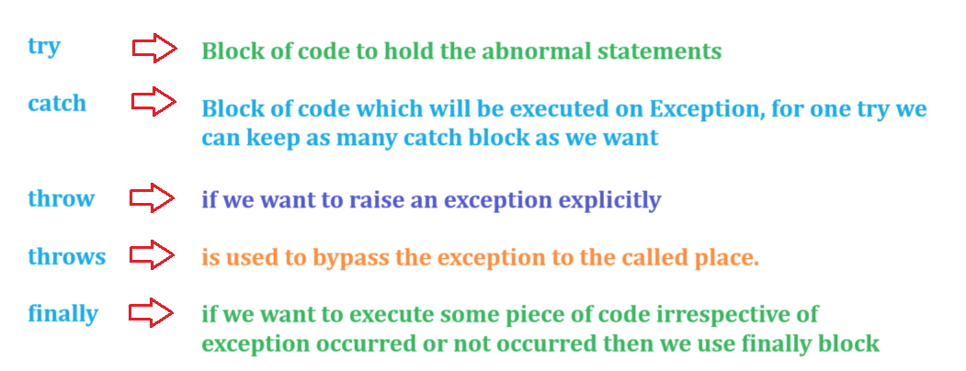

# Collections

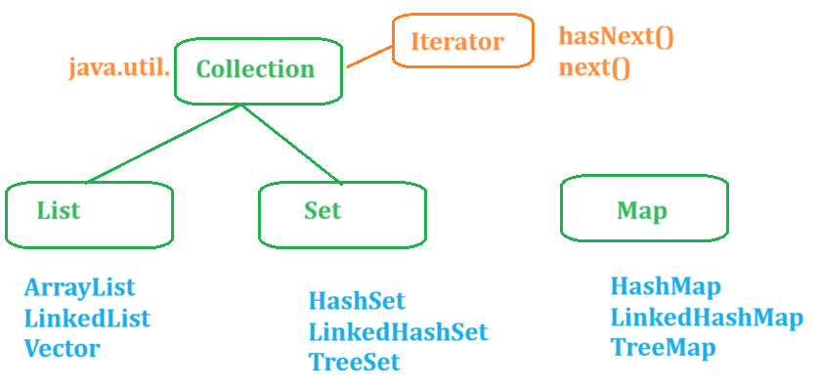

# Generics

Generics are the parameterized collections, if we want to restrict collections to store one type of data then we can use Generics

# Selenium

1. Selenium IDE – Addon
   1. Had same origin policy ISSUE
   2. 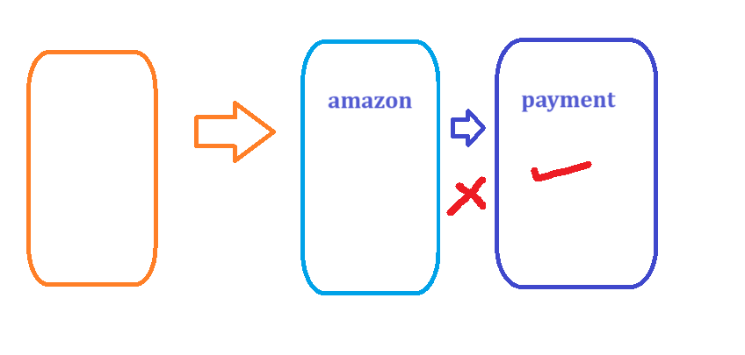
2. Selenium RC
   1. 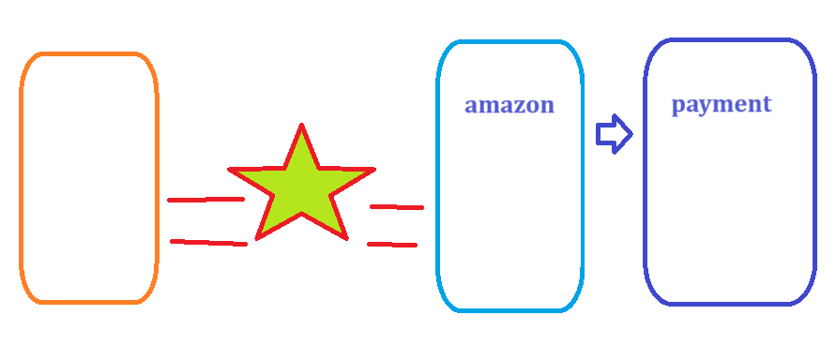
3. Selenium WebDriver - Selenium 2.0 / 3.0 /4.0
4. Selenium GRID – Distributed Execution
   1. 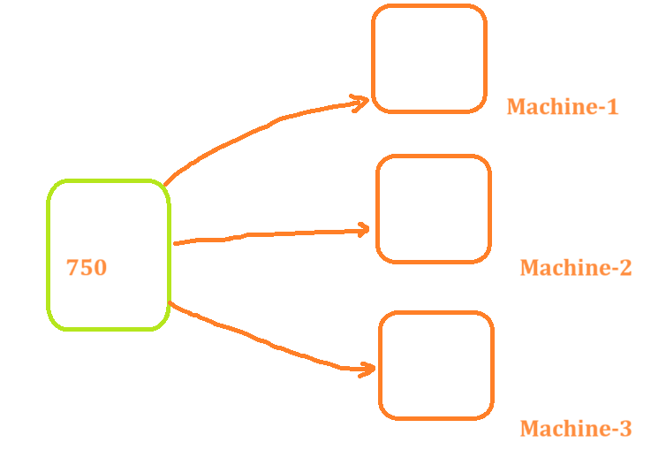

## Features of Selenium

1. Open source Freely available Software
2. Almost all the popular browsers – Chrome, Firefox, edge, safari , opera
3. Multiple programming language – Java, C#, Ruby, JavaScript, Python, Kotlin
4. Supports multiple platforms – Windows, Linux, MacOS
5. Integrate with other tools
   1. CICD – Jenkins
   2. Build automation tool – Gradle or Maven
   3. Dockers – Execute the tests
   4. Testing Frameworks – Junit, Nunit, Pytest, TestNG
6. Parallel Execution – more than one test can be executed at a same time (more than one browser you can open at a time )
7. Distributed Execution – we can configure tests to be executed on multiple machines.

# Architecture of Selenium

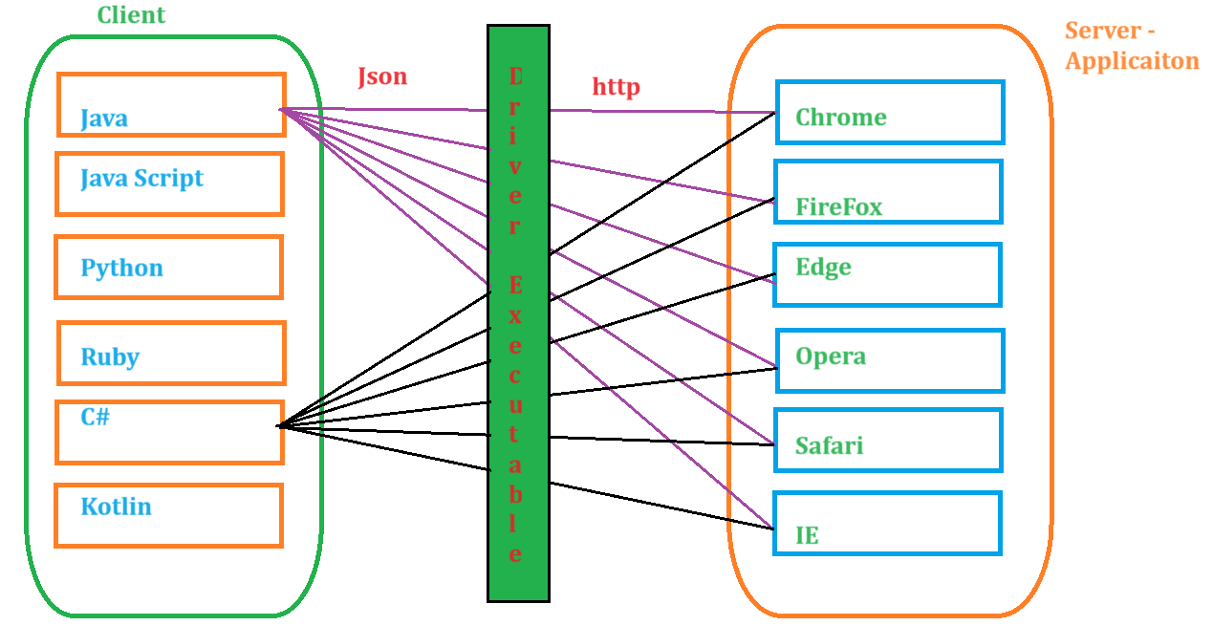

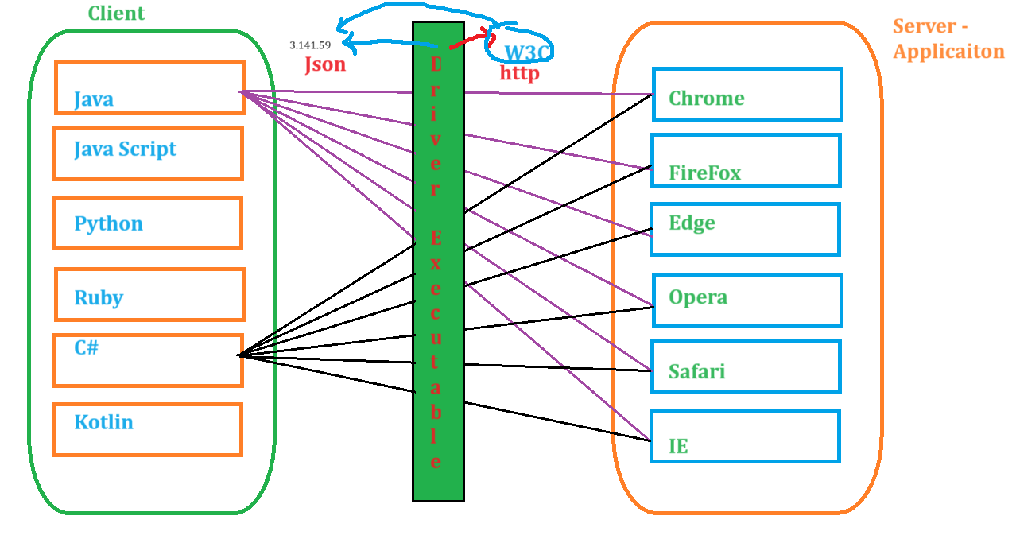

# Selenium Setup using Maven

## Maven :

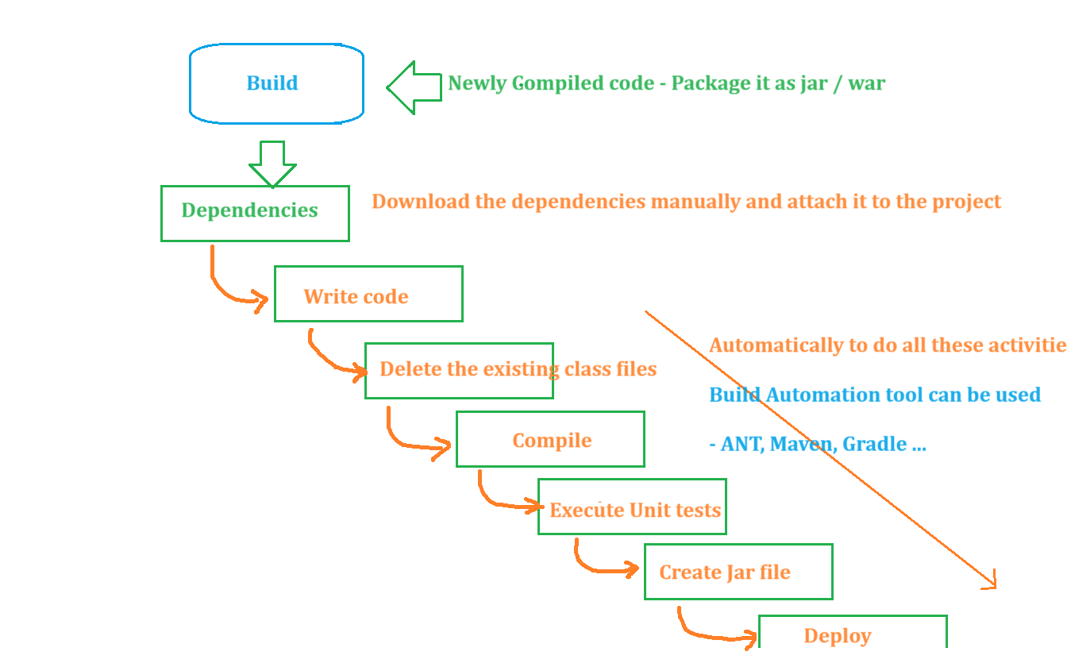

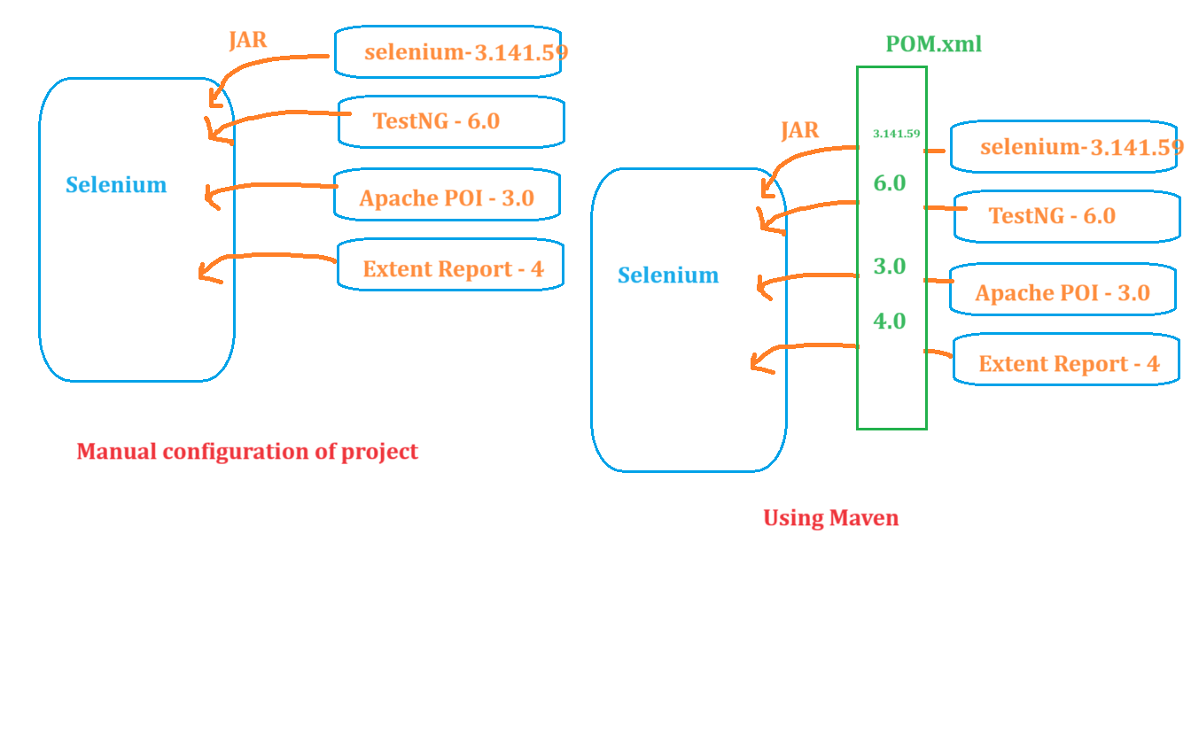

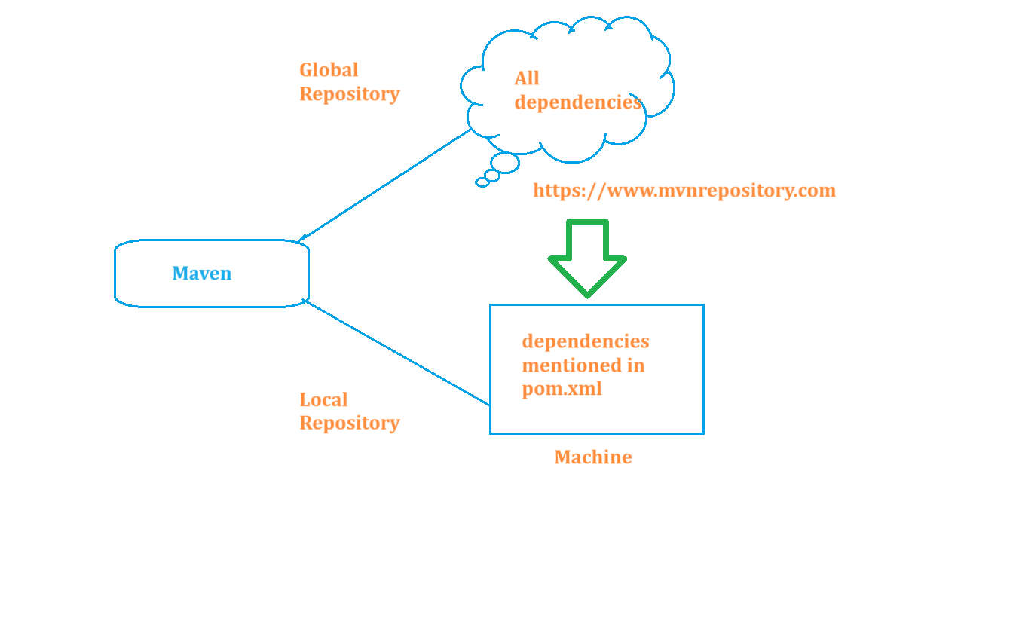

## Install Maven

1. Download the maven from official website
2. Unzip the zip file
3. Set the MAVAN_HOME and M2 directory in System environment variables
4. Update the path with bin directory with bin location
5. Open new command prompt and execute mvn -version to see the version installed

## Creating Maven Project

1. Open Eclipse
2. Create new maven project by selecting maven-archetype-quickstart as artifact id
3. Provide group id :
4. Provide artifact id : for the newly created project
5. Click on finish
6. Update JDK and JRE for the project
   1. Rightclick on project -> properties -> Java compiler -> change to what is installed on machine
   2. Rightclick on project -> properties -> Java Build path -> Libraries -> use the jre from JDK Location
7. Update Pom.xml
   1. Add dependency for selenium and testNG

# Class and Interfaces on a high level

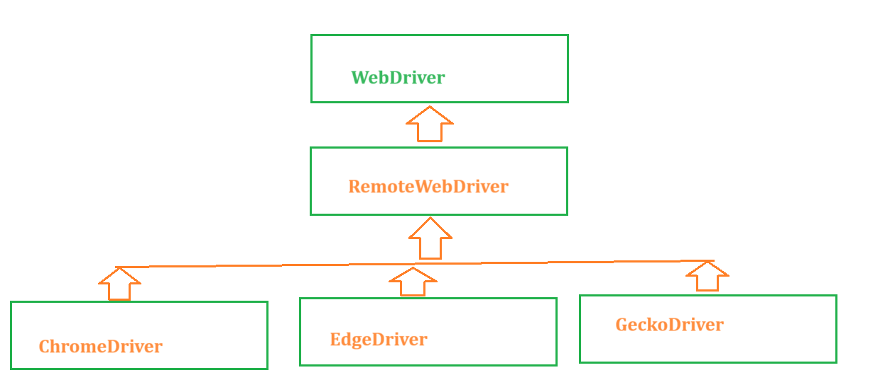

# First Selenium Test

# Object Identification in Selenium

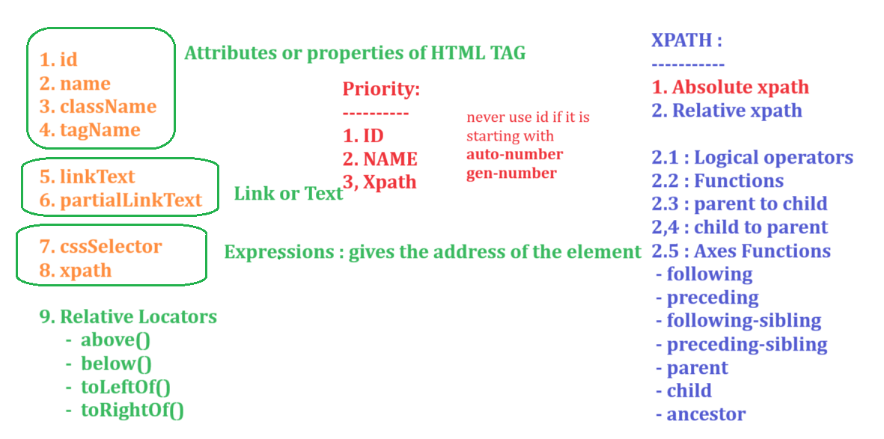

# Basic Web Element Operations

|  |  |
| --- | --- |
| Operations | How |
| Type | sendKeys |
| Click | Click |
| Dropdown selection | SelectClass or click |
| Click – image / link | Click |
| Click on popup | Accept() or dismiss() |
| WebTable | Sendkeys or click |
| Radio | Click |
| Checkbox | Click |
| Calendar | Click |

# Identify the WebElements using xpath

### **Basic Xpath**

//htmltag[@attribute=’value’] => Derive the webelement

Example : [website](https://en.wikipedia.org/wiki/KGF:_Chapter_1) : //input[@name='search']

//th[text()='Directed by']

// htmltag[@attribute=’value’]**/**htmlTag => Traversing from parent to immediate child

Example : [Website](https://formy-project.herokuapp.com/checkbox) : //div[@class='col-sm-8']/input

// htmltag[@attribute=’value’]**//**htmlTag => Traversing from parent to child

### **Logical AND / OR / NOT**

**AND :** When both the properties are matched it returns the web Element

Example : [Website](https://www.makemytrip.com/)  : //div[@aria-label='Mon Jul 22 2024' and @role='gridcell']

**OR :** When any one property is matched it returns the web Element

Example : [Website](https://www.makemytrip.com/)  : //div[@aria-label='Mon Jul 22 2024' or @role='gridcell']

**NOT :** Negation

Example : [Website](https://www.makemytrip.com/)  : //div[@aria-label='Mon Jul 22 2024' or not @role='gridcell'] => will featch all the elemenets on the webpage whose role is not gridcell.

### **Using Functions**

* Text()
  + //th[text()='Directed by']
* Contains(arg1, arg2)
  + Arg1 - > attribute or a text() function
  + Arg2 -> partial value based on first argument passed
  + Example :
    - //th[contains(text(),'Dir')]
    - //img[contains(@src,'poster')]
* Starts-with(arg1, arg2)
  + Arg1 - > attribute or a text() function
  + Arg2 -> partial value based on first argument passed
  + Example :
    - //th[starts-with(text(),'Dir')]

### **Traversing from parent to child**

//xpath of parent/child tag OR child element xpath

//xpath of parent//child tag OR child element xpath

### **Traversing from child to parent**

Whenever you have dependent and independent elements, in your application then always we have to make sure that we write xpath for independent element first from there we traverse to dependent element and for this we have to traverse from child to parent

1. Write a xpath to independent Element
2. Travers to its parent until both dependent and independent elements are highlighted
3. Traverse to dependent Element

Example : [Website](https://en.wikipedia.org/wiki/KGF:_Chapter_1) : //tr[th[text()='Directed by']]//a

[Website](https://holidayz.makemytrip.com/holidays/india/search?fromSearchWidget=true&searchDep=Goa&dest=Goa&destValue=Goa&depCity=Bangalore&initd=searchwidget_landing_Goa_notheme&dateSearched=29%2F07%2F2024&glp=true&pdo=false&rooms=2%2C0%2C0%2C0%2C%2C%2C&affiliate=MMT)

//div[div[div[p[text()='Goa Delights - Free Catamaran Cruise']]]]//span[@class='priceStyle']

//p[text()='Goa Delights - Free Catamaran Cruise']/ancestor::div[@class='packageTextContainer']//span[@class='priceStyle']

## Axes functions : Example - [website](https://en.wikipedia.org/wiki/KGF:_Chapter_1)

Following : from any node till the end of page

//li[@id='toc-Release']/following::li

Preceding : from any node to the beginning of the page

//li[@id='toc-Release']/preceding::li

Flowing-sibling : from any node to the next sibling node

//th[text()='Directed by']/following-sibling::td

//li[@id='toc-Release']/following-sibling::li

Preceding-sibling : from any node to the previous sibling node

//li[@id='toc-Release']/preceding-sibling::li

Parent : from any node to the parent node

//th[text()='Directed by']/parent::tr

Child : from any node to the child node

Ancestor : from any node to the grand parent node

//p[text()='Goa Delights - Free Catamaran Cruise']/ancestor::div[@class='packageTextContainer']//span[@class='priceStyle']

# AutoSuggestions - Playing with Web Elements

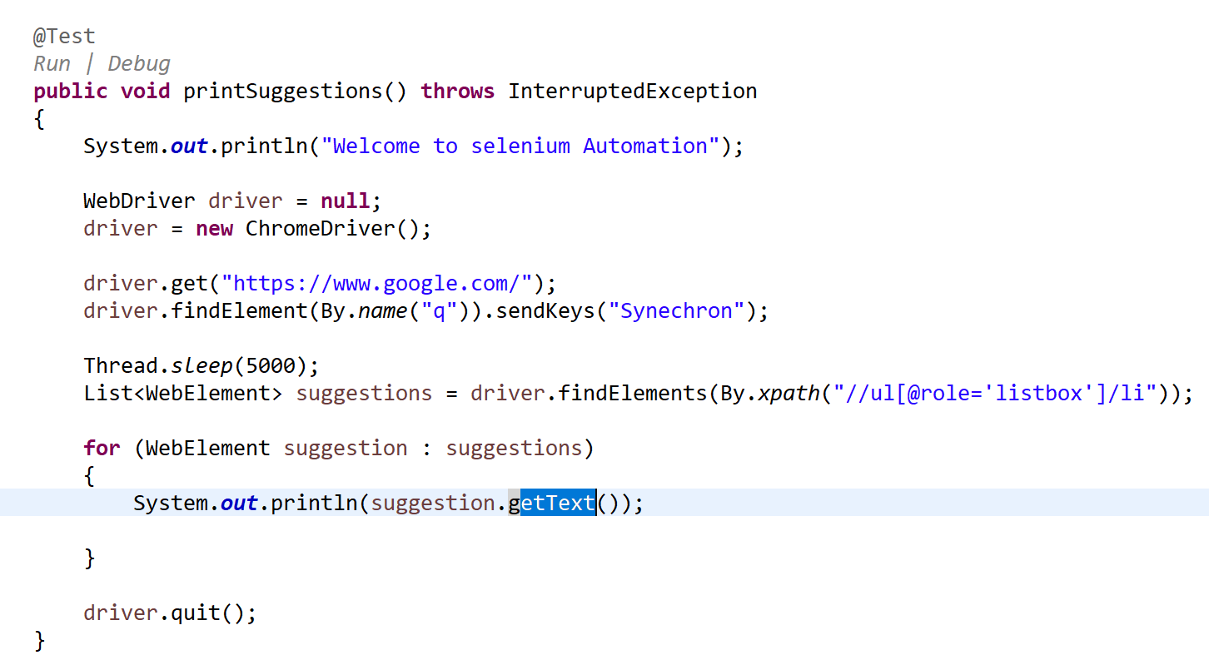

# Automating tool-tip

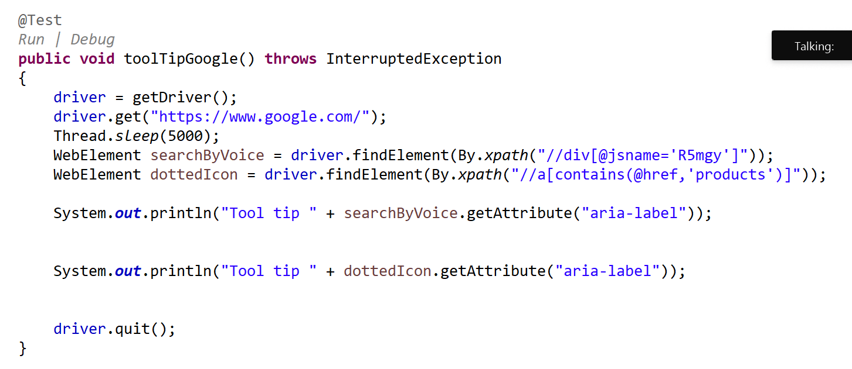

# Browser Operations

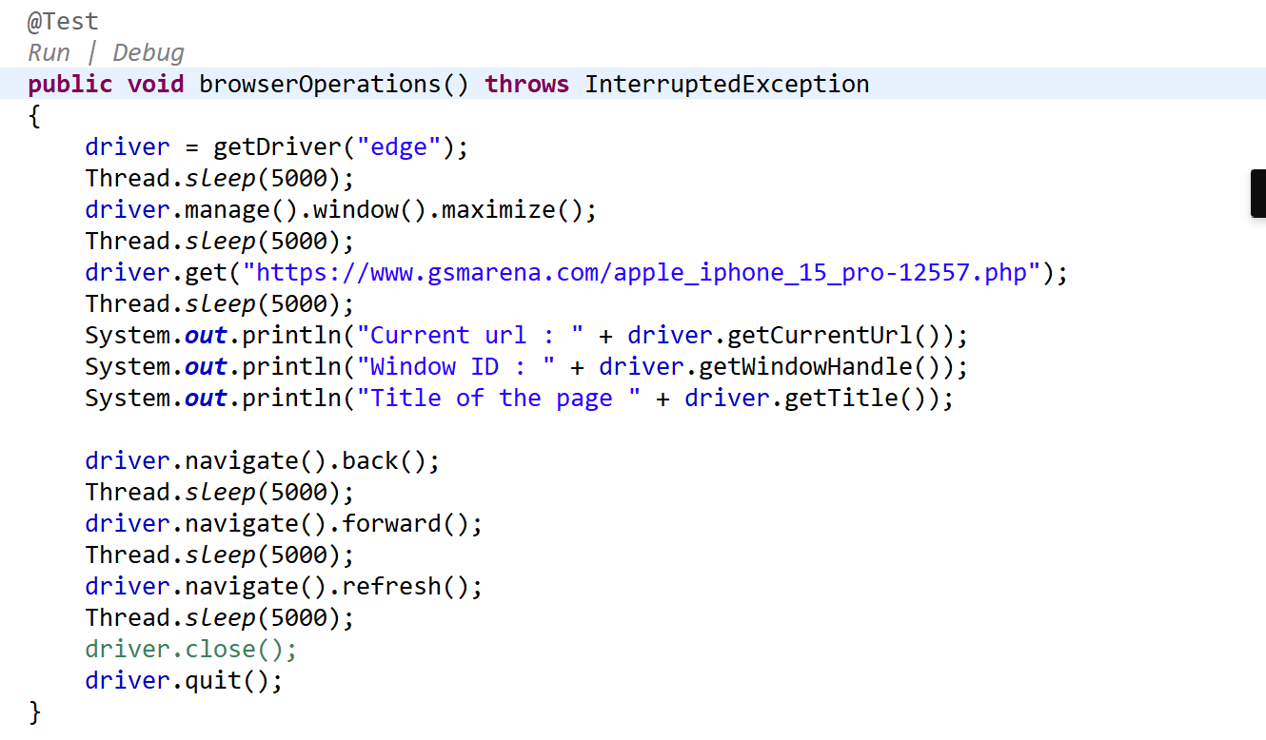

# Sync Issues in Selneium

Sync issues or synchronization issue, The execution speed of the tool is much faster than the execution speed of the application because of which Test Execution will fail. Such issues are called as sync issues or synchronization issues

To handle sync issues,

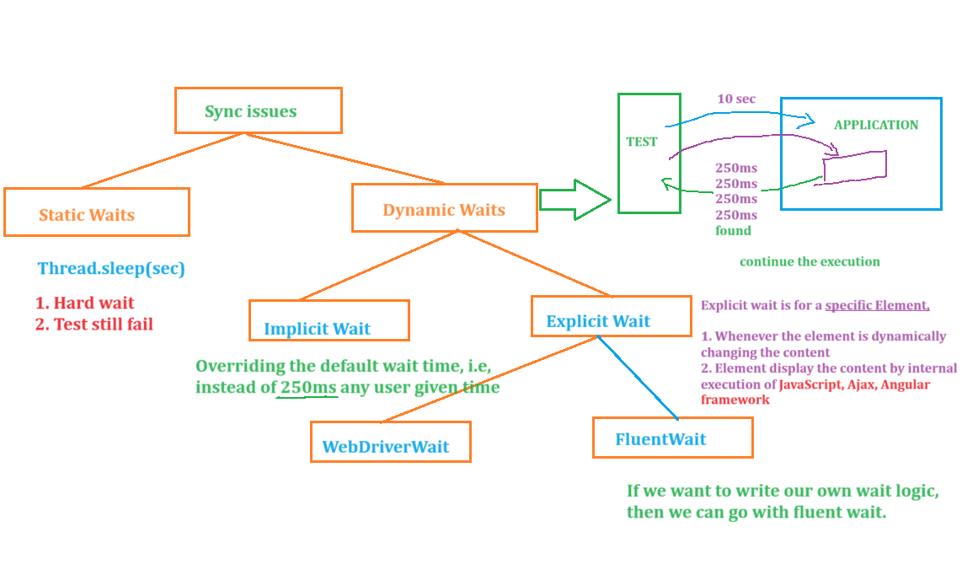

**WebDriverWait Demo :**

**--------------------------------------**

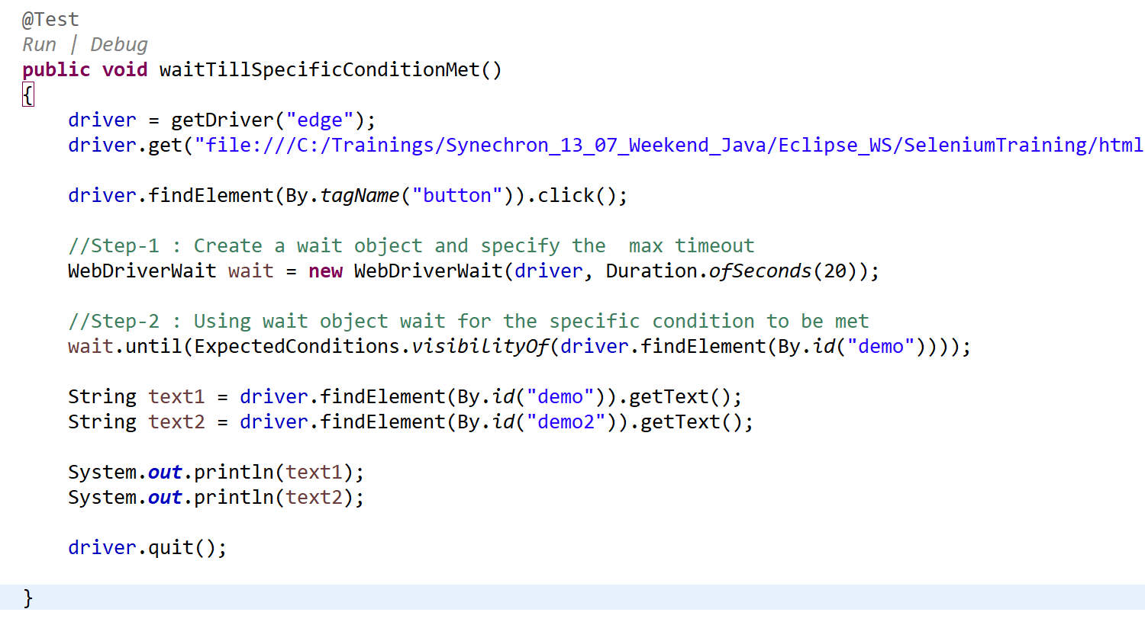

**Fluent Wait Demo :**

**-----------------------------**

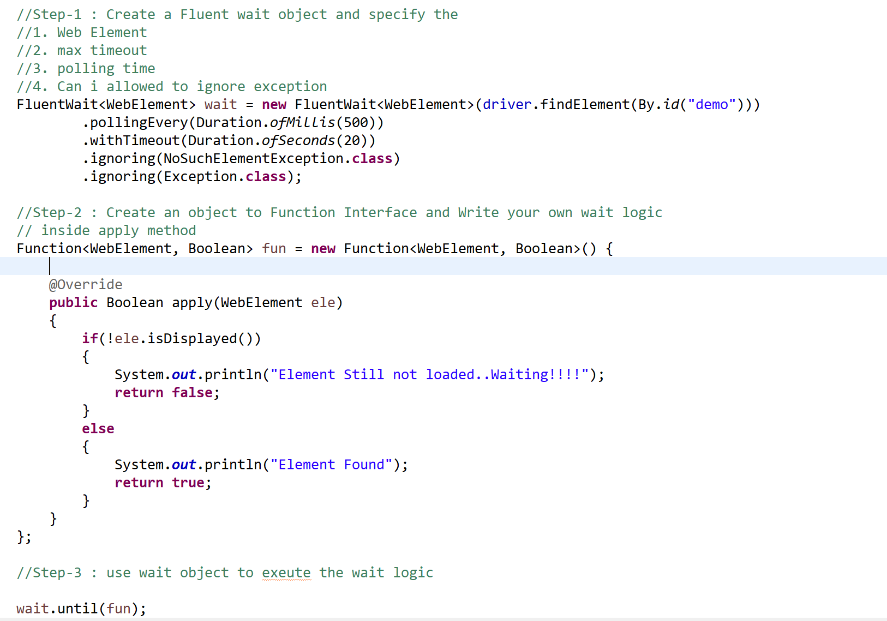

# Select class

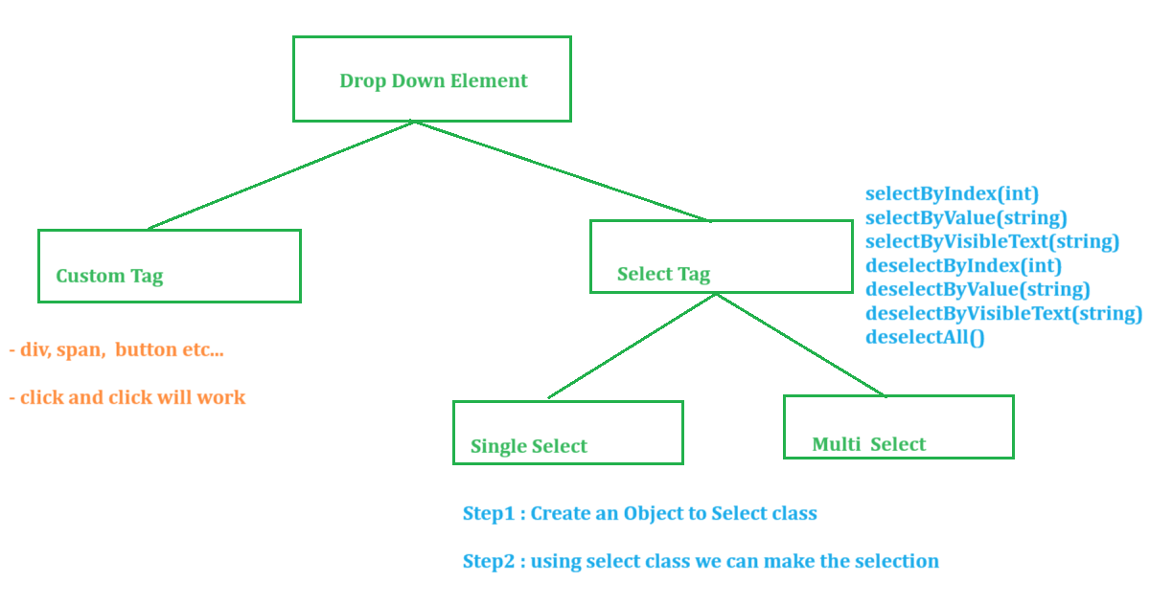

# Actions in Selenium

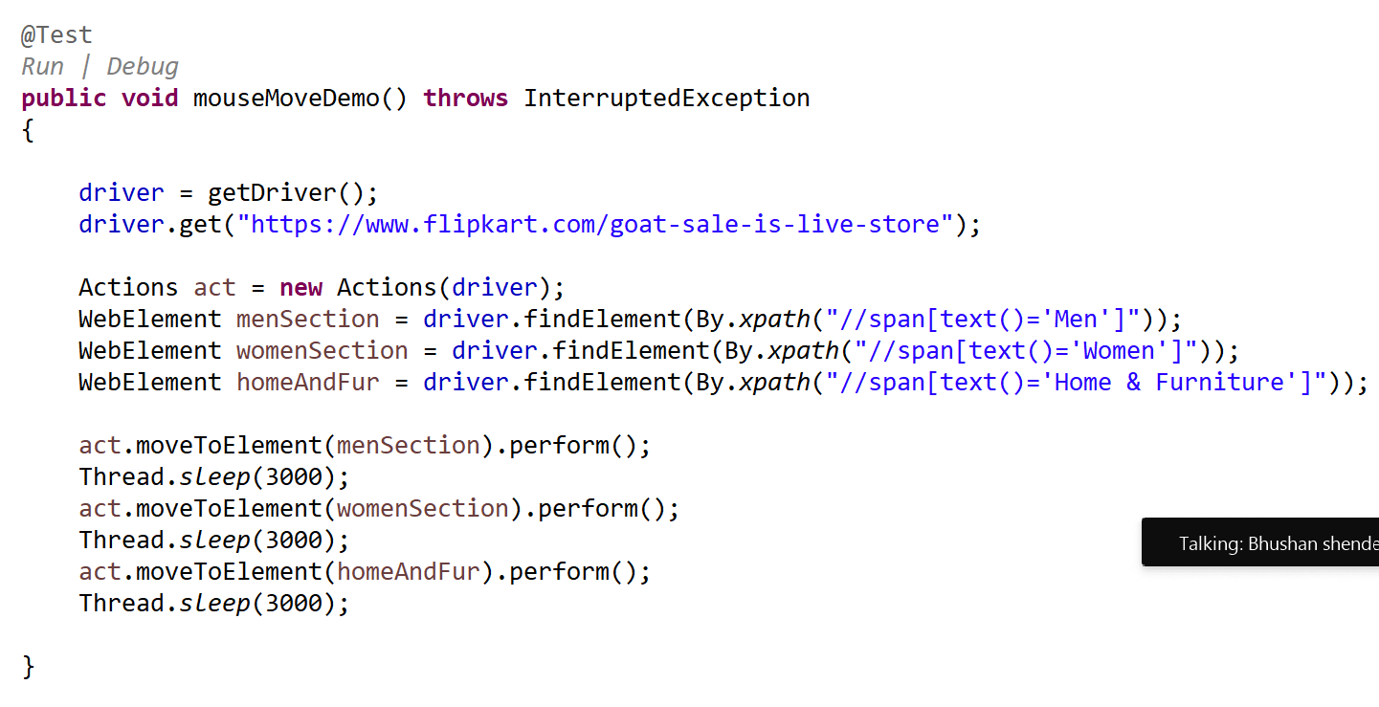

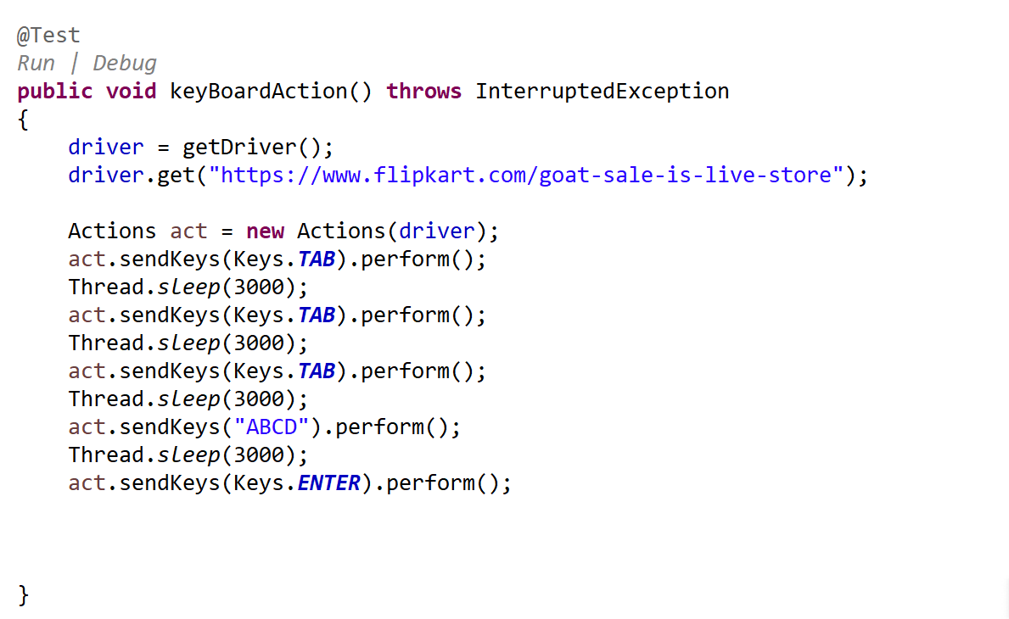

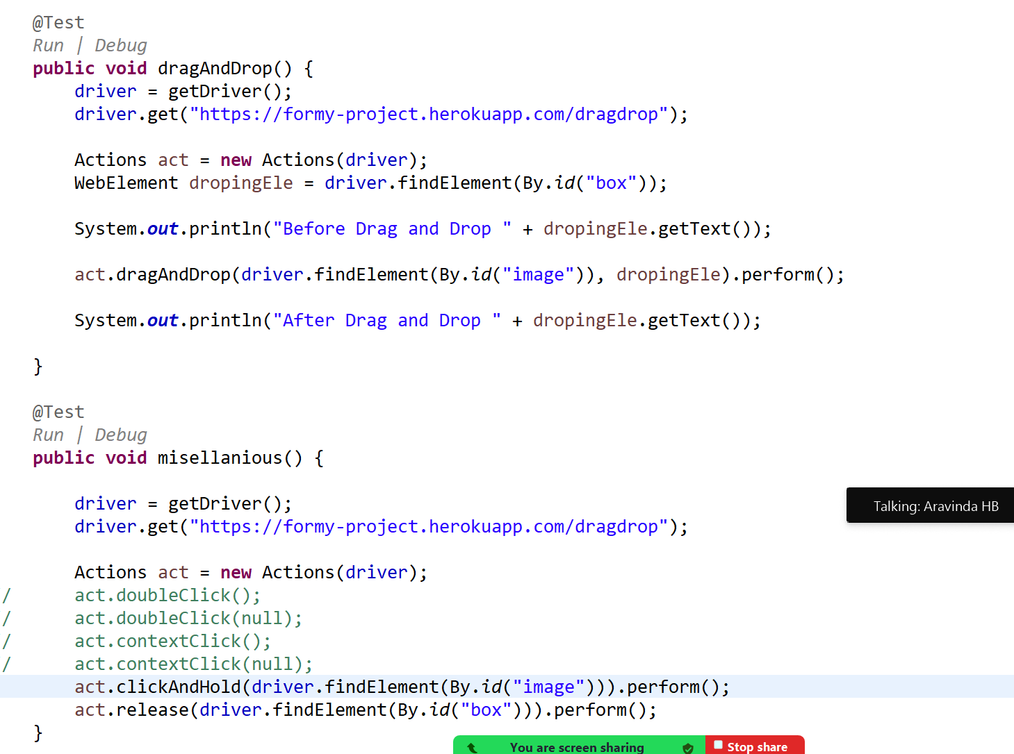

# switchTo ()

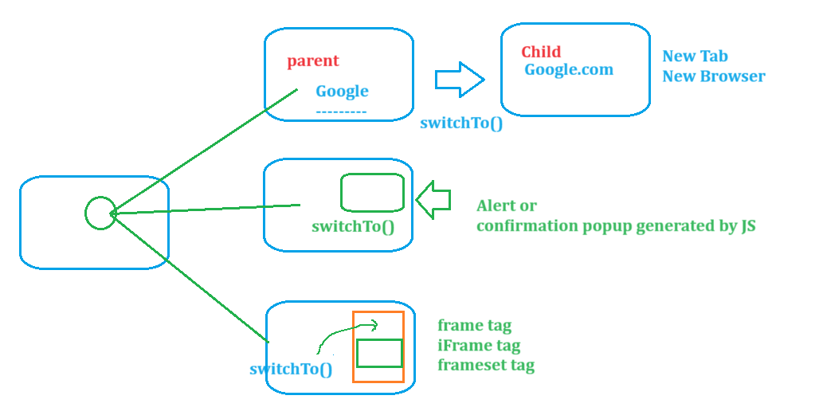

# Data driven Testing – Excel POI

# TestNG

Test Automation Framework,

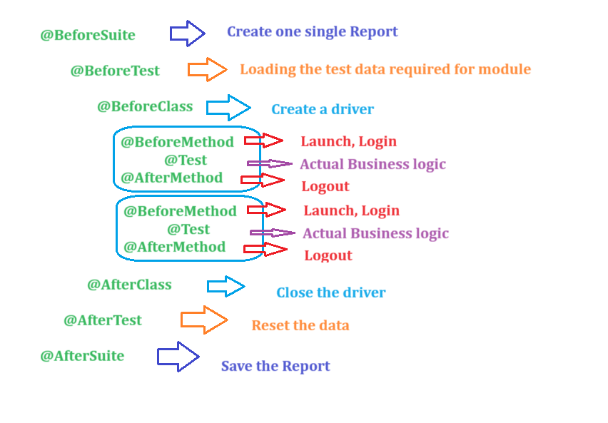

# POM

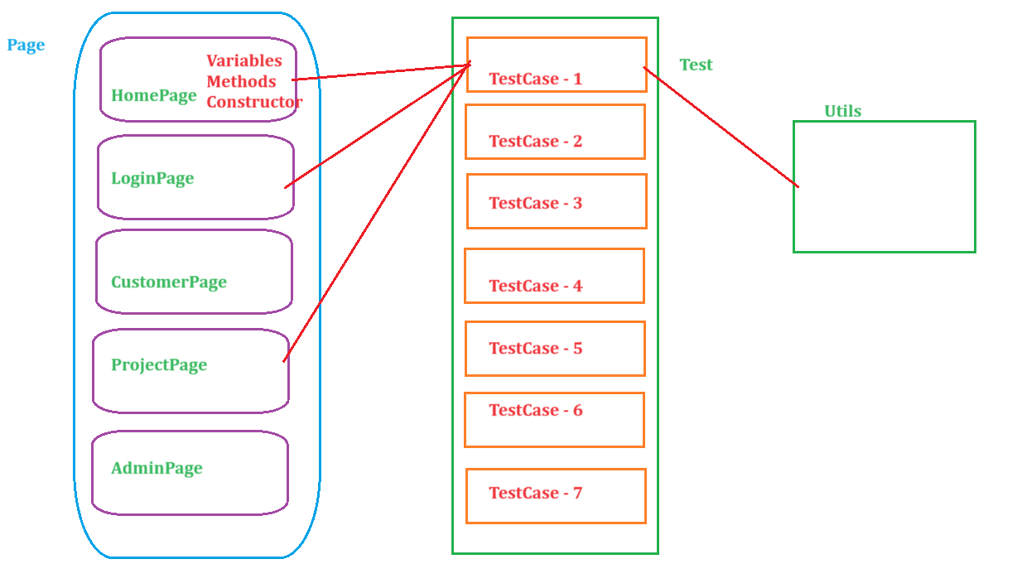

# GRID

# CICD