Java Selenium

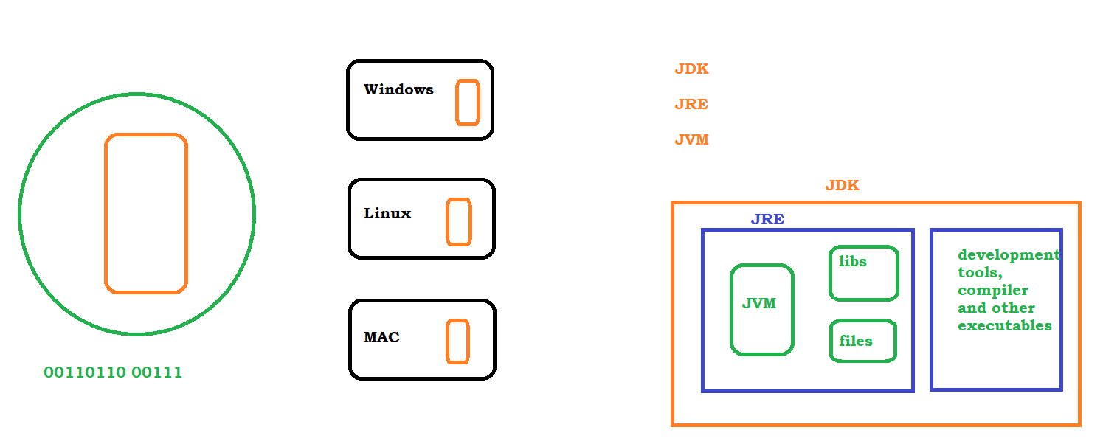

## HelloWorld JAVA Program

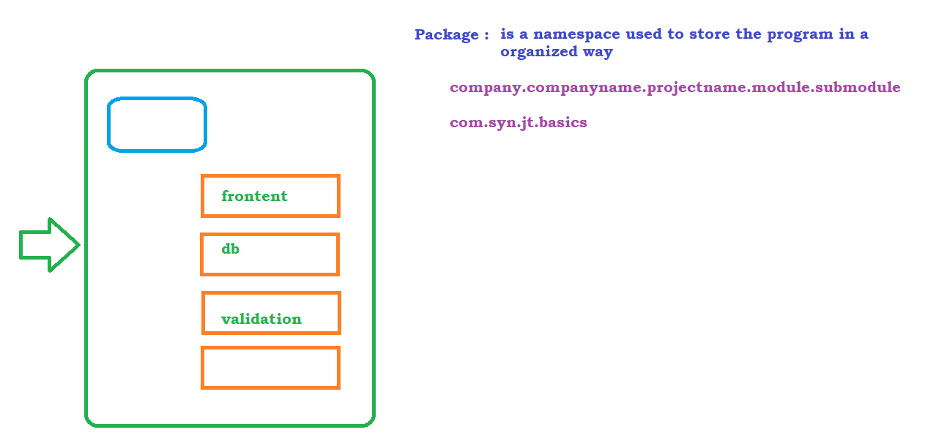

Compilation and Execution

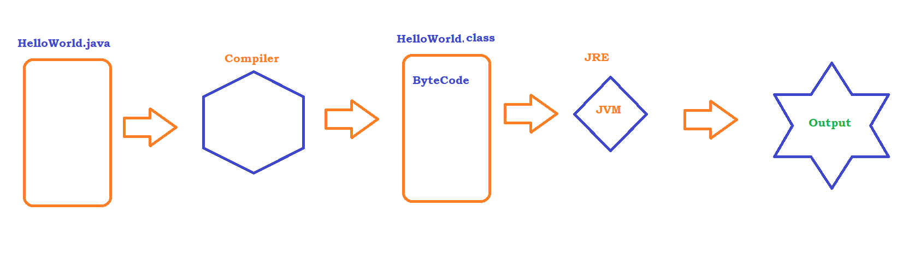

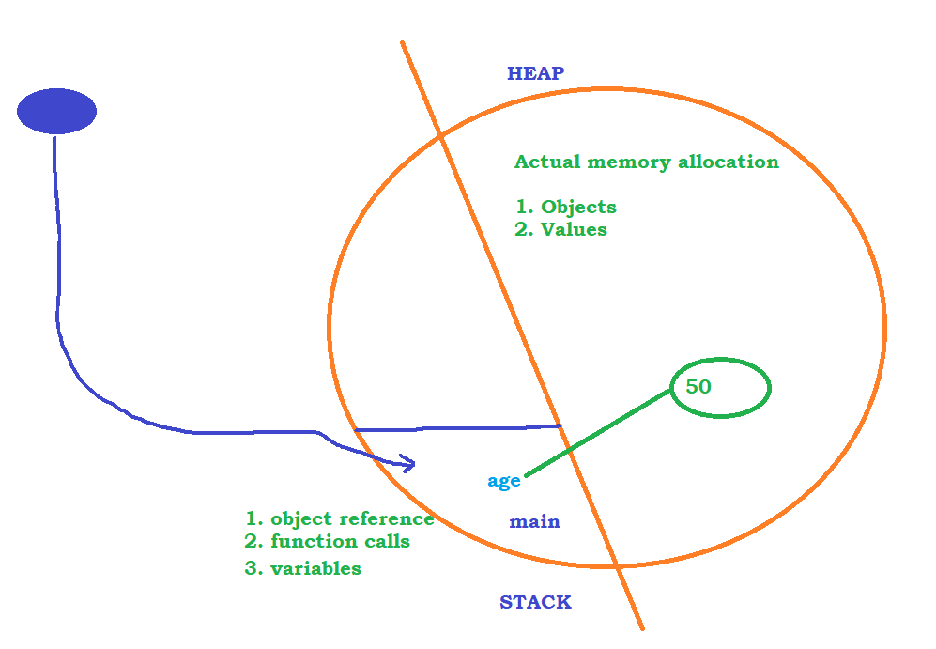

Data types and Variables

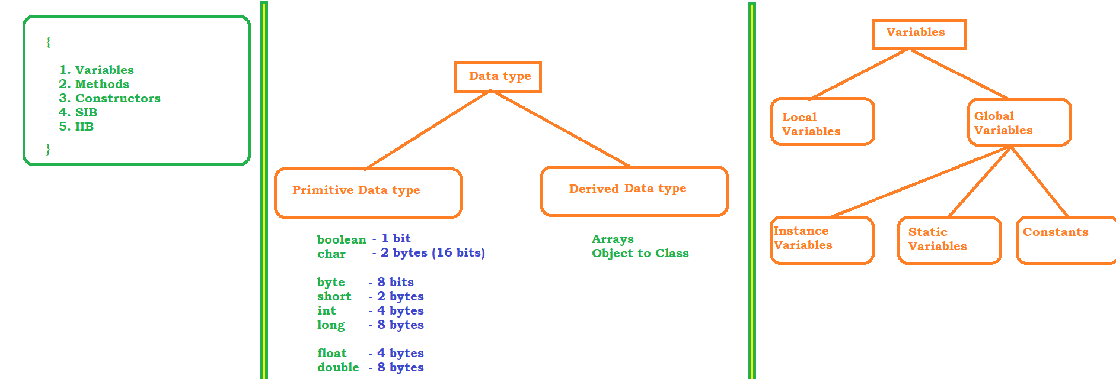

static demo

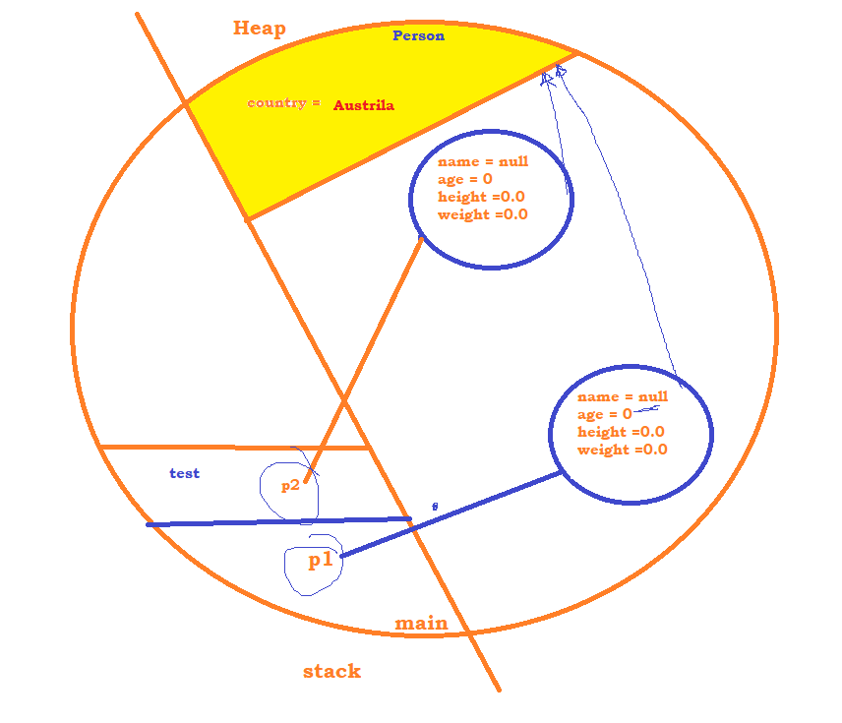

Methods or Functions

methods are reusable entities, we can write once and execute many times

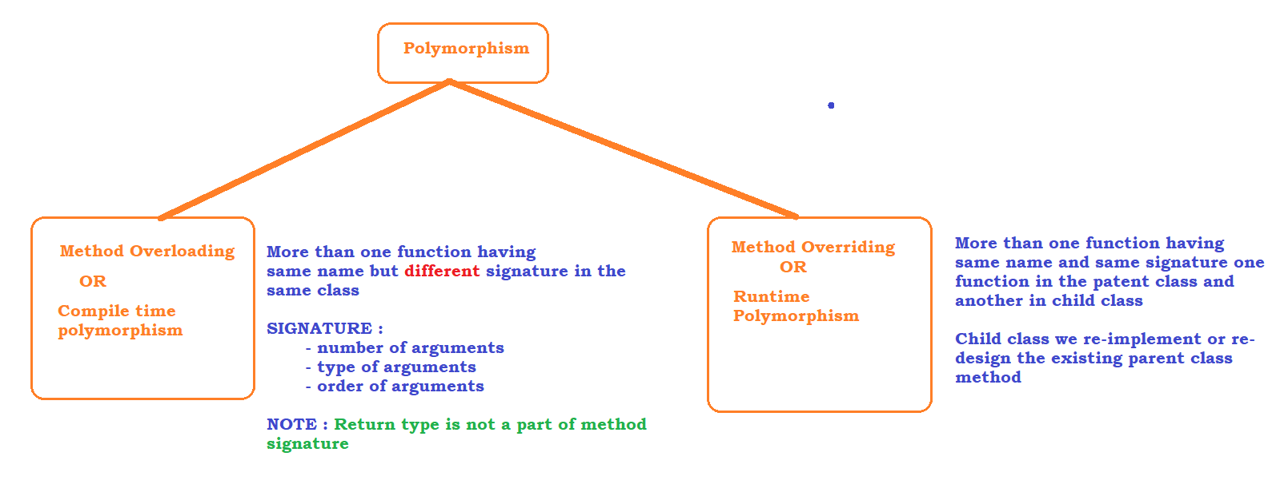

Object class

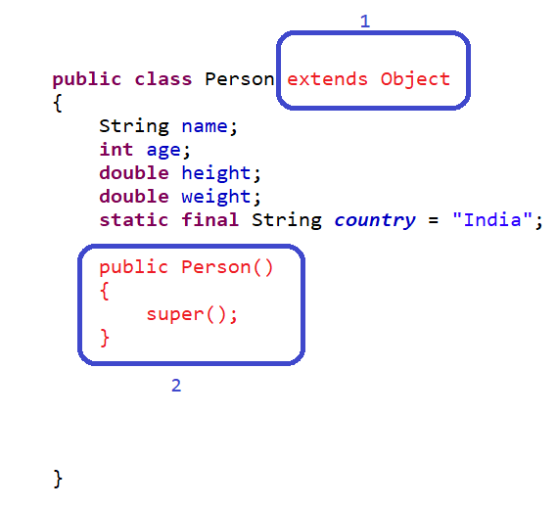

Constructors

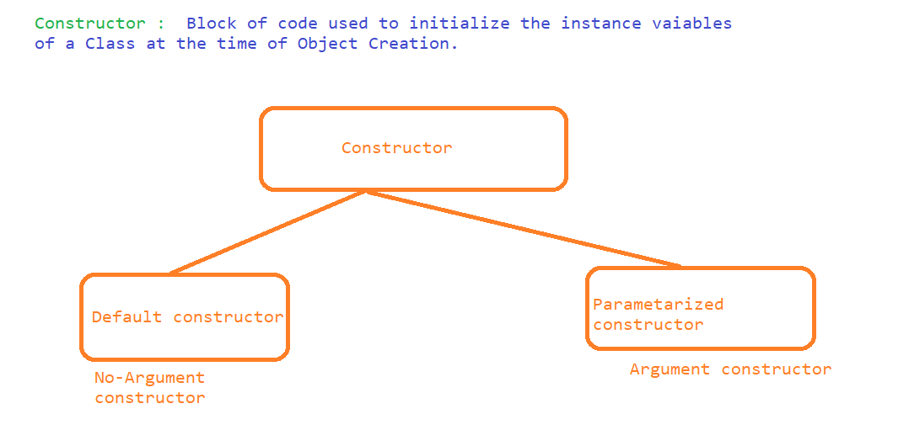

Initialization Blocks

* SIB
* IIB

Access Specifiers and Modifiers

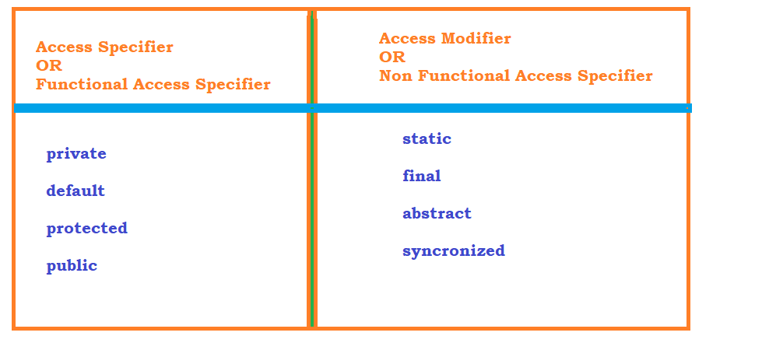

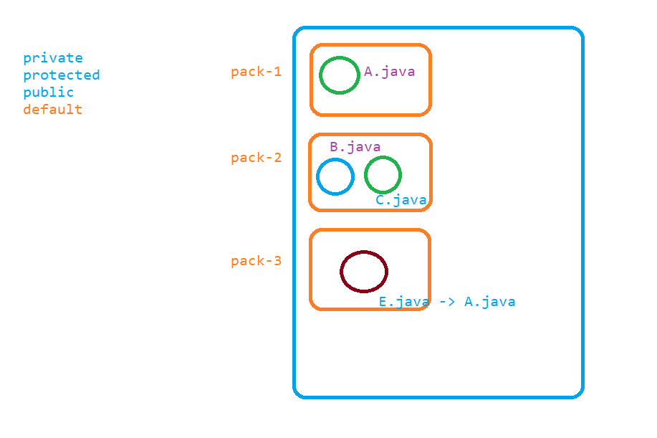

Summary of Access Specifiers and modifiers

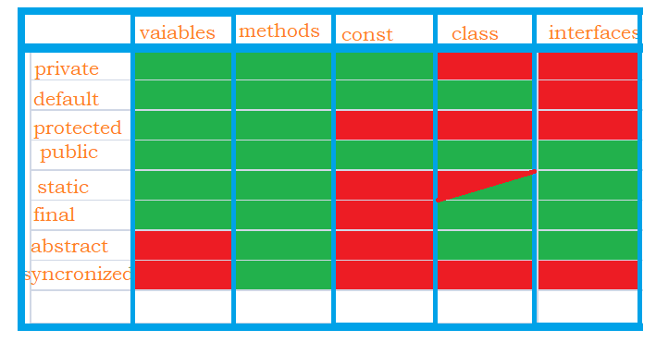

Day-1

data types

primitive datatypes

derived datatypes

variables

Local V

Global V

Instance V

Static V

Const

methods

Overloading

Overriding

Constructors

Access specifiers

Access modifiers

Scanner class

Abstract class

Interfaces

this and super kw

String

* java.lang
* Strings are Immutable in nature
* string functions
* StringBuffer
* StringBuilder

Looping and Conditional Statements

Exceptions

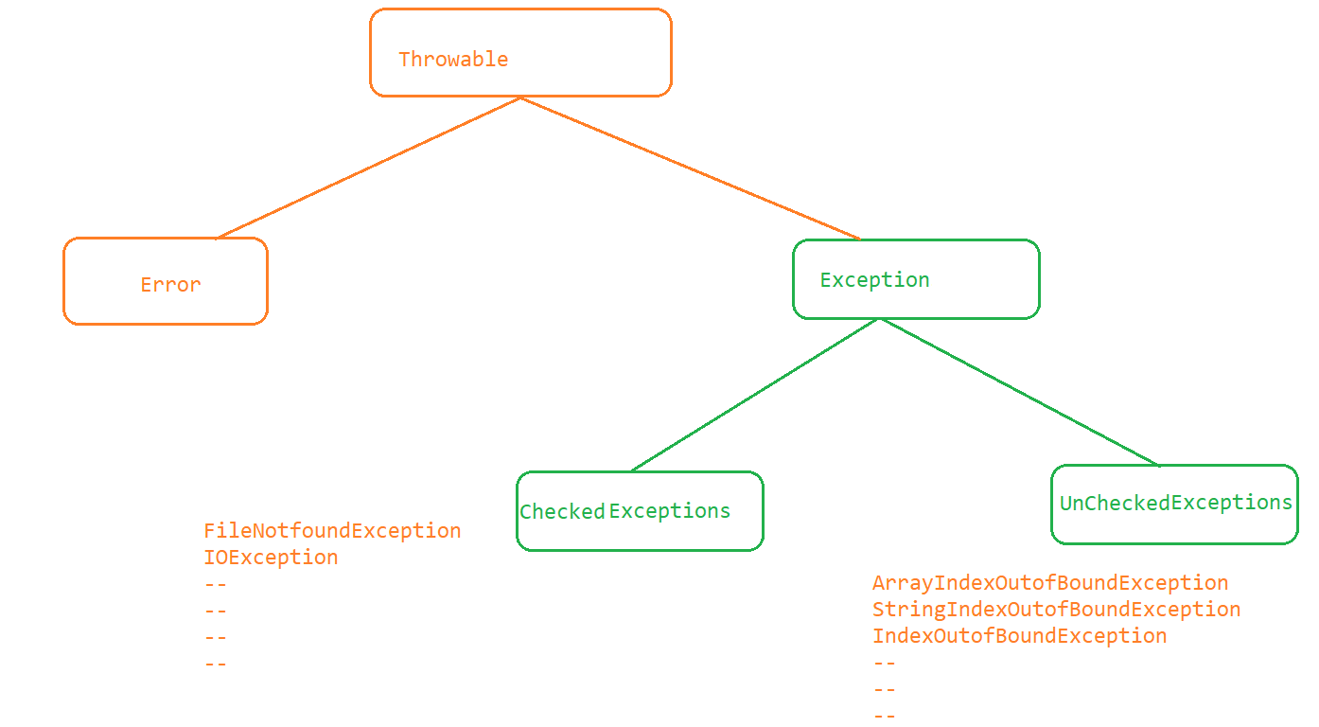

# Exception Handling

