# Java Script

1. History
2. Different from JAVA or OOP
3. Extensions – JS
4. Variables
5. Operators
6. Data types
7. Strings
8. Conditional Statements
9. Looping Statements
10. Arrays
    1. push
    2. pop
    3. shift
    4. unshift
    5. delete
    6. splice
    7. slice
    8. concat
    9. join
11. Functions
    1. function definition
    2. function expression
    3. Arrow Functions
12. Collections
13. OOPS

# Protractor

1. Why ????
2. How this tool is built ?
3. What are the features ?
4. How protractor works ?
5. Protractor Setup
   1. Introduction to maven
   2. Maven life cycle
   3. pom.xml – introduction and useage
   4. updating pom file to configure protractor
6. Async Nature of JS
7. Plugins
8. Jasmine FW
9. Finding Elements in protractor
10. Working with more than one elements in protractor
11. Chain Locators
12. Capturing Screenshots of Failures
13. Reporting
    1. Junit Reports
    2. HTML
    3. Allure Reports
14. Execute Tests on different browser
15. Automate non-angular applications using protractor
    1. Handling sync issues
    2. Browser actions
    3. Actions
    4. switchTo
16. Data driven Testing in protractor
    1. global data
    2. local data
17. POM – Framework
18. Executing the Test Suite
19. Jenkins Execution
    1. configure
    2. auto trigger build

Java script

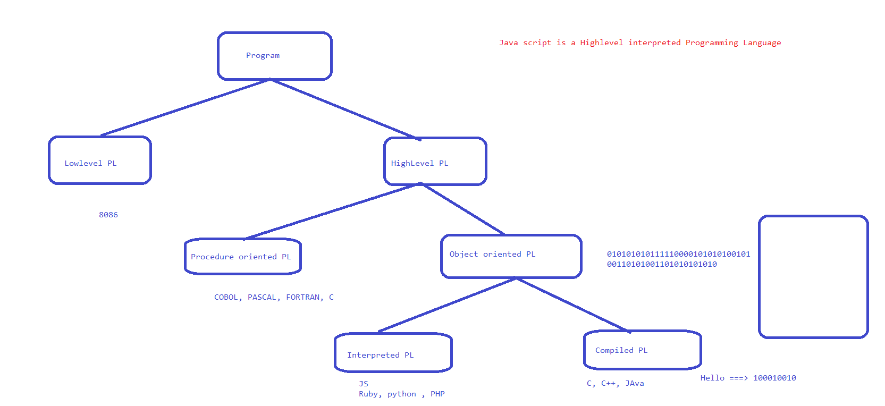

Work flow

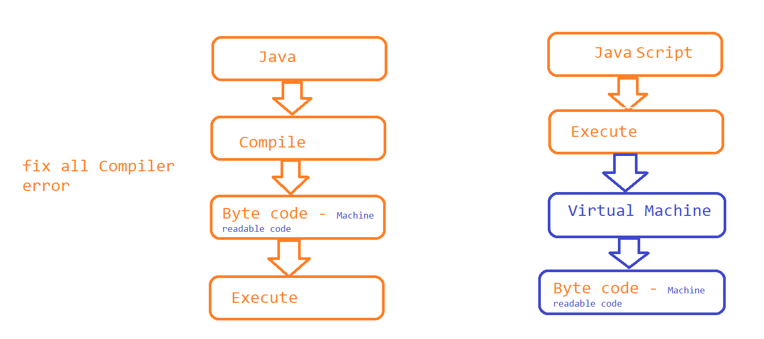

* Java Script was introduced to market in the year 1995 by Bredan Eich.
* Java script is a programming language for web
* Latest ERA, Java script can also be used in a non browser environment ie node.js application
* Java script is made as ECMA Standard specification
* 1999 – Ajax is released
* Node.js
* Java Script can be used for Developing
  + UI
  + Web
  + Mobile
  + Desktop
* Java script Runs on every browser
* <https://en.wikipedia.org/wiki/JavaScript_engine#:~:text=A%20JavaScript%20engine%20is%20a,every%20major%20browser%20has%20one>

Visual Studio Code Editor

* Download the software from <https://code.visualstudio.com/download>
* Follow the installation steps
* Install Extensions / plugins
* Java Script code snippet
* 
* Code Runner
* 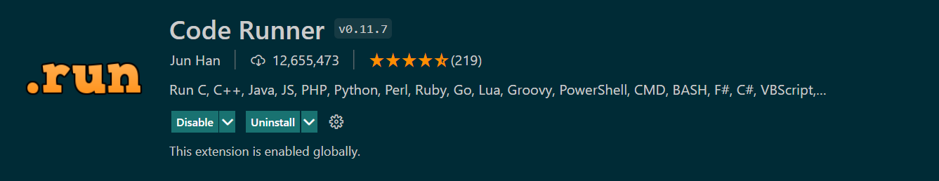
* Live Server
* 

## Install Node JS software on your machine if you want to execute java script program in a non-browser environment

* Download and install <https://nodejs.org/en/download/>
* Once installed open command prompt and type,
  + node –v
  + npm –v
* NOTE: IF YOU HAVE ANY ADMIN RESTRICTIONS FOLLOW THE WORK ARROUND
* create a html file and execute java script inside the html file
  + Writing HTML File
  + create a file with any name and .html as extension
  + Crrl + Space and select HTML Sample
* HTML File with JS Code inside HTML File
* 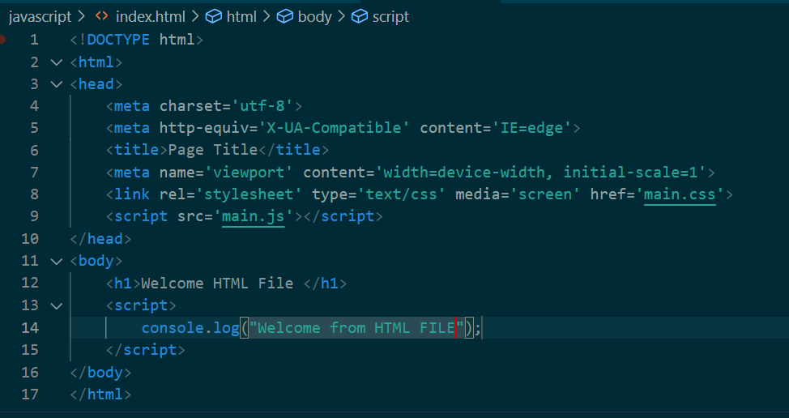
* HTML File with JS Code inside separate Java Script File

Variables

Variables are used to store the value. A value can be categorized into primitive or object.

JS is not strictly type caste programming language, we can use var, let or const to store any type of values.

NOTE : Avoid using var as its a old way of declaring a variables

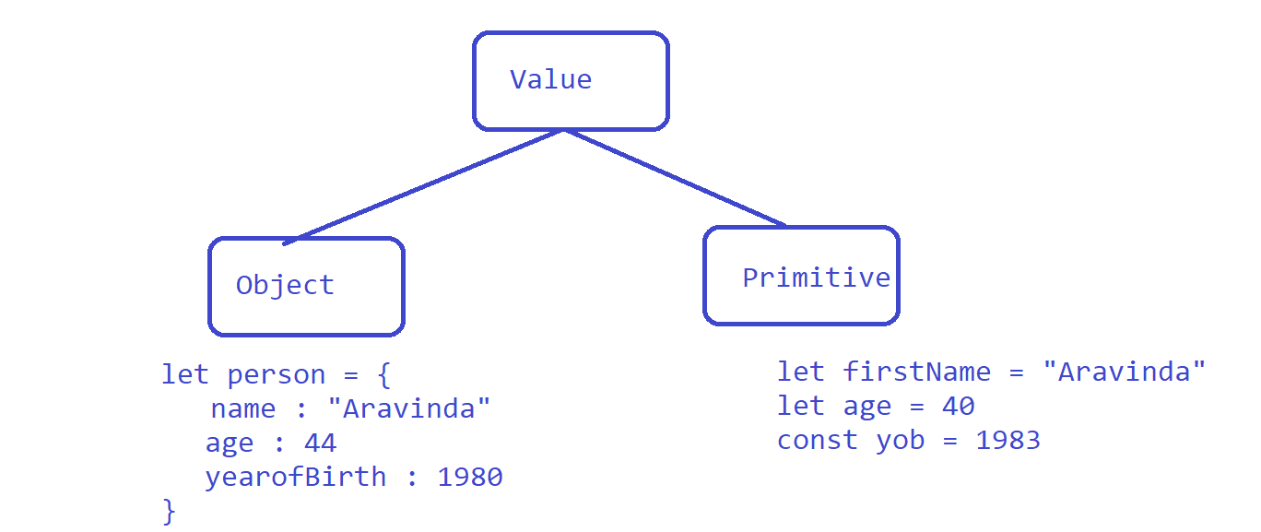

Operators in Java Script

# Arithmetic Operators

* Addition 🡪 +
* subtraction 🡪 -
* Multiplication 🡪 *
* Division 🡪 /
* Module 🡪 %
* Exponential 🡪 **
* Increment 🡪 ++

# Assignment Operators

* Assignment = x=y
* Add and assign += x+=y x = x + y
* Subtract and assign -= x-=y x = x - y
* Multiply and assign *= x*=y x = x * y
* Divide and assign /= x/=y x = x / y
* Module and assign %= x%=y x = x % y
* Exponential and assign **= x**=y x = x ** y

# Comparison Operators

* check equal value == x==y
* check equal value & Type === x===y
* check not equal value != x!=y
* check not equal value, Type!== x!==y
* Greater than > x>y
* Less than < x<y
* Greater than or Equal >= x>=y
* Less than or Equal <= x<=y
* Ternary Operator ?: (x>y)?stmts1:stmts2

# Logical Operators

* Logical AND && => true, when both Operands returns true
* Logical OR || => true, when any one Operands returns true
* Logical Not ! => Inverse of the result

# Type of Operators

* typeof – returns the data type
* instanceof

# Primitive Data types

1. Number
2. String
3. Boolean
4. Undefined
5. Null
6. Symbol
7. BigInt

Strings

* String construction using String concatenation
* String construction using back-tick notation or template literal
* EX :

