Java Script

JavaScript is **a high level, Object Oriented and Interpreted** programming language.

Reference : <https://developer.mozilla.org/en-US/docs/Web/JavaScript/Reference>

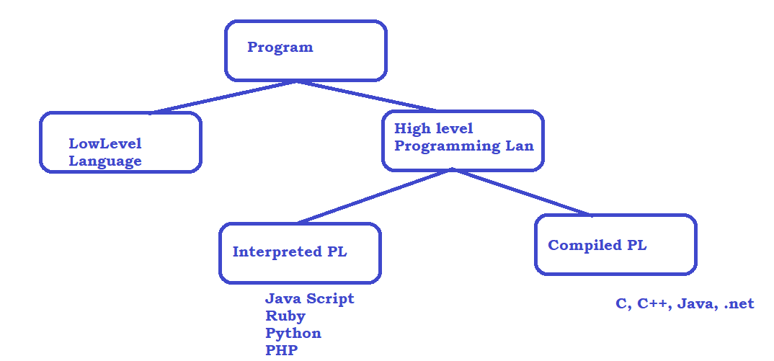

High level difference

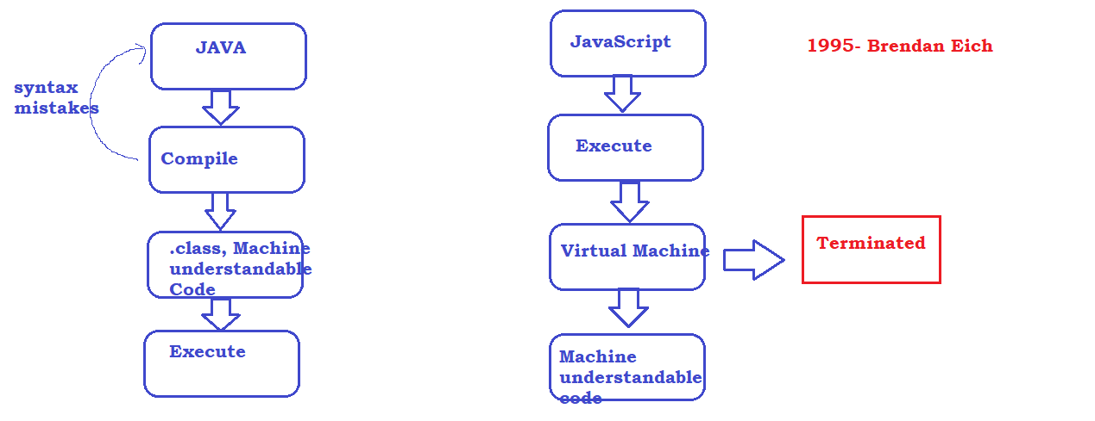

## Java Script Engine :

<https://en.wikipedia.org/wiki/JavaScript_engine#:~:text=A%20JavaScript%20engine%20is%20a,every%20major%20browser%20has%20one>.

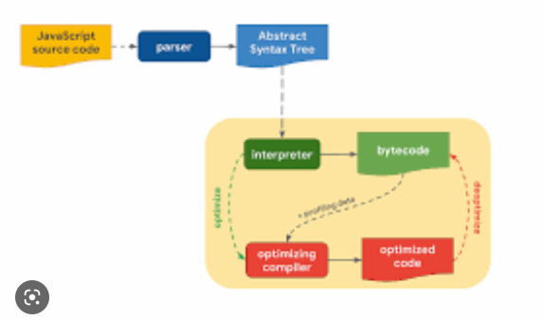

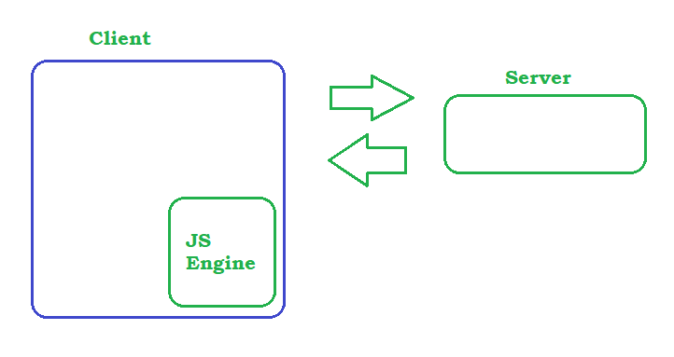

Visual Studio Code Editor

1. Download the software from <https://code.visualstudio.com/download>
2. Follow the instructions – installation steps
3. Use Extensions option to install the plugin
   1. 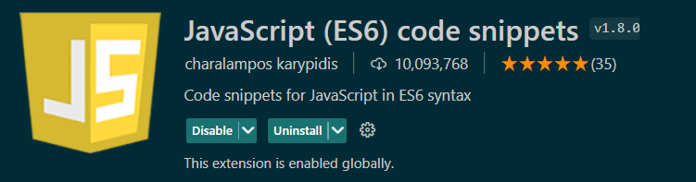
   2. 
   3. 

# Install node software on the machine. If you want to execute JS on a non- browser Environment

* <https://nodejs.org/en/download/>
* Once the installation is completed, open a Terminal
  + Node –v
  + npm –v

Data type and Variables

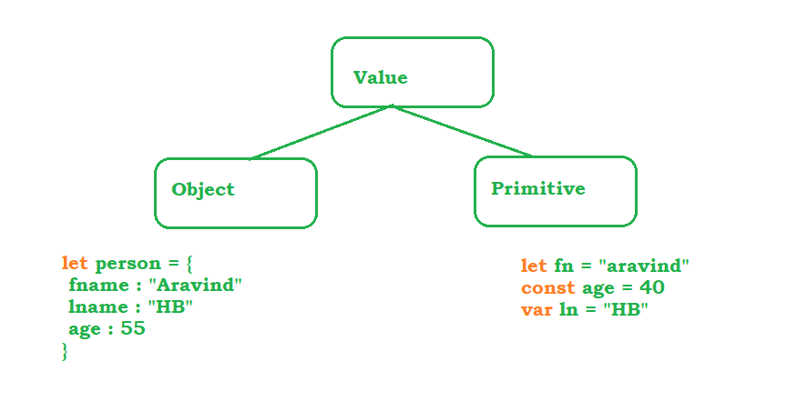

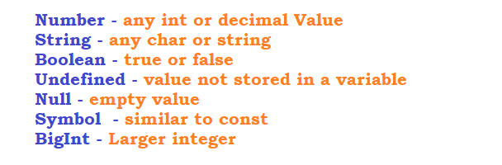

Operators in Java Script

# Arithmetic Operators

* Addition 🡪 +
* Subtraction 🡪 -
* Multiplication 🡪 *
* Division 🡪 /
* Module 🡪 %
* Exponential 🡪 **
* Increment 🡪 ++

# Assignment Operators

* Assign = x=y
* Add and Assign += x+=y x = x + y
* Sub and Assign -= x-=y x = x - y
* Mul and Assign *= x*=y x = x * y
* Div and Assign /= x/=y x = x / y
* Add and Assign %= x+=y x = x % y
* Exp and Assign **= x**=y x = x ** y

# Comparison Operators

* Check equal value == x==y
* Check equal value and type === x===y
* Check not equal value != x!=y
* Check not equal value type !== x!==y
* Grater then > x > y
* Less then < x < y
* Grater then equal >= x >= y
* Less then equal <= x <= y
* Ternary Operator ?> (x>y)?x:y

# Logical Operators

* Logical AND &&
* Logical OR ||
* Logical NOT !

# TypeOf Operators

* typeOf
* instaceOf

Conditional Statements

* if
* if,else
* if,elseif,... else
* switch

Looping Statements

* for
* for each
* while
* do while
* for in
* for of

Arrays

* push
* pop
* shift
* unshift
* delete
* splice
* slice
* join
* concat

Functions

* Function with definition

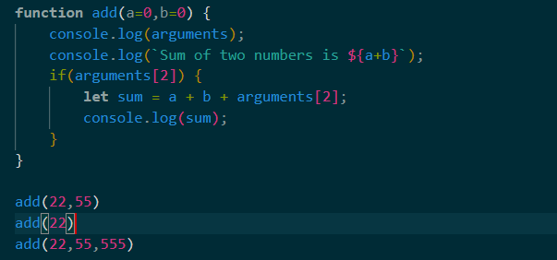

* Function with Expression OR Anonymous Functions

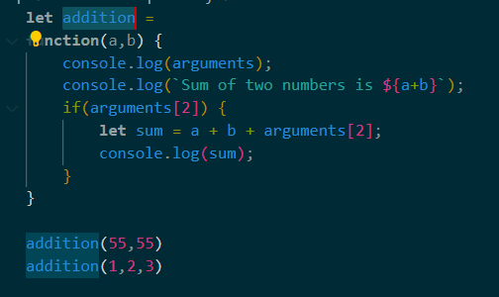

* Arrow Functions

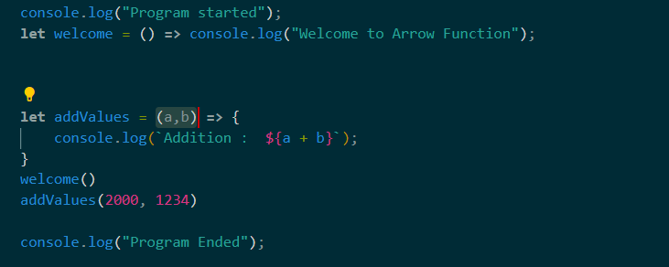

Strings

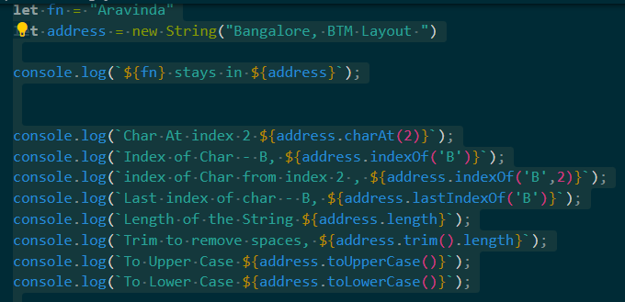

Objects in JS

OOPS

* Abstraction
* Encapsulation
* Polymorphism
* Inheritance

Collections

Set

Map

Reading from KB

1. install readline library from node js
2. <https://www.npmjs.com/package/readline>
3. npm i readline
4. import readline to the program and pass stand input and output
5. execute the program as node program
   1. node <<file name>>

Protractor

protractortest.org

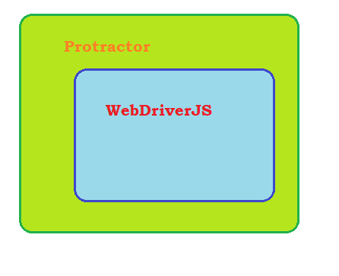

Setup :

1. npm install -g protractor
2. protractor –version
3. webdriver-manager update

C:\Users\Aravind\AppData\Roaming\npm\node_modules\protractor\node_modules\webdriver-manager\selenium

1. Copy the sample Test and conf file from the Reference Document
2. Open terminal and execute
   1. protractor conf.js

High level Diagram :

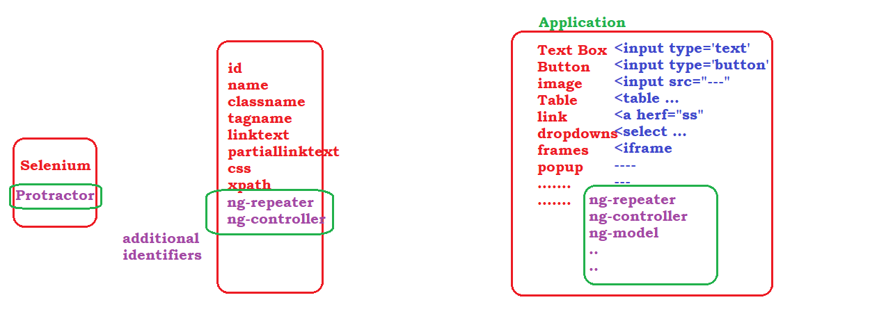

#### How protractor Works

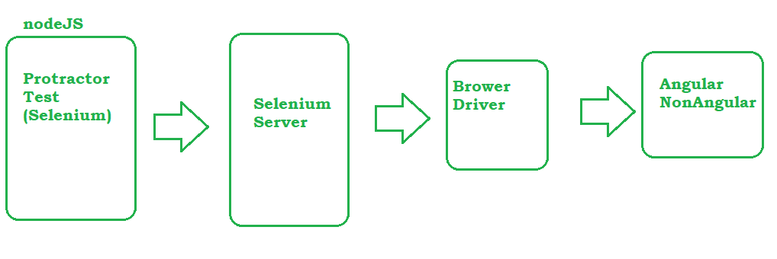

Global Variables

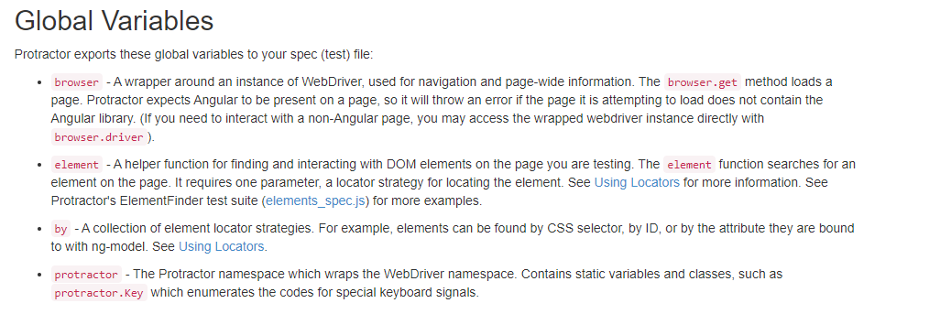

Protractor Plugin



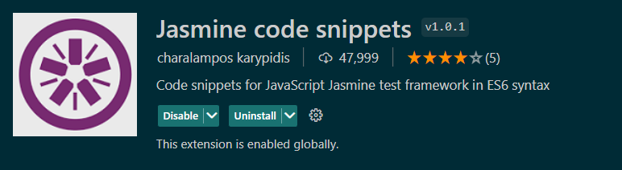



Asynchronous nature of JS

Control will go to next step if any step is waiting for any resource.

We can achieve synchronous nature by resolving promise, to resolve promise we have to use call back function

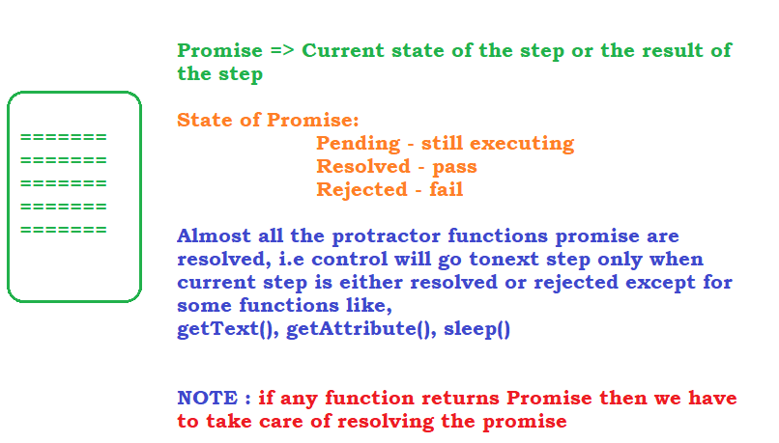

Finding Elements

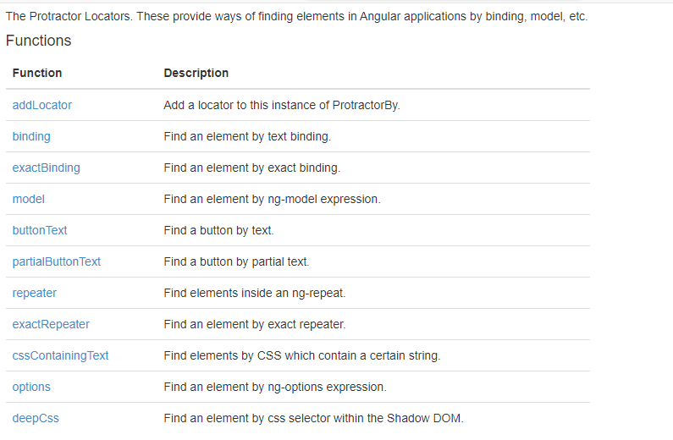

Validation in Protractor

<https://jasmine.github.io/>

<https://jasmine.github.io/tutorials/your_first_suite>

Handling multiple ele & Chain locators

element.all method to play with more than one element

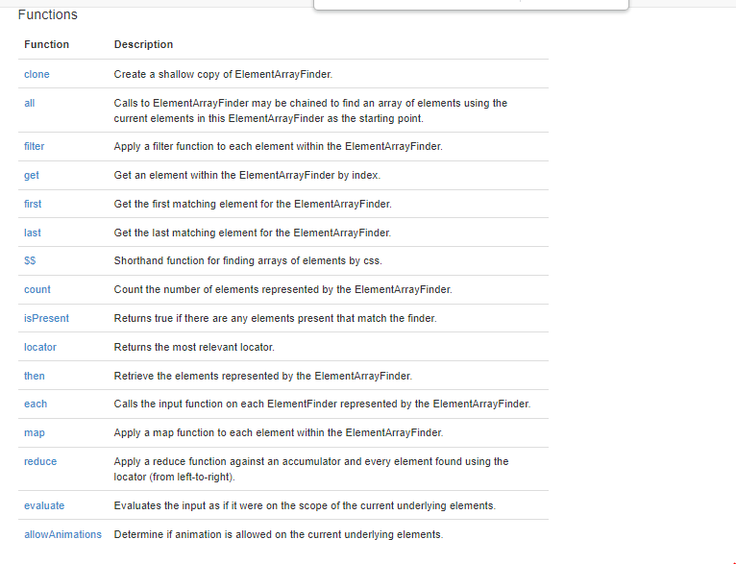

Chain locators :

Finding one element inside the other

Capturing ScreenShots in Protractor

1. Go to npm repository <https://www.npmjs.com/package/readline>
2. Search for protractor-jasmine2-screenshot-reporter
3. <https://www.npmjs.com/package/protractor-jasmine2-screenshot-reporter>
4. install the plugin using npm i protractor-jasmine2-screenshot-reporter
5. verify the package is installed under node_modules
6. Follow the instructions to register the package
7. Execute the test and verify the screenshots

Allure Reports

1. Go to npm repository <https://www.npmjs.com/package/readline>
2. Search for jasmine-allure-reporter
3. <https://www.npmjs.com/package/jasmine-allure-reporter>
4. Install the plugin npm i jasmine-allure-reporter
5. Update conf.js as per the instructions
6. Execute the tests and confirm xml reports are generated
7. To generate HTML Output from allure xml results,
   1. install allure command line tool
   2. <https://www.npmjs.com/package/allure-commandline>
   3. allure serve <<location of xml files>>

HTML Reports using Html Reporter

1. Go to npm repository <https://www.npmjs.com/package/readline>
2. Search for protractor-html-reporter-2
3. <https://www.npmjs.com/package/protractor-html-reporter-2>
4. Install the plugin : npm i protractor-html-reporter-2
5. Update the conf.js as per instructions

Executing Test on a different Browser

* Download the Driver Executable
  + Webdriver-manager update –ie
* Start the selenium Server if browser type is other than chrome and ff
  + Webdriver-manager start
* Update the conf.js with the browser type and selenium hub url

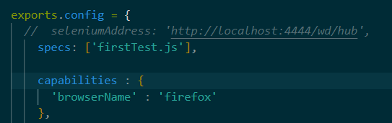

Automating non-Angular Applications

browser.waitForAngularEnabled(false)

Handling Sync Issues

- Create an object to ExpectedConditions : <https://www.protractortest.org/#/api?view=ProtractorExpectedConditions>

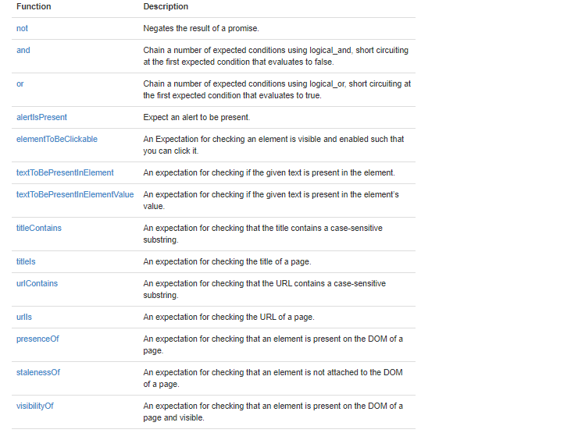

Actions in Protractor

<https://jqueryui.com/droppable/>

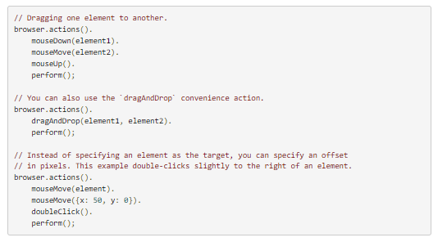

SwitchTo

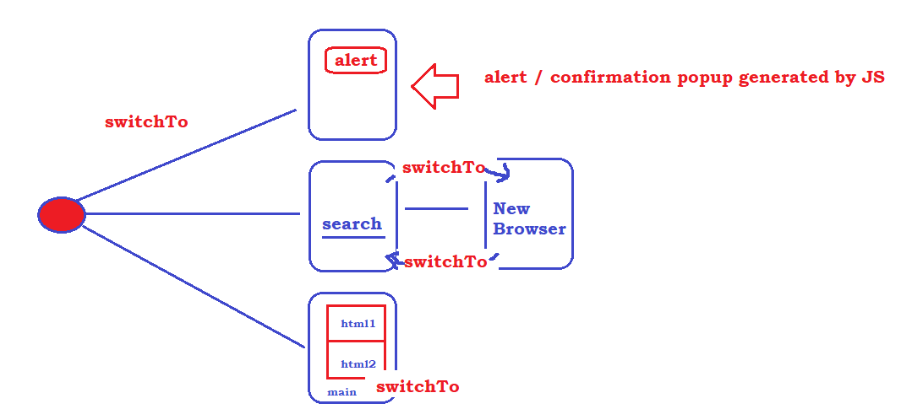

Data driven Testing

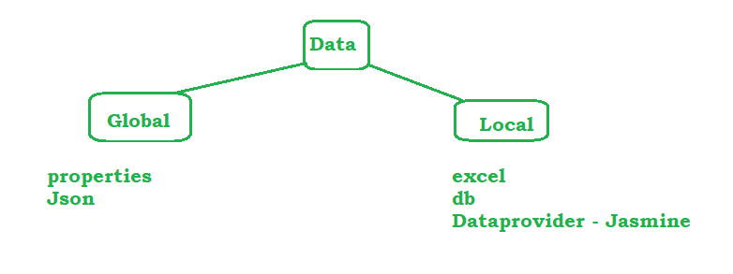

### Data provider :

- download the library from npm repo : <https://www.npmjs.com/package/protractor-html-reporter-2>

- install the lib

- follow the instructions

beforeEach

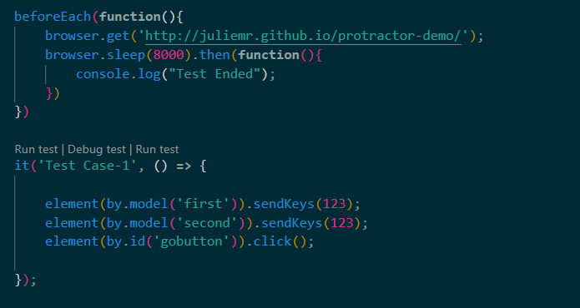

Batch Execution

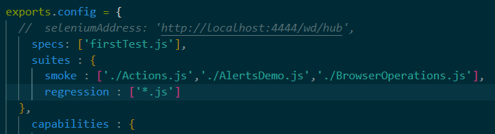

protractor .\conf.js --suite=smoke