Java – 1.8 Features

* **Interfaces with advanced features**
* **forEach**
* **Lambda Expressions**
* **:: Operator**
* **Stream APIs**
* **Date / Time API**

**ForEach**

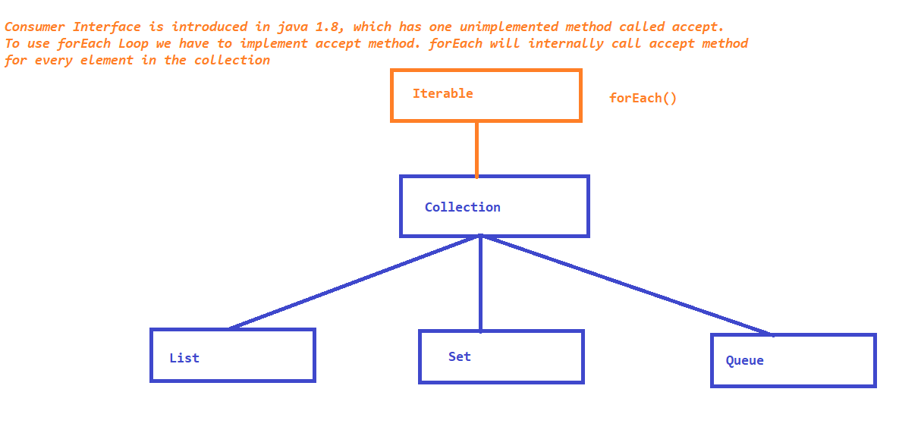

Inner classes in java

Inner class / Nested class is a class within a class. which are mainly introduced to achieve ,

1. Better encapsulation

2. To group the logically similar classes

3. for better readable and maintainable code

Types:

* static inner class :
  + inner class is a member of a parent class
  + inner class is accessible by all the static members of the parent class
* local inner class / instance inner class
  + inner class is a member of a method
  + inner class is accessible only inside the method, and not accessible by any other members of the class
* anonymous inner class

Lambda Expressions

- These are the block of code, which can be executed without object created

- Lambda expressions take no arguments or with arguments and it is capable of returning a value. Lambda expressions are similar to methods.

* Lambda Expressions with no args
* Lambda Expressions with arguments
* Lambda Expressions without return type
* Lambda Expressions with return type
* Lambda Expressions for forEachLoop (consumer accept method)

- 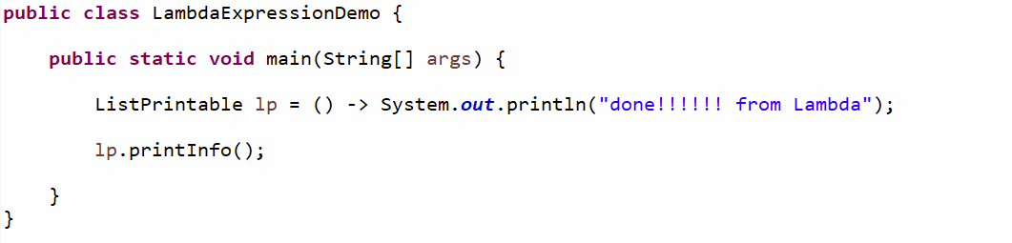

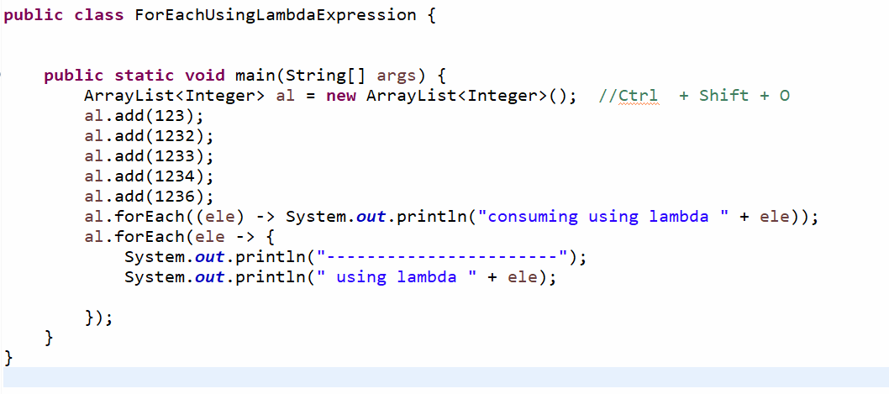

Inner classes OR nested classes

* static inner class
* local inner class
* anonymous inner class

:: Operator