JavaScript

# PROGRAMMING :

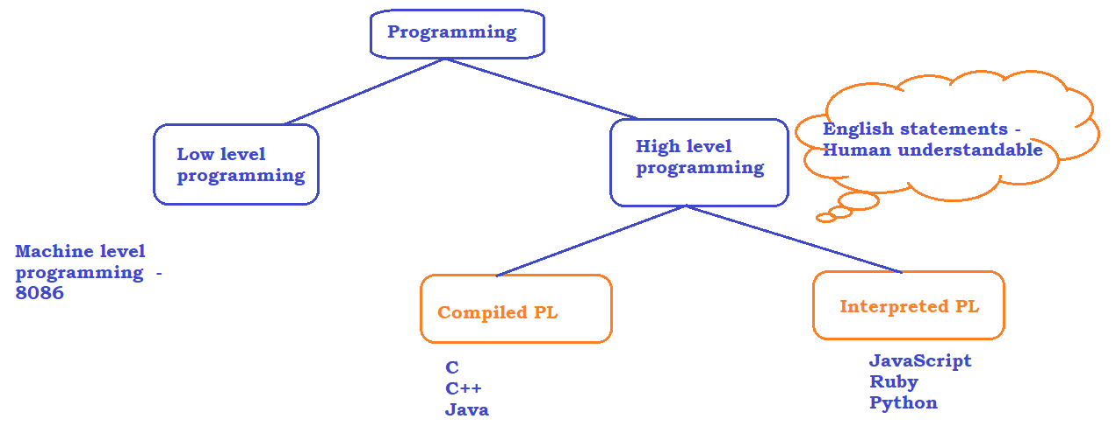

HIGH LEVEL DIFFERENCE

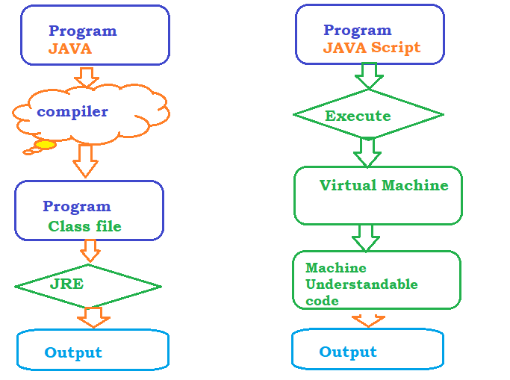

# What is JAVA Script ???

=======================

Javascript is a **High-level** and **Interpreted** programming language.

**High-level :** It’s a Human Readable English Statements

**Interpreted :** Its ready to run code as soon as we complete coding.

# History:

* JavaScript is introduced in 1995-96 as a Programming language for Web, it was mainly used for validating the content on the Web
* Brendan Eich from Netscape Communications ( Mozilla foundation )
* Now, JS can be used as a programming for Web as well as non browser environments such as Node.js Adobe etc
* Node JS, Ajax internally uses Java Script to write Server side programming
* Today, JS is widely used in non browser apps as well, to create UI, mobile, Desktop applications

# How Java Script Run :

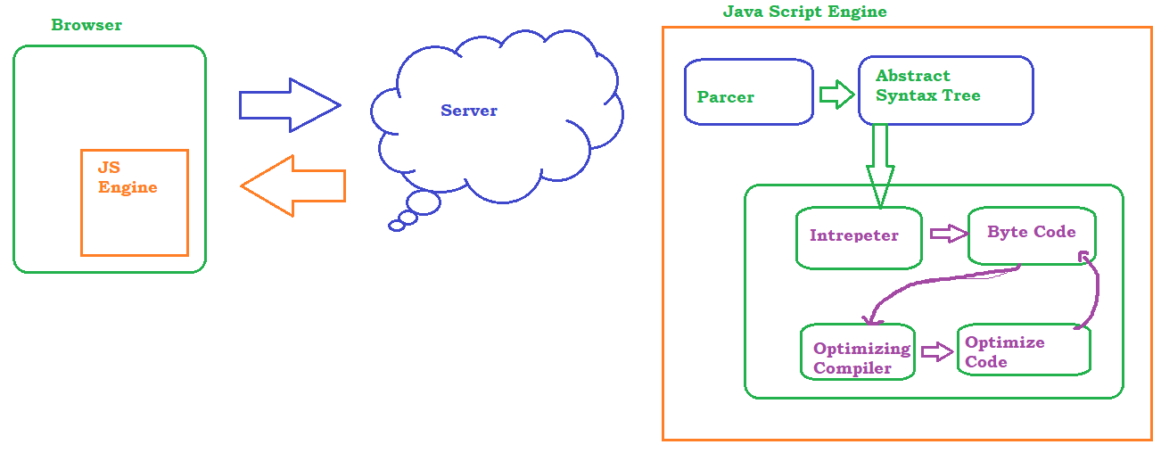

# IDE : Visual Studio Code

* Download the software from <https://code.visualstudio.com/>
* Double click on the installer and follow the instructions to install the software
* Click on file -> Open folder =>Select the Work Space
* File -> Preference -> Color and Theme to change the color of editor
* Use Extensions to install the plugin
* 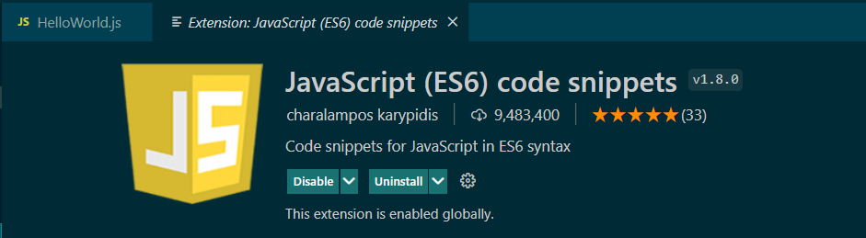
* 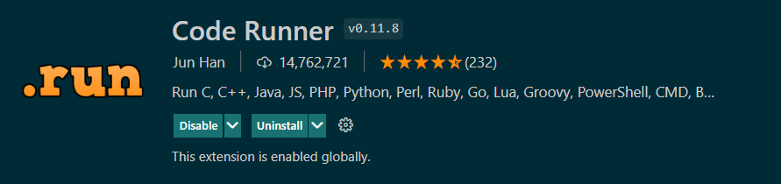
* 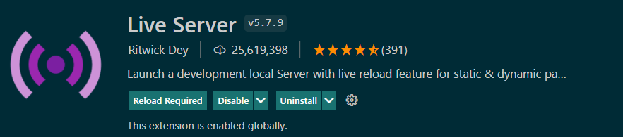

Install NodeJS Software on the machine if you want to execute JavaScript on non-Browser environment

* Download the software from <https://nodejs.org/en/download/>
* Follow the instructions to install the SW
* Open Command prompt and verify the installation by
  + node –v
  + npm –v

Variables :

JS has dynamic typing, based on the value stored in a variable it will assign the data type.

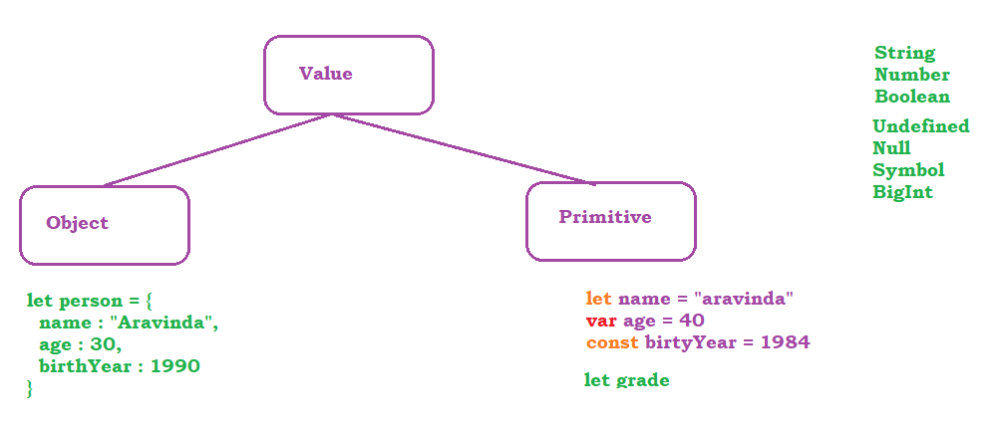

Operators in Java Script

# Arithmetic Operators

* Addition -> +
* Subtraction -> -
* Multiplication -> *
* Division -> /
* Module -> %
* Exponential -> **
* Increment -> ++
* Decrement -> --

# Assignment Operators

* Assign = x=y
* Add and assign += x+=y x = x + y
* Sub and assign -= x-=y x = x – y
* Multiply and assign *= x*=y x = x * y
* Divide and assign /= x/=y x = x / y
* Module and assign %= x%=y x = x % y
* Expone and assign **= x**=y x = x ** y

# Comparison Operators

* Check equal value ==
* Check equal value and type ===
* Check Not equal value !=
* Check Not equal value and type !==
* Greater than >
* Greater than and equal >=
* Less than <
* Less than and equal <=
* Ternary Operator ?:

# Logical Operators

* Logical AND && x ==2 && y ==2
* Logical OR || x ==2 || y ==3
* Logical NOT ! !(x==2)

# Type of Operators

* typeOf()
* instanceOf()

Strings

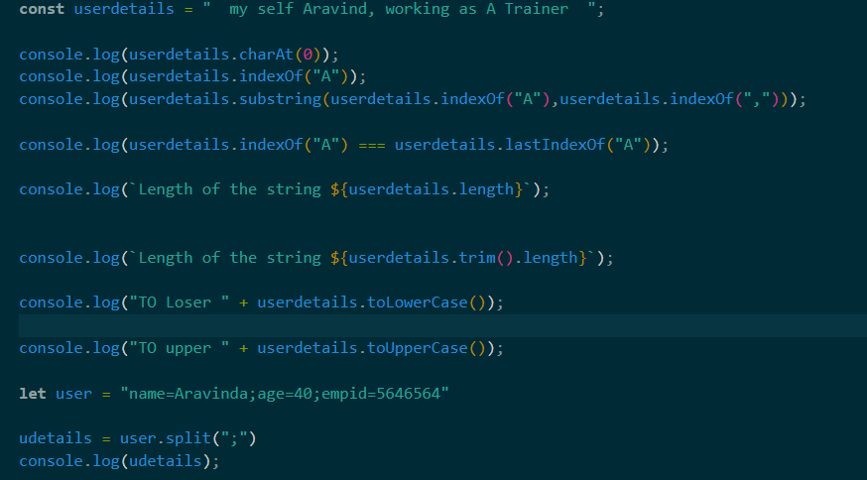

Conditional Statements

* if
* if.. else
* if..elseif..else
* switch
* 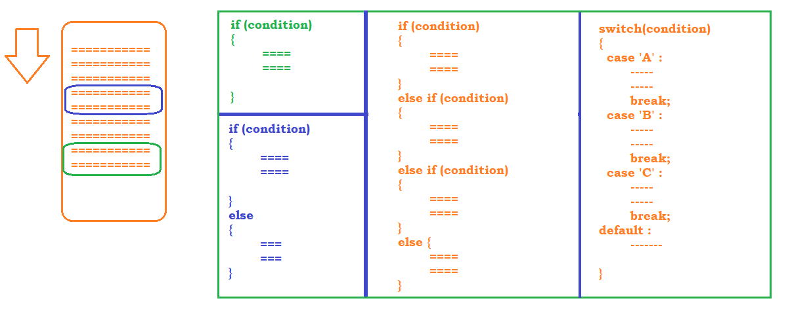

Looping Statements

* for
* for-each
* while
* do-while
* for in
* for of

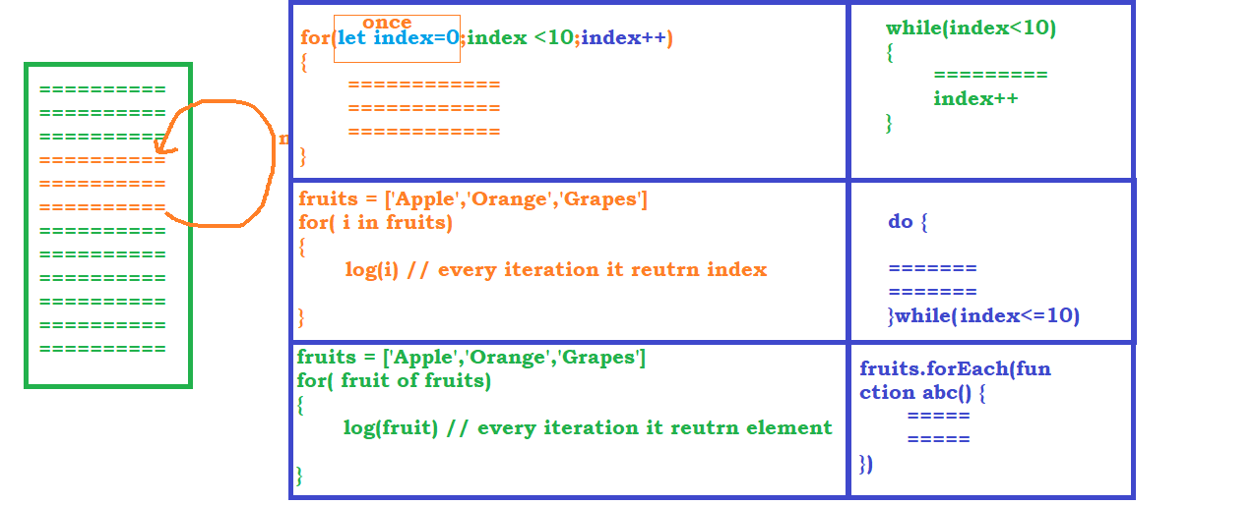

Arrays

* **push** – insert element at the end
* **pop** – delete element at the end
* **shift** – delete element from the beginning
* **unshift** – insert the element at the beginning
* **delete** – remove the element but retain the index
* **slice** - will not alter the original array
* **splice** – will alter the original array
* **concat** – To join one or more array
* **join** – to get string from an array

Functions

* Function with function definition

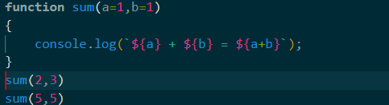

* Function with function Expression OR anonymous function

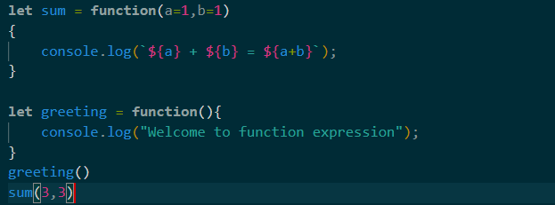

* Arrow functions

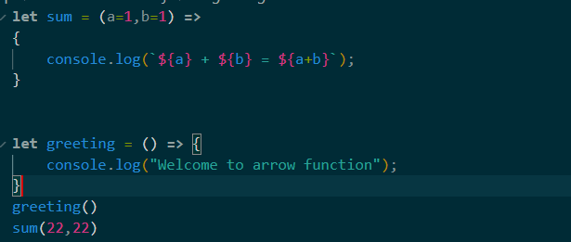

Collections

* Map - Key and Value pair
* Set – To store unique Values

OOP in Java Script

* Class
  + class expression
  + class declaration
* Objects
* Abstraction
* Encapsulation
* Polymorphism
* Inheritance