Why Protractor

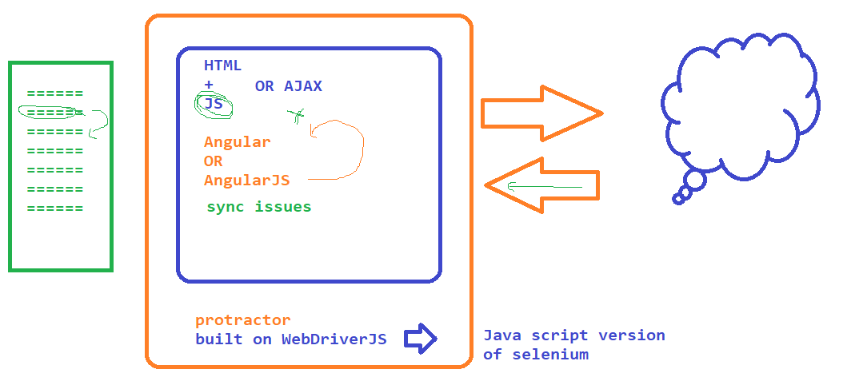

Java Script

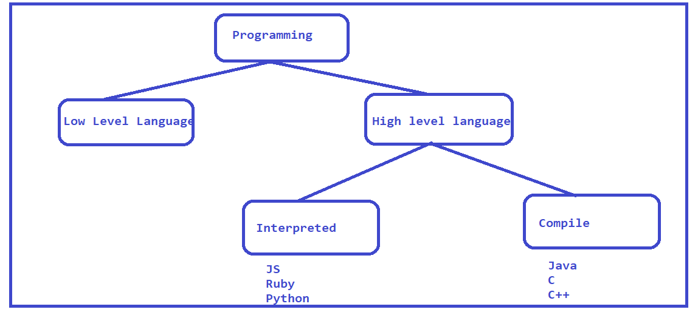

High level Difference

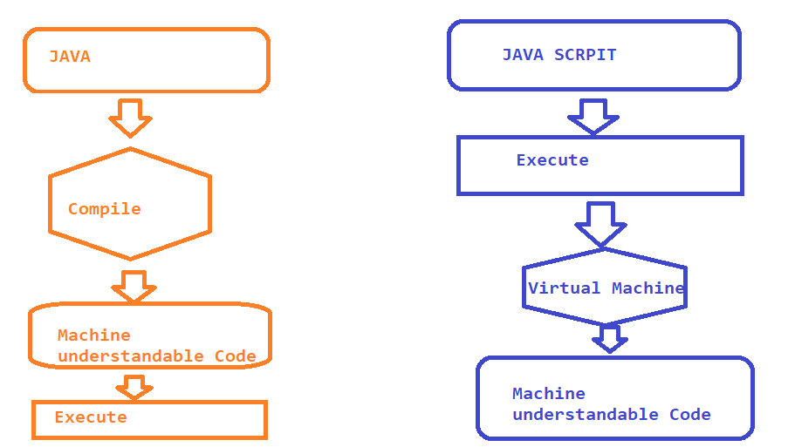

Introduction to JS

* Javascript is a High level and interpreted Programming language
* 1995 JS was first introduced to the market as a programming language for WEB
* from Validations on the WEB
* Java Script can also be used in non-browser environments like Node.js and Adobe etc
* Brenden Eich – 1995 (Natscape Communications Corp)
* JS Engine is required to execute Java script code

Visual Studio code Editor

* <https://code.visualstudio.com/download>
* Follow the instructions to install the software
* Open Visual Studio
* File -> Open Folder and select the folder where you want to store all the files
* Use Extensions option to install the plugin
* 
* 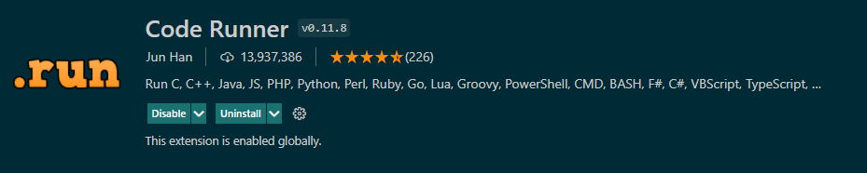
* 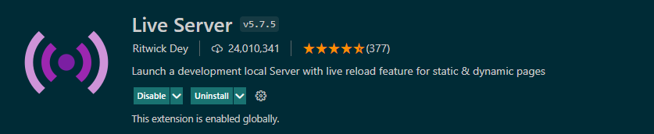

# NOTE : Install Node software on your machine if you want to execute the java script in a non browser environment.

1. Download and install node software - <https://nodejs.org/en/download/>
2. once the installation is done then open terminal
   1. node –v
   2. npm –v

Variables

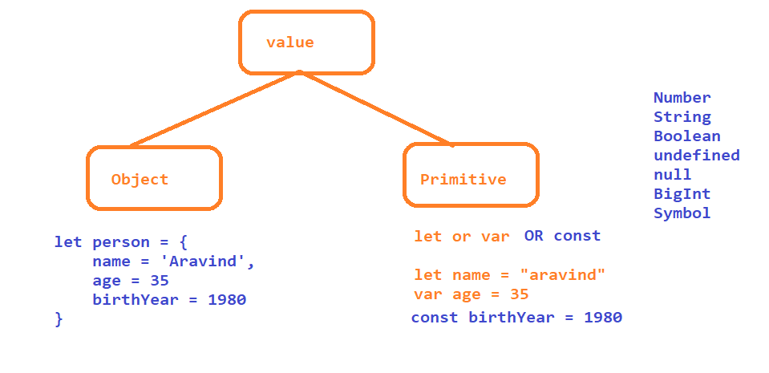

Avoid using VAR as it is old way of declaring a variable

Operators in JS

# Arithmetic Operators

# Addition -> +

# subtraction -> -

# Multiplication -> *

# Division -> /

# Module -> %

# Exponential -> **

# Increment/Decrement-> ++ / --

# Assignment Operators

# Assign = x=y

# Add and Assign += x+=y x= x+y

# Subtract and assign -= x-=y x= x-y

# Multiply and assign *= x*=y x= x*y

# Divide and assign /= x/=y x= x / y

# module and assign %= x%=y x = x %y

# Exponential and assign **= x**=y x= x** y

# Comparison Operator

* 1. Equal Value == x==y
  2. Equal Value and Data Type === x===y
  3. Not Equal Values != x!=y
  4. Not Equal Value and Data Type !== x!==y
  5. Greater than > x>y
  6. Less Than < x <y
  7. Less than or Equal <= x<=y
  8. Greater than or Equal >= x>=y
  9. Ternary Operator ?: (x>y)?”A”:’B’

# Logical Operator

* 1. Logical AND && => Returns true with both are true
  2. Logical OR || => Return true when any op is true
  3. Logical NOT ! => if result true then it returns false

# Type of Operator

* 1. typeOf
  2. instanceOf

Looping and conditional statements

1. if
2. if..else
3. if..elseif.. else
4. switch

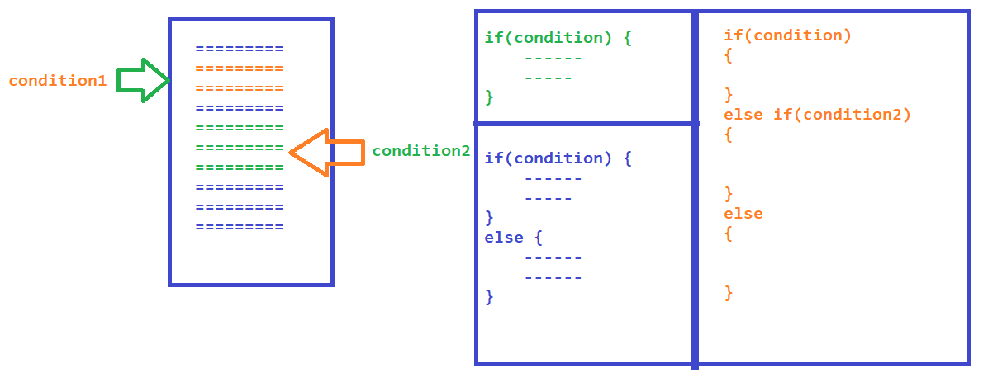

Looping Statements

1. for
2. foreach
3. while
4. dowhile
5. for in
6. for of

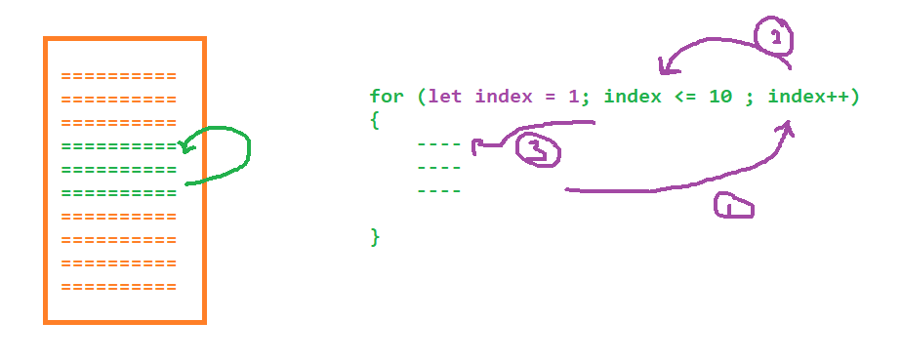

Arrays

to store multiple values in a same variable we can use Arrays

let num = [num1,num2......]

* push – insert the element at the end
* pop - remove the element at the end
* shift
* unshift
* delete
* join
* splice – update the original array
* slice – returns new array, original array is not affected
* indexOf

Functions – reusable entities

# Function with definition

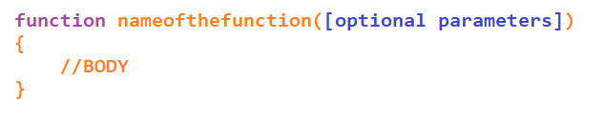

# Function with Expressions or Anonymous Functions

# Arrow Functions

Strings

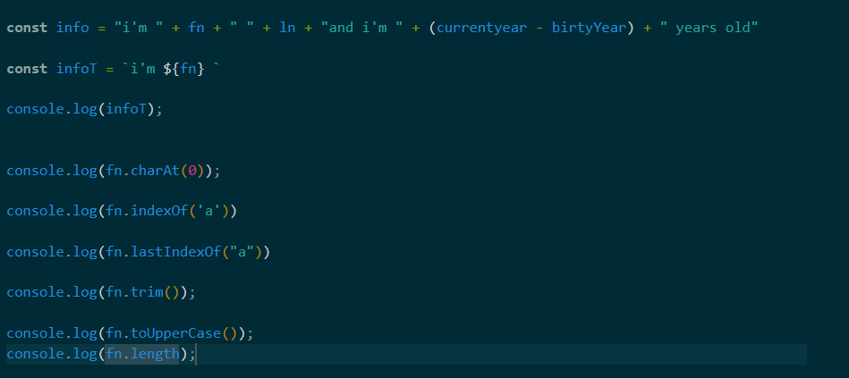

oops

* Class
  + class declaration
  + class expression
* Object
  + functions
  + class
* Prototypes
  + global or class member – not inside object
* Functions
* Inheritance

Collections

MAP - key value pair

SET – unique

Protractor http://www.protractortest.org

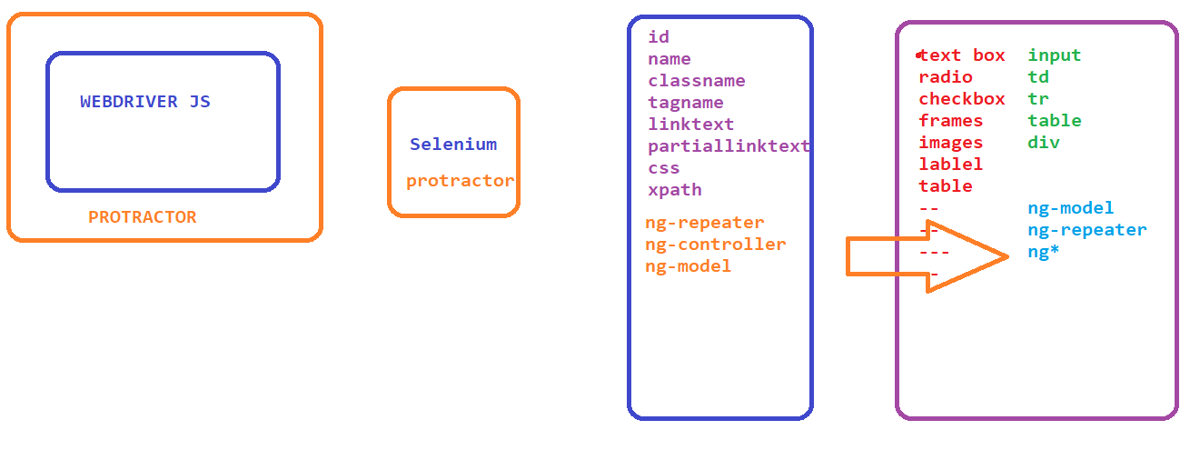

Why protractor:

1. Selenium Webdriver does not have any methods or features to locate the elements specific to angular. to locate angular specific elements easily we have to go with protractor
2. Sync issues can be easily handled in protractor

How protractor works

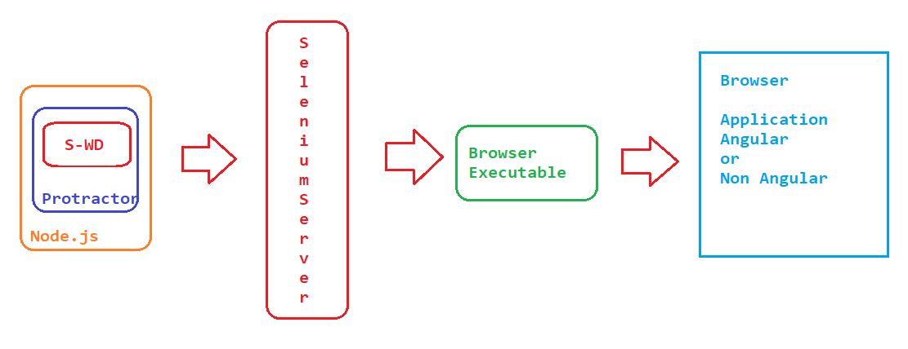

Project Setup

1. Download and install node.js
2. Refer installation steps from official website <http://www.protractortest.org/#/tutorial>
3. Install protractor from
   1. npm install -g protractor
4. Verify the version
   1. protractor –version
5. Update driver executable
   1. webdriver-manager update
   2. C:\Users\Aravind\AppData\Roaming\npm\node_modules\protractor\node_modules\webdriver-manager\selenium
6. To update the specific webDriver version
   1. webdriver-manager update --chrome --versions.chrome=103.0.5060.134
7. If you get any error with respect to Execution policy, execute the below command and continue
   1. Set-ExecutionPolicy -Scope CurrentUser -ExecutionPolicy Unrestricted

Async Nature of JavaScript

execution will not wait until the line of code complete the execution, it will move to next line for execution

TO HANDLE THE ASYNC NATURE WE HAVE TO USE CALL BACK FUNCTION

NOTE: **almost all** the protractor functions are synchronous (execution will not go to next line until it completes the current line execution),

There are functions like gettext getattribure we have to handle async nature

PROMISE :

**Promise** : current state of the step / result of the step

STATE :

pending – still executinig

resolved - pass

rejected – fail

**almost all** the protractor functions are will go to next step when the promise are in resolved or rejected state except for getText or any functions which returns string in application

Plugin





Finding Elements in protractor

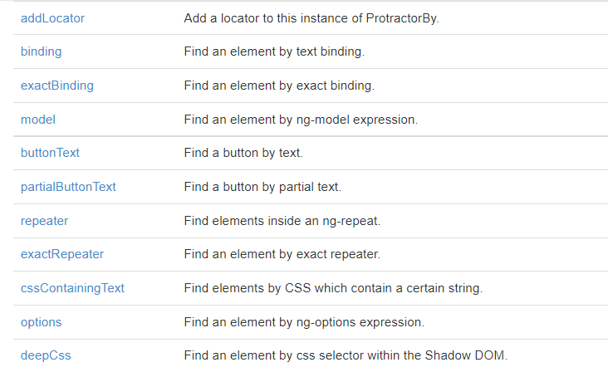

Validation in protractor

using jasmine

Chain locators

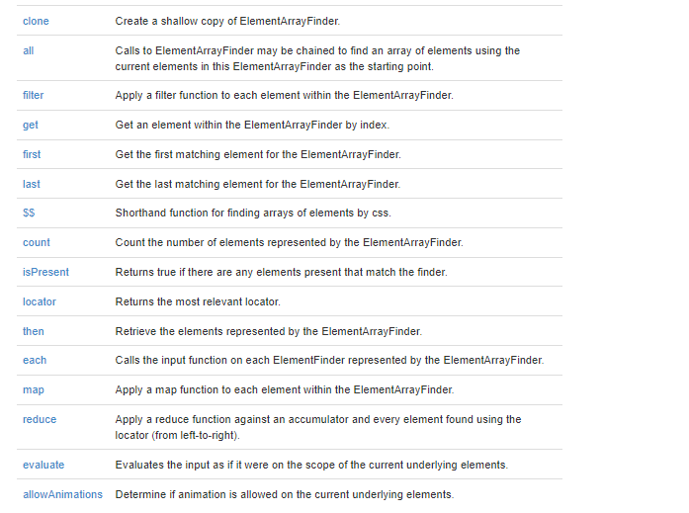

Capture Screen shots on failure

1. Go to npm manager website : <https://www.npmjs.com/>
2. Search for : protractor-jasmine2-screenshot-reporter
3. url : <https://www.npmjs.com/package/protractor-jasmine2-screenshot-reporter>
4. Follow the instructions to install the software
5. Install using - npm i protractor-jasmine2-screenshot-reporter
6. Verify the node module folder to make sure the packages are installed
7. Configure the plugin as per the instructions
8. Execute the tests and verify the screen shots and html report

Allure Reports

1. Go to npm manager website : <https://www.npmjs.com/>
2. Search for : jasmine-allure-reporter
3. url : <https://www.npmjs.com/package/jasmine-allure-reporter>
4. Follow the instructions to install the software
5. Install using - npm i jasmine-allure-reporter
6. Verify the node module folder to make sure the packages are installed
7. Configure the plugin as per the instructions
8. Execute the tests and verify the xml report is generated in allure-results folder
9. To get the HTML report install allure-commandline
10. url : <https://www.npmjs.com/package/allure-commandline>
11. install : npm i allure-commandline
12. Verify the node module folder to make sure the packages are installed
13. Execute allure serve “location of the xml file”