Aravinda: +91-9945045204

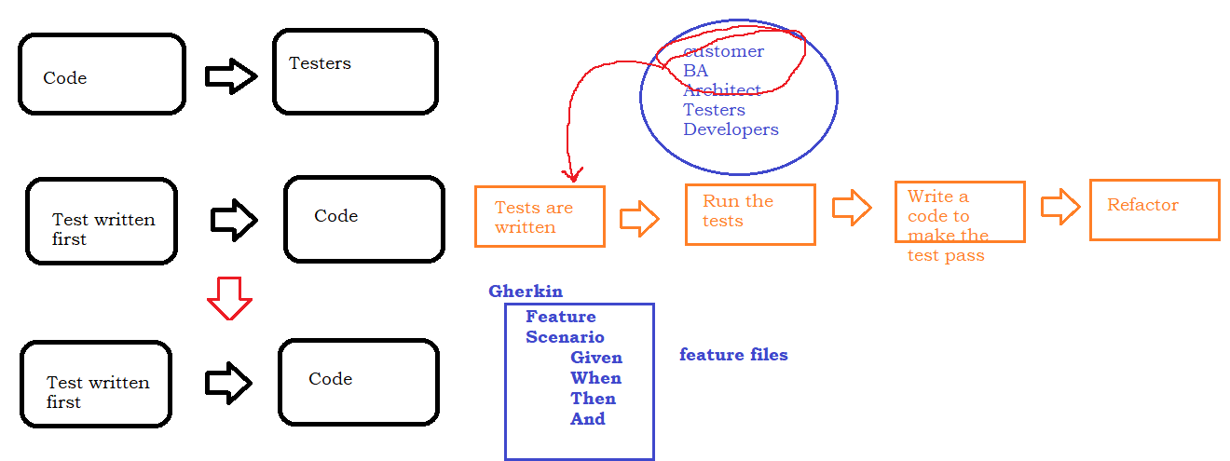

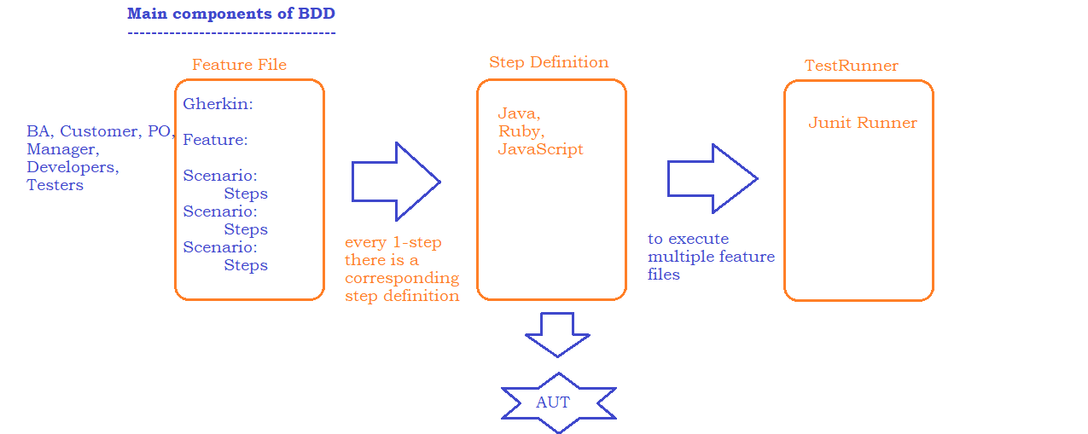

Sample Feature File :

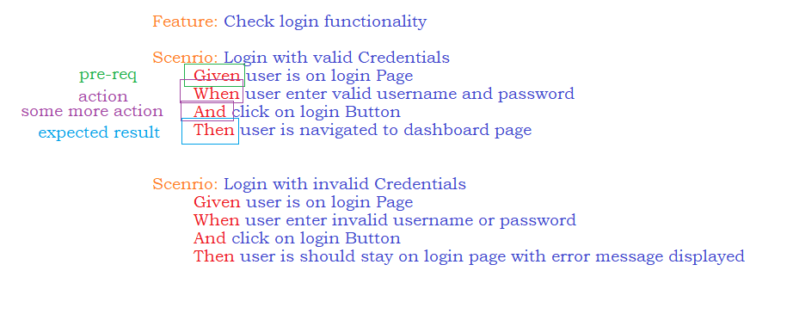

Create a Project :

1. Open Eclipse and click on create maven project
   * Change Compiler from 1.5 to the installed version
   * Change JRE from 1.5 to JRE Present inside jdk
2. Add Dependencies
   * cucumber-java
   * cucumber-junit
   * junit
3. create a feature folder src/test/java
4. Install Cucumber plug-in from Eclipse marketplace
   * Help-> Eclipse MarketPlace -> search for
5. Create a sample feature file and Run the feature file ( Rightclick on file🡪 RunAs🡪 cucumber feature )
6. Copy the missing step definitions and add it in a Step definitions Class
7. Implement all the steps

Data Driven Testing :

