**Java ->**

*- Class - > Blueprint of an Object, members ( variables, methods, constructors, SIB, IIB)*

* *Strict typeCaste => data type*
* 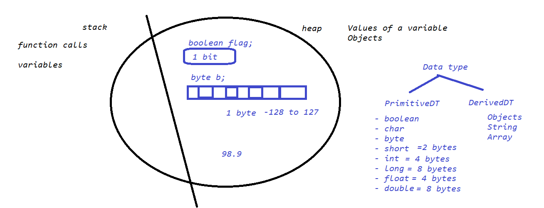

*- Variables*

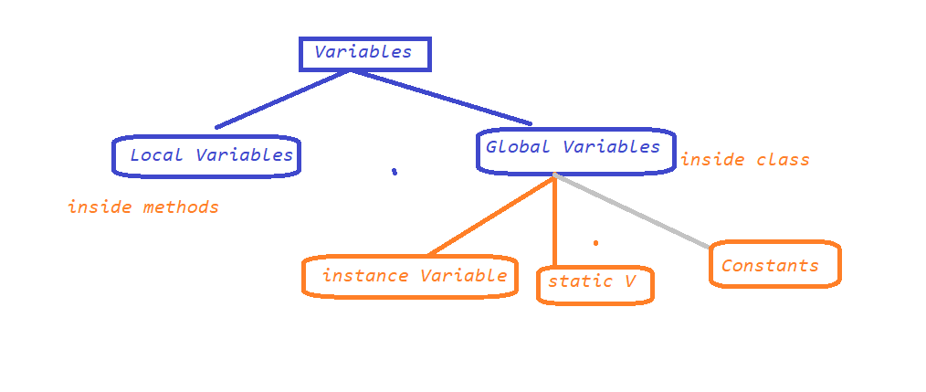

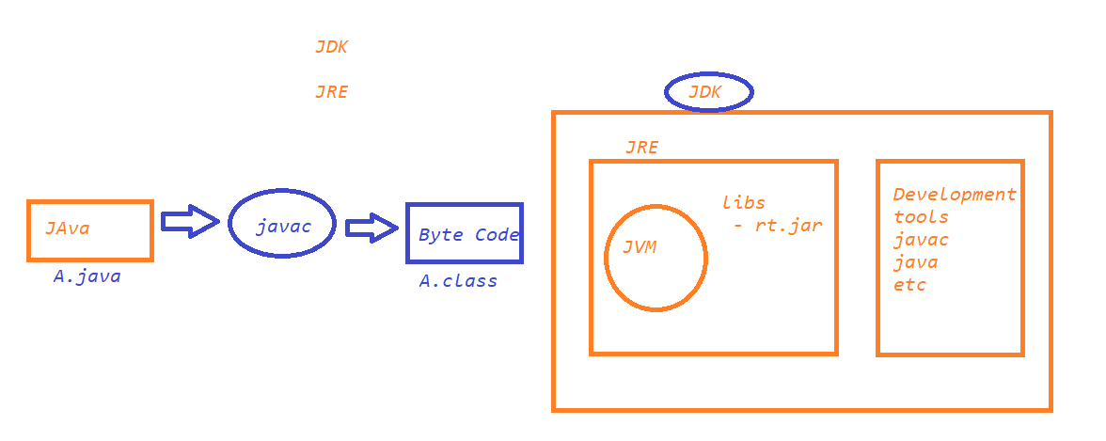

*MAVEN –*

* *Build Tool*
* *Create a maven project*
  + *Change the compiler to the latest installed version*
  + *Change JRE*

*- methods / Functions => reusable entities, which describes the Behaviour*

*[Access specifiers] [Access modifiers] return_type name([argument list])*

*{*

*}*

*NOTE – Object is the super class*

*Polymorphism :*

*1. Overloading*

*sum(int a, int b)*

*sum(int a, int b, int c)*

*2. Overriding*

*ACCESS SPECIFIER (Only to global variables or methods )*

*1. private*

*2. default*

*3. protected*

*4. public*

*ACCESS MODIFIERS (NON FUCTIONAL ACCESS SPECIFIERS)*

*1. static – variables, methods*

*2. final – variables, methods, class*

*3. abstract – methods, class, interfaces*

*4. synchronized (Threads) – methods*

*LOOPING AND CONDITIONAL STATEMENTS IN JAVA*

*for*

*while*

*do,while*

*foreach / enhanced for loop*

*Conditional Statements*

*if*

*if,else*

*if,elseif, else....*

*switch()*

*String – java.lang*

* *charAt(index)*
* *indexOf(char)*
* *lastIndexOf(char)*
* *split(regExp)*
* *contains()*
* *equals()*
* *equalsIgnoreCase()*
* *toUpperCase()*
* *toLowerCase()*
* *length()*
* *replace()*
* *replaceAll()*
* *concat()*
* *StringBuffer or StringBuilder*
  + *reverse()*
  + *insert*
  + *capacity()*
  + *delete(fromIndex, toIndex)*

*- File Handling*

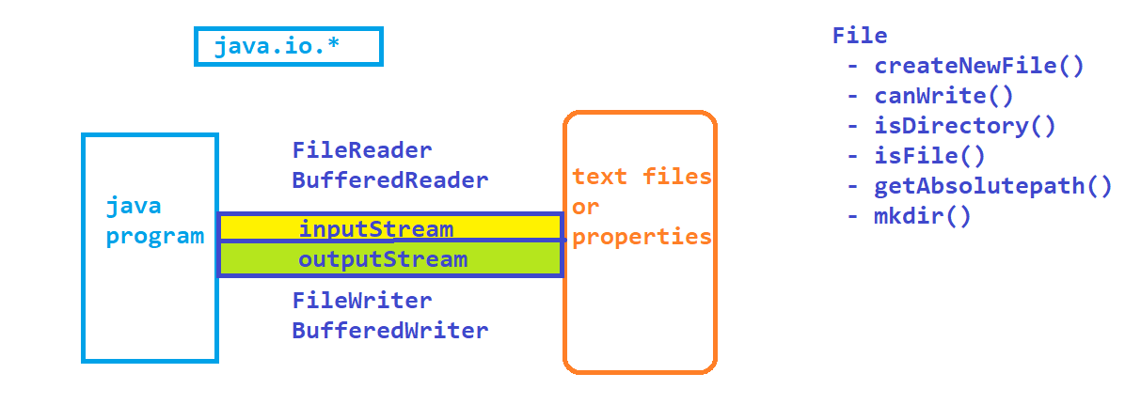

*- Exception Handling techniques*

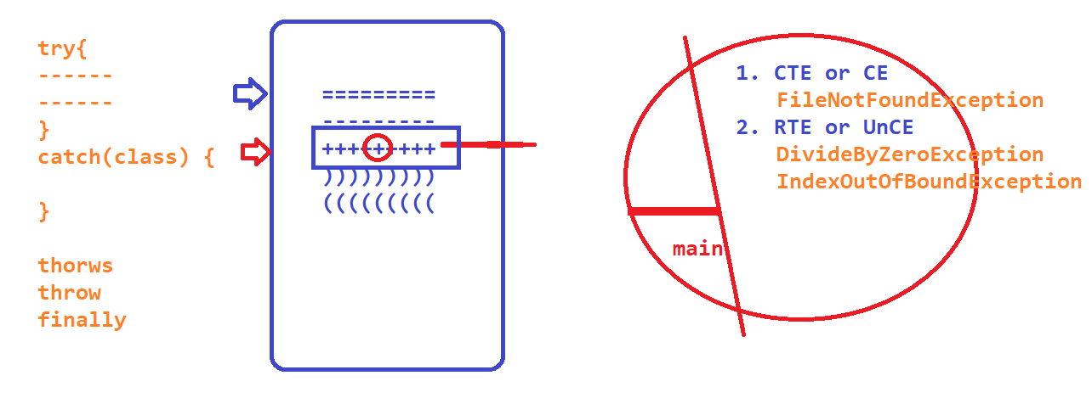

*- Collections*

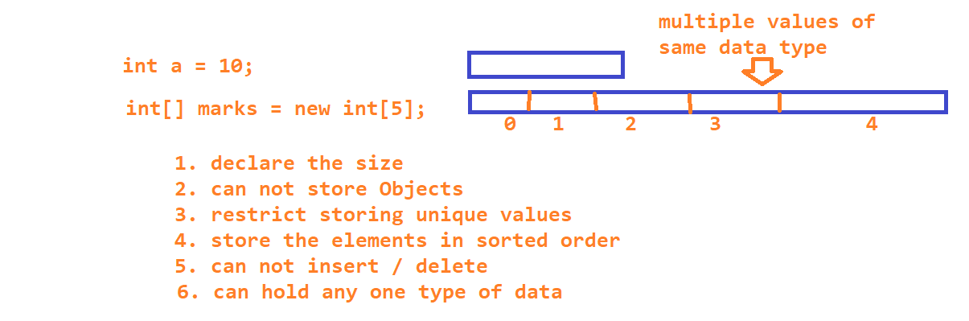

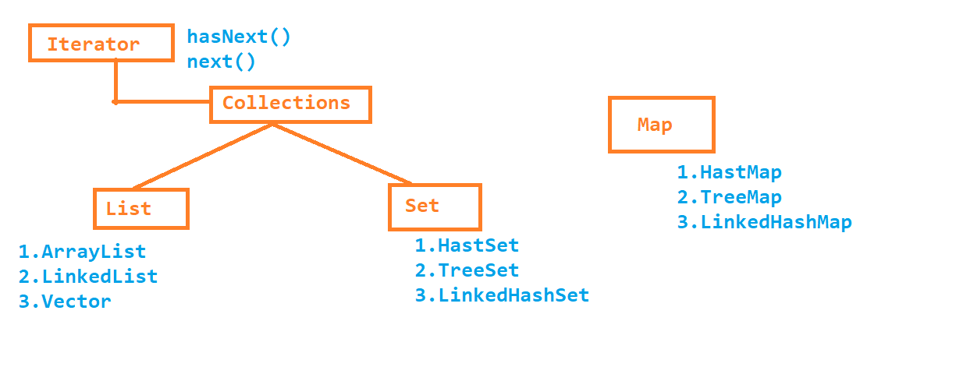

**Selenium ->**

**-** Free software,

- Multiple PL – java, c#, ruby, perl, python, php, js

- Almost all popular browsers – ie,edge,chrome,ff,opera,safari.

- No Dedicated machine is required

- Parallel Execution

- Distributed Execution

- Identification

* id
* name
* classname
* tagname
* linktext
* partiallinktext
* css
* xpath
* 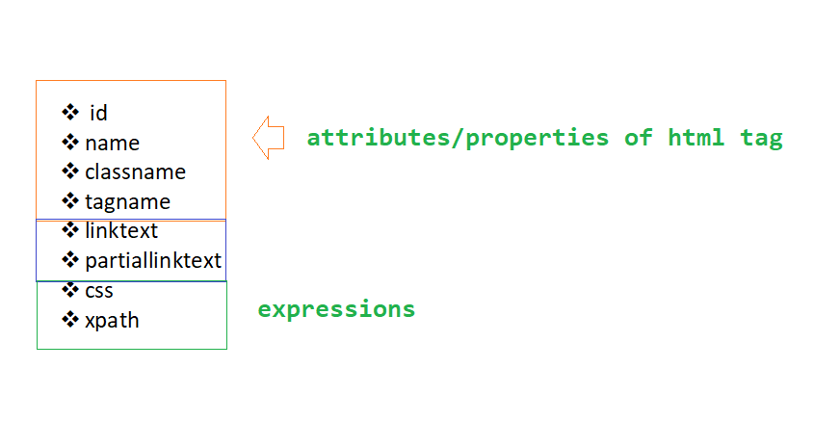
* **Xpath-**
* **----------------------------**

**1. Basic //htmltag[@propertyname='value']**

**2. Logical Operators (and or not)**

**3. functions (text(), contains(arg1,arg2), starts-with(arg1,arg2))**

**4. Parent to child**

**//xpath_parent//xpath_for_child_element**

**5. child to parent(web tables or dependent and independent elements)**

**//child_tag[parent_xpath]**

**6.Axes Functions**

**-----------------**

**- following**

**- preceding**

**- following-sibling**

**- preceding-sibling**

**- parent**

**- child**

**- ancestor**

Examples –

**//htmltag**

**//htmltag[@attribute='value']**

**//a[@title='Eclipse Packages'] - https://www.eclipse.org/downloads/packages/**

Logical operator **- //td[(@class='current day' or @class='wd day' or @class='we day') and text()='2'] - https://www.redbus.in/**

**//htmltag[text()='complete text']**

**//a[text()='Eclipse Packages']**

**//htmltag[contains(arg1,arg2)]**

**->arg1 --> attribute / function**

**->arg2 --> partial text**

**//img[contains(@src,'timer')] ##actitime application**

**//label[contains(text(),'Keep')] ##actitime application**

**//span[starts-with(text(),'iPad')] ##https://www.gsmarena.com/apple-phones-48.php**

**//span[starts-with(text(),'Galaxy Note')]**

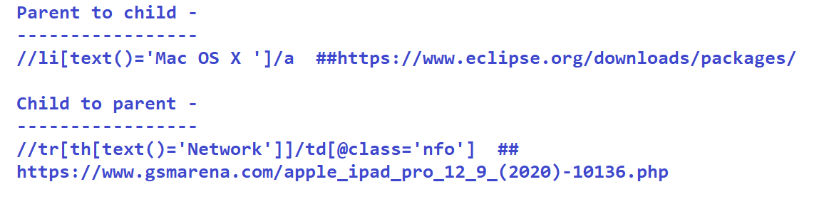

//tr[th[text()='Network']]/td[@class='nfo'] ## https://www.gsmarena.com/apple_ipad_pro_12_9_(2020)-10136.php

//tr[th[text()='Produced by']]/td - ##https://en.wikipedia.org/wiki/V_(film)

## https://www.makemytrip.com/flight/search?itinerary=DEL-BLR-16/09/2020&tripType=O&paxType=A-1_C-0_I-0&intl=false&cabinClass=E

//div[div[div[p[text()='UK-819']]]]//span[@class='actual-price']

//div[div[div[p[text()='6E-2297']]]]//span[@class='actual-price']

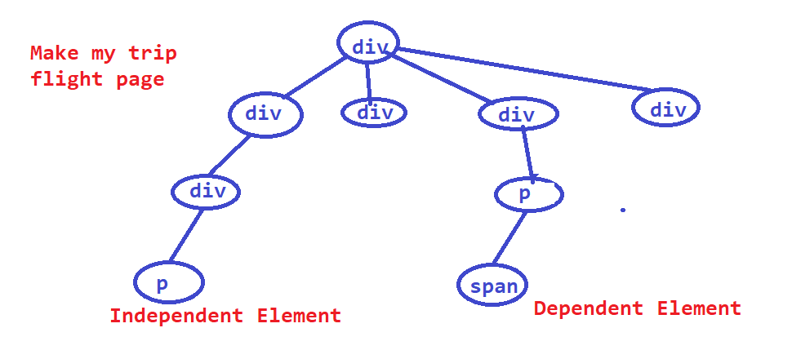

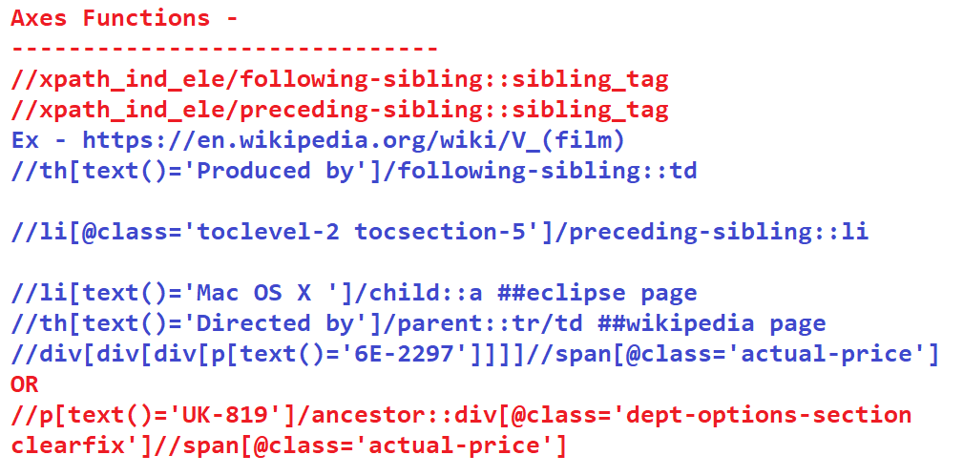

Architecture

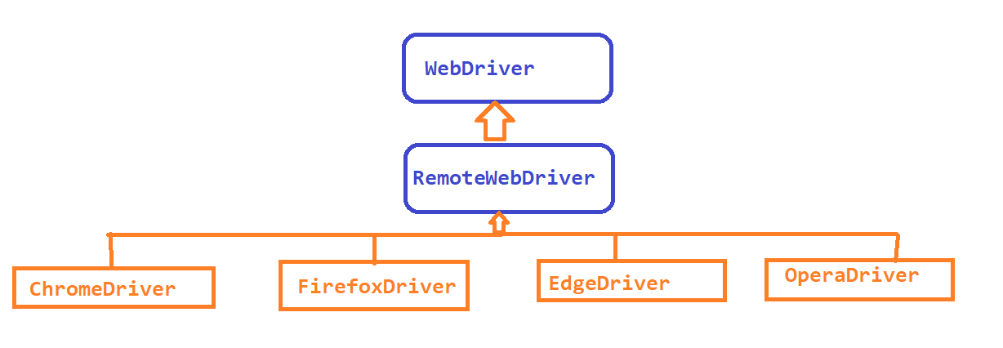

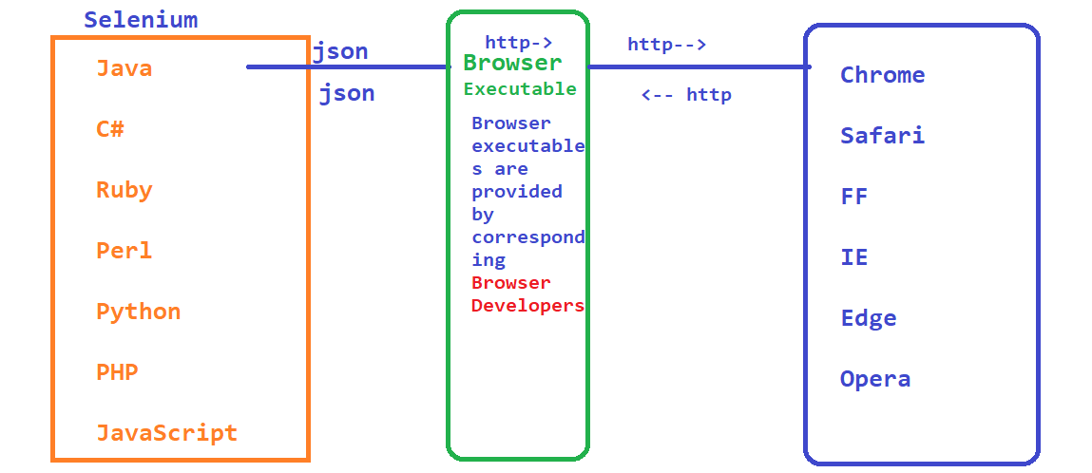

WebDriver –

- get(string) 🡺void

- getCurrentUrl()

- findElement(By)🡪 WebElement

- findElements(By)🡪 List<WebElement>

- manage().window().

- manage().navigate().back() / forward() / refresh()

Sync Issue or Synchronization issue

findElement(By)🡪 default wait time is 0 sec or 250 ms

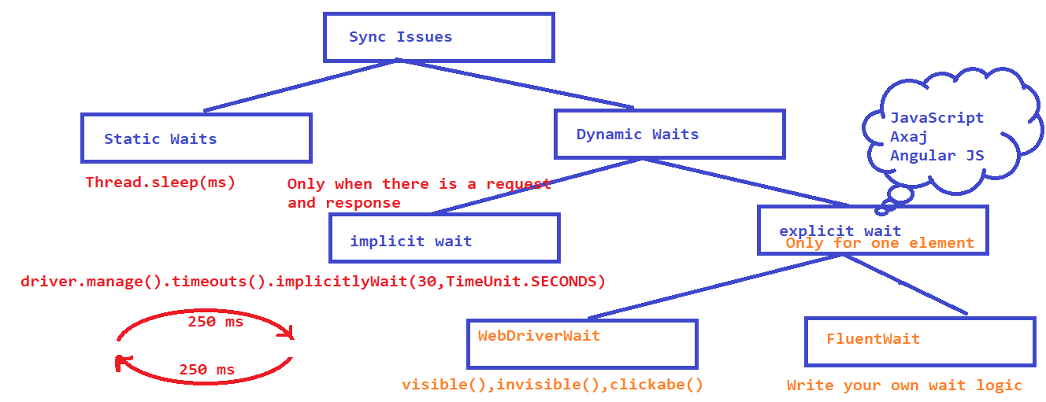

- Dropdowns,

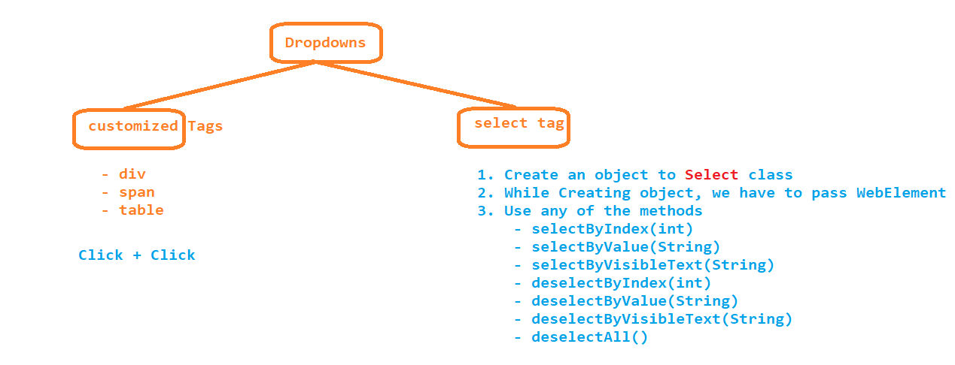

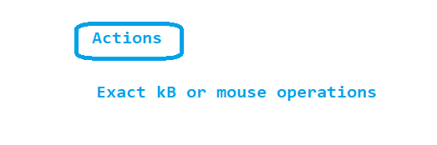

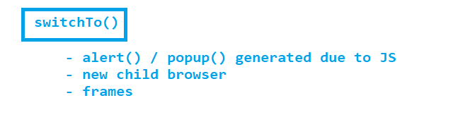

- popup

- Hidden division popup -> normal selenium code

*- Authentication popup*

*- file download popup*

*- file upload popup*

*AUTOIT or SIKULI*

*BDD – approach or a framework,*

*Using BDD –*

* *Web Automation*
* *Mobile Automation*
* *API*
* *Unit Tests*

*Testers*

*Developers*

*BA (SRS)*

*Customers*

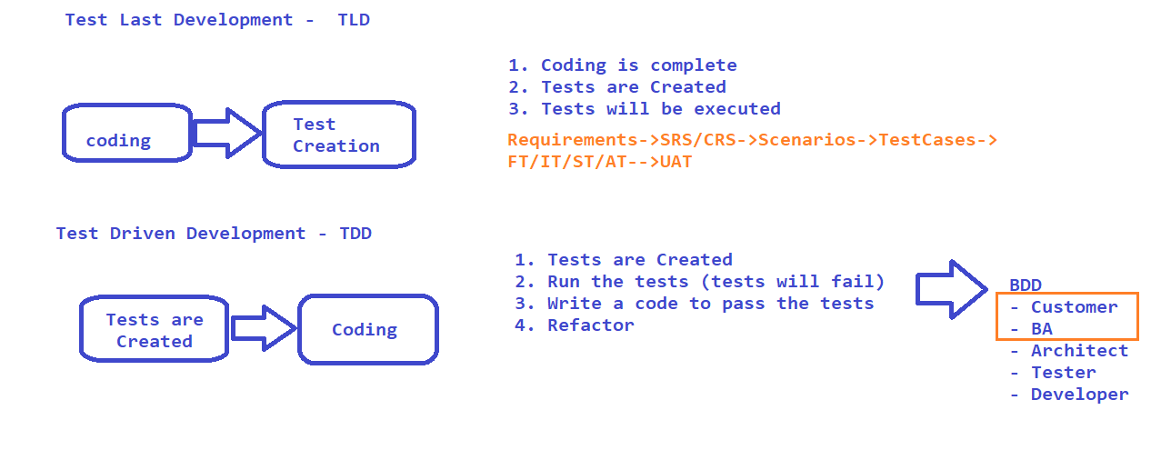

*Main Components of BDD –*

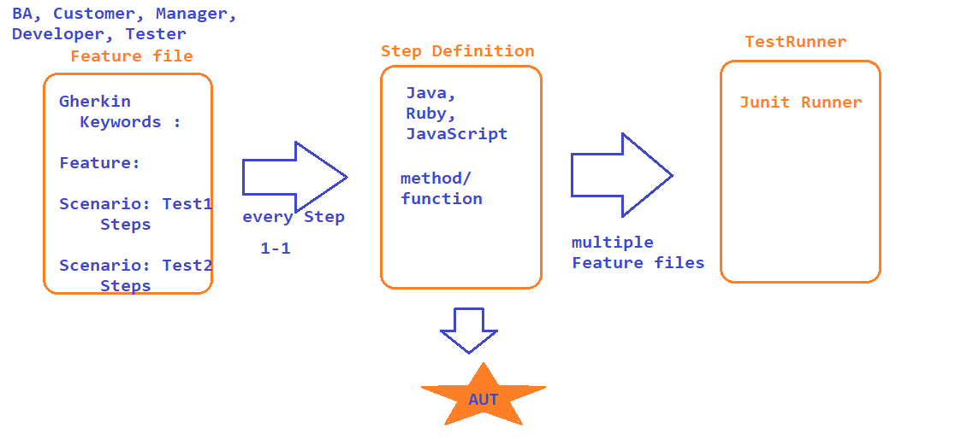

*Sample Feature file*

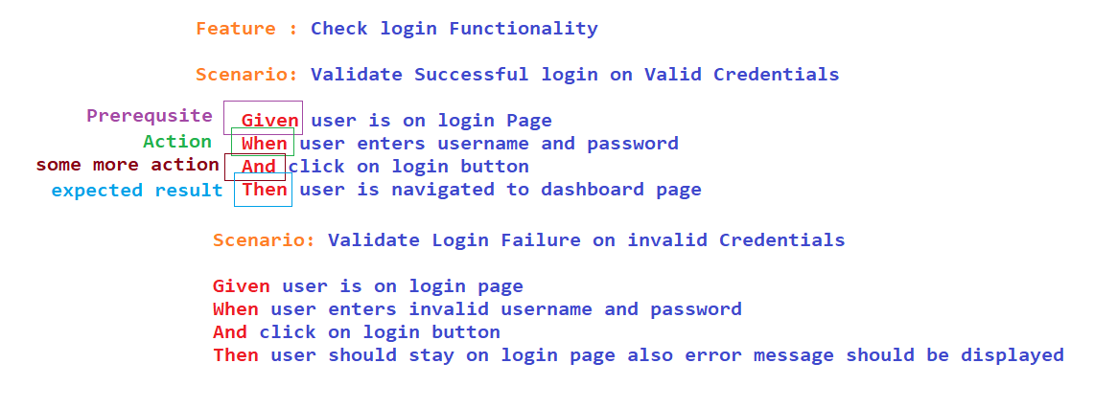

*Creating a Project end to end*

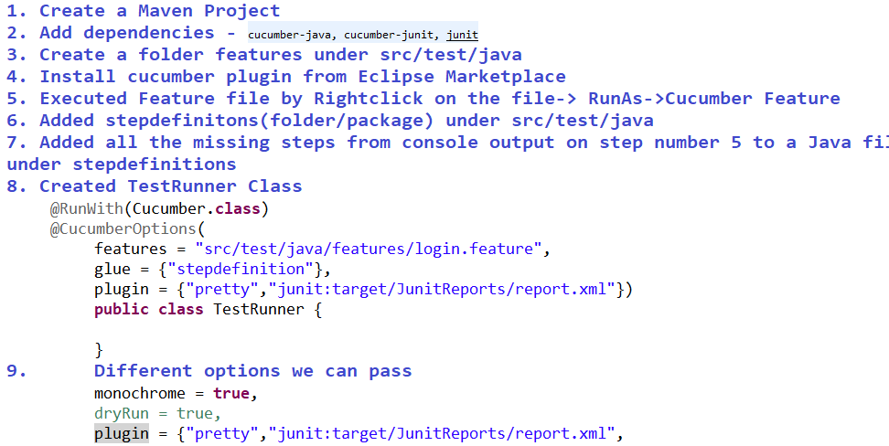

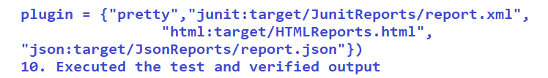

*DataDriven Testing :*

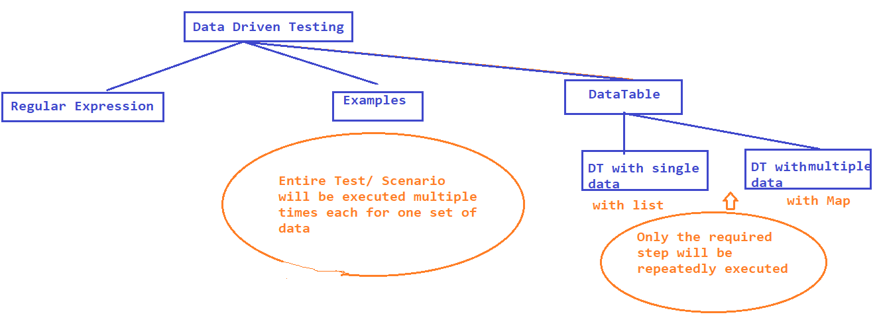

*1. Using Regular Expression in Step definition*

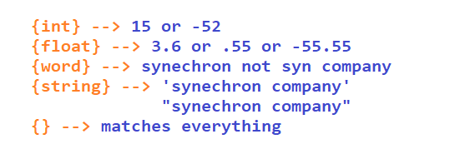

*2.* ***Optional text*** *-> use (char or string) which will be optional in step definition*

*3.* ***Alternative Text*** *-> use (text1/text2), and can be used to have a common step definition for multiple step declaration*

*4.* ***escaping*** *in scenario step -> \\ for escaping any predefined char usage ex-> () or {}*

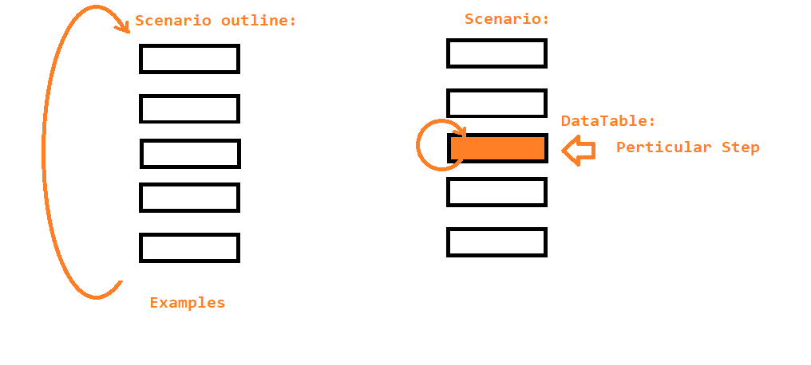

*Assignments -*

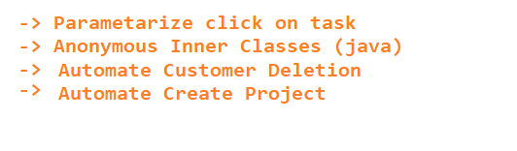

*Difference between Examples and Data table*

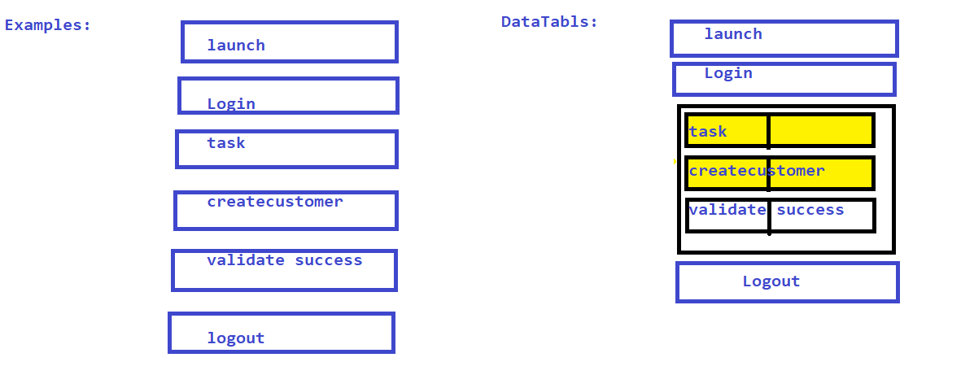

*FluentWait*

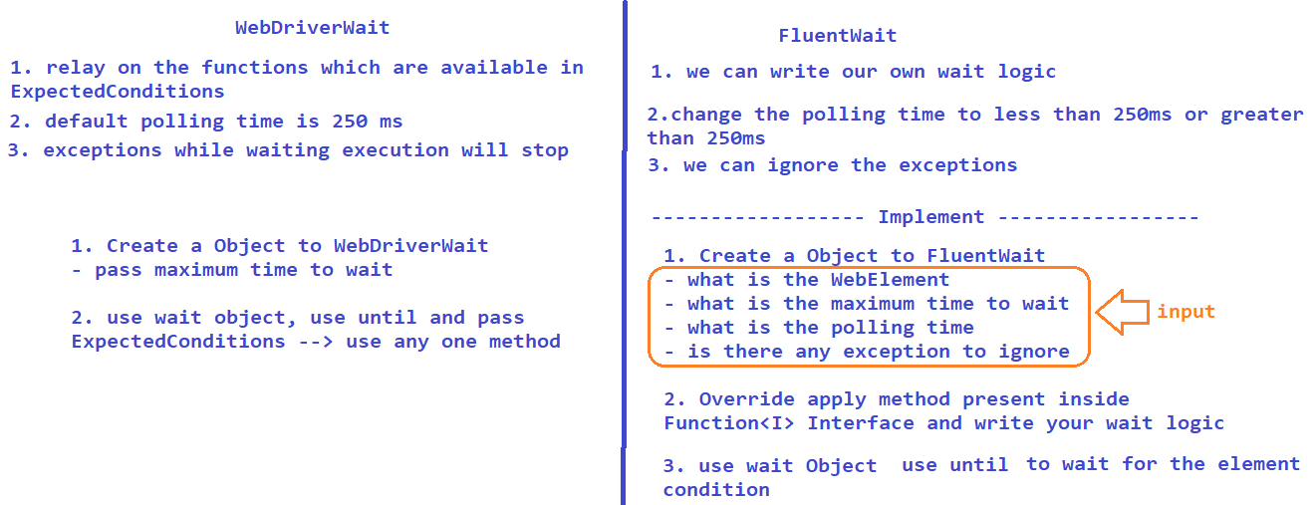

*Tags :*

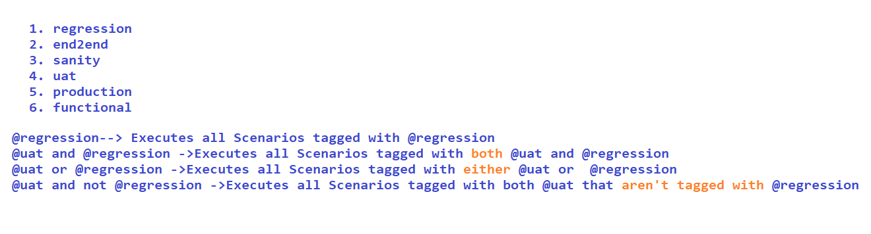

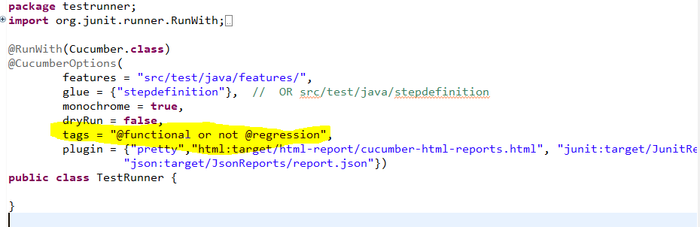

*BackGround in BDD:*

*It is a precondition to the Scenario / Test we write in feature file ex – launch, login, is a common step for all the scenarios. instead of keeping it in all scenario we can move it to Background.*

*Hooks:*

* *similar to Background but here it is for all the feature file and all scenarios*
* *you can execute pre and post condition to a test / Scenario*
* *Only developer(who developed) will know about hooks execution because in feature file there is no clue . to overcome this drawback we have to put a comment section in feature file*
* *@Before*
* *@After*
* *@BeforeStep //in the upcoming releases we may use this*
* *@AfterStep //in the upcoming releases we may use this*

*Page Object Model in BDDCucumber*

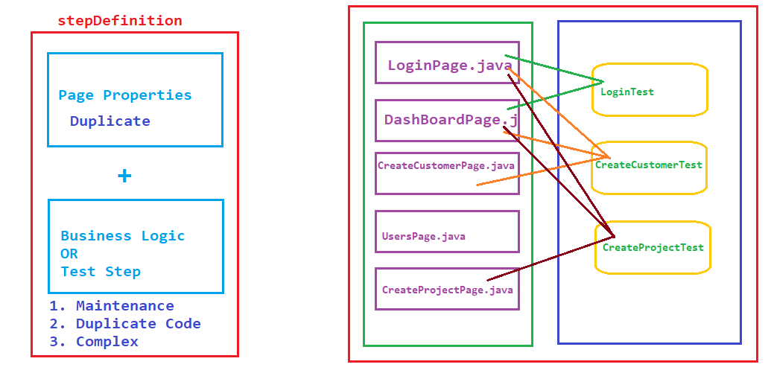

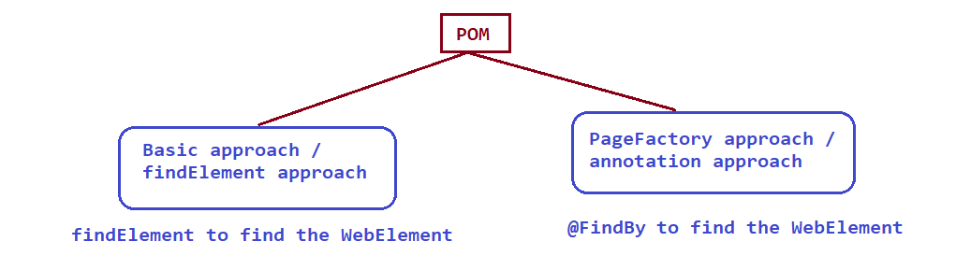

*Assignments –*

* *Jenkins setup ->* [*https://www.jenkins.io/*](https://www.jenkins.io/)
* *goto manage-jenkins*
* 