+91-9945042504

[aru03.info@gmail.com](mailto:aru03.info@gmail.com)

***Xpath***

* Basic
* Logical Operators
  + and
  + or
  + not
* Functions
  + text()
  + contains(arg1, arg2)
  + starts-with(arg1, arg2)
* Traverse from parent to child
* Traverse from child to parent
* Axes Functions
  + following
  + preceding
  + following-sibling
  + preceding-sibling
  + parent
  + child
  + ancestor

BDD

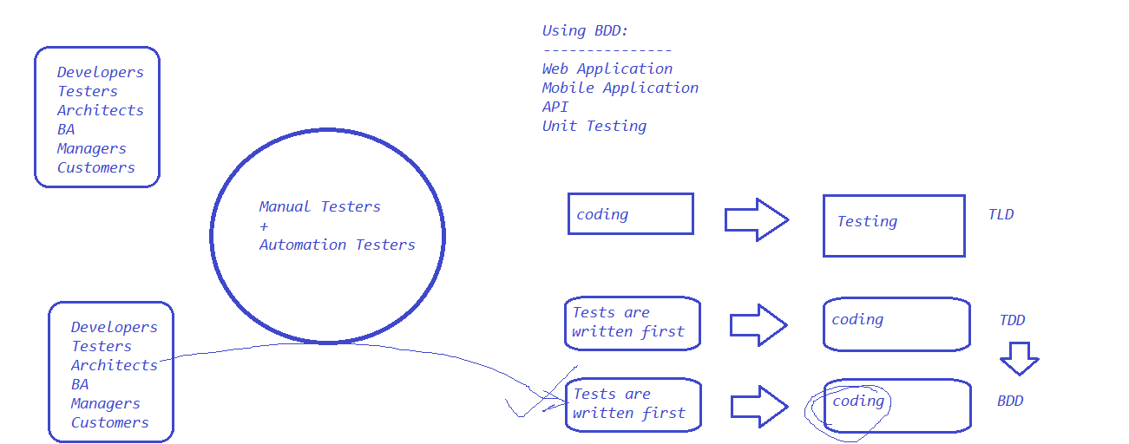

Architecture

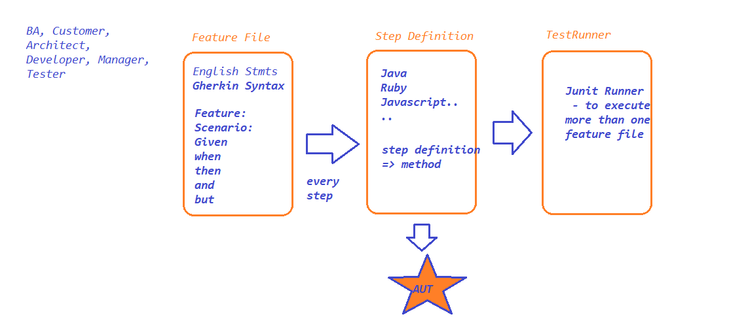

Sample Feature file:

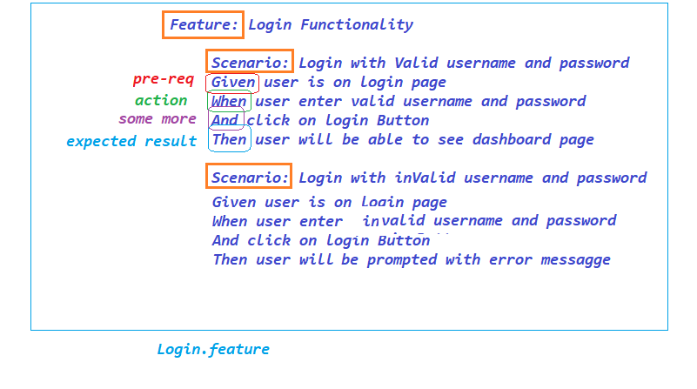

Data driven testing

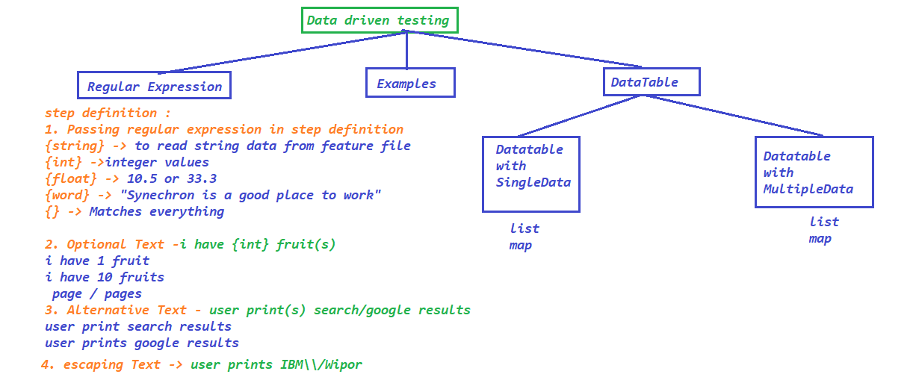

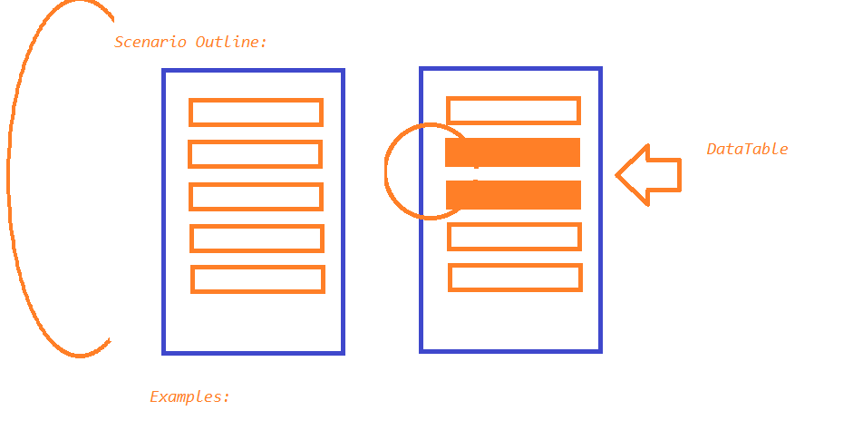

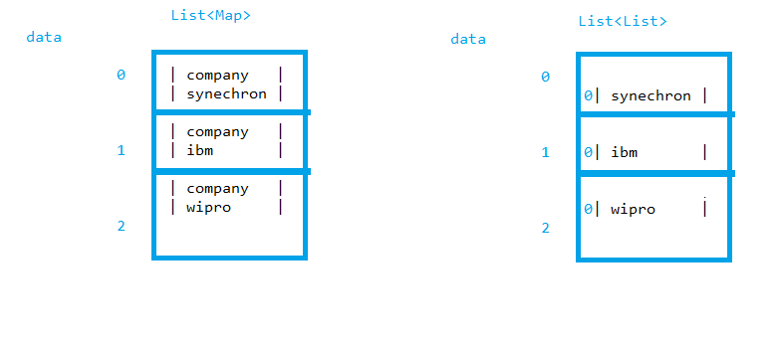

TAGS

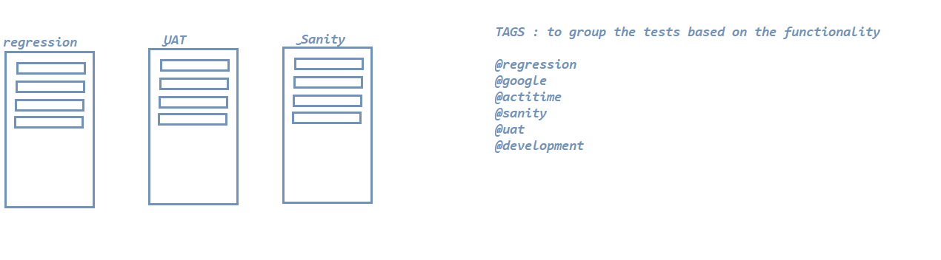

Background:

