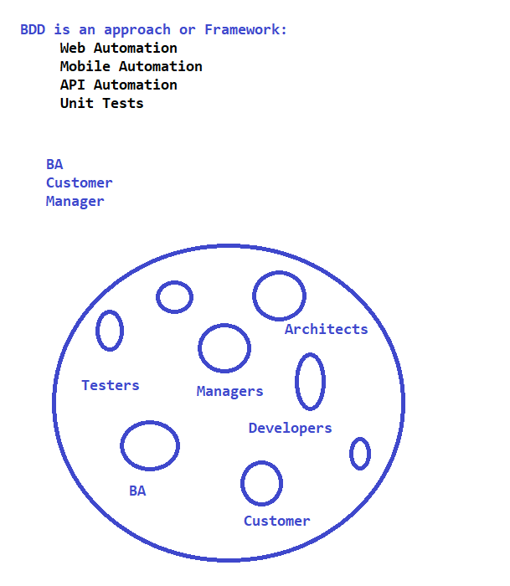

**Development Approach :**

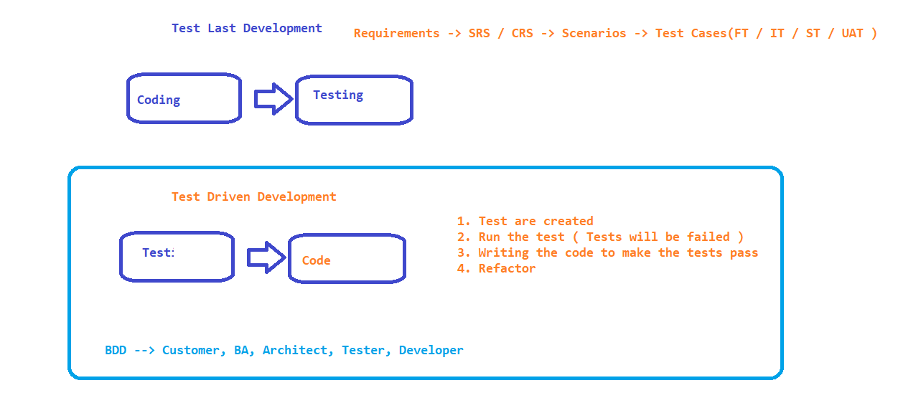

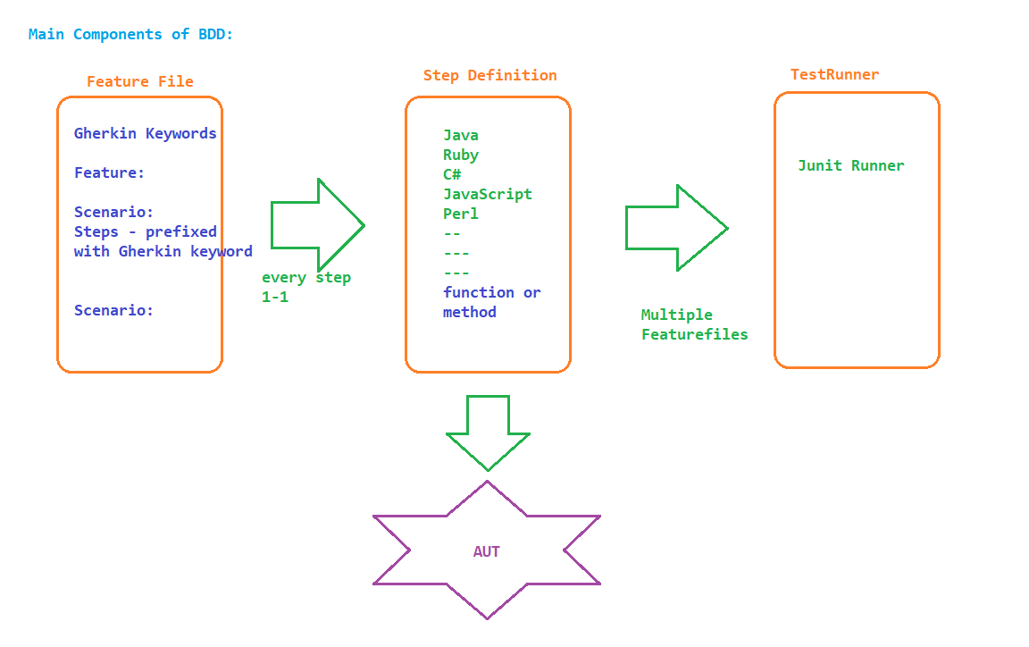

Sample Feature File :

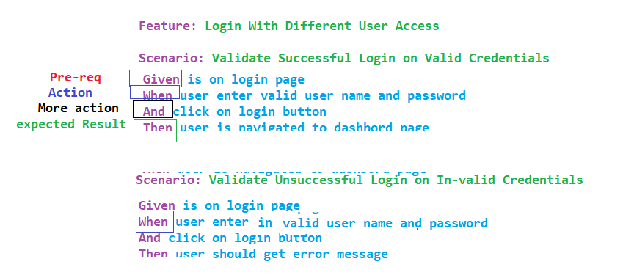

**Installation of MAVEN :**

1. Download the latest zip file from <https://maven.apache.org/download.cgi>

2. unzip the downloaded zip ex: D:\maven

3. Update the Environment variables

MAVEN_HOME - D:\maven\apache-maven-3.6.1

M2 - D:\maven\apache-maven-3.6.1\bin

PATH - D:\maven\apache-maven-3.6.1\bin

4. command prompt – mvn –v

**Eclipse Project Creation:**

1. File -> Create new Maven Project
2. select maven-archetype-quickstart
3. provide groupid
4. provide artifactid
5. click on Finish
6. Update JDK to the latest
   1. Update JDK Version

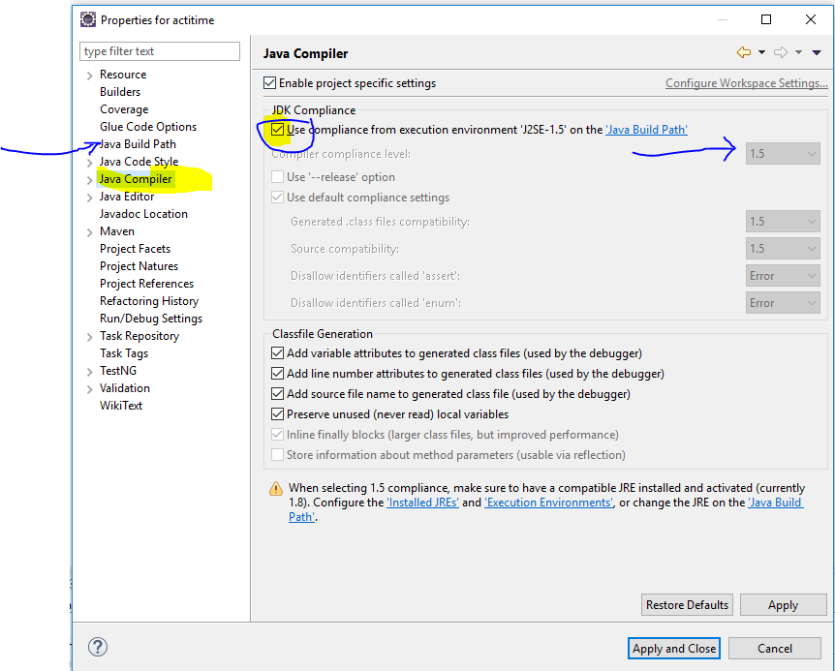

1. Update JRE to the latest
   1. Remove the old JRE

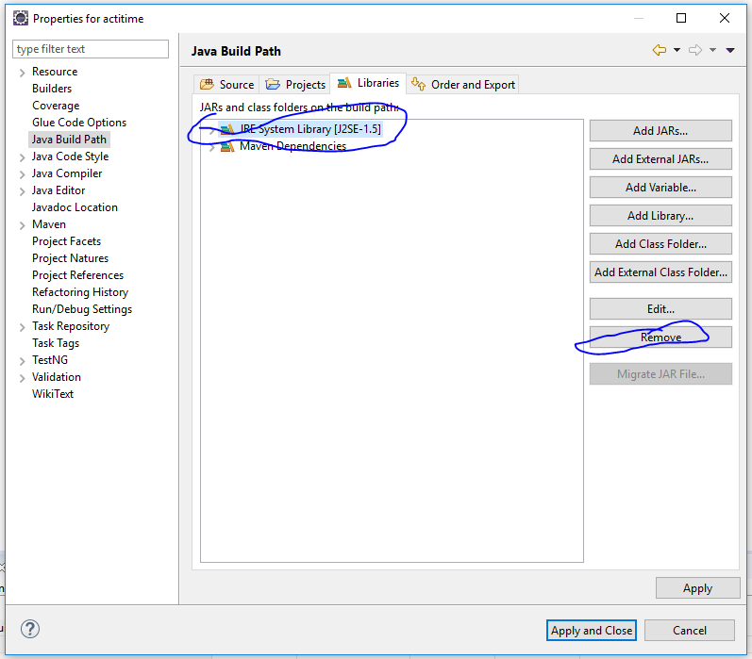

* 1. ADD JRE from the JDK Location
  2. Add library -> JRE System Library 🡪 Alternate JRE Radio button and Click on installed JREs
  3. Browse and select the JRE from JDK Folder
  4. Click on apply and finish

1. Update POM.xml with dependencies
   1. cucumber-java
   2. cucumber-junit
   3. junit
2. Install Cucumber plugin

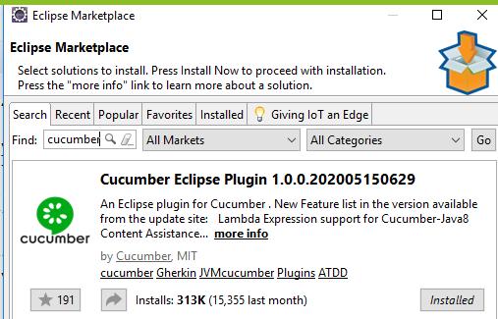

1. Write your first Feature file -> file -> new -> file -> filename.feature
2. Right click on the feature file-> run-> Run configuration -> select cucumber plugin and run the file
3. Console displays the missing steps , create a java file under stepdefinition(new package ) and paste the missing steps
4. update pom.xml with selenium-java and Webdriver manager libraries
5. Write the code
6. Run the test ☺

Maven Architecture :

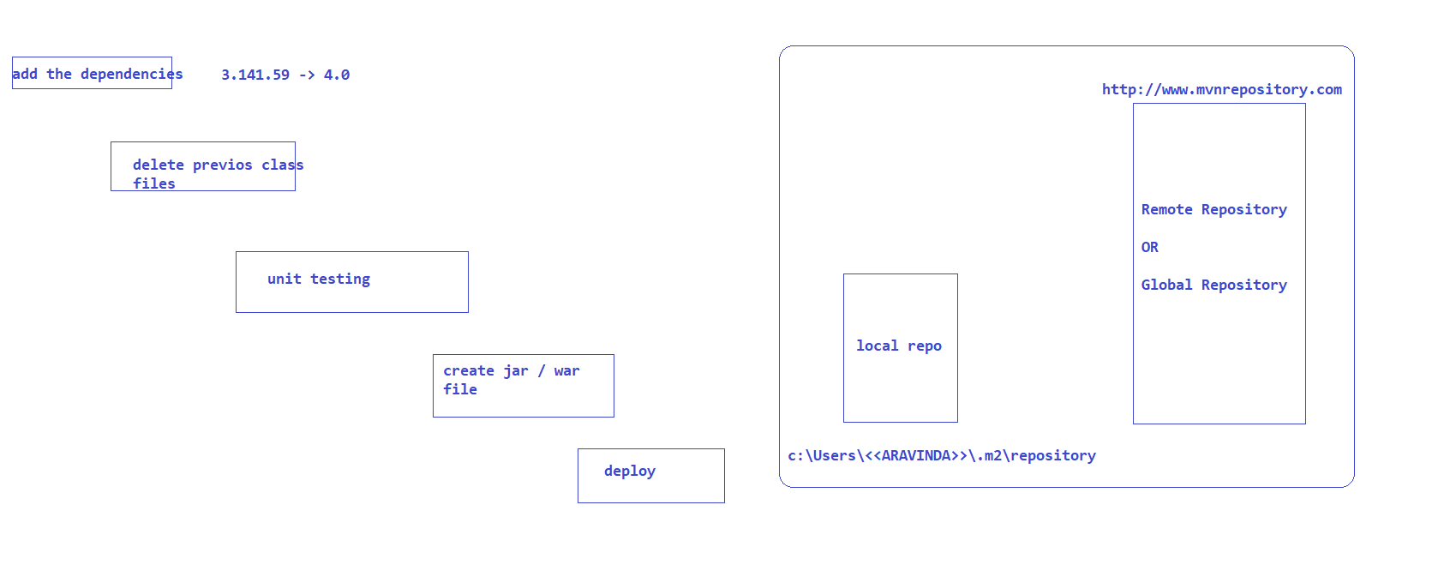

Test Runner File :

Empty java file with 2 annotations to execute the feature files

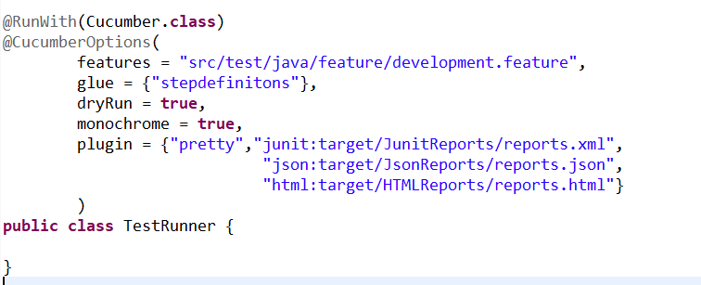

features 🡪 feature file to be executed

glue 🡪 location of step definitions

dryRun🡪 optional by default it is false, to verify 1-1 mapping we can use this

monochrome 🡪 to remove the junk text displayed in console set it to true, by default it is false

plugin 🡪 to get the reports

DataDriven Testing:

Regular Expressions :

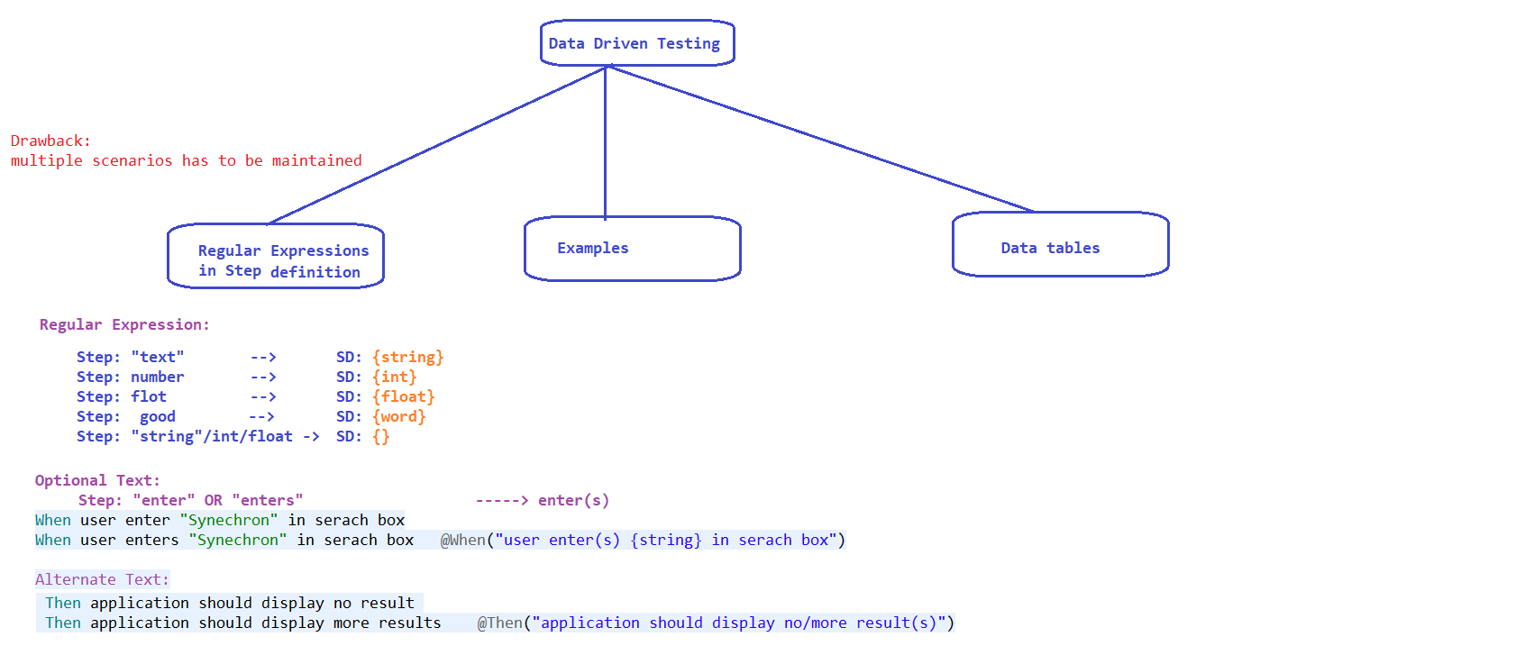

Examples:

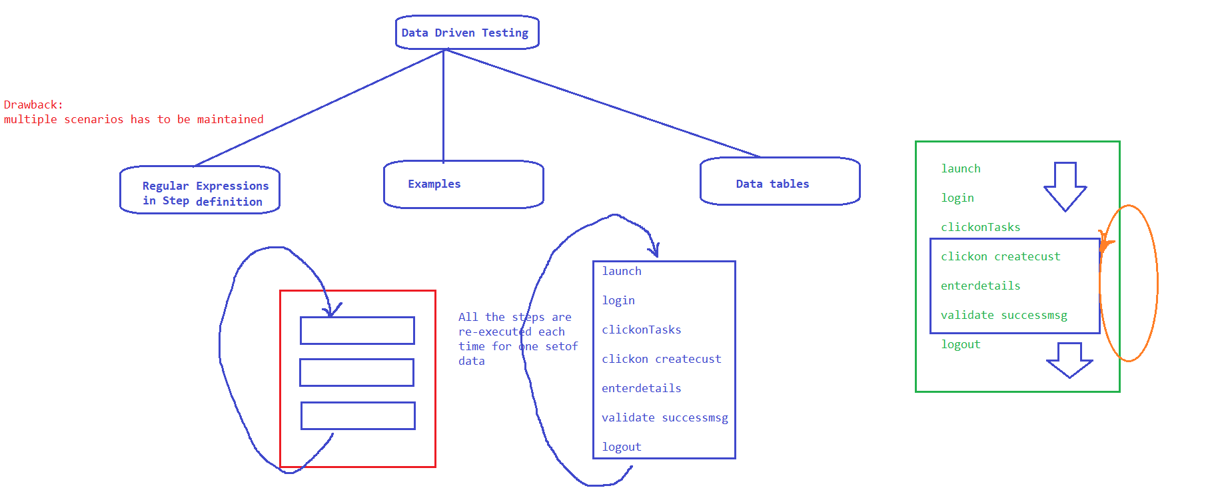

Data tables :

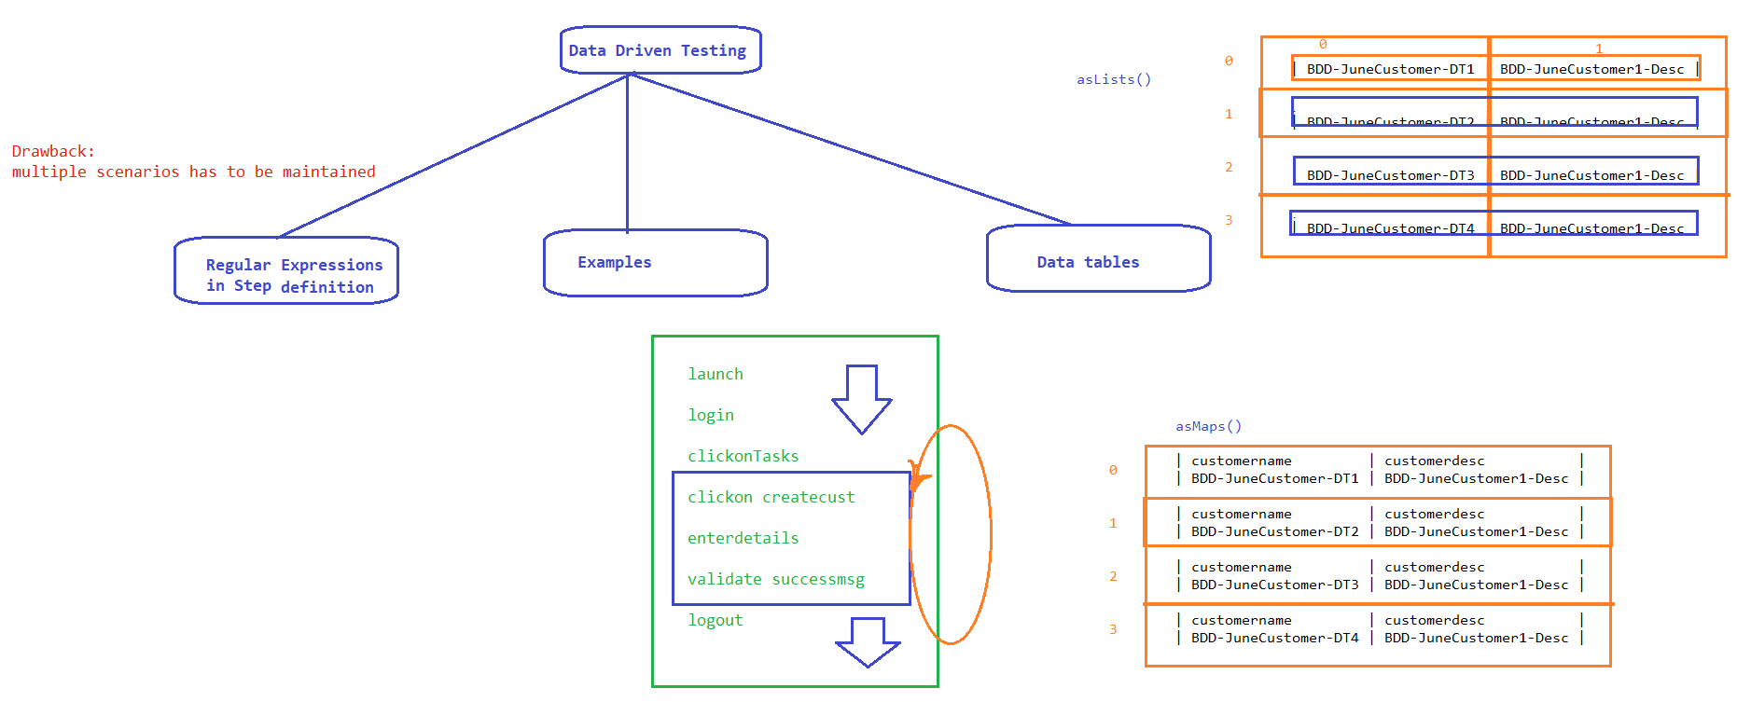

TAGS: - To group the tests based functionality or execution

* regression
* end2end
* uat
* production
* smoke
* sanity

Use tags attribute in cucumber Options

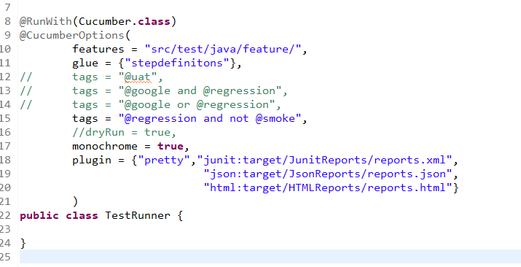

BackGroud:

Preconditions to the Scenario , before executing the scenario our background will be executed!!!

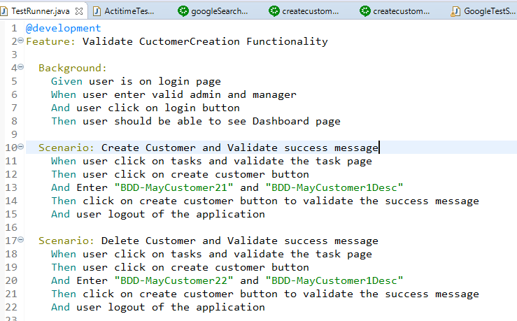

Hooks :

@before

* create a driver
* launch application
* DB connection
* Enabling cookies or proxy settings

@after

* Logout
* closing browser
* close DB connection
* reset all the settings

Tagged Hooks :

@before(“@regression”)

public void launch()

{

}

Order of execution of hooks:

@before(order=1)

@after(order=2)

Hooks on Steps:

@BeforeStep

@AfterStep

**Conditional hooks**

@before(“@regression and @google”)

POM

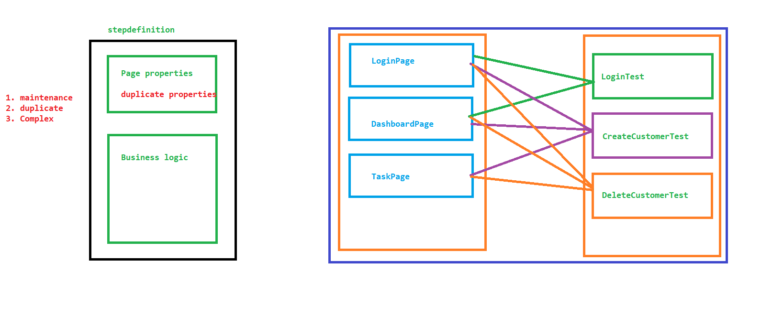

POM Using Page Factory Methodology :