Protractor :

* Tool / Framework which is built on top of WebDriverJS ( Javascript version of Selenium )
* Angular and non-angular application can be automated using protractor
* 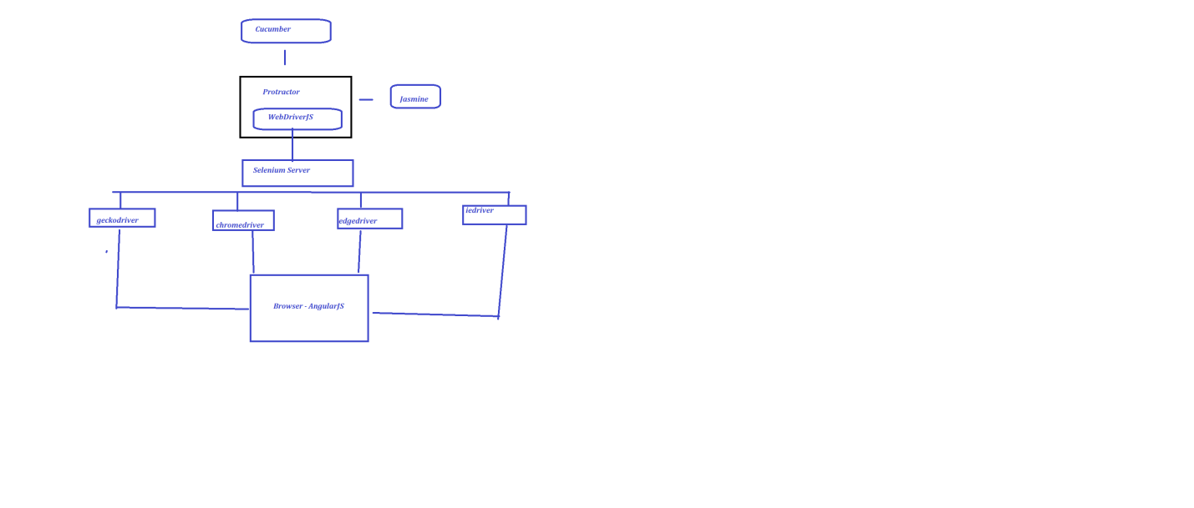

AngularJS

JAVASCRIPT :

Javascript is a high-level and interpreted programming language

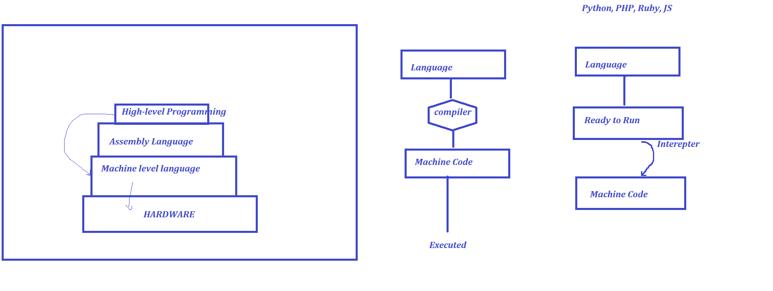

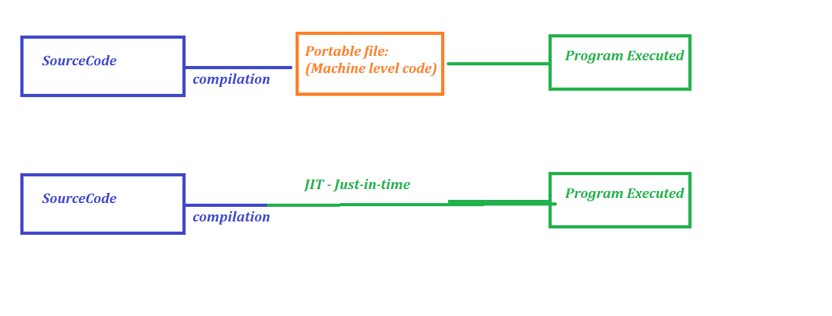

JS Engine

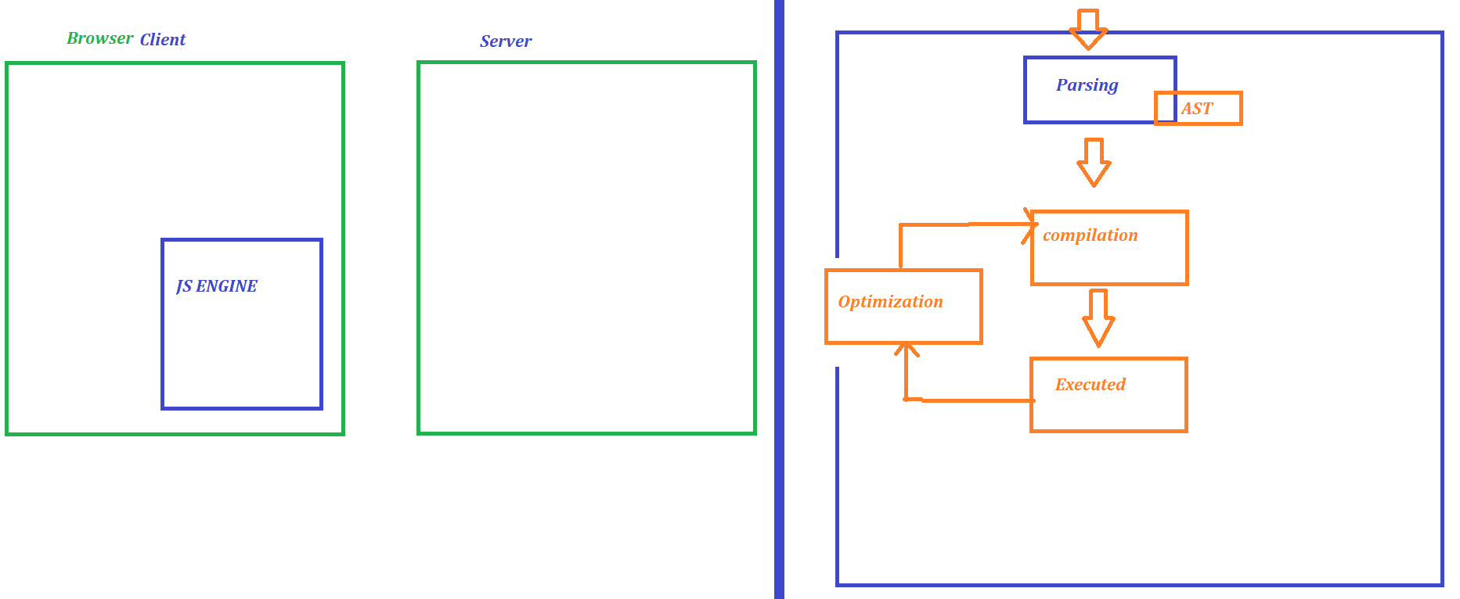

Editor :

Visual Studio code

* Data types Variables and comments
* 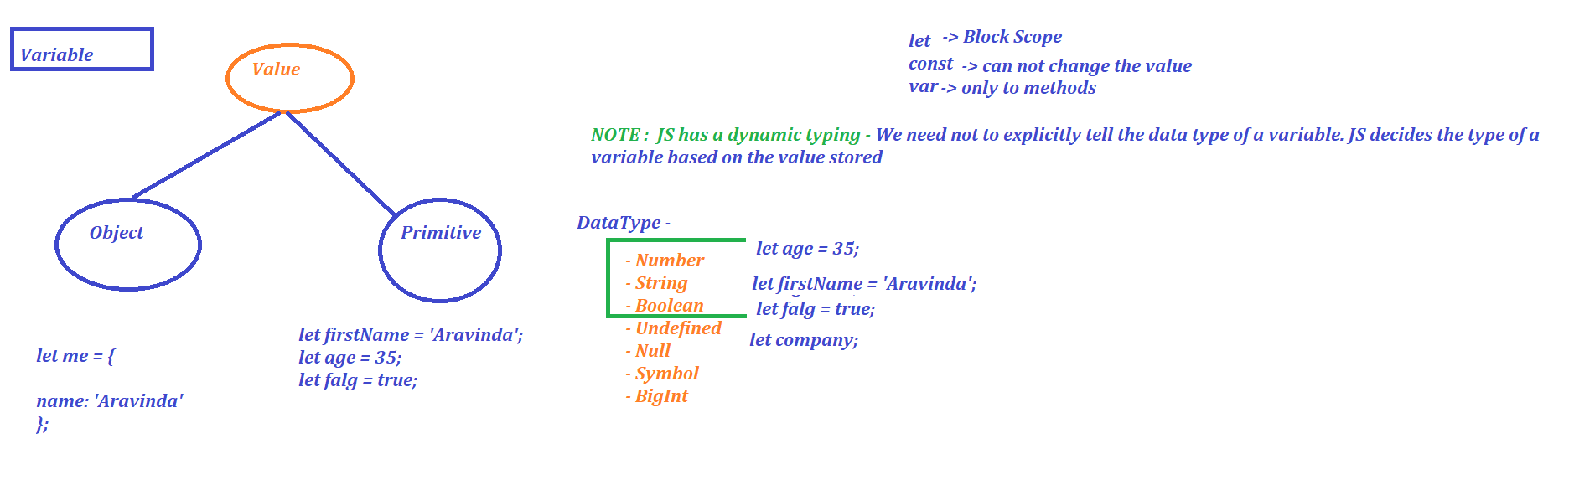

Operators in JS

* Arithmetic operators
* Assignment operators
* 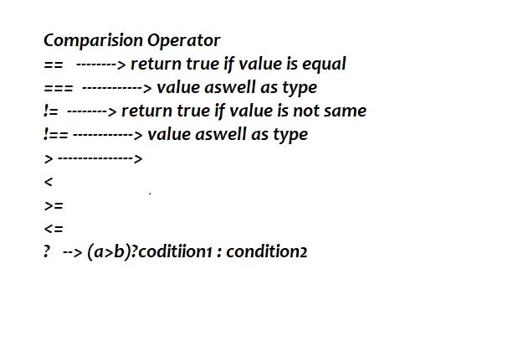

Loops and Conditional statements

PROTRACTOR :

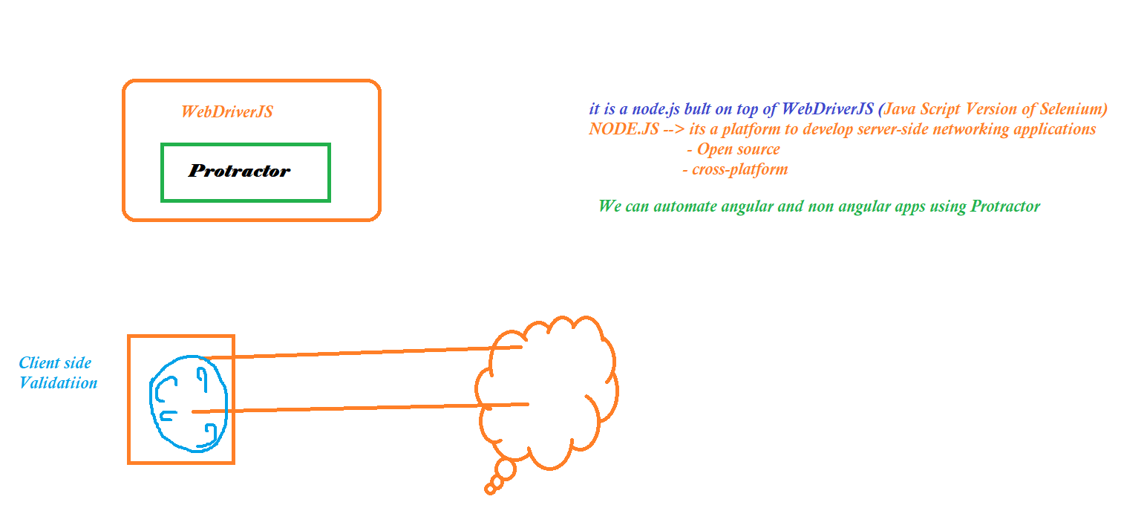

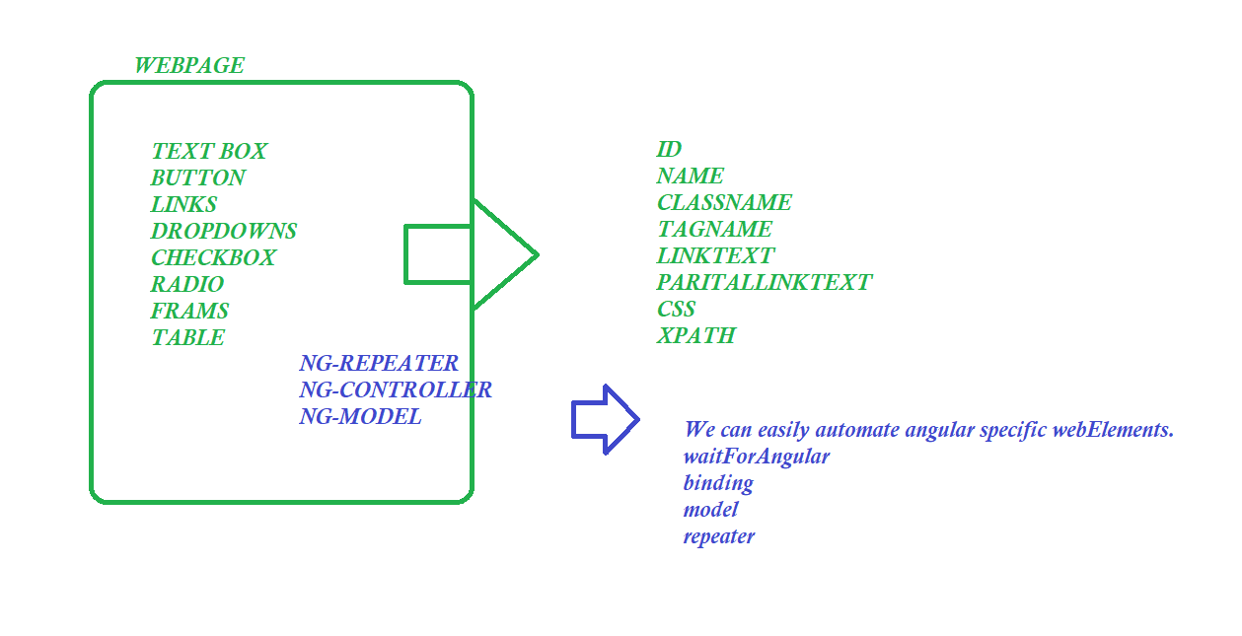

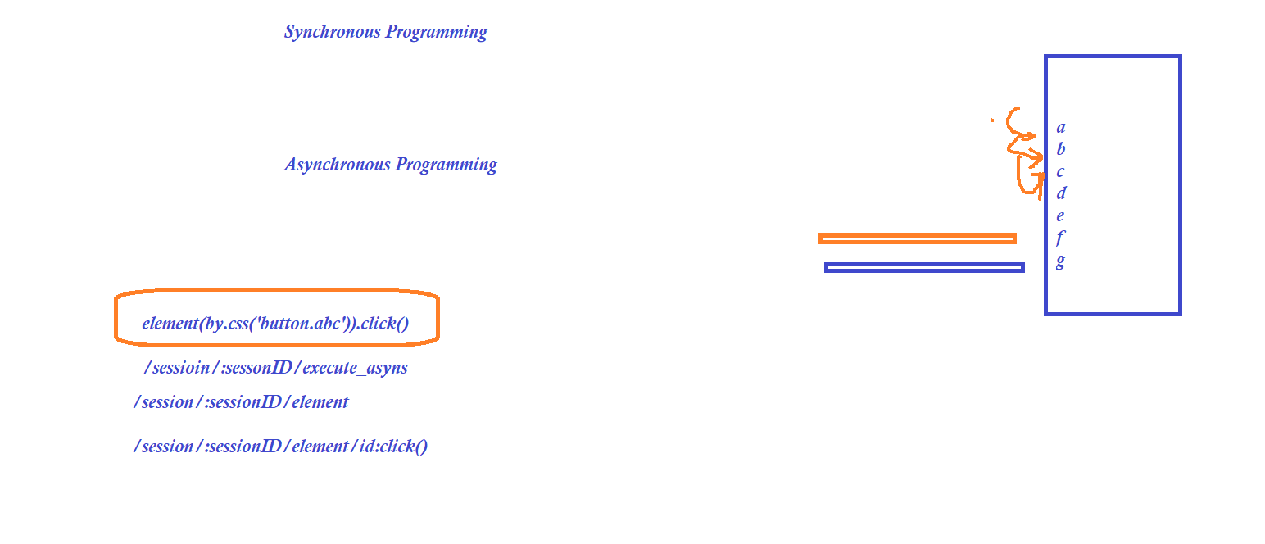  
Installation :

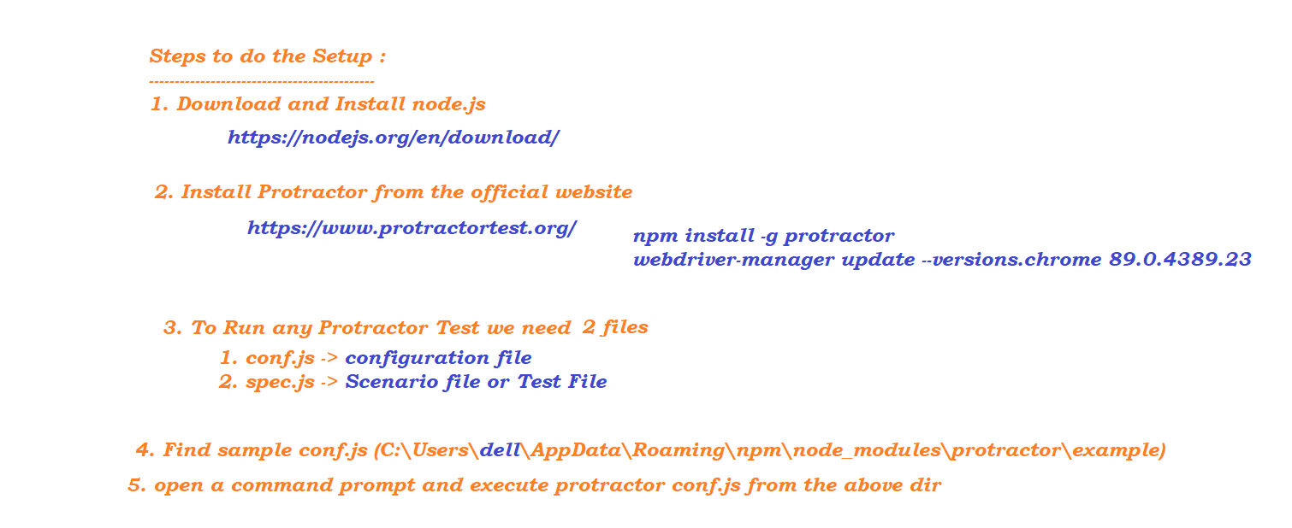

Popular plugins - 