Protractor :

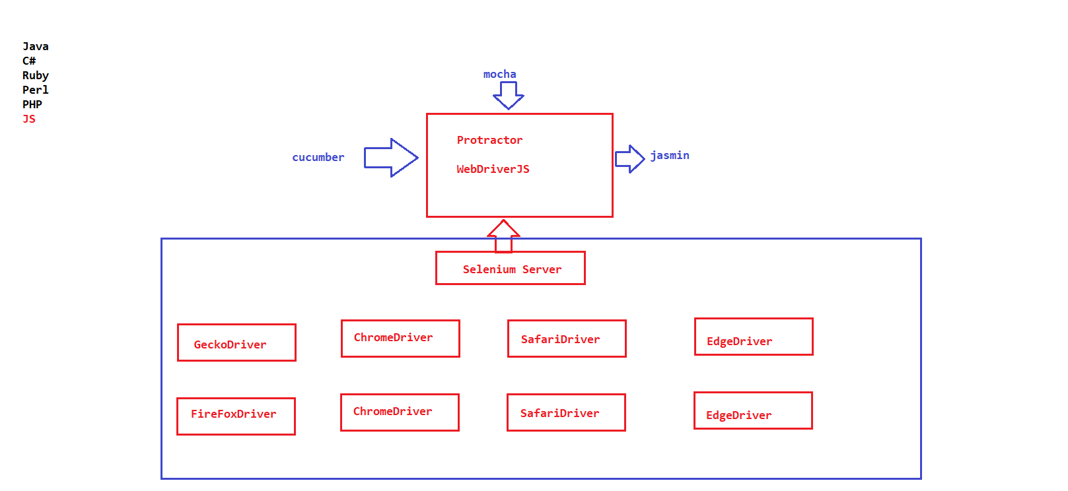

JAVA SCRIPT :

JavaScript is a interpreted programming language

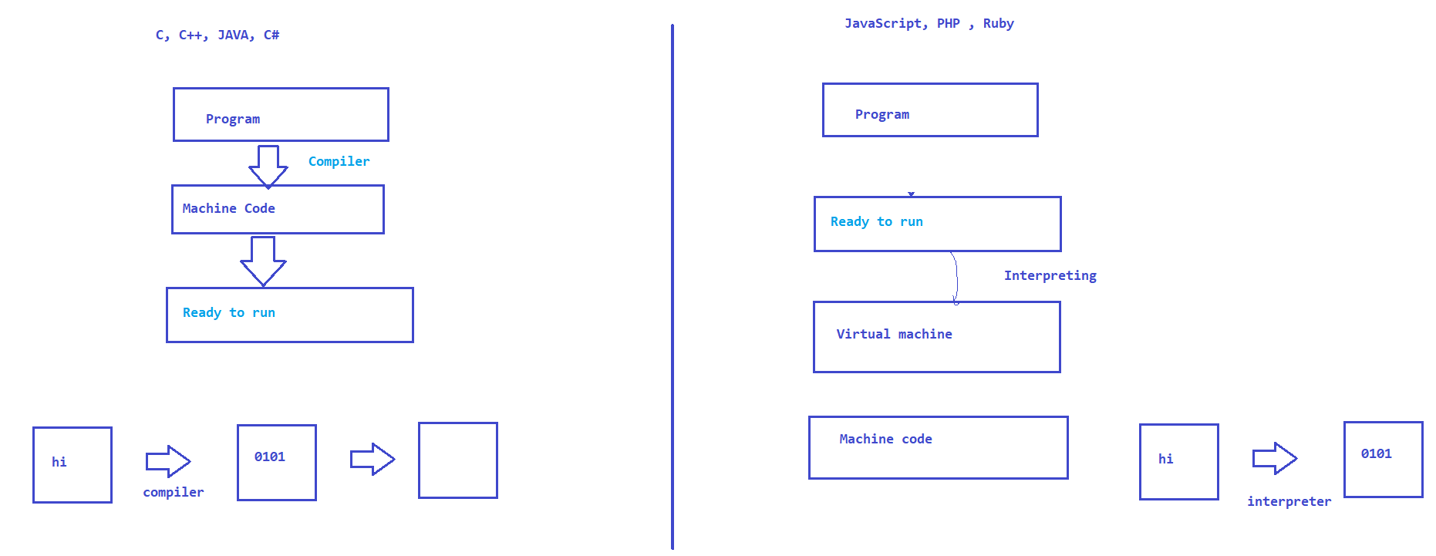

Every Browser comes with JS Engine

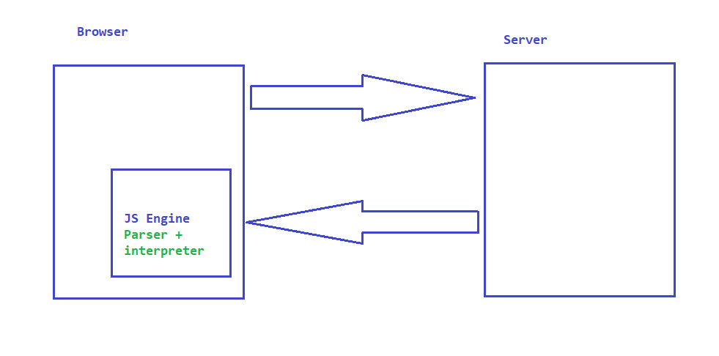

Data types in JS : *Java script has dynamic typing, we need to specify the type of a variable manually. based on the value stored in a variable JS decides what is the data type of a variable.*

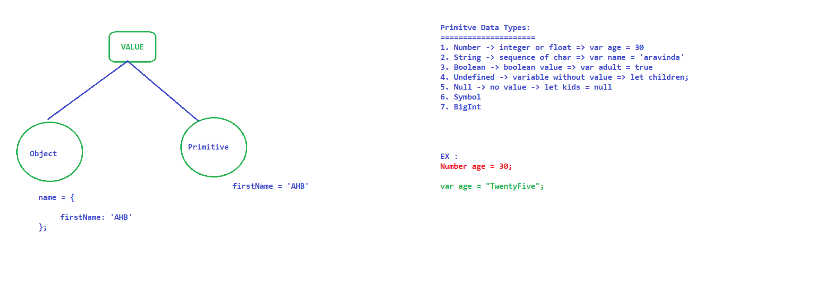

**var** ->legacy / Very old approach

**let** -> value which is changing

**const** -> value cannot be changed these variables are immutable

Operators :

Arithmetic Operators

* +
* -
* *
* /
* %
* **
* ++

Assignment Operators

* = -> Assign -> x = y
* += -> Addition and Assign -> x+ = y => x = x + y
* -= -> Subtraction and Assign -> x- = y => x = x – y
* *= -> Multiply and Assign -> x* = y => x = x * y
* /= -> Divide and Assign -> x/ = y => x = x / y
* %= -> Modulus and Assign -> x% = y => x = x % y
* **= -> Exponential and Assign -> x** = y => x = x ** y

Comparison Operators

* == -> equal to -> 2 ==”2" -> true
* === -> equal to value and equal to type -> 2===”2” -> false
* != -> not equal to -> 2 != 3
* !== ->not equal to value and type
* > -> greater than
* < -> less than
* >= -> greater than or equal to
* <= -> less than or equal to
* (condition)?”f” :”s” -> Ternary operator -> (2 >3)?”first stmt”:”second stat”

NOTE : typeof(variable) returns the type of a variable. based on the value stored

Logical Operators

* && -> logical AND
* || -> logical OR
* ! -> logical NOT

Type Operators

typeof -> returns the type of variable

instanceof ->

CONDTITIONAL STATEMENTS IN JS :

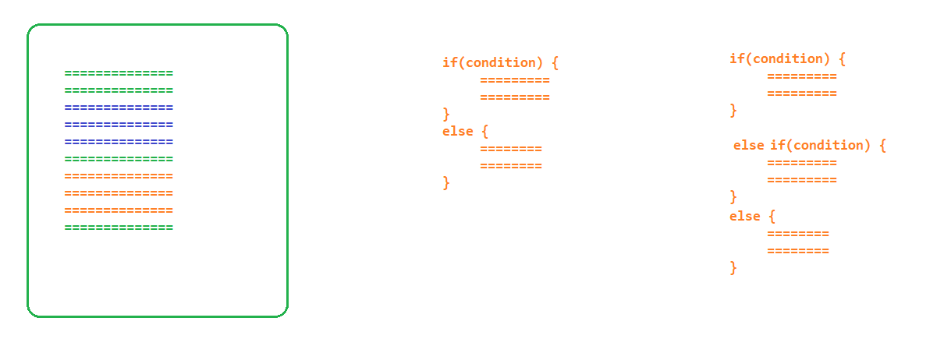

* if
* if,else
* if,elseif, else
* if,elseif…. else
* switch

Looping Statements :

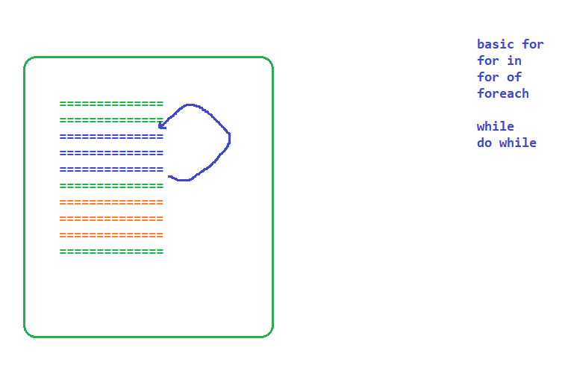

Arrays: