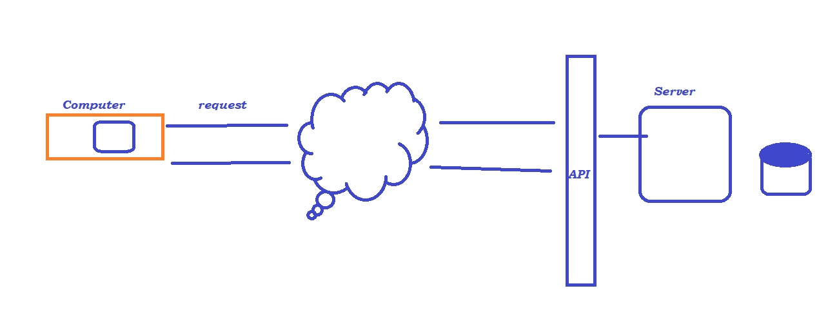

High-level Architecture :

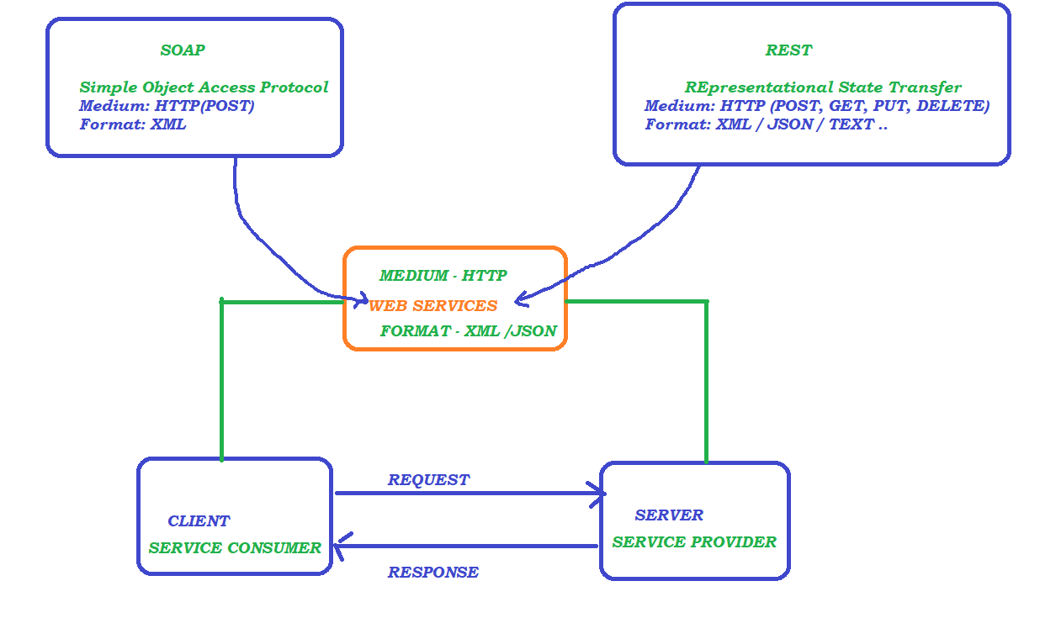

WSDL and UDDI :

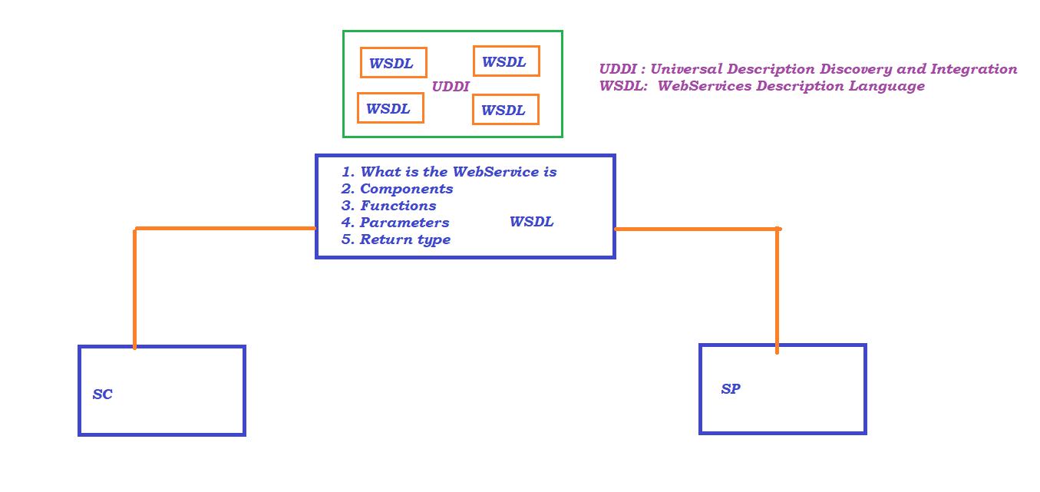

SOAP :

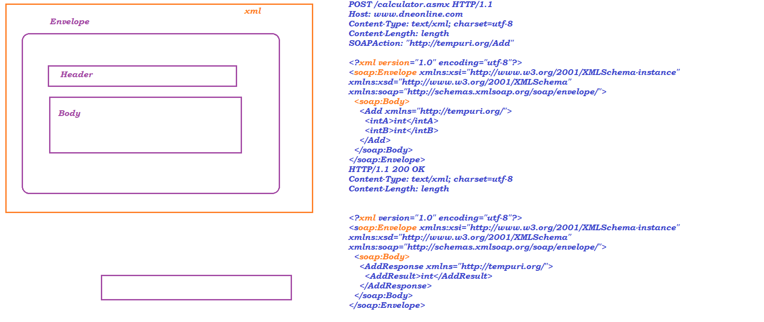

REST:

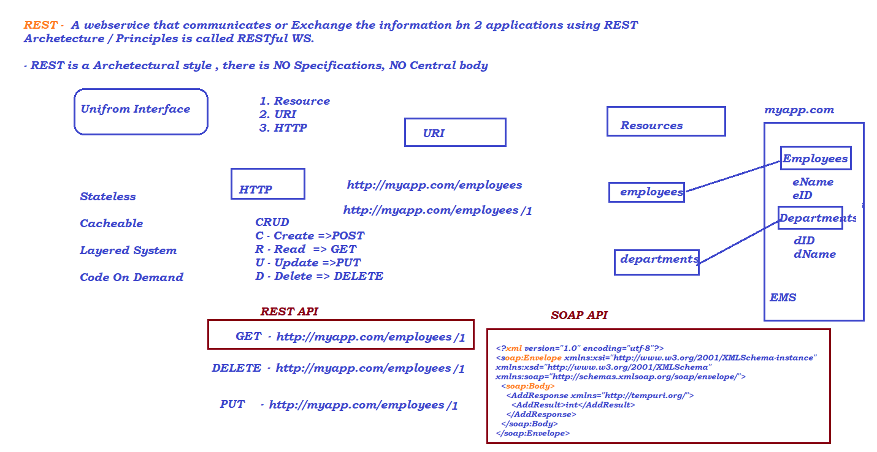

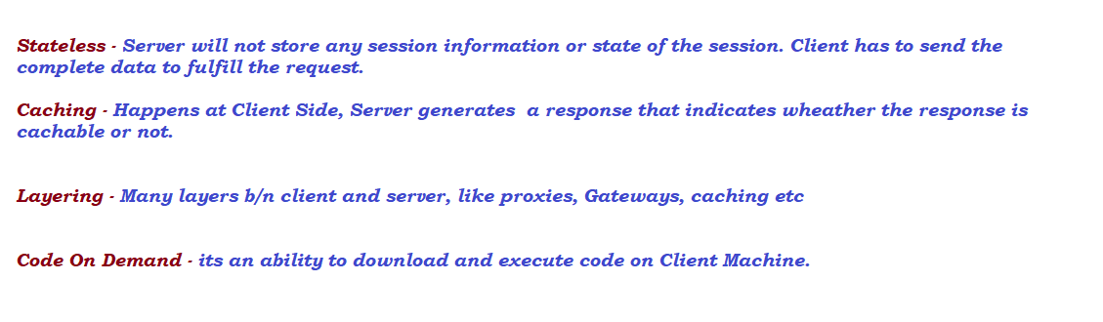

HTTP Request and Response

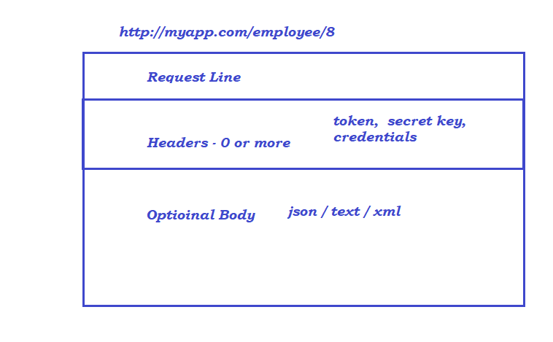

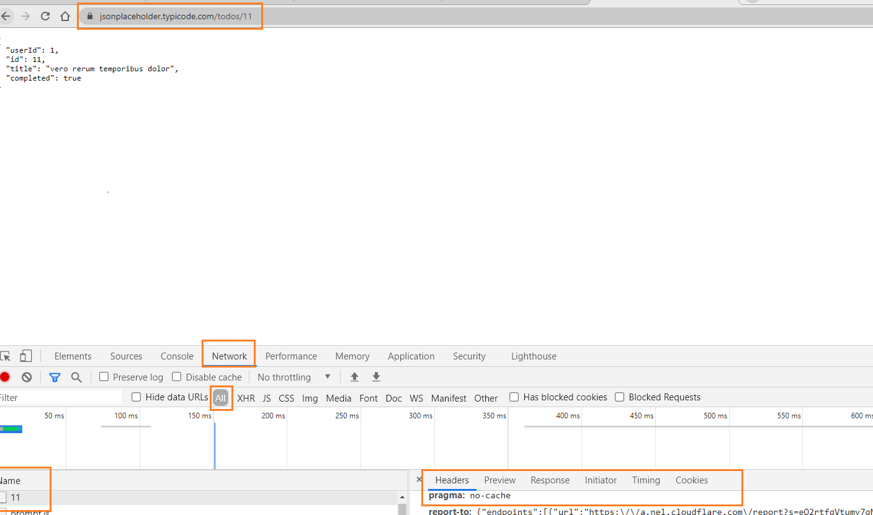

Rest API Elements :

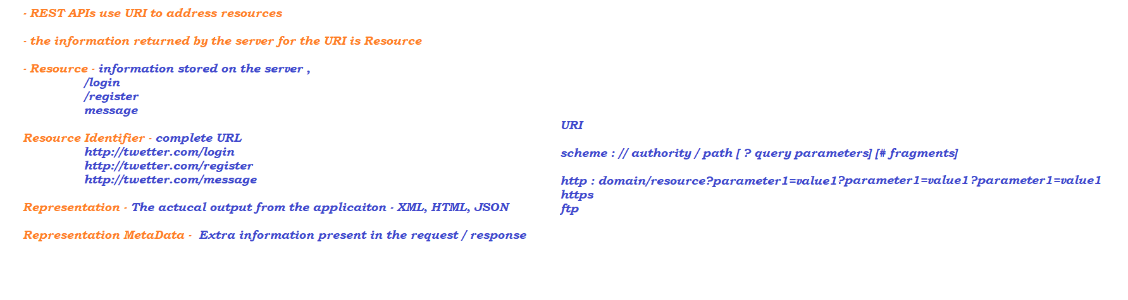

HTTP Methods :

HTTP GET – its used to retrieve the information

- 200 Status code on getting the proper response (i.e, when server identify the resource)

- 404 Status code when server fails to identify the resource

HTTP POST – Its used to create a new resource into the collection of resources

- 201 Status code is returned on successful creation of user

HTTP PUT – Update the existing resource

HTTP DELETE – used to delete the resource / record

PARAMETERS :

1. Path Parameter - is a parameter used to point to a specific resource within a collection. usually Path parameters are identified with /

2. Query Parameter – is a parameter used to filter the records, usually Query parameters are identified with ?

POSTMAN

AUTOMATION:

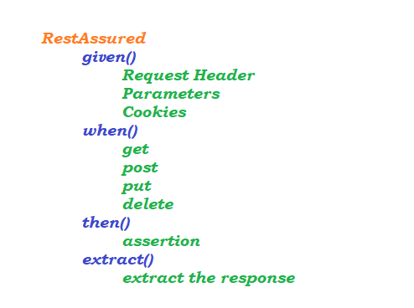

### Don’t have Zoom Client installed? Download Now

Copyright ©2021 Zoom Video Communications, Inc. All rights reserved.

[Privac](https://synechron.zoom.us/en-us/privacy-and-legal.html)

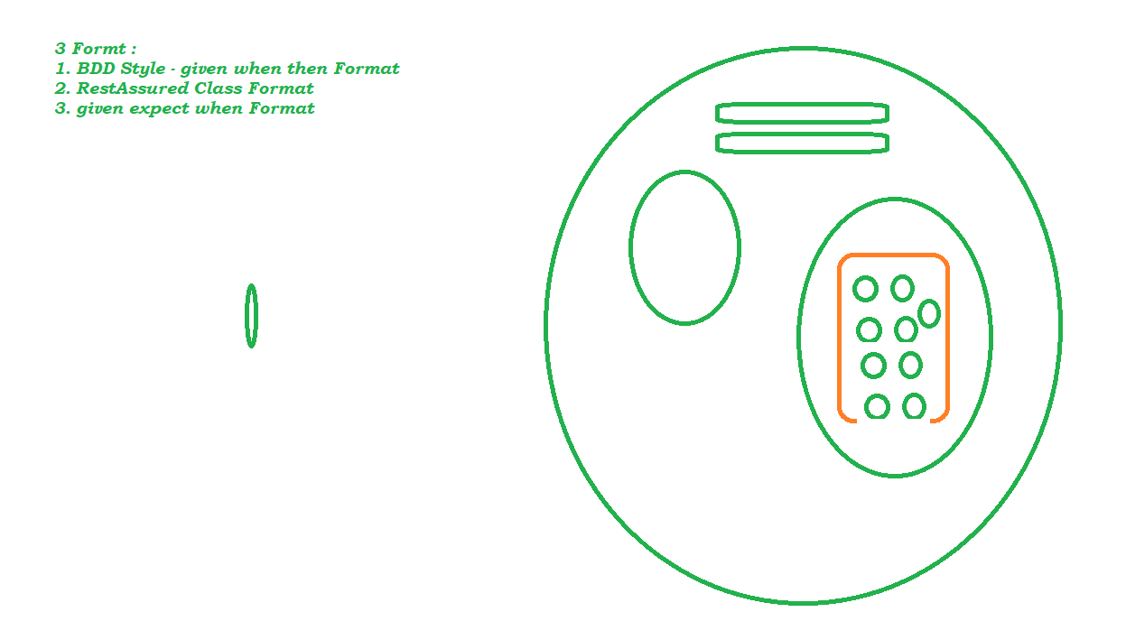

JSON RESPONSE OBJECT :

1. Jayway JsonPath - Java

2. JsonPath ( Rest Assured ) – Groovy

