Maven -

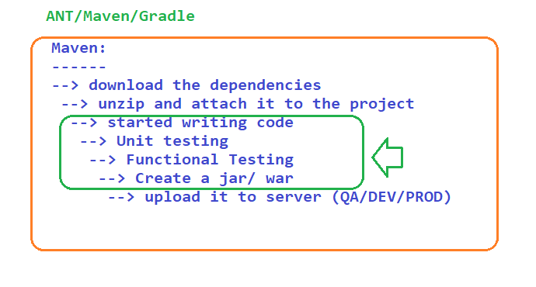

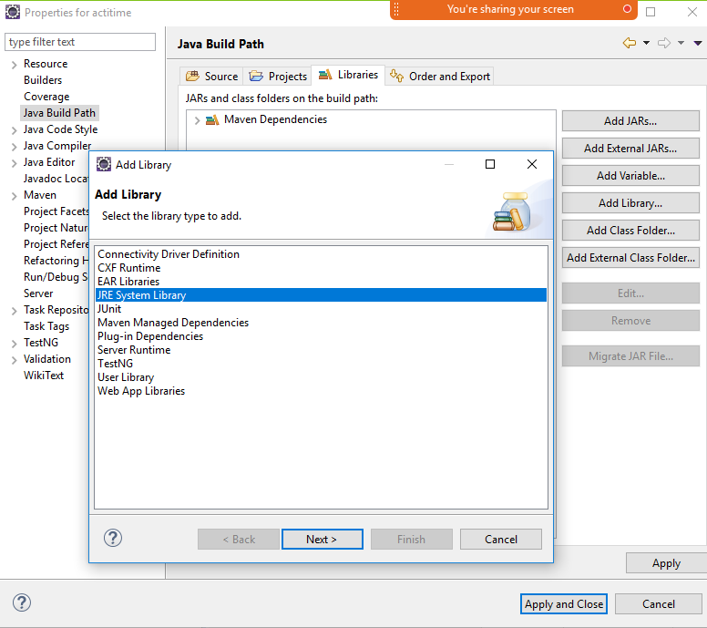

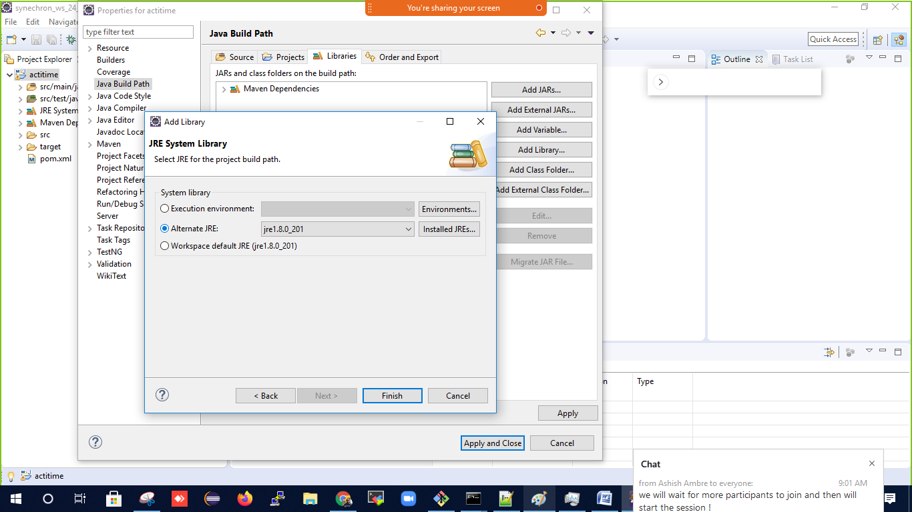

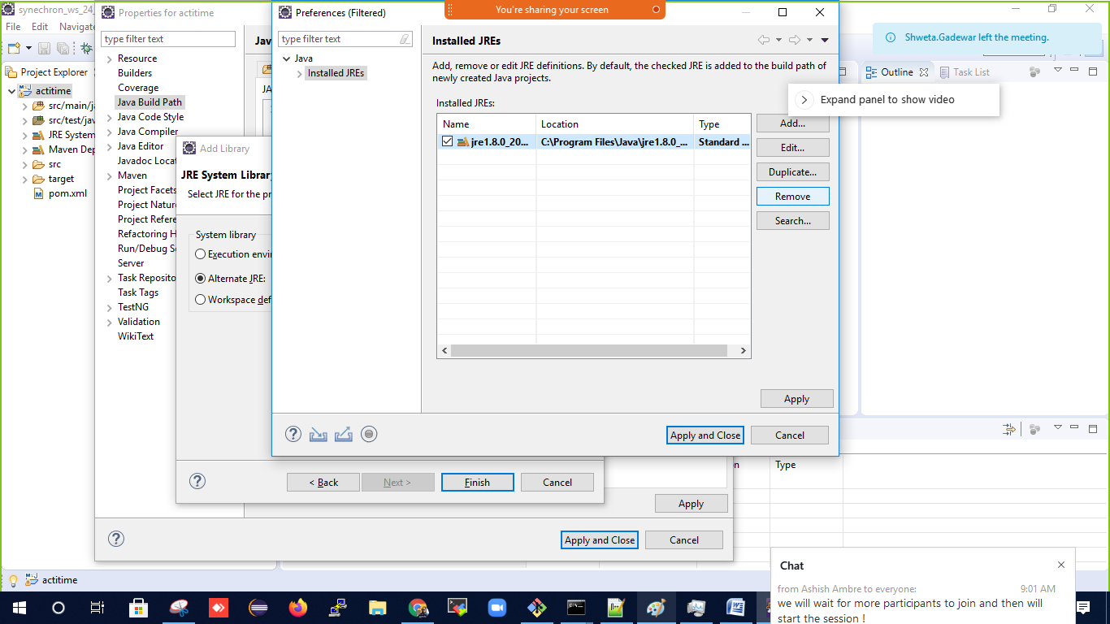

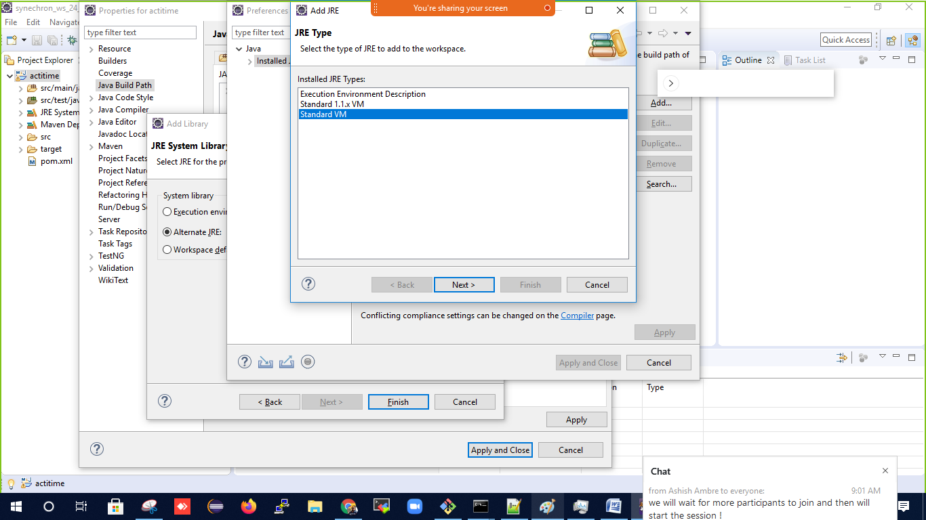

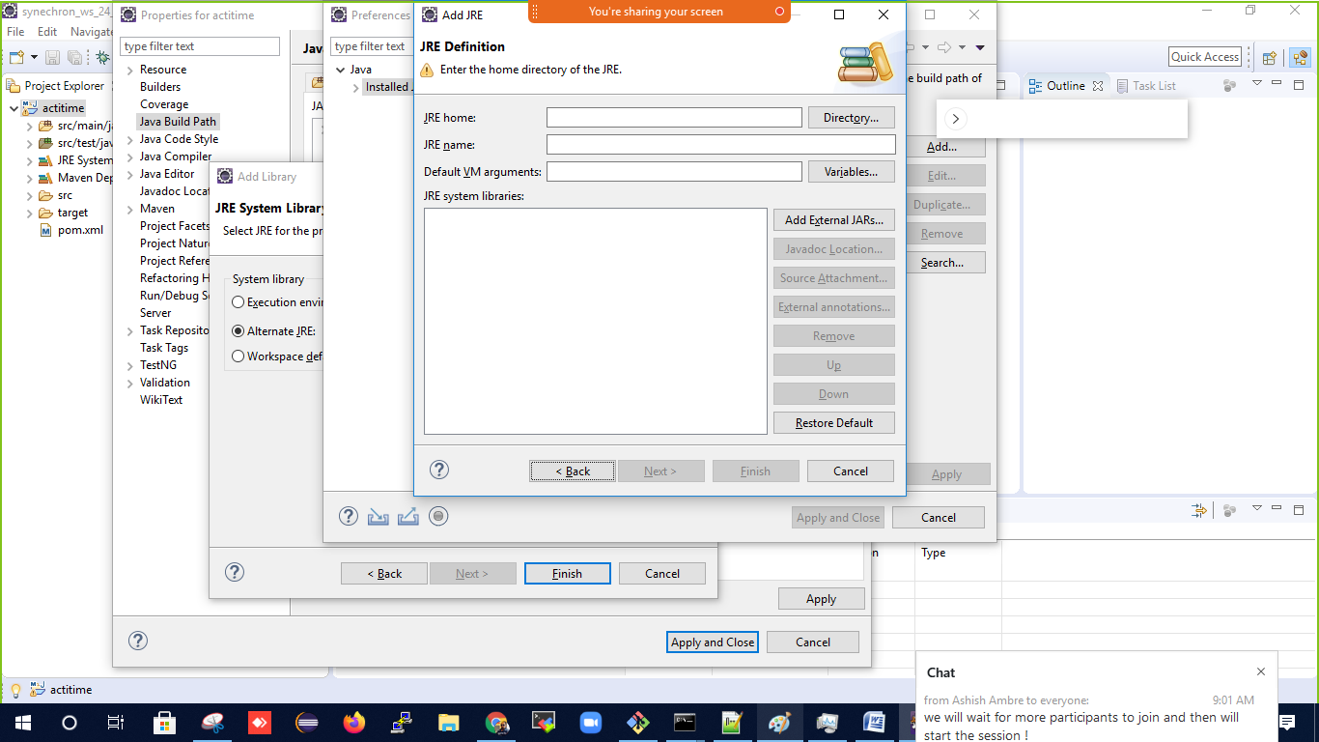

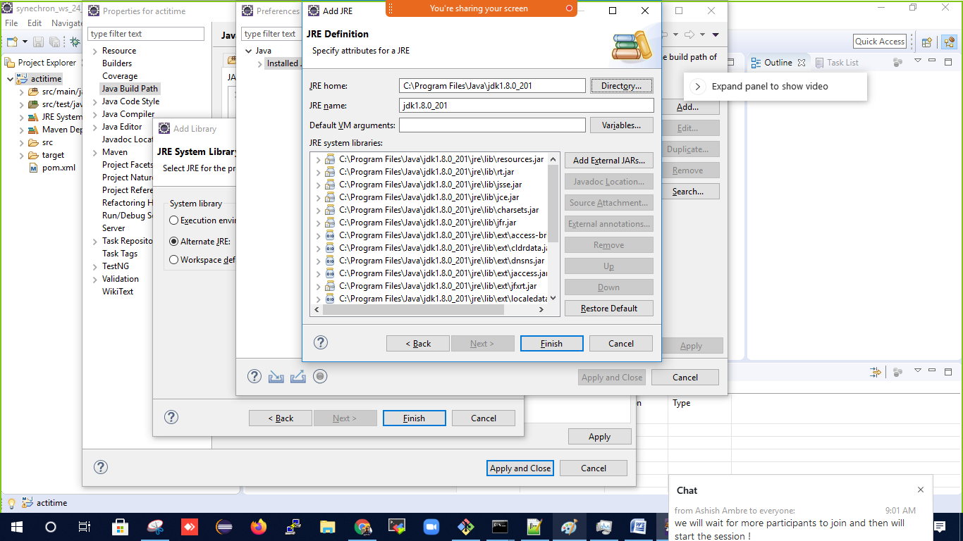

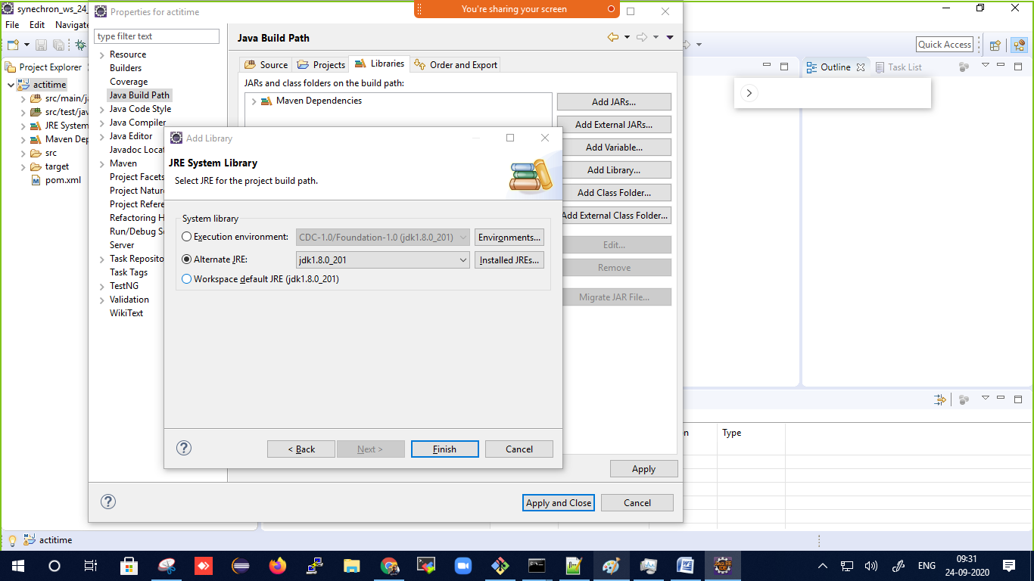

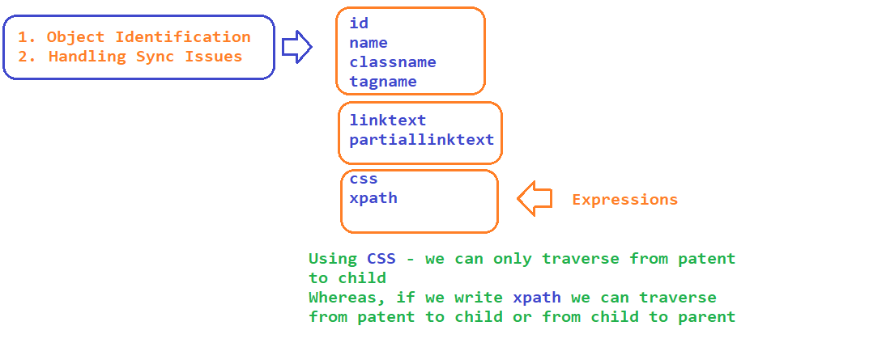

CSS :

htmltag[attribute=’value’] => input[id='username']

htmltag#value OR #value

input#username

input#username

htmltag.value OR .value

input.textField

htmltag[attribute=’value’] > childTAG

a#loginButton > div

**NOTE – NEVER USE INDEX WHILE WRITING XPATH**

XPATH

1. Absolute - /html/body/../../.././

2. Relative - // 🡪 Anywhere in the webpage

1. Basic

* //htmltag[@attribure=’value’]
* //input[@id='username'] or //input[@placeholder='Username']

2. Logical operators -> we can identify using more then one property

* AND -> //td[text()='24' and (@class='current day' or @class='wd day' or @ class='we day')]
* OR-> //td[text()='24' and (@class='current day' or @class='wd day' or @ class='we day')]
* NOT -> //td[text()='21' and not(@class='past day')]

3. Functions

* text() -> hyperlinks with exact text
  + //htmltag[text()=’value’]
  + //h3[text()='Synechron Reviews in Bangalore, India | Glassdoor.co.in']
* contains(arg1,arg2)
  + arg1 -> attribute or text function
  + arg2 -> partial text
  + //h3[contains(text(),'Glassdoor')]
  + //img[contains(@src,'timer')]
* starts-with(arg1, arg2)
  + arg1 -> attribute or text function
  + arg2 -> partial text
  + //h3[starts-with(text(),'Synechron')]
  + //tr[starts-with(@id,'ext-gen')]

4. Traversing from parent to child

* //div[@id='cpTreeBlock']//div[@class='addNewButton']
* //a[@id='loginButton']/div

5. Traversing from child to parent

* //tr[th[text()='Produced by']]/td
* ASSIGNMENT - <https://www.gsmarena.com/apple_ipad_air_(2020)-10444.php>

1. PRINT DISPLAY

2. PLATFORM

4. Axes Functions

* following-sibling -> traverse to the next sibling
  + Syntax -> //xpath/following-sibling::sibling_tag
  + //th[text()='Produced by']/following-sibling::td
* preceding-sibling -> traverse to the preceding sibling
  + //li[a[text()='Random article']]/preceding-sibling::li
* following - > traverse to till the end of the page
  + //li[a[text()='Random article']]/following::a
* preceding -> traverse to the beginning of the page
  + //li[a[text()='Random article']]/preceding::a
* child
  + //li[a[text()='Random article']]/following-sibling::li/child::a
* parent
  + //a[text()='Random article']/parent::li
* ancestor - > traverse from one child to its grand parent
  + //a[text()='Random article']/ancestor::nav

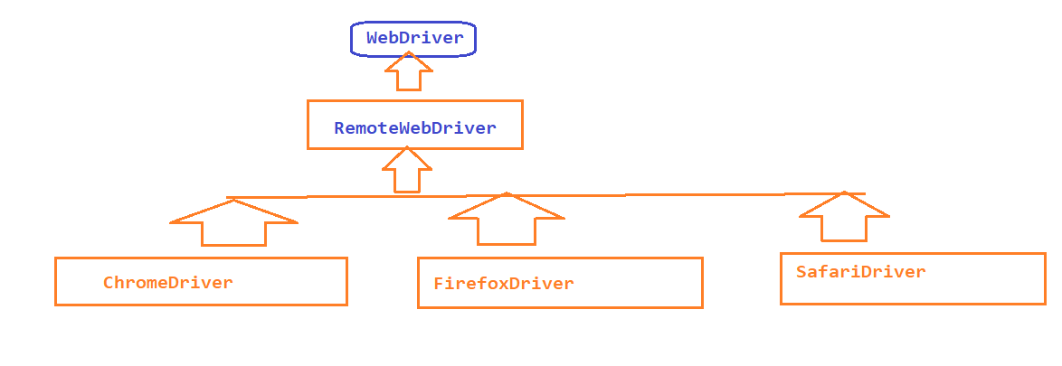

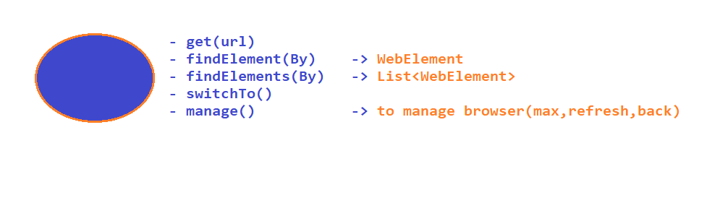

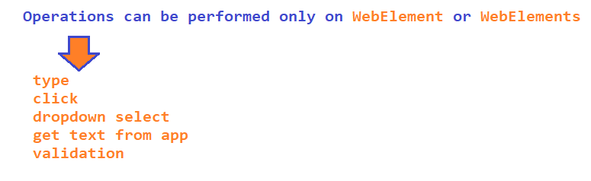

Sync issues

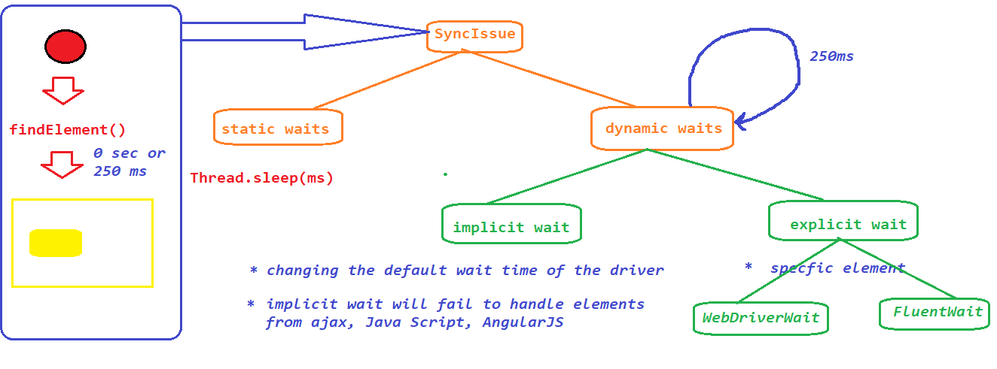

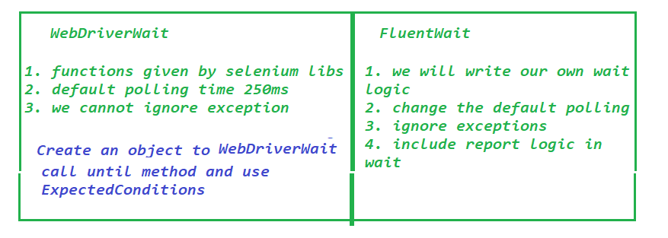

Dropdown –

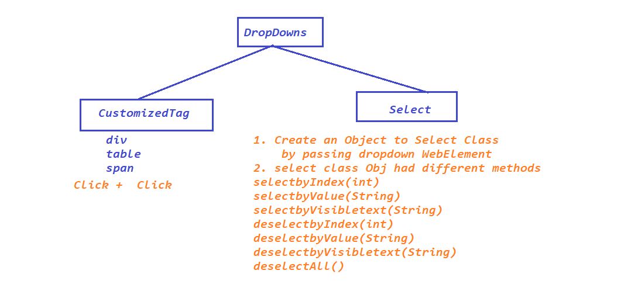

Validations in Selenium –

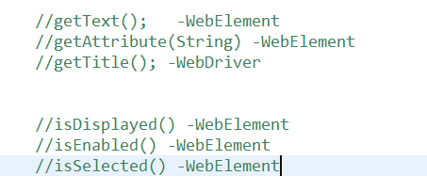

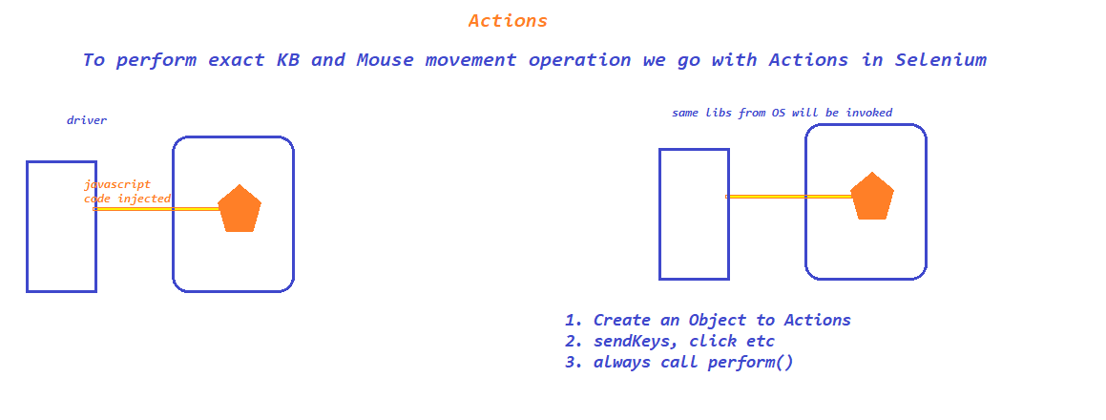

SwitchTo()

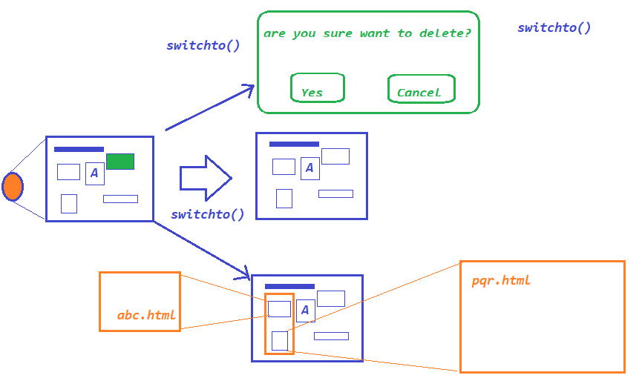

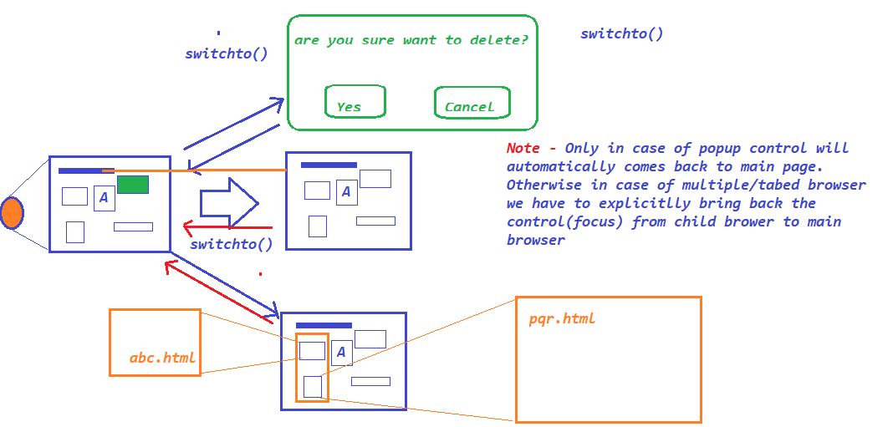

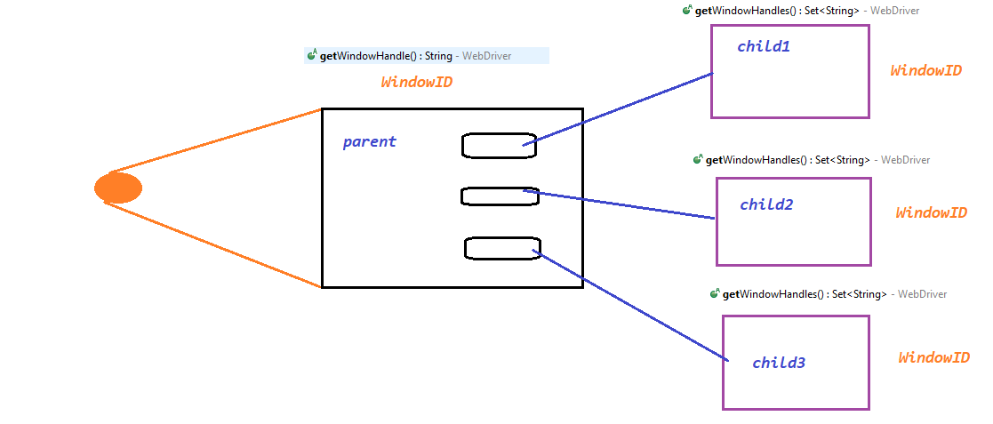

FRAMES

POP

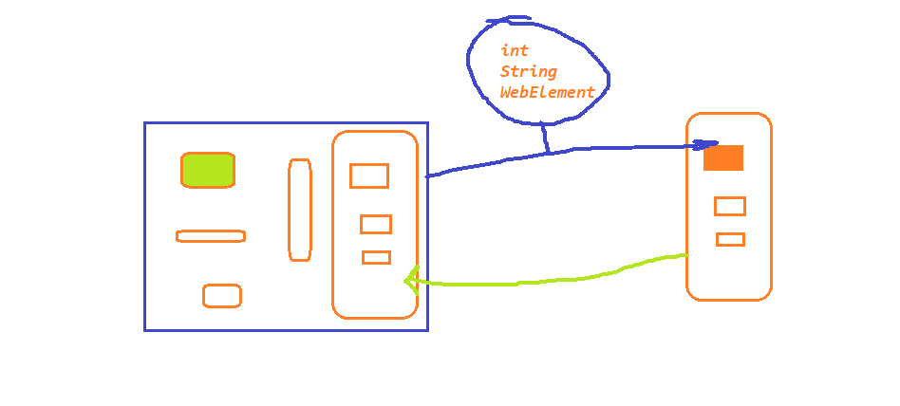

POPUP –

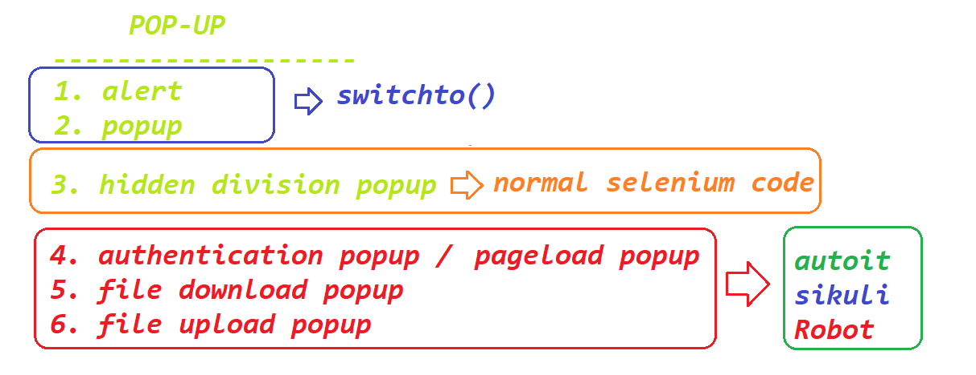

Data driven testing

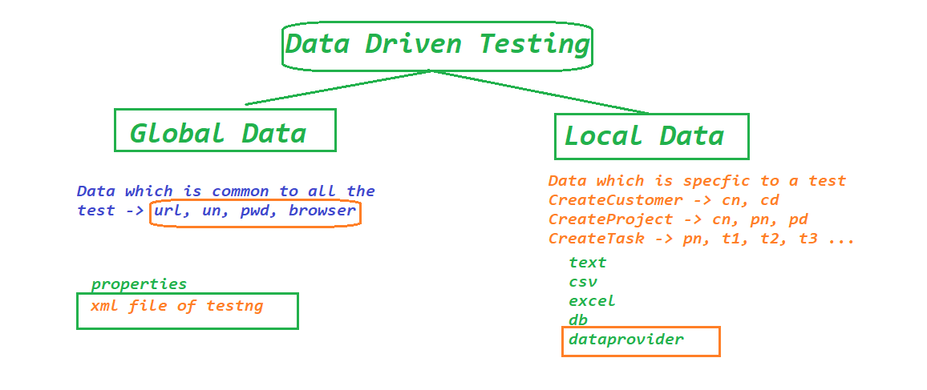

SELENIUM GRID

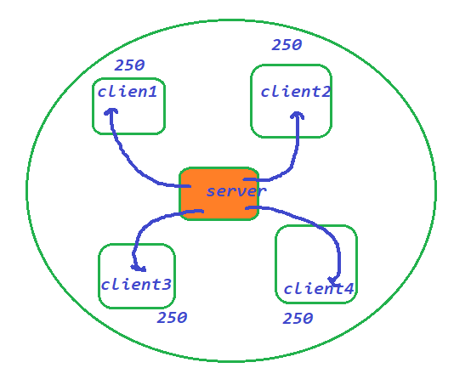

POM