**Appium: - https://appium.io**

* Open source tool
* Native apps, Web Apps or Hybrid apps
* Supports – Android, iOS, Windows Desktop platform
* Support multiple programming languages
  + Java
  + Ruby
  + python
  + C#
  + javascript
  + PHP
  + RobotFramework
* Internally appium also uses selenium Webdriver api’s
* HighLevel Architecture

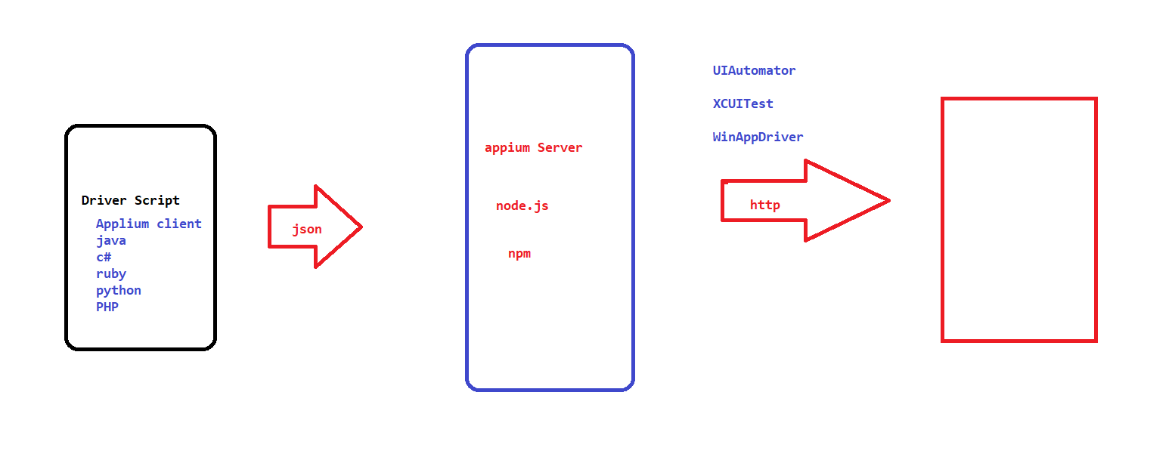

* Detailed Architecture:
* 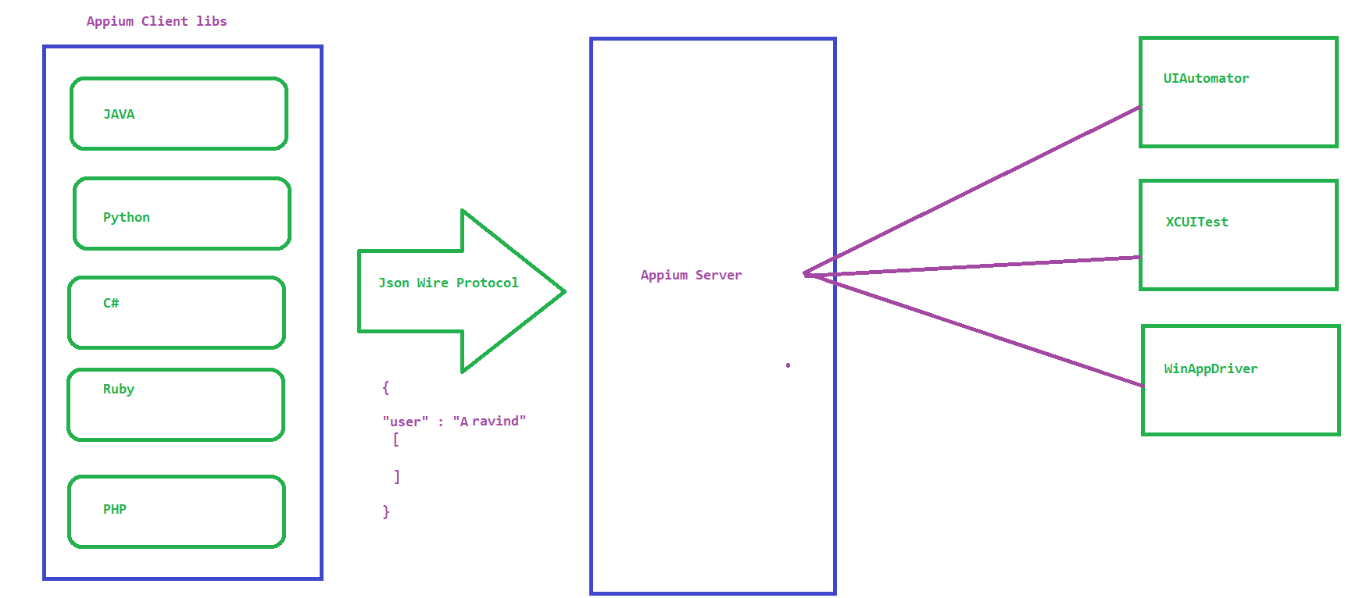

**Setting up Appium on Windows:**

1. **Java JDK**
   1. JAVA_HOME - C:\Program Files\Java\jdk1.8.0_201
   2. PATH - C:\Program Files\Java\jdk1.8.0_201\bin
2. **Download and install Android Studio**
   1. By default Android Studio comes with 2 packages
      1. Android SDK – all the required software to run Emulator
      2. Android Studio – Create a Virtual Device
   2. Open Android Studio and create an empty project (refer below image )-> Wait for build to complete

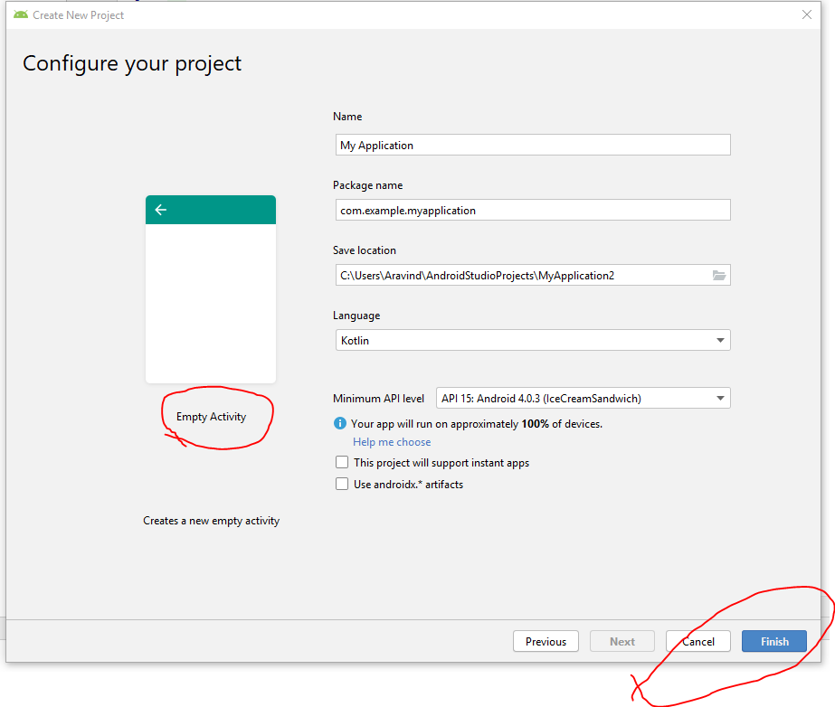

* + 1. Once the build is complete Goto Tools Menu-> and identify AVD Manager and SDK Manager options
    2. Click on SDK Manager and make sure the below highlighted options are selected

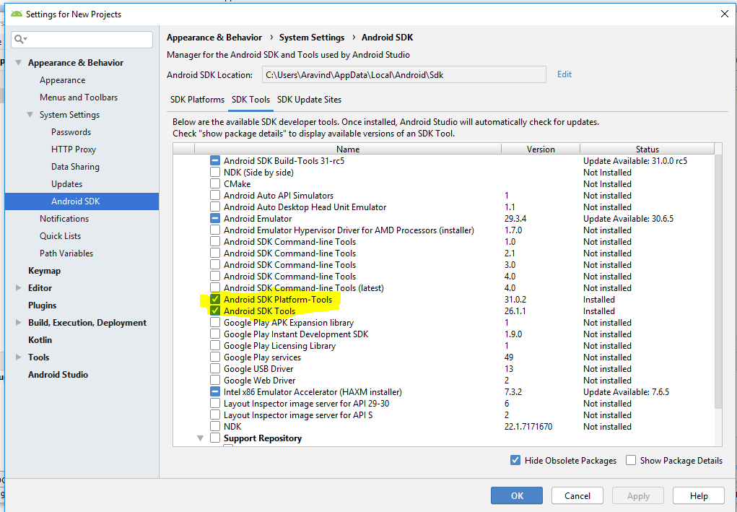

* 1. By Default SDK will be installed in C:\Users\<<UserName>>\AppData\Local\Android\Sdk
  2. set Environment Variable
     1. ANDROID_HOME
     2. C:\Users\Aravind\AppData\Local\Android\Sdk
  3. **Update the PATH Variable**
     1. C:\Users\Aravind\AppData\Local\Android\Sdk\tools
     2. C:\Users\Aravind\AppData\Local\Android\Sdk\tools\bin
     3. C:\Users\Aravind\AppData\Local\Android\Sdk\platform-tools

1. **Configure Virtual Device**
   1. Open Android Studio
   2. Go to Tools menu -> and click on AVD Manager
   3. Click on create virtual device
   4. Select the required phone model and click on next
   5. Download the required OS Version and select it for installation and click Next
   6. Provide AVD Name – EX: Pixel
   7. click on Show Advanced settings and optionally increase the RAM and other HW configuration
   8. click on Finish
   9. To open Emulator from command prompt
   10. **cd C:\Users\Aravind\AppData\Local\Android\Sdk\emulator**
   11. C:\Users\Aravind\AppData\Local\Android\Sdk\emulator**>emulator -avd Pixel**

NOTE –

* 1. ISSUE-1 HAXM not installed error on starting Virtual Device,

Solution : Make sure HAMX is installed as in below image



1. **Installing Appium Server**
   1. Using node software
   2. Using Appium Desktop
      1. go to <https://appium.io/>
      2. click on Download Appium
      3. Install the software on your machine
2. **CONNECTING REAL DEVICE**
   1. ~~GOTO~~ [~~https://developer.android.com/studio~~](https://developer.android.com/studio)
   2. ~~scroll down to Command line tools only AND download the zip~~
   3. ~~unzip inside C:\Users\Aravind\AppData\Local\Android\Sdk\tools\bin~~
   4. ~~go to~~ [~~https://developer.android.com/studio/command-line/sdkmanager~~](https://developer.android.com/studio/command-line/sdkmanager)
3. Enable USB Debugging option on Real Device
   1. settings 🡪 about phone -> (tap 7 times on ) build number
   2. go to developer tools 🡪 enable usb debugging option
4. **Create Project and add Appium Clients**
   1. **File -> New -> Other -> maven -> Maven project**
   2. 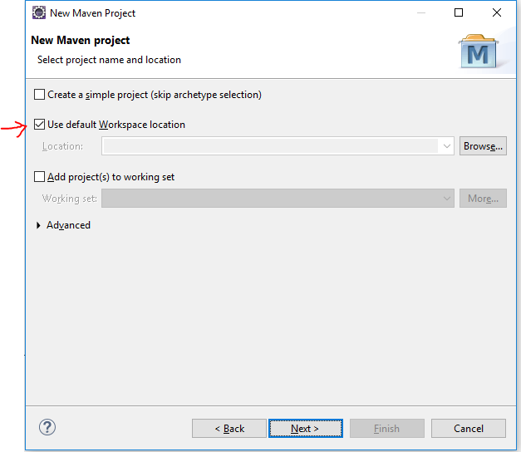
   3. 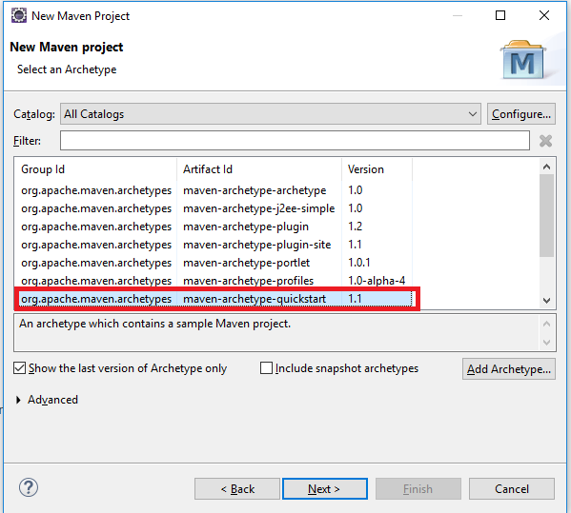
   4. provide groupID and artifactID and click on finish
   5. update pom.xml with the required dependencies
      1. Java-client
      2. selenium-java
      3. testing NOTE : delete scope tag