JAVA, RUBY,PYTHON,PERL,PHP,JS

Prereq: (Pre recorded Sessions on JAVA)

JAVA –

1. Basics of JAVA
   1. How to write a Class
   2. How to write a Method
   3. How to Call the methods

* OOPS Concept ( abstraction, Encapsulation, polymorphism, inheritance )
* Class
* Objects
* Interfaces
* package

1. Variables
   1. local variables
   2. global variables
      1. instance variables
      2. static variables
      3. constants
2. Methods / functions
   1. methods without arguments
   2. methods with arguments
   3. methods without return type
   4. methods with return type
   5. recursive ( method inside a method )
3. Constructors
   1. default
   2. parameterized
4. Access specifiers ( data hiding )
   1. private
   2. default
   3. protected
   4. public
5. Access modifiers ( change the behaviour of a members of a class)
   1. static
   2. final
   3. abstract
   4. synchronized
6. String in JAVA(java.lang)\*\*\*\*\*\*\*\*\*\*\*\*\*\*\*\*\*\*\*\*(reverse, reverse word, change all characters from ‘a’ to ‘A’)
   1. String functions
   2. StringBuffer
   3. StringBuilder
7. Threads
   1. How to achieve multithreading
8. Exception Handling
   1. try
   2. catch
   3. throw
   4. throws
   5. finally
9. File Handling in Java – properties or text
   1. Read a file (InputStream)
   2. Write into a file (OutputStream)
10. Collections
    1. List
    2. Set
    3. Map
11. Generics – Parameterized Collections

Manual Testing :

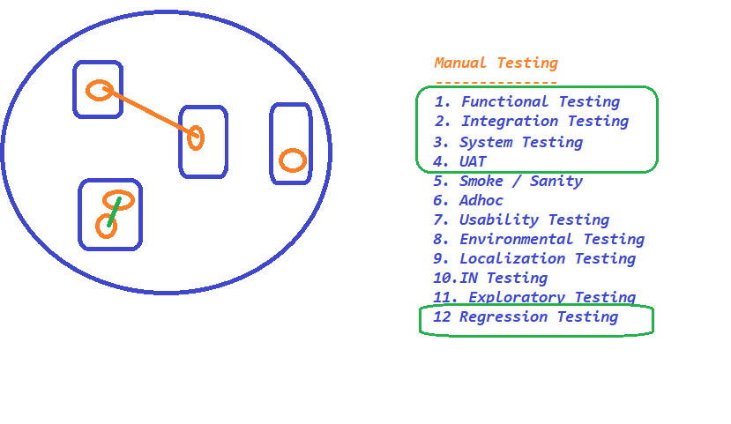

Regression Testing :

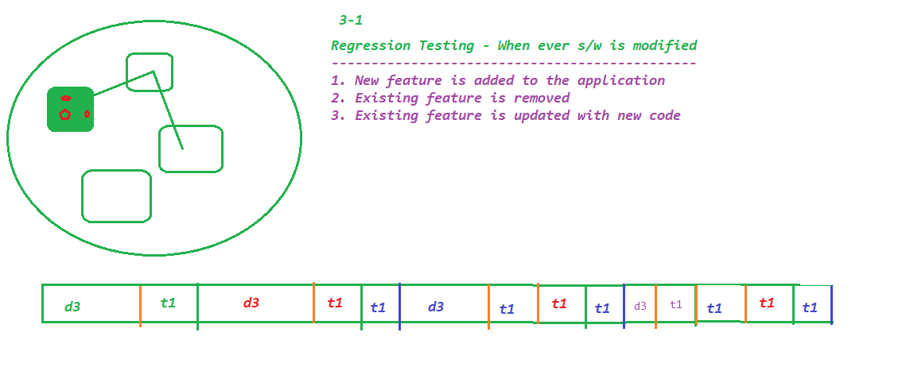

Selenium:

- What is Automation Testing ?

- Why Automation is required ?

- Different Tools ?

1. Test Complete
2. UFT (QTP)- HP
3. Sahi
4. Selenium
5. Katalon Studio
6. SoupUi
7. Cucumber
8. Waitr
9. RFT (Rational Fu Tester) - IBM
10. Test Studio
11. Rspec
12. SilkTest
13. EggPlant
14. Sikuli
15. AutoIT
16. .....

- Why Selenium is popular ?

- Selenium IDE

-CSS

-xPath

* basic
* with filters
* with logical operators
* with functions
* with axes functions
  + traverse between siblings
  + traverse between parent
  + traverse between child
  + traverse between grand parent
  + traverse between grand child

~~- Selenium RC~~

- Selenium WebDriver

- Selenium GRID

AutoIT : Third party tool

Frameworks :

- TestNG

- Page Object Model

Build Automation tools:

Maven

- Batch execution without opening a tool

Jenkins

- BDD -> Cucumber

Demo Application ->