Group name: Delta

Group members: Andrew Schaefer, Jennifer Thomas, Milo Blake, Shane Fox, Caleb Mastromonaco

Case study: Bacchus Winery

CSD-310, Module 11.2 assignment

Milestone #3

**GitHub link:** https://github.com/Ab0213ab/csd-310

**Python Scripts:** see aschaefer-milestone_3_scripts.py (attached in blackboard)

**Report #1** (3 screen shots below)**:**

Like most businesses, Bacchus Winery needs to have reliable suppliers so they can have the equipment needed to help their winery flourish. Therefore, keeping a month-by-month account of just how reliable Bacchus’ suppliers are is a must and the first report allows Bacchus Winery to do just that by analyzing the on-time performance of their suppliers. This report includes a supply’s supplier ID, the corresponding supplier’s name, as well the expected and actual delivery times of each supply so Bacchus Winery can assess if there are any suppliers that might be falling behind the others.

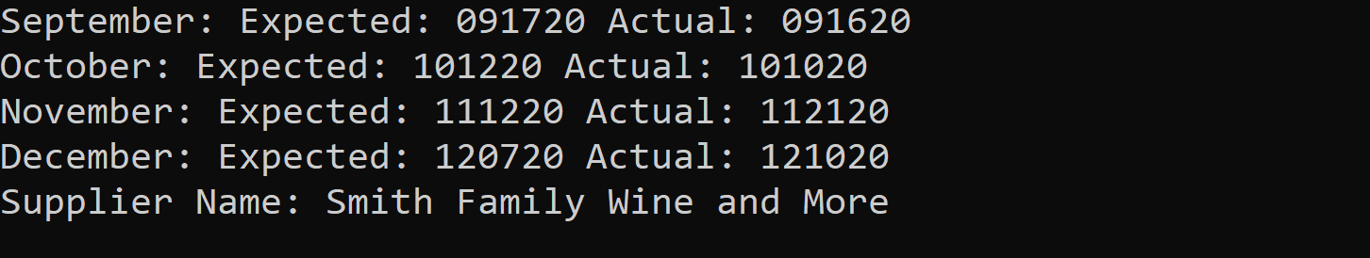

**Report #2** (1 screen shot below):**:**

Among many other things, Bacchus Winery must keep an eye on their inventory to be sure all the products they offer are selling to their full potential. This is where our second report comes in, which provides an easy-to-understand summary of a wine’s name and type, the number of bottles sold, as well as each wine’s distributor’s ID and name. This report will help Bacchus Winery to keep real-time tabs on how well each wine is selling compared to the others which will provide information crucial for making business decisions.

**Report #3** (4 screen shots below):**:**

Although an organization can get nowhere without its employees, they do represent a business cost that must be assessed to remain competitive. Therefore, the third report focuses solely on Bacchus Winery’s many employees and the hours worked by each employee. This report includes an employee’s ID, name, and the hours worked per yearly quarter, providing vital information to assist in determining the winery’s payroll costs.

