Assignment 4: Graph Traversal and Representation System
Project Overview
This project implements a graph data structure using an adjacency list and applies BFS, DFS, and Dijkstra's algorithm on graphs of different sizes.

Class Descriptions
Vertex
Represents a single node in the graph. Stores a unique id.
Edge
Represents a directed connection between two vertices with a weight field.
Graph
Stores the graph using an adjacency list — each vertex maps to a list of its outgoing edges. Memory-efficient for sparse graphs, O(1) average neighbor access.
Methods:
- addVertex(Vertex v) — adds a node
- addEdge(int from, int to, int weight) — adds a weighted directed edge
- addEdge(int from, int to) — adds an unweighted edge (default weight = 1)
- printGraph() — prints the adjacency list
- bfs(int start) — Breadth-First Search
- dfs(int start) — Depth-First Search
- dijkstra(int start) — Dijkstra's Shortest Path
Experiment
Builds graphs of sizes 10, 30, 100, runs BFS and DFS, measures execution time via System.nanoTime().

Algorithm Descriptions
BFS (Breadth-First Search)
Explores all neighbors at the current depth before going deeper. Uses a queue (FIFO).
- Add start vertex to queue and mark as visited
- Dequeue a vertex, process it
- Enqueue all unvisited neighbors
- Repeat until queue is empty
Time complexity: O(V + E) Use cases: shortest path (unweighted), level-order traversal, connected components

DFS (Depth-First Search)
Explores as far as possible along each branch before backtracking. Uses recursion.
- Mark current vertex as visited and process it
- Recursively visit each unvisited neighbor
- Backtrack when no unvisited neighbors remain
Time complexity: O(V + E) Use cases: cycle detection, topological sort, maze solving

Dijkstra's Algorithm (Bonus)
Finds the shortest path from a starting vertex to all other vertices in a weighted graph.
- Set distance to start = 0, all others = ∞
- Pick the unvisited vertex with the smallest known distance
- Relax all its outgoing edges: if dist[current] + weight < dist[neighbor], update
- Mark current as visited, repeat until all vertices are processed
Time complexity: O(V²) with simple arrays (no priority queue) Use cases: GPS navigation, network routing, shortest path in weighted graphs

Experimental Results
Graph structure: each vertex i connects to (i+1) % size and (i+2) % size.
Graph Size | BFS Time (ns) | DFS Time (ns)
10 vertices | 508800 | 467200
30 vertices | 1224600 | 1450300
100 vertices | 3594900 | 845454700
*DFS on 100 vertices spiked due to JVM warm-up overhead, not algorithm behavior.
Observations
- Both algorithms grow linearly — consistent with O(V + E)
- BFS is generally faster due to lower overhead vs recursion
- DFS can spike on first runs due to JVM cold-start

Dijkstra Demo Results
Weighted graph (6 vertices), starting from vertex 0:
Destination | Shortest Distance | Path
0 | 0 | start
1 | 3 | 0 → 2 → 1
2 | 2 | 0 → 2
3 | 8 | 0 → 2 → 1 → 3
4 | 10 | 0 → 2 → 1 → 3 → 4
5 | 13 | 0 → 2 → 1 → 3 → 4 → 5

Screenshots
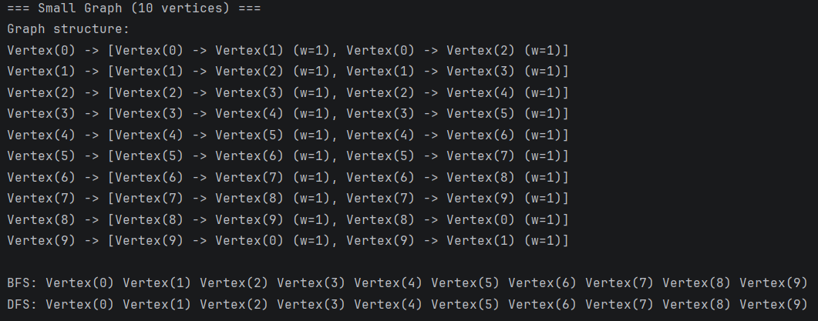
Performance results (10, 30, 100 vertices)
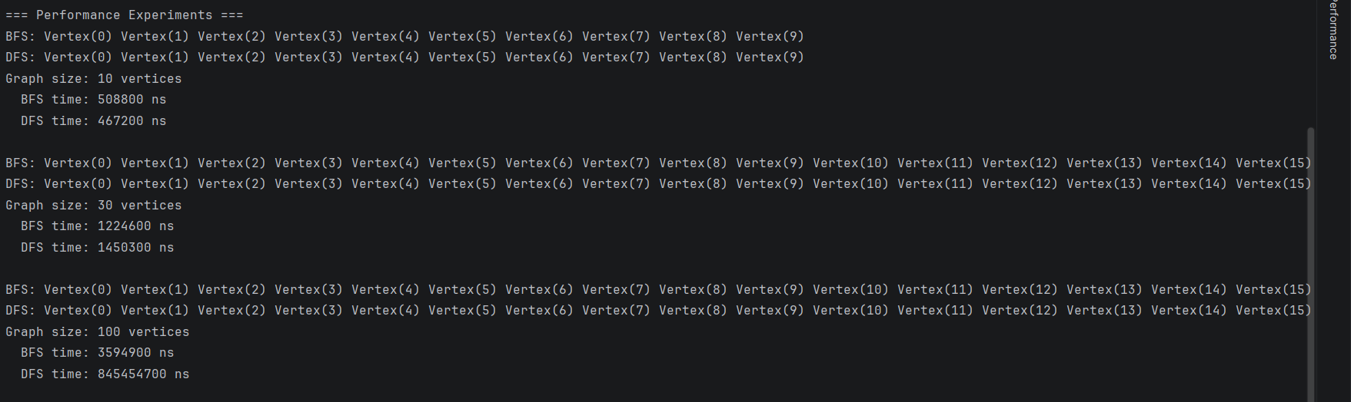
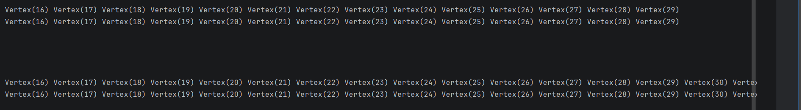
И так до vertex(99)

Dijkstra output
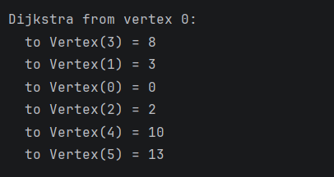

Reflection
This assignment gave me a clear understanding of how BFS and DFS differ in practice. BFS uses a queue and explores level by level — ideal for shortest paths in unweighted graphs. DFS uses recursion and dives deep first — better for detecting cycles or exploring all paths.
The bonus Dijkstra implementation extended the graph to support weighted edges. The key insight is the relaxation step: continuously updating distances when a shorter path is found. Unlike BFS, Dijkstra picks the globally cheapest unvisited vertex at each step, which guarantees correct shortest paths for non-negative weights.

