LAB3.dart
SUBMIT. Checkpoint 1:
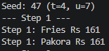
SUBMIT. Checkpoint 2:
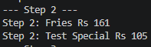
SUBMIT. Checkpoint 3:
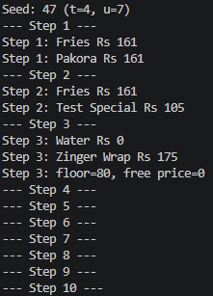
SUBMIT. Checkpoint 4:
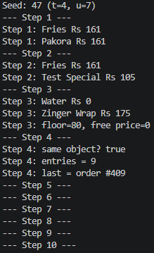
SUBMIT. Checkpoint 5:
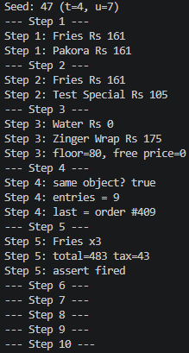
SUBMIT. Checkpoint 6:
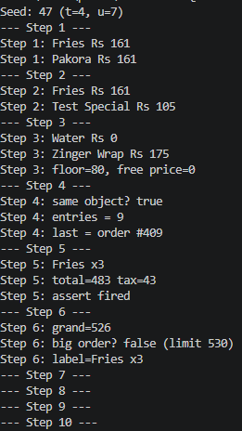

SUBMIT. Checkpoint 7:
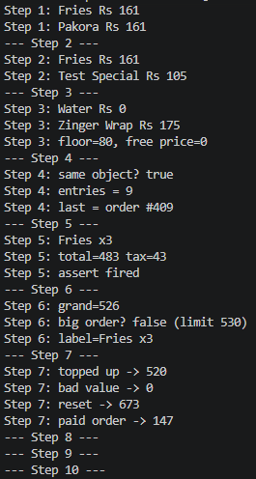

SUBMIT. Checkpoint 8:
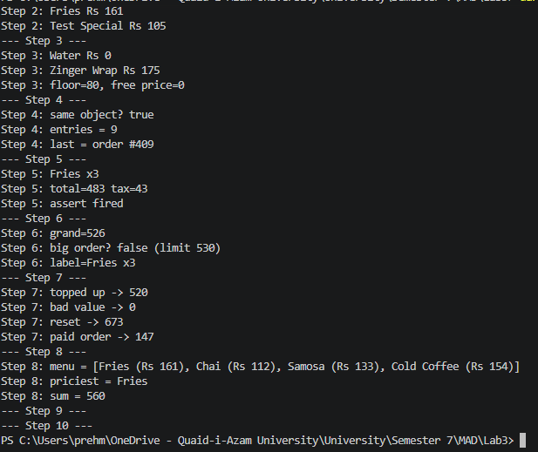

SUBMIT. Checkpoint 9: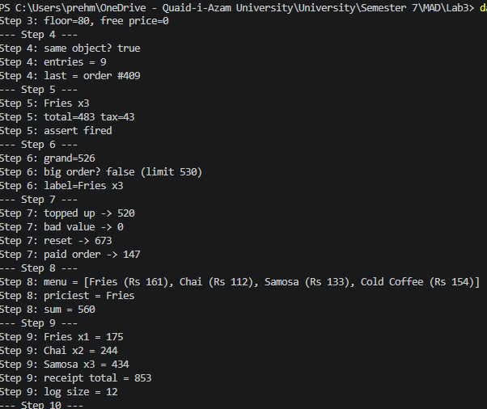

SUBMIT. Checkpoint 10:
