**Normalization**

The table to be normalized is following:



There are a few issues with the above table (insertion, updation and deletion anomaly occurs). This can be resolved by normalization. We can clearly see in the above table that their occurs repeating values in course and student address. Partial dependency occurs in teachers contact and join date. And transitive dependency occurs among the data values of student address. We are going to use normalization steps to resolve this issue.

**1st Normal Form (1NF):-**

The table should only have single(atomic) valued attributes/columns. Many students have opted for more than 1 course in our table. And we have stored the course names in a single column. Same the case is with Student address attribute. As per the 1st Normal form, each column must contain an atomic(single) value.

There are multiple ways to resolve this issue but we are going to resolve this issue by making a new table as described below:

* Identify the repeating groups of data.
* Remove the the repeating group fields to a new table, leaving a copy of the primary key with the table that is left.
* The original primary key will not now be unique so assign a new primary key to the relation using the original primary key as part of a composite key.

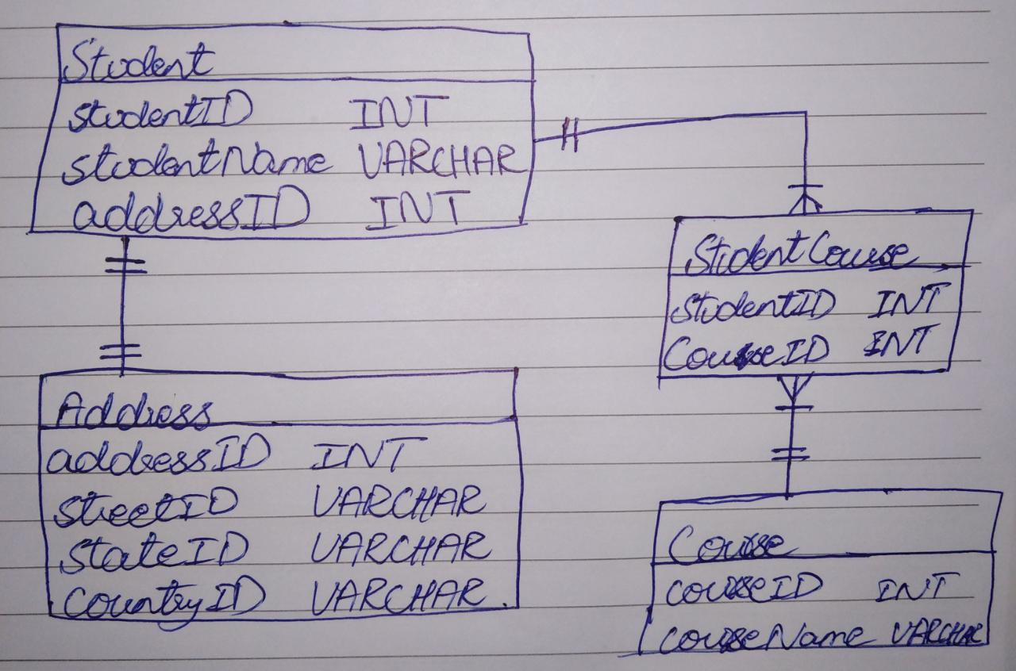

**2nd Normal Form (2NF):-**

­­­Firstly the table should be in 1st NF. After that we need to check the table should not exist partial dependency. If their exist partial dependency, we need to remove it.

* We remove the partially dependent attributes from the relation by placing them in a new relation along with a copy of their determinant.



**3rd Normal Form (3NF):-**

Firstly the table should be in 2nd NF. After that we need to check the table should not exist transitive dependency. If their exist transitive dependency, we need to remove it.

* We remove the transitive dependent attributes from the relation by placing them in a new relation along with a copy of their determinant.

Now at this state we do not have any transitive dependent attribute. But in above given unnormalized table transitive dependency existed in address attribute and in that column, we had transitive dependent attributes which is resolved in 1st Normal while we were resolving repeated multivalued data.

So the final normalized table’s view will be:

