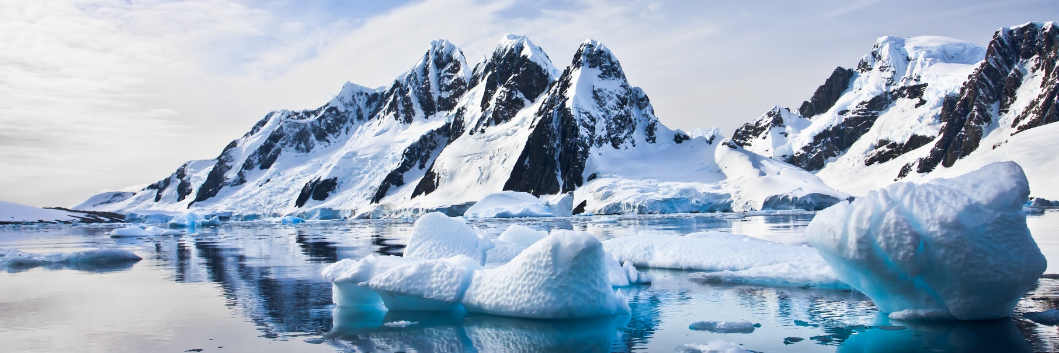

IPBES Dialogue Workshop on

Arctic Indigenous Knowledge

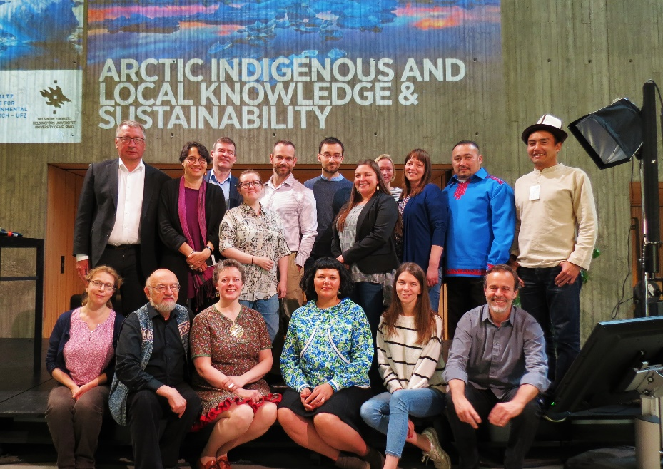
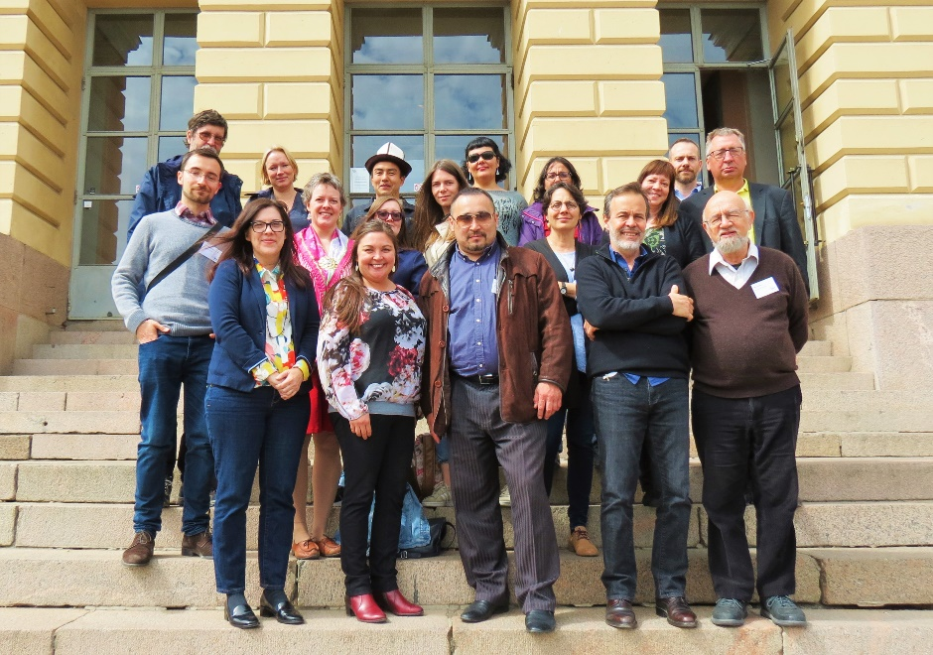

MEETING OVERVIEW
June 6-8, 2018
University of Helsinki, Helsinki, Finland

Introduction

Background
The Intergovernmental Science-Policy Platform on Biodiversity and Ecosystem Services (IPBES) is an independent intergovernmental body established to strengthen the science-policy interface for biodiversity and ecosystem services for the conservation and sustainable use of biodiversity, long-term human well-being and sustainable development. IPBES includes as one of its operating principles the following commitment:

Recognize and respect the contribution of Indigenous and local knowledge to the conservation and sustainable use of biodiversity and ecosystems. UNEP/IPBES.MI/2/9, App. 1, para. 2d

The IPBES Global Assessment aspires to be a relevant, credible, legitimate, authoritative, evidence-based, holistic and comprehensive analysis of the state of the world’s biodiversity and ecosystem services, based on the current state-of-the-art of scientific and other knowledge systems, including Indigenous and Local Knowledge (ILK). The work of IPBES and the general principles of the framework of the Convention on Biological Diversity (CBD) are aligned to ensure the full and effective participation of Indigenous Peoples and Local Communities at various stages of the work programme implementation.

To ensure that ILK is well-embedded in the Global Assessment, IPBES has launched an ILK Consultation Strategy with Indigenous Peoples and Local Communities from all over the world. This strategy has been formally endorsed by the United Nations Permanent Forum on Indigenous Issues (UNPFII). The IPBES Dialogue Workshop on Arctic Indigenous Knowledge aimed to contribute to this consultation strategy by strengthening the knowledge base of the IPBES Global Assessment.

Objectives
The overall goal of the IPBES Dialogue Workshop on Arctic Indigenous Knowledge was to advance the integration of Arctic Indigenous Knowledge on biodiversity and environmental change in the IPBES Global Assessment.

To achieve this main goal, we set three specific objectives:

- Bring together IK holders and scientists to review and provide input to the Second Order Draft of the IPBES Global Assessment, coinciding with its review phase.
- Complement existing sources of Arctic Indigenous Knowledge in the Second Order Draft of the IPBES Global Assessment with relevant knowledge that might not otherwise be available to the authors of the IPBES Global Assessment.
- Organize a public seminar on the importance of bridging diverse knowledge systems for Arctic sustainability, together with relevant stakeholders in Finland.

Participants

Nr | Participant | Institution | Category
1 | Carolina Behe | Inuit Circumpolar Council | IPs
2 | Yury Khatanzeyskiy | Russian Association of the Indigenous Peoples of the North | IPs
3 | Mariia Kosheleva | Russian Association of the Indigenous Peoples of the North | IPs
4 | Liza Mack | Aleut International Association | IPs
5 | Svein Mathiesen | Association of World Reindeer Herders | IPs
6 | Anne Nuorgam | United Nations Permanent Forum on Indigenous Issues (UNPFII) | IPs
7 | Polina Shulbaeva | Center for Support of Indigenous Peoples of the North (CSIPN) | IPs
8 | Gunn-Britt Retter | Saami Council | IPs
9 | Peter Bates | UNESCO/IPBES | IPBES
10 | Fikret Berkes | University of Manitoba | IPBES
11 | Eduardo S. Brondizio | Indiana University Bloomington | IPBES
12 | Álvaro Fernández-Llamazares | University of Helsinki | IPBES
13 | Pamela McElwee | Rutgers University | IPBES
14 | Zsolt Molnár | MTA Centre for Ecological Research | IPBES
15 | Victoria Reyes-García | Autonomous University of Barcelona | IPBES
16 | Aibek Samakov | University of Tübingen | IPBES
17 | Terre Satterfield | University of British Columbia | IPBES
18 | Esther Turnhout | Wageningen University | IPBES
19 | Aulikki Alanen | Finnish Ministry of the Environment | Resource person
20 | Suvi Bögström | Finnish Ministry of the Environment | Resource person
21 | Henna Haapala | Finnish Ministry of the Environment | Resource person
22 | Jari Niemelä | University of Helsinki | Resource person
23 | Heli Saarikoski | Finnish Environment Institute | Resource person

Funding
This Dialogue Workshop was funded by the Finnish Ministry of Foreign Affairs and the Finnish Ministry of the Environment, with support from the Intergovernmental Science-Policy Platform on Biodiversity and Ecosystem Services (IPBES), the University of Helsinki and the Helmoltz-Centre for Environmental Research (UfZ, Germany).

Results of the Dialogue

Overarching comments
The need for Indigenous Peoples in the IPBES assessment process
- There is a need for Indigenous Peoples, inclusive of academic scholars, Indigenous Knowledge holders (e.g., elders), and all others with relevant expertise and knowledge to the topic, to be directly involved in the process of developing the terms of the assessment, including target assessed criteria.
- There is need to include Indigenous Peoples throughout the entire process, from the very beginning, inclusive of the scoping stage, through analysis and output. There is a good network of Indigenous Peoples in IPBES, and we need to strengthen the network.
- There is also a young, early career scientists program, which is an IPBES capacity-building program, and nominations can come from states and organisations.
What is knowledge? How is it used in the Global Assessment? What are the power dynamics?
- IPBES has developed an ambitious strategy to operationalize the incorporation of indigenous and local knowledge (ILK) in its assessments, oriented to bridge ILK and science in an equitable and transparent way. IPBES assessments are the first concerted efforts to bring ILK into assessment processes. But, they are still dominated by scientists to the degree that relevant knowledge from an ILK perspective is isolated to a ‘box’ in the chapter. Dominating a process through a single framework limits the actual inclusion and utilization of Indigenous Knowledge. This can also lead to misrepresentation of Indigenous Knowledge, and furthers a power dynamic that keeps Indigenous Knowledge from equitably being engaged in assessments.
- There therefore seems to be a question of how Indigenous Peoples can provide information that fits with the Global Assessment. BUT this should not be the aim – Indigenous Peoples should provide information that fits Indigenous systems of knowledge, including theories of evidence, classification and “properties” of nature that vary considerably from conventional mainstream science.
- There is a need to pay attention to the differences in understandings between scientists and Indigenous Peoples in relation to concepts such as ecosystem services and conservation. For instance, there are key differences in the way that difference people/cultures approach and develop their views of Arctic ecosystems. These views shape different values and approaches to issues like conservation and determining trade-offs. For example, Inuit views have been developed over millennia, of Inuit as a part of the Arctic ecosystem. The biophysical, geological and human elements are intertwined to provide a holistic view. The dominant mainstream science ecosystem service approach is centered on what benefits humans. The Inuit approach is holistic and considers the benefits throughout the entire ecosystem (which humans are part of). Inuit perspectives and understandings combine bio-physical, social, food, access to food, and the cultural services linked to these. Meanwhile the scientific objectives expressed by the assessment are not always those that many Indigenous People would choose as foci.
- There is also the question of the nature of data itself. The GA has not found much data from the North, and yet there is an extensive body of work from which to draw. The Global Assessment needs to look at whether this absence is explained by data structure or parameters set by IPBES. For example, reference to food security did not include work that has been done by Indigenous organizations. This work is easily accessible online. See for instance Gaudamus 2013, ICC 2015 or Raymond-Yakoubian & Angnaboogok 2017.
- More attention needs to be given to the question of how Indigenous Peoples can give stories in a way that they will be written up in terms that Indigenous Peoples would agree with. Additionally, attention should be given to co-developing frameworks with Indigenous Peoples that provides a platform for inclusion of all information coming from Indigenous Knowledge or science.
Conceptualization
- We need to pay attention to issues of classification. Often there is no term for “nature” in Indigenous languages. There are instead multiple perspectives on nature that turn science classification upside down. The Global Assessment talks mostly about biodiversity, but the Global assessment does not talk about cultural keystone foods or places, for example.
- Indigenous representatives highlighted that the word “management” is often used and focused on in relation to biodiversity conservation. However, many Indigenous Peoples in Canada and elsewhere do not like the word “management” – it implies that you are able to control nature, and places humans above it (Berkes 2018). There are other conceptions that Indigenous Peoples prefer to use. This includes the three Rs – Relations (animals are non-human persons or kin), Respect (approach nature with the appropriate respect and protocols) and Reciprocity (if we have the right attitude towards the environment, the animals will gift themselves to us).
- When “management” is translated into different Indigenous language dialects, the words chosen often reflect a concept of caretaking as opposed to manipulating and controlling. In co-management arrangements the Inuit are often not allowed to use their own language, so they are forced to use terms and concepts from mainstream science, which affects the ways people are able to influence the outcomes. Similarly, in the Sami language Sami might not use the word “management”, but when they talk to others they start to use the term.
- In the context of the Alaskan Inuit food security definition, the concept of “rights” also implies responsibility, not something one is allowed to do. This is illustrative of the challenges of translating concepts from one cultural context into another. Indigenous Peoples recognise that their rights come with responsibilities towards environmental stewardship.
- Many Indigenous representatives at the meeting stressed the profound connection between language and biodiversity. The Alaskan Inuit food security report stresses the importance of language in the context of knowledge transfer, by stating that “the loss of language, in combination with other drivers, increases the chances of food insecurity” (ICC 2015, p. 50).
Right-based approaches
- Rights-based approaches should be set out at the beginning of the Global Assessment, not just at the end. These approaches should set the scene for the Global Assessment. Also, it is important that self-determination is addressed.
- It is important that the Global Assessment recognises the Declaration of Human Rights, and the UN Declaration on the Rights of Indigenous Peoples.
- The Global Assessment is a significant and important opportunity to change to change the ways governments, scientists and communities look at Indigenous Peoples and conservation, and human rights. It could be a turning point in conservation history for developing networks.

“Indigenous” and “local” knowledge
- The term “local knowledge” is very sensitive in the Arctic, as it is often used to marginalise Indigenous Peoples by including the broader non-Indigenous community in decision-making and research.
- Some Indigenous representatives stressed that Indigenous Knowledge and Local knowledge are two different knowledge systems and should not be lumped together. The lumping together of the knowledge systems is often done in a way that further marginalizes Indigenous Peoples.
- It is important to recognize the unique and distinct status of Indigenous Peoples. An important distinction should be made between Indigenous Peoples as rights holders versus stakeholders.
- Indigenous Peoples and Local Communities should therefore be put into two different categories. Indigenous Peoples have self-determination and land rights. In the Arctic, “local” people are usually part of the majority, and do not have rights-based system. When they are lumped together, it obscures that the rights base is different, and Local Communities can start asking for the same rights as Indigenous Peoples.
- This is not suggesting that the Global Assessment should not be inclusive. Although “Indigenous and Local Knowledge” is recognised UN and CBD terminology, the Global Assessment could add in an asterisk that Arctic Indigenous Peoples prefer to have their knowledge recognized as separate from local knowledge. It should be recognized that in the Arctic, Indigenous Peoples refer to their knowledge as Indigenous Knowledge and do not combine it with local knowledge. Indigenous Knowledge is a unique knowledge system with its own methodologies, analysis and evaluation process. This knowledge is thus fundamentally distinct from local knowledge.
- It was noted by IPBES authors that within the Global Assessment, the term “Local Communities” is intended to be inclusive. For example, the term “Indigenous” does not necessarily apply, for example, to sub-Saharan Africa as many people are long present and land-based, but the historical movement of people across millennia renders a strict definition of “Indigenous” as first Peoples or non-settler difficult. The term “local” is an attempt to recognise this range of communities. The Global Assessment needs to actively address and nuance these discussions – where rights issues come into play and where they do not, finding a way to navigate this issue and not undermine Indigenous Peoples’ progress. This issue could be clearly explored in chapter 1, recognizing that it is a complex subject and that the two categories “Indigenous” and “local” have specific meanings in the IPBES context and do not cover the full range of what the Global Assessment is discussing, and the full range of knowledge systems.
- Within the EU, India and other parts of the world there is a concept of Indigenous languages, which are languages spoken by groups who are not necessarily Indigenous Peoples. This is an important distinction to keep in mind.
Community needs from the Global Assessment
- The Global Assessment is a great opportunity for raising the profile of Indigenous Knowledge. There needs to be careful consideration of how to make the Global Assessment fit with the needs of communities, and how to deliver it to them to ensure its usefulness. Is the assessment an intellectual exercise, or will it help communities on the ground, and if so, how?
- The Global Assessment can contribute to showing that many issues are shared between communities, who can feel isolated or regard their struggles as unique to them if, and when, consultation and shared dialogue has not been effective. For example, Sami land cover changes and resulting mental health issues may be wrongly perceived by communities as their own private struggle, rather than as a collective issue.
- While it is important to focus on the benefits that can be wrought from using Indigenous and local knowledge, it is also critically important to focus on problems and issues faced by Indigenous communities as well, as highlighting and sharing these can greatly help advance understandings of the struggles that Indigenous Peoples face.
Languages and accessibility
- Non-English literature and resources should be used in the Global Assessment. For instance, there is a lot of literature in Russian about Arctic biodiversity. Similarly, documentation of Indigenous Knowledge in Russia is written in Russian.
- Russian literature was included in European regional assessment, but not in the Global Assessment.
Understanding the Global Assessment
- A guide to the Global Assessment could greatly help with navigation through the document, and help readers follow specific themes.
- There is an effort to try to have narratives running through the document. There could also be an electronic copy with hyperlinks running through. There are also options for boxes to connect themes.
Resources:
- Berkes, F. 2018. Sacred Ecology. Fourth Edition. Routledge, New York and London. 368 pp.
- Gaudamus L. 2013. Linkages between human health and ocean health: a participatory climate change vulnerability assessment for marine mammal harvesters. Int J Circumpolar Health 72: 20715. Available at: http://kawerak.org/wp-content/uploads/2018/04/Gadamus-article.pdf
- Inuit Circumpolar Council, 2015. Alaskan Inuit Food Security Conceptual Framework: How to Assess the Arctic from an Inuit perspective. Technical Report. Inuit Circumpolar Council, Anchorage, Alaska.
- Raymond-Yakoubian J, Angnaboogok V. 2017. Cosmological Changes. Shifts in Human-Fish Relationships in Alaska’s Bering Strait Region. Kawerak. Available at: http://kawerak.org/natural-resources/social-science/
Note: Additional resources are listed at the end of the report.
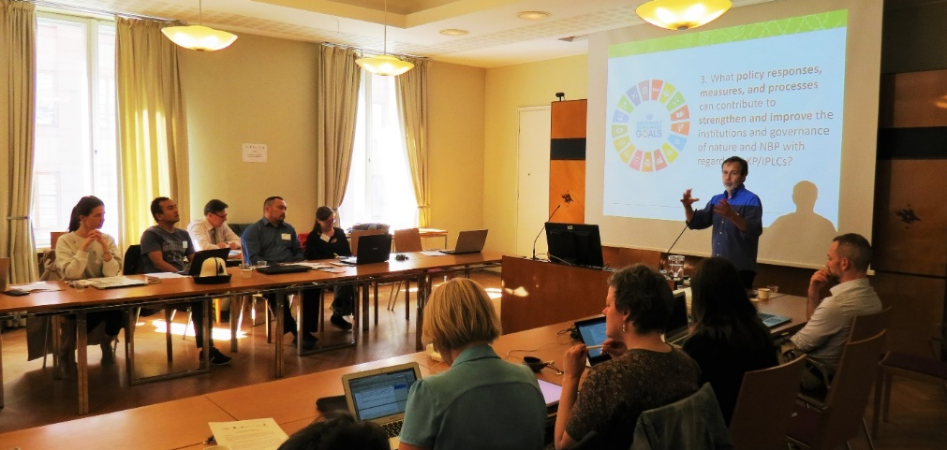

Chapter 2: Nature, trends and drivers

Chair: Svein Mathiesen
Presenter: Zsolt Molnár
Trends and indicators
- There is a need to consider Indigenous Peoples’ holistic indicators. Indigenous Knowledge does not focus on only numbers. A participant shared the importance that Indigenous Knowledge places on using multiple variables. An example was provided of considering salmon, where IK directs the importance of taking in the scales of the salmon, smell, taste, texture, behaviour of the salmon, taste of water and air, riparian vegetation, and temperatures. This is in contrast to science used for management that often focuses solely on population dynamics.
- Indigenous Knowledge generally focuses on the use of multiple variables. As such, variables issued from Indigenous Knowledge cannot always be categorized in the same way as scientists would like. The Inuit Circumpolar Council (ICC) representative offered an example from the Alaskan Inuit food security work that demonstrates the multiple variables used within IK and the focus IK places on the relationship between components as opposed to individual components: If you talk to a walrus hunter about walrus, you hear about ice thickness, ocean currents, and also changes in walrus stomach, blood, and meat. In this, it is also important to be aware of the young male hunters learning how to be in their environment and their relationship with the walrus; of when the young male brings a walrus home for the first time and provides it to an elder – becoming a provider as opposed to being provided for. In this example, we see how the hunter’s health is connected to the walrus and the walrus’ health is connected to the hunter. The two cannot be considered separately. This is how IK links abiotic, biotic, social and cultural elements.
- Animal health is also important to address in terms of trends and indicators, not just population numbers. Indicators should look at the nexus of health of animals, ecosystems, and health of humans. Both Indigenous Knowledge and science are needed to gain a holistic view of the Arctic. Ecological conditions are reflected in health and wellbeing of animals, plants, humans, water, air, in everything. Internal organs are one variable needed to determine ecological conditions (for a Canadian Inuit example, see Berkes and Berkes 2009). There can be an accumulation of heavy metals / pollutants – traced as change in taste or texture. In Russia in some areas there is a change in taste in reindeer meat, depending on what they eat. Tests show high amounts of heavy metals and pollutants – there is a need to understand if it was caused by climate change or other factors such as a change in food web dynamics, freshening of water or increase in salinity in other areas, erosion causing an increase in nutrients and minerals in some bodies of water, or species moving to new areas and transporting nutrients such as fixed nitrogen. Indigenous Peoples need to know what kind of prospects or scenarios they have for the future. They also need to know whether mines are responsible, but extractive industries will not be transparent. Independent assessment and opinion is important.
- Change of languages is itself not only an indicator of biodiversity change (see for example the CBD), but is also linked to ecological well-being. There has been a great deal of work (including a PhD dissertation) on snow terminology in Sami languages, showing the richness of the knowledge (e.g., Eira et al. 2013). The Global Assessment authors may consider that there are similar reports from Indigenous Peoples homelands from across the Arctic on snow, ice, wind, etc. (See for instance the repository of works at Kawerak.org.)
- There is good literature on loss of Indigenous languages, which should be a status and trend measure.
- The Global Assessment needs a way of connecting the indicators and trends to tell a better story. IPBES also has a mandate to collect indicators that tell a different story. It was suggested that new indicators for biodiversity need to be co-developed with Indigenous Knowledge holders and scientists (co-developed referring to an equitable process that would include Indigenous Peoples from the start, through collection of information, to analysis and output). However, indicators are by definition reductive – they cannot tell a holistic story. This is difficult to address. Many indicators used by international organisations are not appropriate. There is a 2-step process that IPBES can try to help contribute to – we can change the indicators that we use, acknowledge bio-cultural connections, and move away from measures that are totally inappropriate. But this doesn’t solve the problem of holism.
- The CBD’s 8j process identifies 3 indicators: language loss, land tenure, and traditional occupations, and these were also used in previous reports of the Arctic Council. There is also an Arctic Human Development Report on indicators (Larsen 2010). It identifies that GDP doesn’t measure what is important. It also identified three other indicators that are crucially important – fate control; cultural integrity; and contact with nature.
- Indigenous Knowledge uses a large number of qualitative indicators, while science relies more often on quantitative indicators, and they are complementary.
- While the Indigenous participants stressed the drawbacks of economic evaluations, an IPBES author noted that so far one of the biggest critiques of the IPBES Global Assessment from State representatives is that there is no economic valuation of biodiversity. If there is an economic value given, the Global Assessment also supplies other values.
- Trends shown in the Global Assessment are global. For example, food production is shown to have increased. Yet we have food insecurity in some areas, so saying there is a trend of an increase in food is not very useful. For example, according to some reports, the Canadian North (as a whole) has a food insecurity problem, due to climate, habitat change, and people spending less time on the land (CCA 2014). However, it was also stressed that Indigenous Peoples hold their own understanding and definitions for food security and insecurity. The report currently does not reflect this understanding.
- There are two sets of documents about Arctic trends and drivers that would be good material for this chapter: the Arctic Resilience Interim Report of 2013 and the Arctic Resilience Report of 2016, and the Arctic Council AMAP studies from 2017.
Creating a Holistic Assessment: providing a platform for the utilization of both IK and science
- The way in which information is categorized can influence our perception of the world, and defines and limits how the world can be described and measured. How information is categorized influences decision and policy-making. The Global Assessment needs to contain a reflection on its use of knowledge and categories. It is important to make room for more than one way of viewing the world. On the topic of Indigenous Peoples food security, it is important that they define what food security means to them. Numbers are used to measure components of food security even under the Alaska Inuit food security work (e.g., ICC 2015). It is not that numbers are not used by Indigenous Peoples, it is that more than numbers are used.
- Food security reports from the Inuit Circumpolar Council could be referred in the report. The references (e.g., ICC 2012, 2015) are not yet in the assessment.
- However, the use of numbers or data needs to balance the need to address different agendas and audiences. Governments often like to have information presented as numbers and graphs, and the Global Assessment needs to do this without being too reductionist.
- Forcing Indigenous Peoples to discuss nature in terms of numbers can impact the ways they understand and manage natural resources. It also degrades the IK and further marginalizes Indigenous Peoples. For Sami reindeer herders the story was not about numbers until the state intervened. Sami began to think in a different way, with ecosystem decline as a result.
- Some scientist argue that putting a monetary value on parts of the ecosystem may aid Indigenous Peoples. However, Indigenous Peoples, including Inuit, hold their own views on the trade-offs between assigning an economic value or not. For instance, in a few areas where it was suggested to place a monetary value on polar bears, Inuit were displeased with the idea. A consensus on this view has not been taken with all Inuit, but it should be remembered that Indigenous Peoples do not always like to put an economic value to things.
Cultural landscapes
- There is some good documentation of Arctic cultural landscapes, for example reindeer grazing on the tundra (e.g., Tyler et al. 2007).
Resources
- Arctic Council 2016. Arctic Resilience Report. Available at: https://oaarchive.arctic-council.org/handle/11374/1838
- Berkes, F. and M. K. Berkes 2009. Ecological complexity, fuzzy logic and holism in Indigenous Knowledge. Futures 41: 6-12.
- CCA 2014. Expert Panel on the State of Knowledge of Food Security in Northern Canada, Council of Canadian Academies (www.scienceadvice.ca).
- Eira, I.M.G., C. Jaedicke, O.H. Magga, N.G. Maynard, D. Vikhamar-Schuler and S.D. Mathiesen. 2013. Traditional Sámi snow terminology and physical snow classification -- two ways of knowing. Cold Regions Science and Technology 85: 117-130.
- Eira, I.M.G. 2012. The silent language of snow. Sami traditional knowledge of snow in times of climate change. A dissertation for the degree of Doctor of Philosophy. https://munin.uit.no/handle/10037/9843
- Inuit Circumpolar Council, 2015. Alaskan Inuit Food Security Conceptual Framework: How to Assess the Arctic from an Inuit perspective. Technical Report. Inuit Circumpolar Council, Anchorage, Alaska.
- Inuit Circumpolar Council, 2012. Food Security Across the Arctic. Prepared by Inuit Circumpolar Council Canada. Background paper of the Steering Committee of the Cricumpolar Inuit Health Strategy. Available at: http://www.inuitcircumpolar.com/icc-canada-health-reports.html.
- Larsen, J.N. (ed.). 2010. Arctic Social Indicators - A follow-up to the Arctic Human Development Report. Documentation. Nordic Council of Ministers. http://library.arcticportal.org/712/
- Tyler, N. J. C., J. M. Turi, M. A. Sundset et al. 2007. Saami reindeer pastoralism under climate change: applying a generalized framework for vulnerability studies to a sub-arctic social-ecological system. Global Environmental Change 17: 191–206.
Note: Additional resources are listed at the end of the report.

Chapter 3: Assessing progress towards meeting major international objectives related to biodiversity and ecosystem and services

Chair: Carolina Behe
Presenter: Victoria Reyes-García
General comments
- International targets are not holistic at all. They do not look at cultural impacts. Working towards one target can lead to a negative impact on another. The Global Assessment is aiming to make these implications more visible and more apparent.
- We must consider costs and benefits of moves towards targets and goals, as some groups of people benefit more than others. As authors it would be interesting to receive IPLC views on if we are approaching some targets or goals.
- Value systems are at play when considering these international objectives. For example, who gets to choose what is sustainable?
- Indigenous Peoples participated in the processes for the Sustainable Development Goals (SDGs) and Convention on Biology Diversity (CBD) Aichi targets, but were unable to really influence the processes. If the targets had been more aligned with Indigenous Peoples realities, it would be easier for Indigenous Peoples to monitor and assess progress.
Protected areas and human rights
- Protected area coverage is the only target that is on target, yet both Indigenous Peoples and scientists have problems with how it is being achieved.
- Authors of the Global Assessment have a significant responsibility to speak loudly on the terrible history of protected areas and indigenous peoples – there is not enough on this topic in the overall report.
- Indigenous Peoples will be affected disproportionately by the expansion of protected area coverage. When a protected area is created, there is a need to look at who gets costs and who gets benefits. Where international conventions involve protected areas, there should be mechanisms to ensure Indigenous Peoples get benefits and not only the costs. Protected areas can have less negative social impacts if they can be used by Indigenous Peoples, for example as a reserve area for grazing.
- The concept of protected areas does not come from an Indigenous Peoples’ conservation perspective.
- Indigenous Peoples have areas that they protect, but these are not included in what international conventions recognise. “Indigenous and community conserved areas” (ICCAs) are one way of exploring these areas. There are also some protected areas that are seasonally based and may be focused on the physical and/or mental well-being of animals, and/or habitat. This is found within the history of traditional management practices.
- There is controversy in the Aleutian Islands around which resources should or should not be protected. There is also the issue of the mixed economy, as Indigenous communities depend on resources for cultural lifestyle as well, e.g. commercial fishing supports traditional activities. Efforts to bring in protected areas impacts the culture of the people on the landscape, and regulations impact their ability to practice their lifestyles. Also managing for one species over another one causes trade-offs and problems.
- The CBD has EBSA (Ecologically or Biologically Significant Marine Areas), but we need Culturally, Ecological or Biologically Significant Marine Areas.
- Implementation of the principle of Free, Prior and Informed Consent (FPIC) is important before identifying protected areas, and also during management decisions in existing protected areas (see Herrmann and Martin 2016).
- Protected Areas can be used as a pretext to exclude groups from access to areas and traditional livelihoods. The Dukha were thrown off land in Mongolia to make way for a protected area in the name of UNEP. In Russia there is a legal regime; where Indigenous Peoples are told that an area is their territory. This is a way of maintaining the reindeer system and maintaining the cultural system. Indigenous Peoples and National Parks is also a priority area for the Russian Association of Indigenous Peoples of the North (RAIPON).
- In Russia many protected areas have been created excluding Indigenous Peoples, and this has resulted in significant issues and problems. E.g. In 2016 there were plans to create a national park on the territory of the Nenets, but the Nenets were able to reach agreement and the park has not been created yet. One of the key issues is that indigenous peoples were regarded as poachers. But the Nenets were able to demonstrate that the indigenous peoples should be able to participate in these processes. In many cases where such plans were made it was actually done by someone other than the representatives of local indigenous populations. In the course of this negotiation, the Nenets were able to reach agreement that the social and economic situation of indigenous peoples should be taken into consideration to allow them to continue their livelihood. The Nenets were able to agree on the conditions with the environment authorities that the indigenous peoples be certified / authorized as representatives of conservation and environmental authorities, and exercise monitoring and control in the protected area. This was very important for the polar bear, bird nesting, and walrus, and currently indigenous peoples are efficiently involved in this kind of conservation management.
- Protected marine areas will increase in the next decade, and many will be located in the Arctic as that is a big available space. This presents a potential threat that could be eventually transformed into an opportunity, if indigenous peoples are engaged from the beginning. An example was also provided from the Inuvialuit Settlement Region (ISR) of Canada. Within the ISR, Inuit worked with the Canadian government for over 13 years to negotiate and agree upon terms of a protected area focused on beluga health.
Co-management
- Co-management, conveys not just rights but responsibilities, which go together. For most Indigenous Peoples, rights and responsibilities go together. Land users have many of the same goals as conservationists.
- At the 2013World Reindeer Herders Congress in China, it was shown that areas that already had regulations concerning reindeer herding showed a higher quality of reindeer herding. This is not just a way of life or a livelihood; reindeer herding includes a broader perspective of communication and relations with other stakeholders and there should be necessary legislation to regulate reindeer herding. It is good that this chapter refers to legislation in national conventions, but it is also important that national conventions are ratified and implemented. Then as far as decision-making is concerned it is clear it is always important to have agreement from Indigenous Peoples.
- In Russia governance systems can be better for Indigenous Peoples than in western European countries. It is possible to have a territory with self-determination, and to have people engaged in managing that area, with only herders on the management board.
- In terms of SDG targets training, some Russian indigenous groups are going to launch an institute for community-based monitors with WWF. They have an agreement with WWF to attract necessary action to involve local actors in this process. Because indigenous peoples know about the animals and biodiversity, so they are an important resource in preserving biodiversity and sacred sites.
- There are also protected area success stories, and the Global Assessment needs to show both sides. There are some good examples of co-management. Indigenous Peoples in the Amazon made an alliance with conservation movements, and this allowed them to increase their lands in the Amazon. The government gave protected areas and incentives for intensive agriculture, so protected areas become islands in areas of destruction.
- Self-determination is crucial. Indigenous management mechanisms are being put forward – making it clear that indigenous peoples have been managing their environments for years.
Limitations of protected areas
- We have targets calling for protected areas, but the push for enforcing them comes when industry encroaches.
- Protected areas also still give a green light that areas outside are open for development. Development is inclusive of tourism and shipping activities.
- In the Laponia Sami administrative unit there are so many wolves that the reindeer are disappearing. As people get disconnected from nature and there is no way to control the wolves.
Flexible protected areas
- Protected Areas need not be fixed in space and time – they can move and their use can shift. This is consistent with Indigenous practices of rotating areas for hunting and grazing (Elmkvist et al. 2004) and their own practices of protecting resources. One potential idea would be to suggest that protected areas can have multiple goals and multiple purposes.
- Connectivity of marine protected areas can follow an Indigenous perspective. You do not manage everything the same way every day of the week. Management systems need to be flexible and constantly adjusted.
Resources
- Elmqvist, T., F. Berkes, C. Folke, P. Angelstam, A.-S. Crépin and J. Niemelä 2004. The dynamics of ecosystems, biodiversity management and social institutions at high northern latitudes. Ambio 33: 350-355.
- Hermann, M. and T. Martin, editors. 2016. Indigenous Peoples’ Governance of Land and Protected Territories in the Arctic. Springer.
Note: Additional resources are listed at the end of the report.
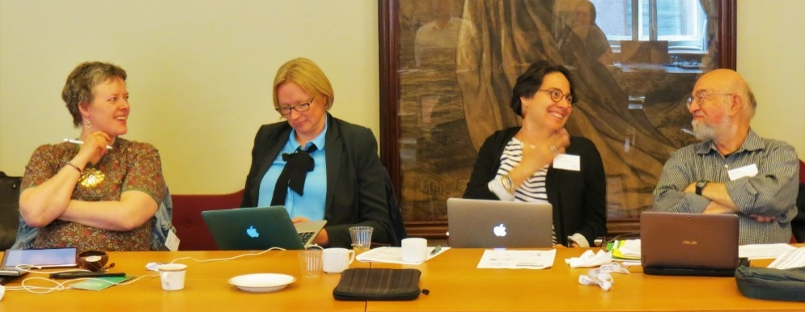

Chapter 4 - Plausible futures of nature, its contributions to people and their good quality of life

Chair: Liza Mack
Presenter: Eduardo Brondizio
Arctic scenarios
- The Global Assessment should be considering scenarios for major tipping points. A major scenario that should be considered is an ice-free Arctic, with consequent resource development, tourism etc.
- Fragmentation of the land is one of the most important drivers of biodiversity change.
- The Millennium Assessment used a very simple scenario approach with just two axes producing four scenarios. Scenarios can help people think if they are comprehensible. If they include many variables and complexities, they can be confusing.
- The Globio programme (a modelling framework to calculate the impact of five environmental drivers on land biodiversity for past, present and future) was developed in Norway in the early 90s due to a gas producing unit on an island in Norway. This was circumpolar scenario work, predicting how biodiversity would be in 2030, with maps.
Participation in scenario development
- There are challenges in scenario planning, as it is hard to combine multiple value systems. Indigenous Peoples often do not write down their knowledge, so it is hard for the Global Assessment to include this knowledge if it is all done from literature reviews. It is important to note that IK has validation processes and Indigenous Peoples do go through a peer review process. It may also be important to note that many Arctic Indigenous organizations have compiled and written reports. These reports are often not published in scientific periodicals and would require additional time and energy to gather. See for instance the work of Eallin 2015 by the Arctic Council Sustainable Development Working Group (SDWG).
- There are scenario workshop reports from Inuit homelands, but this was a challenge as researchers would go to a community with Indigenous Peoples and non-Indigenous Peoples and mass all of the information gathered together, so the Indigenous voice at times may be lost. What is put into the model affects what comes out. However, there is still a concern in lumping together multiple value systems that may result in the further marginalization of Indigenous Peoples. In scenarios workshops, it can be clear that without Indigenous Peoples many issues would not be included, for example marine mammal behaviours can be missed entirely.
- There are multiple ways of Indigenous communication that could be utilized within a scenario planning discussion. For example, storytelling is one of them and it has proven to be a very effective tool for getting ILK into scenarios and building narratives, not only in the Arctic but in most or all Indigenous areas (Cunsolo Willox et al. 2012; Fernández-Llamazares and Cabeza 2018).
- It can also be important to focus on adaptation and positive features of change. Many communities prefer this to dwelling on negative futures.
- The ComMod: companion modelling approach does participatory work on scenarios with communities.
- Cunsolo Willox et al. have also done work on scenarios, looking at Indigenous Peoples’ health in relation to climate change in Canada.
Concepts of the future
- It is challenging to expect Indigenous Peoples to always participate in discussions that are framed by another culture. It was shared, as an example of framing the discussion, that many elders of one Indigenous group do not want to discuss futures in this way.
- Many adult Inuit will engage in a scenarios workshop, but many elders will not. There is a difference between looking at your responsibilities today and predicting the future. Makivik (an Inuit corporation) just made a 100-year plan, but this is slightly different from predicting – it is more how you should act today. The Inuit Circumpolar Council leadership also always focuses on long-term goals.
- There is no taboo in Aleut communities for talking about the future, and people often talk about their grandchildren. There is an inherent understanding that there will be generations after us. For example, that there is a need to be respectful when harvesting so resources can be there for the future.
- Saami can also say that every time you talk about the future, you should add a condition that if you live and if you are well. This shows respect for uncertainty about the future.
- The main point conveyed was that Indigenous peoples should be involved from the conception phase in terms of developing the discussion, framing the discussion, and deciding on the context of a discussion.
Additions to the chapter
- Some major themes that Arctic Indigenous Peoples would choose to include could be listed in the chapter e.g. food security (e.g., Pearce et al. 2015).
- Chapter 2 considers different perceptions of nature. Chapter 4 could consider different perceptions of scenarios.
- The Arctic Resilience Report 2016 has models and scenarios on several threshold changes in the Arctic – identified many ways you could have a system flip, e.g. albedo change due to an ice-free Arctic.
- Authors may also consider other Arctic workshops not specific to scenario planning, where people talk about e.g. concern of loss of language in relation to loss of sea ice.
- Adaptation strategies should also be considered. For example, what is the impact of loss of sea ice and how can communities adapt at different levels? If government regulations allow adaptation to occur it will, so this will have a high impact – the relationships between change and impacts are therefore not linear.
Resources
- ACIA 2005. Arctic Climate Impact Assessment. Cambridge University Press.
- Arctic Council 2016. Arctic Resilience Report. Available at: https://oaarchive.arctic-council.org/handle/11374/1838
- Cunsolo Willox, A., S.L. Harper, V.L. Edge, ‘My Word’ Storytelling and Digital Media Lab, and Rigolet Inuit Community Government 2012. Storytelling in a digital age: digital storytelling as an emerging narrative method for preserving and promoting Indigenous oral wisdom. Qualitative Research 13: 127-147.
- Eallin, 2015. Youth: The Future of Reindeer Herding Peoples. Executive Summary. Arctic Council Sustainable Development Working Group (SDWG), EALLIN Reindeer Herding Youth Project.
- Fernández-Llamazares, A. and M. Cabeza 2018. Rediscovering the potential of Indigenous storytelling for conservation practice. Conservation Letters 11: 1-12.
- Pearce, T., J. Ford, A. Cunsolo Willox and B. Smit. 2015. Inuit traditional ecological knowledge (TEK), subsistence hunting and adaptation to climate change in the Canadian Arctic. Arctic 68: 233-245.
Note: Additional resources are listed at the end of the report.
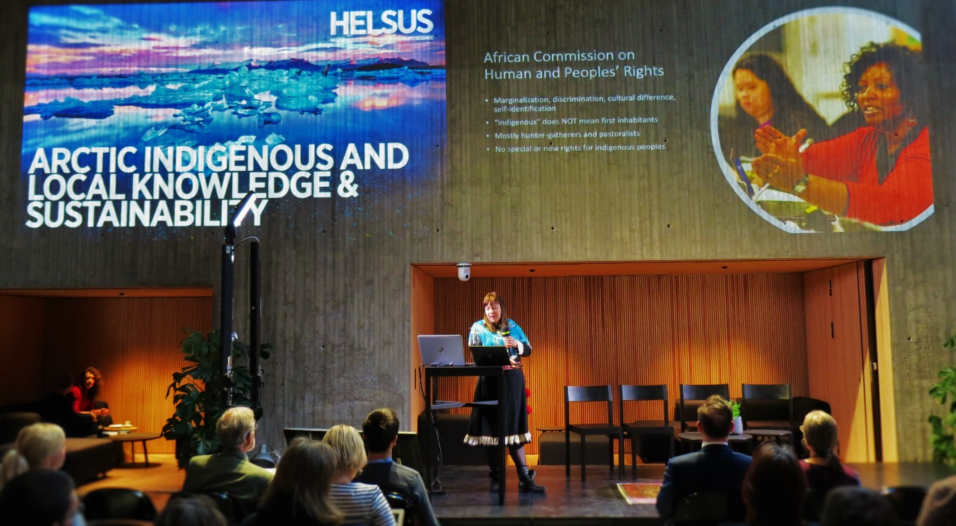

Chapter 5: Scenarios and Pathways Towards a Sustainable Future
Chair: Polina Shulbaeva
Presenter: Terre Satterfield
Food security
- Food security has a lot to do with cultural rights and human rights, and there are social factors at play. As dynamics in communities change (for example out-migration and shifts in livelihood), there are fewer young people to hunt and fish, and elders are often too old to engage in these activities. Access and resources (including financial resources) are also needed to participate in traditional activities.
- Food sovereignty is not equivalent to food security. Surveys of food security often ask if people missed any meals. If the answer is no, it gives the impression of being food secure. But many Indigenous Peoples are missing traditional food, not meals. It does not matter what you have in the freezer, if you don’t have culturally important food (e.g., whale), you feel food insecure.
- Self-determination is critical to Indigenous food security. The Alaska Inuit food security report stresses that the leading driver to food insecurity is lack of decision-making power and management. Food security is distinctly tied to food sovereignty – without food sovereignty, it will not be possible to achieve food security.
- Traditional fishing rights of the Saami were restricted by 80% in a particular river. This has an impact on their food. They had to find ways to supplement their diet. The legislations on hunting times also restricts their traditional way of living. It has a huge impact on the food and health of the Saami people. Possibilities to hunt or fish have been lost. There is a need to look at the impact of legislation on the cultural rights of Indigenous Peoples and on food security.
- In the north, often you can find McDonalds, but there are problems with using locally produced reindeer, with a great deal not used and thrown away. There is also the issue of bird hunting in northern Russia, with strong arguments by ornithologists to abandon this traditional practice. But activities such as these are important to Indigenous cultures and cultural continuity in the Arctic.
- Canada has been subsidizing the transport of food from the South to the North. However, the subsidization did not translate into food sovereignty and lower costs for the northern First Nations and the Inuit. There have been a lot of issues surrounding what is subsidized and who receives benefits to the subsidization. Russia, Norway and Sweden are much better positioned on this regard, as they are producing food in the North. More resources should be put there to promote food security and local food production systems (CCA 2014). Local investments are important to avoid food being imported, and the costs of transport need to be considered.
- One Indigenous participant noted that it is often said that Indigenous Peoples need greenhouses in the north, but Indigenous Peoples did not grow up with fresh lettuce. Arctic Indigenous communities need more focus on traditionally appropriate food, rather than foods from the south. See for instance the work of Eallu (2017) or Eálat (2013).
- Solutions have to be in balance and need secure sustainable development of Indigenous Peoples. We have to remember that Indigenous Peoples usually live in areas that are rich in biodiversity and have lots of different species of animals and plants. It is important to highlight that Indigenous Peoples can provide food not only for themselves, but also for others. It is important to support Indigenous Peoples so they can compete in their current situation. In Russia Local Communities are supported to provide food for themselves. Now, taking into account current population trends and migration to the north, Indigenous Peoples are also asked to provide not only for themselves but also for others.
- The ICC Alaska report (ICC 2015) does not measure food security in terms of numbers; they have other ways of measuring it and conceptualizing – which includes stability, availability, accessibility, decision-making power and management, culture, and health and wellness. These components make up a healthy ecosystem. To evaluate or determine food security, numbers and many other variables would be used. This concept of food security is inclusive of water, air, and all other components that makes up an ecosystem.
- The chapter is not just about food, but also about water, clean air, health and well-being. The modelling process aggregates variables.
Human Rights and Conservation
- The history of conservation and Indigenous People is long and problematic and is therefore a cross-cutting concern for IPBES and more broadly. By examining the history of problems, some key considerations for improvements are:
  - Planning led by indigenous peoples and consent are key to biodiversity decision making as is recognition of historical wrongs in conservation;
  - Violent and militarized forms of conservation and displacement of Indigenous people should be considered a human rights concern, as should the criminalization of traditional livelihoods;
  - Conservation efforts should never exacerbate the poverty and food insecurity of Indigenous people; and
  - Community-based conservation planning and decision-making is key to good conservation, as is indigenous knowledge-based planning.
Biocultural monitoring
- It is important to highlight biocultural monitoring (Gavin et al 2018; Wilson et al. 2018). The concept of cultural keystone species is sometimes used but can be problematic. Regardless, it needs to be emphasized that cultural keystone species are connected to most primary knowledge and related practices central to Indigenous identities, and there are strong connections between these species and other features of the natural world. In this sense, the term biodiversity is not as important as other terms such as variety or biocultural diversity.
Adaptation
- There is a huge literature on the use of Indigenous Knowledge for adaptation, including in the Arctic (Nakashima et al. 2012; Savo et al. 2016). Adaptation is particularly effective in places where the knowledge-base has been built up over a long time-span. This chapter could add a discrete section on adaptation to realize better futures.
Resources
- CCA 2014. Expert Panel on the State of Knowledge of Food Security in Northern Canada, Council of Canadian Academies (www.scienceadvice.ca).
- Ealát, 2013. Reindeer Herding, Traditional Knowledge and Adaptation to Climate Change and Loss of Grazing Land. Norway and Association of World Reindeer Herders (WRH) In Arctic Council, Sustainable Development Group (SDWG), Alta, Norway.
- Eallu, 2017. Food, Knowledge and How We Have Thrived on the Margins. In Arctic Council, Sustainable Development Group (SDWG), Alta, Norway.
- Gavin, M.C., J. McCarter, F. Berkes, A. Mead, E. Sterling, R. Tang and N.J. Turner 2018. Effective biodiversity conservation requires dynamic, pluralistic, partnership-based approaches. Sustainability 10, 1846; doi:10.3390/su10061846
- Inuit Circumpolar Council, 2015. Alaskan Inuit Food Security Conceptual Framework: How to Assess the Arctic from an Inuit perspective. Technical Report. Inuit Circumpolar Council, Anchorage, Alaska.
- Nakashima, D.J., K. Galloway, M. McLean. H.D. Thrulstrup, A. Ramos Castillo and J. Rubis. 2012. Weathering Uncertainty: Traditional Knowledge for Climate Change Assessment and Adaptation. Paris: UNESCO.
- Savo, V., D. Lepofsky, J.P. Benner, K.E. Kohfeld, J. Bailey and K. Lertzman 2016. Observations of climate change among subsistence-oriented communities around the world. Nature Climate Change 6: 462-474.
- Wilson, N.J., E. Mutter, J. Inkster and T. Satterfield 2018. Community-based monitoring as the practice of Indigenous governance: A case study of Indigenous-led water quality monitoring in the Yukon River Basin. Journal of Environmental Management 210: 290-298.
Note: Additional resources are listed at the end of the report.

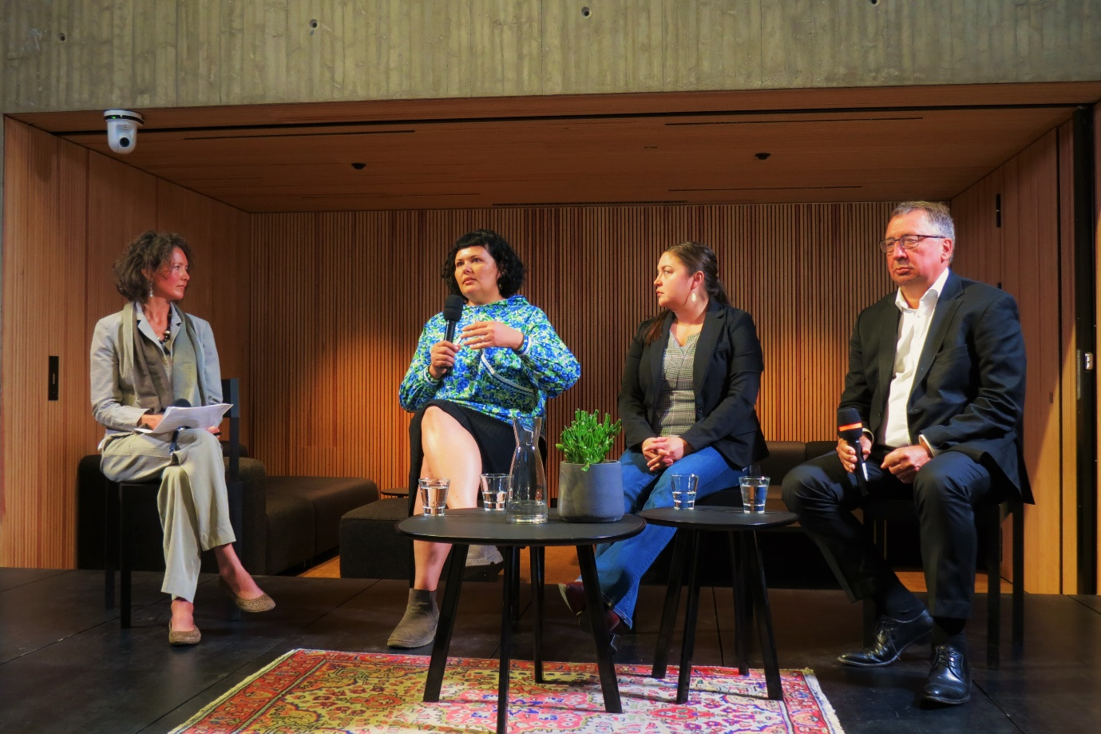

Chapter 6 - Options for Decision Makers
Chair: Anne Nuorgam
Presenters: Pamela McElwee & Álvaro Fernández-Llamazares
Governance
- Arctic Indigenous Peoples are often the first to be impacted by global and regional changes, and they are the first to be expected to change to address the impacts.
- Policy recommendations are proposed, and they often only come from one piece of the puzzle (science). Indigenous Knowledge allows us to put the pieces of the puzzle together.
- The Global Assessment wants to say that the governance structure should be more adaptive and asks how the government structures we build fit the dynamism of knowledge.
- The UN Declaration of the Rights of Indigenous Peoples is prominent in Chapter 6. There is a section on human rights and Indigenous Peoples in conservation.
SDGs
- The priorities set in the SDGs often do not match Indigenous Peoples’ realities. For example, Indigenous Peoples do not define poverty only by money (as it is often implied in reports by development agencies). There is a need for a process that builds equity and explores how governance drives inequality and objectification of the environment.
Arctic Council
- Science-based circumpolar trends and policy are discussed a lot in the Arctic Council, and there is a need to look at synergies between the Arctic Council work and the Global Assessment.
- The Arctic Council is a unique governance system where Indigenous Peoples (i.e., Permanent Participants) sit on the same table with Arctic Foreign Ministers. However, the Permanent Participants do not sit at the same level as the ministers in terms of decision-making. The Arctic Council is a decision-making body, but technically the Permanent Participants do not have voting power. Permanent Participants are often considered, and their voice is at the table, because Permanent Participants literally sit at the same table as the States and raise their positions when they wish, but this is different from equal decision-making power.
- The Arctic Council could be used as a model for governance with Indigenous and Local Communities elsewhere in the world. There are challenges but so far it has been a good solution. Indigenous Peoples should be on same level as ministers of environment.
- The Arctic Council does a good job in terms of horizontal and vertical connections, aggregating information from across the states. This is important because Arctic communities in many parts of the region are isolated. In the case of the Canadian Arctic, much of the area is covered by land claims and co-management systems, which provide these horizontal and vertical linkages. But the isolation of individual communities is still an issue.
- Other participants did not agree that the Arctic Council is a good example of governance with Indigenous Peoples. There are still inequalities. For example, Indigenous Peoples are always being asked to respond to predetermined plans and reports, rather than building something together. It is important to understand the exact structure of the Arctic Council and emphasize the points that work well and build upon them.
- The Sami Council have been promoting the Arctic Council as a good model to new observers to the Arctic Council. Different scales of governance should be kept in mind; the Arctic Council is a model at a certain level. At a local level, e.g. salmon fishing, indigenous peoples are looking more for self-governance.
- The Arctic Council model was rejected by the Pacific as they did not want Indigenous Peoples to have such a prominent place at the decision-making table.
- Bad decision-making is often based on bad science with Indigenous Knowledge not used.
Co-management
- Community-level adaptation is often impeded by regulations and restrictions imposed upon Indigenous Peoples that limit or prevent adaptation informed by Indigenous Knowledge. Without freedom to use their knowledge, Indigenous Peoples cannot adapt.
- If Indigenous Peoples are only allowed to use one language they become limited in the decisions they can make, as it limits how they can think about and describe issues.
- There are many papers on governance in the Arctic and co-management, but most are not written by or evaluated by Indigenous Peoples, and do not include realities on the ground.
- There is a polynya between Canada and Greenland; this ‘great upwelling’ is a biodiversity hotspot. Management rights are being negotiated over this important area.
- The Arctic Council sent out a survey on biodiversity – half of the responses came from Indigenous Peoples. This survey showed that Indigenous Peoples see bad decision-making as the main threat to biodiversity and food security in the Arctic. Building Indigenous Knowledge into decision-making is seen as the solution.
- It is important to consider co-management, and also legal pluralism in which traditional Indigenous systems are recognized. For example, New Zealand has better government to government relations with emergent co-governance for decision-making processes.
- Adaptive management combines the perspectives and practices of co-management and adaptive management (Armitage et al. 2007). Adaptive co-governance is the more inclusive term and allows response to change at the governance level (Folke et al. 2005).
- In Norway co-management boards for reindeer husbandry started in 1976, when a new law was introduced. Sami and Norwegian herders sat on the board, but the workings of the board did not include Indigenous Knowledge, only ‘scientific’ western knowledge. The opposite occurs in Russia, where there is self-determination, and an Indigenous person who is responsible for their brigade is responsible for people and the reindeer. This level of local control is not seen in Norway.
- Reindeer husbandry is a very serious issue, and a great responsibility. Every decision should be made under the principle of causing least harm, so every decision should be well-balanced. If Indigenous Peoples are involved in decision-making, decisions should be based on Indigenous Knowledge, which came from their ancestors.
- Every opportunity should be used to get Indigenous communities into the decision-making process. And for every decision-making process it is important to think forward and make sure representatives of youth are involved. Indigenous communities should also learn from each other and not repeat each other’s mistakes. People or communities cannot have a future unless they know their past, so youth learning about the past is important.
- For the issue of salmon management in Finland, there is no guide on how to take Sami knowledge into account. The Global Assessment could provide a step-by-step guide on how to include Indigenous Knowledge in management systems.
- IPBES authors noted that one of the dilemmas of the chapter is to be balanced about participation. For each positive paper showing positive results from co-management, others show that inequalities can increase. The chapter should not just praise participatory approaches; but it should also recognise that it is better than totalitarianism. It needs to be balanced but hopeful.
- There is a book by Thora Martina Herrmann & Thibault Martin, entitled “Indigenous Peoples’ Governance of Land and Protected Territories in the Arctic” (Springer, 2016) that looks at different angles of governance and has a good discussion on the issues of FPIC.
Capacity building and empowerment
- It is encouraging to see Indigenous Peoples recognised at the level of the Global Assessment in relation to policy.
- There is an increasing space where Indigenous Peoples can participate, but there is still an issue with capacity. There is also a need to build institutions and find funding to help Indigenous Peoples take advantage of these opportunities. Indigenous Peoples need institutions as a foundation to support Indigenous Peoples experts. At present Indigenous Peoples organisations often rely on volunteers, pulling in people from different places, to cover the many meetings and processes that they can now participate in.
- One of the main findings of Chapter 6 is that increasing participation of Indigenous Peoples in environmental governance requires sustained institutional and financial support.
- The term “capacity development” is better than “capacity building” – implies building on strengths, rather than “teaching” communities how to do things (Sen 2013).
- The term “empowerment” may be more appropriate for the development of Indigenous communities and regions, as “capacity building” is often understood as outsiders telling communities what to do. There are people who have the knowledge and know what to do, but maybe extra funding is needed, or room for indigenous scholars to be at the table.
Gender
- Two recent studies show that women are not much engaged in management boards for natural resources, e.g. Swedish reindeer management boards. This shows a challenge of gender balance. When there is not a balanced picture, boards will only be looking at half of the truth or the needs of the population.
- Indian forest council groups with more women have better biodiversity outcomes.
- Regarding management boards and gender dynamics, in two communities in the Aleutians, board dynamics are totally different – one is dominated by men, the other by women.
Sacred sites
- The Circumpolar North is full of sacred natural sites. It is good that sacred sites are mentioned in the chapter. In many cases we are forgetting and becoming more distant from sacred sites. Every Indigenous community has strong knowledge, but we are drifting away from it. Even other nations who do not share Indigenous Peoples’ beliefs, if they are passing by a sacred site they may not believe in it, but they will still stop and stand there. There are some laws and bills passed in Russia that recognise sacred sites of Ins. People living in Nenets District are working on a similar bill.
Resources
- Armitage, D., F. Berkes and N. Doubleday, editors 2007. Adaptive Co-Management: Collaboration, Learning, and Multi-Level Governance. University of British Columbia Press, Vancouver.
- Folke, C., T. Hahn, P. Olsson, and J. Norberg 2005. Adaptive governance of social-ecological systems. Annual Review of Environment and Resources 30: 441-473.
- Herrmann TM, Martin T. 2016. Indigenous Peoples’ Governance of Land and Protected Territories in the Arctic. Springer. Available in pdf online.
- Sen, A. 2013. The ends and means of sustainability. Journal of Human Development and Capabilities 14: 6-20.
Note: Additional resources are listed at the end of the report.
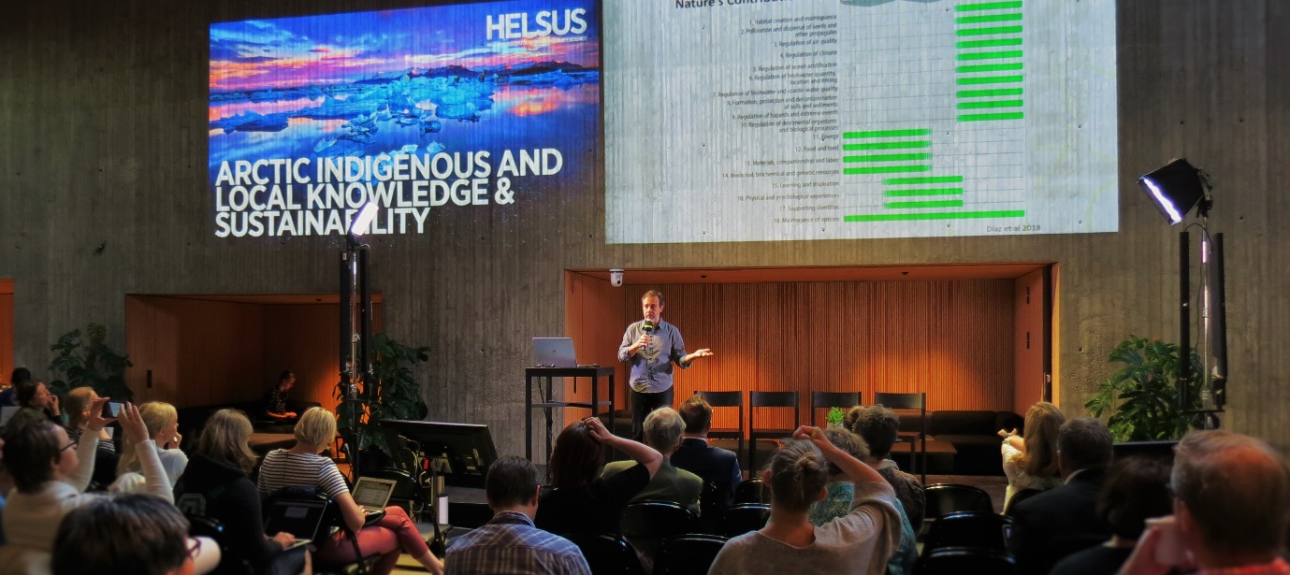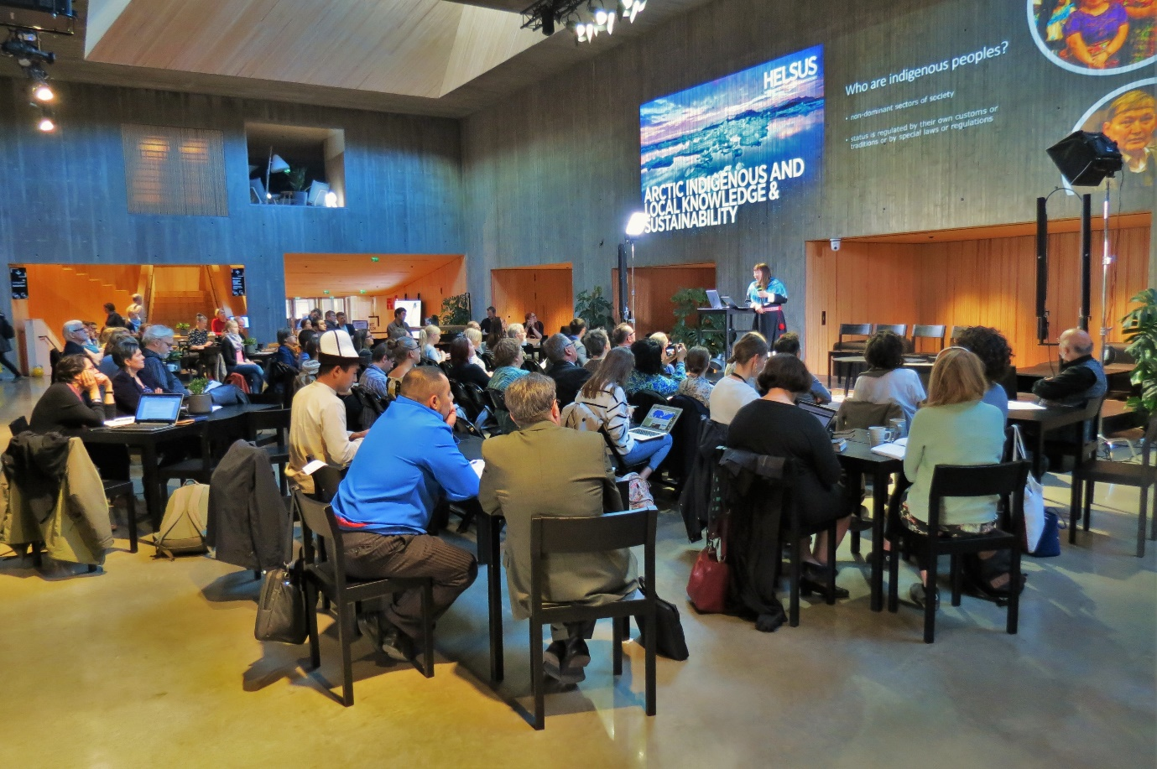

How can the IPBES assessment be useful for Indigenous Peoples?
Chair: Gunn-Britt Retter
- The Global Assessment must include the Arctic, if it is talking about global systems.
- Noting in the report that indigenous peoples should have been included in the scoping of the GA would give recognition to Indigenous Peoples, and would help with efforts to also push the IPCC to better include Indigenous Knowledge. To include Indigenous Peoples and Local Communities in the scoping process of assessments is a recommendation the Global Assessment should make to IPBES.
- The Alaska Food Security Conceptual Framework includes governance and impacts on management of ecosystem and Indigenous Peoples. Strong statements on co-management, food security, and human rights could all be very valuable to the Inuit Circumpolar Council (ICC).
- It is important to review the history of protected areas in the Arctic.
- Focusing on human rights-based resource access can turn discussions around from focusing on large-scale resource exploitation to focusing on small-scale uses and community benefits, Indigenous and other (FAO 2015).
- The assessment must be efficiently communicated to Indigenous Peoples, so that they are able to involve themselves in the assessment process and ongoing policy processes.
- The Global Assessment should be translated into other languages, such as Russian. Without an effort being made to translate it into other languages, it will be difficult for communities to use it. The final document should have an applied focus.
- Many potential audiences will not be reached if the Global Assessment is not translated. The summary for policy-makers of the assessment will be translated into all the UN languages. There are also other options, for example, the IPCC takes a particular section of their reports and then they produce a synthesis about a particular aspect. The Global Environmental Facility would have an interest in providing some technical reports. The same could be done for the IPBES Global Assessment, e.g., producing visual syntheses for particular regions or topics.
- The terminology of ILK vs. traditional knowledge is important, so that the word ‘traditional’ does not get suggest that the knowledge is only relevant to the past. It is good to show that IK is dynamic, not static.
- The Global Assessment should include the responsibilities that come along with rights, for example sustainable harvesting of fisheries.
- The Global Assessment can be a tool to support Indigenous negotiations with governments and other actors. This is an assessment that Indigenous Peoples should want to show to governments, and the Global Assessment should highlight the cultural dimensions of environmental policies.
- The Global Assessment can provide an engine and a universal template to effectively involve Indigenous Peoples in environmental conservation and biodiversity governance.
- The Global Assessment is a chance to make sure that the knowledge-base of Arctic Indigenous Peoples is recognised, protected and used. Indigenous peoples need knowledge cooperation not activism. It is not easy to pass through cultural filters, even in Arctic Ministerial meetings, so it is important to build mutual respect.
- Indigenous peoples need collaboration from different actors and the Global Assessment should reflect this collaboration and this cooperation, including different values and different knowledge systems.
- Indigenous peoples cannot do without science and without scientific knowledge, which should be used to complement Indigenous Knowledge.
- Key issues for Indigenous Peoples include the wellbeing of Indigenous Peoples; biodiversity; self-governance; culture and language; equitable, meaningful inclusion of ILK; and ensuring cultural continuity, and in doing so ensuring that land, air, water is able to support livelihood activities.
Resources
- FAO 2015. Voluntary Guidelines for Securing Sustainable Small-Scale Fisheries. Food and Agricultural Organization of the United Nations, Rome.

What knowledge gaps should be addressed in the IPBES Global Assessment through the Second Order Draft review process? What issues and themes are yet to be covered?
Chair: Fikret Berkes
Decolonising methods
- What are de-colonialising methodologies, and how are they used in the Global Assessment? A framework for decolonizing methodologies could go into chapter 1, which would then set the context. It would be interesting to talk about decolonising moves that are possible and could be entertained, e.g. language (e.g. terminology around “management”), knowledge, conservation (this is already in quite a number of chapters).
- IPBES could also emphasize the importance of decolonizing the recruitment process to be part of IPBES, facilitating the selection of Indigenous participants, practitioners, knowledge holders and scholars.
- The framework of the Global Assessment limits Indigenous Peoples’ engagement “here’s the box – fit your knowledge into it”. Categorization and how we make decisions are crucial considerations. If the Global Assessment can be built on both Indigenous Knowledge and science it will be more robust, but if we categorize in ways that limits and eliminates IK this will limit the report. Indigenous Peoples need to be involved in the analysis of information.
- The Global Assessment should contain a reflection on the process for co-production of knowledge (Miller and Wyborn 2018). Indigenous Knowledge should not be placed in separate boxes. The Global Assessment should challenge the dichotomy of science and ILK.
- There is a need for Indigenous scholars and experts to be involved in all steps.
- There is a need to engage and collaborate with Indigenous Peoples at the start of the assessment process, and in the scoping process. This should be built into the process for future IPBES work.
- Human rights should be fundamental to each chapter.
- Indigenous Peoples need to be involved in the discussions for the ten-year plan for IPBES.
Scenarios
- Another gap may be scenarios for tipping points. Change in the Arctic is not likely to be linear, it will come in abrupt and discontinuous steps. An ice-free Arctic is just one potential scenario. It is not clear which scenarios will end up being more important.
Languages
- Future work should include the analysis of papers in all UN languages, including Russian.
Food security and adaptation
- For the Inuit (and as noted in an ICC declaration) food security is the number one issue. Inuit can adapt, but they are often obstructed by government regulations.
- Climate change is a point of discussion for Inuit from across the Arctic. The conversation is often focused on the need for the world to change their behaviour and the impacts of climate change.
- The Global Assessment should also be considering adaptive capacity, ability to change, and Indigenous Knowledge as a reservoir of options giving the ability to respond to change.
- There is a need to discuss food security from Indigenous Peoples perspectives.
- There is a need for a large discussion in the Global Assessment on adaptation.
Linking biotic, abiotic and cultural elements
- There is a gap in linking biotic and biotic elements, and cultural elements. Having the interlinkages between elements well reflected is important.
SDGs
- There are concerns that Indigenous Peoples could have been more directly involved in defining Aichi and SDG targets.
Sacred sites
- Sacred sites are very important, as they emphasize cultural elements that are intertwined with nature.
Institutions
- There is a need to strengthen and develop Indigenous institutions that can help to promote self-determination, empowerment and participation.
Resources
- Miller, CA and C Wyborn. 2018. Co-production in global sustainability: Histories and theories. Environmental Science & Policy (in press) https://doi.org/10.1016/j.envsci.2018.01.016
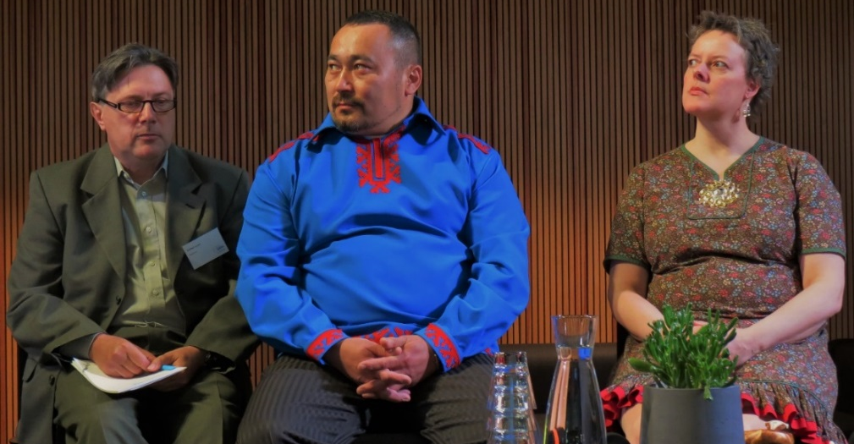

How can Arctic Indigenous Peoples make use of the Global Assessment? What processes would be needed to help with uptake of the Assessment in the Arctic?
Chair: Eduardo Brondizio
- The Sami Council would want a report that can be used as a foundation for policy and arguing for positions. This assessment and the process for working with Indigenous Peoples can serve as a model for pushing the Arctic Council to be better. The Sami Council can use it to demonstrate working methods with policy impact. It can help the Sami Council to build arguments when the Council is taking part in decision-making, and help to improve well-being at local, national and international levels.
- The UNPFII could use this UN document when negotiating with different member states and conservation organisations. It could be a base for drafting recommendations, using the Global Assessment options. During bilateral meetings with governments, UNPFII can use the Global Assessment as a baseline to take discussions forward. The Global Assessment is invited to use UNPFII to disseminate this information as many times as it takes.
- The Global Assessment could be used in negotiations with governments, future programs, and also for adaptation at the local level. For Indigenous youth who can read the Global Assessment, it could fundamentally change minds about what we need to do for the future. The Global Assessment could be a good reference for Indigenous Peoples, for youth, and for governments. Often government and Indigenous Peoples are talking but not understanding one another. We need documents to set a standard and give a common understanding.
- The Global Assessment is the best chance Indigenous Peoples have for the next 10 years, there are not many other processes that provide such an opportunity. This should be an opportunity for everyone to use their own knowledge. Indigenous Peoples are often talking to deaf ears. There are bad management procedures and bad practices in Norway. In the school system of mainstream society, management of nature doesn’t count at all. Norway has about 180 thousand reindeer, with the majority being in north of country. Nobody is willing to discuss the diversity of biodiversity available and how it can adapt to grazing by reindeer. We have to move very quickly into capacity development and dialogue.
- The Global Assessment could help to make the World Bank understand how to work with Indigenous Peoples.
- Educational materials, potentially online courses, based on the Global Assessment would be valuable.
- The Global Assessment should be provided in different national languages. For example, it will be hard to share the Global Assessment with some Aleut leadership as the materials are not in Russian.
- The Global Assessment could be used to push national governments to produce similar, national level assessments.
- The Global Assessment could give Indigenous Peoples ways to communicate what is happening in their part of the world.
- One of the challenges is distribution, and this needs consideration. A website could be a good way of making the Global Assessment accessible, although some areas do not have web access. Being strategic about how the information is given to Indigenous communities is very important. It is a good opportunity but it is also a challenge. It would be beneficial to frame the discussions in terms of colonialisation.
- Dissemination and communication of the Global Assessment are crucially important: posters, websites, fact sheets. This will need funding, and a strategy.
- The Global Assessment could be supplemented by other materials, including a toolkit and fact sheets for Arctic Indigenous Peoples, enhancing the use of the Global Assessment as a tool to communicate and make decisions.
- The Global Assessment is one of the first times there has been thinking on how to engage with Indigenous Peoples and IK, there have been good things, but also critiques. The Global Assessment, IPBES in general, and also Indigenous Peoples need to look at the procedure, and how to facilitate Indigenous participation, so that procedures can be improved.
- The Global Assessment should use the UNPFII when the Global Assessment is in the phase of discussing policy options. The UNPFII can influence member states in the final stage.
- Processes going forward in IPBES are important, not just the Global Assessment. Engaging with Indigenous Knowledge will make future the assessments and the broader work of IPBES more robust.
- It is also important to have robust and holistic assessments of what is going on in the Arctic. There is a lot of good science, but often it is only telling half the story. The “puzzle analogy” put forward by the Inuit Circumpolar Council helps to explain this – many assessments are often only one piece of that puzzle and IK shows us how to pull that puzzle together.
- The results of the Helsinki Dialogue should be reflected in the Global Assessment.
- This report will be turned into comments that will be integrated in the external review of the Second Order Draft of the Assessment.

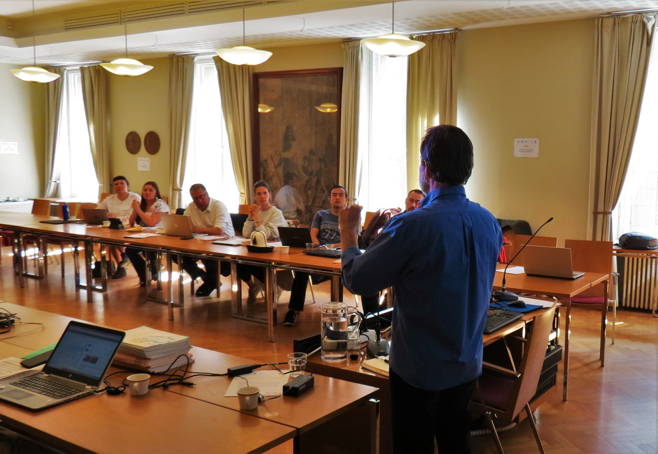

Main closing points compiled by the Indigenous participants at the Dialogue

1. The framework of the Global Assessment put forward is not inclusive of an Indigenous Peoples’ approach and limits the type of engagement that may occur.
2. It is important to engage and collaborate with Indigenous Peoples from the beginning of the assessment process (including at the scoping stage) – and to consider this for all future work. In relation to the development of the ten-year IPBES plan, Indigenous Peoples need to be involved in discussions. Indigenous Peoples understand that they have to be nominated by June 10th for this. But there is a need to figure out a way that Indigenous Peoples can have regional representation and direct involvement from the beginning regardless, because we cannot meet that deadline.
3. With thoughts of the issues and concerns raised over the last two days, we would like to ask that you organize meetings to address some of these issues with us in preparation to the ten-year plan – such as empowerment, capacity building, etc. This aids in us working out a process together.
4. There is a need for IK holders and Indigenous scholars to be actively involved in all steps, including developing methodologies, publications, thematic analysis, etc.
5. There is a need to include a discussion on food security from an Indigenous perspective.
6. There is a need to consider including human rights components within all of the chapters, including the introduction.
7. Key points were made about categorization of information and how this influences the way we make decisions. If information is categorized in a way that excludes Indigenous Knowledge, this can influence the robustness of assessments (if it can be built on both Indigenous Knowledge and science). It should be noted also that Indigenous Knowledge works from multiple variables, while science limits the number of variables used - this influences the trends that are developed and decisions made.
9. Communities will need to be on the IPBES board or else it will not be effective.
10. The Global Assessment needs to make sure that it is relevant to Indigenous communities.
11. For future work, IPBES should consider and analyze publications in all six UN languages, including Russian.
13. There is a need to recognize and discuss co-management, self-determination, and Indigenous management.
14. There should be consideration and explanation of multiple understandings of different concepts, such as conservation.
15. There should be recognition that Indigenous Peoples hold many mechanisms for protecting areas that differ from the mainstream conception, and that these methods are often not included in the consideration of conservation measures.
16. There is a need to understand the impacts that international initiatives and national regulations have on Indigenous Peoples.
17. There is a need to explore the negative history of Indigenous Peoples and biodiversity conservation [burden of conservation].
18. The Global Assessment should make better use of the many papers and reports that are focused on the Arctic and would be of direct relevance to the Global Assessment chapters.
19. There is a need for a larger discussion on adaptation with the Global Assessment.
20. There is a serious concern that SDG and Aichi targets were not reflective of Indigenous Peoples perspectives, and this should be highlighted in the Global Assessment.
21. Arctic Indigenous Peoples are often the first to be impacted by global and regional changes, and they are the first to be expected to change to address the impacts. This should be highlighted in the Global Assessment.
22. Indigenous Peoples recognize that we also need science. Science and IK should be working together to solve problems.
23. Indigenous Peoples would like to see processes that are reflective of a co-production of knowledge in the Global Assessment and future IPBES work.
24. Sacred sites are very important as they reflect the important relationships between biological and cultural diversity.
25. Indigenous Peoples (and indeed all people) are part of the ecosystem and as such, the Global Assessment needs to emphasize cultural elements and how they link to biodiversity and overall well-being of the ecosystem – for example, EBSAs (ecological or biologically significant areas) need to be considered as CEBSAs (culturally, ecological or biologically significant areas).
26. Indigenous Knowledge and Local Knowledge are not the same. Local knowledge should not be defined by Indigenous Knowledge holders or by Indigenous leadership, but a clear explanation of the terms should be given in the Global Assessment.
27. Inuit and ecosystem services – Inuit have their own trade-off systems and have difficulty with the ecosystem service’s evaluation process and concepts.
28. Strengthening and developing Indigenous institutions is essential, to support participation in different processes, self-determination, empowerment, and to promote Indigenous Knowledge.
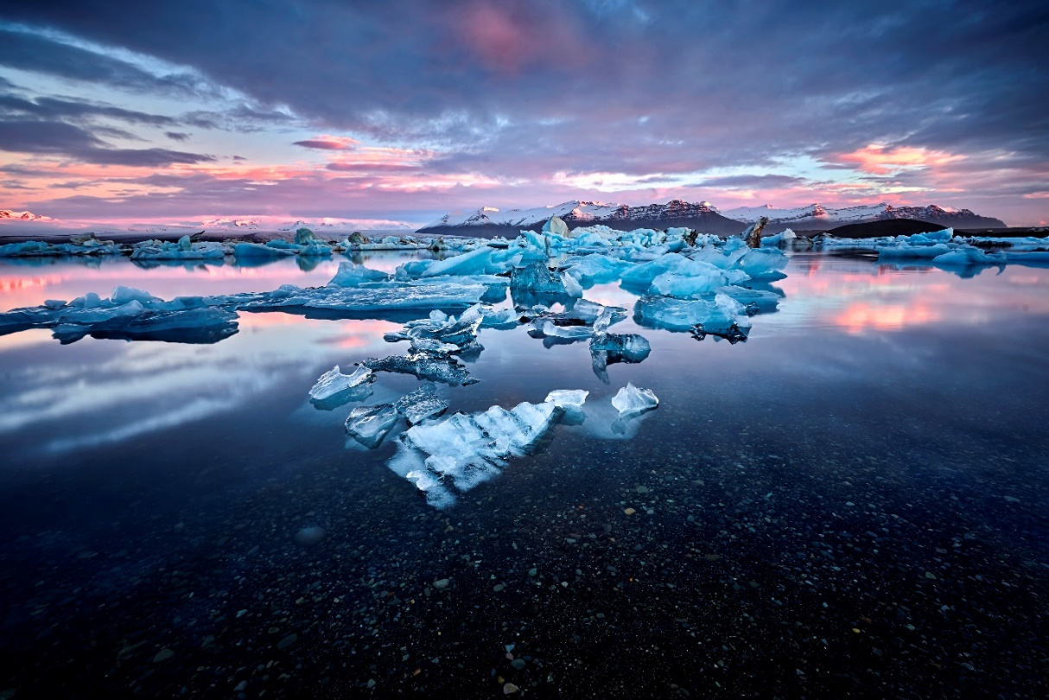

Additional bibliographic resources
During the dialogue, participants suggested a number of resources that should be used in the Global Assessment. These are listed below:
General resources
AMAP, 2017. Adaptation actions for a changing Arctic. Perspectives from the Barents Sea. Arctic Monitoring and Assessment Programme (AMAP), Oslo, Norway. xiv + 267 pp.
AHDR (Arctic Human Development Report). 2004. Akureyri: Stefansson Arctic Institute. http://www.svs.is/en/projects/arctic-human-development-report
AHDR II (Arctic Human Development Report II: Regional Processes & Global Linkages). 2013. Akureyri: Stefansson Arctic Institute. https://oaarchive.arctic-council.org/handle/11374/1653.
Eallu, 2017. Indigenous Youth, Food Knowledge & Arctic Change. International Centre for Reindeer Husbandry (ICR), Kautokeino, Norway.
Eira, I.M.G. 2012. The silent language of snow. Sami traditional knowledge of snow in times of climate change. A dissertation for the degree of Doctor of Philosophy. https://munin.uit.no/handle/10037/9843
Gaudamus L. 2013. Linkages between human health and ocean health: a participatory climate change vulnerability assessment for marine mammal harvesters. Int J Circumpolar Health 72: 20715. Available at: http://kawerak.org/wp-content/uploads/2018/04/Gadamus-article.pdf
Glomsrod S, Duhaime G, Aslaksen I. 2015. The Economy of the North 2015. Statistics Norway, Oslo, Norway.
Inuit Circumpolar Council, 2015. Alaskan Inuit Food Security Conceptual Framework: How to Assess the Arctic from an Inuit perspective. Technical Report. Inuit Circumpolar Council, Anchorage, Alaska.
Raymond-Yakoubian J, Angnaboogok V. 2017. Cosmological Changes. Shifts in Human-Fish Relationships in Alaska’s Bering Strait Region. Kawerak. Available at: http://kawerak.org/natural-resources/social-science/
Chapter 2
Alaskan Inuit Food Security Conceptual Framework: How to Assess the Arctic From An Inuit Perspective, 2016. Available at: http://iccalaska.org/wp-icc/wp-content/uploads/2016/05/Food-Security-Full-Technical-Report.pdf
Bering Strait Marine Life and Subsistence Data Synthesis. Available at: www.kawerak.org/socialsci.html
Coastal Monitoring Indigenous Knowledge Holders Meeting Report. Available at: http://iccalaska.org/wp-icc/wp-content/uploads/2018/01/IK-holder-workshop-report_102116.pdf
Food for the Soul: Bering Strait Region Non-Salmon Fish Preparation and Recipes. Available at: www.kawerak.org/socialsci.html
Indigenous Knowledge and Use of Bering Strait Ocean Currents Report. Available at: www.kawerak.org/socialsci.html
Inuit Circumpolar Wildlife Summit Report - http://iccalaska.org/wp-icc/wp-content/uploads/2018/03/ICC-Wildlife-Management-Summit-Report_Final_for-web.pdf
Larsen, J,N (Ed). 2010. Arctic Social Indicators - A follow-up to the Arctic Human Development Report. Documentation. Nordic Council of Ministers. http://library.arcticportal.org/712/
Qualitative Participatory Mapping of Seal and Walrus Harvest and Habitat Areas. Available at: www.kawerak.org/socialsci.html
Sea Ice is our Highway. Available at: http://www.inuitcircumpolar.com/uploads/3/0/5/4/30542564/20080423_iccamsa_finalpdfprint.pdf
Seal and Walrus Harvest and Habitat Areas for Nine Bering Strait Region Communities. Available at: www.kawerak.org/socialsci.html
The Meaning of Ice: People and Sea Ice in Three Arctic Communities. Shari Fox Gearheard, Lene Kielsen Holm, Henry Huntington. International Polar Institute Press, 2013 - 365 pp.
“The World Has Changed”: Inalit Traditional Knowledge of Walrus in the Bering Sea. Available at: www.kawerak.org/socialsci.html

Chapter 3

A Circumpolar Inuit Declaration on Resource Development Principles in Inuit Nunaat. Available at: http://www.inuitcircumpolar.com/uploads/3/0/5/4/30542564/declaration_on_resource_development_a3_final.pdf
Building an Indigenous Evidence-base for Tribally-led Habitat Conservation Policies. Available at: www.kawerak.org/socialsci.html
Conceptual and Institutional Frameworks for Protected Areas, and the Status of Indigenous Involvement. Available at: www.kawerak.org/socialsci.html

Elmqvist, T., F. Berkes, C. Folke, P. Angelstam, A.-S. Crépin and J. Niemelä 2004. The dynamics of ecosystems, biodiversity management and social institutions at high northern latitudes. Ambio 33: 350-355.
Hermann, M. and T. Martin, editors. 2016. Indigenous Peoples’ Governance of Land and Protected Territories in the Arctic. Springer.
Inuit Circumpolar Wildlife Summit Report - http://iccalaska.org/wp-icc/wp-content/uploads/2018/03/ICC-Wildlife-Management-Summit-Report_Final_for-web.pdf
Inuvialuit Inupiat Beaufort Sea Beluga Whale Agreement - Inuvialuit Traditional Ecological Knowledge (TEK) of Beluga Whale (Delphinaterus leucas) in a Changing Climate in Tuktoyaktuk, NT. Available at: https://atrium.lib.uoguelph.ca:8443/xmlui/bitstream/handle/10214/12143/Waugh_Devin_201801_MSc.pdf?sequence=1&isAllowed=y

Chapter 4

Alaskan Inuit Food Security Conceptual Framework: How to Assess the Arctic From An Inuit Perspective, 2016. Available at: http://iccalaska.org/wp-icc/wp-content/uploads/2016/05/Food-Security-Full-Technical-Report.pdf

Arctic 2030: Planning For an Uncertain Future -
https://www.hks.harvard.edu/sites/default/files/centers/mrcbg/files/57_final.pdf
Circumpolar Inuit Response to Arctic Shipping Workshop Proceedings. Available at: http://www.inuitcircumpolar.com/uploads/3/0/5/4/30542564/201309121300arcticshippingscreenversion_revised.pdf
Flynn M, et al. 2018. Participatory scenario planning and climate change impacts, adaptation and vulnerability research in the Arctic.
Food for the Soul: Bering Strait Region Non-Salmon Fish Preparation and Recipes. Available at: www.kawerak.org/socialsci.html
Inuit Circumpolar Wildlife Summit Report - http://iccalaska.org/wp-icc/wp-content/uploads/2018/03/ICC-Wildlife-Management-Summit-Report_Final_for-web.pdf
NSSI Scenarios Final Reports: Prioritizing Science Needs Through Participatory Scenarios for Energy and Resource Development on the North Slope and Adjacent Seas. Available (including GIS data) at: http://catalog.northslopescience.org/catalog/entries/8302
Thinking about the Arctic’s future: Scenarios for 2040. Audun Iversen, September 2011. Available at: http://site.uit.no/arcticfutures/files/2012/03/Brigham-2007.pdf
Traditions of Respect Book. Available at: www.kawerak.org/socialsci.html
Sea Ice is our Highway. Available at: http://www.inuitcircumpolar.com/uploads/3/0/5/4/30542564/20080423_iccamsa_finalpdfprint.pdf
Chapter 5
Alaskan Inuit Food Security Conceptual Framework: How to Assess the Arctic From An Inuit Perspective, 2016. Available at: http://iccalaska.org/wp-icc/wp-content/uploads/2016/05/Food-Security-Full-Technical-Report.pdf
“Always taught not to waste”: Traditional Knowledge and Norton Sound/Bering Strait Salmon Populations. Available at: www.kawerak.org/socialsci.html
Eallu, 2017. Indigenous Youth, Food Knowledge & Arctic Change. International Centre for Reindeer Husbandry (ICR), Kautokeino, Norway
Food for the Soul: Bering Strait Region Non-Salmon Fish Preparation and Recipes. Available at: www.kawerak.org/socialsci.html
Chapter 6
A Bering Strait Indigenous Framework for Resource Management: Respectful Seal and Walrus Hunting. Available at: www.kawerak.org/socialsci.html
A Circumpolar Inuit Declaration on Resource Development Principles in Inuit Nunaat. Available at: http://www.inuitcircumpolar.com/uploads/3/0/5/4/30542564/declaration_on_resource_development_a3_final.pdf
A Circumpolar Inuit Declaration on Sovereignty In the Arctic. Available at: http://www.inuitcircumpolar.com/uploads/3/0/5/4/30542564/declaration12x18vicechairssigned.pdf
Circumpolar Inuit Response to Arctic Shipping Workshop Proceedings. Available at: http://www.inuitcircumpolar.com/uploads/3/0/5/4/30542564/201309121300arcticshippingscreenversion_revised.pdf
Indigenous Peoples’ Governance of Land and Protected Territories in the Arctic. Available at: https://www.springer.com/us/book/9783319250335
Inuit Circumpolar Council, 2010. Inuit Arctic Policy. Inuit Circumpolar Council, Anchorage, Alaska. Available at: http://www.inuitcircumpolar.com/uploads/3/0/5/4/30542564/inuit_arctic_policy.pdf
Inuit Circumpolar Wildlife Summit Report - http://iccalaska.org/wp-icc/wp-content/uploads/2018/03/ICC-Wildlife-Management-Summit-Report_Final_for-web.pdf
Inuvialuit Settlement Land Claims Agreement. Available at: https://jointsecretariat.ca/wp-content/uploads/2015/11/Inuvialuit_Final_Agreement_2005.pdf
Inuvialuit – Inupiat Polar Bear Management Agreement in the Southern Beaufort Sea. Available at: https://www.fws.gov/alaska/fisheries/mmm/polarbear/pdf/I-I%20Agreemnt%20signed%20March%202000.pdf
Pikialasorsuaq Commission Website. Available at: http://pikialasorsuaq.org/en/
Policy-Based Recommendations from Kawerak’s Ice Seal and Walrus Project. Available at: www.kawerak.org/socialsci.html
Sea Ice is our Highway. Available at: http://www.inuitcircumpolar.com/uploads/3/0/5/4/30542564/20080423_iccamsa_finalpdfprint.pdf
The Incorporation of Traditional Knowledge into Alaska federal fisheries management. Available at: www.kawerak.org/socialsci.html

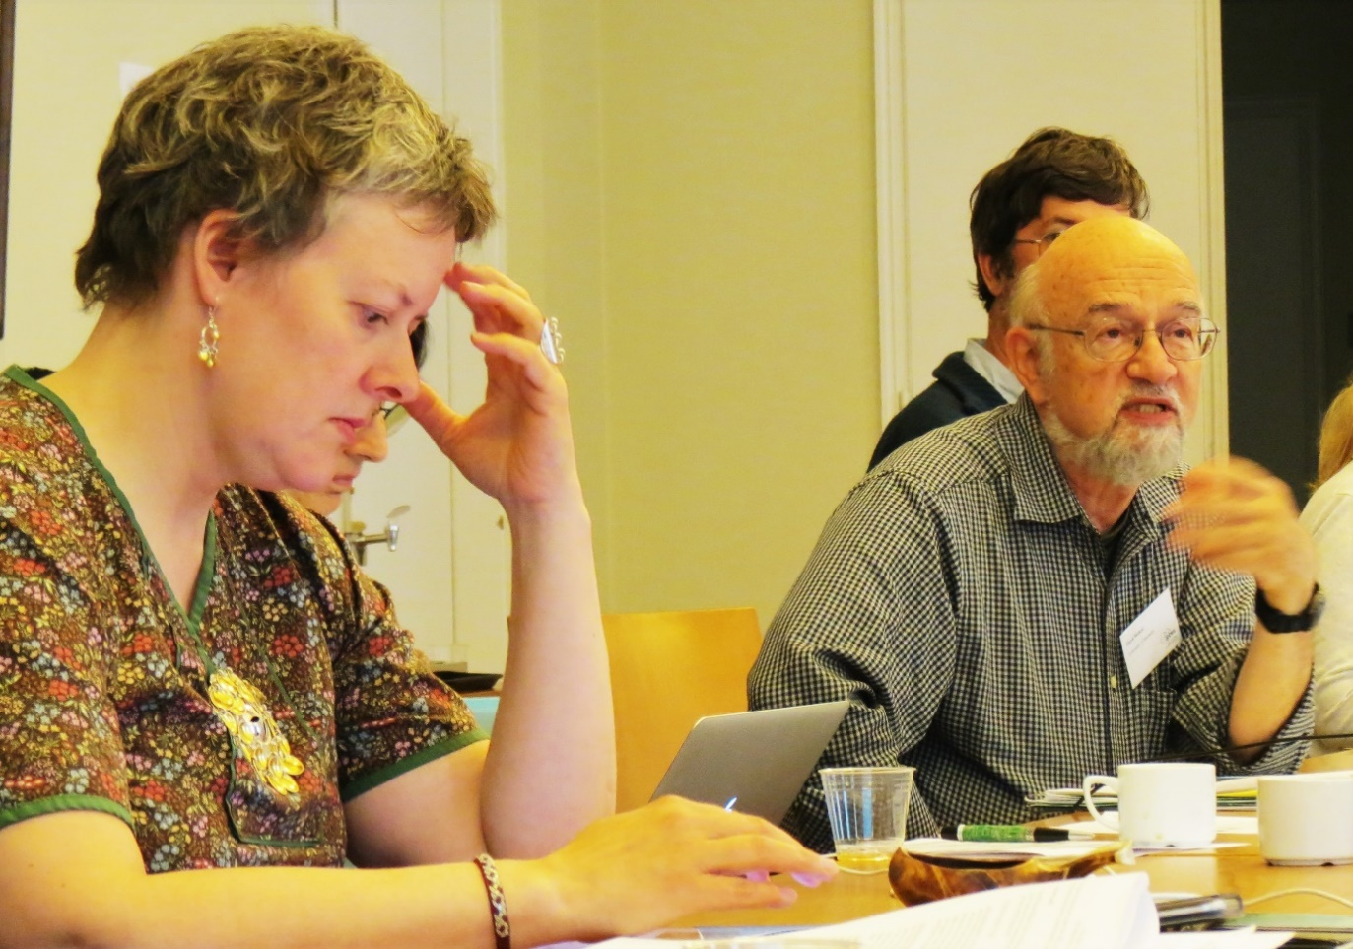
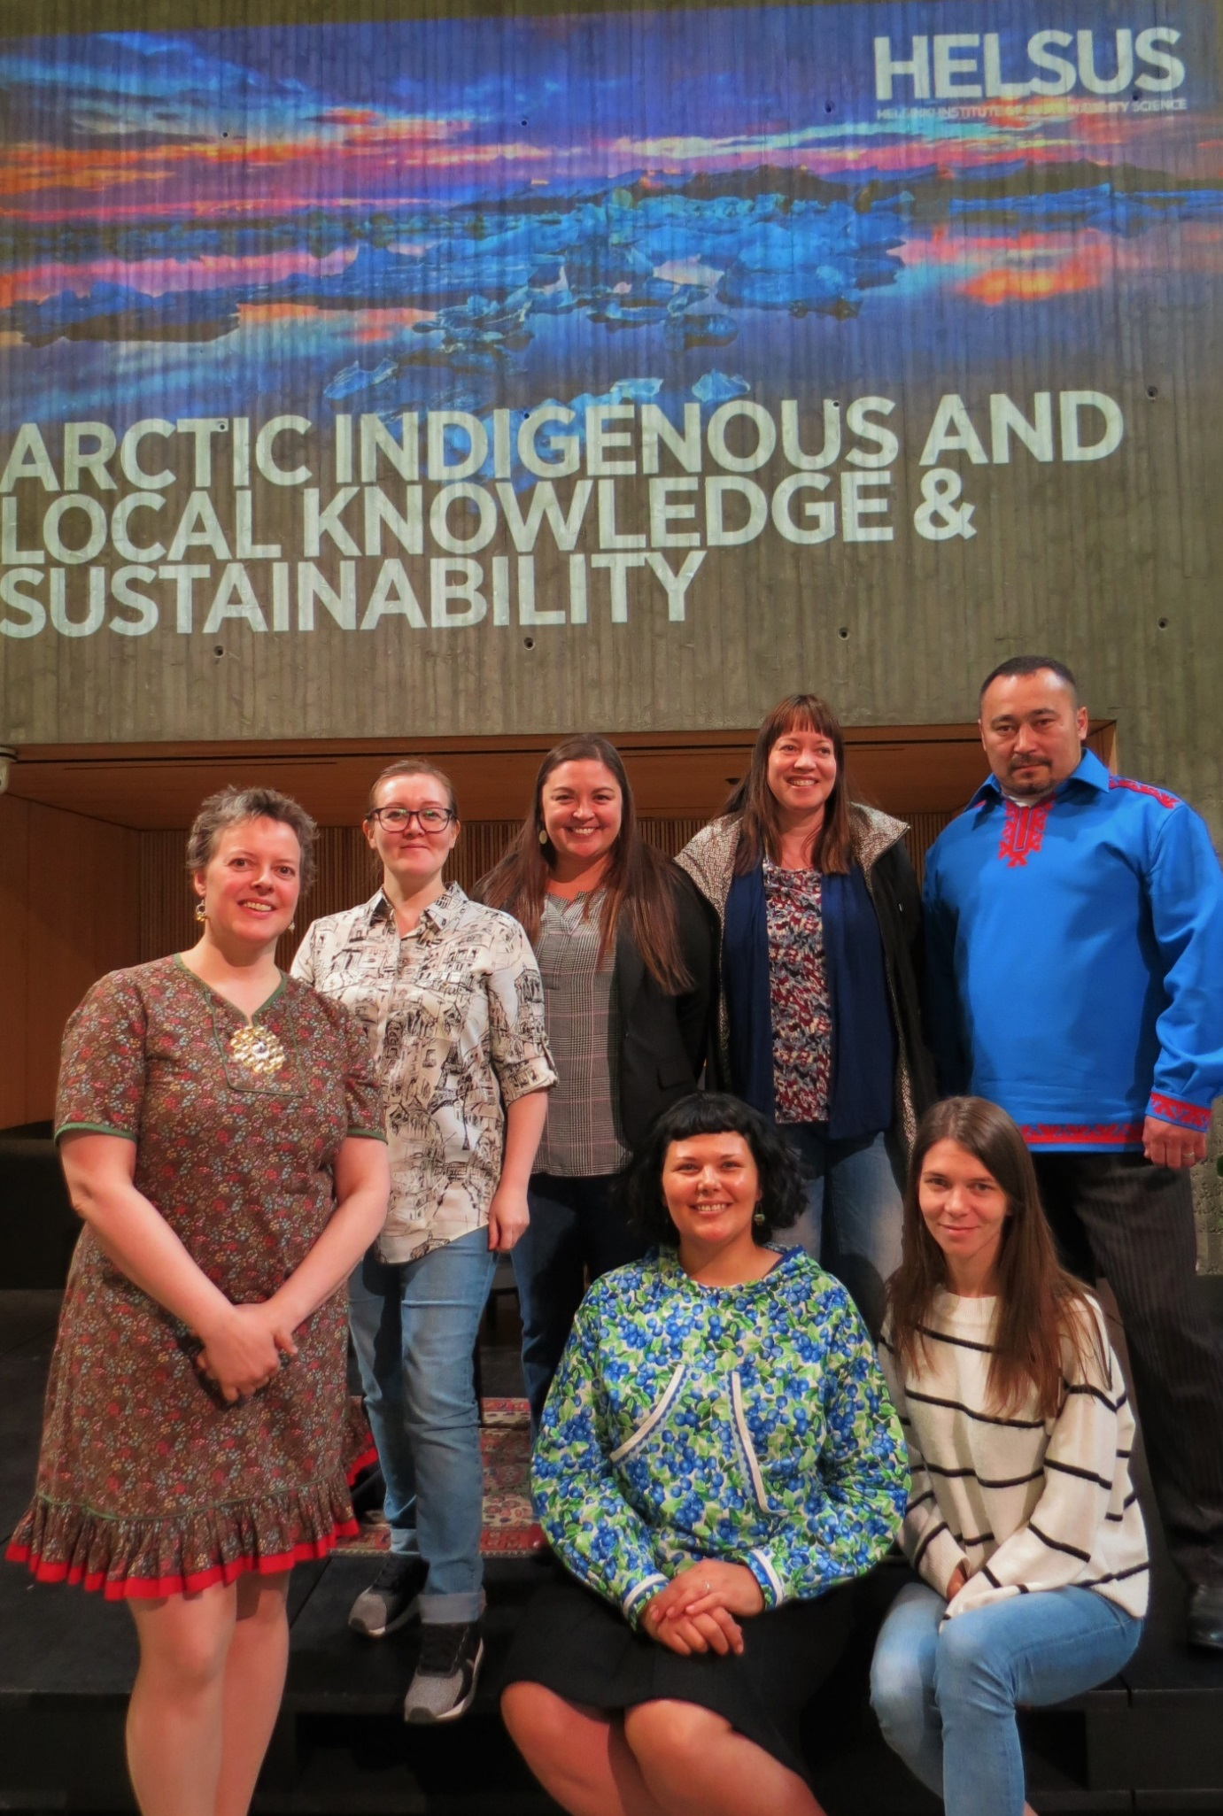

https://www.un.org/development/desa/Indigenouspeoples/wp-content/uploads/sites/19/2016/08/rev_PFII-2017-final-report-Clean_SPFII_19May2017.pdf

