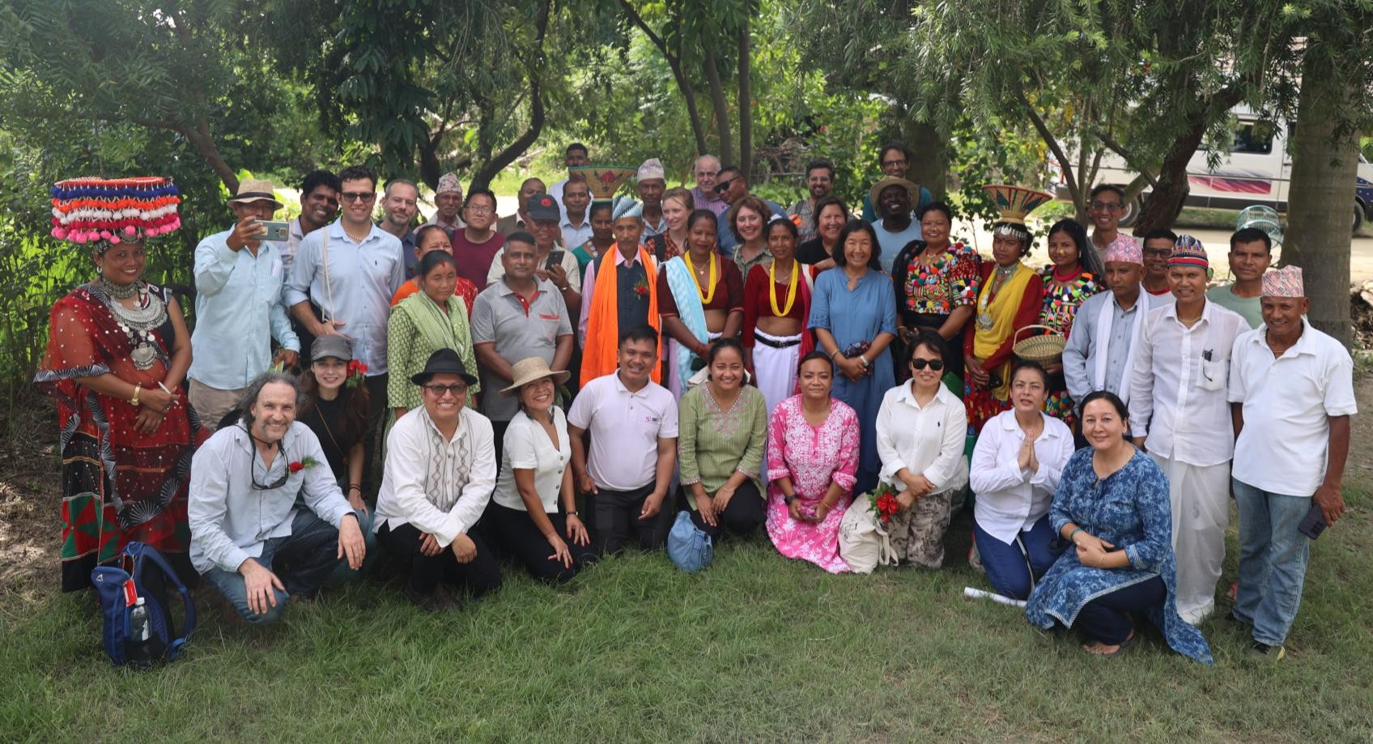
Report

Indigenous and local knowledge dialogue workshop
on the

IPBES monitoring assessment
18 – 22 August 2025, Bardiya, Nepal

Suggested citation
IPBES (2025) Myrle Ballard, Parashuram Chaudhary, Ramila Chaudhary, Biswash Chepang, Q"apaj Conde, Pasang Dolma Sherpa, Preity Gurung, Vidhya Hirachan, Yesenia Hernandez, Mariaelena Huambachano, Johnson Jament, Paulina Karim, Kamal Kumar Rai, Narendra Lama, Roshani Limboo, Loupa Pius, Bhabin Rai, Nick Rahiri Roskruge, Pooja Shrestha, Rodion Sulyandziga. Report of the second Indigenous and local knowledge dialogue workshop on the IPBES monitoring assessment. 18 – 22 August 2025, Bardiya, Nepal.

Disclaimer
The text in sections 3 represents an attempt to reflect solely the views and contributions of the participants in the dialogue. As such, it does not represent the views of IPBES or UNESCO or reflect upon their official positions.

Acknowledgements
IPBES thanks the Tharu community in Dalla, Bardiya for welcoming the participants onto their lands and into their community, and for sharing their time and experiences. We also want to thank CIPRED for their leadership and support during the workshop, and for building strong connections with the lands and local community for the workshop. Their hard work and dedication helped to create an experience in which participants could learn and share beyond the meeting room. We also wish to thank the participants who travelled from across Nepal and from across the world to share their time and knowledge during the workshop. This workshop would not have been possible without your efforts and support.

Table of Contents

Table of Contents 2
- Introduction 4
- Background 5
  - The IPBES monitoring assessment 5
    - Structure 5
    - Scope and rationale 5
  - Context for the dialogue workshop 6
    - IPBES and ILK 6
    - Working with ILK in the assessment process 7
  - Objectives of the ILK dialogue workshop 7
  - Methods for the dialogue workshop 8
  - Free, prior and informed consent 9
  - Benefits to Indigenous Peoples and local communities of participating in the assessments and other activities 10
- Monitoring of biodiversity: Key recommendations and learning from the dialogue workshop 11
  - Introduction 11
  - What should be monitored? 11
  - Developing a concept or definition of monitoring 12
  - Typology of ownership and participation and monitoring 13
  - Conceptualizing and exploring monitoring within ILK systems 14
    - Introducing monitoring within ILK systems 14
    - Maintaining balance and harmony 15
    - Seasonal cycles, calendars and indicators 16
    - Monitoring across biocultural systems for multiple benefits 20
    - Customary governance, roles and responsibilities 23
  - Community-based monitoring and information systems 26
    - Conceptualization 26
    - Indigenous research methods 30
  - Co-production or collaborative monitoring 31
    - Benefits and risks 31
    - Safeguards, protocols and principles 33
  - Aggregating, scaling, indicators and networking 35
    - Challenges 35
    - Strategies and participation 36
    - Indicators 37
    - Networking 39
  - Enabling conditions 41
  - Approaches for the assessment 43
- Next steps 45
Annexes 46
Annex 1: Agenda 46
Annex 2: FPIC document 51
Annex 3: Participants of the dialogue workshop 54

Introduction
This report summarizes the proceedings from the second Indigenous and local knowledge (ILK) dialogue workshop on the assessment on monitoring biodiversity and nature’s contributions to people (the “monitoring assessment”), that is being developed by the Intergovernmental Science-Policy Platform on Biodiversity and Ecosystems Services (IPBES).
The dialogue workshop was held in Bardiya, Nepal from 18 to 22 August 2025. It aimed to provide a platform for discussion between Indigenous Peoples and local communities and assessment authors, with a focus on reviewing the first drafts of the chapters and summary for policymakers, with a focus on key ILK concepts, themes, questions, challenges, opportunities, resources and other issues relating to the assessment.
The workshop also discussed the IPBES assessment on spatial planning and ecological connectivity and constituted the first workshop on that assessment. That part of the workshop is the subject of a separate report which is available online here.
This report aims to provide a written record of the dialogue workshop as it related to the assessment of spatial planning and ecological connectivity, so that it can be used by assessment authors to inform their work on the assessment, and by all dialogue participants who may wish to review and contribute to the work of the assessment moving forward, as well as others who may be interested in subjects relating to ILK and monitoring of biodiversity.
The report is not intended to be comprehensive or to provide definitive resolution to the many engaging discussions that emerged during the workshop. Rather, it serves as a written record of those discussions, which will continue to develop and evolve in the months and years ahead. For this reason, clear points of agreement are discussed, but also, if there were diverging views among participants, these are also presented for further attention and discussion.
The text in section 3 represents an attempt to reflect solely the views and contributions of the participants in the dialogue. As such, it does not represent the views of IPBES or UNESCO or reflect upon their official positions.
The agenda and participants’ list for the dialogue workshop are provided in annexes 1 and 3.

Background

The IPBES monitoring assessment

Structure
The monitoring assessment commenced in 2024 and will be considered by the Plenary¹ at its thirteenth session expected to be held in 2026. The assessment report will consist of a summary for policymakers and four chapters. The chapters are as follows:
      - Chapter 1: Setting the scene
      - Chapter 2: Assessing the data needs
      - Chapter 3: Assessing the challenges in biodiversity monitoring to meet needs
      - Chapter 4: Options for strengthening the capacity to monitor biodiversity worldwide
The assessment will also identify key gaps in knowledge, data, methodologies and reporting standards.

Scope and rationale
The assessment is a methodological assessment, which means that it assesses available methodologies for addressing a specific theme.
As set out in the assessment’s scoping report (available here), the aim of the monitoring assessment is to support national and global efforts to:
      - Monitor biodiversity, nature’s contributions to people and the direct and underlying causes of the observed changes; and
      - Monitor progress towards the goals and targets of the Kunming-Montreal Global Biodiversity Framework.²

¹ The Plenary is the body through which States that are members of IPBES take decisions, which usually meets around once a year.
² The Kunming-Montreal Global Biodiversity Framework was adopted during the fifteenth meeting of the Conference of the Parties (COP 15) of the Convention on Biological Diversity (CBD). This framework sets out an ambitious pathway to reach the global vision of a world living in harmony with nature by 2050. Among the
Framework’s key elements are 4 goals for 2050 and 23 targets for 2030.

The assessment will take into account different knowledge and value systems.
It will assess the current capacity, capability and resources to collect and analyze data at national and global scales. It will assess gaps in data availability and access, and challenges and barriers related to the capacities and means of implementation. The assessment will also identify opportunities to further develop national and regional biodiversity monitoring capacities, and community, Indigenous and citizen-science biodiversity monitoring. The assessment will look at options to enhance cooperation, to promote resource-sharing and reporting.
The full scoping report for the assessment is available here.

Context for the dialogue workshop

IPBES and ILK
IPBES is an independent intergovernmental body established to strengthen the science-policy interface for biodiversity and ecosystem services for the conservation and sustainable use of biodiversity, long-term human well-being and sustainable development.
Since its inception in 2012, IPBES has recognized that Indigenous Peoples and local communities possess detailed knowledge of biodiversity and ecosystem trends. In its first work programme (2014-2018), IPBES built on this recognition through deliverable 1 (c), Procedures, approaches, and participatory processes for working with Indigenous and local knowledge systems. The IPBES rolling work programme up to 2030 includes objective 3 (b), Enhanced recognition of and work with Indigenous and local knowledge systems, which aims to further this work. The IPBES conceptual framework also contains explicit recognition of diverse knowledge and value systems.
The IPBES Plenary established a task force on ILK systems and agreed on terms of reference guiding its operations towards implementing this deliverable. IPBES’ work with Indigenous Peoples and local communities and on ILK is supported by a technical support unit for ILK, hosted by UNESCO.
Key activities and deliverables of the task force and technical support unit on ILK so far include:
      - Progress in the development of approaches and methodologies for working with ILK was made during previous IPBES assessments (Pollination, Pollinators and Food Production, Land Degradation and Restoration, four Regional Assessments and a Global Assessment of Biodiversity and Ecosystem Services, Sustainable Use of Wild Species, Diverse Values and Valuation of Nature, Invasive Alien Species, the Interlinkages among Biodiversity, Water, Food and Health, and Transformative Change);

      - The development and implementation of the “approach to recognizing and working with ILK in IPBES”, which was formally approved by the Plenary at its fifth session in 2017 in decision IPBES-5/1, which sets out principles and approaches for IPBES’s work with ILK;
      - Development and implementation of methodological guidance for recognizing and working with ILK in IPBES, which aims to provide further detail and guidelines on how to work with ILK within the IPBES context; and
      - Development and implementation of a “participatory mechanism”, a series of activities and pathways to facilitate the participation of Indigenous Peoples and local communities in IPBES assessments and other activities, which includes organizing ILK dialogue workshops for the IPBES assessments.

Working with ILK in the assessment process
Following the IPBES approach to ILK and as part of the participatory mechanism, two ILK dialogue workshops are held during the cycle of a “fast-track” IPBES assessment, as follows:
      - Discussing key ILK themes and framing of the assessment (in the first months after an assessment commences); and
      - Reviewing the first draft of the chapters and summary for policymakers (during the assessment’s external review period).
These workshops bring together members of Indigenous Peoples and local communities, Indigenous and non-indigenous scientists, and authors of the assessment to discuss key themes relating to the assessment. They are part of a series of complementary activities for working with ILK and enhancing participation by Indigenous Peoples and local communities throughout the assessment process.
Other activities during an assessment include an online call for contributions, invitations to contributing authors and review of diverse literature and materials.

Objectives of the ILK dialogue workshop
The second ILK dialogue for a fast-track assessment aims to provide a platform for discussion between participants of the workshop about the first drafts of the chapters and summary for policymakers, with a focus on key ILK concepts, themes, questions, challenges, opportunities, resources, ways forward and other issues relating to the IPBES assessment. Specific aims of the dialogue include:
- Presenting and reviewing the draft assessment and generating discussions around the drafts;

- Discussing the key themes or questions of the assessment, to help to further shape an ILK narrative for the assessment and direct the further collection, synthesis and analysis of information;
- Discussing how Indigenous Peoples and local communities conceptualize, undertake and govern monitoring systems and related decision-making;
- Discussing challenges, risks and opportunities related to the assessment from the perspectives of Indigenous Peoples and local communities;
- Further developing case studies of relevance to the assessment;
- Identifying experts who can contribute to the assessment as contributing authors; and
- Identifying resources and sources of information that could be included in the assessment.

Methods for the dialogue workshop
The workshop was held in-person over five days, and it first addressed the assessment of spatial planning and ecological connectivity before turning to the assessment on monitoring biodiversity, although links and connections between the two assessments were drawn and emphasized throughout. Time was also set aside at the beginning of the workshop to allow participants to discuss the issues they wished to address at the workshop, and how these issues should be approached. The agenda is presented in annex 1 of this report.
The process for the dialogue workshop included:
- Initial presentations and discussions on:
  - IPBES and its goals and methods;
  - Workshop aims, methods, and free, prior and informed consent (FPIC); and
  - The assessment, its goals and proposed methods;
- Discussions around the key ILK questions and themes for the assessment of spatial planning and ecological connectivity (the subject of a separate report);
- Presentations and discussions around the draft chapters of the monitoring assessment, including concepts, narratives, typologies and figures;
- A day of community visits to the Tharu community in Dalla, Bardiya, including a community meeting and visits and discussions around the community; and
- Two sessions of the Indigenous Peoples and local community caucus, an informal group composed of Indigenous Peoples and local community representatives, with ad hoc rules of engagement, to give participants a space to discuss any questions, concerns or issues in relation to IPBES, the assessment and the workshop.

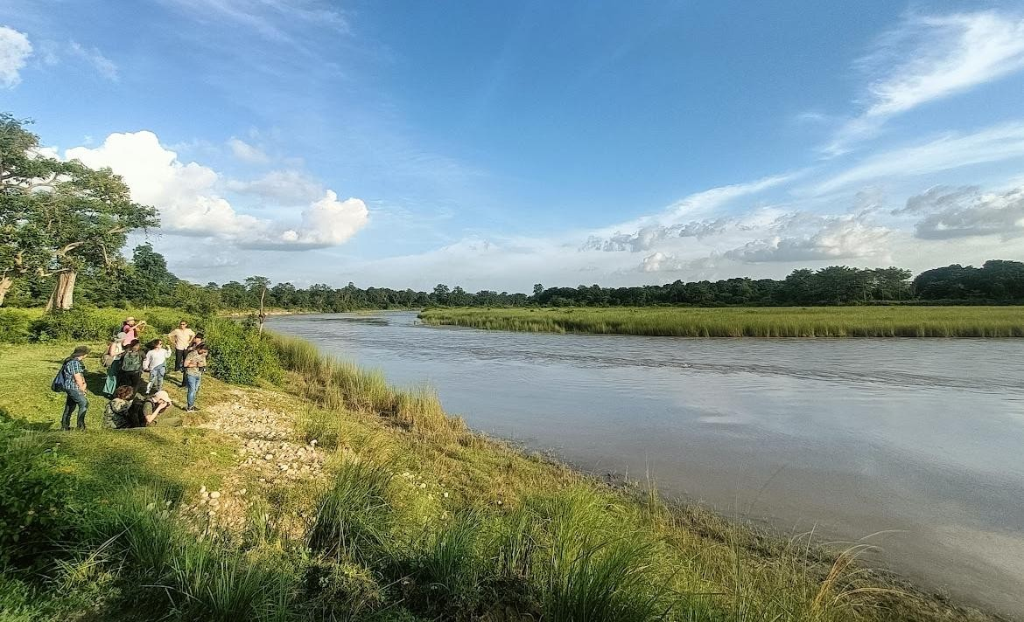
Figure 1: Participants during the field visit looking across to Bardiya National Park.

Free, prior and informed consent
Free, prior and informed consent (FPIC) principles are central to IPBES work with Indigenous Peoples and local communities. A series of ethical principles have been developed to ensure that FPIC is followed in IPBES activities. These principles were agreed upon by the participants from Indigenous Peoples and local communities and IPBES authors in the dialogue, recognizing that participants, authors and the IPBES technical support units have different responsibilities within the process. The principles will be followed by participants from Indigenous Peoples and local communities, the assessment authors group and the IPBES technical support units. The full agreed-upon text and the names of those agreeing to these principles are provided in annexes 2 and 3 to this report.

Benefits to Indigenous Peoples and local communities of participating in the assessments and other activities
During previous ILK workshops, participants emphasized the need for clear benefits to Indigenous Peoples and local communities from their involvement and participation in an assessment process. It was noted that IPBES does not benefit financially from its processes or products, and that the main products of IPBES are publicly available materials, including assessment reports, their summaries for policymakers, webinars and other resources, to provide free and reliable information for policymakers and decision-makers and actors at all levels, including Indigenous Peoples and local communities. Key benefits discussed for Indigenous Peoples and local communities from participating in dialogue workshops and the overall assessment process include:
- The opportunity to enhance relationships, and share experiences, examples and cases among Indigenous Peoples and local communities around the world;
- The opportunity for Indigenous Peoples and local communities to engage in dialogue around experiences and knowledge with IPBES assessment authors;
- The opportunity to bring ILK and the concerns and visions of Indigenous Peoples and local communities to the attention of policymakers and decision-makers; and
- Use of the final assessments as tools to support Indigenous Peoples and local communities when engaging with policymakers, decision-makers and scientists. Part of the planning for the final assessment includes the development of an accessible summary specifically for Indigenous Peoples and local communities, as well as webinars that present the results to Indigenous Peoples and local communities.

Monitoring of biodiversity: Key recommendations and learning from the dialogue workshop³

Introduction
Participants agreed that monitoring is an important topic for Indigenous Peoples and local communities. They emphasized that Indigenous Peoples and local communities have long monitored biodiversity, wellbeing (of humans and other species and elements of nature) and their interconnections, often over thousands of years, with the effectiveness of these systems reflected in the high levels of biodiversity often found across their lands and waters. They noted, however, that these monitoring systems are often neglected, misunderstood or ignored by science. They also observed that monitoring within ILK systems may operate in fundamentally different ways from mainstream scientific approaches, further complicating the relationship between the two knowledge systems.

What should be monitored?
Participants noted that conventional monitoring often focuses on biodiversity, and social systems can be overlooked. They agreed, however, that monitoring is needed across linked biological and social systems, or biocultural systems, recognizing that people are part of nature, and that, in general, it is the connections between people and other aspects of nature that define whether biodiversity and human wellbeing will thrive or decline.
Participants agreed that the example of Bardiya National Park (given in full in the report on the workshop for the spatial planning and ecological connectivity assessment) illustrates this clearly. While tiger numbers in the park have risen significantly, suggesting conservation success, this obscures more troubling trends in human wellbeing, human-wildlife conflict in surrounding areas, and respect for Indigenous rights. Monitoring only tiger populations offers an incomplete picture of the park’s broader impacts and the biocultural relationships associated with it.

³ Disclaimer: The text in section 3 represents an attempt to reflect solely the views and contributions of the participants in the dialogue. As such, it does not represent the views of IPBES or UNESCO or reflect upon their official positions.

Similarly, a participant noted that conservation science often emphasizes species protection while overlooking the ecosystems and Indigenous Peoples that sustain those species. In marine contexts, the protection of species such as sea turtles or blue whales is frequently prioritized without equivalent attention to the ocean and coastal ecosystems they depend on, or to Indigenous knowledge systems and relationships that have long supported both species and habitats. Effective conservation requires protecting ecosystems and peoples alongside species, and monitoring needs to reflect this.
Participants noted that it is also essential that monitoring systems meet all the needs of the KMGBF, where social systems, rights, participation and governance are addressed alongside biodiversity. This adds to the need for holistic monitoring across these issues, rather than focusing only on biodiversity in isolation.
Participants noted that for IPBES, monitoring across interlinked biocultural systems is currently approached through the concept of “nature’s contributions to people” (NCP) which aims to build on the concept of “ecosystem services” to better recognize the central role that culture plays in defining all links between people and nature, while also elevating the role of ILK. Participants noted that the concept of NCP is an improvement on previous concepts, and that monitoring across all of the NCPs is essential.
However, they also noted that the concept of NCP in general does not fit well with the worldviews of Indigenous Peoples and local communities, as it seems to imply a separation of nature and people. Within the worldviews of many Indigenous Peoples and local communities, people exist within and as part of nature. Within nature, they are bound to and in relationship with other forms of life, including animals, plants, rocks, water, landscapes, seascapes, sacred sites, celestial bodies, spirits and others. These bonds and relationships include ethics of responsibility and care, as well as knowledge, practices, livelihoods, identity, rituals and countless other links.
Rather than NCP, concepts such as “biocultural”, “interrelationships” and “reciprocal relationality” may therefore better account for Indigenous and local worldviews, to show humans as an integral part of nature, rather than as a separate entity receiving contributions from it. Monitoring across these biocultural interrelationships is key, and already takes place within many ILK systems, as is discussed below.

Developing a concept or definition of monitoring
Participants noted that the draft of the assessment gave a definition of monitoring. They therefore discussed ways to approach the development of a definition of monitoring that is inclusive of the diversity of ILK systems (discussed more below) and science, and that accounts for monitoring of biocultural systems.

They noted that it may be difficult to find one concept or definition that covers all types of monitoring, and noted that several concepts or definitions may be needed to recognize the diversity and differences within ILK systems and between ILK systems and science. However, they noted that a very simple initial definition is more likely to be inclusive than a definition that lists many criteria.
Participants recommended that a table could be created to show different words and concepts from different Indigenous Peoples and local communities, similar to how key concepts were explored in the Nexus and Transformative Change Assessments. The aim could be to demonstrate diversity, showing regional variation, without trying to exhaustively list all terms and concepts from around the world. The aim would be to make others aware that great diversity exists, and that this diversity needs to be accounted for in further work beyond the assessment, particularly at national and local levels.
Participants also noted that there may not be direct translations of “monitoring” in many Indigenous and local languages and worldviews, with some exceptions. They noted also that science often strives to build concepts and related terminologies that are separate from experience and action, or that categorize experience and action into discrete steps and stages. Meanwhile, much of ILK does not make these distinctions. ILK systems do nonetheless hold complex philosophies and values, but these may be expressed in different ways and encoded in Indigenous languages with no direct translation, for example the word amuyu among Aymara people in Bolivia, which conveys a concept similar to dreams or ambitions.
In many cases, “monitoring” may therefore not be the right concept for engaging with Indigenous Peoples and local communities or describing how they know and relate to their lands and waters and Indigenous and traditional territories. For many Indigenous Peoples and local communities, the question could be more “how do you know things” or “what does your relationship with nature look like, and how do you care for it?” or “how do humans and other elements of nature support and nourish one another?”

Typology of ownership and participation and monitoring
Following the discussions on conceptualizing or defining monitoring, participants were introduced to a draft table⁴ that aimed to show a spectrum of monitoring systems, based on degree of community ownership and participation, from “scientist-led and executed monitoring”, with no community participation, through to “collaborative monitoring” where scientists and community members work together, “autonomous community monitoring”, where communities

⁴ It is not possible to reproduce the table in full here, as it was part of the confidential assessment drafts.

carry out their own research such as CBMIS (see discussions below in section 3.6) and “monitoring within ILK systems” (discussed below in section 3.5).
Participants noted that a challenge of the table is that it refers to scientists in a way that implies that Indigenous Peoples and local communities cannot also be scientists, while in reality there are increasing numbers of Indigenous Peoples and local communities who are trained in science. Another challenge of this wording is the implication that ILK is not itself “scientific”.
Another participant suggested that “Indigenous-led, initiated in collaboration with mainstream science” could be a further category, to emphasize that collaborations can exist that are led by communities themselves. Often these types of arrangements are more likely to meet criteria of true co-production, as the power imbalances inherent in most collaborations may be lessened. These issues are discussed more in section 3.7 on collaboration and coproduction.
Participants also noted the need to make a clear distinction between “citizen science” and monitoring within ILK systems and CBMIS, as citizen science is usually founded on scientific values and worldviews, rather than the values and worldviews of Indigenous Peoples and local communities.

Conceptualizing and exploring monitoring within ILK systems

Introducing monitoring within ILK systems
Participants discussed monitoring within ILK systems, presenting different examples and explanations, and reflecting on how these forms of monitoring may not fit within the draft definition of monitoring given in the assessment.
For example, they noted that often ILK monitoring systems may not be “systematic” or involve “reporting” (which were listed as parts of the monitoring process in the initial definition in the draft assessment). Many ILK monitoring systems are instead fluid and dynamic. Often, observation, learning and actions are intuitively tied together, and people act on the knowledge they gather within the environment without formally documenting or reporting it.
Participants also emphasized the value of experiential knowledge, understandings gained through direct engagement with their lands and waters, which are often not captured or conveyed through scientific concepts. This can include engaging with the environment in holistic and diverse ways, as part of nature, including conversing with key elements in nature, for example winds and rivers, animals and plants, and engaging all senses, including sight, sound, smell, taste and touch, as well as dreaming and rituals. For example, some communities report changes in taste of plants and animals, which may be connected to a changing climate, shifting weather patterns or changes in soil health.

Maintaining balance and harmony
Participants also highlighted that the purpose of “monitoring” by Indigenous Peoples and local communities may more often be connected to maintaining biocultural reciprocal relationships, rather than treating nature as a separate entity that can be measured and monitored, as may be the cases in many mainstream scientific contexts. Stewardship and ensuring that all aspects of biocultural systems can flourish may also be key aims, rather than only monitoring aspects of nature that benefit humans. Ethics, values and philosophies of care are therefore important to highlight when discussing monitoring by Indigenous Peoples and local communities. Rituals and ceremonies are a crucial part of maintaining these relationships and are therefore integral to monitoring within ILK systems. A participant also noted that often, Indigenous Peoples and local communities know that if they maintain or restore balance and harmony, then nature will take care of itself, rather than needing extensive human intervention. Monitoring in this sense also becomes a process of trusting that nature will find its own way, rather than trying to control and manage it.
Examples
In Quechua communities in Peru, work is taking place around the health and well-being of seeds, recognizing that many varieties have been lost, due to colonialism, climate change and other pressures. These traditional seeds are, however, crucial for a healthy food system, and they are also seen as the relatives of the people. Moreover, if Pachamama or Mother Earth is not well, this is reflected in the health of the seeds. Some communities are therefore working to “rematriate”⁵ seed varieties in order to rebuild and restore relationships with seeds that had been lost. They document the names of the seeds along with their stories and associated knowledge and explain why some are no longer thriving as they should, as is seen with certain potato varieties. They also make use of Indigenous ecological calendars to capture seed cycles and ecological flows, as well as the effects of weather and ecosystems on seed growth, the benefits of the plants, and their relationships with communities and local economies. This work also includes learning from neighbouring communities where these seeds are still maintained. Language plays a vital role, so this knowledge is recorded in Quechua and local community dialects. Through this approach, they monitor both seed health and human wellbeing.
In Alberta, Canada, one of the First Nations communities re-introduced bison, which are a keystone species, which among other benefits, suppress forest fires by eating grasses and suppressing its growth. Restoring these species and bringing balance back to the system can be seen as part of monitoring.

⁵ The term “rematriation” stems from a reframing of the concept of “repatriation”, framed in terms of the important leadership and contributions of women to these efforts.

Fishers from the Mukkuvar people in India observe sea conditions throughout each day, noting changes in the weather and the colour of the sea, to support their fishing and sea expeditions. The strength and characteristics of pre-monsoon conditions observed at sea can also help to predict the biodiversity of the coming year. Cyclones can also be foreseen based on the behaviours of sand (beach) crabs, and unseasonal abundance of certain fish catches. These changes can be seen by people who have continuous and daily interactions with nature. Over many years, people begin to see these patterns and interactions. However, they also carry out this monitoring to maintain their relationship with the ocean, which is seen as a mother (kadalamma). Rituals are also part of this process of maintaining relationships. Moreover, people enjoy the aesthetic properties of the sea, furthering their connection with it.
The Shipibo-Conibo in the Peruvian Amazon engage in monitoring of holistic wellbeing. For example, they see that the plant Bobinsana is being impacted by climate change. This is a medicinal plant that is used for treating heart ailments. The people know that the decline in the plant will also be impacting non-human relatives.

Seasonal cycles, calendars and indicators
Participants explained that, as many ILK monitoring systems are focused on maintaining harmony and balance, they may be more focused on the present, and on maintaining balance with seasonal cycles, and tracking indicators in the environment that show timings for activities such as planting crops, harvesting, changing fishing techniques or movement to new areas, rather than trying to monitor or predict change.
Example
In Nepal, the call of some frogs can help to predict the strength of a monsoon. Moreover, when Indigenous elders observe fireflies flying during the night in their farmland, they know the monsoon is about to begin, so it is the time for preparing the fields and planting seeds and crops, among other activities.
Some Indigenous philosophies also emphasize that maintaining relationships in the present ensures a good future, and so current relationships and cycles are more important than trying to predict and manage the future in the long-term.
As such, observing change may not be a main aim of monitoring by Indigenous Peoples and local communities, although they would notice changes occurring in nature and biocultural relationships during these processes, and will often give particular attention to changes when they are detected. This understanding of change can stretch back for long periods, for example in Taiwan, province of China, there are items of clothing baring the emblem of an endemic crab that is now extinct, which elders remember but the youth no longer see.

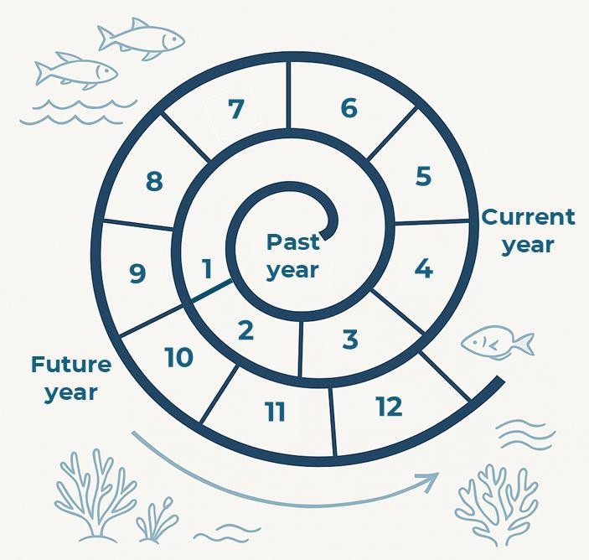
Examples: seasonal calendars
The Indigenous Mukkuvar Ocean Calendar of South Kerala, India, is closely tied to the southwest monsoon. Its first marker is around April 23 (chitira 10), when the Pleiades (aarameenu) become invisible, coinciding with the Tamil calendar’s first month. Another key sign is May 24 (vaikasi 10), when the Orion Belt (mulakkameenu) disappears, marking the monsoon’s onset at sea. These astronomical events guide Mukkuvar fishers, who say at least three years’ observation is needed to grasp the ocean calendar. The year is divided into five periods: early celestial events, southwest monsoon (aani-aadi/melameenu), northeast monsoon (keelameenu), calm season (mariyalum thayum), and mackerel and tuna abundance. Each has distinct ocean conditions, from green, productive waters during the southwest monsoon to blue, clear, less-productive waters in the calm season.

Figure 2: Representation of a Mukkuvar ocean calendar. © Johnson Jament
Newari Indigenous communities in Nepal follow a calendar that is based on lunar cycles. Religious leaders make a new calendar each year, and each festival is planned as per the lunar cycle. There are many such festivals, including the chariot festival in which a chariot is pulled through the city for the rain god, who is very important for agriculture. Two or three weeks after the festival the rain starts in Kathmandu valley. During another festival people clean all the water sources and wells, before the rainy season comes.
Also in Nepal, in a Himalayan semi-arid Mustang village in Gandaki Province at 2,700m, traditional farming relies on snowmelt irrigation and Indigenous knowledge, as well as an irrigation system that also runs a water wheel. Villagers grow naked barley, buckwheat, corn, potatoes, beans and mustard, rotating crops in six-month cycles to match climate and household needs (November to May for naked barley and potatoes, May to November for buckwheat, corn

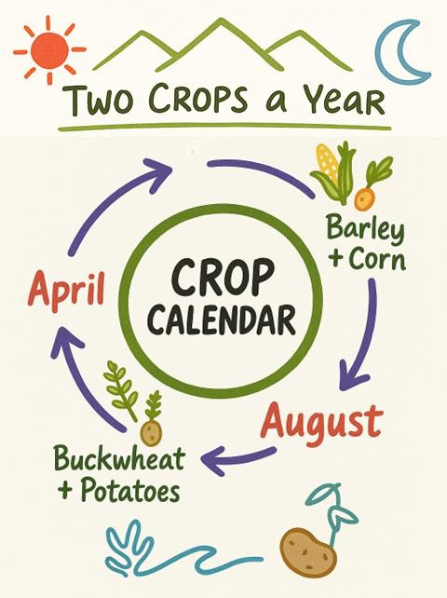
and beans). These practices improve soil health and biodiversity while supporting livestock. Monitoring is integral and farmers track weather shifts, soil conditions and ecological patterns, relying on ancestral knowledge to adapt. Rituals are also a crucial part of this seasonal cycle, and before sowing any crops they worship the land at a white stone that symbolises the heart of the field, asking that the seeds survive. They also follow a lunar calendar, and the planting and harvesting times are determined by the priests in the local monastery, who consult the lunar calendar and are offered bowls of the previous year’s crops with which they perform ceremonies for the current year’s harvest and good rainfall. Local governance also remains very strong, and in these customary systems there is one headman and secretaries who will take care of the irrigation system, the monastery, the forest and the boundaries. Challenges such as drought, landslides and glacier outbursts test resilience, but the governance system, and efforts such as soil protection and planting native trees all strengthen sustainability. This system links food security with biodiversity conservation and community well-being.

Figure 3: representation of a crop calendar from a Mustang village (Gandaki Province, Nepal). © Bidhya Hirachan.
Also in Nepal, many communities follow agricultural calendars that follow the movements of the sun and the moon. These organize the timings for planting and harvesting of different crops, which also follow a series of festivals, for example Kakfewa tangnam in the new year, were land is prepared for crops and potatoes and barley are planted. This is followed by Yakwa in April, which marks the beginning of planting of other crops, and prayers are said by Limbu priests for protection of the crops and for all human and living beings. A third festival is Shishekpa, in July,

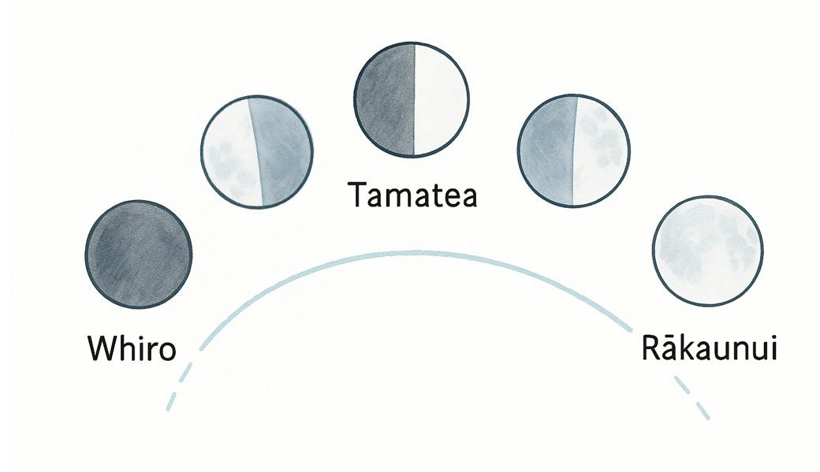
to collectively celebrate the completion of all agricultural activities and harvesting of maize and fruits. A fourth festival, Chasok tangnam, in December marks the harvesting of other crops and thanking god for the protection of the crops and all living beings.
The Andean cross, ‘chakana’ is a cosmological symbol from pre-Incan Andean societies, often interpreted as expressing relationships between time, space, and life, which is still used today. Different interpretations exists across regions and communities. For example, some parts of the cross can represent different times of the year, as well as representing different aspects of the territory from highlands, middle lands and the lowlands in the Amazon. It therefore indicates connections between time and space. Some Andean traditions associate the chakana with cyclical time, including seasonal change, solstices, and equinoxes and agricultural calendars. These teachings are passed from generation to generation.
In New Zealand (referred to by Māori communities as “Aotearoa”) many Māori communities follow the lunar cycle, which changes from the top of the North Island to the bottom of the South Island. Māori teach their youth that they need to observe, they need to learn, and the importance of moving away from a modern calendar and using a cycle that the elders used to work with. This includes Rākaunui the full moon, which signifies the harvesting for certain foods and pollination of some crops by moths when the moon is full. Tamatea, when the moon is half full is the best time of the month for food activities. Building from the lunar cycle there is the monthly cycle. For example, Matariki is the Māori name for the Pleiades star cluster, which heralds the Māori New Year as it rises in June or July. It is necessary to be awake before daybreak to read the night sky to know the timing within the month. Those stars are first visible from various locations in the North Island of the country. People also read tides and bird behaviour. A big challenge is reconnecting youth with this this experience, and rebuilding the methods and cycles.

Figure 4: Grounded in Ātiawa knowledge (Taranaki region), this illustration shows the Māori lunar almanac and how its monthly cycle informs decision-making aligned with environmental rhythms. The Maramataka, or Māori lunar calendar, guides activities sustaining human communities and continues to be applied across Māori and Pacific groups. © Nick Roskruge

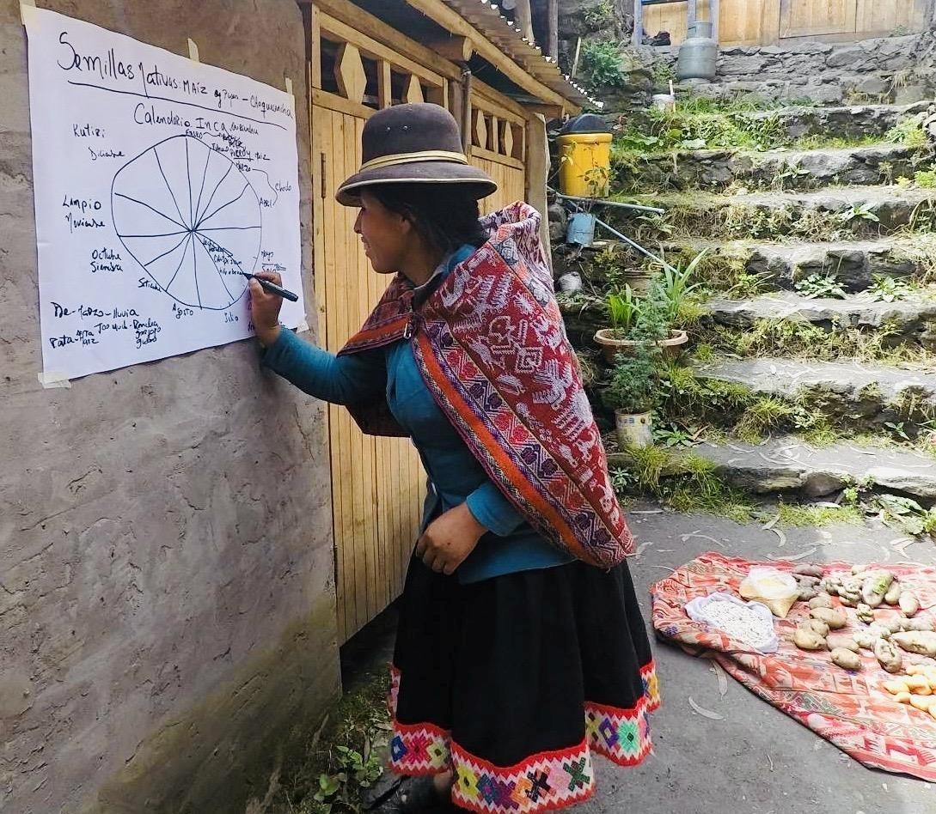
In Peru, ecocultural calendars help to guide agricultural activities throughout the year and support recovery of traditional seeds and agricultural practices.

Figure 5: Marisol Quispe, a member of the Quechua community of Choquecancha in the highlands of Peru, is actively enriching the ecocultural calendar in a “seed sovereignty” workshop. This initiative not only preserves biocultural heritage but also monitoring of biodiversity. Photo credit: Mariaelena Huambachano.

Monitoring across biocultural systems for multiple benefits
Participants also emphasized that monitoring by Indigenous Peoples and local communities can have diverse benefits across biocultural systems, including sustainability of food resources, livelihoods and economic systems, as well as biodiversity conservation and protection of lands and waters from encroachment and degradation by other groups.

Example: Indigenous Mukkuvar fishermen in Kerala, India⁶
The Mukkuvar community’s Indigenous and traditional monitoring systems focus upon a diverse range of marine habitats such as natural reef ecosystems, artificial reefs and shipwreck or boat-wreck zones, which are distributed across the seascape in the district of Thiruvananthapuram, Kerala, South India. What makes this monitoring system particularly unique is that many of these ecological sites have been discovered and mapped over generations by these Indigenous fishers themselves, using their deep knowledge of the sea. This understanding is guided by a traditional navigation technique known as kanicam, which combines observational skills, knowledge of seabed formations, current patterns, water colour, marine species behaviour and land-based reference points such as peaks or mountains along with an understanding of the location of celestial bodies like stars, planets, moon and sun. These community-identified ecosystems may not appear on formal marine charts, but they are intimately known and protected within the community. This Indigenous marine spatial knowledge forms the foundation for territorial governance, community enforcement and sustainable resource use in these zones.
The Mukkuvar fishers engage in active, community-based monitoring and self-policing of their marine territories, for example, bans on certain nets, seasonal closures, discouraging community members from owning and controlling mechanised vessels. These are enforced by customary rules. Violations are often addressed through community meetings or decisions made by village elders or fisher councils, often facilitated by the local parish priests. A key focus of their monitoring is the prevention of destructive and overfishing practices by external actors, particularly mechanised fishing vessels. They strictly regulate access, especially within sensitive zones such as areas up to 5 kilometers from the shore or depths shallower than 30 meters. They monitor and often physically intervene to prevent the entry of mechanised fishers – defined as vessels longer than 20 meters or with engine capacities exceeding 250 horsepower – into these coastal waters. For example, the fishers frequently report unauthorised entry by mechanised boats to local leaders, who in turn take immediate collective action to intercept or expel the intruders. One elder noted, “when a ring/purse seine boat enters, we alert the others immediately – we do not allow them to fish here. This is our sea, and we protect it together.” Most importantly, conflicts related to fishing violations are typically resolved through dialogue and consensus at the village level, avoiding escalation and maintaining social cohesion. Prohibited fishing practices in these territories include the use of trawl nets, purse/ring seines, pair trawling and other non-selective or high impact methods. Instead, Indigenous Mukkuvar fishers rely on traditional and selective fishing techniques, such as hook and line and species-specific nets like notholi vala, chala vala and rolu vala, which target particular fish species and minimise ecological disruption.

⁶ Submitted as a contribution for Chapter 1 of the Monitoring Assessment by Dr. Johnson Jament, who also participated in the workshop.

These practices are deeply rooted in their ILK systems, which promote not just selective fishing, but also seasonal fishing practices that align with the natural rhythms and biological cycles of the ocean, ingrained in the Mukkuvar ocean calendar. For example, during periods of seasonal upwelling – such as the aniyadi or kuluthi season – the Mukkuvar avoid methods like net fishing or light assisted fishing to allow marine ecosystems to regenerate naturally.

Ecological benefits
By respecting the seasonal dynamics, the Mukkuvar fishers help maintain the ocean’s regenerative capacity and natural productivity, ensuring that fish stocks are neither overexploited nor depleted of juvenile individuals. Such practices prevent habitat degradation, reduce bycatch, and eliminate the risk of “ghost fishing” caused by abandoned or lost gear. This ecological stewardship becomes even more crucial in areas already affected by industrial development. For instance, large-scale infrastructure projects, which are often supported by scientific institutions, have already led to the destruction of more than half of some intertidal rocky reef ecosystems, directly threatening biodiversity and undermining ecological resilience. In contrast, Mukkuvar community-based monitoring systems serve as a buffer against further ecological degradation, actively contributing to marine conservation and long-term sustainability.

Social benefits
Beyond ecological protection, the Mukkuvar monitoring systems generate significant social benefits for their communities. By asserting control and autonomy over their marine spaces – claimed as Indigenous and Traditional Territories (ITT) or sea sovereignty – communities maintain a continuous connection with their seascapes and demonstrate respect to their elders’ knowledge related to them. This deep, place-based stewardship reinforces cultural identity, knowledge transmission and collective responsibility. This reduces the risk of conflicts, particularly those arising from external encroachments by mechanised and commercial fishing operations. These systems also act as a deterrent to illegal, unreported and unregulated (IUU) fishing activities, thereby enhancing compliance and reducing reinforcement burdens on external agencies. Furthermore, the localised, spontaneous and community driven governance structure fosters social cohesion and cooperation, strengthening the community’s capacity to manage and respond to ecological or resource-related challenges. In essence, such systems represent a sustainable, socially embedded model of marine stewardship rooted in traditional knowledge and lived experience.

Economic benefits
The Indigenous stewardship and monitoring of reef ecosystems, artificial reefs and shipwreck areas generate vital economic benefits for coastal communities. These ecosystems continue to support the livelihoods of over 10,000 small-scale artisanal fishing families who are directly dependent on them for income, nutrition and access to animal protein. Due to community-led conservation and selective fishing practices, Mukkuvar fishers still secure regular catches,

enabling fishing activities on approximately 150 days each year – an important source of employment and subsistence in these regions. This system is grounded in community values that prioritise maximum collective benefits with minimum ecological disruption, promoting equitable access to marine resources. The guiding principle – “everybody gets something, rather than somebody getting everything” – ensures fair distribution of catches and reduces inequality within the community. Moreover, the continued viability of Indigenous small-scale fisheries sustains a broader network of economic actors. Over 1,000 additional families benefit indirectly through related livelihoods such as fish vending (largely by women), auctioning, small trading, local provisioning and other fisheries-linked services. In this way, Indigenous monitoring systems not only protect marine biodiversity but also uphold resilient local economies rooted in traditional practices and communal values.

Customary governance, roles and responsibilities
Participants also highlighted that while much monitoring within ILK systems may be informal, intuitive and flexible, as discussed above, many ILK monitoring systems are also embedded within complex customary governance systems, with flows of information through communities to councils or other institutions. Meanwhile, in other communities there may be specific people with different roles for monitoring certain aspects of nature, for example traditional healers in Oaxaca who monitor and nurture spiritual relationships. Women may also gather and use resources differently to men, so they may be monitoring different aspects of biocultural relationships. Participants noted that these differences across communities, and within communities, demonstrate that it is important to explore diversity across ILK systems, and within individual communities.
Example: Karamojong pastoralists in north-eastern Uganda⁷
Karamojong pastoralists in north-eastern Uganda depend largely on pastoralism and rangelands for their livelihoods. They maintain long-standing systems of information sharing and governance that encompass social, economic, political and environmental aspects. Their biodiversity and climate monitoring practices are deeply rooted in natural observations, cultural traditions and ecological events.
As part of this system, biodiversity information is collected by herders, dreamers, foreseers, scouts, wild gatherers and hunters. These actors record the presence, absence and emergence of new species, as well as the characteristics of plants and animals – for example, flowering cycles, animal coat colour or changes in wind and water sounds. Commonly monitored species and

⁷ Submitted as a contribution for Chapter 1 of the monitoring assessment by Loupa Pius, who also participated in the workshop.

indicators include bees, butterflies, wildlife, fruits and flowers. Such information is vital for guiding decisions about soil health, hunting restrictions, the availability of herbal medicines, the likelihood of disease or pest outbreaks, household food security and livestock movement. To verify observations, scouts may collect samples, or test plant materials through smell and taste, before passing them on to community analysts. They do not have specific ways of recording these observations. For example, herdsmen on the land know the colours, the fruits, the sound of the birds or of the river flowing, and then they will report to the senior elders, who will interpret the information and decide on its implications.
The Karamojong employ traditional analytical practices to help interpret the observations gathered on the land. These include reading the intestines of slaughtered animals, interpreting water patterns in a calabash and tossing shoes. Elders then form committees to evaluate the state of biodiversity and the rangelands. They track and interpret changes such as shifts in vegetation cover, variations in animal sounds, fruit and flower development, the appearance of invasive species, rangeland encroachment, pasture availability, the arrival of new bird species, presence of other herbivores, seed dispersal cycles and lunar phases.
The Akiriket is a sacred assembly of senior elders, traditionally convened in natural spaces such as groves or rocky shrines. Elders in this forum deliberate on ecological changes and their implications for society. Decisions may include initiating land restoration, restricting the hunting of young or pregnant wildlife, regulating plant harvesting, initiating seasonal migration to allow pasture and water recovery, or promoting sustainable use of natural resources. Implementation is often entrusted to the karachuna (youth age group). The decisions are communicated to the wider community through dialogues, cultural ceremonies and campfire meetings. Communities then act collectively by limiting hunting, restoring degraded areas, practicing controlled harvesting and ensuring sustainable livestock mobility.
Across these processes, learning, feedback and adaptation are continuous. New knowledge is observed, tested and transmitted to the community, strengthening resilience and preparedness in response to ecological change.
Within this complex system, the Karamojong have words that may roughly translate to “monitoring”. Often, they are used differently, in different respects, for example, the word Aripirip may convey monitoring – in that it implies that people keep seeing or observing what is happening. Another word Akiyenikin conveys more of the complete process to understand what is happening, and why.

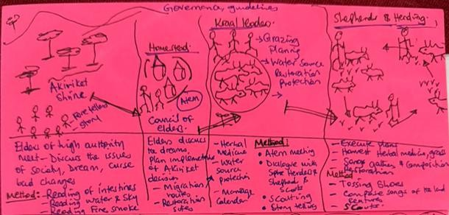

Figure 6: A sketch of the customary governance among pastoralists in Uganda. Information flows from left to right, from the Akiriket (traditional parliament/ shrine or meeting place) to the Atem (council of men and elders) to the Kraals (enclosures for livestock) to the individual shepherds and herders. [with thanks to Loupa Pius]
Other examples
In Nepal, many Indigenous communities manage their lands, waters, farming, hunting and gathering through their customary institutions, including customary laws, oral histories and protocols. The whole community, including the priests, elders, youth and women hold diverse and important knowledge that helps to monitor and maintain these systems.
In Oaxaca, Mexico, monitoring is carried out throughout the year, is led by agrarian authorities and involves residents over the age of 18. Community monitoring often involves activities, for example gathering in the forest, which is often done by men, but then information is shared with families and the authorities. The authorities also relay the findings of monitoring to the community. This is supported by western science tools, which also report the state of the ecosystem for broader governance processes. As the communities have legal rights over lands and territories, this enables them to have control over monitoring activities. Results of monitoring allow the communities to make decisions about the forest, for example removing wood to reduce fire risk.

Community-based monitoring and information systems
Participants discussed the growing importance of CBMIS. They explained that many communities are currently developing CBMIS to support their governance and self-determination. The new programme of work on traditional knowledge indicators for the KMGBF also references CBMIS. CBMIS also have the potential to support monitoring in relation to Section C of the KMGBF.

Conceptualization
Participants noted that it is important to share a conceptualization of what is meant by the term “CBMIS”, as this term can be used by different groups in different ways. Participants discussed a draft conceptualization of CBMIS that had been developed by the monitoring assessment author team, by reviewing materials that had been published on CBMIS, mostly by Indigenous organizations.⁸
The draft conceptualization was as follows:
- CBMIS are initiatives by Indigenous Peoples and local communities to generate data and information on the state of their territories and resources, as well as human well-being.
- Indigenous Peoples and local communities own and lead the planning, implementation and application of CBMIS and CBMIS support Indigenous Peoples’ and local communities’ goals and aspirations.
- CBMIS often contribute to Indigenous Peoples’ and local communities’ governance systems by strengthening the local knowledge base for territorial and resource management and community development, for example by documenting external threats or supporting claims for land or marine tenure.

⁸ These resources include:
- Mara Stankovich (Global Workshop Report); Chico Cariño, Maria Elena Regpala, Jo Ann Guillao, and Grace Balawag (Philippine Workshop Report) (2013). Developing and Implementing Community-Based Monitoring and Information Systems: The Global Workshop and the Philippine Workshop Reports. Tebtebba Foundation. ISBN No.: 978-971-0186-16-7
- Tebtebba. Community-Based Monitoring and Information Systems (CBMIS) Website
- Farhan Ferrari, M., de Jong, C., & Belohrad, V. S. (2015). Community-based monitoring and information systems (CBMIS) in the context of the Convention on Biological Diversity (CBD). Biodiversity, 16(2–3), 57–67. https://doi.org/10.1080/14888386.2015.1074111
- Forest Peoples Programme (2024) Info note #4: Traditional Knowledge Indicators. Information note for CBD COP16 in Cali, Colombia

- As a secondary application, they can also contribute to broader environmental governance agendas such as the implementation of the KMGBF.
- Fundamentally, CBMIS are grounded in ILK systems and the values and worldviews of Indigenous Peoples and local communities, for example, goals, aims and priorities may be framed by ILK systems, worldviews and values.
- CBMIS, however, utilize a broad range of methodologies selected and adapted for the context and aims of CBMIS, such as community surveys, participatory 3-D cultural mapping, or resource inventories. As such, they mix ILK and science, and embody adaptation, change and innovation.
- Indigenous Peoples and local communities may collaborate and partner with other actors such as NGOs and external researchers for some aspects of CBMIS, for example data management or capacity-building around research methods, but control rests with the community.
- CBMIS ensure that Indigenous Peoples and local communities have sovereignty and control over their data.
Participants broadly agreed with the conceptualization. They noted, however, that often it is difficult to draw firm lines between holistic monitoring within ILK systems and CBMIS. Many ILK systems may now use elements of “scientific” methods or technology, for example phones and GPS to orientate themselves on the land, or weather reports from government meteorologists to support their herding or fishing activities. It can therefore be inappropriate to enforce a line between ILK systems and more mixed methods.
It was noted, however, as a key difference that Indigenous Peoples and local communities often implement CBMIS as something akin to a research project, often in response to external pressures or threats. Participants highlighted a number of external pressures or goals that CBMIS may seek to address, including protecting lands and waters and Indigenous and traditional territories, gaining external recognition for knowledge, stewardship, land ownership or governance systems, monitoring and reporting human rights violations, or supporting good governance of lands and waters at national levels. As such, CBMIS may be somewhat different from monitoring within ILK systems, which may be more tied to traditional practices, livelihoods and governance to meet a community’s or individual’s needs or are part of more traditional systems of management of lands and waters. Nonetheless, there may be some cases of communities implementing CBMIS entirely to meet their own internal management and communication needs, but again these may broadly follow processes akin to a research process.
Participants also noted that it may be difficult to clearly differentiate between CBMIS and some projects that are organized by NGOs, external researchers or governments, which may include

many elements of CBMIS and community participation. The key difference here may be whether control rests with communities through all stages of the project. Projects where this is not the case, and where control sits more with external entities, might better be referred to as “collaborative monitoring”, which can also exist on a scale with different levels of community and external engagement.
While recognizing that there are no firm lines between these concepts, participants agreed that the conceptualization above is helpful for broadly explaining what is meant by “CBMIS”, and how it differs from monitoring within ILK systems and other forms of collaborative monitoring.
It was also noted that the “information systems” part of the terminology is important, as this implies that communities are also managing and storing data and information themselves, rather than this being done by external actors. It was also noted that information systems can include communication systems, which means that communities control how knowledge and information is communicated to external actors.⁹ It was also noted that control of community data and information is key, and that communities should have control over what they share with external actors. They may therefore document information within their CBMIS that is only for internal community use.
Example: CIPRED’s experience with CBMIS in Nepal
Participants from CIPRED, an Indigenous-owned and -led NGO from Nepal, presented and explained their approach to CBMIS, using the examples of their work with the Dura and Tharu communities in Nepal.
The overall aim is that CBMIS can promote Indigenous Peoples’ sustainable self-determined development approaches and that it can be a basis for community planning, decision-making, action and development. CIPRED has aimed to ensure that communities are central to the development of the monitoring process, and to generating and analyzing data related to land, territories and resources.
In terms of methods, focus groups and workshops were held in the communities to understand their goals and challenges, and to build community ownership of the projects. Meetings were also held with local government representatives and others, so they felt that the projects were also supporting their needs. Community members, including youth and women, have been taught to collect the data, and they have continued this process. Reports are prepared and

⁹ For more discussion of this, see: Reports of the Community-Based Monitoring and Information System Workshops. Global workshop was held on 26-28 April 2013 in Bonn, Germany and the Philippine workshop was on 25-27 February 2013 in Quezon City, Philippines

validation meetings are held with the local government representatives to ensure that they see value and importance in the findings.
The CBMIS focus on a number of broad themes. In relation to land, territories and resources the CBMIS help to document traditional land use and occupancy, which can support legal recognition of Indigenous territories. It also documents status and trends in land use change and land tenure in the traditional territories; land use and land ownership status (whether land is owned by a clan, tribe, community or others); and areas of customarily managed forest, private forest and community forest. The CBMIS also document Indigenous Peoples’ water management as a way of demonstrating the existing work of the community in protecting water courses. This also includes monitoring of water quality (as perceived by community or through science-based tests that may include volume and discharge) and water utilization (including domestic, agriculture, commercial and others).
In relation to human rights in conservation, CBMIS supports communities to monitor and record human rights abuses, such as illegal land grabs, resource exploitation, or violations of FPIC. It also allows the community to record and access information on damage to their crops, homes and livestock due to wildlife intrusion. It also monitors individual human rights violations. Finally, it allows access to information related to cases filed in court and their status and case resolution description, as well as to cases filed in the customary justice systems, including their status and resolution description.
The CBMIS also support monitoring in status and trends in the practice of traditional occupations (which is tied to Indigenous indicators developed for the CBD), including livelihoods and occupations, and roles of men, women and youth, and threats and challenges.
They also support monitoring of languages, including numbers of speakers of Indigenous languages, language description (including if it is primarily used for conversation), modes of transmission, language vulnerability, threats and challenges.
The CBMIS also aim to support customary governance systems, by documenting them and supporting their revitalization, as well as providing a tool for supporting relevant knowledge and practices. This also supports conflict resolution, equitable access to resources, and inclusive participation and representation in collective decision-making. For example, the Dura community has existing customary laws and practices, including designations of some forest areas for community use (e.g., for firewood of building houses), prohibitions on sales of timber and firewood to outsiders, and strong restrictions on cutting down trees and plants or quarrying in and around water sources and spring areas. Documenting these practices through the CBMIS supported the community in maintaining control of their forest areas, which were almost placed under local government control, but now the community can manage these areas themselves.

CIPRED has also worked to communicate with other stakeholders, for example research institutions, universities, the World Wildlife Fund and the Indigenous Nationalities Commission so that awareness of the CBMIS and their results are also recognized at national levels, as this is a crucial level for action and resolution of issues identified by the CBMIS.
Other examples
In Oaxaca, Mexico, community monitoring programmes are also in place, and show various benefits to communities, including empowerment of the people on their territories, supporting decision-making and ratifying rights to manage the land, and communication and negotiation with government and academics.

Indigenous research methods
Within the context of CBMIS, and collaborative monitoring and research more broadly, participants highlighted the importance of understanding Indigenous methodologies and Indigenous research frameworks. These are being developed by some Indigenous scholars, so that they can perform research in ways that honour and follow approaches to learning and knowing within ILK systems. Participants, however, noted that much of what is published on Indigenous research methodologies may not be written by Indigenous Peoples.¹⁰
Participants also noted that, while communities may wish to access and use technologies such as 3D mapping, GIS and remote sensing data, they often want to use these within their own methodologies and knowledge systems. A challenge is that communities need to understand the technologies well enough so that they can strategically integrate them into their own knowledge systems and ways of working, or there is a risk that the technology can become an imposition of methods and ways of thinking.
Example
The Three-Eyed Seeing framework among Anishinaabe First Nations in Canada links Indigenous Science, Western Science and Our Relations, which includes the waterways, lands and beings that cannot speak for themselves. Through Indigenous monitoring, observing seasonal cycles, ecosystems and cultural laws, Anishinaabe communities track change and guide stewardship. When combined with scientific methods and respect for land, water and both living and non-

10 Suggested resources on Indigenous methodologies written or co-authored by Indigenous Peoples included: Chapter 3 of the IPBES Assessment of the Values and Valuation of Nature, which presents a discussion of the different ways in which Indigenous Peoples and local communities may approach or conceptualize methods, and the book “Recovering Our Ancestral Foodways: Indigenous Traditions as a Recipe for Living Well” which also has a chapter on Indigenous methodologies.

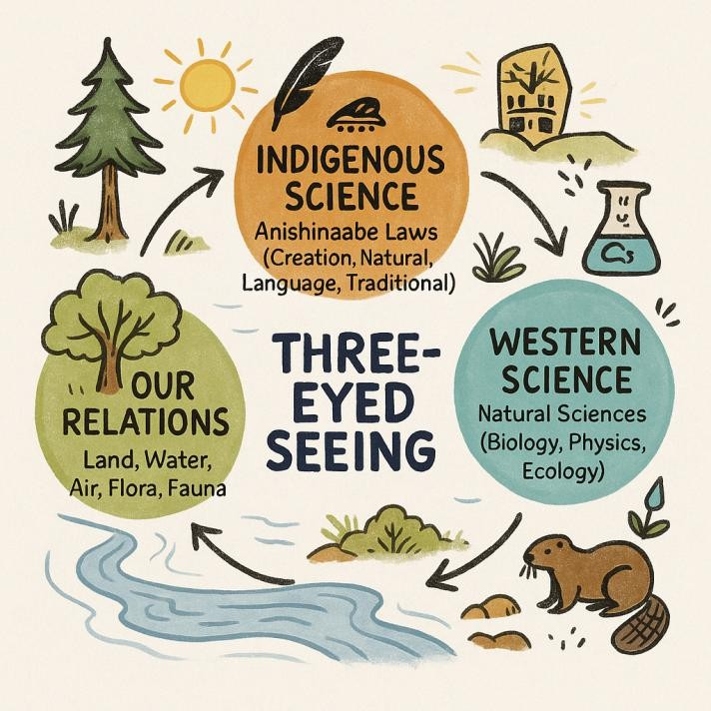
living beings, this approach fosters resilience and balance for present and future generations. Importantly, the framework gives voice to “Our Relations”, as Indigenous People interpret their messages and learn how to protect them more effectively.

Figure 7: The Three-Eyed Seeing framework among Anishinaabe First Nations in Canada. © Myrle Ballard

Co-production or collaborative monitoring

Benefits and risks
Participants discussed co-production and collaborative monitoring, noting that co-production is a central theme of chapter 4 of the monitoring assessment.
Some participants expressed unease over this focus, noting that often it is non-Indigenous scientists who favour co-production, and that often it implies that Indigenous Peoples and local communities contribute knowledge into scientifically determined frameworks, goals and processes. This can also lead to assumptions about which knowledge is valid or not, and who should validate knowledge. Often knowledge that does not fit within the pre-determined frameworks and processes is rejected or ignored, or knowledge that cannot be supported by science is rejected. This can lead to misrepresentation and distortion of ILK.
Participants also noted that poorly planned co-production can lead to communities losing control of their knowledge and information, as they are entered into distant databases with limited or complicated access processes.

Participants noted that, crucially, a focus on co-production, in terms of attention, effort and funding, can mean that ILK-led processes are not given the focus that they deserve, or the support that could enable them to enhance their contributions to larger scale monitoring systems in ways that also support community aspirations, values and knowledge systems.
Other participants noted that they are more open to co-production, as there are benefits for Indigenous Peoples and local communities, including learning from other systems of knowledge or technologies that can supplement and support ILK systems. Another potential benefit is the opportunity to contribute to good governance and management of biodiversity at national and other levels, which can benefit communities. A further benefit is the opportunity to demonstrate that ILK systems can make contributions to understanding and managing biodiversity at national or global levels, which can then help to support efforts for Indigenous Peoples and local communities to gain control of their own lands and waters, including marine areas.
However, participants also noted that true co-production means that the underlying values, frameworks, assumptions and processes of a monitoring system should be co-developed and agreed upon, rather than only data collection. This is a significant challenge, especially at larger scales. Validation should also only take place within ILK systems, and processes may need to be put in place to ensure this is achieved. Participants noted that the ultimate validation of ILK systems is their success at managing biodiversity over millennia.
Participants noted that there are some successful examples of co-production taking place in this way, often at smaller scales. The assessment could aim to gather and analyze these for lessons learnt.
Examples
In southern India, weather forecasts are provided by the scientific community. These forecasts are beneficial to the Mukkuvar community as they help to plan fishing expeditions, as the community knows the ways in which biodiversity interacts with the weather systems. Moreover, the community also checks the accuracy of weather information when at sea, and provides feedback to the scientific community, who can then make changes in their weather models, which improves the accuracy of the models. This collaboration and feedback benefits both the community and the meteorologists. However, in another similar case, meteorologists would not believe that a certain wind system existed as it did not fit with their models, and community researchers had to do mapping and prove that the wind system did in fact exist due to interactions with the mountains on land. This shows that the relationship between science and ILK systems can be of benefit, but it can also be challenging and time consuming for communities.
In Taiwan, province of China, the Community Forestry Programme is a government-supported project in which communities can apply for financial support to conduct monitoring in their own territories. The monitoring is then designed and implemented by the communities themselves.

The financial support is used for equipment or to support youth to stay in the community to carry out the monitoring programme. The programme is nearly 24 years old and 1,100 communities now participate. The communities monitor protected species, and this data is extremely important for the government in terms of understanding trends in biodiversity conservation. Usually, the monitoring projects weave local knowledge and technical knowledge, as well as some technologies, for example camera traps and remote sensing. Information is then stored in a fully accessible biodiversity database run by the government, and information is also kept in the communities themselves, for example in shared online folders and on websites, and the communities further utilise it in place-based education and ecotourism that supports livelihoods.
An assessment author shared an example from South Africa, where a system of community health care workers working in communities supplements the formal health care system, as there are few “western” trained doctors and hospitals may be far away. The healthcare workers go to people’s houses, and collate information, analyse and follow up with people who need to be sent to the clinic or hospital. Traditional healers have also developed a role within this system, and have changed from being spiritual guides to also diagnosing and treating common ailments, and deciding when somebody needs to be moved to the hospital. This is not an example of biodiversity monitoring, but it shows how the two systems, scientific and ILK, can work together.

Safeguards, protocols and principles
Participants emphasized that safeguards are crucial to ensure that collaboration and co-production take place in ways that are equitable and beneficial to Indigenous Peoples and local communities. They noted that even in countries which do not enforce or recognize the UNDRIP, and in communities who may not be aware of their rights, external researchers can still assume the responsibility to respect these rights, including by engaging with available guidance, such as the Code of Ethics of the International Society of Ethnobiology.¹¹ These protocols and principles include a commitment to obtain FPIC, in that communities have the right to say no to projects, or to refuse to disclose knowledge that they deem confidential or private.
Participants highlighted that data control and sovereignty are also key, with the understanding that communities maintain control of their knowledge, information and data even when it is shared with other people and processes. The CARE principles on Indigenous data governance and sovereignty (Collective benefit, Authority to control, Responsibility and Ethics) and OCAP principles (Ownership, Control, Access, and Possession)¹² provide some frameworks for these considerations. They noted that relevant articles of the CBD such as article 8(j) and 10(c) and the

¹¹ See: https://www.ethnobiology.net/what-we-do/core-programs/ise-ethics-program/code-of-ethics/
¹² See, for example, https://fnigc.ca/ocap-training/

Akwé: Kon Guidelines also set important standards.¹³ Participants highlighted that communities should have the right to full access to products created with their knowledge, in accordance with these guidelines. They highlighted as bad practice that documented ILK is often locked within inaccessible databases or in journals that require paid access, and noted that this should be avoided. Publications based on ILK should be freely available to the communities they are based on.
Participants also noted the need for clear benefits to be agreed with communities in advance. In many cases a clear road map may need to be developed with communities, including processes, systems and capacity-building that may need to be developed with communities, so that they can access and benefit from information and products. Co-authorship and full acknowledgement of Indigenous contributions is also essential. Participants suggested that there should be a mechanism through which communities can report unethical behaviour, as a warning for other communities.
Participants also raised concerns over biopiracy and misappropriation of knowledge, noting that communities and researchers need to be conscious of these risks. Documenting, mapping and sharing knowledge and locations of plants and animals can facilitate other organizations to learn about them and locate them without safeguards or regard for intellectual property. A participant also shared an example in which scientific and community-generated fish location data were published by the government with the intention of supporting community fishers. However, this led to overfishing and depletion of fish stocks.
Participants also noted a need to focus on gendered aspects of knowledge, as often women have different knowledge to men, for example on specific species or places due to their livelihood practices or due to taboos and access rights in communities. Attention is also needed to how benefits or negative impacts, for example negative impacts from environmental degradation or loss of community wellbeing, or benefits from projects, are distributed across communities, as often women may be more vulnerable while also being the least likely to receive benefits and support.
Participants also emphasized the importance of biocultural community protocols or other guidelines and rules developed by communities, often based on their customary governance, that can explain a community’s approach to research, the necessary safeguards and processes (e.g., seeking advance approval by a community council for a proposed research project), including how to seek FPIC, and data management and control protocols. They noted that where such documents have been developed, they can be important tools for communities who are

¹³ See: https://www.cbd.int/doc/publications/akwe-brochure-en.pdf

approached by external researchers, and they can be important guides for researchers wanting to understand how to appropriately engage with a community. They can also enhance participation in governance by different parts of a community, for example, women, youth, shamans or others. Examples of biocultural protocols can be found in the Nagoya Protocol’s Access and Benefit-sharing Clearing-House.¹⁴
Example
In Calpulalpam de Mendez, in Oaxaca, Mexico, a biocultural community protocol has been supporting the community in managing their relationship with researchers, including biologists who want to access community lands. Other examples of biocultural community protocols from Mexico include the protocols developed for Ejido Nejapa de Madero¹⁵ and San Juan del Río¹⁶ in Oaxaca.

Aggregating, scaling, indicators and networking

Challenges
Participants noted that a key challenge in discussions of monitoring systems and ILK is how aggregation or scaling can be done appropriately, and if ways can be found to appropriately synthesize information from different communities to build a national or global picture.
Participants noted that there are several challenges, including that knowledge often loses its context and meaning when taken from its local context. The sheer diversity of knowledge systems and monitoring systems at community level can overwhelm efforts to aggregate and synthesize, leading to drives to simplify and standardise, which can further remove meaning from the knowledge. Communities can also lose control of their information as it passes into distant data repositories or complex models. Distrust between communities and governments and researchers, and distrust between communities, can also complicate efforts to find agreed standards and approaches.
Participants also noted that there can be challenges with scaling down, as broad global- or national-scale assessments or other processes may have little relevance or applicability at local

¹⁴ See: https://www.cbd.int/abs/theabsch.shtml
¹⁵ See: https://absch.cbd.int/api/v2013/documents/9FE22165-47F8-DBCD-2932-3EC82414E894/attachments/213325/PROTOCOLO%20COMUNITARIO%20BIOCULTURAL%20DEL%20EJIDO%20NEJ APA%20DE%20MADERO%2C%20YAUTEPEC%2C%20OAXACA-MEXICO..pdf
¹⁶ See: https://absch.cbd.int/api/v2013/documents/991DE64B-0EBD-71FD-135E-ECCBD5E5469E/attachments/213450/Libro%20SJR%20final.pdf

levels, and additional processes of localization may therefore be needed to disaggregate information and determine what is relevant to diverse local contexts.

Strategies and participation
Participants noted, however, that in spite of the challenges discussed above, there are many examples of systems, processes and approaches for bringing together ILK across different scales, including work on indicators (discussed below).
Participants noted that, if communities decide to participate in broader monitoring efforts, they may need to be strategic and build collaborative networks between communities. Strategies can also include acknowledging that some of their knowledge is important at the local level where it is tied to livelihoods, spirituality and other crucial systems, but that only some information needs to be shared externally, for example observations about general trends in biodiversity or rights violations. Broader frameworks and common themes or principles may need to be agreed upon that account for diversity. In doing this, it will always be important to be aware of the ways that context, specificities (for example information on specific locations where knowledge was applied and gathered) and ownership can be lost in moving to national and global levels, and the risks and limitations inherent in this.
Participants emphasized that for all these systems, it is important to also ensure that communities can participate throughout the different levels of the system, and that there is good communication on how information is used, so that they can maintain awareness and control over their information.
Examples
In New Zealand there are diverse ways that Māori can participate in and oversee monitoring systems and environmental management processes, for example as part of the Environmental Protection Agency, which has a Māori oversight committee (Ngā Kaihautū Tikanga Taiao). There are processes which are stronger and weaker in relation to participation within the political system, and further exploration of these could be interesting for understanding the institutional and political frameworks for scaling locally-based monitoring and knowledge up to other levels. Limited resources remain a key challenge, in particular funding, which can lead to competition between communities rather than collaboration. A lack of trust between communities and the government can also limit what communities are willing to share. There are also challenges in finding common elements between tribes, and some groups are reluctant to generalize, as this can risk losing the context and vitality of their knowledge. A key focus has also been placed on training youth and bringing them back to their culture and knowledge systems so that they can contribute to monitoring and oversight efforts.

In Kenya and Uganda, the Centre for Research and Development in Drylands is documenting knowledge and practices for stopping the spread of invasive plant species in the drylands, which can also show how knowledge from across large areas can be brought together.
In Colombia, many Indigenous organizations aspire to lead their own information systems and community-based monitoring initiatives. To advance these efforts, they often collaborate with other institutions, whether public agencies or NGOs. There have also been dialogues between the National Statistics Department and Indigenous organizations interested in ensuring that their information and data are integrated into national information systems. However, community monitoring initiatives rarely engage with one another. Each asserts its own autonomy, yet there can be little recognition that, in order for certain types of information to be scaled up to the national level, a minimum degree of agreement on methodologies and indicators is required. Without such alignment, key demands of Indigenous organizations – such as claims to land, the recognition of their own health systems, and others – struggle to gain traction at the national level. Interoperability is a constant demand from Indigenous organizations so that their information may be recognized as official by the State. However, this aspiration collides with the lack of dialogue among the different community monitoring initiatives and the absence of agreements to develop certain indicators in a consistent manner.
Participants also noted that at the national level, processes for the development of National Biodiversity Strategies and Action Plans (NBSAPs) can be a key area for engagement by Indigenous Peoples and local communities, along with other oversight and monitoring processes implemented by governments. They recommended that the assessment could perform an evaluation of NBSAPs and their inclusion of ILK systems and ILK monitoring information, to draw out good practices and lessons learnt.
Example
In the Philippines, Indigenous organizations across the country have collaborated in creating their own “Indigenous Peoples’ Biodiversity Strategy and Action Plan” which aims to inform and complement the official government NBSAP.¹⁷

Indicators
Participants also noted the potential of commonly agreed overarching ILK indicators, for example the traditional knowledge indicators developed for the CBD and KMGBF, in a process that started in 2004 through a series of workshops and other processes with Indigenous Peoples and local

¹⁷ See: https://transformativepathways.net/philippine-indigenous-peoples-biodiversity-strategy-and-action-plan/

communities. These were then further adapted for the KMGBF through a series of workshops and expert groups.¹⁸ They are:
      - Linguistic diversity and number of speakers of indigenous languages;
      - Land use change and land tenure in the traditional territories of Indigenous Peoples and local communities;
      - Practice of traditional occupations; and
      - Degree to which traditional knowledge and practices are respected through the appropriate and respectful integration, participation and safeguards in the national implementation of the strategic plan.
A participant raised a concern that in general, the language used in the traditional knowledge indicators seems to centre land-based tenure and does not seem to adequately reflect marine and coastal territories, customary ocean rights and livelihood systems of coastal Indigenous Peoples. For many coastal Indigenous Peoples, traditional territories are not limited to land but extend across coastal waters, reefs, fishing grounds and offshore seascapes (including areas beyond national jurisdiction), governed through customary tenure and stewardship systems. The absence of explicit reference to marine and coastal rights risks marginalising ocean-based Indigenous livelihoods and governance systems, particularly in contexts where conservation, fisheries management and marine spatial planning directly affect customary fishing grounds. He recommended that these aspects should be included within the indicators, to explicitly include land-sea continuums. This could be reformulated as “Land and sea use change, and land, coastal and marine tenure in the traditional territories and seascapes of Indigenous Peoples and local communities.”
Also at the global level, the Indigenous Navigator¹⁹ provides a framework and a set of tools for Indigenous Peoples to systematically monitor implementation of their rights. The Local Biodiversity Outlooks²⁰ are also tools that demonstrate how Indigenous Peoples from around the world have brought together their diverse experiences and then analysed overarching trends, drivers and ways forward, following the structure of the Aichi Biodiversity Targets. A third edition is being produced to reflect on the targets of the KMGBF.

¹⁸ See for example:
https://www.cbd.int/doc/c/283e/eb7c/6a953a1e098b6c46e0f3be8d/sbstta-26-inf-11-en.pdf
https://transformativepathways.net/experts-work-on-assessing-status-of-traditional-knowledge-indicators-for-the-global-biodiversity-framework/
¹⁹ See: https://indigenousnavigator.org/
²⁰ See: https://localbiodiversityoutlooks.net/

Participants also shared examples at national levels, where guiding indicators have been developed with communities, that can then be selected or adapted to the community level (see example below). This can help to frame community efforts so that their knowledge is relevant for policymaking, whilst giving scope for adaptation to give communities control in developing indicators that are appropriate for local contexts and knowledge systems.
Example
In Taiwan, province of China, a tool has been developed to support community monitoring of landscapes and seascapes. The tool has five perspectives: ecological, production, cultural, governance and livelihoods. Communities can decide for themselves how to use the tool, and they can develop and adapt their own indicators from a range of 20 options. The results are analysed and embedded in action plans on the ground. This has been implemented in 16 communities, and networking and sharing of experiences is being encouraged, and experiences and lessons learnt are being documented. Challenges remain in how to link more qualitative data with quantitative data produced by scientific organizations also working in the country.
In Nepal, work has also been done to bring together Indigenous Peoples from around the country so that their knowledge can be included in the country’s NBSAP. This has partly involved co-designing metrics and developing output and outcomes associated with indicators, with milestones across time. Previous top-down approaches had failed as Indigenous Peoples and local communities had not seen value in the processes proposed.

Networking
Participants noted that an additional, crucial strategy for scaling and aggregation is to enhance networking at different scales between communities engaged in locally based monitoring systems. Groups of people can be brought together at different levels, for example groups from across a country can come together to discuss their observations and build a picture of biocultural trends, challenges or other aspects at a larger scale. This strategy can also avoid the challenges associated with loss of control and access to information, which can occur if knowledge moves to national or global levels, but the knowledge holders do not. There are some examples of this type of networking at national, regional and global scales, all of which would benefit from increased funding and participation (see below).
Example
In Mexico, a policy on natural resources calls for regional committees, and the heads of agrarian committees need to meet twice a year and exchange information between communities, including around watershed management and to apply for funding. Payments for ecosystem services schemes have also enhanced collaboration, with communities agreeing together to plant trees, combat fires and manage water.

The Indigenous and Community Conserved Areas (ICCA) network in Nepal has done extensive work to bring together Indigenous Peoples from across the country to document their customary governance and contributions to biodiversity conservation and wellbeing. This type of network can also be a basis for coordinating monitoring between communities.
Networks have been created for vicuña management, connecting Argentina, Bolivia, Chile and Peru. Vicuñas are wild and were on the verge of extinction, and so it was prohibited to use vicuñas for many years, and as a result population numbers recovered. In the 1990s sustainable use was started again by local communities. There were growing experiences in Bolivia of community-based management, and some of the people involved went to Argentina to train communities on how to monitor and manage vicuñas. This is a serious undertaking, as the community need to create a management plan, and they need to monitor vicuñas in their areas. This has led to some networks, and communities meeting twice a year to share data on vicuña monitoring. The government lacks financial resources, so relying on local communities and their data is essential, and this also benefits local livelihoods.
At global scales the International Indigenous Forum on Biodiversity,²¹ which is tied to the CBD, the Network of the Centers of Distinction on Indigenous and Local Knowledge,²² which was created in part to support the work of IPBES, and the United Nations Permanent Forum on Indigenous Issues (UNPFII), also provide models of how Indigenous Peoples and local communities are networking and sharing knowledge and experiences at global levels, and participants noted that these could be better supported to enhance their reach and participation.
Indigenous organizations led by women, for example, Red de Mujeres Indigenas Sobre la biodiversidad (Indigenous Women’s Biodiversity Network), Centro de Culturas Indígenas del Perú – CHIRAPAQ (Centre of Indigenous Cultures of Peru), and the Center for Indigenous Peoples’ Research and Development (CIPRED) in Nepal, also show the ways that Indigenous women’s leadership can bring knowledge-holders together at national levels to share knowledge and build strategies, common positions and actions. Many of these Indigenous organizations are also members of international Indigenous organizations and networks, such as IIFB or UNPFII, which shows how connections can be made across scales.

²¹ See: https://iifb-indigenous.org/
²² See: https://www.codilk.org/

Enabling conditions
Participants emphasized that building broader enabling conditions is essential to support the diversity of monitoring systems discussed above (monitoring within ILK systems, CBMIS, collaborative and co-production).
Participants noted that vibrant and dynamic ILK knowledge systems are essential foundations for Indigenous and local monitoring. They emphasized that there are currently many threats to ILK systems and to Indigenous Peoples and local communities, including evictions and reduced access to lands, waters and resources, which in turn limits or curtails the ability of Indigenous Peoples and local communities to monitor these areas. Social changes, language loss and disconnection of youth from culture, knowledge, lands and waters, is another threat to monitoring by communities.
Participants therefore noted that governments and others can better support monitoring by Indigenous Peoples and local communities by supporting Indigenous education, languages, livelihoods, land and marine tenure and access to lands and waters, and reducing degradation of the lands and waters on which knowledge systems are based. In many cases, efforts to reconnect youth to their cultures, languages and knowledge systems also need support.
Limited opportunities for Indigenous children to learn about local ecosystems within formal schooling systems also weaken intergenerational transmission of often place-based ecological knowledge, with implications for biodiversity conservation and ecosystem services. Context-specific, place-based education that recognizes Indigenous knowledge holders as educators can strengthen biodiversity outcomes while supporting cultural continuity.
Educating non-Indigenous learners about ILK or Indigenous and local ways of knowing is also critical for long-term biodiversity governance and social-ecological sustainability, and building respect for rights and cultural diversity.
Participants also highlighted that favorable policy and legal frameworks may be necessary to support Indigenous Peoples and local communities, especially if they are also to participate in national processes. This can include the right to self-determination and control over their lands and waters, Indigenous and traditional territories and resources, so that communities are empowered and given the space to manage their own territories, including culturally appropriate monitoring systems. The assessment could engage in an analysis of existing policy frameworks that are favorable to Indigenous Peoples and local communities, and their knowledge systems, with the examples of Peru and Ecuador highlighted at the workshop.
Example
In 2025, Nepal’s Supreme Court issued an order mandating the enforcement of international human rights treaties like the UNDRIP and the International Labour Organizations Convention

169,²³ which could help to build policy and actions that support and protect communities in ways that also support them in contributing to monitoring processes in equitable and mutually beneficial ways.
Participants also emphasized that capacity-building is needed on both sides. It is needed for external scientists and policymakers, so that they can learn how to work with diverse knowledge and governance systems and can better recognize and support existing community monitoring efforts. This includes local governments, which are sometimes unaware of global initiatives and may be somewhat disconnected from decisions being made in their capital cities at national levels.
Capacity building is also needed for communities so they can understand the potential long-term benefits and risks of entering into co-production and collaboration, so they do not enter into unbalanced relationships and arrangements with external actors. Capacity building may also be needed so they can develop their understanding of how they can manage and control their own processes, data and information and the knowledge and skills for working with newer technologies, so they can organize and execute their own research, noting that there are risks in introducing new methods, ways of thinking and technologies into ILK systems, so this should be done with care. Capacity building of youth to carry out research can also help to connect them to their elders and ILK systems. Peer-to-peer learning and training provided by Indigenous organizations were highlighted as ways that communities can learn from other Indigenous Peoples, which is more likely to lead to culturally appropriate results.
Participants also emphasized the importance of building long-term relationships alongside capacity. For many communities, it is important that they recognize the government officials or researchers who are working with them, that they have time to build trusting relationships, and that they see these people learning alongside them. In many cases, however, external partners are present only for short periods, as projects have short durations or people change roles within governments and organizations. Efforts to remedy these issues would enhance the efficacy and benefits to all from collaborations.
Participants also emphasized that funding support is needed for communities, for training, to support monitoring activities on land and waters and to purchase needed equipment. Participants noted that in many cases, communities need to compete with universities or large research institutions for funding. Often, funding goes to these larger organizations and little trickles down to communities. However, access to adequate funding should be a pre-condition

²³ See: https://normlex.ilo.org/dyn/nrmlx_en/f?p=NORMLEXPUB:12100:0::NO::P12100_ILO_CODE:C169

for collaboration or co-production, and funding structures and processes may need to change to make access and reporting easier for communities with fewer people and resources.
Some participants noted that Payment for Ecosystem Services schemes, including biodiversity credits and carbon credits, if appropriately designed, could potentially support communities to manage and monitor their lands and waters. Other participants noted that some communities are skeptical of these schemes, as they can risk changing values, for example changing perceptions of stewardship from a responsibility to manage lands and waters, to an activity for which payment is due. Payments can also inspire competition between individuals or groups who feel they are entitled to payments as they are owners or managers of particular areas or resources. In some cases, therefore, sustainable funding to support restoration and management projects may be more appropriate than payments to communities. The key element is that such schemes should be developed with communities, to understand their needs and values and the types of support that will best meet their needs.
Example
Payment schemes have been introduced for key species in Taiwan, province of China, including for leopard cat and bears. The community can apply for funds for camera traps, and if they are able to take a photo of a bear, for example, they can receive payments as recognition of their good management. The information is entered into a national database, and also brings credit to the hunters who know the landscape and know where to set the camera traps.
Participants explained that a further challenge is that many Indigenous Peoples are not recognized as Indigenous by their governments or society in general. For example, this is the case for many coastal communities in Asia, and in Nepal there are 123 Indigenous languages but only
59 Indigenous “nationalities” are recognized. As such, many of the rights and principles developed for Indigenous Peoples are not seen to apply to them, sometimes even by the communities themselves. This can leave these communities vulnerable to exploitative and extractive processes where data is taken from them with few benefits. The lack of recognition or attention to many communities can also lead to gaps in knowledge and information, for example for afro-descendants or local communities. A more thorough recognition of the diversity of Indigenous Peoples and local communities and more elaboration of research processes, principles and disaggregated information that are appropriate for different groups may be needed to adequately engage with more communities across the globe.

Approaches for the assessment
Participants noted that the monitoring assessment should be accessible to Indigenous Peoples and local communities, so clear language will need to be used. Figures and diagrams can also support understanding and uptake. Informal translations can also be supported by the network

of authors and task force members, particularly of materials for Indigenous Peoples and local communities developed from the assessment.
Participants discussed the balance between presenting case studies around monitoring and Indigenous Peoples and local communities. They noted that case studies can be useful for representing global diversity, and must therefore be chosen carefully to ensure a global balance. However, the assessment needs to also go beyond case studies, as the risk is that this can give the impression that ILK only functions in small, unique cases. The assessment may therefore need to also synthesize and draw connections between cases to show the global scale and significance of monitoring within ILK systems, whilst also representing diversity and being careful not to generalize.
They also noted that the assessment should not only be relevant to the KMBGF, but also to other processes such as the SDGs.
Participants also noted that acknowledgement of Indigenous contributions to the assessment will need to be carefully considered and highlighted, including contributions of participants of dialogue workshops.

Next steps
The following next steps will take place after the workshop:
- A report was developed from the dialogue workshop (this report), which was sent to all participants for them to edit, make additions and approve prior to finalization and publication online;
- Using the report as a resource, and building on their learning from the workshop, the authors continued to develop the draft chapters of the assessments, including adding case studies shared during the workshop, developing a figure on ILK monitoring systems and reframing concepts and analysis based on feedback from participants;
- Author teams may reach out to participants and other members of Indigenous Peoples and local communities, to invite them to be contributing authors; and
- The authors will continue to develop the chapters and summary for policymakers until the assessment is considered by the IPBES Plenary in the second half of 2027.

Annexes

Annex 1: Agenda

Monday 18 August – the assessment of spatial planning and ecological connectivity
8.30am-9.00am | Registration
9.00am-9.45am | Opening, introductions:  - Opening prayer (Parshuram Choudhari and Ramila Choudhari, community leaders)  - Welcome to the participants (Pasang Dolma Sherpa, CIPRED)  - Welcome and thanks from the IPBES ILK task force (Nick Rahiri Roskruge, co-chair of the task force)  - Introduction of the participants (Vidhya Hirachan and Preity Gurung, CIPRED)
9.45am-10.15am | Introduction to the local area and national context:  - Introduction to the community (Tilak Ram Lamsal, Mayor, Thakurbaba Municipality, Bardiya)  - Introduction of the community followed by a short video on Rights Based Conservation (RBC), cases from Bardiya National Park and Suklaphanta National Park (Preity Gurung, CIPRED)  - The Nepal NBSAP and Indigenous Peoples (Pooja Shrestha, NIWF)
10.15am-10.45am | Background to the assessments:  - Introduction to IPBES and its work with Indigenous and local knowledge (Mariaelena Huambachano)  - Context for the workshop and aims, methods and agenda of the dialogue (Peter Bates)  - The Global Biodiversity Framework (Q”apaj Conde)
10.45am-11.00am | Refreshment break
11.00am-11.15am | Introduction to the assessment of spatial planning and ecological connectivity – scope, aims, process (David Gonzalez)
11.15am-12.30pm | Discussion: First reflections:  - From the IPBES team: what are the aspirations and plans for this assessment relating to ILK?  - What are the aspirations and concerns of Indigenous Peoples and members of local communities in relation to spatial planning at different scales?  - How could the assessment be useful for Indigenous Peoples and members of local communities?  Presentations:  - Bikin National Park, Russia (Rodion Sulyandziga)  - ILK and marine spatial planning in India (Johnson Jament)  - CIPRED experiences with spatial planning, national parks and Other Effective Area-Based Conservation Measures (OECMs) in Nepal (Pasang Dolma Sherpa and Biswash Chepang)
12.30pm-1.30pm | Lunch

1.30pm-3.00pm | Discussion:  - How do Indigenous Peoples and local communities conceptualize landscapes and seascapes, and conservation, management and restoration?
3.00pm-3.15pm | Refreshment break
3.15pm-5.15pm | Discussion:  - How do Indigenous Peoples and local communities engage in landscape and seascape planning, management, restoration and governance, within ILK systems or using ILK systems and mixed methods and tools from science
5.15pm-5.30pm | Preparation for tomorrow’s community visit
5.30pm-6.00pm | Caucus of Indigenous Peoples and local communities

Tuesday 19 August – community visit
9.30am | Bus to Community meeting hall, Dalla, Bardiya
10.00am-1.00pm | Welcome to the participants by Tharu traditional dance  - Welcome song (Sharmila Tharu)  - Welcome to the participants (Chanda Bahadur Tharu, Badghar, community elder)  - Objective of the workshop and expectation from the visit (Peter Bates, UNESCO)  - Welcome remarks (Tej Bahadur Bhat, Mayor of Madhuban Municipality, Bardiya)  - Customary governance systems of Tharu Indigenous communities, “Badghar”, how they have been monitoring and managing the resources, benefit sharing mechanism (Parshuram Choudhari)  - Questions and answers  - Bio Break  Issues and concerns of the community in the National Park, buffer zone and community forest (moderated by Pasang Dolma Sherpa, CIPRED)  - Human wildlife conflict and compensation (Nayaram Sunar, Bardiya)  - Access to the natural resources and ancestral domain (Sumitra Choudhari, Bardiya)  - Displacement, eviction and migration (Premwati Rana, Kanchanpur)  - Sharing and reflections from the participants  - Questions and answers
1.00pm-2.00pm | Lunch
2.00pm-5.00pm | Visiting late Nabina Tharu family member  - Introduction of the family  - Sharing the story of Nabina  - Questions and answers  - Tea and snacks  Stop to watch local Tharu women fishing and to discuss their knowledge systems
6.30pm-9.00pm | Community dinner

Wednesday 20 August – the assessment of spatial planning and ecological connectivity / the monitoring assessment
9.00am-9.45am | Reflections on the previous day, planning for the day
9.45am-10.30am | Discussion:  - Challenges and benefits for Indigenous Peoples and local communities around spatial  planning, e.g., from protected areas, or recognition of “other effective area-based conservation measures”
10.30am-10.45am | Refreshment break
10.45am-12.30pm | Discussion continued:  - Challenges and benefits for Indigenous Peoples and local communities around spatial planning, e.g., from protected areas, or recognition of “other effective area-based conservation measures”  - Ways forward for Indigenous Peoples and local communities around spatial planning and restoration  - What are the principles, methods, tools, capacity needs and policy frameworks that are  needed?
12.30pm-1.30pm | Lunch
1.30pm-3.00pm | Discussion:  - Ways forward for the spatial planning and ecological connectivity assessment – key methods, themes and concepts  - What should be the main aims of the assessment?  - How can it be useful for Indigenous Peoples and local communities?
3.00pm-3.15pm | Refreshment break
3.15pm-3.45pm | Introduction to the monitoring assessment (Peter Bates and the assessment authors):  - Context, aims, methods, timelines, chapters, final product, ILK in the assessment, overview of progress so far, introduction to the ways monitoring is being conceptualized
3.45pm-5.00pm | Discussion / reflections on progress:  - The monitoring assessment team’s understanding of ILK in this assessment, and how they envision supporting conditions that encourage respectful and beneficial sharing of ancestral knowledge by ILK holders  - How can the assessment be useful for Indigenous Peoples and members of local communities?  - What are the aspirations and concerns of Indigenous Peoples and members of local  communities in relation to monitoring through local, national and global scales?
5.00pm-5.30pm | Caucus of Indigenous Peoples and local communities

Thursday 21 August – the monitoring assessment
9.00am-9.45am | Reflection on the previous day, report back from caucus, plans for today
9.45am-10.45am | Discussion: ILK systems  - How do Indigenous Peoples and members of local communities conceptualize and engage in monitoring in their own communities and knowledge systems? What do they think is important to monitor? What is the relationship between monitoring and community decision-making and governance?  - How does this differ from “western” scientific methods and priorities?  - Reflections on monitoring “nature’s contributions to people”?  - Developing a figure on monitoring within ILK systems (Paulina Karim)
10.45am-11.00am | Refreshment break
11.00am-12.30pm | Discussion: ILK systems continued
12.30pm-1.30pm | Lunch
1.30pm-3.30pm | Presentations and Discussion: Community-based monitoring and information systems (CBMIS)  Presentation:  - Experiences with CBMIS in Nepal (Biswash Chepang) Discussion:  - Sharing the “monitoring typology” (how different types of monitoring are being discussed and categorized in the assessment)  - Sharing the conceptualization of CBMIS developed for the assessment  - What are the purposes of CBMIS monitoring for communities and their visions for this? (e.g., self-governance, advocacy, territorial claims)?  - What elements of ILK can be communicated via CBMIS / other systems?  - What may get lost?
3.30pm-3.45pm | Refreshment break
3.45pm-5.25pm | Discussion: from CBMIS to broader collaborative monitoring platforms  - In which ways are communities and their organizations interested in co-developing monitoring initiatives? What would that look like?  - Can different community initiatives be linked and networked? How?  - What are the benefits to Indigenous Peoples and local communities from collaborating on monitoring systems at different scales?  - What are the issues and challenges with working on broader monitoring systems at different scales? What are the limitations? What gets lost?  - Navigating the relationship between ILK and science in monitoring systems: perspectives  on weaving Indigenous and scientific methods respectfully without compromising ILK
5.25pm-5.30pm | Closing of day
5.30pm-6.00pm | Caucus of Indigenous Peoples and local communities

Friday 22 August – the monitoring assessment
9.00am-9.15am | Reflections on previous day, planning for final day
9.15am-10.45am | Discussion: Principles and processes  - Strengthening CBMIS/monitoring systems: what principles ensure community control, data sovereignty, and alignment with local values and worldviews? (e.g., including FPIC or the CARE principles)  - Participation, agency and decision-making: how do Indigenous Peoples and local communities ensure genuine participation and leadership in monitoring efforts? What does meaningful agency look like? How does this compare to the typologies presented earlier (reflect back and discuss typologies table)  - How can tensions between local monitoring needs and global monitoring agendas be  addressed? What are the specific risks associated with sharing information, and / or aggregating monitoring information?
10.45am-11.00am | Refreshment break
11.00am-12.30pm | Discussion: How to co-develop monitoring systems / capacity-building and support needs  - How can monitoring initiatives be designed so they support Indigenous Peoples and local communities, through capacity-building or support for local governance, etc?  - What are the policy needs of Indigenous Peoples and local communities in the context of monitoring? What policies provide strong enabling conditions to support involvement, contributions and leadership in monitoring?  - What are the needs in relation to financial support for monitoring, particularly in relation to ensuring the longevity of monitoring initiatives, and dedicated support for developing  monitoring in collaboration with Indigenous Peoples and local communities or with ILK?
12.30pm-1.30pm | Lunch
1.30pm-2.00pm | Caucus of Indigenous Peoples and local communities
2.00pm-2.30pm | Report back from caucus of Indigenous Peoples and local communities
2.30pm-3.30pm | Overview discussion:  - What should be the main aims of the assessments?  - How can they be useful for Indigenous Peoples and local communities?  - How should ILK be acknowledged and protected in global assessments?
3.30pm-3.45pm | Refreshment break
3.45pm-4.15pm | Overview discussion continued
4.15pm-4.30pm | Next steps and participation in the assessments:  Timelines for collaboration, communication and dialogue throughout the assessment process
4.30pm-5.00pm | Closing remarks  - Participants’ reflections  - UNESCO  - Vidhya Hirachan, CIPRED Closing prayer

Annex 2: FPIC document

Free, Prior and Informed Consent
The individuals whose names are listed at the end of this document agreed during the dialogue workshop to follow the principles and steps laid out in this document.

Background
Within the framework of the UN Declaration on the Rights of Indigenous Peoples (UNDRIP), principles of Free, Prior and Informed Consent (FPIC) apply to research or knowledge-related interactions between Indigenous Peoples and outsiders (including researchers, scientists, journalists). Given that the dialogue process includes discussion of Indigenous and local knowledge of biodiversity and ecosystems, there may be information which the knowledge holders or their organizations or respective communities consider sensitive, private, or holding value for themselves which they do not want to share in the public domain through publications or other media without formal consent.

Principles
The dialogue will be built on equal sharing and joint learning across knowledge systems and cultures. The aim is to create an environment where people feel comfortable and able to speak on equal terms, which is an important precondition for true dialogue.
To achieve these aims, the following goals are emphasized:
- Equality of all participants and absence of coercive influence
- Listening with empathy and seeking to understand each other’s viewpoints
- Accurate and empathetic communication
- Bringing assumptions into the open
If participants feel that the above goals are not being achieved at any point during IPBES activities, participants are asked to bring this to the attention of the organizers of the activity, or the IPBES technical support unit on ILK, at: ilk.tsu.ipbes@unesco.org.

Sharing knowledge and respecting FPIC
To ensure that knowledge is shared in appropriate ways during dialogue workshops and other IPBES activities, and that information and materials produced after these activities are used in ways that respect FPIC, the following was put forward:

Guardianship – participants who represent organizations and communities
  - Principles of guardianship will be discussed with Indigenous and local community participants at the beginning of IPBES activities.
  - Participants who represent organizations or communities will act as the guardians of the use of the knowledge and materials from their respective organizations or communities that is shared before, during or after the workshop. Any use of their organizations’ or communities’ knowledge will be discussed and approved by the guardians, as legitimate representatives of their organizations or communities. Guardians are expected to contact their respective organizations and communities when they need advice. Guardians are also expected to seek consent from their organizations or communities when they consider that this is required, keeping in mind that sharing details of their community’s knowledge can potentially have negative consequences, for example sharing the locations and uses of medicinal plants.

FPIC rights during dialogue workshops and other activities
  - The FPIC rights of the Indigenous Peoples participating in dialogue workshops or other activities will be discussed prior to the beginning of the activity, until participants feel comfortable and well informed about their rights and the process, including the eventual planned use and distribution of information. This discussion may be revisited during the activity, and will be revisited at the end of dialogue workshops once participants have engaged in the dialogue process.
  - Participants do not have to answer any questions that they do not want to answer, and do not need to participate in any part of an activity in which they do not wish to participate.
  - At any point, any participant can decide that they do not want particular information to be documented or shared outside of the activity. Participants will inform organizers and other participants of this. Organizers and participants will ensure that the information is not recorded. Participants can also request that the information is only recorded as a general statement attributed to a region or country, rather than to a specific community.
  - Permission for photographs must be agreed prior to photos being taken and participants have the right not to be photographed. Organizers will take note of this.

After the activity
  - Permission will be obtained before any photograph of a participant is used or distributed in any form.
  - Permission will be obtained before any list of participants is used or distributed in any form.

  - Participants maintain intellectual property rights over all information collected from them about themselves or their communities, including photographs. Their intellectual property rights should be protected, pursuant to applicable laws.
  - Copies of all information collected will be provided to the participants for approval.
  - The information collected during the activity will not be used by IPBES for any purposes other than those for which consent has been granted, unless permission is sought and given by participants. Participants note that IPBES does not have control over how others may use its publicly available materials that may contain ILK.
  - Participants can decline to consent or withdraw their knowledge or information from the process at any time, and records of that information will be deleted if requested by the participant. Participants should however be aware that once an assessment is published it cannot be changed, and information incorporated into the assessment can therefore no longer be withdrawn from the assessment after this point.
  - Participants have the opportunity of reviewing and commenting upon the final product during the draft review period, and a dialogue workshop will be organized to support this, bearing in mind that responsibility for the final product rests exclusively with the authors.

Annex 3: Participants of the dialogue workshop
Name | Activity/Organization/Theme
Opening Ceremony – Community Field Visit
Sharmila Tharu | Song
Chandra Bahadur Tharu | Badhghar customary institution
Nayaram Sunar | Human wildlife Conflict
Sumitra Chaudhary | Access to resources
Premwoti Rana | Displacement/migration

List of Community Consultation Participants
Nayaram Sonar | Buffer Zone Community Forestry User Groups
Maghuram Chaudhary | Badhghar customary institution
Chandra Bahadur Tharu | Badhghar customary institution
Sumitra Chaudhary Bika | Women’s Group
Shristi Chaudhary | Women’s Group
Govinda Chaudhary | Youth Group
Amin Chaudhary | Buffer Zone-Community Forest User Committee
Mangal Tharu | Buffer Zone-Community Forest User Committee
Hemanta Acharya | Buffer Zone-Community Forest User Committee
Lila Tharu | Tharu Community Member
Asmita Tharu | Tharu Community Member
Kunti Rana Magar | Tharu Community Member
Jaggu Shahi | Tharu Community Member
Tej Bahadur Bhatt | Mayor, Madhuban Municipality
Mek Bahadur Gurung | NEFIN District Coordination Councils
Saraswoti Rana | Rana Tharu Community Member
Premwoti Rana | Rana Tharu Community Member
Tilak Ram Lamsal | Mayor, Thakur Baba Municipality

National Participants
Kamal Kumar Rai | Society for Wetland Biodiversity Conservation / former IPBES ILK task  force member
Roshani Limboo | Coordinator of the ICCA Youth Network Nepal
Pooja Shrestha | National Indigenous Women Forum Nepal

International participants
Myrle Ballard | Canada / IPBES ILK task force / University of Calgary
Q"apaj Conde | Bolivia / IPBES ILK task force / CBD secretariat
Yesenia Hernandez | Mexico / IPBES ILK task force
Mariaelena Huambachano | Peru / IPBES ILK task force / Syracuse University
Johnson Jament | India / School of Global Studies, University of Sussex, UK
Paulina Karim | Russia / IPBES ILK task force / National Dong Hwa University
Loupa Pius | Uganda / IPBES ILK task force / KAYESE Community Organisation
Rodion Sulyandziga | Russia / Center for Support of Indigenous Peoples of the North (CSIPN)
Nick Rahiri Roskruge | New Zealand / Co-chair of the IPBES ILK task force / Tahuri Whenua  Māori horticultural collective

IPBES assessment authors
Gaby Lichtenstein | Chapter 1 – Monitoring assessment
Patrick O'Farrell | Chapter 2 – Monitoring assessment
Pablo de la Cruz | Chapter 3 – Monitoring assessment
Olga Lukyanova | Chapter 1 – Assessment of spatial planning
Ehsan Pashanejad | Chapter 2 – Assessment of spatial planning
Medani Bhandari | Chapter 5 – Assessment of spatial planning

CIPRED Participants
Vidhya Hirachan | Board member
Pasang Dolma Sherpa | Director
Biswash Chepang | Programme Coordinator
Preity Gurung | Programme Officer
Bhabin Rai | Programme Assistant
Narendra Lama | Field Coordinator
Parashuram Chaudhary | Community Focal Person
Ramila Chaudhary | Field Officer

IPBES and UNESCO secretariats
Peter Bates | IPBES technical support unit on ILK / UNESCO
Claire Bracegirdle | IPBES technical support unit on ILK / UNESCO
David Gonzalez | IPBES secretariat
Barsha Lekhi | UNESCO office in Kathmandu

56
Report of the second Indigenous and local knowledge dialogue workshop for
the IPBES monitoring assessment

