IPBES report
Indigenous and local knowledge dialogue workshop on scenarios and the Nature Futures Framework
Online, 28-30 September and 19 October 2021

Suggested citation:
IPBES (2021) Report of the indigenous and local knowledge dialogue workshop on scenarios and the Nature Futures Framework. Online, 28-30 September 2021 and 19 October 2021.

Compiled by:
Peter Bates, Marco Immovilli and Machteld Schoolenberg

Disclaimer:
The text in sections 4, 5, 6 and 7 represents an attempt to reflect solely the views and contributions of the participants in the dialogue. It does not represent the views of IPBES or UNESCO or reflect upon their official positions.

Contents
1. Introduction 5
1.1. This report 5
1.2. Context of the ILK dialogue workshop 5
1.3. Objectives of the ILK dialogue workshop 6
2. Background 7
2.1. IPBES and ILK 7
2.2. Brief background to scenarios 8
2.3. The need for new scenarios 8
2.4. Scenarios and ILK 9
2.5. The IPBES Nature Futures Framework and its methodological guidance 9
3. Process of workshop 11
3.1. Dialogue workshop schedule 11
3.2. Review of the Nature Futures Framework 11
3.3. Visioning activity 11
3.4. Participants 12
3.5. FPIC 12
4. Overarching recommendations from the dialogue on the Nature Futures Framework and its methodological guidance 13
4.1. Feedback on the Nature Futures Framework 13
4.1.1. Overall feedback 13
4.1.2. The shape of the framework 13
4.1.3. The values systems in the Nature Futures Framework 13
4.2. Scenarios and IPLC conceptions of the future 14
5. Narratives from the three regions 17
5.1. Introduction 17
5.2. Asia-Pacific session narrative 17
5.2.1. Food systems 17
5.2.2. Knowledge systems 18
5.2.3. Spirituality 18
5.2.4. Cross-cutting 19
5.3. Asia Pacific session visualization 19
5.4. Asia-Pacific session artwork 23
5.5. Africa session narrative 25
5.5.1. Knowledge systems 25
5.5.2. Protection and use of lands and waters 25
5.5.3. Governance systems 26
5.6. Africa session visualization 26
5.7. Africa session artwork 30
5.8. Americas session narrative 32
5.8.1. Strong roots in traditional knowledge, practices, spirituality and worldviews 32
5.8.2. Dynamic and innovative communities 32
5.8.3. Food systems 33
5.9. Americas session visualization 34
5.10. Americas session artwork 38
6. Regional discussions 40
6.1. Asia-Pacific 40
6.1.1. Food systems 40
6.1.2. Knowledge systems 42
6.1.3. Spirituality 44
6.1.4. Governance 44
6.2. Africa 46
6.2.1. Knowledge systems 46
6.2.2. Protection and use of lands and waters 49
6.2.3. Governance systems 50
6.3. Americas 52
6.3.1. Strong roots in traditional knowledge, practices, spirituality and worldviews 53
6.3.2. Dynamic and innovative communities 55
6.3.3. Food systems 58
7. Plenary session 60
8. Next steps 61
Annexes 62
Annex 1: Agendas 62
Annex 2: FPIC document 66
Background 66
Objectives of the workshop 66
Principles 66
Sharing knowledge and respecting FPIC 67
Annex 3: Participants of the dialogue workshop 69
Annex 4: Process for developing the three artworks for the workshop 72
Moodboards for planning the artworks 73

Introduction

This report
This is the report on the indigenous and local knowledge (ILK) dialogue workshop on scenarios and the Nature Futures Framework (NFF). The dialogue was held online due to COVID-19, with three regional sessions over 28-30 September 2021 and a final plenary session on 19 October 2021. The report aims to provide a written record of the dialogue workshop, which can be used to inform the further development of the NFF and its methodological guidance. The report also aims to be a resource for all dialogue participants and others who are interested in working with ILK and scenarios.
The report is not intended to be comprehensive or give final resolution to the many interesting discussions and debates that took place during the workshop. Instead, it is intended as a written record of the discussions, and this conversation will continue to evolve over the coming months. For this reason, clear points of agreement are discussed, but also, if there were diverging views among participants, these are also presented for further attention and discussion.
In sections 3, 4, 5, 6 and 7 the text represents an attempt to reflect solely the views and contributions of the participants in the dialogue. As such, it does not represent the views of IPBES or UNESCO or reflect upon their official positions.
The agenda and participants’ list for the dialogue are provided respectively in annexes 1 and 3.

Context of the ILK dialogue workshop
The dialogue workshop was held in the context of the review period for the NFF and its methodological guidance, which are explained in detail in section 2 below. The review period ran from 6 September 2021 to 31 October 2021.
This was an important phase of the NFF development process, as it provided an opportunity for scientists, decision-makers, practitioners, indigenous peoples and local communities (IPLCs) and other knowledge holders to provide feedback on the draft descriptions of the NFF and its methodological guidance. Diverse engagement in the external review is vital to ensure the quality, applicability and policy relevance of the NFF. The ILK dialogue workshop was organized to enhance participation by IPLCs in this review, and to begin to explore possible future work on ILK and scenarios.
The dialogue workshop contributes to the implementation of the IPBES approach to recognizing and working with indigenous and local knowledge approved by the IPBES Plenary in decision IPBES-5/1.

Objectives of the ILK dialogue workshop
This dialogue workshop had two overarching objectives:
- To engage IPLCs in reviewing the draft NFF and its methodological guidance. These reviews provided feedback to authors regarding strengths, gaps and additional sources of information that can help in better including IPLC perspectives. The results of the dialogue were entered into the review process of the NFF and its methodological guidance as a series of review comments, for the attention of the IPBES task force on scenarios and models.
- To work with IPLCs to catalyse the building of regional-scale scenarios of futures, based on their knowledge, experience, values, principles and philosophies. This exercise could then be a useful tool for IPLCs, as well as being informative to future IPBES assessments and work on scenarios and models.

Background

IPBES and ILK
IPBES is an independent intergovernmental body established to strengthen the science-policy interface for biodiversity and ecosystem services for the conservation and sustainable use of biodiversity, long-term human wellbeing and sustainable development.
Since its inception in 2012, IPBES has recognized that IPLCs possess detailed knowledge on biodiversity and ecosystem trends. In its first work programme (2014-2018), IPBES built on this recognition through deliverable 1 (c): Procedures, approaches and participatory processes for working with indigenous and local knowledge systems. As part of its work programme up to 2030 IPBES has objective 3 (b) Enhanced recognition of and work with indigenous and local knowledge systems, which aims to further this work.
Recognizing the importance of ILK to the conservation and sustainable use of ecosystems as a cross-cutting issue relevant to all of its activities, the IPBES Plenary established a task force on indigenous and local knowledge systems and agreed on terms of reference guiding its operations. IPBES work with IPLCs and on ILK is also supported by a technical support unit (TSU) on indigenous and local knowledge, hosted by UNESCO.
Key activities and deliverables so far include:
- Progress in the development of approaches and methodologies for working with ILK was made during previous IPBES assessments (of Pollination, Pollinators and Food Production, Land Degradation and Restoration and four Regional Assessments and a Global Assessment of Biodiversity and Ecosystem Services);
- The development and implementation of the “approach to recognizing and working with ILK in IPBES”, which was formally approved by the Plenary at its fifth session in 2017 and which sets out basic principles for IPBES’s work with ILK;
- Development and implementation of methodological guidance for recognizing and working with ILK in IPBES, which aims to provide further detail and guidelines on how to work with ILK;
- Development and implementation of a “participatory mechanism”, which is a series of activities and pathways to facilitate the participation of IPLCs in IPBES assessments and other activities; and
- Organizing ILK dialogue workshops for the assessments, most recently for the assessments on sustainable use of wild species, values and valuation of nature, and invasive alien species.

Brief background to scenarios
Scenarios are representations of possible futures. They provide a full narrative of the future, which can include a vision (a description of a possible future) and the pathways that could take us there (see figure 1). They describe how drivers/causes of change could unfold and affect nature and people in the future.
Scenarios allow the description and evaluation of possible futures based on choices made today, and they can include alternative policy or management options.
Scenarios can be quantitative (figures and mathematical models) and/or qualitative (stories and narratives about the future).
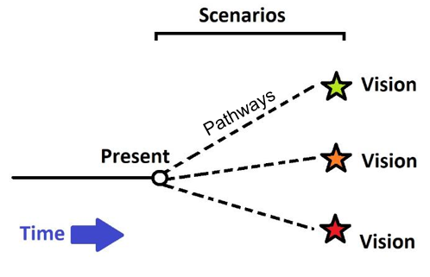
Figure 1. Simplified diagram of scenarios, showing visions and pathways.

The need for new scenarios
The IPBES Methodological Assessment of Scenarios and Models (2016) concluded that there is a need for new scenarios that can support future IPBES assessments and, in general, research and policy discussions related to biodiversity and ecosystem services.
To meet this need, new scenarios would need to facilitate:
- Both the assessment of the role of nature as well as the dynamics between nature and people in sustainable futures;
- Exploration of interactions between nature and human wellbeing with associated global goals and targets; and
- Consideration of alternative pathways to reach integrated sustainability targets, particularly the potential synergies and trade-offs between the four Sustainable Development Goals (SDGs) directly related to the biosphere (life on land, life under water, action on climate change and freshwater). For IPLCs, SDG 1 (no poverty) and SDG 2 (zero hunger) may also be very important to consider, as these SDGs specifically address indigenous peoples, land tenure and livelihoods. Distributional dimensions of all SDGs also need to be examined, particularly if trade-offs are being addressed.
The former IPBES expert group and current task force on scenarios and models have therefore developed and refined the “Nature Futures Framework” (NFF), through participatory workshops and other activities. The NFF is intended as a tool to catalyse the formulation of multiscale scenarios with a strong focus on desirable visions for human relationships with nature. The NFF is further introduced below.

Scenarios and ILK
Engaging IPLCs in the further development of scenarios is essential. IPLCs are key actors in the conservation and sustainable use of biodiversity and ecosystems services. Their knowledge, values and perspectives can also be fundamental to fostering transformative change not only at local but also at regional and global scales. Many communities hold ILK passed down and enhanced through many generations, and this long-term knowledge can be used to inform and support future visions. As they often view humans and nature as an integrated whole, they may have specific ways of conceptualising paths forward for their communities, lands and waters, as well as assessing likely changes that will occur.
Working with IPLCs and their knowledge is therefore essential to move beyond science-driven scenarios, and to build scenario narratives based on multiple perspectives and values. If processes of scenario development are inclusive and transparent, then resulting scenarios can aim to have broader ownership, relevance, and uptake for decision-making at all levels, including by IPLCs.
However, IPBES assessments have consistently highlighted a lack of global-scale scenarios that engage with ILK or that are developed with IPLC participation. Much ILK related to future visions has also remained undocumented or unexplored. The NFF aims to support the process of working with ILK within scenarios for nature futures.

The IPBES Nature Futures Framework and its methodological guidance
The development of the NFF was started by the IPBES expert group on scenarios and models in 2016 and, since 2019, was continued by the IPBES task force on scenarios and models. The NFF emerged from an analysis of many visions of desirable futures for biodiversity and people, including IPLCs. As a result, the NFF recognizes that different people and societies value nature in different ways, and that this may lead to very different conceptions of desirable futures. The draft NFF therefore aims to be a tool to help those involved in scenario building to conceptualize and describe multiple, diverse desirable futures for human-nature relationships, and to recognize and address different values of nature more explicitly. This should also support a more transparent discussion on trade-offs and synergies of different interventions that can be undertaken within governance.
The NFF places relationships between people and nature at its centre (see figure 2, below). It is constructed around three primary “value perspectives of nature”, which aim to encapsulate the diversity of values, relationships, benefits and perspectives that humans have for nature, while focusing primarily on broad-scale differences between “intrinsic”, “instrumental” and “relational” perspectives and values.
“Intrinsic” values refer to nature’s inherent value, which is not generated by or connected to human beings; “instrumental” values refer to the value attributed to nature as a means to achieve a specific end, for example nature as a provider of services such as food or fuel; “relational” values refers to the values relating to desirable relationships, such as those among people, and between people and nature. For example, many IPLCs may hold relational values in which they do not conceptualise a distinction between people and nature, and their relationships with nature may be expressed through concepts of kinship and spirituality. Among other goals, the NFF aims to help to better reflect these ILK systems and values in scenarios.
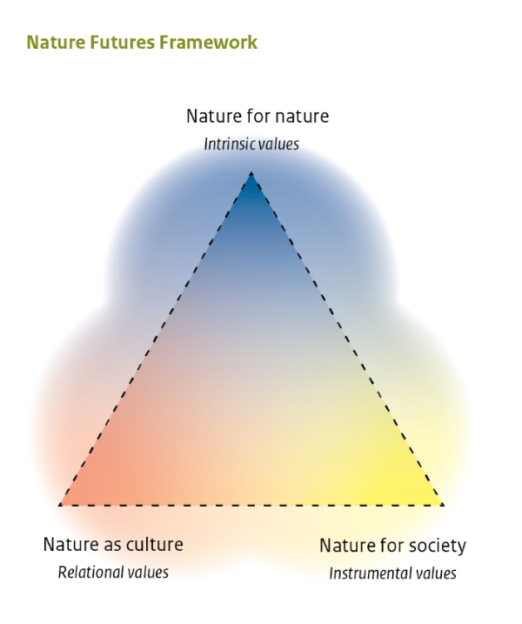
Figure 2: The Draft Nature Futures Framework, adapted from Pereira et al. (2020).

Process of workshop

Dialogue workshop schedule
The dialogue ran over four days, with three regional sessions at different times to suit different time zones, followed by a plenary for all regions, as follows:
Regional session: Asia-Pacific (in English and Russian)
Tuesday, 28 September 2021, 5 a.m. to 8 a.m. Central European Summer Time
Regional session: Africa and Europe (in English and French)
Wednesday, 29 September 2021, 1 p.m. to 4 p.m. Central European Summer Time
Regional session: Americas (in English and Spanish)
Thursday, 30 September 2021, 6 p.m. to 9 p.m. Central European Summer Time
Plenary session (in English, French, Russian and Spanish)
Tuesday, 19 October 2021, 1 p.m. to 4 p.m. Central European Summer Time
The agendas for the sessions are given in annex 1.

Review of the Nature Futures Framework
During the dialogue, background and information about the NFF and its methodological guidance were presented by the members of the task force on scenarios and models, and participants were invited to discuss and comment.
Comments made by participants during the dialogue were compiled in the formal review template, including overarching comments from the dialogue and a series of comments from each regional session. Workshop participants were invited to review these comments, and following additional edits from participants, these were submitted to the IPBES secretariat on 29 October 2021. These comments are presented in Section 4 below.

Visioning activity
During the dialogue workshop participants also participated in a visioning activity, as a way of further exploring the NFF, and of beginning to build regional visions from IPLC perspectives. This took place in the following steps:
Step 1: In advance of the workshop, participants were asked to think of one or more existing community strengths or innovations. These could be current positive and inspiring strengths or initiatives that hold potential to shape a more just, prosperous, and sustainable future. They could be ways of knowing, practices or belief systems, community level innovations, initiatives or organizations, or cultural narratives that could contribute to positive change. When preparing these existing strengths, participants could aim to answer the following questions:
- What are your community’s existing strengths and innovations?
- Are they based on your community’s knowledge system, practices and worldviews?
- What would need to happen in order for these existing strengths to grow – to contribute to better futures at the local, regional and global level?
Participants were invited to send photographs, brief videos, a few words or lines of text, or slides in advance to help them present their existing community strengths.
Step 2: Participants were then invited to briefly present their existing community strengths during the regional sessions of the workshop. The presentations led on to a discussion of what would need to happen in order for these strengths to grow (referred to as “pathways”) and how these could begin to form visions of better futures at regional levels.
Step 3: These discussions of existing strengths, pathways and visions were documented as a narrative from each region, in three forms: a textual narrative; a schematic on a “Jamboard”; and as an artwork for each region produced by indigenous artists from India after the regional sessions (see annex 4 for a description of the process for creating these artworks).
Step 4: These materials were presented back to the participants during the plenary session on 19 October 2021 for comments, additions and verification by participants, and some changes and edits were made following this process. The plenary discussions were also captured by a graphic harvester.
The final materials are presented in section 5 of this report. The process for developing the artworks is also further explained in annex 4. Further country-specific detail of the discussions in the regional sessions and plenary is given in section 6. The graphic harvester’s artwork from the plenary is presented in section 7.

Participants
Participants included ILK holders and ILK experts who are IPLCs, as well as members of the task force on scenarios and models and task force on ILK. A full participants list is given in annex 3 of this report.

FPIC
Free, prior and informed consent (FPIC) principles are central to IPBES work with IPLCs, and a series of ethical principles have been developed to ensure that FPIC is followed in IPBES activities (see annex 2 of this report). These principles were agreed upon by the participants of the dialogue, and will be followed by both IPLC participants, NFF authors and the IPBES secretariat. The names of those agreeing to these principles are provided in annex 3 to this report.

Overarching recommendations from the dialogue on the Nature Futures Framework and its methodological guidance
Over the course of the dialogue, IPLC participants made a series of comments and recommendations for the NFF and its methodological guidance, and on scenarios work in general, for the consideration of the task force on scenarios and models. This section sets out these overarching comments provided by the participants.

Feedback on the Nature Futures Framework

Overall feedback
Participants recognized the work of the task force members in developing the NFF and noted that it can help to provide a framework for the development of scenarios based on different values and knowledge systems.

The shape of the framework
Participants reflected on the triangular shape of the NFF as it was visually represented in the draft document. Participants shared the following reflections:
- Participants noted that for many IPLCs, relationships between humans and nature are not as geometrical as represented in the NFF;
- They also highlighted that the triangle shape has a top and a bottom and that this can imply a hierarchy of values, even if this is not what the experts intended; and
- Participants explained that they would prefer to see a cyclical shape, that could represent the holistic interconnectedness of the fundamental elements in IPLC cosmologies (often nature, universe and people).

The values systems in the Nature Futures Framework
Participants also discussed the values systems represented by the corners of the NFF, including where they see IPLC values represented. These included positive reflections about the inclusion of the corner with the representation of “nature as culture” and “people’s contributions to nature”.
- A participant from Kenya noted that it is positive that “people’s contribution to nature” is included in the NFF as well as nature’s contributions to people, as this can be missing in most processes. He noted that sometimes society sees nature as providing people with services, and because of this conceptualisation people begin to commercialize nature. The whole concept of ecosystems services can sometimes suggest that nature is there to serve people. For many IPLCs, in contrast, nature is part of a life support system. He noted that seeing nature as a life support system and not as something delivering services would lead to a better relationship between people and nature.
Other participants noted that IPLC values would not automatically fall in one specific corner of the NFF, and that there are issues with separating out IPLC values:
- A participant from the Philippines noted that IPLCs might be situated in a big circle inside the triangle, because IPLCs often have all the three values (nature for nature, nature for society, nature as culture) working together holistically. Also, there may be other circles emanating from the tips of the triangle which link IPLCs with broader society and influence the entire context and system.
- A participant from Canada explained that, unfortunately, indigenous peoples are often caught between a spectrum where on one side there is overexploitation by corporations and, on the other side, so-called “fortress conservation”, which aims for no human footprint. Indigenous peoples are often caught between the no-human footprint part of conservation while, on the other hand, their local practices and knowledge are being eroded by the corporate model of development. The NFF pyramid can seem like ILK is one aspect that could be extracted or excluded from this spectrum.
Other participants saw benefits in having value systems separately represented on the three corners:
- A participant from the Philippines noted that there are different core values held by different communities and groups. It can be useful to distinguish them from each other, even though indigenous peoples in the workshop were reiterating that their values are holistic, and that IPLCs would be in a circle in the middle of the triangle and not just one corner. However, conflicts can arise when pursuing intrinsic values leads to the exclusion of IPLCs from conservation areas. Likewise, a very strong emphasis on nature for people can lead to IPLCs constantly being told that they have too much land and that this is needed for economic development, and that therefore indigenous territories cannot be recognized. Those are contested and conflicting values, so if the NFF creates a dialogue across value systems, and allows IPLCs to see their values as mostly reflected in one point of the triangle, then that could be a helpful awareness-raising tool. The use of the shades and circles, in the middle and surrounding the figure, might be useful to capture the holistic elements.

Scenarios and IPLC conceptions of the future
Participants reflected on existing scenarios thinking, as well as giving insights into the ways that IPLCs conceptualize time and the future, emphasizing that scenarios should reflect these different conceptualizations. Participants shared the following reflections:
- Participants from Bolivia and Guatemala noted that for many indigenous peoples the future is rooted in their present and past, and they look to the past to plan and project themselves in the future. To go forward, they have to be able to look back. It is impossible to create future pathways with IPLCs without also considering past and present.
- A participant from Mexico explained that, generally, human beings are not at the centre of indigenous visions. Human beings are part of nature, so indigenous visions are centred on nature with human beings as part of this whole. For many IPLCs, projections, predictions, weather and future forecasts were essential to try to understand the complexity of the universe, without placing the human being at the centre of it.
- Another participant from Mexico highlighted that IPLCs around the world have been able to make many impressive predictions of the future, noting that in many IPLC perceptions time functions as great cycles and is not linear. For instance, Mayas measure time with the “long count” with great cycles of more than five thousand years. One of the main points of difference between IPLC predictions and science may be that many science-based scenarios and models are often looking for end points. Meanwhile, many indigenous peoples do not see the future as an endpoint. They instead see the future as a place where everything stays in the best state without complexities and uncertainties, in something of an equilibrium state.
Overall, participants highlighted the importance for IPLCs of working with scenarios, and of creating their own scenarios of the future at different scales:
- A participant from Kenya explained that part of the work of the African Biodiversity Network (ABN) is to revive what has been lost in communities. Because the future is rooted in learning from the past, during dialogues with communities it is important to first go through a process of remembering: What has the community gone through? What did territories and lands look like when biodiversity was rich in the past? One of the scenarios that ABN are working on with the Stockholm Resilience Centre considers when biodiversity was rich in the past. Through that journey, some members of communities can realize that human activities have largely been drivers of biodiversity loss. That realization can come as a shock, because sometimes they are simply trying to make their livelihoods and, for example, they cut trees and burn charcoal. When they go through the journey of thinking through the past, this then allows them to think very creatively about the future: How can they bring their rich biodiversity back? Some communities find creative ways to bring back those forests either by planting trees in the middle of towns or being more conscious of how they can reduce destruction. This has the potential to generate a positive future.
- A participant from Panama explained that the Kuna people are always thinking about the future and their youth. All the work that they do aims to involve youth in recovering traditions, conservation and other activities.
- A participant from Mexico noted that it is important to envision the future, as human beings could potentially have good or bad futures. There is therefore a need to avoid bad futures, with the goal of protecting nature and respecting and recognizing the rights of indigenous peoples. This requires striking a balance by using different approaches to envision different positive futures and avoiding negative futures.
Some participants also emphasized the benefits of co-producing scenarios with science in order to build and verify scenarios:
- A participant from Argentina noted that it is important that IPLCs envision their own futures, but that it is also important for IPLCs to review scenarios that the scientific community is working on, so that IPLCs can contribute to them in a concrete way and decide which scenarios are the best for IPLCs. She noted that often it seems that there is an assumption that loss of biodiversity will be resolved magically, and nature will continue giving people all the benefits that are needed, but this is not possible.
Participants noted, however, that co-production of scenarios may require new methods, and that the IPLC perceptions of time and human-nature relations discussed above will need to be central:
- A participant from Mexico explained that it is important to understand how indigenous peoples build and use scenarios and models for the future. Other knowledge systems have different ways to build scenarios, but for IPLCs this is more qualitative than quantitative. It would be important to develop methods to integrate this kind of modelling and scenario-building into mainstream scenarios and models. The question is: how to include qualitative visions, such as those emerging from songs and history? How to build a joint methodology to work with scenarios and models?

Narratives from the three regions

Introduction
Besides commenting and reflecting on the NFF and its methodological guidance, participants engaged in a visioning exercise guided by task force members, as described in section 3.3. In this exercise, participants were asked to briefly present existing community strengths and innovations regarding ecosystem management and nature conservation from their communities. Starting from these examples, they were invited to reflect on what would need to happen in order for these community strengths and innovations to grow, in conjunction with other strengths and innovations presented by other participants, and what the futures based on these processes might look like.
These existing community strengths and innovations, potential pathways and future visions were documented and verified in three different ways during the workshop, as presented below for each region:
- A narrative from each region, each divided into three themes, highlighting examples of existing community strengths and innovations, pathways and visions around major themes that emerged during the discussions;
- Visualizations of the narratives for each region, developed on a Jamboard during the regional sessions; and
- Artworks for each region which represent the knowledge emerging from the regional sessions, developed after the regional sessions and presented to the plenary session for comments.
More detailed accounts of the discussions for each region are given in section 6 of this report.

Asia-Pacific session narrative
Some of the main themes of discussion for the Asia-Pacific region were food systems, knowledge systems and spirituality. These themes are connected and mutually supportive, so they could be seen as aspects of a single narrative.

Food systems

Existing strengths and innovations
For the theme of food systems (which is mostly represented by the green sticky notes on the Jamboard in section 5.3), participants presented existing community innovations that included the revitalization of home gardens and traditional recipes in the Philippines and India, which strengthen both food security and culture. Similarly, participants from Vanuatu and the Solomon Islands shared the importance of local plants for food production. Paddy field irrigation management for food, biodiversity and water was also presented from the Philippines. Participants also shared how communities are exploring marketing of sustainable food products in Thailand and Australia.

Future vision
From these discussions, an aspect of a future vision emerged, of innovative indigenous and local food systems supporting communities’ cultural, spiritual, material and economic needs. These food systems enhance biodiversity, and communities benefit from and have control over the marketing of traditional foods.

Pathways
To arrive at this future, further revitalization of traditional food systems is key. This could be achieved through increasing respect and recognition for traditional forms of cultivation, including rotational farming. Enhanced customary governance of landscapes would also be needed, with recognition of land tenure and rights. Networks and agreements for marketing traditional foods may also need to be developed.

Knowledge systems

Existing strengths and innovations
On the theme of knowledge systems, (which is mostly represented by the yellow sticky notes on the Jamboard in section 5.3), existing community innovations were also shared from across Asia and the Pacific. Participants shared examples of knowledge systems around food production and bees in Thailand, which they are transferring to younger generations by encouraging youth to learn on the land with elders. In the Philippines, communities have documented knowledge about home gardens and traditional recipes.

Future vision
From these discussions, an aspect of a future vision emerged of strong, dynamic indigenous knowledge systems that can adapt to a changing world, and communities in which youth have multiple ways of knowing, including ILK and science.

Pathways
For this future to be achieved, participants emphasized the need to strengthen knowledge transmission in both formal education and through traditional institutions, including connecting elders and youth during activities on the land. Building regional networks and knowledge hubs was also discussed, as was the need to document knowledge and best practices relating to food and governance. In this regard, the role of women is central as they are holders of important knowledge.

Spirituality

Existing strengths and innovations
Around the theme of spirituality (which is mostly represented by the orange sticky notes on the Jamboard in section 5.3), existing community strengths were shared, including examples of ceremonies and rituals around seeds in Nepal. An example of spirituality connected to forests was also shared from Siberia in Russia. Similarly, a participant from New Zealand shared their knowledge about the water cycle, its spiritual value and connection to divinities. A participant from Vanuatu also discussed spiritual aspects of food production in their region.

Future vision
From these discussions, another aspect of a future vision emerged, in which spirituality is fundamental to connections between people, animals, plants, food and water. In this vision, spirituality and spiritual connections guide and inform knowledge transmission, food production, landscape management and governance.

Pathways
For that future to be achieved, there is a need to continue and revive spiritual practices, such as the performance of ceremonies and rituals connected to nature. Participants emphasised the importance of teaching younger generations about the spiritual aspects of community, nature, food, water and governance. Maintaining indigenous languages, in which many spiritual concepts are encoded, also plays a crucial role.

Cross-cutting
For all of the visions mentioned in the Asia-Pacific regional dialogue, recognition and support from national governments were highlighted as being an important pathway (shown mostly by the pink post-its), as national governments often provide the conditions that either limit or support many aspects of community life.

Asia Pacific session visualization
The following visualization (figure 3) was developed on a Jamboard during the workshop. It is split here into three parts to improve legibility: 3a. existing community strengths and innovations; 3b. pathways; and 3c. vision. The colours of the sticky notes in the Jamboard aim to connect the notes to the different themes that emerged during the discussions: green relates to food systems and sustainable use of ecosystems; yellow relates to knowledge systems; orange relates to ceremonies, rituals and spirituality; pink relates to governance systems; blue relates to indigenous networks and social movements.
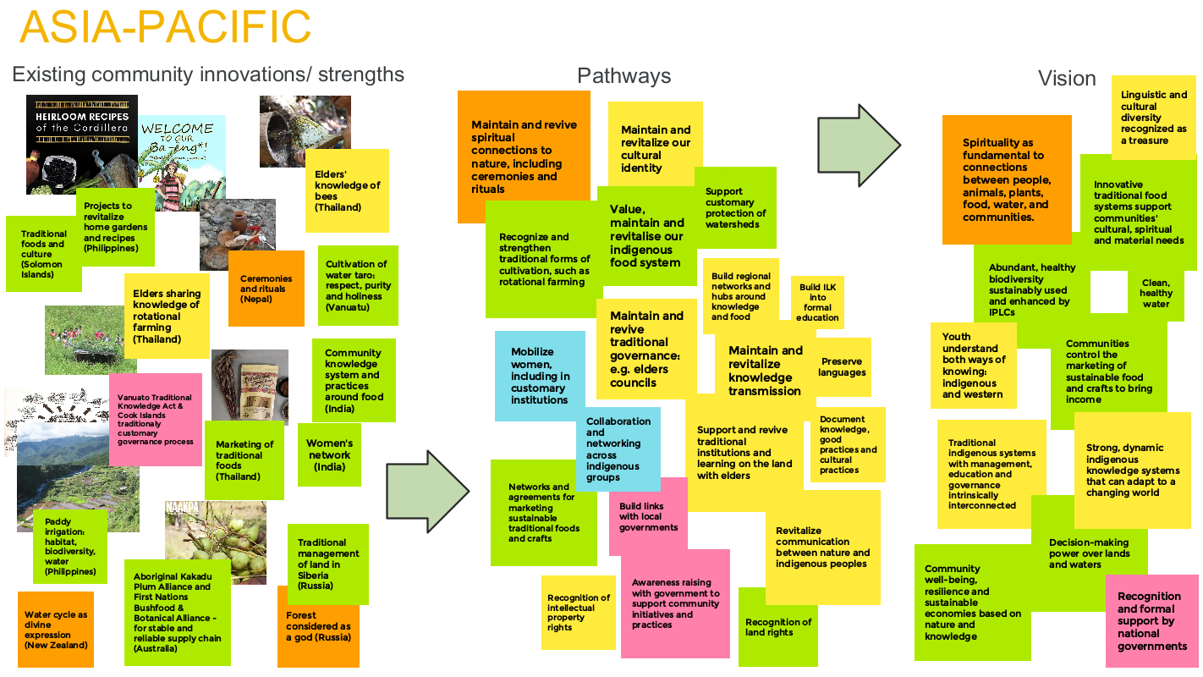
Figure 3a. Jamboard illustrating existing community strengths and innovations for Asia-Pacific presented during the workshop.
Figure 3b. Jamboard illustrating pathways discussed during the Asia-Pacific session of the workshop that could lead to the vision shown in Figure 3c.
Figure 3c. Jamboard illustrating aspects of a future vision discussed during the Asia-Pacific session.

Asia-Pacific session artwork
The artwork on the next page (Figure 4) is a representation of the Asia-Pacific session of the workshop, created by Anjali Choudhary.
Anjali comes from an indigenous group from Bihar in India, and practices a contemporary form of Madhubani art. These paintings are created mostly by women using natural colours and sticks to paints. The painting is brightly coloured with a mix of several hues, along with a white border to all lines which is a major technique used. These artworks typically show scenes from small rural regions and the everyday interaction with nature. Here, Anjali has captured the main themes of the session, including food systems, knowledge systems and spirituality.
For more information on the process for creating this artwork, please see annex 4.
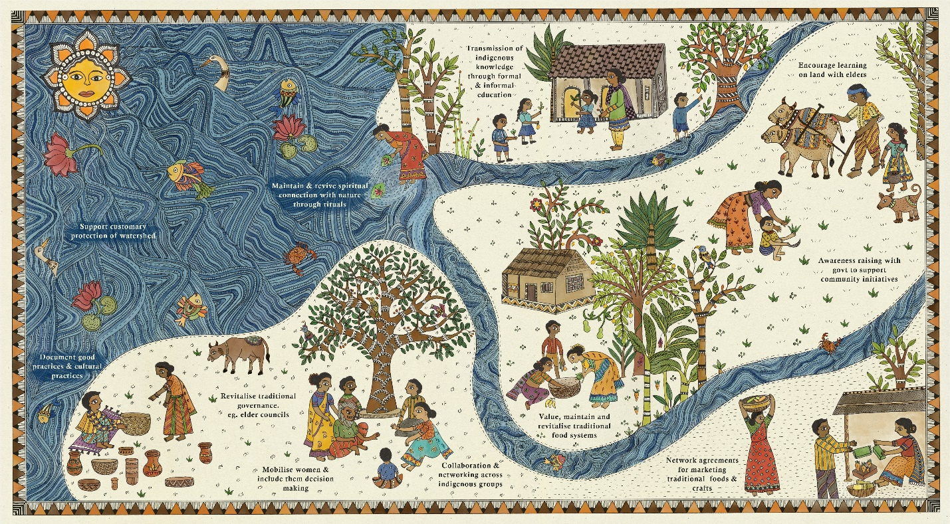
Figure 4: Representation of the Asia-Pacific session of the workshop, created by Anjali Choudhary.

Africa session narrative
Some of the main themes of discussion in the regional session for Africa were knowledge systems, protection and use of lands and waters, and governance systems. These themes are connected and mutually supportive, so they can be viewed as aspects of a single narrative.

Knowledge systems

Existing community strengths
On the theme of knowledge systems (mostly represented by the yellow and orange sticky notes on the Jamboard in section 5.6), participants presented existing community strengths that highlight how ILK can be maintained and revitalized. The role of women was discussed as women are the holders of a wealth of ILK. Women are also often mobilizing themselves to preserve and transfer knowledge. For example, participants from Uganda reported that women created a cultural centre where they collect artifacts produced by community members. Participants also discussed the importance of oral stories, songs and poems for the maintenance of their knowledge systems. An example of this was given from the Afar region in Ethiopia where pastoralist communities compose poetry to share knowledge about nature and politics.

Future vision
From these discussions, an aspect of a future vision emerged, where ILK systems about nature, landscape management, food, cultural traditions and spirituality are maintained and revitalized among the communities and across generations.

Pathways
To achieve this vision, the role of intergenerational learning was greatly emphasized, which can be enhanced through learning on the land, in schools, through cultural centres and even through media such as local radio. Continuation of spirituality, ceremonies, traditions and languages is also an important part of this. Participants also highlighted that ILK needs to be recognized as a legitimate source of knowledge by governments, and that indigenous intellectual property rights need to be protected.

Protection and use of lands and waters

Existing community strengths
On the theme of protection and use of lands and waters (mostly represented by the green sticky notes on the Jamboard in section 5.6), participants shared existing community strengths and innovations, explaining that respect is key to their relationship with nature, and that traditionally communities utilize different methods for sustainably managing natural resources. For example, communities across Kenya and Rwanda observe periods of “no access” to some areas to support the regeneration of nature. Similarly, participants shared that in their communities they respect sacred forests and mountains and they teach the young about the importance of respecting the sacredness of nature, totems and taboos. Participants also shared their management practices to maintain and protect natural areas, such as a watershed protection technique called Lotemechu and traditional terracing in Kenya.

Future vision
From these discussions, an aspect of a future vision emerged, in which lands and water are both protected and used sustainably. In this vision, IPLCs would have direct control over their natural resources, and nature’s contributions to people would be recognised.

Pathways
To achieve this vision, participants discussed the need to recognize indigenous conservation values within mainstream conservation debates. Furthermore, they stressed the importance of recognizing and respecting land rights and land tenure. They also emphasized the need to restore access to land and forests for traditional practices, as well as the need for collaboration between IPLCs and local and national governments.

Governance systems

Existing community strengths
On the theme of governance systems (mostly represented by the pink sticky notes on the Jamboard in section 5.6) participants shared examples of existing community strengths including a council of elders in Kenya, where governance is retained at the local level. In this system, the members of the council discuss territorial issues, such as banning any activity that impacts on nature and people’s wellbeing. Participants highlighted that the council has changed over time, so that women now also have roles in this institution.

Future vision
From these discussions, participants expressed another aspect of a future vision, in which decision-making at the local level is done by traditional institutions, including councils of elders. In this vision, IPLCs are at the forefront of local initiatives, instead of decisions being made by outsiders. The vision also includes the participation of IPLCs in decision-making at national, regional and global scales.

Pathways
To achieve this, participants emphasized the need to revitalize and support customary governance practices and institutions, including by empowering women. IPLCs need to have control over natural resources and they need support for community capacity-building. Participants emphasized the need for government policies that support and enhance community innovations and dynamism. Finally, they noted the importance of good global policies that support IPLCs, which should be respected and implemented by national and local governments.

Africa session visualization
The following visualization (figure 5) was developed during the workshop to represent the discussions. It is split here into three parts to improve legibility: 5a. existing community strengths and innovations; 5b. pathways; and 5c. vision. The colours of the sticky notes in the Jamboard aim to connect the notes to the different themes that emerged during the discussions: yellow relates to knowledge systems; green relates to protection and use of lands and waters; pink relates to governance systems; orange relates to ceremonies, rituals and spirituality; blue relates to indigenous networks and social movements.
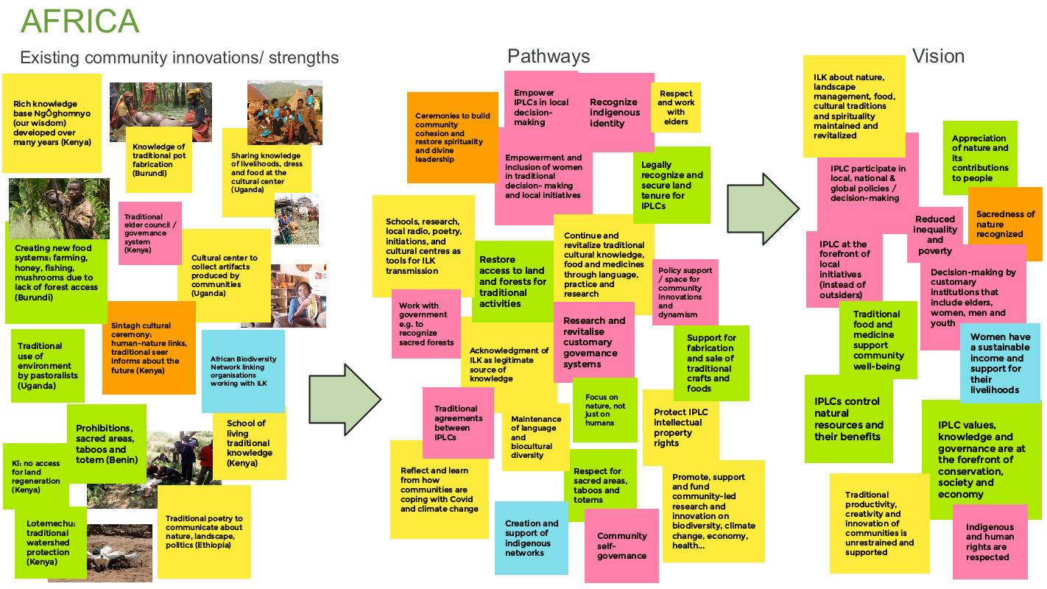
Figure 5a. Jamboard illustrating existing community strengths and innovations presented during the Africa session of the workshop.
Figure 5b. Jamboard illustrating pathways discussed during the Africa session of the workshop, which could lead to the vision shown in Figure 5c.
Figure 5c. Jamboard illustrating elements of a future vision discussed during the Africa session.

Africa session artwork
The artwork on the next page (Figure 6) is a representation of the discussions during the Africa session of the workshop created by Choti Tekam.
Choti comes from an indigenous group from Central India called “Gond” – “the people from the green hills”. They believe god is in everything in nature, and through their work they show a relationship of worship and respect for nature.
In the artwork, Choti has captured the key themes of knowledge systems, protection and use of lands and waters, and governance systems.
For more information on the process for creating this artwork, please see annex 4.

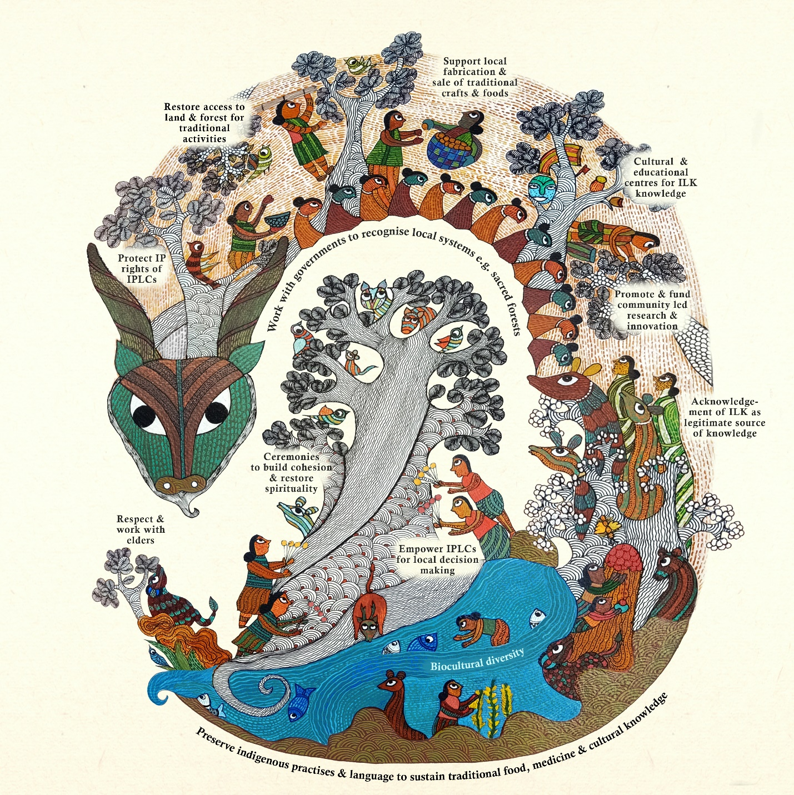
Figure 6. Artistic representation of the Africa session of the workshop, created by Choti Tekam.

Americas session narrative
Some of the main themes of discussion in the session for the Americas were: strong roots in traditional knowledge, practices, spirituality and worldview; dynamic and innovative communities; and food systems. These themes are intertwined and mutually supportive, so they can be seen as aspects of a single narrative.

Strong roots in traditional knowledge, practices, spirituality and worldviews

Existing strengths and innovations
Participants shared existing community strengths and innovations around the theme of “strong roots in our traditional knowledge, practices, spirituality and worldviews” (mostly represented by the orange and yellow sticky notes on the Jamboard in section 5.9). These include examples from Costa Rica of the importance of songs for healing people and for agricultural systems. In Mexico, a strong sense of community is fostered by traditional festivities. In Panama, Kuna communities maintain rituals, sacred sites and respect for the spirits in all aspects of nature. In Bolivia, during the Covid-19 pandemic, indigenous youth made face masks with traditional designs to promote this aspect of their culture. Participants from Colombia also explained how they have been able to practice ancestral traditional knowledge in higher education.

Future vision
From discussion of these examples, an aspect of a future vision emerged, of “strong roots in our identity, land, language, knowledge, traditional governance, kinship, ancestors and spirituality”, where the three axes of humans, nature and the universe are in balance, and it is recognized that humans do not own nature.

Pathways
To achieve this future vision, participants discussed different pathways. These included the need to consider different perceptions of time and the need to look backwards to the past in order to go forward to the future. Participants also noted the need to revitalize and maintain rituals and ceremonies for community wellbeing and cohesion, and to maintain connections with nature by building nature-centred community visions. Maintaining and reviving languages and knowledge is also very important, and this can partly be achieved by including ILK in education systems and generating intercultural dialogue between science and ILK systems.

Dynamic and innovative communities
Another theme that emerged was that of dynamic and innovative communities (mostly represented by the blue and pink sticky notes on the Jamboard in section 5.9).

Existing strengths and innovations
Participants presented examples of existing community strengths and innovations around this theme, including the political and economic value of a culturally important traditional beverage from Mexico. A participant also shared how communities are mobilizing to develop a nature park in Antigua to protect biodiversity and restore access to clean water.

Future vision
From these discussions, another aspect of a future vision emerged, of dynamic, innovative communities, where IPLCs lead in transforming economies and societies, where youth are able to derive an income from nature, and where communities receive benefits from the use of their natural, cultural and bio-cultural wealth.

Pathways
To achieve this aspect of the vision, participants discussed the need to create community scenarios, plans and regulations using ILK and IPLC conceptions of time. The development of networks, including for women and youth, was discussed along with the recognition of indigenous intellectual property rights and inclusion and participation in government processes.

Food systems
Food systems also emerged as a major theme (mostly represented by the green sticky notes on the Jamboard in section 5.9).

Existing strengths and innovations
Participants presented examples of existing community strengths and innovations around this theme, including el Chaguite, which are traditional food systems in Costa Rica that ensured self-sufficiency to communities during the Covid-19 pandemic. Some communities in Argentina base their culture on the planting and harvesting of maize, using traditional knowledge to know which types of maize seeds to plant based on their observations of the climate in August. In Mexico, traditional beverages have cultural and, increasingly, economic importance.

Future vision
From these examples, a further aspect of a future vision was discussed, of “resilient food systems, with food security and sovereignty supported by sustainable agriculture, forests and seas”. Clean waters, lands and soils are central to this aspect of the vision.

Pathways
To achieve this aspect of the vision, participants highlighted that it is crucial to maintain a cycle between humans and nature, and to maintain and restore ecosystems. Recognition of IPLC contributions to nature, and IPLC land and territory rights, customary tenure and land management systems is also key. Advocacy and dialogue with governments at the local, national and international level (such as during the negotiations for the post-2020 global biodiversity framework) are important. Advocacy and dialogue with the private sector are also important, while at the same time lands and waters must be protected from negative impacts caused by large corporations.

Americas session visualization
The following visualization (figure 7) was developed during the workshop to support the discussions. It is split here into three parts to improve legibility: 7a. existing community strengths and innovations; 7b. pathways; and 7c. vision. The colours of the sticky notes in the Jamboard aim to connect the notes to the different themes that emerged during the discussions: yellow relates to knowledge systems; orange relates to ceremonies, rituals and spirituality; pink relates to governance systems; blue relates to indigenous networks and social movements; green relates to food systems and sustainable use of ecosystems.

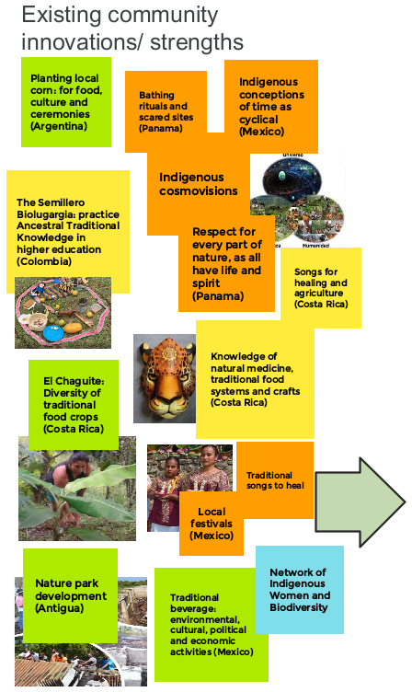
Figure 7a. Jamboard illustrating existing community strengths and innovations presented during the Americas session of the workshop.
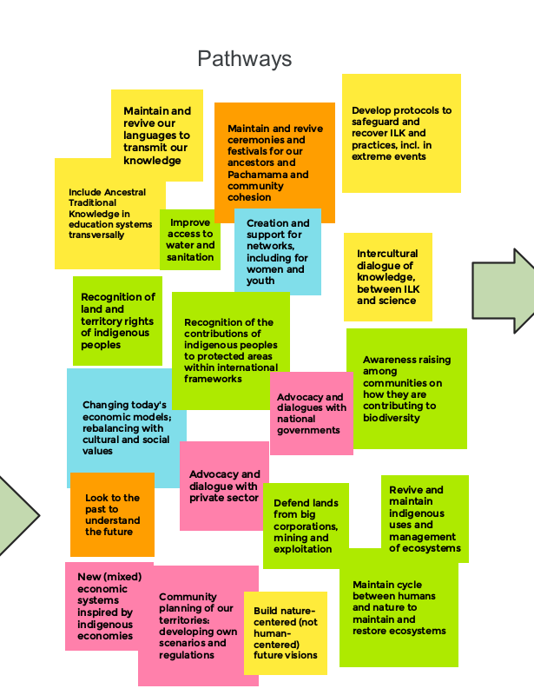
Figure 7b. Jamboard illustrating pathways discussed during the Americas session of the workshop, which could lead to the vision shown in Figure 7c.
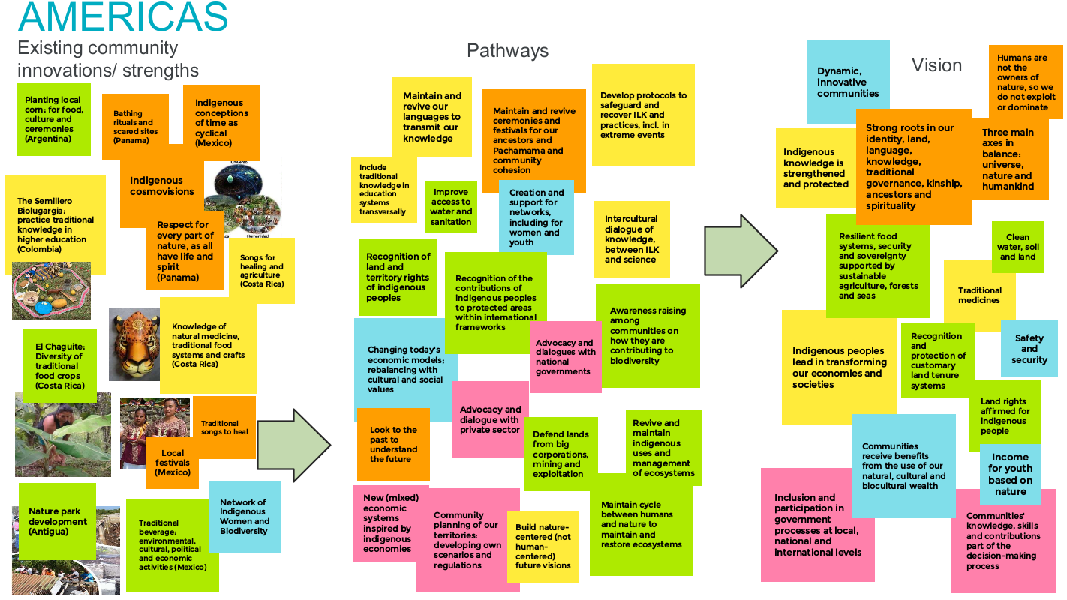
Figure 7c. Jamboard illustrating elements of a future vision discussed during the Americas session.

Americas session artwork
The artwork on the next page (Figure 8) is a representation of the discussions during the Americas session of the workshop created by Naresh Bhoye. Naresh comes from an indigenous group from Central India called “Warli”. His work is done on cloth or paper, using cow dung and calcium colours. In the artwork, he captured the key themes of indigenous and local knowledge, indigenous conceptions of time, intergenerational knowledge transmission, protection and restoration of ecosystems, and advocacy with governments.

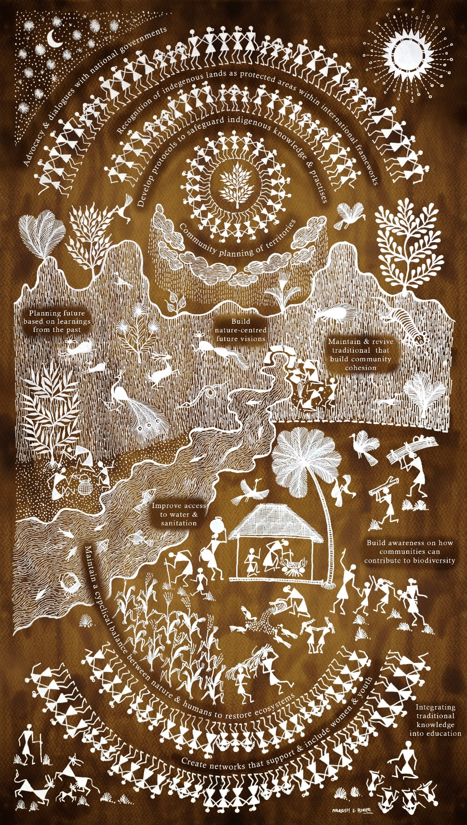
Figure 8. Artistic representation of the Americas session of the workshop created by Naresh Bhoye.

Regional discussions
This section presents more detail of the many varied discussions that took place during the workshop, with the aim of providing a more complete record of the discussions. They are ordered along the main themes that were highlighted in section 5.

Asia-Pacific
The Asia-Pacific discussions are organised here along three broad themes: food systems, knowledge systems and spirituality.

Food systems
India: As an existing community strength, there is a plant called ngum in the local language (Job’s tear, Coix lacryma-jobi Linn). It is used for preparing food such as cookies and porridges as well as beverages like rice wine and rice beer, and it is very culturally important. It is a climate resilient crop, which is resistant to extreme weather conditions – which is an important characteristic in times of climate change. In the past, this was considered “poor peoples’ food” and the communities nearly forgot the value of the crop. However, after mobilizing women – who often hold and practice knowledge about crops – the communities succeeded in reviving the crop and now it is becoming popular again, because people realize the healing benefits it brings. Ngum is based on community’s knowledge systems and practices. Communities share seeds so they do not buy them from the markets and they also exchange labour and information around the seeds. Ngum is an example of a crop that would fit well within multiple corners of the NFF. This crop is nourished by natural rainfall, where nature supports nature. It is also supporting the local economy, food and health, and that is an example of nature for society. Finally, it is relational because it supports cultural as well as communal harmony. There is also a network of 1250 villages as well as a women’s network. As part of Naga culture, all women have kitchen or backyard gardens, which is part of the local food system. This has recently been strengthened, particularly during the pandemic, and following the Global Food Summit. Before, the communities did not always give enough value to their indigenous food systems.
Philippines (a, b): The Cordillera is a forested region in the Philippines and community managed agro-forestry systems protect these forests. In turn these forests keep the rivers flowing, and this supports the ricelands, which is terraced agriculture. The rice terraces are a living example of peoples’ contribution to nature. From a dry grassland, the Igorots (an indigenous group in the Philippines Cordillera) constructed the paddy fields and connected this to the forest through irrigation. In this way they became production sites for hundreds of traditional rice varieties, for aquatic fauna and aquatic and non-aquatic food crops. They also host insects, snails, fish, and edible weeds. Much biodiversity is found around these places and all the needs of the people are met, including spiritual and cultural needs, for example for rituals and for feeding animals.
Philippines (a): As an existing community strength, ba-eng is a home garden where community members plant trees, vegetables, roots and crops around their houses so that these sustain their nutrition and livelihoods. This aims to revitalize indigenous food systems in an urban area where indigenous peoples have been pushed to the margins and they have lost part of their land. In revitalizing their own gardens, they are revitalizing their cultural identity. As an existing community innovation, communities have also produced a publication, “Heirloom Recipes of the Cordillera”, to support the revitalization of indigenous food systems. The awareness of indigenous peoples’ own foods and agricultural systems is happening in other parts of the Cordillera and they are collecting these together in the book, which explains their “heirloom recipes”: how indigenous people prepare their meals using foods from forests, home gardens, rivers, and so on. Importantly, many schools are now using these publications in their educational system because the Philippines has a law to indigenize the curriculum. As a positive development, the publication and indigenous peoples’ efforts towards the transmission of knowledge are now recognized by a presidential heritage award for excellent education.
Philippines (a): In the Philippines, new collectives and groups are developing. Some of the communities built linkages with local governments and local governments have started to put the revitalization of food systems (including organic systems) into their plans as priorities, because they are conscious of the need to transform food systems.
Solomon Islands: As an existing community strength, Ngali nuts, fruits and seeds are very important, and they can be used to prepare traditional food. They can be preserved for long periods of time and used year-round. They are also very important in cultural traditions.
Vanuatu: As an existing community strength, water taro is an important crop for the cultural and social life of communities. The cultivation of the water taro takes place with respect for the purity and holiness of nature because water taro provides food during disasters, and it sustains livelihoods and income of the families. The water taro is carefully cultivated in a natural irrigation system using the natural river flow, and the taro gardens are surrounded by forests for the better growth of the water taro.
Thailand: A challenge for the future is the need to create regional networks around indigenous knowledge and food. Some organizations are starting but the challenge in the future will be to enhance these networks. For example, the Asia Indigenous Peoples Pact (AIPP) has started to discuss food systems. At the same time, awareness needs to be created among governments to recognize indigenous knowledge and local food systems. There are some small opportunities to do this, for example with the ASEAN Social Forestry Network, where some NGOs are trying to advocate for indigenous knowledge and food. Using these kinds of avenues, IPLCs need to create processes to work with groups at the regional level. These may not immediately function as IPLCs would wish, but at least part of the discussion can include the issues that are important for IPLCs, and in the long term this may increase awareness, so these types of collaboration are important as first steps. In the future, organizations can create these kinds of mechanisms and channels and networks on traditional local food and biodiversity.
Australia: In Australia, most of the market suppliers of traditional foods are non-indigenous people. This cuts out the relationship that aboriginal people have to their country. There has been a long discussion to make sure that indigenous peoples can control their own food as well as the way it is sold and marketed. The Northern Australia Aboriginal Kakadu Plum Alliance was formed some years ago to try to achieve this, as indigenous Kakadu plum suppliers created an alliance to ensure that the market for this indigenous product, which has proven to have a very high vitamin C content, is captured. It was funded initially by the Indigenous Land and Sea Corporation which is part of the federal government. They have since become independent. The alliance is working to create collaborations across different indigenous groups around this one species. Currently, the alliance is tackling institutional issues and roadblocks related to legislation in Australia. Australia is a complex landscape when it comes to indigenous land rights and this alliance is trying to address these institutional barriers.
Australia: Another alliance that was formed to address similar issues to those described in the example above is the First Nations Bushfood and Botanical Alliance, which has just been established. This alliance was established because the existing structure for bringing together bushfood suppliers in Australia was dominated by non-indigenous suppliers. Additionally, there was no real space for suppliers to have discussions on how to get into the market and how to support communities. This alliance was funded independently. It was supported by a business in Sydney that sells indigenous plants using indigenous knowledge. This organization has helped bring together most of the businesses and entrepreneurs to discuss how they can coordinate their work. This is an important community innovation because it brings together people who would not ordinarily work together, because there are lots of disparate indigenous groups who work on very different bushfood plants. The main goal is then to carry out advocacy activities aimed at the government.

Knowledge systems
Russia: Management, education and governance are intrinsically interconnected in traditional indigenous systems. All traditional knowledge that is transferred to younger generations is connected to the management of natural systems. This is connected to languages, religions, and other traditional contexts. Collectives of indigenous people are also crucial as one person cannot manage their land alone.
Thailand: In many communities, the elders have important knowledge. However, nowadays they often do not have the chance to transfer this knowledge to their children. Communities have also found that new educational systems are not effective for transmitting knowledge. To respond to this issue, one community tried to create space for young people, especially for students, to learn outside the school, in the fields and forests, so they can learn about the livelihoods of the community. The community is trying to revitalize traditional institutions where elders transfer knowledge in daily life by means of ritual practices. Maintaining and supporting these practices is a very good mechanism for knowledge transfer, as schools are not enough to transfer the knowledge of communities. An example of a learning activity that needs to be mainstreamed to transfer knowledge from elders to young people is rotational farming: together with elders and students, community members share knowledge on how to practice rotational farming and show students that they can find more varieties of species of plants and vegetables in the farmed areas. Another example of knowledge that needs to be retained and transferred cross-generationally is the knowledge around harvesting honey from bees. Many people need to protect themselves from bee stings, but the elders take their clothes off and the bees do not sting them. This shows how elders have knowledge and techniques to work with nature.
Thailand: ILK also needs to become dynamic, and the community has found that it can innovate in different areas. An example of this is the ways in which the community has started to market traditional foods. One of the spices grown from rotational farming is processed into what they call the “rotational cracker” which smells and tastes good, and is then sold. Another example is dry vegetables, which are created through a traditional method of drying lettuce to keep it in wintertime. They also have tea leaves that are traditionally prepared and then marketed. This process of innovation is very important, particularly to create income for young people, and the youth have the skills and knowledge required for marketing and innovating.
Thailand: Another example of how the community’s knowledge system is innovating is related to fallow areas, which are fields that have already been harvested and that people leave to slowly go back to forest. Those areas are high in biodiversity. One of the community’s new findings is that fallow areas are very good for bee keeping. This also creates indirect effects, in that the bees increase biodiversity. Flowers and all kind of plants are increasing in number and fallow areas become very good ecosystems. Farmers are always trying to create new benefits for the ecosystem. The fallow area has a particular species of tree that is very good for nutrients, soil fertilizing and fast-growth, so people are trying to collect these seeds and increase their number in fallow areas, so these trees grow in increasing numbers. Fallow areas are therefore becoming increasingly important and rich in biodiversity.
Thailand: Some of the traditional systems described above have already been stopped by new development projects. Where rotational farming is not possible, community members create a “little farm” around their houses, where they try to set up a small plot based on rotational farming models. They plant traditional species as well as a mix of some new species. In this way, their gardens can become an integrated farm with agroforestry. These gardens have become models for other villages and the “little farms” have become mainstream, so the indigenous food systems are not at risk.
Vanuatu: A nature focus can improve livelihoods and wellbeing. It is clear that nature or nature-based solutions are increasingly essential to community wellbeing and society. Nature-based solutions need to be created for economic, spiritual and cultural issues, using traditional knowledge. Societies can benefit from learning from indigenous peoples, whether those learnings are documented or passed across generations orally. For example, in Vanuatu in 2015, using indigenous knowledge helped communities to adapt to and resist natural disasters, including a destructive cyclone. Biodiversity is very important and the wellbeing of communities depends on the wellbeing of nature. The best way to conserve biodiversity is looking at ILK that has been transmitted across many generations.

Spirituality
New Zealand (Aotearoa in Māori): The prestigious status of water is deeply rooted in the spirituality and metaphysical worldview of Māori. The hydrological cycle is a divine expression of love between the heavens and earth, and each stage is a critical component. This is an ancient dynamic system that originates in the water heavens of Maru, where the source of freshwater spills over and becomes the first sacred teardrop from the skies, known to Māori as Te Ihorangi. Te Ihorangi married Huru-Te-Rangi, the Goddess of winds and together, with their children, they work on beginning the precipitation process. Once that teardrop meets the earth, the next phase begins. When it comes to water on earth, Māori refer to Parawhenuamea, who is known to be the origin, personification, and parent of freshwater on Earth – including flooding. She married Kiwa, Guardian of the Great Ocean or Te Moana Nui a Kiwa, and together they personify the ocean and estuaries. This is considered to be the shared domain where the couple meets. From their union, Hine-Pukohurangi, Hine-Te-Ihorangi, Hine-Parawhenuamea and others who represent the different forms of water such as the rains, fogs, and mists, were born. This completes the collection phase. The next phase of the hydrological cycle is evaporation. Hine Pukohurangi, the Goddess of the mists and fogs, is released by Papatuanuku, causing evaporation that eventually reaches the house of Tū-Kapua, the guardian of clouds. The next phase, condensation, relies on the combined efforts of Tū-Kapua and Tawhirimatea, the God of the Winds, completing this cycle and beginning the process once again. This is a granular explanation for all forms of water and illustrates the Māori belief that they ultimately trace their ancestry to the rivers, creeks, streams, and lakes as part of their ancient lineage back to Ranginui, and Papatuanuku.
Russia: Traditional management of land in Siberia is an example of an existing community strength. Indigenous peoples see their forest as a god. They depend on their forest and use traditional knowledge to take care of the forest. For instance, they do not chop wood, and instead collect dried branches to heat their houses. They have lots of wild crops that they use as food, for example mushrooms and berries, which they collect only during certain periods, and that is the basis for traditional livelihoods for the community. They also sell them. Overall, they interact with the climate, nature, rivers and woods in a highly positive way, using their traditional knowledge. Traditional management of their land is their existing community strength that can give them a good outcome in the future.

Governance
In the Cook Islands and Vanuatu, there is a successful network of traditional healers that is supported by governance structures. Furthermore, part of those governance structures is embedded in existing legal frameworks. Vanuatu also has a Traditional Knowledge Act and the Cook Islands also have a recognized traditional customary governance process. In terms of moving forward, there is a legal space within formal institutions to recognize some of these customary governance processes, and some governments do this well. This can also be recognized through the CBD.
Australia: Another crucial element is that mixed economies and indigenous economies can offer an alternative model to industrial development. There is an Australian academic at the Centre for Aboriginal Economic Policy Research (CAEPR) at the Australian National University, Canberra, who uses the term “hybrid economy”. There is a discussion that might be useful around the interface between indigenous economies and capitalist market economies, although there are issues with the term “hybrid”. It is also important to highlight that until these resources are recognized as belonging to indigenous peoples, indigenous peoples are locked into trying to claim back their rights. In Australia, they are often forced to do that by engaging in capitalist market economies, and they have to put intellectual property rights on their own knowledge, as they have no other options.
India: It is crucial that traditional governance systems are acknowledged, as they are the custodians of knowledge systems, food systems and spirituality and they maintain the cycles and connections with nature. Increasingly, governments are recognizing the importance of traditional knowledge, partly because of the role it can play in combatting climate change. Also, corporations, via corporate social responsibility, are recognizing ILK and supporting the documentation of good cultural practices in India. Indigenous arts and crafts are becoming very popular, but this raises another issue: that of protecting intellectual property rights. Indigenous women are having issues because the government declared that one particular design would become a national cloth, without acknowledging the holder of that design. While ILK is increasingly recognized, there is the concurrent issue of how to protect intellectual property rights.
India: On the ground, communities have extensive knowledge and good practices, but a regional knowledge hub is needed to achieve policy change, make ILK visible and keep the benefits with the people. Such a hub could facilitate and collect knowledge, facilitate cooperation between different knowledge holders and communities and strengthen local initiatives for advocacy. A regional hub should be directly linked to local initiatives because indigenous knowledge evolves from their land. In that way communities can address food systems and the diversity of crops and biodiversity and people can benefit from this knowledge by accessing this information.
Philippines (a): Asia-Pacific is the richest region in both cultural and linguistic diversity. However, some governments in Latin America and North America have already included this diversity in policy frameworks, and they can seem to have more visibility. However, in Asia-Pacific, with the exclusion of Australia and New Zealand, there is very little recognition of the importance of this cultural and linguistic diversity, and indeed it is often framed as a challenge. However, this should be acknowledged as a great richness and treasure, and as a contribution to the region.
Philippines (a): When discussing future visions, it is also important to note that indigenous peoples cannot exercise self-determination with bigger dominant structures pressuring communities and their future aspirations.
Philippines (b): The important questions are: How can the negative impacts of extractive industries be stopped? Subsidies and the use of pesticides and corporate agriculture are still ongoing at present. How can this be stopped?

Africa
Some of the main themes of discussion in the regional session for Africa were knowledge systems, protection and use of lands and waters, and governance systems.

Knowledge systems
Ethiopia: An example of an existing community strength is one aspect of Afar pastoral knowledge: the “camel praise poetry”. The Afar have a culture of composing poetry about camels, and these poetries encompass many aspects of Afar indigenous knowledge. During different occasions of the day, for example during leisure time when herders are resting or travelling, they write poetry. The Usually, they focus on camels because this is an important animal, but camels are not the only focus. The poetries also communicate information about nature, politics and the challenges they face. For everyone who wants to understand Afar, it is important to listen to camel poetries. In the poetry, they talk about nature in different ways. Sometimes nature is used by human beings. They talk about different trees and soils. For instance, there are lots of issues with Prosopis juliflora, a new invasive plant, and now there are poems written about this tree because it is becoming a challenge. At its base, poetry is a way of teaching the young about Afar herding and pastoralism, as they teach children what they see in nature. It is also about appreciating nature for what it is, regardless of whether it is useful for the Afar or not.
Ethiopia: The creation of a third space of knowledge where ILK and science operate “together” in the form of hybrid knowledge should be a pathway, as well as a vision, for future scenarios. An example of this could be the very rich knowledge on weather forecasting and climate change, and traditional weather calendars. This type of knowledge seems very common across pastoralist groups in Africa, for example among Afar pastoralists.
Kenya (a): Some communities are on a journey to assert their rights to their cultural and customary governance. They have gone through a process of encoding the traditional governance structure of clans. They are also reviving their spiritual and divine leadership to move away from colonization. One community held a traditional burial ceremony according to customary law for one of their spiritual leaders. This was the first to be held in the community after many years of colonialism and Christianity. However, the journey the community is on to revive their traditional strengths and knowledge is not easy.
Kenya (b): Pokot indigenous peoples live across Kenya and Rwanda and have an intricate and interconnected relationship with nature, with a rich knowledge base Ngőghomnyo (our wisdom) developed over many years. Traditional knowledge and value systems still shape Pokot peoples’ way of living, and this is anchored in the Pokot language and oral traditions. They have a strong relationship with nature, linked to their culture, their lineage and to the way their clans are organized. The traditional knowledge and ancestral wisdom links to ecosystems and governs how Pokots see and understand ecosystems and ecosystem services and how healthy ecosystems are linked to peoples’ cultural and spiritual wellbeing.
Kenya (b): Pokots also have a cultural ceremony called Sintagh that is undertaken annually. It is a culmination of different celebrations occurring every year. It is held in June at a date determined by the high priest at Ghatya Karor, Asar village, Muino location, which is considered the cradle of the Pokot peoples. The preparation activities, which culminate in June, start on 22 March every year by lighting a holy bonfire using special twigs and grass. The white smoke from the fire must blow southwards. If it blows north, west or east the process will be repeated until it is right. Pokot community member pilgrims converge and celebrate for a whole week at this specific sacred venue and it is mandatory to attend for four consecutive years without fail, and hence ensure continuity of this tradition. It has attendance from all over Pokot lands, sometimes with thousands of people. The Talai (Pokot seers including Kasait Clan) are allowed to preside over the ceremony. Holy water is sprayed from a special pond on a flat rock of about 2 ft square wide next to the shrine into the arena, so the worshippers will be sanctified and protected from evil adversaries. The function of this celebration is to showcase the importance of links to nature. According to Mr. Losiwanyang Sirkoy the current “priest” in charge of the Sintagh shrine, the purpose of the annual ceremony is to thank Tororot (the Pokot God) for life and protection during the previous year and also to appeal to God to bless the new year (June marks the new calendar year for Pokot peoples), thank Tororot for the past year’s harvests of Pwer (millet), and herald the end of cultivation and seed sowing of the present year. The ceremony also shows the community what awaits them for the new year, and the priest interprets the new year’s outlook for the community through the direction of the smoke from a special fire lit by the priest during the ceremony. Animal sacrifices (of cows and goats) are also made as required in this ceremony.
Kenya (a): Indigenous peoples recognize that their elders are the custodians of ILK and that they hold the knowledge of the territory. It is therefore one of their traditions that they invite the elders to receive them, to bless them and to pray for them. In relation to Covid-19, when diseases come, the community has to come together to perform ritual ceremonies, which was a way of building solidarity, which is essential when the community faces a threat. Solidarity and unity are one of the medicines for these shocks. An elder said that in his experience the traditional food, lifestyle, and the way people eat are all very important against the disease. Eating well boosts your immunity and doing rituals and ceremonies and feeling in harmony with everything and with the space where you are, is all part of the solution. There is a lot that can be learnt from indigenous knowledge.
Kenya (a): Indigenous peoples are working on the revival of traditional foods and medicines in Kenya. The National Museum of Kenya started a program to work with traditional herbalists. However, despite the acknowledgment that ILK can offer solutions, governments are very reluctant. One of the things that needs to be emphasized is that ILK does not require science or any other knowledge system to validate it. Indigenous peoples have their own ways to validate their own knowledge. For instance, if they pray and the rain comes, it is not a scientific process.
Kenya (b): Intergenerational learning is highly important, as well as supporting indigenous networks that are working on the revitalization of knowledge. The educational system has a role to play in the valuation of the traditional knowledge system. The importance of language, whether in songs, in poems or oral history, for traditional knowledge is clear because the challenges of losing languages are known, and so languages should be maintained and promoted. Oral stories and poems about biodiversity, passed from generation to generation, are also important in most pastoralist communities in Kenya. The conservation of biocultural diversity should also be promoted as important for human development and wellbeing, and space should be made for this in discussions about sustainability and conservation. Traditional knowledge can help modern society to address challenges as it can offer new pathways to wider society.
Uganda: In Karamoja (a region in Uganda), one community went through numerous challenges, and initially shied away from utilizing indigenous knowledge to produce indigenous items. In 2019, in consultation with a few locals and local women, they started an initiative, a cultural centre, where they collected their own capital and finances to create items produced by nature. Women started collecting beautiful artifacts from communities. At the beginning, they did not think that it would be successful. However, communities were eager to share their knowledge and the items that they have been able to produce from nature. They were so eager and passionate to share information not only so that they can invest in this initiative, but also as a means to continue transferring indigenous knowledge, particularly on cultural food production, stories and best practices. This has empowered people. The project is three years old, and it is receiving attention. The communities are thinking of having a community museum because, although they have so many artifacts already, they still do not have a museum. The nearest museum is in the city, around 500 km away from the community and hence it is not easily accessible. Communities are passionately contributing to the development of the idea of the museum. Museums in many countries are supported by foreigners, and perhaps by archaeologists and tourists, but this is the first time that a local community initiative is developing. On top of this, this initiative could also help women to have a sustainable income, support their livelihoods, support educational systems of children and continue sharing knowledge.
Uganda: Many indigenous people have artifacts, and often they are used in advertising in private sectors, such as tourism, hotels and airports, etc. Other companies have used indigenous artifacts and knowledge and innovation to run their business. There is a need to protect this property from being used for private purposes by investors at the expense of indigenous peoples.

Protection and use of lands and waters
Benin: For centuries, there were sacred forests in Benin. Over time, with slavery and colonization, a lot of sacred forests were destroyed, but the indigenous religion, which is based on four elements, helped IPLCs to conserve their traditions and history. In the end, this religion was also influenced by the colonial system, and this has harmed the conservation of resources and knowledge. Components of conservation at the community level include initiation of new generations, where they go into the forest to learn the prohibitions, the sacred areas, taboos and totems. There are rules on which species can be used. For example, hunters cannot kill animals of certain species. There are customary structures in IPLC society and communities need to preserve this way of being, so that they can take back their space and their forest. In 2012, the government decided to adopt a regulation to recognize sacred forests, and communities are continuing to work with them to transmit knowledge to new generations. As part of this struggle, they are also involving women, who play an essential role in conservation and who are partly the owners of ancestral knowledge, for example about ancestral vegetables.
Benin: Humanity needs to recognise that this land will be left to future generations. Human-beings must live in harmony with nature and share feelings of love for humans and other living creatures. Humans are destroying the environment and need to reconcile with nature to have what they need in terms of food. Agroecology and organic agriculture need to be employed. The focus must also shift from being exclusively on human beings to sharing space with all living creatures. Gaps between rich and poor are artificial gaps, created by policies, and inequality needs to be reduced. The land needs to be shared and people should be allowed to move across borders as animals do. Knowledge also needs to be shared. It might be utopic, but nature brings us back to these basics.
Botswana: The indigenous peoples of Botswana are stewards of biodiversity conservation and have lived in the world in more harmonious sustainable ways.
Burundi: Indigenous peoples have challenges to carry out their agricultural and hunting practices due to lack of land and lack of access to forest for hunting. In Burundi, traditionally, indigenous people used to hunt. However, now it is not possible to hunt because there is no forest. Biodiversity and ecosystems are degraded by extreme exploitation due to the expansion of agriculture. Also, access to remaining forests is limited by laws that do not allow people in Burundi to hunt. However, indigenous peoples are still using their knowledge to maintain their traditional food systems, and they are taking new initiatives despite numerous challenges. Because it is difficult to access the forest, people plant trees to have fruits. Another method is small-scale activities with poultry, cattle, pigs, rabbits and guinea pigs. These activities can replace traditional hunting. Other initiatives include breeding bees for honey production, growing mushrooms and planting kitchen gardens, fishing in the lake, and making ceramic products. Indigenous peoples also fabricate pots, using fire, which were used for long time in Burundi. However, clay has become scarce as this is currently also used for materials in the fabrication of bricks for the construction sector, so funding is needed to source clay for pot production. In particular, it is important to protect the indigenous knowledge of pots because now these pots are made also by others.
Kenya (b): Pokot value systems often form diverse ethics and principles about the governance of ecosystems, including relationships and responsibilities. These include: Osïltino Pokot, kïrut, konyït pich nko tukun lowor (customary practice, taboos, values protocols); Kono pich (ancestral lineage, genealogical connections, relationships, links to ecosystems); Ripoto kor (authority over land and resources). For the Pokot, Kor encompasses the ecosystems and all lifeforms that exist in the territory, that is plants, animals, people, the intangibles, and others. According to Pokot, everything that is in Kor, whether living or non-living, has spirit and life in different forms and therefore this must be respected. Kïkröy gives a constant reminder to ensure intergenerational equity for natural, treasured resources, passed from one generation to the next, in as good a condition or state as has been determined in the previous generation. This ensures observance of good practices and values for protection of ecosystems for the future. Pokot peoples also have cultural tools that help connect humans, their activities and use to ecosystems, e.g., traditional assessment of rangelands that uses traditionally identified indicators (e.g., bioindicators).
Kenya (b): In Pokot communities in Kenya there are many practices that support good futures for communities. One of them is Ki where a community, which practices nomadic, semi-nomadic and agro-pastoralism, has observance of no access periods to support regeneration and to continue promoting sustainable use. Another practice is the protection of watersheds, through a practice called lotemechu that involves traditional techniques of constructing a barrier using local materials. It allows for water purification and slow runoff. Trees growing along rivers are also considered to be the homes of supernatural beings who guard the water. If anybody cuts a tree, they will be required by the elders to provide a goat to be sacrificed to appease the supernatural beings. All these practices enable communities to access water throughout the year. On the slopes, Pokot communities also practice traditional terracing töromo, even though they are not farming in most areas, which allows landscapes to be protected from flooding and other challenges. Another practice is the designation of different protected areas within the community. Traditionally, all activities are prohibited in certain areas, with no human activities such as habitation, cutting of trees or cultivation. Such areas include the sources of rivers and certain mountains, for example Mount Mtelo, which is the resting place for the feet of the Pokot god Tororot, and all Pokots look to it for protection. Designated protected areas enable communities to ensure sustainable use and protection of the ecosystem. There is a school of living traditional knowledge to enhance intergenerational learning and there is constant community conversation around the subject. Also, via local media the community are supporting the revitalization of different cultural knowledge within the community. All of this is to enable continuity and continuation of these practices of land management.

Governance systems
Botswana: In Botswana, issues of indigenous identity are still in a grey area. The national position is that all Batswana are indigenous. The question of aboriginality or of “who came first” is not used to identify indigenous peoples. Botswana voted in favour of the United Nations Declaration on the Rights of Indigenous Peoples (UNDRIP), but there can be a lack of implementation at the local level that would favour indigenous peoples. In Okavango, there are indigenous peoples (San peoples – Khwe and ||Anikhwe) who are not granted indigenous identity and rights. Due to this, indigenous peoples of Botswana have often become victims of systematic exclusion in society. The San people of Botswana continue to struggle due to fragmentation, lack of homogeneity, technical capacity challenges, lack of representation and resource limitations. They are living among groups of people who migrated from different parts of Africa, and they have to assimilate and learn mainstream ways of doing things. Indigenous populations were evicted in some areas to open the way for national parks and mining areas. They were evicted because they did not have legal ownership of land in a way that would be recognized in modern land tenure systems. Even today, Botswana has started a resettlement programme where some indigenous communities were brought into mainstream society, where they are expected to assimilate into dominant ethnic groups and into dominant economic and conservation approaches. Given the indigenous vulnerability due to poverty and alienation from the means of life and livelihood, they do not have equal position to debate for their rights. Therefore, they are on the side-lines of communities, they are not involved in decision-making platforms and there is a lack of participation. Consequently, indigenous knowledge, indigenous identities and indigenous conservation values are not integrated into modern conservation discourse, policies and management. Elders are dying and taking their knowledge with them. This is an ongoing problem, although there has been broader engagement of indigenous activists to make Botswana realize the knowledge base that is being compromised due to this exclusion. The country is still far from coming to a consensus where indigenous identities and values are incorporated into conservation debates. To move forward, respecting indigenous rights would leverage more relevant biodiversity values, which could promote research and innovation for current needs in terms of biodiversity conservation, climate change, economy, health and others. It is for everyone’s benefit and could help to attain more pragmatic and inclusive sustainable human development and biodiversity conservation, as alluded to by CBD principles and other global conservation frameworks and targets.
Ethiopia: Ethiopia is a multi-ethnic federation, in which there are different ethnic groups who have their own autonomous states which they administer themselves. Self-determination is at the centre of the federation, and this has been the system for the last 30 years. This system has its own problems but, in terms of developing ILK and bringing ILK into practice and policy, it is helpful, at least symbolically. In the older states, aspects of culture and knowledge, which have been suffering for centuries, are coming back and some of them are also becoming parts of the governance structures. In Afar, for example, the government is both a combination of customary as well as state structures. This has enabled much of the knowledge that was disappearing to be revitalized and play a role in decision-making, education, and many other aspects of life. Self-determination, giving indigenous peoples the ability to govern themselves, would go a long way in terms of incorporating ILK in various aspects of life.
Kenya (b): In terms of governance systems, Pokot people have an elders’ council in place. The elders’ council has three levels: the first is the lower level called Kokwo, the second level is called Kokwo Poy, and the third, highest level is Kokwo Echot-Akiko, where they discuss territorial issues, and issues concerning communities banning any activity impacting nature and human wellbeing. Initially, the council only included men but, over the past five years, women are now also part of the council. In particular, older women leaders from the communities are now part of the first two of the three council levels, where they participate in all decision-making. Now progress is being made to integrate them into the highest third level. Communities are key drivers of change but they are not working in a vacuum: they have national governments. However, most conflicts come from indigenous peoples not having secure tenure and because land and territories are not legally recognized, so land rights are the most important aspect. Even in Kenya, where this is recognized in policies, it is important to really integrate this also into smaller plans that are developed within biodiversity and climate change policy.
Uganda: In terms of a future vision, the power of control of natural resources could be given back to the communities. This would give them the chance to use natural resources to be more productive. Industrialization has overwhelmed the creativity and innovation of many communities. Many communities want to go back and take along the young generations who are focused on and distracted by modernization. ILK and indigenous capacities have historically strengthened communities to become more productive. It is therefore necessary to have better, clearer policies to improve utilization and protection of community innovations. This way communities can act to bring about sustainable development. Without the communities injecting their indigenous knowledge, it will be difficult to improve lives at the local level. For example, it was not envisioned that one pastoralist community would embrace a community cultural centre, but the community were able to tap into this and build on capacities of the community members, and perhaps enhance their knowledge system. This way communities are at the forefront and can support different futures. There is a need therefore to be open-minded and to support where needed. Policy frameworks often do not focus on supporting indigenous initiatives and capacities and as a result it is difficult to get funding to do these activities. Proposed pathways to build on community strengths therefore include government policies that support the revival of community strengths and innovations, availability of funding opportunities for community strengths and innovations to survive, capacity-building for communities, and support for the documentation process of community knowledge and strengths by indigenous peoples.
Uganda: In 1973, there were many conflicts among communities in Uganda, where there are also many Kenyans, but they developed a traditional agreement on how they would share natural resources, specifically water and pastures, among themselves. To date, after more than 45 years, the agreement has never been broken. It has not been abused perhaps partly because the communities themselves were at the forefront and engaged in its creation. Relating all of this to government initiatives, specifically in Uganda, there is the example of disarmament which happened around ten years ago. Communities have not been included in that process and conflict is returning related to sharing natural resources. However, when communities participate in agreements, they can maintain and utilize them. Additionally, policies are needed that work at a global level and that support the productivity of communities. It is important to make sure that indigenous communities have a say and participate in global policies.

Americas
Some of the main themes of discussion for the Americas were: strong roots in traditional knowledge, practices, spirituality and worldview; dynamic and innovative communities; and food systems. The detail of these discussions is presented below.

Strong roots in traditional knowledge, practices, spirituality and worldviews
Antigua: Antiguan local community groups have much knowledge and information. However, they might not realise how their actions are contributing to biodiversity targets as outlined by the CBD, and it can be helpful to inform them of this to increase pride and respect for their own knowledge systems. During the Covid-19 pandemic, there was a strong emphasis and return to local products for food and healing, such as lemons, coconuts, cherries, etc. People are eager to eat whatever food is in season, to get local products for healing.
Belize: Indigenous peoples are always looking to ancestral wisdom to know how to be well in the now. To allow future generations the ability to enjoy life and live well, their future must be rooted in their present and past. An indigenous knowledge system is not static but rather it continues to change and grow even in constrained spaces. Indigenous people have new ideas and technologies that are balanced with ancestral values and governance systems. But central to this is indigenous identity as rap Chooch, that is “children of the Earth”. The notion can be thought of as a web of reciprocal and interdependent relationships not only with the land, but which extends to relationships between humans and other beings with whom humans share the land. This is at the basis of practices of community, se komonil.
Colombia: An existing community strength and innovation is the Semillero Biolugargogía, a system of learning and teaching which allows indigenous peoples to practice ancestral traditional knowledge in higher education. This is based on community knowledge systems and worldviews. Through an intercultural dialogue of knowledge, and with the consent of knowledge holders (indigenous peoples, peasant/campesino, and afro-descendent communities), they design their own knowledge about life. For this to grow to contribute to a better future, the government, through higher education systems, would need to include traditional knowledge transversally in its different academic programs. Also, creating physical spaces, such as those offered by natural architecture, would be important.
Costa Rica: The Brunka people are located in the canton of Buenos Aires. They speak Brunkajc, a language used traditionally and still today. Also, they maintain Kagru and Mura dances, which are dances between Spanish and indigenous people that represent the struggle of indigenous peoples. They dance it at the end of the year, and it is a cultural tradition. The communities preserve their knowledge of natural medicine, traditional food systems and their handicrafts, some of the best known in the country and internationally, such as the masks or cotton fabrics with the colour purple from the mussel called Murice.
Cost Rica: There are three main axes that are part of the indigenous vision: universe, nature and humankind, which need to be in balance. The knowledge of the universe is important for agriculture, transportation and the creation of life, as they are based on the movements of the sun, moon and waters. Indigenous knowledge is based on nature, as nature will impact on human behaviour. If there is no balance between these three elements of the universe, nature and humankind, people lack balance. If people destroy natural resources, as can be seen with climate change, there will be a lack of balance. Spirituality, indigenous rights and security are key as well. Songs are vital in indigenous culture and they are used to heal. The power of music is important even during agricultural activities.
Mexico: Local festivals such as the patron saint festivals are very important cultural moments for many indigenous communities. Some community members have a way of rebalancing social and monetary aspects. Communities invite these people to be leaders of celebrations and by organizing festivals they strengthen community cohesion. In this way, the community can counter different problems such as criminality and violence. This is very important in the region and there are community members that come back to the local communities for these festivals, and this is how they maintain their territories. Also, some communities of Oaxaca have systems for minimising danger or violence. If there is a problem in a location, they ring bells and people gather to protect the community.
Nicaragua: Indigenous peoples are encountering impacts due to climate change, especially in the Caribbean region. In the last years, they suffered from three hurricanes, and the categories of these are getting stronger. After emergencies such as hurricanes, rehabilitation and recovery projects need to quickly address the recovery of livelihoods. Protocols need to be developed to safeguard traditional knowledge, particularly in emergencies and extreme events. While ecosystem recovery solutions are often proposed, there is often not enough attention to the recovery of traditional practices and knowledge, but these should also be taken into account.
Panama: For Kuna people, human beings are not the owners of nature. Rather, the owner of nature is nature itself. Human beings are part of nature, and this means that humans depend on nature. This vision is not respected when nature is exploited, and when humans think that they are dominant to nature. This is why, in the Kuna worldview, earthquakes are nature’s response to those human actions that do not respect nature and its harmony. Based on this principle, Kuna people try to have a balance with nature. Another element of Kuna’s vision is that everything that is part of nature has life, including rocks, seas, rivers and trees. This is different from what is taught at school, where children are taught that rocks are not alive. All natural elements have life and at the same time they have a spirit, and for this reason people must respect the spirits of each element of nature. For example, the tree is a brother because it gives fruit and materials that people need to live. The river is also a fundamental element of nature because it represents energy for Kuna people. To show an example of this knowledge, consider a ritual that Kuna people follow in the morning. When they are getting ready to go to the forest, they must bathe, because water will give them energy and comfort them. Further, they bathe before going out because they cannot go to see a brother without having bathed before. The sea represents their grandmother. It protects the people. It gives them food, fish and seafood. They cannot go fishing in some sites because it would disrupt their tranquillity. Some sites are sacred, so that there is a place where animals survive and thrive. Since they consider that the world is a whole and they are part of nature, they cannot cause changes that suddenly destroy the habitats of animals and plants and biodiversity. This is a vision that they have. Knowledge is evolving as ecosystems are changing, too, whether due to misuse, exploitation or natural processes. Nature brings catastrophes because it is a signal to its children that they are disrupting nature and misusing it. The Kuna must transmit their knowledge to future generations before they reach their time to go to another life. When Kuna people die, they become spirits of the wind and by then the young must have the knowledge. It is important to maintain indigenous languages because they are the means that allow indigenous peoples to transmit their knowledge to the future generations.

Dynamic and innovative communities
Antigua: Communities want a future where their knowledge, their skill sets, and their contributions can be part of the decision-making process. This calls for inclusion and participation. Last year, the government signed on to the Escazú agreement (Regional Agreement on Access to Information, Public Participation and Justice in Environmental Matters in Latin America and the Caribbean). However, so far there has been little advocacy. Economic interests are being pushed forward rather than environmental protection. Therefore, local groups must take bold leadership to have a voice, to show that they have the knowledge to protect biodiversity. This can put them in conflict with government policies. The local groups must become a part of the process. More dialogue between local people, governments and the private sector are needed to support local environmental stewardship.
Antigua: Some Antiguan communities have no water and go through long periods of drought, often leading to a crisis situation. There was a historic reservoir, but younger generations did not remember. To remedy this, the communities came together to clear the area and started the restoration of the reservoir. The restoration also led to the development of a nature park. The park is a community-based tourism venture where children, nature lovers, locals and community members can play the local Warri board game, enjoy the trails, birds, honeybees, and flowers, while living in harmony with nature. Celebrating the flamboyant trees, planting grasses, discovering local knowledge by rebuilding the stone ponds, restoring degraded areas by planting local grasses, and adding locally made compost to build the soils to increase the water holding content of the soils all help to restore the relationship of people and nature. Mitigating the drought is leading to the development of a national park, to bring back the history, culture and knowledge. The community applied to the government to list this as a historic site. This site could also be characterized as what the IUCN refers to as an “other effective area-based conservation measure” (OECM).
Argentina: The International Indigenous Forum on Biodiversity (IIFB) has been working on many different proposals for the post-2020 global biodiversity framework, which will set the biodiversity agenda for the next years. The IIFB has been advocating for the participation of IPLCs and the recognition of land and territories of indigenous peoples. Specifically, they are recommending that there should be a recognition within the framework that areas controlled by IPLCs should be included and considered as protected areas. The territories of indigenous peoples are increasingly pressured by exploitation of natural resources. The only scenario that they see that allows harmony with nature is what the elders say: leave nature in peace. Many indigenous peoples want to be in peace, and they want to keep on living the way they used to, and to keep on preserving their land and their biodiversity. For this to happen, they need recognition of their land and territories, so that people can manage their own way of connecting with nature. Therefore, within the post-2020 global biodiversity framework, they want to include rights of communities and land rights so that they can have their rights respected, to promote biodiversity and wellbeing, including for non-indigenous peoples.
Belize: In southern Belize, indigenous groups have developed what they call “the future we dream”. It is a process they engaged in after years of strategic litigation to secure customary land rights recognition in the domestic courts. With the affirmation of rights in 2015, the communities wanted to embark on a dream journey to allow them to re-root themselves in their land, language, and ancestral memories and wisdom. Out of this process, a collective vision of new routes for their futures was born. This is what is guiding all their work moving forward. Central to this visioning they asked three questions: 1) Who are we? 2) What are our strengths/assets and pains/threats? 3) What is our vision of the future? From this, “the future we dream” for indigenous people must be rooted in indigenous cosmovision and in land, relationality and kinship, where:
- Land rights are affirmed for indigenous peoples;
- Law or administrative measures are adopted by states to respect, recognize and protect customary land tenure systems of indigenous peoples; and
- Indigenous peoples are leveraging their cultural and natural resources to build biocultural innovations for a greater wellbeing.
Bolivia: The Latin American Youth Network has been preparing some specific radio programs and videos to create awareness in Guatemala of the Covid crisis. In Mexico, they were also giving out food and providing traditional seeds and food. Traditional seeds were also donated.
Canada: Indigenous peoples have been voicing issues and concerns about governance, the importance of traditional ways of life, the importance of language and how it has to be transferred to youth, and related issues. However, they are always confronted with the fact that they are not able to practice any of these in reality. Indigenous peoples offer an alternative model of development as opposed to industrial models. ILK is practiced, and it is a contribution to sustaining biodiversity for today and future generations. Mixed economies, local economies and indigenous economies could be highlighted, and this could significantly support some of the struggles that indigenous peoples are facing in trying to ensure that traditional knowledge survives.
Colombia: One initiative is the Indigenous Women’s Network on Biodiversity. It is working to join different initiatives and aiming at global advocacy. Nationally, they have been participating in several spaces. This is an important initiative to gain new spaces for transformation. Another example is a specific initiative that gave the opportunity to women to work with natural dishes and food. It is an interesting project which also involves architecture and weaving. In order to think about future scenarios, water and nature need to be defended against exploitation and mining. Some communities have more than 40 requests for specific mining projects in their area, so the communities are working hard on these topics. Mining concessions have been requested especially in the areas where water resources are located. The communities’ aim is to protect their land from these activities.
Costa Rica: By 2050 a new, more balanced political and economic framework will need to be put in place based on human rights and a sustainable economic system, using and conserving nature with equity. In this regard, indigenous systems are seen as survival systems, rather than being recognized as economic models. In other words, there is a clash between models of development and indigenous issues. A contribution for the future that indigenous peoples can bring is the great potential for changing economies, based on ILK. This could be a resilient and sustainable economic system that would include knowledge that can be used against the climate crisis. States are looking at nature-based solutions, but the fear is that these solutions are coming together with extraction of natural resources. Indigenous economies offer a vision based on mixed economies and mixed markets that would follow sustainable patterns and take care of the environment to ensure protection as well as income for communities.
Mexico (a): In Mexico, most communities have control over their lands and natural resources. When this is recognized, they can make decisions on their territories for themselves, including for example a highland area which is a unique area in Oaxaca. They have an activity called the “community planning of our territories”. In many countries, governments impose regulations but, in the Mexican case, communities have developed their own plans and scenarios for the territories. For example, they did an activity where they developed a vision for the next 20 years. New methods are needed to catalyze processes within IPLCs against dominant paternalistic schemes. Paternalistic attitudes can be held by outside actors, such as universities, NGOs, and others. IPLCs need to create their own processes, initiatives, economies and so on. Indigenous peoples have many challenges, but they are like seeds that need some water to create a great forest.
Mexico (a): As a future vision, there should be recognition of the rights of indigenous peoples to their territories, resources and culture; dialogues with national governments to work together for the conservation of nature and the good life of people and societies; sustainable initiatives where communities meet their needs, conserving their culture and receiving benefits from the use or exploitation of communities’ natural, cultural and biocultural wealth; and conservation and revitalization of culture and safeguarding of natural, cultural and biocultural heritage, in dialogue and exchange with other peoples of the world.
Panama: People need to think about the future to ensure that conservation continues. Conservation is not just for today. All the work has to be focused on the future and youth have to be involved in these efforts. With the work that has been done under RAMSAR, CBD and IPBES, humanity must think about how they want to conserve ecosystems, since ecosystems will play an important role in the future. Nature will always be related to production and income for youth and will provide them with traditional medicines. The Kuna people work with young men and women and children to plan conservation and build the relationship that they will have with nature so that they can also think about their children and grandchildren.
United States: As a future vision, indigenous peoples should lead in transforming their economies and societies to be sustainable, just, and support all life and ecosystems. There is an initiative of some indigenous nations in the USA to plan and prepare their communities to cope with climate change. It is based on the Ojibwe (or Anishinaabe) cultures of the Great Lakes region in the north central part of the country. It is called Dibaginjigaadeg Anishinaabe Ezhitwaad – A Tribal Climate Adaptation Menu, and can be downloaded here: https://forestadaptation.org/learn/resource-finder/tribal-climate-adaptation-menu. Three “mini-scenarios” of the future focused on increasing power of Indigenous communities have also been created with the US Forest Service: https://www.fs.usda.gov/treesearch/pubs/61564.

Food systems
Argentina: Corn is an important part of community life. In Argentina, many IPLCs are farmers, and their life is based on corn. Daily life and practices maintain the different varieties of seeds of corn. Communities talk with nature to learn the conditions of the upcoming year, whether there will be drought or rain, and so on. Based on this, they also determine which kind of corn they need to plant and when they should plant it. If, for example, it is going to be a dry year, based on what they see in nature, they will plant a specific variety. They have to understand different varieties of corn, and also the corn’s interactions with other plants, such as squash. If they stop planting corn, they will have a sad future because they will lose their culture, they will not be able to have their ceremonies and they will not be able to prepare their food. Their future is based on the past. They are connected with their ancestors. A significant part of their ceremonies consists of offering Chicha, a drink based on corn, to their ancestors and to Pachamama. If they do not do their ceremonies for their ancestors, it will have a negative impact on their future and will harm their food. Young people are moving to the city and, partly because of outside pressures changing their values, they are no longer planting corn. If there are bad seeds that do not resist the cold and cannot grow well, it will have an impact on the future. Communities have a diversity of seeds and they need this diversity to maintain their culture, world vision and practices. All of this is related to water, to soil, to land, which must not be contaminated. If communities do not have good land and water, they will not have a good harvest. They also need strong animals. Now people are introducing other types of seeds and this is of concern. Indigenous organizations are raising awareness on the importance of traditional seeds, and not contaminating them with other varieties of corn coming from outside.
Costa Rica: It is necessary to maintain traditional indigenous production systems as a guarantee of food security and sovereignty, and at the same time to strengthen natural ecosystems for the benefit of all. In the case of Costa Rica, indigenous communities have preserved traditional systems of agricultural production and conservation of natural resources based on a territorial planning of six strategies areas. This allowed them to have a system of crop rotation, guaranteeing soil conservation and food security. From the forest, they supplement their diet with fauna species and forest products, such as palm heart, leaves and chelitos, etc. From the sea, they obtain fish, salt, mangrove products and others materials for their dyes or medicine. A positive example in Costa Rica is El Chaguite. It is a backyard cultivation system that recreates at a small scale a diversity of food crops necessary for the Brunka people’s kitchen (yucca, bananas, tomatoes, chillies, yams, tiquisque, oranges and lemons, etc.), combined with small animals such as chickens, ducks and rabbits. There are also medicinal plants or species for handicrafts. They are usually close to the house, where the family can easily grow crops. During the Covid-19 pandemic, the community did not suffer from hunger, even though they were isolated. As a result, representatives from the government came to the community to try to find out more about the Chaguites. There is a great deal of interest in the seeds and how the communities are dealing with climate change. They had the capacity to manage during Covid because they were using their own seeds that have been protected for many generations. They all have their small chickens, breeding animals and everything was complementary, and this supported them during crisis. This is also related to keeping ecosystems alive, like the forest. This is a constant cycle between humans and nature. They do not really exploit their resources. On the contrary, if they are damaged, the community try to recover them. This is a symbiotic relationship with nature.
Mexico (a): In the community of San Andrés Huayapam they have a traditional beverage made of corn and cocoa. It is a unique beverage prepared in other communities, too, but the only place where they have the tree providing the ingredients is in that community. This is because, while the central valley of Oaxaca is a semi-arid area, around the village of San Andrés Huayapam the mountains form a semi-closed watershed that gives high humidity, and there are rainforest trees. Many environmental, cultural, political and economic activities surround this specific beverage. For instance, they have a fair for this beverage and women who prepare the beverage go to market to sell it. They depend economically on this beverage, and therefore the related natural resources, including the watershed, as well as the traditions and language, need to be protected. The community needs to have social networks to enhance the environment and to face various threats and land issues. Another example is that people who wish to move away from cities come to this beautiful, rural part of Oaxaca to live. The communities need to protect their natural patrimony from the destruction that can come from these people. More generally, the future of food from the indigenous world will be defined by the response to external pressures, adaptation and innovation, as can be seen with the Covid-19 pandemic, where traditional crops were revitalized, or with climate change, where crops are being modified and new ways of growing crops are being devised to make efficient use of water and soil. The future of the agro-socio-ecosystems of the indigenous communities will bring some surprises, as indigenous people are always looking for ways to improve and innovate.
Mexico (b): In relation to food, it is highly important to not only consider production but to also look at everything related to food resilience, for example the ways in which IPLCs prepare and cook food, etc. All aspects need to be revitalised. Food systems are important to connect with nature and to take care of the future.
Panama: Two scenarios for the future can be imagined. One is the pessimistic view where genetically modified organisms (GMOs) will invade indigenous land and territories. GMOs are banned in Kuna territories: communities are farming with organic products and they do not use GMOs. The pessimistic scenario is to lose all indigenous traditional agricultural practices and to eventually use GMOs and non-organic products. There is great pressure working against Kuna territories. There are corporations at the global level working with GMOs and applying pressure at different levels. The positive scenario relates to the recovery of local seeds. Native seeds need to be preserved for future generations, keeping Kuna knowledge and agricultural practices. Even though Kuna say that spirits are there to protect future generations, to achieve these visions, they need to work hard now. Part of this is to try to analyse their mistakes, as mistakes are made by all peoples. The community needs to look back to look forward, and think about how to get to that future, ideal scenario. That is the challenge. The work must be done now rather than left for the future. Maintaining biodiversity protection, recovering threatened ILK, indigenous education, and keeping native language are key so that the communities can go towards these future visions.

Plenary session
The plenary session focussed on sharing, discussing and validating the different materials and outcomes of the regional sessions (as reflected in sections 4, 5 and 6). The main outcomes of the plenary session are therefore integrated throughout sections 4, 5 and 6 of this report. A graphic recorder (Michelle Buchholz, Cassyex Consulting, of the Wet’suwet’en peoples and region, now known as Smithers, B.C., Canada) created a visual representation of the plenary discussions, which is presented here in Figure 9.
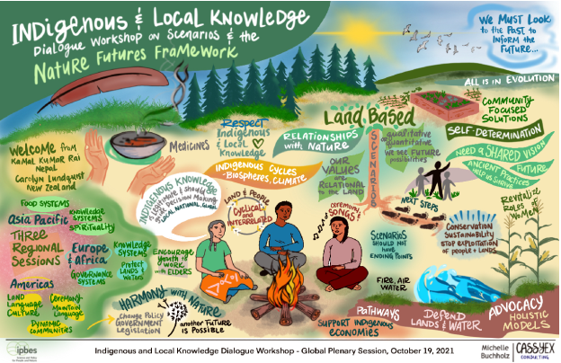
Figure 9: Graphic representation of the plenary discussions of the scenarios worksop, created by Michelle Buchholz of Cassyex Consulting

Next steps
The following steps took place after the dialogue:
- The IPBES task forces and technical support units held follow up calls and email discussions where needed for participants who did not have enough time during the workshop or who could not be heard due to connection problems.
- The IPBES task forces and technical support units drafted comments from the dialogue for the review of the NFF and its methodological guidance. The comments were sent to all participants for their edits and additions. After some edits, and as there were no objections, the comments were submitted through the external review process on 30 October 2021.
- A report from the dialogue workshop (this report) was drafted, which was also sent to participants for review and comments, before being published online.
- Participants were also invited to personally participate in the review for the NFF, which ran until 31 October 2021. Participants were invited to contact the IPBES technical support units for any assistance.
- Participants and task force members discussed the potential for a follow up ILK dialogue on scenarios in 2022 to further build on the outcomes of this workshop.

Annexes

Annex 1: Agendas
Regional session: Asia-Pacific (in English and Russian)
Tuesday 28 September, 5am-8am Central European Summer Time
Time | Activity | Speakers
5h00- 5h05 | Opening | Kamal Kumar Rai  Carolyn Lundquist  Joji Cariño
5h05-5h15 | Introductions | Joji Cariño
5h15-5h25 | Aims, methods, agenda and FPIC | Machteld Schoolenberg  Peter Bates
5h25-5h30 | Introduction to IPBES  IPBES work with ILK | Joji Cariño
5h30-5h45 | Introduction to scenarios  - Why are they important?  - The importance of ILK in scenarios  - The Nature Futures Framework | Carolyn Lundquist
5h45-5h50 | Questions | Carolyn Lundquist
5h50-7h00 | Visioning activity:  - Introduction  - Participants describe existing community strengths and innovations  - What kind of future emerges when these seeds combine and connect? | Sylvia Karlsson-Vinkhuyzen
7h00-7h05 | Break
7h05-7h45 | Open guided discussion – Building towards regional visions. Guiding questions:  - What would the impact of these perspectives be at a regional level (Asia-Pacific)?  - What can broader society learn from these perspectives?  - What would need to change at a regional level?  Open guided discussion – Nature Futures Framework:  - Does the NFF provide space for these IPLC visons and values to be well represented?  - Does anything need to change?  - Can you imagine using the NFF to represent your values and visions to policymakers or other actors? | Carolyn Lundquist
7h45-7h55 | Next steps | Carolyn Lundquist
7h55-8h00 | Closing | Polina Shulbaeva  Carolyn Lundquist

Regional session: Africa (in English and French)
Wednesday 29 September, 1pm-4pm Central European Summer Time
Time | Activity | Speakers
13h00- 13h05 | Opening, | Edna Kaptoyo  Shizuka Hashimoto
13h05- 13h15 | Introductions | Peter Bates
13h15- 13h25 | Aims, methods, agenda and FPIC | Machteld Schoolenberg  Peter Bates
13h25-13h30 | Introduction to IPBES  IPBES work with ILK | Peter Bates
13h30-13h45 | Introduction to scenarios  - Why are they important?  - The importance of ILK in scenarios  - The Nature Futures Framework | Shizuka Hashimoto
13h45-13h50 | Questions | Shizuka Hashimoto
13h50-15h00 | Visioning activity:  - Introduction  - Participants describe seeds  - What kind of future emerges when these seeds combine and connect? | Laura Pereira
15h00-15h05 | Break
15h05-15h45 | Discussion  Open guided discussion – Building towards regional visions. Guiding questions:  - What would the impact of these perspectives be at a regional level (Africa)?  - What can broader society learn from these perspectives?  - What would need to change at a regional level?  Open guided discussion – Nature Futures Framework:  - Does the NFF provide space for these IPLC visons and values to be well represented?  - Does anything need to change?  - Can you imagine using the NFF to represent your values and visions to policymakers or other actors? | Laura Pereira
15h45-15h55 | Next steps | Laura Pereira
15h55-16h00 | Closing | Edna Kaptoyo  Shizuka Hashimoto

Regional session: Americas (in English and Spanish)
Thursday 30 September, 6pm-9pm Central European Summer Time
Time | Activity | Speakers
18h00-18h05 | Opening | Viviana Figueroa  Carolyn Lundquist  Ana Maria Hernandez Salgar
18h05-18h15 | Introductions | Yolanda Lopez
18h15-18h25 | Aims, methods, agenda and FPIC | Machteld Schoolenberg  Peter Bates
18h25-18h30 | Introduction to IPBES  IPBES work with ILK | Ana Maria Hernandez Salgar
18h30-18h45 | Introduction to scenarios  - Why are they important?  - The importance of ILK in scenarios  - The Nature Futures Framework | Carolyn Lundquist
18h45-18h50 | Questions | Carolyn Lundquist
18h50-20h00 | Scenarios activity:  - Introduction  - Participants describe seeds  - What kind of future emerges when these seeds combine and connect? | Maria Gasalla
20h00-20h05 | Break
20h05-20h45 | Discussion  Open guided discussion – Building towards regional visions. Guiding questions:  - What would the impact of these perspectives be at a regional level (Americas)?  - What can broader society learn from these perspectives?  - What would need to change at a regional level?  Open guided discussion – Nature Futures Framework. Guiding questions:  - Does the NFF provide space for these IPLC visons and values to be well represented?  - Does anything need to change?  - Can you imagine using the NFF to represent your values and visions to policymakers or other actors? | Maria Gasalla
20h45-20h55 | Next steps | Machteld Schoolenberg
20h55-21h00 | Closing | Sherry Pictou  Carolyn Lundquist

Plenary session (in English, French, Spanish and Russian)
Tuesday 19 October 2021, 1pm-4pm Central European Summer Time
Time | Activity | Speakers
13h00-13h05 | Opening | Kamal Kumar Rai  Ana Maria Hernandez Salgar  Carolyn Lundquist
13h05-13h15 | Introductions | Peter Bates
13h15-13h20 | Aims, methods, agenda and FPIC | Machteld Schoolenberg  Peter Bates
13h20-13h30 | Brief recap:  - Introduction to IPBES and work with ILK  - Scenarios and the NFF | Carolyn Lundquist
13h30-14h00 | Report back from regional sessions | Joji Cariño,  Edna Kaptoyo  Yesenia Henandez
14h00-14h10 | Presentation of artworks | Nikita Jain
14h10-14h55 | Discussion:  - Is anything missing or incorrect from the regional pathways and visions?  - Is there a better way to represent these regional visions?  - What can these scenarios tell us at the broader regional level? | Peter Bates
14h55 | Photo
14h55-15h00 | Break
15h00-15h40 | Discussion continued:  - Are these visions useful for your work / communities? How?  - What would participants want to see happen next? | Machteld Schoolenberg
15h40-15h50 | Graphics from graphic facilitator | Michelle Buchholz
15h50-15h55 | Next steps for IPBES | Machteld Schoolenberg
15h55-16h00 | Closing | Sherry Pictou  Ana Maria Hernandez Salgar

Annex 2: FPIC document
Free Prior Informed Consent (FPIC) principles for sharing of knowledge during the indigenous and local knowledge dialogue workshop on scenarios and the Nature Futures Framework
Online, 28 - 30 September and 19 October 2021
The individuals whose names are listed in annex 3 agreed during the dialogue workshop to follow the principles and steps laid out in this document.

Background
Within the framework of the UN Declaration on the Rights of Indigenous Peoples (UNDRIP), principles of Free Prior Informed Consent (FPIC) apply to research or knowledge-related interactions between indigenous peoples and outsiders (including researchers, scientists, journalists, etc.). Given that the dialogue process includes discussion of indigenous knowledge of biodiversity and ecosystems, there may be information which the knowledge holders or their organizations or respective communities consider sensitive, private, or holding value for themselves which they do not want to share in the public domain through publications or other media without formal consent.

Objectives of the workshop
The objectives of the dialogue workshop with IPLCs are:
- Consulting IPLCs on the NFF and methodological guidance, with the aim of ensuring that the NFF will be an appropriate tool for working with ILK in scenarios and future visions at multiple scales;
- Carrying out a practical activity around scenarios, future visions and ILK, as a way of further exploring the NFF and its methodologies. To this end a visioning, back casting and pathway exercise will be carried out, with more information shared in advance of the workshop.
- Gathering community examples from these practical activities, to begin to address the knowledge gap on ILK and scenarios and to explore opportunities to catalyse further work. From this, the dialogue aims at building wider regional qualitative ILK scenario examples.
It is hoped that the workshop will provide an opportunity for all participants to learn more about IPBES and scenarios, and to reflect and learn from one another about how indigenous and local knowledge can inform and influence environmental decision-making.

Principles
The dialogue will be built on equal sharing and joint learning across knowledge systems and cultures. The aim is to create an environment where people feel comfortable and able to speak on equal terms, which is an important precondition for true dialogue.
To achieve these aims, the following goals are emphasized:
- Equality of all participants and absence of coercive influence
- Listening with empathy and seeking to understand each other’s viewpoints
- Accurate and empathetic communication
- Bringing assumptions into the open
If participants feel that the above goals are not being achieved at any point during IPBES activities, participants are asked to bring this to the attention of the organizers of the activity, or the IPBES technical support unit on ILK, at: ilk.tsu.ipbes@unesco.org.

Sharing knowledge and respecting FPIC
To ensure that knowledge is shared in appropriate ways during dialogue workshops and other IPBES activities, and that information and materials produced after these activities are used in ways that respect FPIC, we propose the following:
- Guardianship – participants who represent organizations and communities
- Principles of guardianship will be discussed with IPLC participants at the beginning of IPBES activities.
- Participants who represent organizations or communities will act as the guardians of the use of the knowledge and materials from their respective organizations or communities that is shared before, during or after the workshop. Any use of their organizations’ or communities’ knowledge will be discussed and approved by the guardians, as legitimate representatives of their organizations or communities. Guardians are expected to contact their respective organizations and communities when they need advice. Guardians are also expected to seek consent from their organizations or communities when they consider that this is required, keeping in mind that sharing details of their community’s knowledge can potentially have negative consequences, for example sharing the locations and uses of medicinal plants.
- FPIC rights during dialogue workshops and other activities
- The FPIC rights of the indigenous peoples participating in dialogue workshops or other activities will be discussed prior to the beginning of the activity, until participants feel comfortable and well informed about their rights and the process, including the eventual planned use and distribution of information. This discussion may be revisited during the activity, and will be revisited at the end of dialogue workshops once participants have engaged in the dialogue process.
- Participants do not have to answer any questions that they do not want to answer, and do not need to participate in any part of an activity in which they do not wish to participate;
- At any point, any participant can decide that they do not want particular information to be documented or shared outside of the activity. Participants will inform organizers and other participants of this. Organizers and participants will ensure that the information is not recorded. Participants can also request that the information is only recorded as a general statement attributed to a region or country, rather than to a specific community.
- Permission for photographs must be agreed prior to photos being taken and participants have the right not to be photographed. Organizers will take note of this.
- After the activity
- Permission will be obtained before any photograph of a participant is used or distributed in any form.
- Permission will be obtained before any list of participants is used or distributed in any form.
- Participants maintain intellectual property rights over all information collected from them about themselves or their communities, including photographs. Their intellectual property rights should be protected, pursuant to applicable laws.
- Copies of all information collected will be provided to the participants for approval.
- Any materials developed for IPBES assessments or other products using information provided by participants will be shared with the participants for prior approval and consent.
- The information collected during the activity will not be used for any purposes other than those for which consent has been granted, unless permission is sought and given by participants.
- Participants can decline to consent or withdraw their knowledge or information from the process at any time, and records of that information will be deleted if requested by the participant.
The participants of the workshop, listed in annex 3 below, agreed to follow the principles and steps laid out in this FPIC document.

Annex 3: Participants of the dialogue workshop
Africa
Name | Country | Affiliation
Mulubrhan Balehegn Gebremikael | Ethiopia | Institute of Food and Agricultural Sciences, University of Florida
Aliou Bouba | Cameroon | Mbororo, IPGFforSD, MBOSCUDA and ADJEMA
Edna Kaptoyo | Kenya | Pastoral Communities Empowerment Programme (PACEP)
Elifuraha Laltaika | Tanzania | Association for Law and Advocacy for Pastoralists (ALAPA), Tumaini University Makumira, Tanzania
Hannah Longole | Uganda | Executive director of Ateker Cultural Center
Simon Mitambo | Kenya | Africa Biodiversity Network, Kenya
Martin Mwenda Muriuki | Kenya | Institute of Culture and Ecology (ICE)
Appolinaire Oussou Lio | Benin | Fondateur du Groupe de Recherche at d’Action pour le Bien-Etre au Benin
Rodah Rotino | Kenya | Pastoral Community Empowerment Programme (PACEP)
Gakemotho Satau | Botswana | Bugakhwe (San), TOCaDI (Trust for Okavango Cultural and Development Initiative)
Severin Sindizera | Burundi | Coordinator of Association for Integration and Sustainable Development in Burundi (AIDB)

Americas
Name | Country | Affiliation
Edith Bastidas | Colombia | Focal Point in Colombia for the Indigenous Women's Network on Biodiversity in Latin America
Natalie Boodram | Grenada | CANARI Programme Manager, Senior Technical Officer, NEA coordinator
Adrian Cashman | Barbados | AKWATIX Water Resources Consultant/ Global Water Partnership - Caribbean Deputy Chair of Technical Committee
Cristina Coc | Belize | Indigenous leader from Central America
Q”apaj Conde | Bolivia | Convention on Biological Diversity
Jósimo da Costa Constant | Brasil | Puyanawa Anthropologist
Mike Dockry | USA | Indigenous scholar
Sandra Ferguson | Grenada | Civil Society Co-chair on the Co-ordinating Team re the Grenada National Ecosystem Assessment
Viviana Figueroa | Argentina | IPBES ILK Task Force / Indigenous Women Network on Biodiversity
Guadalupe Yesenia Hernández Márquez | Mexico | ILK focal point for IPBES in Mexico
Onel Masardule | Panama | Executive Director of the non-profit Foundation for the Promotion of Indigenous Knowledge
Ángela Milady Mavisoy | Colombia | Estudiante Kamënts̈á y Coordinaodra del Semillero biolugargogía de memorias y sabídurías ancestrales de la Universidad del Cauca / Kamënts̈á Student and Coordinator of the Semillero biolugargogía de memorias y sabídurías ancestrales of the Universidad del Cauca.
Willian Jairo Mavisoy Muchavisoy | Colombia | Profesor del Departamento de Estudios Interculturales, Director del Grupo de Investigación en Educación Rural Intercultural y líder de la línea Memorias y sabidurías ancestrales, también Mentor del Semillero biolugargogía de memorias y sabidurías ancestrales, Universidad del Cauca - Popayán / Professor of the Department of Intercultural Studies, Director of the Intercultural Rural Education Research Group and leader of the Ancestral Memories and Wisdoms line, also Mentor of the Biolugargogy of Ancestral Memories and Wisdoms seedbed. University of Cauca, Popayán
Jadder Mendoza | Nicaragua | Centro de Estudios y Desarrollo de la Autonomía CEDEA / Centre for the Study and Development of Autonomy CEDEA
Angie Pino Narváez | Colombia | Campesina student, Universidad del Cauca - Popayán
Sherry Pictou | Canada | IPBES ILK task force / Schulich School of Law, Dalhousie University
Donald Rojas Maroto | Costa Rica | President of the National Indigenous Bureau, Costa Rica
Eliana Marcela Sánchez | Colombia | Estudiante Yanakuna, Universidad del Cauca - Popayán
Ruth Spencer | Antigua | Coordinator - Training, outreach and resource mobilization of the Freetown Community Group/Caribbean Marine Managed Areas Network
Edith Yurani Macías | Colombia | Estudiante Yanakuna, Universidad del Cauca - Popayán

Asia-Pacific
Name | Country | Affiliation
Jocelyn (Joji) Cariño | Philippines | IPBES ILK task force / Forest Peoples Programme / Centres of Distinction on Indigenous and Local Knowledge
Florence Daguitan | Philippines | Tebtebba, Philippines
Daya Dakasi Da-Wei Kuan | Taiwan | Associate Professor in the Department of Ethnology at National Cheng Chi University (NCCU)
Jimmy Kereseka | Solomon Islands | Environment Officer, Lauru Land Conference of Tribal Community (LLCTC)
Kamal Kumar Rai | Nepal | IPBES ILK task force / Society for Wetland Biodiversity Conservation Nepal
Thingreiphi Lungharwo | India | Naga Peoples Movement for Human Rights (NPMHR)
Willy Missack | Vanuatu | Biodiversity Conservation Specialist, Food and Agriculture Organization of the United Nations (FAO) in Vanuatu
Margaret Raven | Australia | Senior Scientia Lecturer, Social Policy Research Centre, and Environment & Society Group; UNSW Sydney
Polina Shulbaeva | Russia | Centre for Support of Indigenous Peoples of the North (CSIPN)
Tui Shortland | Aotearoa/ New Zealand | Director, Te Kopu, Pacific Indigenous & Local Knowledge Centre
Prasert Trakansuphakon | Thailand | Pgakenyau Association for Sustainable Development (PASD)

IPBES task forces on scenarios and models and indigenous local knowledge
Name | Country | Affiliation
Ana María Hernández Salgar | Colombia | Chair of IPBES / Co-chair of the IPBES task force on indigenous and local knowledge
Adriana Flores | Mexico | Co-chair of the IPBES task force on indigenous and local knowledge
Shizuka Hashimoto | Japan | Co-chair of the IPBES task force on scenarios and models
Carolyn Lundquist | New Zealand | Co-chair of the IPBES task force on scenarios and models
Ana Paula Aguiar | Brazil | IPBES task force on scenarios and models
Khaled Allam Ahmed | Egypt | IPBES task force on scenarios and models
Jocelyn (Joji) Cariño | Philippines | IPBES task force on indigenous and local knowledge
Viviana Figueroa | Argentina | IPBES task force on indigenous and local knowledge
Maria Gasalla | Brasil | IPBES task force on scenarios and models
Sylvia Karlsson-Vinkhuyzen | Sweden | IPBES task force on scenarios and models
Kamal Kumar Rai | Nepal | IPBES task force on indigenous and local knowledge
Laura Bosch Pereira | South Africa | IPBES task force on scenarios and models
Garry Peterson | Canada | IPBES task force on scenarios and models
Sherry Pictou | Canada | IPBES task force on indigenous and local knowledge
Carlos Zambrana-Torrelio | Bolivia | IPBES task force on scenarios and models

IPBES secretariat
Name | Country | Affiliation
Machteld Schoolenberg | Netherlands | IPBES technical support unit on scenarios and models
Marco Immovilli | Italy | IPBES technical support unit on scenarios and models
Yolanda Lopez-maldonado | Mexico | IPBES technical support unit on indigenous and local knowledge
Peter Bates | UK | IPBES technical support unit on indigenous and local knowledge

Annex 4: Process for developing the three artworks for the workshop
IPBES worked with Nikita Jain, who works to connect indigenous artists in India to projects. Nikita identified three indigenous artisans, based on the relatability of their experiences with the themes that emerged through the IPBES workshops. Each of these artisans comes from communities that have a very strong connection with their surroundings, landscapes and local ecosystems. Their daily lives and art have been deeply rooted in and interdependent on nature. They mostly use colours obtained from plants, flowers and soil.
Nikita held participatory workshops with each artisan, where they discussed this relationship, what changes they are seeing and what can be done to preserve what is essential. This was a free-flowing conversation and was recorded in notes, around the following questions:
- How would you describe your relationship with nature and the land?
- How is this reflected in your art?
- How do you think this connection with the land has changed/ is changing?
- What important knowledge do you think is getting lost? And why does this need to be retained? What can we do to retain it?
- What is your vision for the future?
After these conversations they spoke about the three sessions conducted by IPBES and the outcomes from there, as well as the overlaps with all that came out from the artists workshops. Then they did an exercise and created moodboards (figures 10, 11 and 12, below) to visualise some of the key outcomes.
Draft artworks were then shared with IPBES, before the artworks were finalized and presented to participants at the plenary session of the workshop.

Moodboards for planning the artworks
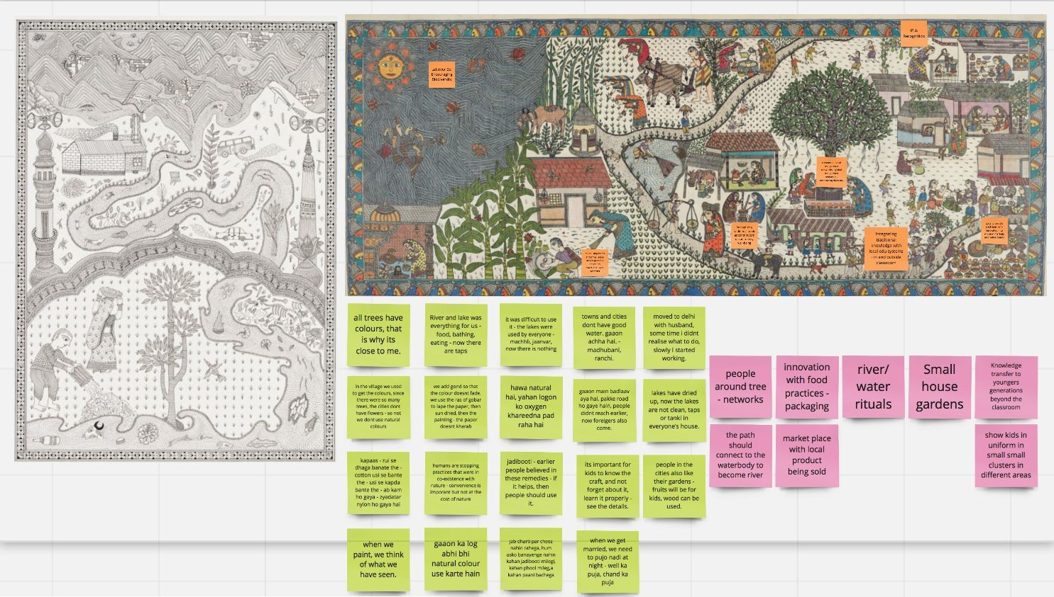
Artisan
conversations
Emerging themes
Figure 10. Moodboard, ideas and visuals from Asia-Pacific dialogue
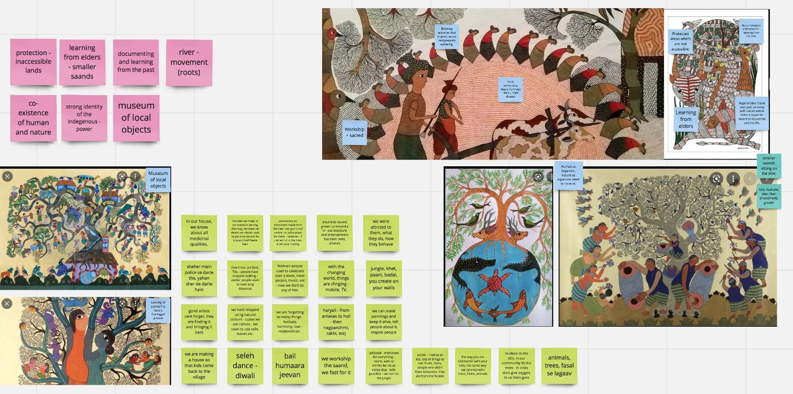
Figure 11. Moodboard, ideas and visuals from Africa dialogue
Artisan conversations
Emerging themes

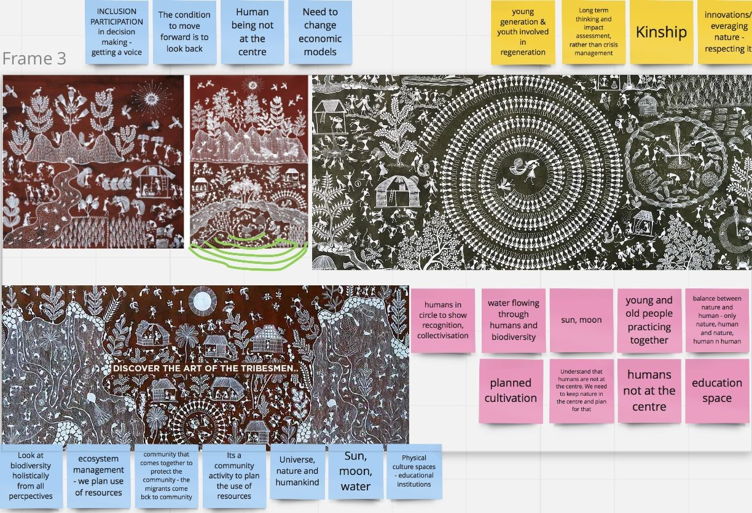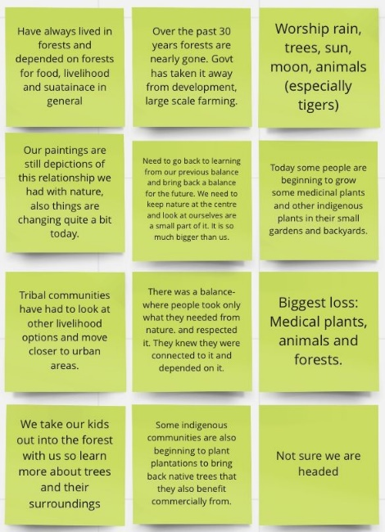
Artisan
conversations
Emerging themes
Figure 12. Moodboard, ideas and visuals from Americas dialogue

Pereira et al. (2020). Developing multiscale and integrative nature–people scenarios using the Nature Futures Framework. People and Nature 2(4), 1172-1195. https://doi.org/10.1002/pan3.10146
A Jamboard is an online tool from Google, which allows sticky notes, images and other media to be placed and edited on an online board.
The text in section 4 represents an attempt to reflect solely the views and contributions of the participants in the dialogue. As such, it does not represent the views of IPBES or UNESCO or reflect upon their official positions.
One example of current analysis of the future from indigenous Mayan communities from Mexico: https://www.frontiersin.org/articles/10.3389/fsufs.2021.618453/full
The text in section 5 represents an attempt to reflect solely the views and contributions of the participants in the dialogue. As such, it does not represent the views of IPBES or UNESCO or reflect upon their official positions.
The text in section 6 represents an attempt to reflect solely the views and contributions of the participants in the dialogue. As such, it does not represent the views of IPBES or UNESCO or reflect upon their official positions.
https://naakpa.com.au/
https://www.fnbbaa.com.au/about
With thanks to Ms. Kahu Armstrong for providing this text after the workshop, based on a video presented during the workshop. Please see https://www.awateaorganics.nz/water for more information.
See: Mulubrhan Balehegn (2016). Ecological and Social Wisdom in Camel Praise Poetry Sung by Afar Nomads of Ethiopia. Journal of Ethnobiology 36(2):457-472. DOI:10.2993/0278-0771-36.2.457. https://www.researchgate.net/publication/303831189_Ecological_and_Social_Wisdom_in_Camel_Praise_Poetry_Sung_by_Afar_Nomads_of_Ethiopia
See: Mulubrhan Balehegn, Selam Balehey, Chao Fu & Wu Liang (2019). Indigenous weather and climate forecasting knowledge among Afar pastoralists of north eastern Ethiopia: Role in adaptation to weather and climate variability. Pastoralism: 9: 8. https://pastoralismjournal.springeropen.com/articles/10.1186/s13570-019-0143-y
https://en.reddejovenesindigenas.com/; https://www.voicesofyouth.org/blog/reciprocity-indigenous-teaching-better-2021
The text in section 7 represents an attempt to reflect solely the views and contributions of the participants in the dialogue. As such, it does not represent the views of IPBES or UNESCO or reflect upon their official positions.

