Report

Indigenous and local knowledge dialogue workshop

on

Scenarios of the future
23-26 May 2025, Subic Bay, the Philippines

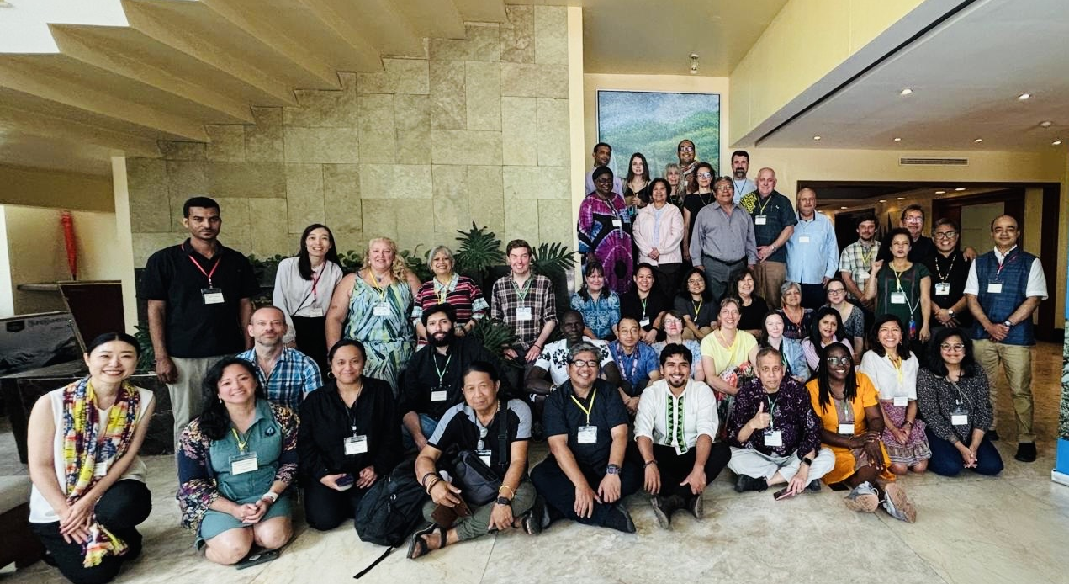

Suggested citation
IPBES (2025). Wilfredo Vidal Alangui, Myrle Ballard, Rande C. Bayate, Jill Cariño, Joji Cariño, Adelaido Corcino, Bolivia Delgado, Dave De Vera, Binota Moy Dhamai, Catherine Febria, Elisabeth Gilmore, Mariaelena Huambachano, Mochamad Indrawan, Alice Zione Kammwamba, Sylvia Karlsson-Vinkhuyzen, Zhinal Kinoc, Despina Kitnova, Abigail Kitma, Mahdi Kolahi, Paulina Karim, Maritess Literal, Carolyn Lundquist, Yesenia Hernández Márquez, Onel Masadule, Alice Mathew, Ryan S. Mohammed, Lucy Mulenkei, Melissa Nursey-Bray, Karin Nutti Pilflyky, Ismael Ocen, Ramon de la Concepcion Pichs-Madruga, Sam Poskitt, Teriitutea Quesnot, Sakshi Rana, Maria Elena Regpala, Sandi Ringham, Nick Rahiri Roskruge, Thomas Schmitt, Polina Shulbaeva, Josefa Cariño Tauli and Nutdanai Trakansuphakon. Report of the Indigenous and local knowledge dialogue workshop on Scenarios of the future. 23-26 May 2025, Subic Bay, the Philippines.

Disclaimer
The text in section 3 represents an attempt to reflect solely the views and contributions of the participants in the dialogue. As such, it does not represent the views of IPBES or UNESCO or reflect upon their official positions.

Acknowledgements
IPBES wishes to thank the participants who travelled from across the Philippines and from across the world to share their time and knowledge during the workshop. IPBES also wants to thank the local organizers: the Network of the Centers of Distinction on Indigenous and local knowledge (COD-ILK); Partners for Indigenous Knowledge Philippines (PIKP); the Philippine Association for Intercultural Development (PAFID); and in particular the Kanawan Magbukon Aeta for welcoming the participants and sharing their knowledge. Further, IPBES would like to acknowledge the financial contribution provided by the Ministry of the Environment of Japan to support the organization of this workshop.

Table of Contents
Table of Contents 2
1 Introduction 4
2 Background 5
2.1 IPBES, ILK and scenarios 5
2.1.1 IPBES 5
2.1.2 IPBES and ILK 5
2.1.3 IPBES and scenarios 6
2.1.4 The IPBES Nature Futures Framework 7
2.1.5 Indigenous Peoples and local communities and futures thinking in IPBES assessments 8
2.1.6 The Plenary request and planning for the workshop 9
2.2 The workshop 10
2.2.1 Workshop objective 10
2.2.2 Workshop outcomes 11
2.2.3 Workshop methods 11
2.2.4 Free, prior and informed consent 13
2.2.5 Benefits to Indigenous Peoples and local communities of participating in IPBES activities 13
2.2.6 The local context 14
3 Learning and recommendations from the dialogue workshop 15
3.1 Aspirations for scenarios work with Indigenous Peoples and local communities 15
3.2 Typology of scenarios work 17
3.3 Futures thinking within ILK systems 18
3.3.1 Worldviews, values and knowledge about nature 18
3.3.2 Conceptualization of time and futures thinking in communities 22
3.3.3 Benefits of ILK approaches for futures thinking 27
3.3.4 Challenges to ILK futures thinking 28
3.4 Opportunities for co-production of scenarios and visioning 30
3.4.1 Indigenous-led research and co-production of scenarios and visioning 30
3.4.2 Co-production between non-Indigenous scientists and Indigenous Peoples and local communities 41
3.5 Ways forward 49
3.5.1 Ways forward: Futures thinking within ILK systems 49
3.5.2 Ways forward: Co-production and co-creation 52
3.5.3 Ways forward: Nature Futures Framework 59
3.5.4 Ways forward: IPBES 60
3.5.5 Ways forward: IPBES second global assessment 60
3.5.6 Ways Forward: Future workshops 62
4 Next steps 65
Annexes 66
Annex 1: Agenda 66
Annex 2: FPIC document 71
Background 71
Principles 71
Sharing knowledge and respecting FPIC 71
Annex 3: Participants of the dialogue workshop 73

Introduction
This report summarises the proceedings of the Indigenous and local knowledge (ILK) dialogue workshop on scenarios of the future that was organized by the Intergovernmental Science-Policy Platform on Biodiversity and Ecosystems Services (IPBES). The full title of the workshop agreed by the IPBES Plenary was “Workshop to reflect on scenarios and models to better account for different knowledge systems, including Indigenous and local knowledge systems, and Mother Earth-centric scenarios and models.”
The dialogue workshop was held in Subic Bay, the Philippines, from 23 to 26 May 2025. It aimed to provide a platform for discussion between Indigenous Peoples and local communities and members of the IPBES task forces on Indigenous and local knowledge and on scenarios and models, as well as others with experience and expertise in scenarios work.
This report aims to provide a written record of the dialogue workshop, which can inform the future work of the IPBES task forces and can be a resource for all dialogue participants who may wish to review and contribute to the IPBES work at the interface of scenarios and models and Indigenous and local knowledge, as well as others who may be interested in this theme.
The report is not intended to be comprehensive or to provide definitive resolution to the many engaging discussions that emerged during the workshop. Rather, it serves as a written record of those discussions, which will continue to develop and evolve in the months and years ahead. For this reason, clear points of agreement are discussed, but also, if there were diverging views among participants, these are also presented for further attention and discussion.
The text in section 3 represents an attempt to reflect solely the views and contributions of the participants in the dialogue. As such, it does not represent the views of IPBES or UNESCO or reflect upon their official positions.
The agenda and participants’ list for the dialogue workshop are provided in annexes 1 and 3.

Background

IPBES, ILK and scenarios

IPBES
IPBES is an independent intergovernmental body established to strengthen the science-policy interface for biodiversity and ecosystem services for the conservation and sustainable use of biodiversity, long-term human well-being and sustainable development.

IPBES and ILK
Since its inception in 2012, IPBES has recognized that Indigenous Peoples and local communities possess detailed knowledge of biodiversity and ecosystem trends. In its first work programme (2014-2018), IPBES built on this recognition through deliverable 1 (c), Procedures, approaches, and participatory processes for working with Indigenous and local knowledge systems. The IPBES rolling work programme up to 2030 includes objective 3 (b), Enhanced recognition of and work with Indigenous and local knowledge systems, which aims to further this work. The IPBES conceptual framework also contains explicit recognition of diverse knowledge and value systems.
Recognizing the importance of ILK to the conservation and sustainable use of ecosystems as a cross-cutting issue relevant to all of its activities, and noting also that approaches and methods for working with ILK and Indigenous Peoples and local communities in global and regional scale assessments would need to be developed, the IPBES Plenary established a task force on ILK systems and agreed on terms of reference guiding its operations towards implementing this deliverable. IPBES’ work with Indigenous Peoples and local communities and on ILK is supported by a technical support unit for ILK, hosted by UNESCO.
Key activities and deliverables of the task force and technical support unit on ILK so far include:
- Progress in the development of approaches and methodologies for working with ILK was made during previous IPBES assessments (Pollination, Pollinators and Food Production, Land Degradation and Restoration, four Regional Assessments and a Global Assessment of Biodiversity and Ecosystem Services, Sustainable Use of Wild Species, Diverse Values and Valuation of Nature, Invasive Alien Species, the Interlinkages among Biodiversity, Water, Food and Health, and Transformative Change);
- The development and implementation of the “approach to recognizing and working with ILK in IPBES”, which was formally approved by the Plenary at its fifth session in 2017 in decision IPBES-5/1, which sets out principles and approaches for IPBES’s work with ILK;
- Development and implementation of methodological guidance for recognizing and working with ILK in IPBES, which aims to provide further detail and guidelines on how to work with ILK within the IPBES context; and
- Development and implementation of a “participatory mechanism”, a series of activities and pathways to facilitate the participation of Indigenous Peoples and local communities in IPBES assessments and other activities, which includes organizing ILK dialogue workshops for the IPBES assessments.

IPBES and scenarios
IPBES recognizes the value of scenarios and models in its assessments, with one of the first assessments being ‘The Methodological Assessment Report on Scenarios and Models of Biodiversity and Ecosystem Services’ (IPBES 2016).
Scenarios can assist in understanding how the drivers impacting biodiversity and ecosystem services might evolve in the future, and what the consequences might be for nature and nature’s contributions to people, as well as people’s contributions to nature. Scenarios also can be used to assess the implications of different policy and management options, and how different targets could be achieved. Recognizing the contribution of scenarios and models to the IPBES work programme, the IPBES Plenary established a task force on scenarios and models and agreed on terms of reference guiding its operations towards implementing this deliverable.
Key activities and deliverables of the task force and technical support unit on scenarios and models build on recommendations from the IPBES assessment report, and those relevant to ILK include:
- Catalyzing the further development of scenarios and models for future IPBES assessments, including development of a novel scenarios framework that can incorporate multiple worldviews and the diversity of values human’s hold for nature, and supports participatory co-development of scenarios.
- Mobilizing and broadening involvement of ILK for scenario analysis and modelling, including scenarios and models based primarily on such knowledge.
- Promoting co-design and co-production of knowledge in the process of building scenarios.
- Supporting development of locally-based indicators based on traditional knowledge and improving understanding of role of biodiversity and ecosystem services and their links to the well-being of Indigenous Peoples and local communities.

The IPBES Nature Futures Framework
In order to catalyse the development of biodiversity-centric scenarios, the IPBES task force on scenarios and models developed the Nature Futures Framework (NFF), a flexible tool to support the development of scenarios and models of desirable futures for people, nature and Mother Earth, and its methodological guidance through a series of participatory processes that included Indigenous Peoples and local communities. It is shown in figure 1 below. The NFF aims to be a tool for catalysing the development of scenarios of desirable future human-nature relationships based on diverse value perspectives and communicating the importance of considering scenarios based on multiple values and knowledge systems. The NFF includes two parallel figures; the first portrays three overlapping value perspectives (intrinsic, instrumental and relational values for nature), whereas the second portrays a cosmovision of worldviews where the multiple values for nature and people are intimately related in complex ways and are difficult to define as separate value entities due to biocultural connections between humans and nature. Accompanying the NFF is a methodological guidance that aims to support the use of the NFF to generate diverse scenarios across scales.
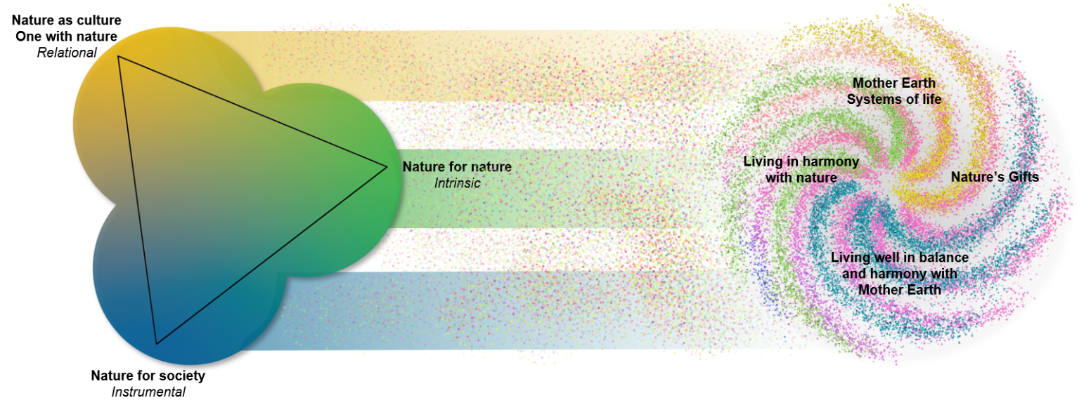Figure 1: the Nature’s Futures Framework
The task forces on scenarios and models and on Indigenous and local knowledge have also previously organized two workshops that brought together Indigenous Peoples and local communities and researchers, with the aim of exploring ILK, future visions and scenarios:
- An online workshop (28 - 30 September and 19 October 2021) (report available here); and
- A workshop in Leticia, Colombia (13-16 February 2023), in the context of the IPBES assessment of transformative change (report available here).
These workshops began to explore concepts of time, philosophies about the future, visions and pathways for human-nature relationships of Indigenous Peoples and local communities at regional scales.

Indigenous Peoples and local communities and futures thinking in IPBES assessments
Indigenous Peoples and local communities are key actors in the conservation and sustainable use of nature and nature’s contributions to people. For example, the IPBES Global Assessment (2019) showed that at least a quarter of the global land area is traditionally owned, managed, used or occupied by Indigenous Peoples, and that, in addition, a diverse array of local communities manages significant areas. Many communities hold dynamic ILK which has been passed down, adapted and enhanced through many generations. This long-term knowledge, combined with keen observations of the present, can also inform and support visions and expectations for the future. Many communities may also have distinct perspectives, philosophies and approaches to thinking about the future, time and space. As they often view humans and nature as an integrated whole, they may also have specific ways of conceptualising paths forward for their communities, lands, forests, rangelands and waters, as well as assessing likely changes in the future.
Similarly, the findings of IPBES assessments have consistently highlighted the importance of ILK for conceptualising and planning for better futures at global scales. However, they have also highlighted a lack of scenarios that engage with ILK or that are developed with participation by Indigenous Peoples and local communities, particularly at the global scale. They also noted a need to move beyond science-driven scenarios, and to build scenario narratives based on diverse knowledge systems, multiple perspectives and values with a strong focus on desirable visions for human relationships with nature. Such scenarios can aim to have broader ownership, relevance, and uptake for decision-making at all levels, including by Indigenous Peoples and local communities.
While there are a growing number of visioning and futures-oriented projects taking place at local levels, some run by communities themselves as part of their planning for their futures, much ILK related to future visions has remained undocumented or unexplored, and many future-oriented activities in communities may also not be documented in ways that make them accessible to others (e.g., community land use planning or education and awareness programs). There has also been some visioning work done by Indigenous Peoples and local communities at the global scale (for example, the work on transitions in the Local Biodiversity Outlooks 2). However, there is much to learn about how ILK and science could co-produce scenarios at larger scales to answer what-if questions and help planning, both for achieving “living in harmony with nature”, what methods and tools might be needed, and the risks and advantages to Indigenous Peoples and local communities and their knowledge systems.

The Plenary request and planning for the workshop
Based on the processes and outcomes described above, the IPBES Plenary, at its tenth session in 2023, requested the IPBES task forces on scenarios and models and on Indigenous and local knowledge to continue this work, including by organizing an in-person workshop to contribute to the reflection on scenarios and models that better account for different knowledge systems, including ILK systems, and Mother Earth-centric scenarios and models, as included in the Nature Futures Framework, between the tenth and twelfth sessions of the Plenary, and presenting a report, including additional methodological guidance, at the twelfth session (Annex VIII to decision IPBES-10/1).
The workshop was therefore organized by the task forces, as described below, through a series of online meetings and stages of further developing aims, objectives and methods that meet the request from the Plenary. This included developing a concept note that was presented to the Plenary at its eleventh session in 2024.

The workshop

Workshop objective
The objective of this workshop, in line with the concept note, was to explore the following questions:
- How do organizations or communities of Indigenous Peoples and local communities conceptualise the future? What are the examples of communities or organizations doing “scenario building” or “visioning” work, or other work that explores futures in different ways? What are the goals of these activities? What methods are they using and why?
- How can this work by Indigenous Peoples and local communities inform and contribute to IPBES assessments and other processes related to scenario analysis to start filling the gaps recognized by previous assessments? What are the potential challenges and risks? What would be the benefits to Indigenous Peoples and local communities?
- Which different processes, tools and methods are needed for working with ILK and Indigenous Peoples and local communities in scenario building at a global or regional scale? How should these be developed? What are the potential challenges and risks? What would be the benefits to Indigenous Peoples and local communities? What would be the benefits of global efforts towards achieving living in harmony with nature?
- Is there a role for the NFF to help communicate the findings of visioning processes with Indigenous Peoples and local communities, including to IPBES assessments, policymakers and others working with scenarios and models? If so, how?

Workshop outcomes
Outcomes of the workshop include:
- A report summarising existing case studies and methods for working with different knowledge systems, including ILK systems in scenarios and visioning at different scales (this report).
- If deemed appropriate by participants, enhanced methodological guidance for scenarios work with ILK and Indigenous Peoples and local communities at global and regional scales, also as input to improve the methodological guidance for the NFF.
- A roadmap on future engagement and collaborations outside of IPBES between various communities (ILK knowledge holders, scenarios and modelling groups, etc.), including for the further development of the NFF and its applications to support assessments and policy discussions on nature and nature's contribution to people.

Workshop methods
A call for nominations of participants for the workshop was issued by the IPBES secretariat in January 2025, and based on this call, participants were selected by the IPBES Multidisciplinary Expert Panel in consultation with the two task forces in line with the provisions of the procedures for the development of IPBES deliverables, using agreed upon criteria, with attention to regional and gender balances.
The workshop was held in-person over four days, with an online introductory session in the weeks before to provide initial background and support preparation. Time was also set aside at the beginning of the workshop to allow participants to discuss the issues they wished to address at the workshop, and how these issues should be approached. The agenda is presented in annex 1 of this report. The process for the dialogue workshop included:
- An online introductory session, to discuss:
  - IPBES and its objective and methods;
  - Background to IPBES work on ILK and scenarios and models; and
  - Workshop aims, methods and free, prior and informed consent (FPIC);
  - Key themes and questions, and invitations to participants to bring or prepare songs, artworks, objects or anything else that helps to represent their community’s relationship with nature and ways of thinking about the future.
- At the workshop itself:
  - Initial presentations and discussions giving further detail on IPBES, its work with ILK and scenarios and models, and goals and aims of the workshop;
  - Presentations and discussions on community-based futures thinking, planning and conceptualizations of the future;
  - A community visit to the community of the Kanawan Magbukon Aeta, to discuss community futures thinking, future challenges and ways forward;
  - Presentations and discussions around scenario methods, including qualitative and quantitative methods, and processes, opportunities, challenges, risks and ways forward for weaving ILK with other scenarios approaches;
  - Breakout group sessions, which were held in three languages (Filipino, Spanish and English) to support fluid discussions, each with facilitators and notetakers; and
  - An Indigenous and local community caucus, an informal group composed of Indigenous Peoples and local community representatives, with ad hoc rules of engagement, to give participants a space to discuss any questions, concerns or issues in relation to IPBES and the workshop.

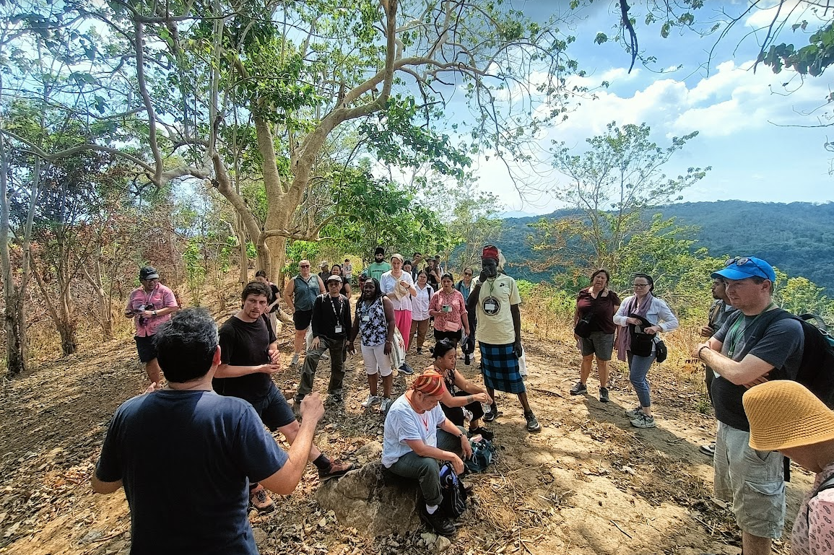
Photograph 1: Participants during the field visit to the Aeta community and lands.

Free, prior and informed consent
Free, prior and informed consent (FPIC) principles are central to IPBES work with Indigenous Peoples and local communities. A series of ethical principles have been developed to ensure that FPIC is followed in IPBES ILK dialogue workshops. These principles were agreed upon by the participants from Indigenous Peoples and local communities and IPBES task force members in the dialogue, recognizing that participants, task force members and the IPBES technical support units have different responsibilities within the process. The principles will be followed by participants from Indigenous Peoples and local communities, task force members and the IPBES technical support units. The full agreed-upon text and the names of those agreeing to these principles are provided in annexes 2 and 3 to this report.

Benefits to Indigenous Peoples and local communities of participating in IPBES activities
The organizers recognized that ensuring and clearly explaining benefits to Indigenous Peoples and local communities was an essential part of preparing for the workshop. This had also been emphasized by participants in previous IPBES ILK workshops, where participants also discussed benefits from participation and how these could be enhanced.
In this context, it is important to note that IPBES does not benefit financially from its processes or products, and that the main products of IPBES are publicly available materials, including assessment reports, their summaries for policymakers, webinars and other resources, to provide free and reliable information for policymakers, decision-makers and actors at all levels, including Indigenous Peoples and local communities.
Key benefits for Indigenous Peoples and local communities from participating in dialogue workshops and IPBES more broadly include:
- The opportunity to enhance relationships, and share experiences, examples and cases among Indigenous Peoples and local communities around the world;
- The opportunity for Indigenous Peoples and local communities to engage in dialogue around experiences and knowledge with IPBES assessment authors;
- The opportunity to bring ILK and the concerns and visions of Indigenous Peoples and local communities to the attention of policymakers and decision-makers; and
- Use of the final assessments and other products of IPBES when engaging with policymakers, decision-makers and scientists.

The local context

Background
The workshop was held on the ancestral lands of the Aeta Magbukun. Aeta representatives participated in the workshop, and all the workshop participants visited the Kanawan Magbukon Aeta community near Subic Bay to discuss with leaders, elders and youth about community challenges, visions and strategies.

The Aeta Magbukun
The Aeta Magbukun are an Indigenous group in Central Luzon, often underrepresented in formal records. Their ancestral domain covers over 34,000 hectares, including areas within the Subic Bay Forest Reserve.
The Aeta Magbukun of Bataan constitute one of the five main groups of Aeta in Central Luzon and is the least known of all Aeta groups. A substantial number live in villages within and around extents of Mt. Natib and Mt. Kaikurong in the Bataan and Subic Bay National Parks including some areas within the remaining forest cover and watershed areas of Mariveles Mountain.
Aeta Magbukun of Kanawan continue in a large part to depend on their access and relationship to the natural resources around their community and to their traditional beliefs and practices.

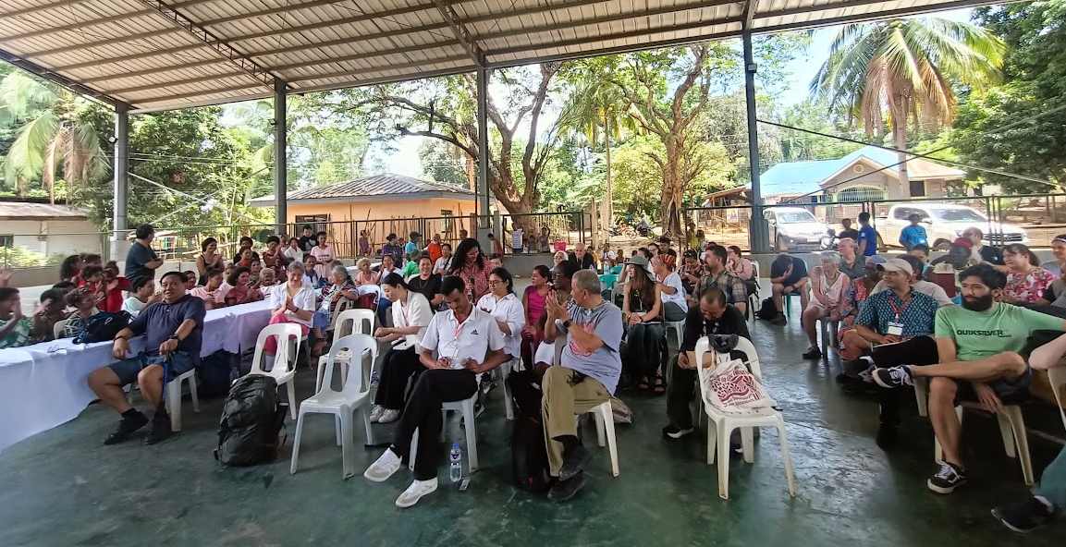
Photograph 2: Participants during the discussions in the community of the Kanawan Magbukon Aeta.

Learning and recommendations from the dialogue workshop
This section highlights the key messages, recommendations and examples shared by Indigenous Peoples and local communities and other participants during the workshop. To preserve authenticity, the content presented here closely reflects the participant´s statements and comments during the workshop, with only minor editorial adjustments for clarity.

Aspirations for scenarios work with Indigenous Peoples and local communities
At the outset of the workshop, participants shared a series of expectations for the workshop, and for IPBES work on scenarios and ILK. These included:
- Indigenous perspectives and values about nature: Participants expressed an overarching hope that Indigenous perspectives and values about nature are included in shaping the shared future of the planet.
- Foster mutual learning: Participants emphasized the value of exchanging experiences and methodologies for future visioning across Indigenous, local and scientific knowledge systems. They noted the need for a strong desire from both sides to co-learn and co-create meaningful approaches to future scenario development.
- Meaningfully co-create scenarios with ILK: Many participants emphasized the need to embed Indigenous and local knowledge not only as a data source for existing work with scenarios, but more importantly as a worldview and knowledge system that can provide new foundations, values, concepts and methodologies for scenarios work. They emphasized the need to recognize Indigenous leadership, and that ILK systems have always provided frameworks and methods for exploring and planning for the future. They also emphasized that they should be seen as leaders, partners and collaborators, rather than only as contributors or in supporting roles within the scenario building processes. They noted that there are many potential advantages to scientists and Indigenous Peoples and local communities working together to co-produce scenarios, if this work is done well and with respect, as is discussed below.
- Respect the validity of ILK systems: Participants also noted that ILK should not need to be validated by western science, because it is already an existing knowledge system with proven success in managing relationships between people and nature. ILK should thus be viewed as a distinct and equally valid way of knowing, equivalent to science. They noted that where validation is needed, this should be done by ILK holders within their own knowledge systems. Participants expressed hope that this workshop, and future work on scenarios and ILK, would offer tools and frameworks for validation to occur within ILK systems.
- Bridge policy and local realities: Participants emphasized that the outcomes should aim to influence and support biodiversity policies at national, regional and international levels. It is essential that these policies are informed by Indigenous and local perspectives, reflecting their lived experiences at the local scale. Biodiversity action and protection primarily take place at local scales, much of it managed and supported by Indigenous Peoples and local communities and their unique knowledge systems. They highlighted that Indigenous Peoples and local communities, as inseparable parts of nature, both shape and are shaped by their environments through constant interaction. They are able to rapidly recognize changes and adapt, and they understand the importance of maintaining balance and harmony with nature. Participants stressed that ILK and traditional systems remain at the margins of most policies and are not sufficiently recognized or respected by many governments. They emphasized that this is not only an issue around biodiversity-related policies, but all policies – especially those linked with natural resources (agriculture, pastures, water, forests, mineral resources) as well as education, health, and social sectors. These should all aim to consider and act on ILK, and value the contributions of Indigenous Peoples and local communities in nature protection. Participants emphasized that such recognition is essential for sustaining healthy ecosystems and, in turn, ensuring human well-being.
- Focus on action and implementation: Participants also noted the importance of focusing on building actionable plans and strategies, or clearly supporting such plans and strategies, rather than only focusing on theoretical issues.
- Supportive financial mechanisms: Participants highlighted the urgent need for policies to be accompanied by adequate financial mechanisms that enable the effective participation of Indigenous Peoples and local communities in protecting and maintaining nature, as well as supporting them to practice traditional sustainable use of natural resources, and to maintain and transfer their diverse cultural, knowledge and value systems. These mechanisms are critical for turning policy goals into concrete action on the ground.
- Strengthen connections across communities: Participants noted the importance of building lasting relationships among participants from different regions, cultures and disciplines – creating a collective community of practice around ILK and scenario development.
- Support for and focus on youth and future generations: Some participants highlighted the importance of passing knowledge and resilience to younger generations, ensuring continuity of cultural identity, ILK and stewardship of nature. Participants noted their hope that work on scenarios and ILK becomes part of this broader goal of many Indigenous Peoples and local communities, as intergenerational connections are crucial for many communities when engaging in work on futures. One participant expressed this as “strengthening our futures by reconnecting with our roots”.
- Support Indigenous rights: Participants highlighted that all discussions and future work should be grounded in supporting Indigenous rights. A participant read from the Kari-Oca Declaration, grounding the day’s reflections in foundational Indigenous rights, emphasizing sovereignty, cultural identity and intergenerational responsibility.

Typology of scenarios work
Three broad and overlapping categories of “futures thinking” or ways of working with scenarios were discussed, to help frame the discussions at the workshop:
- Futures thinking within ILK systems (discussed in section 3.3): This concept aims to represent the vast diversity of ways in which Indigenous Peoples and local communities would conceptualise, understand, think about, represent, predict and know the future within their own traditional worldviews, knowledge, management and governance systems.
- Co-production and co-creation: which for the purposes of the workshop and this report are divided into two sub-categories:
  - Indigenous-led research and co-production: (discussed in section 3.4.1): These are initiatives and projects that are conceptualised, led and implemented by Indigenous Peoples and local communities. They may weave Indigenous and scientific approaches, for example, by using tools like geographic information systems (GIS) and mental mapping (including drawings), and may engage some non-Indigenous researchers or other actors in supporting, advising or capacity-building roles. Whichever methods are used, they are nonetheless grounded in community leadership, worldviews and values. One aim of such initiatives may be to convey ILK of the future to broader audiences (e.g., governments or outside researchers). This category may include some of the most successful examples of weaving knowledge systems, as Indigenous Peoples and local communities are choosing which scientific methods or concepts they wish to use to support, supplement or expand their ILK systems, and are in control of the relationship between knowledge systems and actors.
  - Co-production between scientists and Indigenous Peoples and local communities (discussed in section 3.4.2): This category includes projects that may be co-conceived, co-designed and co-implemented by Indigenous Peoples and local communities and non-Indigenous scientists. Often, these efforts rely more on scientific concepts and methods, and the underlying values and worldviews may be more of a mix between both knowledge systems and worldviews. Co-production can be challenging, as, often, scientific assumptions, methods and leadership come to dominate, but there are successful examples.
- Science-based scenarios work: These are projects and processes conceptualised and led within scientific knowledge systems. They may include some input from ILK systems, but often ILK is used as a source of data rather than as a foundation for concepts, goals and methods. They are not considered in detail in this report, although many of the findings are relevant to projects of this type that wish to work with ILK systems and include participation by Indigenous Peoples and local communities.

Futures thinking within ILK systems

Worldviews, values and knowledge about nature
Participants highlighted that, as a foundation for all types of work with ILK systems and scenarios, it is first important to understand Indigenous and local worldviews, values and knowledge about nature, as well as the relationships with nature held by Indigenous Peoples and local communities. These form a foundation from which other aspects of their knowledge systems, including futures thinking, can be understood. Other initiatives and projects can also be built on these foundations, with curiosity, care and respect.
Participants shared personal and community-based connections to nature, reflecting deep-rooted relationships with lands, waters, animals, plants, air, sky, sun, moon and stars and how these are tied to ancestral traditions. Many emphasized that nature is not separate from people. Several participants showed or brought symbolic items, including an artwork from northern Russia, beads from Kenya, embroidery from North Macedonia and a rattan bag from the Philippines. Others sang songs to represent that nature and culture are one in their communities.
Key reflections included:
- Spiritual and cultural bonds with the land: Participants described their reverence for the land, mountains, rivers and forests, and how this is reinforced and expressed through ceremonies, for example, the worship of mountain deities in India, songs from Panama, and burial practices in the Philippines, including recognizing that “from soil we come and to soil we return” and natural laws for Canadian First Nations of how Earth was created and the original purpose of waters, lands, air, flora, and fauna. In Malawi, ritual forest ceremonies strengthen community identity and ecological knowledge, reaffirm ancestral ties to the land, regulate access to sacred groves, and provide a forum where elders transmit ecological knowledge on species, seasons and taboos to younger generations. These gatherings strengthen community identity, reinforce customary governance and sustain the ecological integrity of forest and watershed areas.
Example
A participant from Siberia in Russia explained that an ancient bronze figure of a three-headed moose (see image below) symbolizes the unity of people, spirits and the land. The moose is a spiritual marker of the Upper World. Meanwhile the moose is the main animal that is hunted in the large wetlands of Siberia, and is therefore the source of people’s lives.
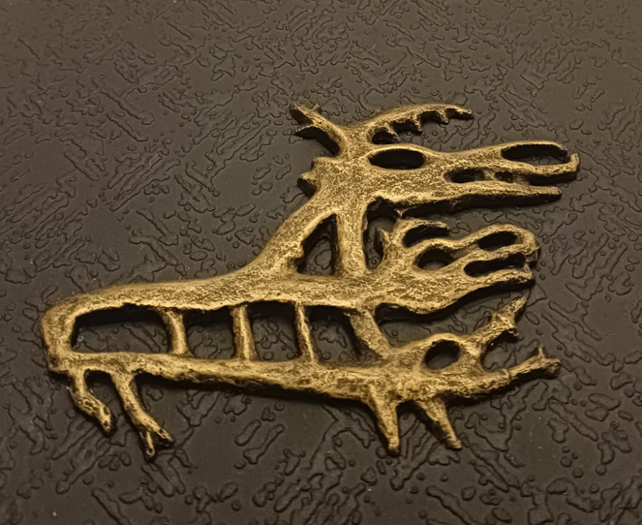
Figure 2: bronze figure of a three-headed moose, photo: Polina Shulbaeva
- Nature as identity: Some participants noted that nature is central to the identities of their communities, including for Indigenous communities in the Cordillera region of the Philippines, for reindeer herders in Sweden, and for connections to the ocean in Polynesia.
- Nature as livelihood: Some participants highlighted that nature is central to their livelihoods, for example, pastoralists in Uganda, reindeer herders in Sweden where families follow the herds through eight seasonal migrations, and rotational farming systems in northern Thailand.
- Nature as health and wellbeing: Participants emphasized that nature is seen as their doctor and medicine, and source of wellbeing, including in the Philippines, Uganda and the coast of Panama.
- Nature as homeland and home: Some participants emphasized that nature is their homeland and their home – not a distant entity, including participants from the Philippines and Panama.
- Nature as food and water source: Many participants highlighted that nature is their main source of food, for example, in the Philippines and on islands off the coast of Panama. Meanwhile, a participant from Iran highlighted the crucial role of water for communities living in an arid zone, while communities in the Philippines explained how protecting forest watersheds as water sources is central to their knowledge systems.
- Nature as a knowledge system and school: Participants, including from Uganda, Russia and Sweden, highlighted that nature is a source of knowledge. Often, Indigenous Peoples and local communities are learning through experience within nature, in many cases accompanied and guided by elders. For example, knowledge of berry picking and handicrafts are learnt this way in Sweden. Rotational farming in northern Thailand is also a space for community bonding, knowledge transmission and intergenerational learning. Nomadic peoples, for example, in Russia, were also highlighted for their ongoing monitoring of environmental changes, such as shifts in wildlife. Participants also highlighted that their bonds with nature are in turn strengthened through their knowledge about it.
- Nature as future: Crucially for this workshop, some participants highlighted that nature is the future. A participant from the Philippines highlighted that nature serves people now, but it must be cared for so it can continue to serve future generations. Another participant from the northern wetlands of Russia highlighted that she learnt from the older generations that “if you learn to live with nature, and understand it, you will find your future”. Another participant shared how in Malawi emphasis is placed on protecting sacred lands as future assets.
- Reciprocity, balance and harmony: Participants also noted that reciprocal relations with nature are key, including in northern Thailand, where communities consider that, if they eat from the forest or use the water, they need to care for them in return. Other participants also noted that many landscapes are co-shaped by people and nature, and Indigenous communities are crucial because they often live within nature and foster balance and harmony, including through sustainable use, stewardship, rituals and knowledge. Ancestral and community laws, values, ethical principles and governance systems may guide communities in this aspect.
Example
A participant from the Philippines shared worldviews and visions on living in harmony with nature among some communities in the Philippines. She noted that these relationships are rooted in caring, respect and responsibility for the earth. They are deep reciprocal connections with the land and nature, with people and communities, and with divine presence or the “Unseen”. Related knowledge and values are passed on from generation to generation as a guide for the day-to-day lives of past, present and future generations, teaching people to appreciate what the land provides, avoid wastefulness, take only what is needed, give back to the land that nurtures them, and live in community with others. She noted that territories and resources are of fundamental importance to Indigenous Peoples’ well-being, while Indigenous Peoples also provide critical contributions to biodiversity that benefit society at large. As such, Indigenous Peoples make vibrant contributions to the world’s biological and cultural diversity.

Example – Aeta worldviews and values
Aeta highlight values such as makisama (communal harmony), respect for elders, and care for nature as kin. They deeply value connection and co-existence with nature. Land is identity, history, and spiritual life. It provides sustenance, medicine, shelter and embodies ancestral presence. Loss of land is viewed as the loss of self. The traditional diet includes wild meat (e.g., native pig), tubers, root crops and fruits, gathered using traditional knowledge of seasonality, animal behaviour, and ecological signs. The Aeta read the environment through cloud formations, humidity, bird sounds and other natural indicators. These inform timing for hunting, planting and healing rituals.
ILK is transferred through oral transmission, ritual dance, forest immersion and seasonal ceremonies. Designated elders serve as culture bearers and are responsible for instructing youth on what is allowed, what is sacred, and what must not be disturbed. Violations often require ritual apologies and offerings. Events like Bataan Foundation Day are used to publicly maintain cultural identity, with traditional dance, attire, music and oral histories. These are also used to educate youth and assert cultural sovereignty. Community governance is based on a dual structure: formally elected leaders (Barangay Captain and Tribal Chieftain) and elders’ councils, who hold authority over rituals, conflict resolution and customary law. The sacred connection to Apo Namalyari (supreme spirit) and local nature spirits shapes everyday decision-making and spiritual governance. All major decisions are discussed among elders and then shared for community-wide dialogue. The process is non-hierarchical, based on consensus, ritual guidance and collective memory.
Ecological stewardship is embedded in rituals, spatial taboos and seasonal cycles, especially concerning forest use, water and sacred spaces.
The micro-watershed above the community provides water for the Aeta and much of Subic Bay, and the community works to protect it. A community-led system requires hunters to double as forest monitors, reporting environmental changes or violations. Sacred forests and watersheds are self-regulated through customary law, complemented by engagement with NGOs and local government.

Conceptualization of time and futures thinking in communities
Participants highlighted that communities have always understood, thought about, represented, planned for and predicted the future within their own traditional worldviews, knowledge, management and governance systems. Therefore, scenarios and futures thinking should not be framed as an invention by science.

Conceptualizations of time and the future
Participants noted the importance of acknowledging the diversity of different conceptualizations of time that can be seen in different communities. Some may be cyclic and relational sequences, contrasting with linear concepts of time and target-driven approaches. Some of these approaches can also be seen in scientific work on scenarios. Participants also noted that many Indigenous perspectives and philosophies about time can promote deep-time and long-term thinking. This can be in contrast to the short-term horizons prioritized by many global processes (e.g., targets and goals with ten- or thirty-year horizons) or economic and political models that encourage rapid development rather than sustainable futures.
Participants also explained that, for many Indigenous Peoples and local communities, envisioning futures and moving forward requires looking back at lived experiences. These “baselines” for community futures thinking may be provided by storytelling and oral histories of the past, including memories of disasters and environmental changes. Indigenous and local languages may also convey important information about the past. Ancestral laws and principles also provide important foundations from which Indigenous Peoples think about the future.
Examples
A participant from Canada highlighted Indigenous concepts like the “next seven generations” as guiding principles for long-term sustainability and scenario planning. Communities also rely on traditional laws (creation, natural, language and traditional), language and cultural teachings for planning and ecosystem monitoring. Language and place names also encode environmental information. Reviving cultural practices like wild rice harvesting also connects people to the land, enhancing their ability to create good futures for their people and their lands.
A participant from Sabah, Malaysia, shared a guiding principle from her community, “gompi-guno”. In the Dusun language, the term means “use and care". It conveys a dual responsibility to protect nature from harm while making thoughtful use of its resources. This ethic shapes practices such as rotational farming, forest stewardship, care for the river and collective agreements to let land rest and regenerate when overused. More than just practical rules, gompi-guno reflects an intergenerational duty to safeguard the land as a living legacy for future generations.
A participant from Peru explained how the future is intertwined with nature through eco-cultural, agricultural and lunar calendars (Inti and Killa) that communities use to manage planting and harvesting cycles. Within this, time is cyclical, non-linear, and governed by natural rhythms and Indigenous worldviews, emphasizing reciprocity, balance and interdependence between humans and ecosystems. Decisions are made every day concerning the future and the communities’ relationships with Pachamama (Mother Earth), drawing on their Indigenous philosophies of living in harmony with nature to ensure long-term sustainability.
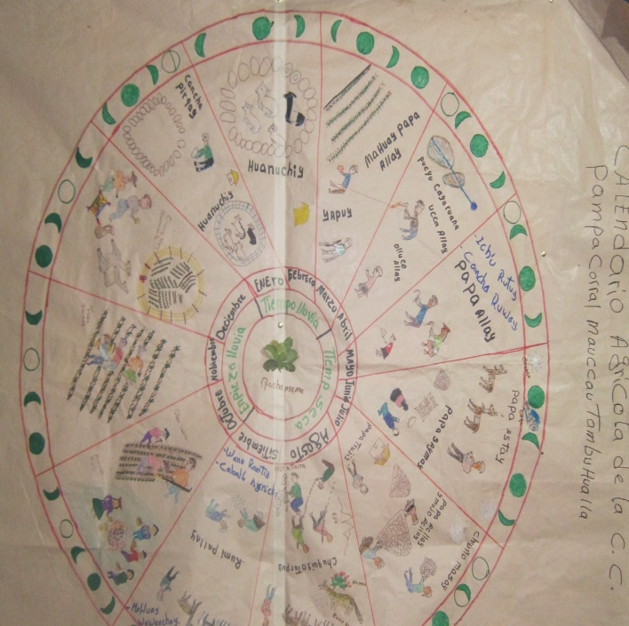
Figure 3: Inca agricultural calendar, Photo: Mariaelena Huambachano
A participant from Iran shared that Indigenous concepts of the future are influenced by proverbs and oral wisdom through a lens of accountability, environmental stewardship, and spiritual interconnectedness, for example, “He who sows the wind shall reap the storm”:
«هرکه باد بکارد، طوفان درو می‌کند»
This phrase aims to remind people of the long-term consequences of actions and is often cited in conversations about intergenerational justice and sustainability. On the other hand, another example, “This too shall pass”:
«این نیز بگذرد»
This is a poetic way of maintaining resilience, patience and faith, especially during environmental or political hardship.
A participant from North Macedonia explained that concepts of the future can be understood through traditional embroidery, where geometric symbols, such as the triangle and the circle, carry deep cultural meaning, reflecting the cycles of nature and life. The patterns also echo the ancient Macedonian sun with its sixteen rays, symbolizing continuity and the connection between past, present and future. Through such art, local knowledge, understanding and visions of the future are abstractly reflected in cultural expression. These motifs embody harmony between the spiritual, ecological and social worlds, offering a vision of the future rooted in balance and resilience. She also referred to the Great Mother, a Neolithic figure from Macedonia dating back more than 8,000 years, which embodies fertility, wisdom and balance between humans and nature, reminding communities to remain rooted in the Earth while being open to the future.
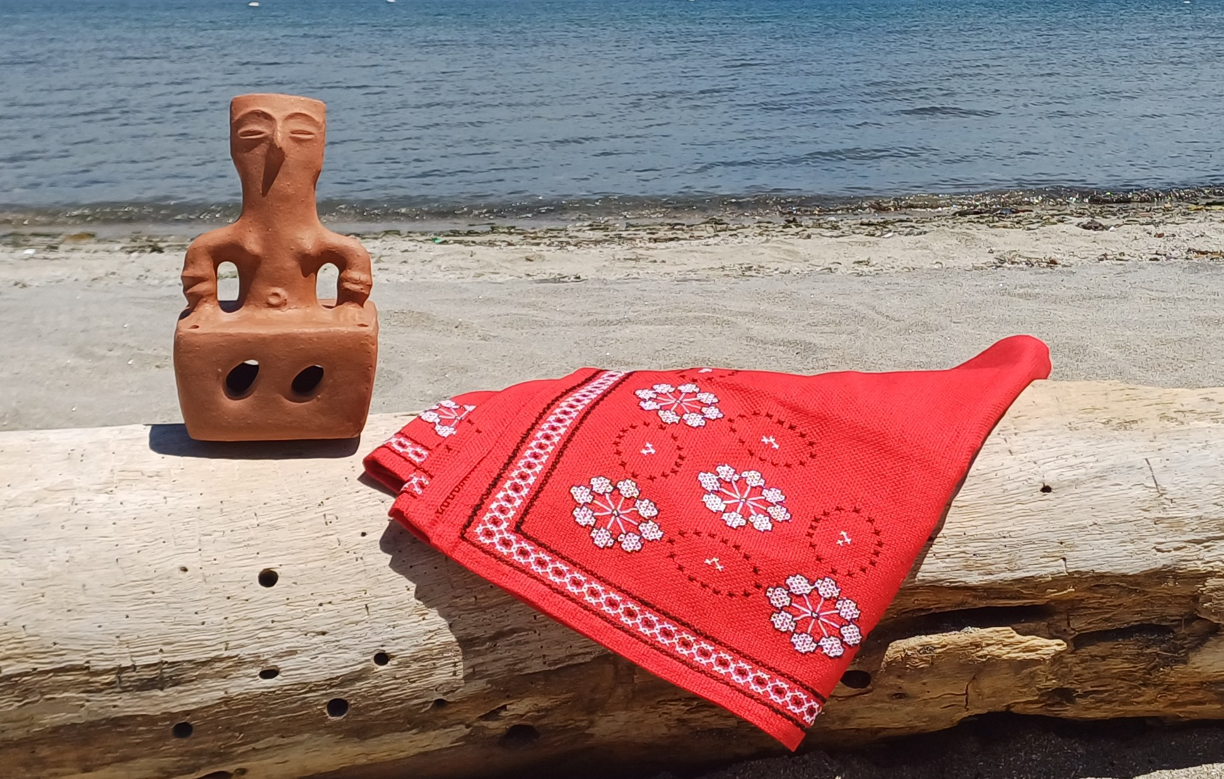
Figure 4: Embroidery and a figurine of the Great Mother from North Macedonia
A participant from Malawi explained that, in the Khulubvi Forest, the concept of the future is closely tied to the health of forests and ancestral practices; the forest is a living archive of tradition and prophecy.
A participant from Trinidad and Tobago explained cultural idioms, such as “jus now” and “now now”, and how they reveal nuanced temporal understandings. These terms reflect urgency, flexibility, and social expectation but do not prioritize formalized planning structures.
A participant from Russia shared that, in some Indigenous communities in Siberia, mythological and cosmological symbols guide communal visioning and governance. Elders play a central role in sustaining cultural memory and transmitting strategic insights. Oral storytelling and sacred artifacts are used as planning tools, and community rituals align human activity with spiritual beliefs. Community strategies and plans emphasize continuity and respect for ancient ways of knowing. Also, they use a special term “phylla” which indicates a better future and is used by the community when they start to plan for the future.
A participant from Uganda explained how some pastoralist communities read moon phases, ant behavior and animal intestines to forecast the weather and agricultural conditions.
A participant from New Zealand (Aotearoa) shared a proverb “Ka mua, ka muri” (I walk backwards into the future), which demonstrates Māori perspectives of time and planning scenarios for the future, as the past, present and future are interconnected. Time is circular and looking to the past is important for understanding the present and to make informed decisions for Indigenous and ecosystem futures. Elaborating further, she also reiterated the importance of engaging youth in future planning scenarios.

Ways of thinking about the future
Participants also discussed different ways that Indigenous Peoples and local communities may be thinking about the future or engaging in futures thinking.
Participants emphasized that many communities are always thinking about the future, including through:
- Cultural continuity and future generations: Many participants shared the importance of intergenerational knowledge transfer to sustain communities and cultures. The role of elders, youth and especially women in maintaining this continuity was noted throughout the discussions.
- Adaptation and future resilience: Participants highlighted that ensuring future resilience is a key concern for many communities, through adaptation, innovation and learning from the past, including past disasters and changes. Many communities are thinking through how to shape their adaptive responses to climate and biodiversity challenges, as well as colonialism and other impacts on their lives.
- Food security and sovereignty: Participants highlighted that many communities are thinking about and planning for the future due to concerns about future food security and food sovereignty, for example, in Peru (see example below).
Example
Quechua communities in the region of Lares, Peru, are practicing women-centered health and agricultural practices. This effort includes a “seed re-matriation” project to revitalise traditional crops and resist genetically modified organisms, with a focus on adaptative and restorative strategies and planning for future uncertainties and shocks.
- Water scarcity and security: Some participants highlighted how some communities are managing and planning around water, including in the Philippines near Subic Bay, where Aeta communities are protecting crucial headwaters (see example in section 3.3.1 above), and in Iran, where communities face intense water scarcity (see example below).
Example
Communities in Iran employ qanat water cooperatives for sustainable irrigation, relying on seasonal migration, and observing natural signs such as ant behavior and sheep fertility ratios to forecast weather. They practice collective thinking and resilience rooted in dryland farming, water governance, and traditional adaptation to scarcity.
As an example, Qanats, originating in Iran around 1000 BC, are an ancient water management system. These underground channels, also known as karez or kāriz, have been used for thousands of years to bring water from underground sources to the surface for irrigation and domestic use, particularly in arid regions. Qanats can be taken to symbolize Iran's traditional methods of dealing with drought and represents the accumulated knowledge passed down through generations regarding water management. The qanats’ structure, maintenance and geographical distribution show their significance in Iran's history. The expertise required to build and maintain these systems highlights their sophisticated design.

Prediction and planning
Participants also highlighted that many communities engage in planning and prediction, often based on in-depth knowledge of the past and ongoing observation and land-based monitoring of animal and plant behaviours, seasonal cycles and weather patterns.
Examples
In Khorasan and other dryland regions of Iran, communities have historically engaged in future-oriented planning through:
- Water cooperatives (known as qanat councils) where users collaborate to manage water fairly and sustainably;
- Pastoral nomads’ seasonal migration routes, which reflect deep ecological memory and adaptive decision-making under changing conditions;
- Traditional rituals, such as the Baran Khani (praying for rain), where spiritual belief, climate perception, and collective hope converge.
A participant also gave examples that had been shared with him by members of the nomadic communities of northeastern Iran, particularly from the Abolhasani and Sangasari tribes, who inhabit the Khar Turan Biosphere Reserve – a region of rich ecological and cultural diversity. These communities have developed sophisticated, experience-based methods for forecasting climate conditions through careful observation of animal behavior, interspecies relationships and ecological cues. Some examples include:
Short-term weather prediction (originally provided by Mr. Salehi, Abolhasani Tribe): Nomads observe the behavior of their livestock, especially sheep, at sunset. If the animals resist entering the pen and take every chance to graze, it suggests poor weather for the following day. The animals instinctively sense scarcity and attempt to eat as much as possible. If they enter calmly, it indicates that the weather will likely remain favorable.
Annual rainfall prediction (originally provided by Mr. Salehi, Abolhasani Tribe): During their summer migration to the highlands, nomads observe the sleeping patterns of domestic and wild animals. When animals sleep peacefully in one spot, it is seen as a sign of a wet year ahead. Restlessness or constant movement during the night is interpreted as an omen of drought.
Winter severity prediction (originally provided by Mr. Alamdari, Sangasari Tribe): The nomads watch ant behavior in the summer. High activity and food gathering by ants indicate an approaching harsh winter with likely snowfall. Less activity signals a milder season.
Predicting wet vs. dry years (originally provided by Mr. Alamdari, Sangasari Tribe): One method is observing the ratio of male to female lambs born in a season. A higher number of male lambs is thought to predict a wet year, while a higher number of females suggests an upcoming dry year. The logic stems from an instinctive response in animals to environmental stress, favoring female offspring to ensure species survival during droughts.
Agroecological practice (originally provided by Mr. Alamdari, Sangasari Tribe): When a walnut tree bears little or no fruit, gardeners sometimes symbolically threaten the tree or make minor cuts into its trunk. This traditional practice, especially common with young trees, is believed to stimulate fruiting by triggering the tree’s survival mechanisms. Rooted in local knowledge, this method may also have biochemical explanations.

Benefits of ILK approaches for futures thinking
Participants emphasized that these ways of understanding and managing the future are crucial for Indigenous Peoples and local communities and have proven positive impacts on biodiversity conservation and human wellbeing. Local examples from Iran, Uganda, and Canada also show traditional forecasting is not only viable but essential for ecological adaptation and resilience.
They noted that Indigenous Peoples and local communities have long engaged in future scenario-building, rooted in their cultural values and traditional knowledge. These visions offer important pathways that should be incorporated into broader environmental assessments and planning processes. Community narratives are also a powerful foundation for creating relevant and culturally grounded future scenarios. Indigenous perspectives on time, as cyclical and interwoven, can also challenge and inform linear models, often used in scientific futures work. Bridging these knowledge systems offers an opportunity for enhancing the development of pluralistic scenarios. ILK also often holds descriptions of past ecological states and environmental and cultural changes, and these grounded, place-based experiences can be essential for looking to the future.
Participants highlighted that ways of knowing and learning within ILK systems, such as experience on the land, storytelling, art-based practices, community conservation (which can be reported in case studies), rituals and local monitoring provide rich insights into human-nature relationships, spiritual values and long-term environmental change.
They also noted that standard scenario models often use 2030, 2050 or 2090 timelines, while Indigenous approaches emphasize multi-generational visions – often planning 500 years into the future or for the next seven generations.

Challenges to ILK futures thinking
Participants emphasized that there are many overlapping threats to Indigenous and local knowledge, and Indigenous ways of thinking about, predicting and managing for the future. These include loss of biodiversity and cultural practices due to industrial development, including renewable energy, monocultures, spread of invasive and alien species, climate change, displacement and harassment of communities and environmental defenders. They also noted that, with social changes, many children and youth do not hold the same knowledge that previous generations did, as schools and new technologies take over from traditional ways of learning and knowing. Declines in languages that underpin ILK systems are also a serious threat to knowledge and culture. Participants also noted the research agendas and methods imposed on communities from outside can also serve to undermine and change their knowledge systems, so poorly implemented research is a threat in itself.
Examples
A participant from Uganda explained that his community has long relied on traditional knowledge to predict weather and make decisions, including interpreting the behaviour of goats and cows or the flowering of mangoes. However, the introduction of improved breeds and crops is disrupting these indicators. Development pressures, including oil and mineral extraction, also threaten to displace communities from their traditional lands.
A participant from Canada explained that climate change is impacting community knowledge systems and livelihoods. Trees are dying as their roots rot; lakes are filling with algae; and species, including fish, are disappearing, which disrupts fishers’ livelihoods and knowledge systems.
Participants noted that new or newly arrived religious movements, for example Christianity, often forbid rituals and offerings, undermining traditional ecological knowledge. They highlighted violence in countries in Latin America, where traditional healers have been targeted by newer religious sects. Another participant explained that, in some Asian countries, some people fear to practice shamanism due to conflict with dominant religions.
Other participants also reflected on how people from different cultures increasingly arrive into lands of Indigenous Peoples and local communities, due to globalization and other processes. Within this, it is important to recognize the rights of Indigenous Peoples, and the rights of those local communities who have historical connections to these places, while also finding ways to work with everyone to protect and manage the environment.
Participants also noted, however, that, in today’s world, many external or outside factors from local, national and global levels impact communities, and communities are part of countries that have their own governance systems. It can therefore be necessary to engage in translation and communication of ILK, which can require new methods and ways of representing knowledge so that some ILK can be better understood by others, for example, researchers and governments.
Example – challenges for the Aeta
The Aeta of Bataan used to roam through the mountains, but they are gradually finding themselves in settlements beside the mountains. They have been assigned into settlement areas, and schools and health centres have been provided near their communities.
Previously, the community was relocated without free, prior and informed consent (FPIC). However, the community resisted marginalization through continued spiritual, legal and cultural assertion. The community successfully obtained a Certificate of Ancestral Domain Title covering 12,000+ hectares, despite historic displacements in the 1980s. This title provides partial recognition, but overlapping legal frameworks (e.g., national parks, military land conversion laws) undermine Indigenous control and lead to uncertainty among the Aeta people regarding their rights. The community maintains that the native title is pre-existing and sovereign.
Participants cited the Joint Management Agreement with Pastolan Aeta and the Subic Bay Metropolitan Authority as a model of co-governance, involving shared responsibilities and benefits, including from renewable energy installations.
Aeta lands are under increasing pressure from commercial and infrastructure projects, including from the Subic Bay Metropolitan Authority and Bataan Techno Park and land encroachment. Despite the Certificate of Ancestral Domain Title recognition, these areas overlap with national park designations and development zones, which create governance conflicts. For example, there is tension between the national parks’ concept of a protected area, as a “no-touch” zone where nothing can be taken or used, and the Aeta conceptualization, which allows water and other resources to be used in a wise manner, at sustainable levels, recognizing that people are part of nature.
The Aeta’s role in protecting and managing an important watershed which provides water for downstream communities is also not recognized, so the community does not receive benefits from this important contribution to the wellbeing of the area.
Invasive species are also a threat to the forest and the activities of the Aeta, including challenges from historical planting on non-native trees, which affect the water table.
Infrastructure gaps, limited public services, and the lack of a local economy are a further challenge for the long-term well-being of the Aeta community. This is causing out-migration among youth and men for better life and opportunities.
Youth interest in culture and knowledge is also waning due to changes in aspirations, digital distractions, urban proximity and migration, as well as education systems not tailored to Indigenous identity, prompting concerns about cultural erosion. However, elders take the youth with them during activities in the forest, and organize youth camps, forest retreats and ritual apprenticeships. Nonetheless, generational gaps and external influences remain a key concern for long-term cultural resilience.

Opportunities for co-production of scenarios and visioning
Participants highlighted that many Indigenous Peoples and local communities see value in co-production and co-creation of research, including work on scenarios. There are Indigenous concepts that support this type of interaction and collaboration, including the double-hulled waka (parallel canoes) metaphor from -New Zealand (Aotearoa), which shows how science and ILK systems can proceed together and strengthen each other. The concept of “two-eyed seeing” or “three eyed seeing” from Canada (see below) also shows how Indigenous Peoples and local communities and non-Indigenous scientific researchers can enhance their understanding by using both systems of knowledge. Participants also noted that there are members of Indigenous Peoples and local communities who are trained in “western” science, so they may bridge both ways of knowing.
Participants noted that a key factor in co-creation and co-production can be who is leading the project or research. In this section below, co-production led by Indigenous Peoples is considered separately from co-production led by outside scientists or other researchers. It is, however, noted that often there is not a clear distinction between these two sub-categories, and that Indigenous leadership and participation between different projects is often more of a gradient than a fixed category.

Indigenous-led research and co-production of scenarios and visioning
Participants shared that, in many cases, Indigenous Peoples and local communities are leading research projects around futures or planning. These are taking place at different scales, including local, national and global.
Often, Indigenous Peoples and local communities engage in diverse methods for working with ILK, including Indigenous research methodologies such as storytelling, oral traditions and land-based monitoring. Increasingly, these may also include methodologies and approaches from science, including mapping and GIS, or some data or information from science that supports the work with ILK systems. Regardless of the methods or information used, these projects and processes are grounded in community worldviews, values and goals. Indigenous Peoples and local communities also ensure that all methods and information used resonate with Indigenous and local community ways of acquiring, sharing and disseminating knowledge. As such, these experiences are good examples of co-production and co-creation between knowledge systems.
Participants shared different examples, as discussed below, organized by different scales.

Local level
Participants highlighted that a wide diversity of projects and initiatives are taking place at the local level, but these are not usually recognized or known as they may not be documented in scientific literature, or there may be little communication and outreach beyond community-levels. Understanding this diversity can be crucial for gaining a more global understanding of futures thinking and the potential for work with scenarios that include ILK.
Examples
A participant from Taiwan, Province of China, introduced her experiences with ‘future-scaping’ co-visioning workshops as a tool for co-creating a mid-term compass for an integrated landscape-seascape approach (ILSA) in the Xinshe Village, Hualien County. The Xinshe ILSA is a long-term multi-stakeholder approach (2016 to 2026) that brings together two Indigenous communities (Amis and Kavalan), four government agencies, a local primary school, and a university (facilitator) for the social-ecological revitalisation of the Xinshe landscape and seascape. Its action plan focuses on five key perspectives: ecosystem health, sustainable resource use, Indigenous knowledge and innovation, multi-stakeholder governance, and local livelihoods. Through a series of ‘future-scaping’ workshops in 2021-2022, the two communities discussed the following questions: ‘Where do we want to be in 2026 (at the end of the Xinshe ILSA in December 2026) and 2050 (a longer-term horizon of living in harmony with nature)?’ and ‘How do we get there?’ Following this co-visioning exercise and working in partnership with other stakeholders (expert knowledge holders), they co-translated these visions into 19 locally grounded and actionable priorities of the mid-term action plan (2023-2026). The action plan is currently operationalized through a division of responsibilities, engagement of new collaborating partners and regular multi-stakeholder platform meetings. The Xinshe ILSA has become a model for community-driven scenario planning. Its experience is scaled out to other communities across the island.
A participant from Uganda shared insights from his experience with natural resource monitoring in pastoralist regions. He noted that, while areas rich in critical resources, such as minerals, have been mapped at the national level, this information is often not accessible to local communities. He discussed how Indigenous land use conflicts and environmental pressures are not always understood by the government. He recommended that the mapping process should be effectively communicated to local communities and that national strategies be aligned with local needs through active engagement in community-led workshops.
A participant from Mexico explained that some Indigenous communities are using land-use planning and biocultural community protocols to guide their future. These protocols are created by communities to define how they relate to their land and how they want to engage with outsiders. They may include rules and guidance that aim to establish more equitable relationships with outside governments, businesses and researchers, and to ensure the recognition of and respect for Indigenous rights, such as free, prior and informed consent. The approach is based on cultural values, traditional governance, and respect for nature. The protocols may also include a vision for the community, founded in community values and governance and developed through a participatory process. For example, a vision for the year 2050 in one community includes restored ecosystems, community-run mezcal production, revitalized language and culture, and sustainable tourism. The process empowers communities to manage their resources while asserting their rights. Methods include: community outreach, training and review; organization of community assemblies and meetings; selection of the Community Project Support Team (i.e., committee); collection, analysis, validation and systematization of information; capacity-building of the community team (e.g., on biodiversity, Indigenous rights, and biocultural approach); community research about genetic resources and associated traditional knowledge; formulation of the general proposal, based on the content of the biocultural protocol; development and integration of the protocol; systematization of information and validation of the proposal and the Biocultural Protocol; submission into the Access and Benefit-sharing Clearing-House, where biocultural protocols and other similar documents can be stored to enhance transparency; and promotion of these documents.
Also, in Mexico, community life plans are utilized to support Indigenous governance and scenario building from the community level. These plans reflect collective visions grounded in cultural and ecological values.
A participant from Thailand shared the example of rotational farming networks that enable communities to engage with external partners while maintaining decision-making authority. These spaces serve as venues for knowledge exchange, community pride and continuity of traditional practices.
A participant from Iran explained that, in recent years, local NGOs and elders have worked together to integrate Indigenous knowledge into watershed planning, climate adaptation strategies and youth education, aiming to ensure cultural continuity while engaging with modern tools, including remote sensing and participatory GIS. They have also worked to combine traditional forecasts with scientific tools, such as GIS mapping.
A participant explained that, in the Khulubvi Forest of Malawi, knowledge is increasingly preserved and shared through collaborative dialogue between local elders and researchers, which aims to ensure both conservation and education. Participatory mapping is also used to document Indigenous knowledge of the area.

National level
Participants noted that, increasingly, Indigenous Peoples and local communities are collaborating and leading projects at the national level, particularly when the aim is to influence or engage with their national governments so that they can build common positions or understand the diverse situations and aspirations of communities across the country. These projects help to demonstrate ways in which ILK, which is sometimes seen to only have relevance at local levels, can, with care, be scaled up to national levels.
Methods included:
- Widescale consultations, capacity-building and documentation of knowledge with communities (see the example below from the Philippines);
- Decoding of ancestral knowledge from diverse sources to find common principles and visions of living well (see the example below from Bolivia); and
- Storymaps which document diverse local observations on a large-scale map alongside climate science (see the example below from Saami lands).
Participants noted that there is a balance between finding ways to bring out common concepts, trends and ideas whilst also recognising local level diversity and that some knowledge may not be scaled up or taken beyond its context.
Examples
A participant from the Philippines explained the goals and process of the Indigenous Peoples’ Biodiversity Strategy & Action Plan (IPBSAP). The IPBSAP is a document developed by several Indigenous groups in the Philippines, which is intended to influence and complement the national targets of the government’s Philippine Biodiversity Strategy and Action Plan (PBSAP). The IPBSAP aims to ensure that Indigenous Peoples’ views and concerns are considered in the formulation and implementation of the PBSAP. It also aims to respond to the Kunming-Montreal Global Biodiversity framework (KMGBF), and to ensure that the KMGBF’s particular targets and provisions related to Indigenous Peoples are considered in the Philippines. It outlines the contributions and activities of Indigenous Peoples towards reaching those targets, such as biodiversity conservation, traditional governance, knowledge systems and community-based monitoring. It also reviews the status of biodiversity on Indigenous Peoples territories. This aims to ensure that Indigenous Peoples’ initiatives and activities can be accounted for and reported towards meeting the 2030 and 2040 targets, as well as 2050 goals.
The IPBSAP gives a summary of the relevant policy, governance and financing landscape, and sets out a future orientated action plan in line with the 23 targets of the KMGBF, and guidance from Indigenous Peoples for future biodiversity action in the Philippines. It also highlights the importance of rights, including free, prior and informed consent, community-based documentation, research, monitoring and information systems, and protection of environmental defenders. It is the result of an Indigenous-led consultation process initiated by Indigenous organizations, supported by other NGOs, which formed a group called the Indigenous Peoples and Biodiversity Coalition Philippines. The coalition convened at least 30 organizations, led capacity-building activities to enhance understanding of the KMGBF and the NBSAP, and ran national and regional roundtables to bring Indigenous Peoples together to discuss the development of the document.
Next steps include ongoing localization and validation, continued policy advocacy on the PBSAP, implementation of Indigenous-led conservation and sustainable use, community-based monitoring and information systems to track progress towards goals and targets, reporting through collecting case studies and resource generation for implementation and monitoring.
Participants from the Philippines also shared information about the Ancestral Domain Sustainable Development and Protection Plan (ADSDPP), which is a government-recognized, community-level planning instrument designed to safeguard ancestral domains. Ideally, it is community-owned, -led and -validated, with data derived from local knowledge systems. Its effective implementation relies on:
- Strong community leadership and internal capacity;
- Sufficient time and funding;
- Use of cultural elements, such as storytelling, seasonal calendars, rituals, omens, and dreams;
- Integration of practical tools, including systems analysis and problem trees.
Youth and elders both play vital roles; youth are engaged through visioning exercises and art-based methods while elders ground the process in tradition and experience.
Along with the IPBSAP process, the Philippine examples revealed a rich diversity of methodologies that blend Indigenous and scientific approaches. Key strengths include:
- Deep cultural grounding and long-term perspective;
- Emphasis on community agency and sovereignty;
- Integration of spiritual, ecological and practical knowledge.
However, challenges persist. The risk of co-optation by government agencies is significant, particularly when facilitators lack cultural competence or seek to dominate the process. Additionally, conflicts between customary laws and state policies, limited legal recognition, loss of language and cultural continuity and insufficient enforcement undermine the impact of Indigenous-led planning.
A participant from North Macedonia described participatory methods that have been used in the country, which aim to form a bottom-up and landscape-based approach to managing protected areas. These methods included community mapping, companion modeling, questionnaires, joint visioning, and collaborative work with elders, school students and community members. Open discussions, forums and fairs also facilitate knowledge exchange on traditional fruit and crop varieties, stock-breeding, local products, recipes and traditional crafts. They support documentation, co-creation and local empowerment.
A participant from Bolivia presented the national approach to biodiversity called “Living Well” (Vivir Bien), which centres Mother Earth in all aspects of life. This approach challenges western, human-centred views and promotes harmony between people and nature. The wisdom of Living Well is protected in languages, textiles, ceremonies, dances, sciences, myths and sacred places, but there may need to be a process of decoding and revitalization of what was lost or hidden as a result of colonialism and capitalism.
Mother Earth-Centric Actions are “cosmobiocentric” and rights-based approaches, embedded in the concept of Living Well in balance and harmony with Mother Earth, promoting the continuity of all living beings and their communities and ensuring the non-commodification of environmental functions of Mother Earth. Mother Earth-Centric Actions are based on the sciences, epistemologies and knowledge of Indigenous Peoples and local communities, inherited from ancestors, which can act as the basis to establish a new life path for the whole of humanity.
The most important Mother Earth-Centric Actions are the following:
- Recognition of Mother Earth as a living being and subject of law;
- Development of policy instruments for protecting, managing and restoring nature without the commodification of its environmental functions;
- Integration of cosmobiocentric approaches of Living Well in balance and harmony with Mother Earth in countries’ policies, programs and projects;
- Facilitate the epistemological parity between the western-world modern science and the eastern-world ancestral science, strengthening inter-scientific dialogue among them;
- Promotion of economic growth along with mechanisms of reciprocity for wealth redistribution, avoiding individual economic accumulation and inequities;
- Development of educational processes related to living well in harmony with Mother Earth;
- Interventions for the promotion of respect to all forms of life in the planet, avoiding artificial and synthetic life and transhumanism;
- Promotion of peoples and nature’s communities of life for the peaceful coexistence of all living beings in the totality of Mother Earth;
- Implementation of actions for strengthening the role of Indigenous Peoples and local communities, women, girls and youth in the fulfilment of the objectives of the Convention on Biological Diversity;
- Implementation of joint mitigation and adaptation actions linked to sustainable development and poverty eradication, contemplating equity, common but differentiated responsibilities and non-market approaches to address climate crisis;
- Promotion of sustainable patterns of consumption and production, being aware of the limits of Mother Earth;
- Development of jurisdictional, integrated and socioecological approaches for the management of ecosystems, including protection of environmental functions, sustainable production systems and eradication of poverty;
- Enhancement of Indigenous Peoples and local communities’ participation in the management of systems of life and ecosystems, recognizing social, economic, juridic, political and cultural plurality, among other aspects.
The codes of living well in harmony with Mother Earth are also encoded in the colours of the Wiphala flag:
- White: The order of the cosmos and of the natural world, which has a critical structure of complementary between opposite pairs;
- Green: Mother Earth and Nature are living beings with consciousness;
- Blue: The energy of coexistence of life is composed of networks of material and spiritual energy;
- Purple: The organization of communities is essential for the upbringing of life systems;
- Red: The multiverse is an organic and harmonious totality;
- Orange: Life is the meaning of everything, it is the beginning and the end;
- Yellow: The support of the whole is the dialogue between nature, human society and extra-human society.

Figure 5: the Wiphala flag

Regional / global
Participants also discussed regional and global-scale projects led by Indigenous Peoples, which further demonstrate methods for working with ILK at larger scales.
Example
A participant presented key insights from Local Biodiversity Outlooks 2, a project and publication that presents the perspectives and experiences of Indigenous Peoples and local communities on the current social-ecological crisis and their contributions to the Convention on Biological Diversity and the Sustainable Development Goals. As part of this work, the second edition of the Local Biodiversity Outlooks explores six key transitions in the section Transitions Toward Living in Harmony with Nature that were developed through an analysis of multiple case studies and visions of Indigenous Peoples and local communities from across the world to draw out key synergies and themes. The six key transitions proposed by Indigenous Peoples and local communities are:
- Cultural transitions: Embracing diverse ways of knowing and being within a sacred living world;
- Land transitions: Securing customary land tenure for wellbeing and biodiversity resilience;
- Governance transitions: Enabling inclusive and self-determined decision-making structures;
- Financial transitions: Ending harmful incentives and valuing culture-based solutions;
- Economic transitions: Supporting local economies rooted in sustainability;
- Food transitions: Revitalizing Indigenous food systems to support health and biodiversity.
These transitions reflect intergenerational visions and emphasize the importance of walking forward with ancestral wisdom to co-create resilient futures.
The thinking around futures for this project also included the development of a problem tree and a solution tree (see figures 6 and 7 below), which help to set out the main challenges from the perspectives and experiences of Indigenous Peoples and local communities, and the solutions that need to be created.

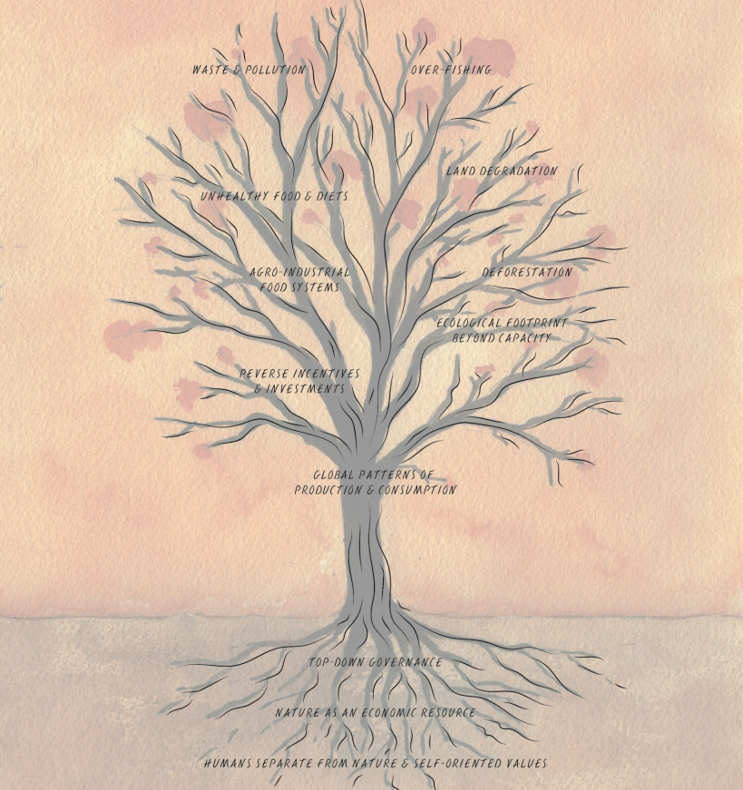
Figure 6: Problem tree from the Local Biodiversity Outlooks 2 (Section IV: Transitions towards living in harmony with nature).

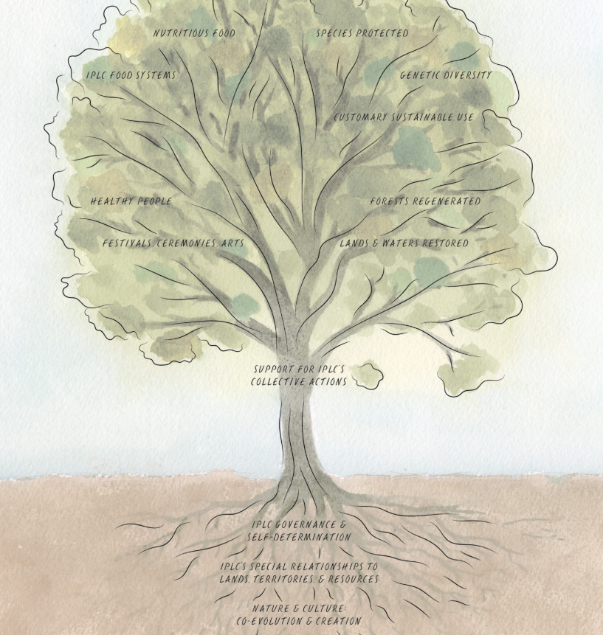
Figure 7: Solution tree from the Global Biodiversity Outlooks 2 (Section V: IPLC contributions to the 2050 vision).
During the workshop, the Spanish-speaking breakout group, which was predominantly comprised of participants from Latin America, also developed a sketch of different scenarios, ranging from positive scenarios, including creative adaptation with communities with strong economies and ecosystem preservation capacities, to negative scenarios, including loss of identity and ecological disconnection, weak preservation efforts and erosion of cultural connections. These scenarios were based on internal factors, including cultural preservation, local medicine, food security, and external factors, such as market, technology, and policy. The axis included economic sustainability vs. social-cultural-environmental sustainability. They also noted that there may be mixed scenarios, with variations in financial and ecological indicators, showing the need for balance. This also serves as a demonstration of how Indigenous Peoples can work together, in this case from across a region, to develop scenarios at different scales.
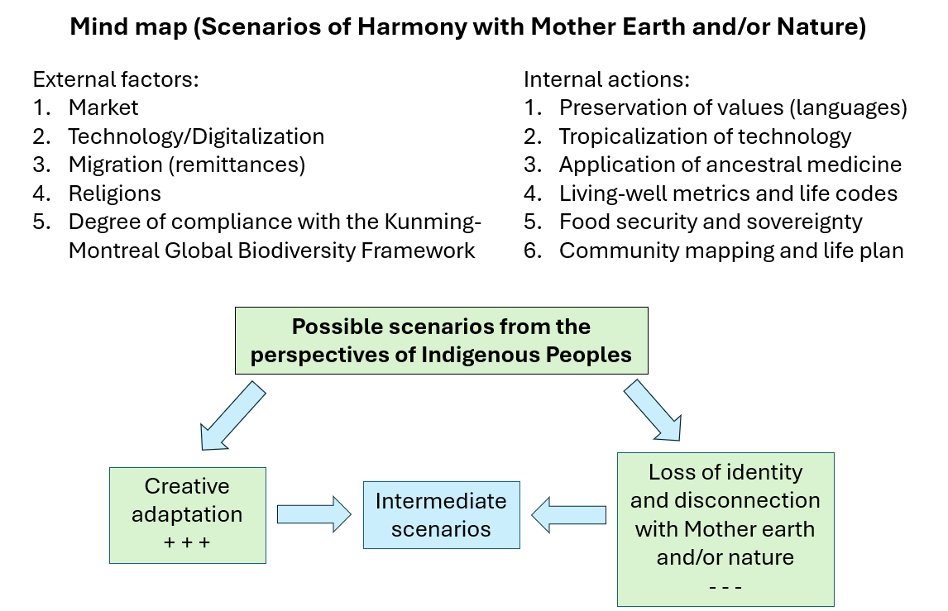
Figure 8: Sketch of scenarios for Indigenous Peoples by the Latin America breakout group.

Benefits and strengths
Participants highlighted that Indigenous-led projects can be a good way to ensure that communities are in control of the projects, and are able to ensure that methods, goals and results are serving community needs. As such, they may be good examples of co-production and co-creation between knowledge systems, as different methods and concepts may be used from across both knowledge systems.
These types of Indigenous-led projects may be effective in communicating and explaining ILK and community goals, aspirations and challenges to outside audiences, including governments and researchers, so a mix of methods becomes important for documentation, translation and communication.
Participants also noted that these projects can support community cohesion or planning. They can help to strengthen links between elders and youth, as both play vital roles. For example, youth can be engaged through visioning exercises and art-based methods and may have experience with different research methods, while elders ground the process in tradition and experience and ILK.
Participants also noted that local scenarios created from these types of projects, although diverse, reveal shared challenges and commonalities between worldviews across many Indigenous contexts. These can serve as foundations for building global Indigenous scenarios, as discussed above. This process of bringing together local scenarios and other projects that reflect on the future can ensure the visibility of diverse perspectives in global assessments, including those of IPBES.

Challenges
Participants highlighted that, while Indigenous-led projects may meet community goals and align with ILK systems, they may, in some cases, struggle to connect with broader scientific or political processes due to a lack of respect, acceptance or attention given in those processes to community-based research and governance or ILK systems more broadly.
Funding can also be a key issue for many community-led initiatives as many communities do not have the internal resources to support a large research project and external resources can be difficult to find. Participants noted a significant difference in funding given to science versus Indigenous-led activities.
Participants also noted that the challenges and risks to ILK systems discussed above, including declines in biodiversity and negative impacts on cultural practices, pose challenges and risks for Indigenous-led projects.
Additionally, conflicts between customary laws and state policies, limited legal recognition, and insufficient enforcement of laws that can support Indigenous-led implementation of findings can undermine the impact of Indigenous-led activities.

Co-production between non-Indigenous scientists and Indigenous Peoples and local communities
Participants discussed examples and lessons from the ways that Indigenous Peoples and local communities are co-producing knowledge in collaboration with other researchers or organizations. They noted that there are successful examples. However, they also noted that there is a strong risk of co-option or misinterpretation of knowledge during these processes, or that ILK is only used superficially as a source of information, rather than as a foundational framework. Power imbalances between ILK and science, and between Indigenous Peoples and scientists can be a source of these issues.

Examples from the local and national levels
A participant from the Saami Council emphasized the role of the Saami Council as a transnational organization that represents Sámi people across Norway, Sweden, Finland and the Kola Peninsula in Russia. She shared that the Council engages in protecting Saami rights, culture, languages and traditional knowledge. In the context of biodiversity and environmental governance, the Saami Council has worked to ensure that Indigenous worldviews and knowledge systems are included in decision-making at national and international levels. She highlighted the importance of self-determined futures, noting that Saami communities want to shape scenarios based on their own values, relationships with the land, and cultural continuity. She emphasized that Saami perspectives challenge dominant Western scientific frameworks by centering relational knowledge, seasonal cycles and responsibility to future generations. She also pointed out that the Saami are not only stakeholders but rights-holders, and this distinction is key in how they engage with scenario processes. Following this, she shared a project “Our land is different now”, which aims for co-production between science and ILK around climate change, including combining past and future trends of weather, snow and ice cover with Saami observations of conditions on-the-ground, including animal behaviour and impacts on livelihoods. This project has shown how ILK from across a large area can be represented in a storymap alongside maps and other data from climate scientists, showing climate impacts, to the benefit of both systems of knowledge. This project has shown advantages for climate science as it allows better understanding of changes on the ground and how these impact livelihoods. It also shows benefits for Saami, as some aspects of the projected climate futures are not within the realm of lived experience, for example, new highs in temperatures, and therefore ILK systems may need added support to manage them.
A participant from Indonesia reflected on three decades of participatory action research among Indigenous Peoples in an island outpost of Indonesia, emphasizing the key role of ILK in conservation. In a peer-to-peer strategy based on respect, the work reconstituted cultural heritage, defended sacred forests, such as Mbumbu, and secured tenure rights. Families established conservation sites, including Kokolomboi, Komba-komba, Meselesek, and Lalengan, restored habitats from local seeds and facilitated citizen science through biodiversity records, such as the Banggai Crow Corvus unicolor and Peleng Tarsier Tarsius pelengensis. Government recognition further supported these efforts, however, volunteerism and spirituality sustained community motivation, leading to a call for official recognition and compensation for Indigenous contributors.
A participant from the United Kingdom discussed projects focused on ecosystem services and natural capital, stressing the importance of including local perspectives in environmental planning. He shared examples from participatory agricultural projects in African countries that support small-scale farmers, advocating for the broader application of successful grassroots practices.
A participant from Malawi described how national-level ecosystem assessments can be avenues to explore the connections between biodiversity and ILK, as has been the case in Malawi, where extensive work has taken place to work with communities across the country to understand their perspectives, challenges, management systems and governance relating to biodiversity. She stressed that engagement must be genuine and go beyond token consultation. She advocated for building ILK into baselines, strategy development, and scenario frameworks, while ensuring these are mainstreamed across all planning processes.
A participant from North Macedonia shared that efforts are being made there to bridge local knowledge with conservation science, emphasizing the role of women and spiritual values in sustainability. Communities are being engaged in freshwater conservation efforts and pastoralist knowledge is being integrated into national conservation planning. She urged alignment with international biodiversity goals like those from the Convention on Biological Diversity, and highlighted the need to involve communities in a respectful and meaningful way during planning processes.
A participant outlined a strategic plan to integrate ILK into biodiversity conservation policy in Trinidad and Tobago through a structured national outlook. He explained that existing biodiversity strategies often overlook ILK and this plan aims to bridge this gap. It includes a stepwise process for working with ILK:
- Literature review and ILK gap analysis;
- Community consultations with diverse groups (e.g., Merikins, Rada, Orisa, Hindus, First Peoples);
- A national dialogue hosted at Banwari Trace Archaeological Site;
- Review of existing legislation (e.g., Wildlife, Forestry, Fisheries Acts);
- Multi-stakeholder policy dialogues involving ministries, agencies, and Indigenous Peoples and local communities; and
- Capacity-building workshops and GIS-based mapping of ILK biodiversity sites.
The desired outcome is the development of inclusive ILK policy recommendations, establishment of a comprehensive ILK database, and enhanced recognition of ILK as a key component of natural heritage and biodiversity management. At present, however, the project is still searching for funding.
A participant from Uganda shared some local co-production initiatives including a UNESCO-supported project for linking Indigenous and scientific knowledge and building community-driven models for co-producing data on weather and seasonal changes.
A participant from French Polynesia shared that the current rapid global changes may bring challenges for some ILK, in that some traditional observations, rules or empirical laws might not be valid anymore. As such, Indigenous Peoples may also need conventional science and tools to better anticipate and deal with these rapid changes. For example, in French Polynesia and Cook Islands, rapid proliferation of Taramea (crown-of-thorns starfish) impacted the coral reefs and as a result, the local small fisheries. There are now projects that combine environmental modeling with local knowledge to better anticipate the appearance of the Taramea within the lagoons.

Examples from regional and global levels
A member of the IPBES task force on scenarios and models presented outcomes from the IPBES online visioning workshops that took place in 2021. The workshops had three sessions: for Africa; Asia and the Pacific; and the Americas, which focused on building qualitative regional-scale visions and scenarios with Indigenous Peoples and local communities. There was also an overarching plenary session to discuss synergies and common themes. For the creation of the regional visions, participants were asked to share existing community strengths and initiatives, and from these, to share their visions for possible positive, good futures for their communities. They were then asked to explain the challenges that would need to be overcome and the pathways that would need to be created to achieve these good futures. From this, a series of regional scenarios were created. For example, for Asia and the Pacific, three main thematic narratives emerged for the visions for the region, including:
- Food systems: innovative Indigenous and local food systems supporting communities’ cultural, spiritual, material and economic needs;
- Knowledge systems: strong, dynamic Indigenous knowledge systems that can adapt to a changing world, and communities in which youth have multiple ways of knowing, including ILK and science;
- Spirituality: spirituality is fundamental to connections between people, animals, plants, food and water. In this vision, spirituality and spiritual connections guide and inform knowledge transmission, food production, landscape management and governance.
Results were presented in three ways: as a written narrative; as a series of diagrams showing the visions and pathways as they were documented during the workshop (see figure 9 below); and as a series of artworks created by Indigenous artists, which aimed to show the different aspects of the visions and pathways and their connections (see figure 10 below).

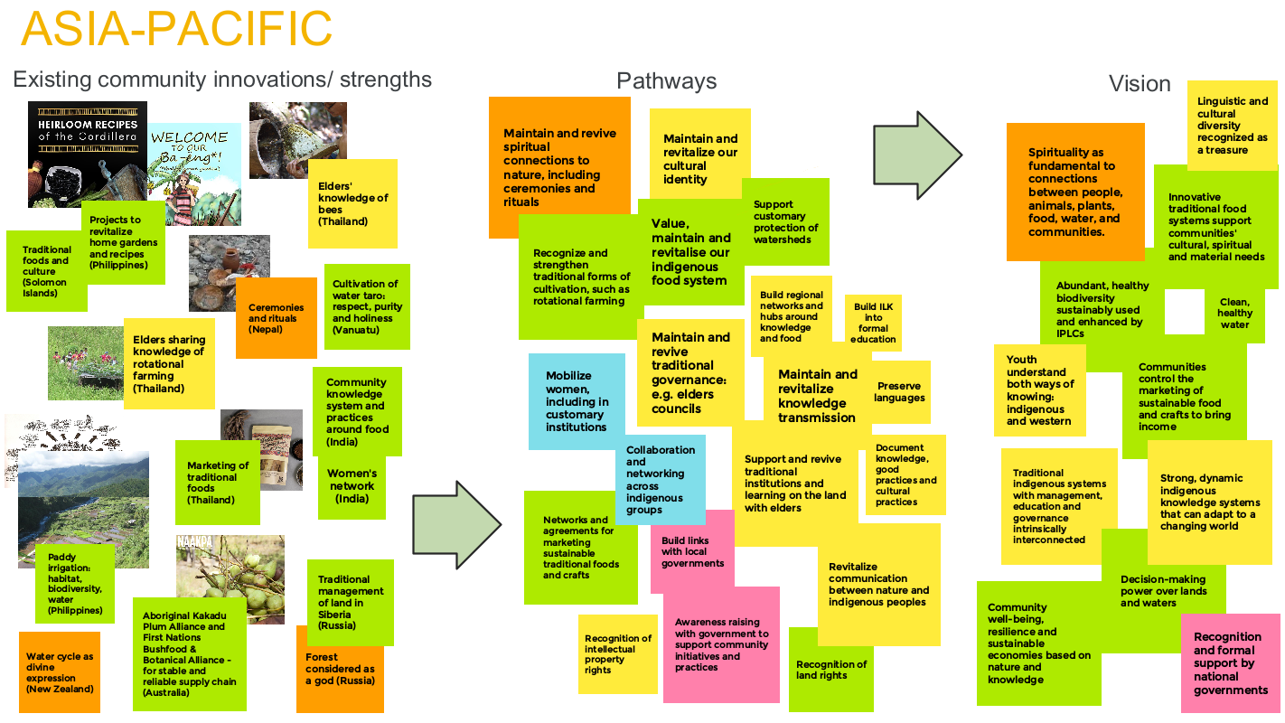
Figure 9: Representation of the Asia-Pacific session of the online workshop on scenarios and ILK

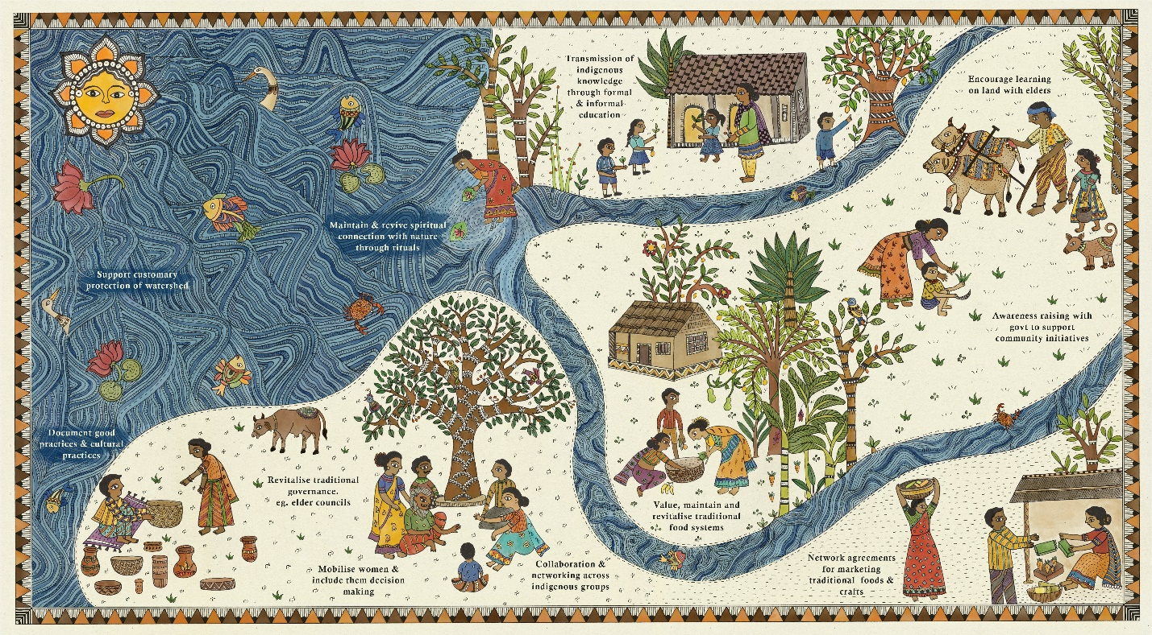
Figure 10: Artistic representation of the Asia-Pacific session of the online workshop on scenarios and ILK, created by Anjali Choudhary.
A participant who was an Indigenous author in the IPBES Transformative Change Assessment discussed the assessment, which did extensive work on perspectives and future visions of Indigenous Peoples and local communities within the context of global, system-wide transformation. A key activity was the work with Indigenous contributing authors, who were each asked about their visions for the future and how these related to transformative change, challenges and pathways. By synthesizing these contributions and bringing out key themes, a global overview of Indigenous perspectives was achieved, whilst still recognizing diversity and areas where there were differences.
Additionally, a key case study discussed the legal recognition of personhood for the Whanganui River in New Zealand (Aotearoa), reflecting a paradigm shift toward relational governance and ILK-led environmental stewardships. The assessment stresses that embracing Indigenous values, governance systems, and long-term visions is crucial for deep, lasting change in biodiversity governance. Te Uruwera Ranges and Mount Taranaki have since been granted legal personhood in New Zealand.
A participant also shared plans for the inclusion of ILK in the IPCC assessment reports, particularly relating to scenarios within the 7th Assessment Report (AR7). He traced the evolution of IPCC scenario development from the IPCC Scenarios 1992 (IS92) to Assessment Report 6 (AR6), noting gaps in cultural representation and ILK integration. AR7 explicitly references ILK alongside "scenarios, pathways, futures and projections". He outlined planned workshops and progress on collaborative author selection processes to support more inclusive methodologies. The goal is to foster genuine engagement between science and Indigenous Peoples and local communities, improve scenario relevance, and reduce knowledge silos in global climate assessments.

Benefits and strengths
Participants highlighted the benefits of collaborations between scientists and Indigenous Peoples, noting the potential for enhancing both systems of knowledge and understanding about the environment. Such projects can also enhance crucial links between ILK systems and scientific or policy processes, in ways that may not be possible through community-based research alone.
With rapid environmental change and climate change, some communities may wish to receive additional support from scientific systems so that they can better apply their ILK and traditional systems of management, as discussed in the examples above for French Polynesia and the Saami, where biological invasions and climate extremes are bringing previously unknown challenges. At the same time, ILK systems can also inform the scientific community in developing innovative adaptation techniques or management plans that are culturally appropriate and functional within the local environment.
The potential for building trust and relationships between Indigenous Peoples and local communities, scientists and policymakers was also highlighted as an important aspect.

Challenges
Participants also noted a number of challenges with co-creation between scientists and Indigenous Peoples and local communities. They noted that there is a strong risk of co-option or misinterpretation of knowledge during these processes, or that ILK is only used superficially as a source of information, rather than as a foundational framework that should be taken as seriously as scientific frameworks. They noted that, often, Indigenous Peoples and local communities may be expected to provide information within pre-created frameworks to support pre-existing expectations of results, and that, as a result, ILK that does not meet these pre-existing assumptions is often rejected. There may also be assumptions that science should validate the information provided by ILK systems, and as a result, ILK that cannot be validated in this way is often rejected or ignored. Participants discussed how to resolve this, as presented in section 3.5.2.1 on ways forward.
Participants emphasized that power imbalances between ILK and science, and between Indigenous Peoples and scientists, can be a source of these issues, combined with a lack of will to rethink scientific frameworks to place ILK as a foundational concept and principle.
Participants also expressed concern that reducing ILK to diagrams or text in reports can strip it of context, depth, and meaning.
Participants also noted that the inaccessibility of much ILK, as it is not documented or is only documented in Indigenous and local languages, further imbalances how ILK can influence projects and processes, especially at national and global scales.
This lack of accessibility of ILK is combined with the many threats and challenges faced by many Indigenous Peoples and local communities, discussed above, which puts them at a disadvantage in terms of capacity and time that they can spend on research activities. Funding is also usually skewed towards supporting science over ILK systems and community projects.
Participants also highlighted that for many Indigenous Peoples and local communities, relationships are key, and that building trust and mutual respect between researchers and communities takes time and consistency. This can be especially important where there is a history of misappropriation or misuse of ILK by researchers, governments or others. However, building trusting relationships can be difficult when researchers only spend a few weeks or a project cycle with a community, and then do not return. Government officials can also change, which hampers the development of relationships between communities and governments. Research fatigue from multiple uncoordinated projects is also an issue in many communities. Funding cycles, which are often for a year or a few years, also hinder efforts to build meaningful relationships between researchers and communities.
As a result, many processes that aim for co-creation and co-production with Indigenous Peoples and local communities may not be successful in terms of really learning from ILK systems and building true collaborations and partnerships. This can be detrimental for efforts to understand and protect nature and community wellbeing, and to empower communities and build their capacity.

Ways forward
During the course of the workshop, including through the case studies and examples shared, participants reflected on the strengths and challenges for different types of futures thinking and scenario development, and from these, they discussed various ways forward. These are presented below.

Ways forward: Futures thinking within ILK systems

Roots in ILK
Participants emphasized the need for more scenario development to be entirely grounded in Indigenous knowledge systems and philosophies, as well as futures thinking within ILK systems. Practices, such as ritual-based forecasting, seasonal calendars and traditional governance frameworks offer valuable and place-based approaches to understanding and planning for the future.
They also noted that, to plan effectively for the future, an understanding of the current situation and the historical relationship of Indigenous Peoples and local communities with nature is first needed. This includes their activities, needs, resource use, monitoring practices, adaptive capacities, methods and ways of documenting, and sharing knowledge. This provides a strong foundation for analyses, assessments, and the development of scenarios, strategies and policies to support more resilient and sustainable societies, enhancing both community and individual well-being. It would also allow ILK to be properly recognized within policy and planning at local, national, regional and global levels.
Working with these knowledge systems requires attention to Indigenous methodologies, systems of learning, and languages. Goals can include supporting communities to manage environmental and social change whilst also documenting knowledge systems, including worldviews, philosophies, values and frameworks that can inform other ways of understanding and planning for the future.
Moreover, participants noted that these ILK systems form the basis of all other work around co-production and it is important that they receive due attention, recognition, respect and support, which can sometimes be lost when co-production projects become too dominated by scientific frameworks and assumptions, as is also discussed below in 3.5.2.

Supporting and revitalizing ILK
Participants highlighted that it is therefore essential to support ILK systems as these underpin the ways that Indigenous Peoples and local communities forecast, predict and manage for the future. This support can include work to mitigate the threats to ILK systems (discussed in section 3.3.4) and support for ILK systems and the communities who hold them. This includes supporting revitalization and knowledge transmission, recognition of contributions to biodiversity conservation and environmental management, customary governance and ownership of lands and respect for rights, as in the case of the Aeta (see example below). These broader goals of supporting the foundations of ILK systems and the communities who hold them should be a key feature and goal of work with ILK and scenarios.
Revitalization efforts, such as reintroducing ancestral seeds (Peru) and forest rituals (Malawi), highlight the resilience and leadership of Indigenous communities in reclaiming heritage. In particular, respecting Indigenous rights, including crucially rights of land tenure, is essential for the continuity of ILK systems, as is recognition of customary governance systems.
Youth engagement was also highlighted as an important consideration. Examples were shared from the Karen People of Northern Thailand of youth creating social enterprises, organizing cultural festivals, and acting as online influencers to promote local knowledge and practices. Gendered approaches and recognizing the roles of women, including in resilience and livelihoods, were also highlighted as key.
Participants also noted the importance of integrating Indigenous ways of knowing and learning into education systems, as well as facilitating and honouring elder-youth dialogues. For example, in the Philippines, this includes the Indigenous Peoples Education (IPEd) programme under the Department of Education.
Moreover, participants highlighted that there is a need for global religions to respect Indigenous spirituality as a crucial part of environmental stewardship. Revitalizing Indigenous spirituality is essential as a foundation for conservation efforts, cultural survival and planning for good futures. Participants also reflected on the value of movements to integrate Indigenous spirituality with mainstream religion, such as “Laudato Si” in Catholicism, in which the pope acknowledged ILK systems.
Example - Aeta community aspirations for the future
The Aeta community discussed their aspirations for the future, which include:
- Protection of territories, lands and waters;
- Preservation of communal values of mutual respect, kindness and cooperation, especially Pakikisama—the Filipino ethic of harmony and good relations;
- Cultural preservation through language and tradition, supported by strong intergenerational ties;
- Cultural resilience and interconnection; i.e., all aspects of community life, from stories to food to spirituality, are tied to land and tradition;
- Empowering the younger generation to embrace cultural identity and knowledge and to participate in both cultural preservation and forest stewardship;
- Transmission of culture and knowledge to younger generations through social media and educational curriculum;
- Strengthening of Indigenous governance structures and revival of provincial Aeta networks;
- Full recognition and control over ancestral domains, including the long-awaited issuance of ancestral domain titles;
- Inclusion of traditional land use practices in formal government management plans;
- Active engagement in policymaking to ensure Indigenous perspectives shape governance;
- Payment for ecosystem services or similar recognition of the contributions of Aeta management of the forested watershed for downstream communities and industry, although legal and regulatory barriers complicate implementation.; and
- Capacity-building for effective advocacy and co-management of the forest.
Strategies engaged by the community to reach these goals include:
- Designation and support of culture bearers who work to integrate Indigenous traditions into formal education;
- Proactive engagement with local governments and NGOs to address legal and ecological concerns;
- Community-led reforestation with native species;
- Representation through the Indigenous Peoples Mandatory Representatives to ensure their voice in policymaking;
- Strengthening community roles by gender and generation, ensuring inclusive leadership and participation;
- Emphasizing experiential cultural learning, letting youth explore rituals, forest knowledge, and traditions;
- Advocating for visibility in broader spaces, telling their stories and shaping external perceptions of Indigenous life; and
- Pride in innovation using natural resources (e.g., bamboo rice).
However, while it was noted that the Aeta are demonstrating leadership and resilience in the face of cultural and social change, there are many aspects for which they require additional recognition or cooperation from outside, including the crucial issue of recognition of land rights, which is a key challenge and need for many Indigenous Peoples and local communities, and equitable participation in governance, especially regarding forest and land management.

Ways forward: Co-production and co-creation
Many participants identified the concepts of co-creation and co-production as central, recognizing the strengths that can accrue when ILK systems and science work together. However, co-production and co-creation require a number of considerations to ensure that they are effective, equitable and support the needs and rights of Indigenous Peoples and local communities. Often, projects that are Indigenous-led may provide good examples as communities have control over concepts, goals and methods. However, participants also recognized that, in order to engage with global scenarios processes, it may be necessary for Indigenous Peoples and local communities to co-create projects with scientists and other actors. Nonetheless, as much as possible, these efforts should strive to be Indigenous-led and reflect the worldviews, knowledge systems, values, aspirations and priorities of Indigenous Peoples and local communities.

Respect and validation
Participants noted that a key challenge for true co-production and co-creation remains the lack of respect and acceptance given to ILK systems in many scientific processes. They emphasized the need to highlight Indigenous-led conservation success stories and to demonstrate that Indigenous Peoples and local communities are leaders and co-creators of conservation strategies and planning, as a way of demonstrating the importance and success of their ways of knowing and managing the environment.
They also emphasized the need to recognize ILK as a legitimate and important source of knowledge. Some participants also noted that ILK should be considered a science in itself. Therefore, rather than treating ILK as supplementary, anecdotal, or only as a source of data, it should be acknowledged as a dynamic and evolving knowledge system with its own concepts, methodologies, authority and rigor. It can therefore provide the foundations of work on scenarios, or it could reframe what a scenario is and how it should be created and represented. This requires a fundamental shift in the dominant scientific paradigm to make space for multiple ways of knowing, including ILK.
Participants also noted that a key factor is that ILK should be validated within its own systems of knowledge, rather than being validated by science. They noted that there are systems within some communities for analysing and validating knowledge, and that these could be explored as they are often not well documented or understood.
A participant noted that while many government-endorsed platforms often marginalize Indigenous epistemologies, some institutional models, such as the Canadian Government’s Indigenous Science Division in Environment and Climate Change Canada (ECCC), illustrate how ILK can be formally embedded alongside science in national and global policy processes.

Foundations and concepts
Participants noted that working with and benefiting from ILK requires more than data collection with Indigenous Peoples and local communities within existing frameworks. It, instead, requires embedding Indigenous worldviews and philosophies, including Sumaq Qamaña, Buen Vivir, and Ñandereko (concepts from Bolivia), and ways of knowing and learning into the planning, methods, processes and outputs of scenario development. These holistic ILK systems can help to move beyond conventional models by emphasizing balance, reciprocity and harmony with nature.
Participants highlighted that these ways of understanding and conceptualizing the future should also form foundations for other forms of collaboration and co-production between ILK and science, as the recognition of these foundations is essential to build true collaborations beyond only relying on ILK as a source of data.

Leadership, ownership and relationships
Participants emphasized that meaningful co-production and co-creation of scenarios requires recognition of community ownership and leadership, including embedding Indigenous leadership in all decision-making processes. It also often requires long-term relationship-building, which may need to start many years before a project commences as it takes time to build trusting relationships.
Participants noted that Indigenous Peoples and local communities should be involved from the earliest planning stages through implementation, evaluation and continuous feedback loops. This ensures that scenario frameworks, knowledge contributions and final outputs remain rooted in Indigenous worldviews, values and priorities.
Participants also explained that meaningful engagement requires honouring Indigenous leadership and contributions through practices, including co-authorship, co-naming and ensuring that communities retain ownership of the knowledge they help generate. Outputs and findings should also be returned to and validated by the communities, maintaining reciprocity and transparency throughout the process.

Co-creating goals and benefits
Participants emphasized that, beyond overarching concepts and foundations, it is important to ensure that the key questions and goals of research are originating from Indigenous Peoples and local communities and that they clearly understand and have mapped out how they will benefit.
Participants noted that benefits can take many forms, for example, supporting ILK systems and community governance and rights, supporting ILK based early-warning systems for community adaptation, enhancing biodiversity conservation or facilitating communication with national governments.
Participants also highlighted that benefits of their contributions and efforts are already felt beyond their communities, as conservation and sustainable use by Indigenous People and local communities represent significant contributions to global biodiversity goals, maintaining functioning ecosystems and human wellbeing.
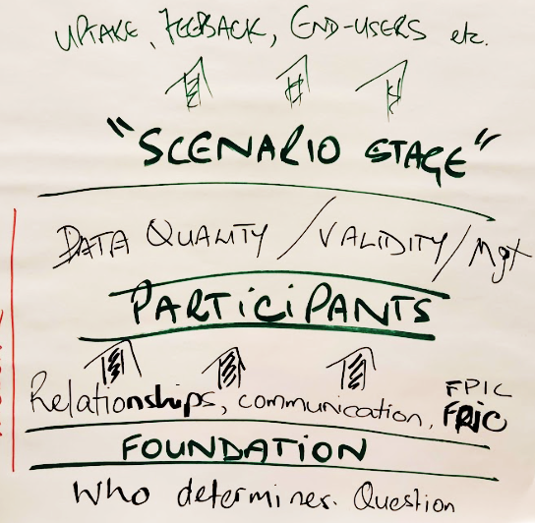
Figure 11: A diagram created by participants at the workshop showing the importance of the foundations of research projects and how these foundations influence everything that follows.

Co-creating methodologies
Participants emphasized the importance of co-creation of methods with Indigenous Peoples and local communities, integrating their worldviews, lived realities and knowledge systems. This may often involve co-developing and co-implementing a diverse mix of methodologies, which can be qualitative or quantitative.
Participants noted that the process should prioritize accessibility, cultural appropriateness, adaptability and ethical engagement. Recognizing and measuring intangible values, such as spiritual significance, requires the inclusion of qualitative and social science tools that explore non-material dimensions that are often overlooked by traditional scientific methods. Participants also emphasized that much ILK cannot be represented by text alone or by diagrams. It is therefore necessary to find ways to work with and accept diverse forms of knowledge.
Participants recommended various different methods that could be explored further and that may bring different advantages when developing culturally appropriate research methods:
- Narrative scenarios;
- Participatory Action Research (PAR);
- Participatory mapping and GIS;
- Digital platforms like Mapeo and Google Earth Pro;
- Community-based monitoring;
- Visioning and mental mapping and Fuzzy Cognitive Maps (FCM);
- Sense mapping (place-based approach, feelings, emotions, more than classic mental maps);
- Art- and culture-based storytelling and music;
- Video-voice and photo-voice;
- Role games;
- Dialogues of knowledge systems; and
- Online surveys or multilingual questionnaires.
The participants also emphasized that the workshop itself showed the importance of inclusivity and bringing together Indigenous Peoples, local communities and researchers, to discuss and build shared visions of the future.
Some participants also discussed the potential of artificial intelligence (AI) as both an opportunity and a challenge. They noted that AI may have potential to support research processes and could support the preservation and translation of Indigenous languages and knowledge. However, they noted concerns around data ownership, intellectual property rights, and potential misuse. As a safeguard, communities must always validate outputs.
Ultimately, the use of these approaches should aim to enhance the accuracy, legitimacy and ethical grounding of work with scenarios by aligning with the lived realities of Indigenous Peoples and local communities and their knowledge systems.
Researchers must always ask if the information is being heard, recorded and interpreted as intended.
Intergenerational participation, particularly including youth, women, and elders, is also vital to ensuring both continuity and innovation within Indigenous knowledge systems.
Overall, participants emphasized the need to document and guide the diversity of methodological approaches used in scenario building, particularly within ILK contexts. There was a call for more detailed guidance on how to incorporate varied approaches (e.g., participatory games, storytelling, and visioning) into scenarios.

Indigenous methodologies and frameworks
Participants highlighted that Indigenous Peoples are themselves developing frameworks for methods. These models and frameworks can serve to structure the formulation of mixed methods, and should be explored as a foundation to efforts towards co-production.
Examples
A participant from Peru explained the use of Khipu, a traditional Andean system of knowledge encoding, which has been developed into an ethical and culturally meaningful methodology for scenario planning with communities.
A participant from Canada (Anishinaabe Nation), explained the concept of “Three-Eyed Seeing” which guides community decision-making by integrating Indigenous laws, Western science, and spiritual perspectives or “our relations” which includes all flora and fauna, as well as water, air, sky, sun, moon and stars. Methodologies include oral tradition, oral history, storytelling, community-based participatory research, listening and engaging elders, knowledge holders and youth. It is founded on the recognition that combining two sciences, including “western” science with Indigenous science, will give better understanding.

Scale and diversity
Participants reflected on the examples shared during the workshop for work with ILK at national, regional and global levels, noting that these demonstrate that work with ILK is possible and beneficial beyond the local level. They therefore recommended a multi-scalar approach, which should aim to link ILK meaningfully across local, national and global research and policy frameworks. However, within this, recognition of the diversity of Indigenous Peoples and local communities is critical. Since each community’s scenarios reflects their specific context, it is important to avoid a one-size-fits-all representation while also drawing out common themes at different levels.
They noted that more work is needed to explore how to do this well, and more resources will need to be invested. Collecting and exploring local level case studies could be one approach, which would be useful for IPBES assessments. Participants also noted that many documented scenarios already exist at the local level, for example, in the form of community declarations or development plans. Exploring the diversity and synergies between these could be one path forward.
Participants noted that these processes can be beneficial for global understandings of possible futures and the steps needed to get there. This process can also be beneficial for communities themselves as they can learn from other communities and find synergies to amplify their voices. For example, learning across continents (e.g., Asia, Africa, and Latin America) can enhance Indigenous Peoples’ and local communities’ understandings of food systems, climate adaptation, and biodiversity.

Quantitative data and modeling
Participants noted that the integration of quantitative evidence alongside ILK can be important for communicating effectively with a range of stakeholders, including policymakers. While qualitative data remain critical for conveying ILK and there are many rigorous methods for analysing and representing qualitative information, data-driven approaches were also noted as important for legitimacy and advocacy in broader governance frameworks. However, participants emphasized that quantitative data should not replace qualitative explorations of worldviews and contexts. Overall, they noted that more work is needed to understand how best to work with ILK and quantitative data without losing crucial contexts and values from ILK systems.
Participants also discussed modelling. They noted that, as with the methods and overarching research process described above, it can be important to find models that accurately reflect ILK systems, worldviews and values, rather than only inputting ILK “data” into existing models. They noted that much more attention and resources need to be directed towards this.

Indicators
The participants briefly discussed indicators, however, it was agreed that more time and attention is needed on this topic.
Participants noted that a great challenge is how to integrate indicators from both science and ILK systems in scenarios, and they noted that indicators should be agreed and validated by Indigenous Peoples and local communities. They also highlighted that Indigenous Peoples and local communities have their own indicators, which they use to understand seasons, animal movements, ecological restoration and other aspects of relationships within nature.
They noted that there needs to be participation not just in developing indicators, but participation in developing the framework in which the indicators are shaped. Indigenous Peoples and local communities need to be included across all stages.
Land use change and secure land tenure were suggested as core indicators for understanding environmental impacts in Indigenous territories as these are critical elements for many Indigenous Peoples and local communities. They noted that there are some ongoing contributions and initiatives, such as the Philippines’ contribution to the Convention on Biological Diversity through submissions on KMGBF Indicator 22.1 (land use and tenure).

Safeguards, ethics and data sovereignty and control
Participants emphasized that safeguards and ethical considerations should be at the heart of methods development and the entire scenarios co-development process. Principles, such as free, prior and informed consent, should be foundational while ensuring ownership and sovereignty over data is key, including clearly establishing community ownership of the data, as well as protocols for who can use the data, how it can be used, and where and how it will be stored to ensure community access and control.
These processes should also be co-developed with the communities in question to make sure they are appropriate and responsive to community needs. It is also important to note that not all knowledge will be shared during research processes as many communities hold sacred and protected information. Building reciprocal trust can facilitate knowledge sharing while some knowledge may never be shared.

Capacity-building
Participants emphasized that work with scenarios and ILK should aim to build community capacity, not just to extract knowledge. The ultimate vision is for Indigenous Peoples and local communities themselves to lead the modelling, analysis, planning and communication and to become the scenario builders, not just contributors. It is also important to enhance community capacity for them to become knowledge brokers so that they are in control of how they share their knowledge with the scientific community for evidence informed decision-making.
A participant from Canada proposed that a checklist tool to guide communities through “dreaming” or visioning exercises could be developed. This kind of practical framework could help structure local scenario-building efforts and support inclusive and participatory planning.

Funding and resources
Participants highlighted that, in general, there is a large funding gap between science and ILK systems and that this limits the ways in which ILK can inform processes beyond communities. Even within the limited funding available, often it does not reach the communities and is, instead, focused on external researchers. Hence, proper resource mobilization mechanism should be developed. They emphasized that addressing funding issues is key to further work with ILK and scenarios. Funding must be culturally appropriate, with allocation and reporting adapted to community needs.
Enhanced support and resources allocated to translation is also critical as many communities do not speak majority languages, which can form a barrier to communities understanding global processes and research and a barrier to researchers, governments and others from understanding ILK.

Policy uptake / Whole-of-society approaches
Participants proposed that policies at both national and global levels should explicitly require the consideration of local needs and ILK in strategy development, investment planning, and other decision-making processes. Global frameworks and agreements could play a key role in requiring national governments to recognize ILK in meaningfully ways, ensuring that Indigenous Peoples and local communities are not left marginalized in the planning and implementation of development initiatives.
Participants also noted that it is important to promote whole-of-government and whole-of-society approaches, ensuring shared ownership of scenarios, rather than researchers from Indigenous Peoples and local communities working in silos. Partnerships with actors, such as social enterprises, media organizations, and different government departments, were noted as important. Identifying allies across sectors, especially those aligned with sustainable development and community engagement, was seen as a practical step toward long-term cooperation.
Participants also suggested that policymakers need to invest in learning from ILK and understanding its relevance and rigor. They noted that scenarios that include ILK, and ILK in general, need to be received by a supportive policy environment.
They also noted that enhanced coherence across governance levels is needed. Indigenous Peoples and local communities play important roles at local, national and global levels, and ensuring their contributions are reflected in all scales of policy and decision-making was considered essential. Engagement at the regional level, including through platforms, such as the ASEAN Centre for Biodiversity, was also highlighted as a complementary strategy to national and global efforts. In the larger scope, these regional processes and bodies can help nations to discuss and think together. They also noted that integration is needed across nature-focused and climate-focused initiatives, which would also reflect the holistic worldviews of Indigenous Peoples and local communities.

Ways forward: Nature Futures Framework
Participants acknowledged the NFF as a conceptual entry point for work with multiple values in scenarios whilst others noted that there is a need for a more inclusive, flexible and nuanced approach that fully incorporates Indigenous worldviews and experiences.
In particular, the triangular framework on the left-hand side of the NFF was reconfirmed as overly simplistic and not fully reflective of Indigenous cosmovisions, which emphasize deep interconnections between nature, culture, and spirituality that are not conveyed in the NFF’s terminology about value perspectives (intrinsic, instrumental and relational). Moreover, other terminology, for example, “nature as culture” was also seen to create a separation between nature and culture. ILK concepts are also not well-developed in the cosmovision on the right-hand side of the NFF diagram. Participants asked that other representations and frameworks also be explored by IPBES to further work with ILK and scenarios, including frameworks derived from entirely ILK systems as these may provide more appropriate foundations for future work with ILK and scenarios.
Participants also recommended expanding the NFF to include not only desirable futures but also undesirable or “business as usual” scenarios, helping to highlight risks, consequences and the need for interventions.
Overall, participants noted that methodological adaptations are urgently needed to position ILK as central, rather than peripheral, to scenario development, particularly at global scales. This workshop was seen as a meaningful step toward that goal, fostering revisions to guidance and representation that better reflect the contributions and leadership of Indigenous Peoples and local communities.
Participants also highlighted that they expect more efforts in the future towards showing how their future pathways and ways of life could be built into global scenarios, for example, what will happen if biocultural relationships with nature are expressed at national/regional/global scales and not just used to populate ILK indicators and Indigenous values for Indigenous lands.

Ways forward: IPBES
Participants recognized that IPBES work with ILK and scenarios is at an early stage. They recommended setting a long-term vision, developing strategic directions, and identifying gaps to be addressed with inclusive tools and approaches. Future engagements, including follow-up meetings, regional workshops, and cross-initiative collaborations, should build on this work.

Ways forward: IPBES second global assessment
Participants noted that it is essential that this workshop on scenarios feeds into future IPBES assessments. It was explained that the IPBES second global assessment has a separate chapter on ILK, which, as chapter 2 of the assessment, aims to provide frameworks and concepts that can inform the following chapters. Meanwhile, chapter 4 will focus on future pathways, and part of this analysis should be framed by chapter 2. This workshop is therefore seen as one of the first steps in that process, and this report will be one resource that the authors can use to guide them.
Participants saw IPBES as a science-based platform with a somewhat rigid government-led process. The scope of the assessment may, therefore, not completely reflect community priorities and needs. However, it is essential to work to translate the scope to meet community needs and priorities as far as possible and to find space for ILK concepts and frameworks, most likely in chapter 2, while also considering how best to appropriately translate and provide ILK to meet the assessment’s needs, including for chapter 4 on future pathways. They also emphasized the need for Indigenous review processes for the validation of the ILK so that it is not misinterpreted.
Overall, participants emphasized that ILK should be central and foundational to the second global assessment, in recognition of the crucial role of Indigenous Peoples and local communities and their knowledge in biodiversity conservation, sustainable use and human wellbeing.
Participants highlighted that the second global assessment should also have a framework for incorporating ILK and advancing IPBES work on this research paradigm. It will need to be clear what kind of information is required and a strategy will need to be in place to gather and analyse it.
They noted that there are significant gaps in relation to ILK being readily available for direct use in assessments due to much ILK being undocumented, or being documented in Indigenous and local languages, or not being in the form of easily recognisable scenarios.
Participants noted that a mix of strategies will most likely be needed to fill these gaps, following the guidance given above, for example, the guidance around working at different scales and using materials from communities that express visions and pathways, including declarations, community plans and biocultural community protocols, which could be analysed for synergies and key themes whilst recognizing and highlighting diversity (section 3.5.2.7). They also noted that the work of previous assessments should be integrated and expanded. Free, prior and informed consent is essential for all facets of work with ILK in assessments.
Participants emphasized that Indigenous Peoples and local communities should be regarded as key contributors to the second global assessment. They expressed the hope that members of Indigenous Peoples and local communities will be selected as authors. This will enable them to share their knowledge in their own way and build their capacity for such similar future opportunities.
Participants also noted that other contributions by Indigenous Peoples and local communities should be well acknowledged, recognizing the many ways that Indigenous Peoples and local communities contribute to global wellbeing in terms of knowledge and biodiversity conservation and management.
There were also requests for more transparency on how contributions from Indigenous Peoples and local communities would be used in reports and assessments. There was recognition of the need for improved communication and better mechanisms to track how inputs from Indigenous Peoples and local communities are used throughout the assessment process.
Participants also noted that capacity-building is essential to enable Indigenous Peoples and local communities to actively participate in review and validation processes, ensuring meaningful involvement across all stages of assessment. Workshops for exploring drafts and validated results are also key.
Participants proposed that assessments should not just be a repository of knowledge. They should aim to inform policy and action, and follow-up outreach and communication with communities, governments and others is essential. The assessment could also better reflect the needs and priorities of Indigenous Peoples and local communities, including their goals for self-determination, sustainable living, environmental stewardship, community wellbeing and revitalization, and strengthening of knowledge and governance systems. The assessments could also further enhance the visibility of Indigenous Peoples and local communities in policy-making arenas and facilitate the incorporation of their knowledge and participation into national and global strategies and processes. Case studies can showcase effective work with ILK and inspire broader adoption of co-production and other methods.
Participants noted that it is also important to evaluate whether and how IPBES findings have reached and benefited Indigenous Peoples and local communities, either directly or through implementation and action by governments or others. They noted the need for greater visibility and communication of IPBES messages across societies and observed that public awareness of the Platform and its relevance remains low in many parts of the world. Participants also noted that the assessment can rely on existing networks and communication channels to enhance communication between the work in the assessment and communities. Plain-language summaries and translations should aim to ensure community feedback loops and wider dissemination.
Participants noted that awareness and understanding of engagement mechanisms for Indigenous Peoples and local communities remain limited in many states who are members of IPBES. Strengthening awareness of networks, including the International Indigenous Forum on Biodiversity and Ecosystems Services (IIFBES) and the Open-ended Network of IPBES Stakeholders (ONet), and building capacity among national focal points were proposed as ways to address this gap.

Ways Forward: Future workshops
Participants made a number of comments and recommendations for future workshops.
- Shared experiences and challenges: Participants from Indigenous Peoples and local communities expressed common concerns and aspirations, including long-standing cultural, environmental, and governance issues. The choice of location, including in a country with a strong Indigenous presence, was seen as especially valuable in enabling broader participation and grounding discussions in real-world contexts.
- Participation and process observations: Attendees observed an increase in Indigenous representation, compared to previous events. However, several participants noted that the objectives and the role of Indigenous Peoples and local communities within the process were not always clear. This affected the ability of some participant groups to prepare and engage fully, including through discussions with their communities before the workshop.
- Clarification and preparation needs: Many participants expressed the need for greater clarity in advance of such meetings. Suggestions included the provision of clear objectives, preparatory materials, and expectations to help participants gather input from their communities and contribute effectively.
- Recommendations on participation: Recommendations were made to enhance inclusion, including:
- Ensuring Indigenous involvement from the beginning of all processes.
- Further planning, preparation and pre-engagement whilst participants welcomed the online planning meeting and other materials sent in advance of the workshop.
- Support to youth participation and representation from vulnerable communities.
- Provision of financial support through a voluntary fund accessible to all sociocultural regions.
- Capacity-building and communication: Participants recommended more support for understanding and navigating technical and institutional processes, including:
- Culturally appropriate capacity-building initiatives.
- Translation services to support participation in multiple languages.
- Mechanisms to clarify the origin and use of contributions from Indigenous Peoples and local communities in reports.
- Cultural inclusion and knowledge sharing: Cultural practices, such as storytelling and oral traditions, were proposed as methods for knowledge-sharing within IPBES processes, as well as art-based approaches. Attendees advocated for broader inclusion of these practices in official workshop agendas.
- Administrative, knowledge capacity, and logistical suggestions: The suggestions to adjust meeting formats included holding shorter caucus meetings daily rather than one long session at the end. Improved support was recommended for new participants to better understand IPBES structures and terminology.
- Internal coordination within the caucus of Indigenous Peoples and local communities: Participants discussed strategies to enhance their internal coordination, including onboarding processes for new members and maintaining regular caucus meetings during events.
- Closing themes and key messages:
- Participants expressed gratitude for the connections made, the knowledge shared, and the opportunity to collaborate.
- A strong appreciation was expressed to the local organizers and host communities, particularly the Indigenous Peoples of Kanawan. Their participation and openness were pivotal in grounding the discussions. Continued respectful engagement and visibility in policy dialogues was deemed essential.

Next steps
The following next steps took place after the workshop:
- A report was developed from the dialogue workshop (this report), which was sent to all participants for them to edit, make additions and approve prior to finalization and publication online;
- Using the report as a resource, the task force on scenarios and models, in collaboration with the task force on ILK, will further develop the methodological guidance for the NFF (August-October 2025); and
- The IPBES second global assessment will start its work towards the end of 2025 and authors, particularly of chapters 2 and 4, will use this report as a resource.

Annexes

Annex 1: Agenda
Agenda for the workshop to reflect on scenarios and models to better account for different knowledge systems, including Indigenous and local knowledge systems, and Mother Earth-centric scenarios and models
23-26 May 2025
Subic Bay, the Philippines

12 May 2025 - Online Introductory meeting
Time (CET) | Items
12h00-12h05 | Opening/welcome
12h05-12h15 | Introductions (Full introductions at the workshop itself)
12h15-12h45 | Overview of IPBES, Indigenous and local knowledge task force, scenarios and models task force and their importance for nature and Indigenous Peoples and local communities; Previous work on Indigenous and local knowledge and scenarios
12h45-13h00 | Introduction to the local context
13h00-13h20 | - Proposed objectives/draft agenda  - Free, Prior and Informed Consent (FPIC)  - Benefits of the workshop for Indigenous Peoples and local communities  - Overview of methods (visioning, art-based, participatory scenarios)
13h20-13h50 | Discussion – objectives and methods
13h50-14h00 | Next steps / Closing
15h00-15h15 | Logistics questions and answers

Friday 23 May: Day 1 – Introductions, background and community futures thinking
Time (local) | Item
9h30-10h00 | Registration/coffee
10h00-10h30 | Traditional welcome / Opening ceremony
10h30-11h30 | Introductions and hopes for the workshop  - Using diverse cultural or free formats (e.g., photos, artefacts, stories, initiatives)
11h30-11h40 | Introduction to the hotel and the local area
11h40-12h00 | Introduction to the local context and plans for the community visit, and discussion
12h00-12h30 | Framing the workshop: agenda, objectives, outcomes, and community co-benefits
12h30-14h00 | Lunch
14h00-14h45 | Discussion on framing the workshop
14h45-15h30 | Community worldviews, experiences and methods around futures thinking and planning:  - What does the future mean for your community /people?  - How do communities plan for and manage future challenges within traditional systems and within their own knowledge and governance processes?  - Sharing local initiatives and vision-building exercises (stories, artefacts, songs, drama)
15h30-15h45 | Break
15h45-16h30 | Community worldviews, experiences and methods around futures thinking and planning
16h30-17h00 | Reflections on the day/preparation for day 2
18h00- | Reception sponsored by the Ministry of the Environment, Japan

Saturday 24 May: Day 2 – Community visit, community futures thinking and connections to national and international processes
8:h30-17h30 | Community visit  - How the community engage in future thinking within their knowledge systems / customary governance  - Other participants can also share experiences  - How have outside pressures, challenges or opportunities encouraged or forced communities to document or translate their ways of thinking about the future for discussions or negotiations with governments, researchers or others:  - Water extraction  - Land rights  - National Park governance and co-management  - IPBSAP process and local participation  - Other participants can also share experiences  - Reflections on challenges and opportunities for futures visioning  - Reflections on lessons for scenario building

Sunday 25 May: Day 3 – Visioning and scenarios approaches, connecting to national and global levels
9h00-9h15 | Plenary recap of day 2, plan for day 3
9h15-9h45 | Plenary reflections on the community visits
9h45-10h30 | Presentations: co-creation or scenarios and visioning approaches using mixed methods:  - Introduction: What are scenarios (diverse scenarios approaches) including role of indicators  - Examples:  - Local level  - National level  - Regional/global  - LBO2 transitions  - IPBES visioning workshop  - Transformative change assessment  - IPCC  - Q&A – with brief reflections in plenary on the methods for visions and scenario development used in these examples – those Indigenous own and those facilitated, co-created, etc. [to wrap up and lead into breakouts]  Note: These presentations aim to frame the discussions for the rest of the day, looking at various strategies for making Indigenous values, visions and scenarios visible in IPBES outcomes
10h30-11h00 | Refreshment break
11h00-12h30 | Group discussions: Divide into four groups (two English-speaking, one Spanish-speaking, and one Filipino-speaking)  - Sharing of more examples of visioning, future planning, scenario development, etc., from participants.  - Capture various aspects of the methodologies used (Indigenous People owned, collaboration with Indigenous and local knowledge and science and how, resource use, time required, use of art, story, etc.)  - Reflections on the diversity of the methodologies, and their strengths and weaknesses
12h30-14h00 | Lunch
14h00-15h30 | Group discussions  - How can ILK inform and contribute with their knowledge, values and worldviews in relation to the future of the scenario’s chapters in IPBES assessments (specific example: chapter 4 of the second global assessment)  - This could include:  - Bringing in autonomous-led Indigenous Peoples’ local scenarios (narratives)  - Bringing in autonomous Indigenous Peoples’ global scenarios (narratives and more)  - Contributing to the global modelled scenarios based on the Nature's Futures Framework  - Challenges, risks, opportunities and benefits for each
15h30-15h45 | Refreshment break
15h45-16h55 | Plenary report backs and discussion
16h55-17h00 | Closing of day

Monday, 26 May: Day 4 - Visioning and scenarios approaches, connecting to national and global levels, caucus and closing
9h00-9h15 | Plenary Reflections on days 1, 2 and 3, Plan for day 4 (and brief presentations)
9h15-10h30 | Group discussions continued:  - Key messages to the global assessment?  - How this work can be useful for Indigenous Peoples and local communities and the global community’s effort towards the goal of living in harmony with nature and human wellbeing  - Linking to local, national and global work by Indigenous Peoples and local communities  - Road map – ways forward
10h30-10h35 | Refreshment break
10h35-11h30 | Group discussion
11h30-12h30 | Plenary report back and discussion
12h30-13h30 | Lunch and group photos
13h30-14h30 | Caucus for Indigenous Peoples and local communities
14h30-15h00 | Plenary: Report back from the caucus for Indigenous Peoples and local communities and discussion
15h00-15h15 | Refreshment break
15h15-16h30 | Plenary Discussion:  - Overarching themes, messages and lessons learnt.  - Ways forward
16h30-16h45 | Next steps and timelines for collaboration and communication
16h45-17h00 | Closing

Annex 2: FPIC document
The individuals whose names are listed in annex 3 of this document agreed during the dialogue workshop to follow the principles and steps laid out in this document.

Background
Within the framework of the UN Declaration on the Rights of Indigenous Peoples (UNDRIP), principles of Free Prior Informed Consent (FPIC) apply to research or knowledge-related interactions between Indigenous Peoples and outsiders (including researchers, scientists, journalists, etc.). Given that the dialogue process includes discussion of Indigenous knowledge of biodiversity and ecosystems, there may be information which the knowledge holders or their organizations or respective communities consider sensitive, private, or holding value for themselves which they do not want to share in the public domain through publications or other media without formal consent.

Principles
The dialogue will be built on equal sharing and joint learning across knowledge systems and cultures. The aim is to create an environment where people feel comfortable and able to speak on equal terms, which is an important precondition for true dialogue.
To achieve these aims, the following goals are emphasized:
- Equality of all participants and absence of coercive influence
- Listening with empathy and seeking to understand each other’s viewpoints
- Accurate and empathetic communication
- Bringing assumptions into the open
If participants feel that the above goals are not being achieved at any point during IPBES activities, participants are asked to bring this to the attention of the organizers of the activity, or the IPBES technical support unit on ILK, at: ilk.tsu.ipbes@unesco.org.

Sharing knowledge and respecting FPIC
To ensure that knowledge is shared in appropriate ways during dialogue workshops and other IPBES activities, and that information and materials produced after these activities are used in ways that respect FPIC, we propose the following:
- Guardianship – participants who represent organizations and communities
- Principles of guardianship will be discussed with participants from Indigenous Peoples and local communities at the beginning of IPBES activities.
- Participants who represent organizations or communities will act as the guardians of the use of the knowledge and materials from their respective organizations or communities that is shared before, during or after the workshop. Any use of their organizations’ or communities’ knowledge will be discussed and approved by the guardians, as legitimate representatives of their organizations or communities. Guardians are expected to contact their respective organizations and communities when they need advice. Guardians are also expected to seek consent from their organizations or communities when they consider that this is required, keeping in mind that sharing details of their community’s knowledge can potentially have negative consequences, for example sharing the locations and uses of medicinal plants.
- FPIC rights during the dialogue workshops and other activities
- The FPIC rights of the Indigenous Peoples participating in dialogue workshops or other activities will be discussed prior to the beginning of the activity, until participants feel comfortable and well informed about their rights and the process, including the eventual planned use and distribution of information. This discussion may be revisited during the activity, and will be revisited at the end of dialogue workshops once participants have engaged in the dialogue process.
- Participants do not have to answer any questions that they do not want to answer, and do not need to participate in any part of an activity in which they do not wish to participate;
- At any point, any participant can decide that they do not want particular information to be documented or shared outside of the activity. Participants will inform organizers and other participants of this. Organizers and participants will ensure that the information is not recorded. Participants can also request that the information is only recorded as a general statement attributed to a region or country, rather than to a specific community.
- Permission for photographs must be agreed prior to photos being taken and participants have the right not to be photographed. Organizers will take note of this.
- After the activity
- Permission will be obtained before any photograph of a participant is used or distributed in any form.
- Permission will be obtained before any list of participants is used or distributed in any form.
- Participants maintain intellectual property rights over all information collected from them about themselves or their communities, including photographs. Their intellectual property rights should be protected, pursuant to applicable laws.
- Copies of all information collected will be provided to the participants for approval.
- Any materials developed using information provided by participants will be shared with the participants for prior approval and consent.
- The information collected during the activity will not be used for any purposes other than those for which consent has been granted, unless permission is sought and given by participants.
- Participants can decline to consent or withdraw their knowledge or information from the process at any time, and records of that information will be deleted if requested by the participant.
- Participants should have the opportunity of reviewing and commenting upon the final product, bearing in mind that responsibility for the final product rests exclusively with the authors, and that it cannot be changed once it is published online.
The participants of the workshop, listed below in annex 3, agreed to follow the principles and steps laid out in this FPIC document.

Annex 3: Participants of the dialogue workshop
Lists of participants
NOMINATED PARTICIPANTS
Adelaido CORCINO |  | Ayuuk Intercultural Higher Institute, Mexico
Bolivia DELGADO |  | Vice Presidency Office of the Plurinational State of Bolivia
Mochamad INDRAWAN |  | Member of the IPBES task force on capacity-building / Research Center for Climate Change, Universitas Indonesia, Indonesia
Alice Zione KAMMWAMBA |  | Lilongwe University of Agriculture and Natural Resources, Malawi
Despina KITANOVA |  | Macedonian Ecological Society, North Macedonia
Mahdi KOLAHI |  | Ferdowsi University of Mashhad, Iran
Onel MASARDULE A. |  | Foundation for the Promotion of Indigenous Knowledge, Panama
Alice MATHEW |  | Indigenous Women Biodiversity Network, Malaysia
Ryan S. MOHAMMED |  | Member of the IPBES task force on capacity-building / National Trust of Trinidad and Tobago, Trinidad and Tobago
Lucy MULENKEI |  | Indigenous Information Network, Kenya
Melissa NURSEY-BRAY |  | University of Adelaide, Australia
Karin NUTTI PILFLYKT |  | Saami Council, Norway and Sweden
Ismael OCEN |  | Ocean One Social Research Centre, Uganda
Sam POSKITT |  | James Hutton Institute, United Kingdom of Great Britain and Northern Ireland
Teriitutea QUESNOT |  | Université Côte d’Azur, France
Sandi RINGHAM |  | University of Waikato, Te Ara Whanui Research Centre (Ngāti Kuri), Aotearoa-New Zealand
Polina SHULBAEVA |  | Center for Support of Indigenous Peoples of the North, Russian Federation
Nutdanai TRAKANSUPHAKON |  | Pgakenyaw Association for Sustainable Development, Thailand
MEMBERS OF THE TASK FORCE ON INDIGENOUS AND LOCAL KNOWLEDGE
Wilfredo Vidal ALANGUI |  | University of the Philippines Baguio, the Philippines
Myrle BALLARD |  | University of Calgary, Canada
Joji CARIÑO |  | Convener for Centers of Distinction on Indigenous and Local Knowledge (COD-ILK), the Philippines/ Forest Peoples Programme, United Kingdom of Great Britain and Northern Ireland
Binota Moy DHAMAI |  | Australian National University, Australia
Catherine M. FEBRIA |  | University of Windsor, Canada
Mariaelena HUAMBACHANO |  | Syracuse University, United States of America
Paulina KARIM |  | Forestry and Nature Conservation Agency/ National Dong Hwa University, Republic of China
Yesenia Hernández MÁRQUEZ |  | Rueda de Medicina A.C. / Biodiversity Women Caucus/  Partnership for financing Community based  Conservation and Restoration, Mexico
Nick Rahiri ROSKRUGE |  | Tahuri Whenua Inc. Soc, New Zealand
MEMBERS OF THE TASK FORCE ON SCENARIOS AND MODELS
Elisabeth GILMORE |  | Carleton University, Canada
Sylvia KARLSSON-VINKHUYZEN |  | Wageningen University, Netherlands
Carolyn LUNDQUIST |  | National Institute of Water & Atmospheric Research/  University of Auckland, New Zealand
Sakshi RANA |  | Wildlife Institute of India, India
Thomas SCHMITT |  | Karlsruhe Institute of Technology, Germany
RESOURCE PERSON
Ramon de la Concepcion  PICHS-MADRUGA |  | IPCC Vice Chair/ Centre for World Economy Studies (CIEM), Cuba

NATIONAL PARTICIPANTS
Rande C. BAYATE |  | SILDAP SE, the Philippines
Zhinal KINOC |  | Indigenous elder of the B'laan tribe, the Philippines
Abigail KITMA |  | Tebtebba, the Philippines
Maritess LITERAL |  | Leader of the Aeta communities in Bataan, the Philippines
Josefa Cariño TAULI |  | Partners for Indigenous Knowledge Philippines (PIKP), the Philippines
LOCAL ORGANIZERS
Jill (Jaqueline) CARINO |  | Partners for Indigenous Knowledge Philippines (PIKP), the Philippines
Maria Elena REGPALA |  | Centers of Distinction on Indigenous and Local Knowledge (COD-ILK), the Philippines
Dave de VERA |  | Philippine Association for Intercultural Development,  Inc. (PAFID), the Philippines
IPBES SECRETARIAT
Peter BATES |  | Technical support unit for the task force on Indigenous and local knowledge
Mesfin Sahle ACHEMO |  | Technical support unit for the task force on scenarios and models
Pankaj KUMAR |  | Technical support unit for the task force on scenarios and models
Noriko MORIWAKE |  | Technical support unit for the task force on scenarios and models
Naoko SUZUKI |  | Technical support unit for the task force on scenarios and models

The report from this workshop is available here.
The Nature Futures Framework presents three value perspectives of nature in a triangle. In the “nature for nature” perspective, people view nature as having intrinsic value, and value is placed on the diversity of species, habitats, ecosystems and processes that form the natural world, and on nature’s ability to function autonomously. The “nature as culture”/ “one with nature” perspective primarily highlights relational values of nature, where societies, cultures, traditions and faiths are intertwined with nature in shaping diverse biocultural landscapes. The “nature for society” perspective highlights the utilitarian benefits and instrumental values that nature provides to people and societies. The coloured circles associated with each value perspective blend together where they intersect, indicating that they are not mutually exclusive. The specific value perspectives that define the corners of the triangular representation of nature futures emerged through numerous stakeholder consultations with a focus on providing a framework for scenario development. According to other knowledge systems and worldviews, as portrayed in the right-hand part of the figure, human-nature relationships may be perceived in different ways. The examples in the right-hand part of the figure are taken from the IPBES conceptual framework but are not an exhaustive list of knowledge systems and worldviews. The bands and dots indicate that the right-hand part of the figure and the left-hand part of the figure are intimately related, but in complex ways that cannot be described in a one-to-one relationship.
What are scenarios and models? See: https://www.ipbes.net/scenarios-models/what
See: - Pereira, L.; Davies, K.; den Belder, E.; Ferrier, S.; Karlsson-Vinkhuysen, S.; Kim, H.; Kuiper, J.; Okayasu, S.; Palomo, M.; Pereira, H.; Peterson, G.; Sathyapalan, J.; Schoolenberg, M.; Alkemade, R.; Carvalho Ribeiro, S.; Greenaway, A.; Hauck, J.; King, N.; Lazarova, T.; Ravera, F.; Chettri, N.; Cheung, W.; Hendriks, R.; Kolomytsev, G.; Kuiper, J.; Leadley, P.; Metzger, J.-P.; Ninan, K.; Pichs, Ramon; Popp, Alexander; Rondinini, C.; Rosa, I.; van Vuuren, D.P.; Lundquist, C. (2020). Developing multi-scale and integrative nature-people scenarios using the Nature Futures Framework. People and Nature 2: 1172-1195. Submitted Nov 2019. Revisions March 2020. Accepted 14 July 2020. http://dx.doi.org/10.1002/pan3.10146; and - Lundquist, C. and 74 international co-authors. 2017. New visions for nature and nature’s contributions to people for the 21st century. NIWA Science and Technology Series Report No. 83. Wellington, New Zealand, 123 pp. https://niwa.co.nz/coasts/ipbes-nature-futures-workshop
While “Indigenous science” is considered to be part of ILK systems in many countries and communities, in this report “ILK systems” and “science” are used to refer to the knowledge systems of Indigenous Peoples and local communities and scientific systems, respectively.
With thanks to Dave De Vera of PAFID for providing this background to the local context.
Disclaimer: The text in section 3 represents an attempt to reflect solely the views and contributions of the participants in the dialogue. As such, it does not represent the views of IPBES and UNESCO or reflect upon their official positions.
The Kari-Oca Declaration and Indigenous Peoples’ Earth Charter was developed at the World Conference of Indigenous Peoples on Territory, Environment and Development, 25-30 May 1992. It is available here.
See: https://lbo2.localbiodiversityoutlooks.net/transitions-towards-living-in-harmony-with-nature/
The storymap can be found here: https://storymaps.arcgis.com/stories/b7f8e949186f430f96fe569664b0532d
For more information on the term ‘Mother Earth’ in the IPBES context, see the IPBES Conceptual Framework. https://doi.org/10.1016/j.cosust.2014.11.002

