Report

Second Indigenous and local knowledge dialogue workshop

on the

IPBES assessment of transformative change

and

scenarios of the future
Reviewing the first draft of the assessment

13-16 February 2023, Leticia, Colombia
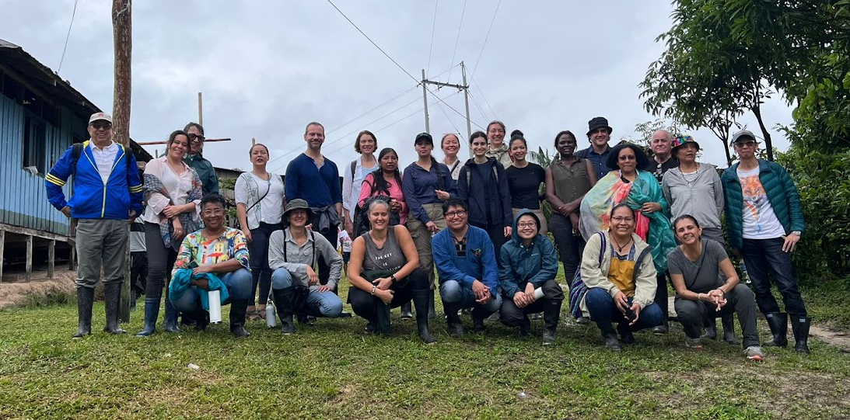

Suggested citation
IPBES (2023). Devi Anggraini, Edith Magnolia Bastidas Calderon, Ramiro Batzin, Julio Bombare, Cristina Coc, Q”apaj Conde, Mateo Estrada Cordoba, Julio César Estrada, Viviana Figueroa, Yesenia Hernandez, Hannah Longole, Onel Masardule, Hénry Negedeka, Sherry Pictou, Diana Quintero Rodríguez, Martha Rosero, Nick Roskruge, Darío Silva, Rodion Sulyandziga and Pirawan Wongnithisathaporn. Report of the second Indigenous and local knowledge dialogue workshop on the IPBES assessment of transformative change and scenarios of the future: reviewing the first draft of the assessment. 13-16 February 2023, Leticia, Colombia.

Disclaimer
The text in section 3, represents an attempt to reflect solely the views and contributions of the participants in the dialogue. As such, it does not represent the views of IPBES or UNESCO or reflect upon their official positions.

Acknowledgements
We are very grateful to the National Organization of Indigenous Peoples of the Colombian Amazon (OPIAC) for their support in organizing and carrying out the workshop, including for connecting the workshop with local Indigenous leaders. We are also very grateful to the community of Arara for hosting the community visit and for sharing their time and knowledge with participants, and to the shaman who met with us in the maloca in Leticia and shared his wisdom with the group. We are also grateful to the Sinchi Institute for hosting the workshop and for supporting planning, logistics and facilitation.

Table of Contents
1. Introduction 4
2. Background 5
2.1. The IPBES transformative change assessment 5
2.2. Context for the dialogue workshop 6
2.2.1. IPBES and ILK 6
2.2.2. ILK in the assessment process 7
2.2.3. IPBES work on scenarios and ILK 8
2.3. Objectives of the ILK dialogue workshop 10
2.4. Methods for the dialogue workshop 10
2.5. Free, prior and informed consent 11
2.6. Benefits to IPLCs of participating in the assessments and other activities 12
3. Key recommendations and learning from the dialogue workshop 13
Overarching comments on the process and aims of the assessment 13
Chapter 1: Transformative change and a sustainable world 15
Who and what needs to change? 15
Diversity of IPLCs 16
Conceptualizations 17
Chapter 2: Visions of a sustainable world – for nature and people 18
Conceptualizations of the future 18
IPLC visions for a good future 19
Chapter 3: How transformative change occurs 24
Decolonization 24
Enhancing rights and justice systems 25
Transforming governance 26
Transforming relationships between knowledge systems 27
Mobilization of IPLCs 28
Transformative changes in global systems 29
Implementation of transformative changes 30
Chapter 4: Overcoming the challenges of achieving transformative change 31
Broader society’s values and perceptions 31
Governance 31
Rights and justice 31
Economic systems 32
Environmental degradation, criminalization and conflict 32
Social change in communities 33
Chapter 5: Realizing a sustainable world for nature and people: transformative strategies, actions and roles for all 34
Overarching actions 34
Roles, responsibilities and actions 35
4. Next steps 44
Annexes 45
Annex 1: Draft Agenda 45
Annex 2: FPIC document 47
Annex 3: Participants of the dialogue workshop 50

Introduction
This is the report of the second Indigenous and local knowledge (ILK) dialogue workshop for the thematic assessment of the underlying causes of biodiversity loss, determinants of transformative change and options for achieving the 2050 vision for biodiversity (the transformative change assessment), which is being developed by the Intergovernmental Platform on Biodiversity and Ecosystems Services (IPBES). The workshop was held in Leticia, Colombia from 13 to 16 February 2023. The workshop took place within the first external review of the assessment, which ran from 3 February to 17 March 2023. The workshop aimed to provide a platform for Indigenous Peoples and local communities (IPLCs) to discuss the draft assessment chapters with the assessment authors.
In recognition of the synergies between the themes of the transformative change assessment and IPBES work on scenarios and models (see section 2.2.3), the workshop was co-organized with the IPBES task force on scenarios and models.
This report aims to provide a written record of the dialogue workshop, which can be used by assessment authors to inform their work on the assessment. It is also intended as a resource for all dialogue participants who may wish to review and contribute to the work of the assessment moving forward.
The report is not intended to be comprehensive or give final resolution to the many interesting discussions and debates that took place during the workshop. Instead, it is intended as a written record of the discussions, and this conversation will continue to evolve over the coming months and years. For this reason, both clear points of agreement and diverging views among participants are presented for further attention and discussion.
The text in section 3 represents an attempt to reflect solely the views and contributions of the participants in the dialogue. As such, it does not represent the views of IPBES or UNESCO or reflect upon their official positions.
The agenda and participants’ list for the dialogue are provided in annexes 1 and 3.

Background

The IPBES transformative change assessment
The full title for the transformative change assessment is “the assessment of the underlying causes of biodiversity loss, and the determinants of transformative change and options for achieving the 2050 Vision for Biodiversity”. The assessment commenced in 2021 and will be completed in 2024. It will consist of 5 chapters and a summary for policymakers and is being drafted by almost 100 authors from all regions across the world. The chapters are as follows:
- Chapter 1: Transformative change and a sustainable world
- Chapter 2: Visions of a sustainable world – for nature and people
- Chapter 3: How transformative change occurs
- Chapter 4: Overcoming the challenges of achieving transformative change
- Chapter 5: Realizing a sustainable world for nature and people: transformative strategies, actions, and roles for all
“Transformative change” was defined by the IPBES Global Assessment of Biodiversity and Ecosystem Services (2019) as “a fundamental, system-wide reorganization across technological, economic and social factors, including paradigms, goals and values, needed for the conservation and sustainable use of biodiversity, long-term human wellbeing and sustainable development”.
The IPBES Global Assessment concluded that the 2050 Vision for Biodiversity cannot be achieved without transformative change, and that measures necessary to enable transformative change will require fundamental changes in social, economic and technological structures within and across nations. These changes will include achieving a sustainable economy by tackling poverty and inequality, enabling integrative, inclusive, informed and adaptive governance, enhancing the conservation and sustainable use of nature, and promoting sustainable production, consumption, and food systems. The transformative change assessment aims to inform decision-makers on options to implement transformative change.
The transformative change assessment report will assess and compare different visions, scenarios, and pathways for a sustainable world, including visions of IPLCs. Further, the report will assess the determinants of transformative change, how it occurs, and which obstacles it may face.
Finally, the report will assess which practical options for concrete action to foster, accelerate, and maintain transformative change toward visions of a sustainable world exist, which practical steps are required to achieve these visions, and how progress towards transformative change can be identified and tracked.
IPBES recognizes that IPLCs hold knowledge, practices, worldviews, and values that can inform and provide examples of efforts to conceptualize, understand and create transformative change. This knowledge includes culturally specific visions of the future and strategies, pathways, and frameworks for achieving those visions. IPLCs also stand to be directly impacted – either positively or negatively – by transformative changes taking place in society as a whole. Participation of IPLCs is therefore crucial to the assessment.
More can be read about the transformative change assessment, including its scoping report, here: https://ipbes.net/transformative-change.

Context for the dialogue workshop

IPBES and ILK
IPBES is an independent intergovernmental body established to strengthen the science-policy interface for biodiversity and ecosystem services for the conservation and sustainable use of biodiversity, long-term human well-being and sustainable development.
Since its inception in 2012, IPBES has recognized that IPLCs possess detailed knowledge of biodiversity and ecosystem trends. In its first work programme (2014-2018), IPBES built on this recognition through deliverable 1 (c), Procedures, approaches, and participatory processes for working with Indigenous and local knowledge systems. The IPBES rolling work programme up to 2030 includes objective 3 (b), Enhanced recognition of and work with Indigenous and local knowledge systems, which aims to further this work.
Recognizing the importance of ILK to the conservation and sustainable use of ecosystems as a cross-cutting issue relevant to all of its activities, and noting also that approaches and methods for working with ILK and IPLCs in global and regional scale assessments would need to be developed, the IPBES Plenary established a task force on Indigenous and local knowledge systems and agreed on terms of reference guiding its operations towards implementing this deliverable. IPBES’ work with IPLCs and on ILK is supported by a technical support unit for ILK, hosted by UNESCO.
Key activities and deliverables of the task force and technical support unit on ILK so far include:
- Progress in the development of approaches and methodologies for working with ILK was made during previous IPBES assessments (Pollination, Pollinators and Food Production, Land Degradation and Restoration, four Regional Assessments and a Global Assessment of Biodiversity and Ecosystem Services, Sustainable Use of Wild Species, and Diverse Values and Valuation of Nature);
- The development and implementation of the “approach to recognizing and working with ILK in IPBES”, which was formally approved by the Plenary at its fifth session in 2017 in decision IPBES-5/1, which sets out principles and approaches for IPBES’s work with ILK;
- Development and implementation of methodological guidance for recognizing and working with ILK in IPBES, which aims to provide further detail and guidelines on how to work with ILK within the IPBES context; and
- Development and implementation of a “participatory mechanism”, a series of activities and pathways to facilitate the participation of IPLCs in IPBES assessments and other activities.

ILK in the assessment process
Following the IPBES approach to ILK and as part of the participatory mechanism, dialogue workshops are being held during the cycle of the transformative change assessment, as follows:
- Reviewing the scoping report (online, 16 July 2020);
- Discussing key ILK themes and framing of the assessment (29 June to 1 July 2022, Bonn, Germany);
- Reviewing the first draft of the chapters (13-16 February 2023, Leticia, Colombia – the subject of this report); and
- Reviewing the first draft of the summary for policymakers (SPM) and the second draft of the chapters (TBC – likely December 2023).
These workshops bring together IPLCs and authors of the assessments to discuss key themes relating to the assessments. They are part of a series of complementary activities for working with ILK and enhancing participation by IPLCs throughout the assessment process.
Other activities during an assessment include an online call for contributions, invitations to contributing authors and review of diverse literature and materials (see figure 1).
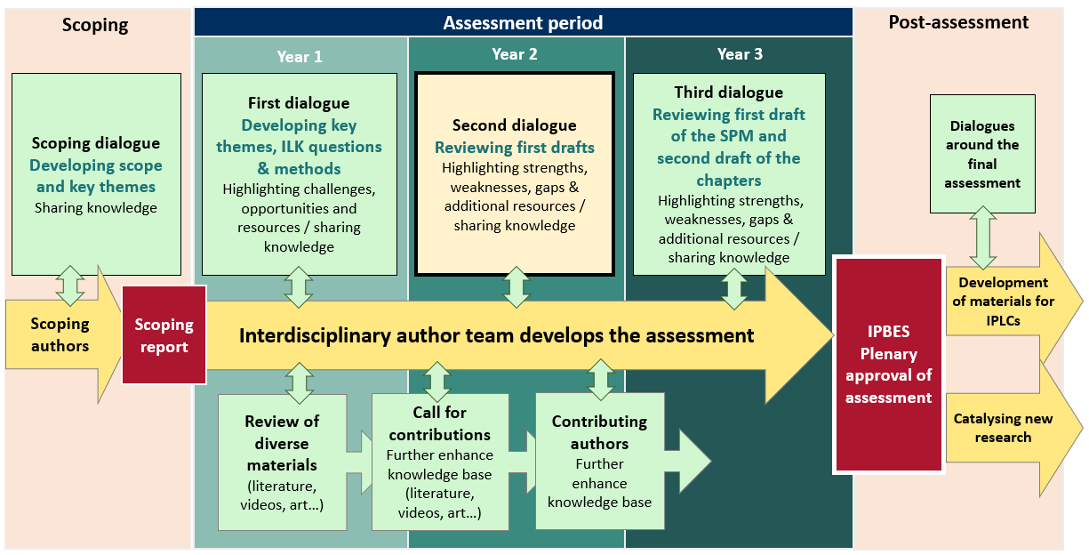
Figure 1: Timeline of work with ILK in IPBES assessments, following the IPBES approach to ILK.

IPBES work on scenarios and ILK
Existing scenario approaches, especially at global and regional scales, have limitations and gaps that constrain their utility for understanding future trends in biodiversity. In recognition of this gap, IPBES developed work on scenarios of nature implemented by a task force and supported by a technical support unit.
IPBES also recognized that working with IPLCs and their knowledge systems is essential to build scenario narratives based on multiple perspectives and values, with the goal of enhancing ownership, relevance, and uptake for decision-making at all levels, including by IPLCs.
IPBES therefore developed a series of activities for working with ILK and IPLCs in connection to scenarios, with a particular focus on the development of the Nature Futures Framework, including an online dialogue workshop with IPLCs.
What are scenarios?
Scenarios are representations of possible futures. They provide a full narrative of the future, which can include a vision (a description of a possible future) and the pathways that could take us there (see figure 2). They describe how drivers/causes of change could unfold and affect nature and people in the future. Scenarios allow the description and evaluation of possible futures based on choices made today, and they can include alternative policy or management options.
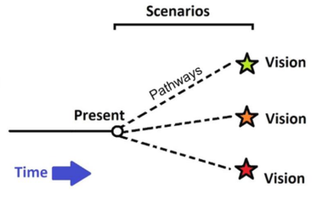
Figure 2. Simplified diagram of scenarios, showing visions and pathways

In recognition of the synergies between the themes of the transformative change assessment and IPBES work on scenarios, the workshop was co-organized with the IPBES task force on scenarios and models. Activities at the workshop included visioning and pathway building exercises, which are methodologies for developing scenarios (see section 2.4 for methods). This was in the framework of the task force on scenarios and models’ deliverable to provide advice on scenarios and models to IPBES assessments and serves to enhance the task force’s work on the methodological guidance for the Nature Futures Framework.

Objectives of the ILK dialogue workshop
The objectives of the ILK dialogue workshop were as follows:
- Reviewing the first drafts of the chapters of the transformative change assessment, for strengths, weaknesses, gaps and ways forward to reflect ILK and the visions, strengths and challenges of IPLCs;
- Developing a series of comments from IPLCs that can be entered into the assessment’s formal external review process;
- Exploring through practical activities how IPLCs understand transformative change, including the changes they wish to see for their communities and the world, their visions for the future, and pathways, challenges and opportunities for achieving these visions;
- Beginning to develop case studies of relevance to the assessment;
- Identifying resources and sources of information that could be included in the assessments; and
- Exploring key issues for IPLCs and ways forward in relation to the further development of IPBES work with scenarios.

Methods for the dialogue workshop
The dialogue took place over four days, and the agenda is presented in annex 1 of this report. Methods for the dialogue workshop included:
- Presentations and discussions on IPBES and its goals and methods, the draft chapters of the assessment and free, prior and informed consent;
- During small group and larger group sessions, a visioning and pathways activity was carried out. This activity aimed to loosely follow the chapters of the transformative change assessment. As such, participants were asked to consider the following questions:
- What would a “good future” look like for your community and territories? What do you want your community and lands to look like in the future? Who, as IPLCs, do you want to be in the future?
- What are the current challenges or obstacles to achieving this good future?
- What are the current strengths of your community and territory?
- What positive forces currently exist in broader society that can support communities?
- What would need to happen to overcome challenges and build on existing strengths, so that communities can achieve good futures? What should the next steps be?
- How would these changes also contribute to global well-being?
- A visit to a maloca (traditional communal house that also serves spiritual purposes) in Leticia to learn from a shaman about Indigenous spirituality and ways to lead a good life; and
- A visit to the Arara community near Leticia, to discuss with community members’ about their aspirations for the future and community development.

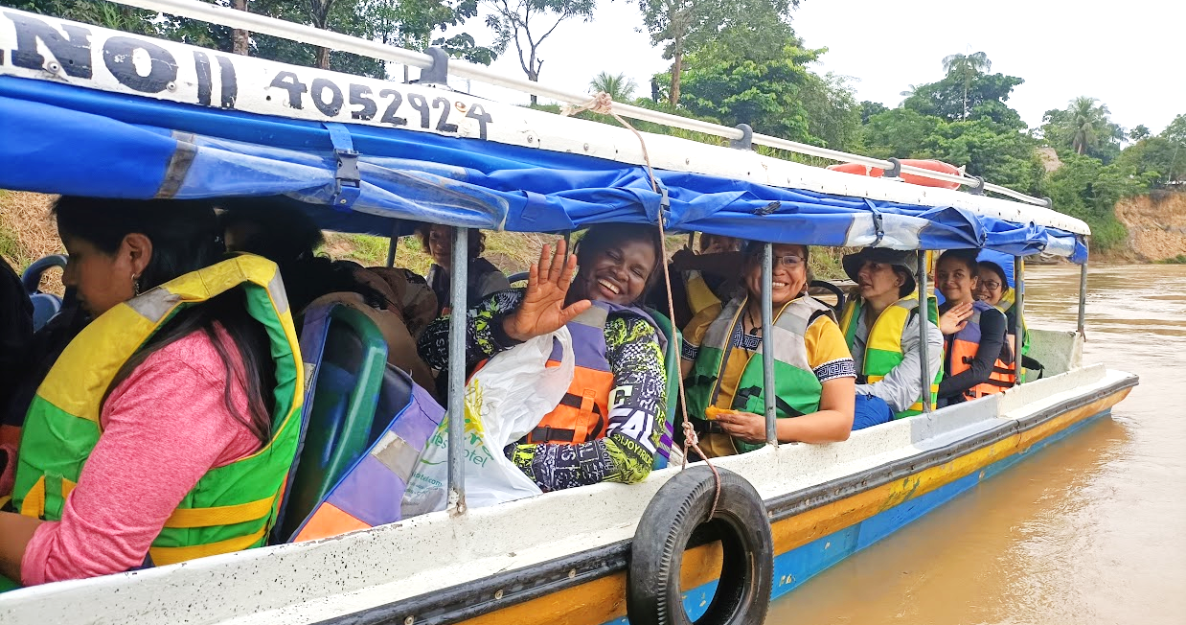
Figure 3: On the way to the Arara community.

Free, prior and informed consent
Free, prior and informed consent (FPIC) principles are central to IPBES work with IPLCs, and a series of ethical principles have been developed to ensure that FPIC is followed in IPBES activities. These principles were agreed upon by the participants of the dialogue, and will be followed by IPLC participants, the assessment authors group and the IPBES secretariat. The full agreed-upon text and the names of those agreeing to these principles are provided in annexes 2 and 3 to this report.

Benefits to IPLCs of participating in the assessments and other activities
During previous workshops, participants noted that there need to be clear benefits to IPLCs if they are to participate in an assessment process. It was noted that IPBES does not benefit financially from its processes or products, and that the main products of IPBES are publicly available resources, including the assessments, which aim to provide free and reliable information for policymakers and decision-makers and actors at all levels, including IPLCs. Key benefits of participating in dialogue workshops, and the assessment process as a whole, for IPLCs that were discussed included:
- The opportunity for IPLCs to share experiences with other IPLCs around the world;
- The opportunity for IPLCs to share and exchange experiences and knowledge with IPBES assessment authors;
- The opportunity to bring ILK and IPLC concerns to the attention of policymakers and decision-makers; and
- Use of the final assessments as a tool when IPLCs are working with policymakers, decision-makers and scientists, noting that part of the planning for the final assessment includes the development of an accessible summary for IPLCs and webinars that present the results to IPLCs.

Key recommendations and learning from the dialogue workshop
Over the course of the workshop, IPLC participants made a series of comments and recommendations for the transformative change assessment. From this process, a series of comments were entered into the assessment’s formal online review process for the consideration of assessment authors. The section below builds on the comments provided by the participants, providing added detail and examples that were shared during the workshop. As much as possible, the text reflects what was said during the workshop by participants, with only minimal editing.

Overarching comments on the process and aims of the assessment
There was great concern from IPLC participants that governments will not act on the findings of the assessment, as they are not binding. Participants highlighted that a clear strategy is needed for implementation of the findings of the assessment. They emphasized that IPLCs should be key actors and partners in the transformative change process, with guaranteed participation and collaboration. This process begins with how the assessment is written – it should be actionable with clear steps for implementation and participation.
Overall, participants noted that it can be difficult to think positively about transformative change when many of the global trends are very negative. However, they also recognized the importance of building aspirations for better futures.
Participants emphasized that there is also great concern from IPLCs that the 2050 Vision is too far in the future as many urgent challenges for IPLCs need resolving today, rather than within a 30-year time frame. It will be important for the assessment to highlight how the impacts of the global biodiversity crisis are affecting IPLCs in significant ways that have not yet necessarily been felt by global society. For example, many IPLCs are already experiencing direct impacts of climate change.
Participants also asked that the assessment emphasize the voices of IPLCs, by including narratives and non-written forms of knowledge expression, rather than only including text and analysis. They noted the importance of providing a full, holistic representation of ILK and IPLC visions, values, concerns and pathways, that also includes spiritual aspects, rather than only selecting small fragments of knowledge.
Participants noted the importance of introducing and clearly explaining the methodology for working with ILK and IPLCs within the transformative change assessment, as well as explaining why such a methodology is important. The development of the assessment and the use of the final assessment product should aim to be transformative in terms of participation and amplifying the voices of IPLCs. In this way, the transformative change assessment could serve a crucial role in demonstrating new ways and approaches for working with and recognizing ILK and co-production between different knowledge systems.
Participants noted that new ways of acknowledging and citing IPLCs and ILK within the assessment would be an important step towards making the assessment a transformative process. The assessment should include a paragraph to highlight that the assessment has benefited from the collective contributions of IPLCs, as well as specifically citing and acknowledging contributions as fully as possible. Participants also noted that the term “grey literature” is inappropriate for referring to ILK that is being represented in forms other than peer-reviewed journals, as could be seen to imply an inferiority.
Participants noted that the assessment falls within the UN decade on Indigenous languages, so the assessment could center languages as much as possible, including using Indigenous and local languages within the assessment.
Following the principles and process of FPIC and engaging in ongoing communication with IPLCs will be important throughout the development of the assessment, as will ensuring benefits to IPLCs through activities and materials after the assessment is completed.
Participants highlighted that when discussing Indigenous Peoples and local communities in the assessment, it will be important to recognize that Indigenous Peoples have a distinct normative rights framework under the UN Declaration on the Rights of Indigenous Peoples (UNDRIP), the American Declaration on the Rights of Indigenous Peoples, the International Labour Organization’s Indigenous and Tribal Peoples Convention No. 169, and others, and that Indigenous rights should therefore be discussed separately from local community rights, which are generally treated differently at the international level.
A participant at the dialogue workshop noted that, while local community rights frameworks are still under development at the international level, there are some international instruments that recognize local communities’ rights, e.g. the UN Declaration on the Rights of Peasants, as well as different local community frameworks at national levels.

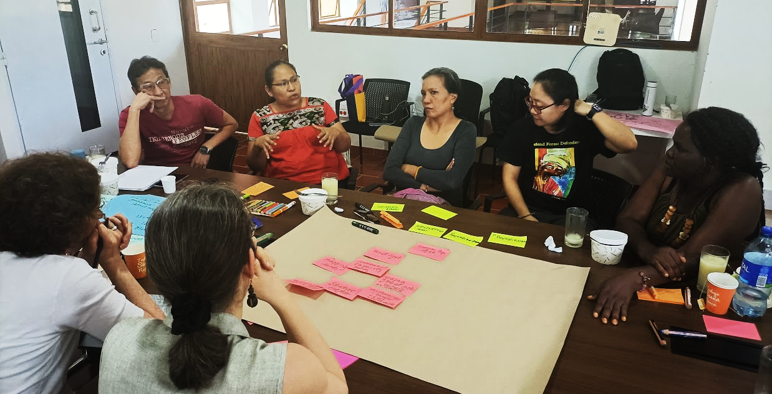
Figure 4: Discussions in a breakout group during the workshop.

Chapter 1: Transformative change and a sustainable world

Who and what needs to change?
Participants highlighted that they have concerns about the concept of transformative change, including that it can give the impression of a universal change that will be imposed on IPLCs in the name of environmental protection, as has been the case with other concepts in the past. In Chapter 1 it will therefore be important to introduce the key question of who and what needs to change and how, noting that different groups have different roles and responsibilities.
Participants noted that in general, IPLCs are not responsible for the current global environmental crises. It is rather global governmental, economic, industrial, extractivist and colonial systems that are at the root of the crises. These systems therefore need to change, along with broader societal paradigms, values and connections to relationships with nature. Therefore, many IPLCs may want to see transformative changes in broader society and big global systems, including governments, business and industry, rather than significant changes in their own communities.
Participants also noted that often IPLCs have been resilient in the face of the changes they have experienced in their territories because of non-Indigenous actions, culture and systems, and that much of this resilience comes from the knowledge and spiritual systems of IPLCs. Many IPLCs wish to continue their cultures, identities and livelihoods in their territories and preserve their systems of knowledge, values and life. As such, one aspect of the transformative change they desire is for broader society to understand and recognize IPLCs, and to create spaces and systems that support IPLCs and enhance their autonomy and self-determination. Changes in how IPLCs are perceived by broader society may be key – for example recognition that IPLCs are biodiversity guardians or custodians, as opposed to views that lead to evictions of IPLCs from protected areas.
Participants also noted that when considering this transformative change for broader society, much may be learned from IPLC values and knowledge, including ways of living sustainably and connecting with nature.
Participants emphasized that participation by IPLCs in discussions and processes of transformative change will therefore be key, including around issues that seem far from communities, noting that IPLCs can be important actors for global change at all levels and that their knowledge and values can help to inform directions and pathways for change. They also stand to be further impacted by transformative changes in big global systems, both directly and indirectly. IPLC participation in discussions and actions for transformative change therefore needs to be ensured and monitored, with clear indicators.

Diversity of IPLCs
Participants also noted that when discussing IPLCs and transformative change, attention to the diversity of IPLCs and their current situations will be key. This should include communities that may frequently be invisible, such as afro-descendants in the Americas.
For examples of diversity, participants highlighted that some IPLCs may prioritize restoring and strengthening their traditional ways of life, values, and governance systems, especially where these have been significantly impacted by colonialism and other modern pressures. Others who have been less impacted may want to maintain what they have managed to preserve. Others may wish to see modern elements of development such as roads, hospitals and schools, often whilst also wishing to maintain their roots in their values and identities. Many communities will include some mix of these aspirations and visions for the future. It will thus be important to highlight that there is diversity between communities — the original diversity that has always existed, and then the diversity between communities that have maintained their knowledge, values and governance systems and live in healthy abundant environments, and those who have lost much of their knowledge, values and governance systems due to external pressures, or who live in highly degraded environments.
Participants also emphasized that recognizing diversity within individual communities is also important, for example between elders and youth, and women and men. It will be important to ensure that chapter 1 and all subsequent chapters consider gender perspectives and the specific situations and capacities of women.
Workshop participants noted that it will also be important to recognize that ILK, and IPLC ways of living, are also dynamic and always changing, so they should not be represented as static or from the past. However, many communities seek to maintain core values and beliefs through this dynamic process.

Conceptualizations
Participants also noted that there needs to be careful consideration of key concepts from the perspective of IPLCs, including “change” and “the future”. These concepts will need to reflect conceptions of many IPLCs of time as cyclical and non-linear, and the importance of maintaining balance and harmony even through change. As discussed above, reconstruction and revitalization may be an important focus for IPLCs when talking about transformative change, building back what has been lost or damaged both culturally and environmentally. It will also be important to highlight that IPLCs make decisions every day concerning the future and their relationships with nature. Thus, they are well placed to be involved in these discussions, even where their conceptualizations of time and the future may differ from those of broader society. This is further discussed below for Chapter 2.

Chapter 2: Visions of a sustainable world – for nature and people

Conceptualizations of the future
Participants noted that before discussing visions of the future, it is important to consider how IPLC conceptualizations of the future may differ from those of the rest of society. They explained that in many IPLC communities, for example in the Colombian Amazon, the past, present, and future are not linear but are perceived cyclically, and through generations: the grandfather is the past, the son is the present, and the grandson is the future, tied together through the transmission of knowledge. In this conception, it is possible to restore or bring back cultural, ceremonial and land and water-based practices, rather than always progressing towards the future. Maintaining balance may also be more important for many communities than affecting change, which is usually a preoccupation of, and imposition by, people from outside.

Example
The Siriano people of Colombia consider time as cyclical: the past, present and future are connected, and life forms a positive spiral, in which dialogue and the transmission of knowledge are key to sustaining systems, while also feeding back and learning from previous experiences.

Participants also noted that in some communities, people do not talk about the future, as this is recognized to be unknown. It can be more important to live well every day rather than trying to make changes with a plan for the future. In this conception, if people maintain and care for the community, nature and spirits, there is no need to worry about the future.
Other participants noted the diversity of views of the future between IPLCs. For example, a participant noted that the Kuna people from Panama do think and talk about the future, and they do so based on a collective future, because individuals may pass on but the community and collectivity still continues. Similarly, other Indigenous communities plan and manage their resources so that they can be sustained for future generations, for example the Seventh-Generation Principle seen in Canada, which guides Indigenous Peoples to think of the impacts of today’s thoughts, decisions and actions on people seven generations in the future.
Participants also noted that on a collective level, many communities have done work to set out their visions, for example through talking/spoken maps (mapas parlantes) in Costa Rica. These maps are a collective effort with youth, elders, women and men, where elders look to the past, including 100 to 200 years ago, in order for the community to discuss and make projections for the future. Visioning work done by communities in Belize also demonstrates ways that communities are working to collectively set out their future visions and pathways to achieve them.
In relation to the visioning exercise in Belize, a participant explained that the framing of visioning questions can also be very important for IPLCs. When asked what they want for the future, many community members may respond that they want roads, hospitals, internet and other aspects of development. However, when asked “who are you?”, and “who do you want to be?” community members may respond that they are hardworking, peaceful, and harmonious, and that they want to be open to the outside world and new opportunities and technologies, but with strong roots in their traditions, spirituality and knowledge and value systems.

IPLC visions for a good future
Participants explained many different aspects of IPLC visions for good futures, many of which are shared by many communities around the world, whilst also noting that there is diversity between and within communities.

Restoring and maintaining balance and relationships
Participants highlighted that for many IPLCs, key features of future visions include maintaining or restoring relationships, respect, reciprocity, responsibilities and solidarity between people and the land, waters, rocks, animals, plants, spirits and the cosmos. Balance and harmony between people and these elements are key, partly maintained through rituals and ceremonies, as well as IPLC knowledge systems and other daily practices and values. Participants noted that if the western world could also turn to such spiritual connections, this would be a transformative change.

Examples
A participant explained that in New Zealand (Aotearoa in the Māori language) the concept of ‘whakapapa’ shows relationships through generations and ancestors. It also includes their important relationship with the ocean. People are considered the guardians (kaitiaki in Māori) of nature, and there is a recognized system of responsibility, in which animals and trees can also be considered as guardians. There is also a system for resource management enshrined in the concept of ‘kaitiakitanga’. People are born with the responsibility and obligation to be a guardian. Not everyone has the same level of responsibility, and there are individual, family, and age levels for responsibility, and this relates to the position individuals have within that system. However, these relationships are becoming weaker, and they need to be taught to children and youth, or they will not be reflected in the future.
A participant from Canada shared a quote by a young Indigenous person in the film We Story the Land: “When you are out in the woods or on the water, you become very in tune [that] you are part of it… then you realize our people have been here. When you are standing there you can start thinking really about what it means about actually where you are standing. There’s not a time that we don’t know that we haven’t been here, or our ancestors haven’t been here. So to me we are a part of this land. We are like the blood that runs through the veins of the trees and streams. We are part of that.” (Martha Stiegman and Sherry Pictou. 2016. Co-directors)
A participant from Thailand explained that humans are born with five spirits within them, and then there are also 32 spirits in the land, which are connected to people, so the rest of a person’s soul, or spirit, is in the forest, with the land, trees, stones and rivers. A person is therefore not a human alone, but is connected to nature.

Self-determination, governance and rights
Participants reported that the right to self-determination for Indigenous Peoples is fundamental to most Indigenous visions. It means that IPLCs would have control over decisions affecting their lives, visions and futures, allowing them to freely choose their political status and also provide for their economic, social and cultural development. This should be explored in detail in the assessment, as a key element for transformative change. Participants also noted their wish that governments would not see self-determination as a threat or a challenge, as many communities wish to contribute positively to their countries, but from a position of self-determination.
Linked to this, decolonization is an important foundation for the visions of many IPLCs, recognizing that for many communities, colonization has been, and continues to be, a highly disruptive and damaging process. Conservation was highlighted as a movement that needs to be decolonized in order to benefit IPLCs, and to fully benefit from their contributions.
Participants highlighted that recognition of Indigenous governments by national governments, and policies that support local-level decision-making and customary governance systems is key to many Indigenous visions. Governments and the international community would need to implement the framework of rights recognized in different national and international frameworks in this regard, including UNDRIP, as these give protection to customary governance systems.
Participants also highlighted the importance of recognizing Indigenous land rights within many Indigenous visions, as this is crucial for good management, planning, food security, education on the land, health, and many other aspects of IPLC livelihoods and cultures, as well at conservation of biodiversity. As such, Indigenous Peoples would be treated as actors who need to be consulted and treated as owners of their territories.
Sovereignty, prosperity, and dignity are also key features of many IPLC visions. Participants also highlighted that identity is also a fundamental principle, especially for Indigenous Peoples who are not recognized by their national governments. This principle is linked with territories, natural resources, knowledge and spirituality.

Community and peace
The concept of “community” was highlighted as a central concept by many participants, noting that in the past, and continuing in many places today, community support and sharing are key to a good life for many IPLCs, where friends, relatives and neighbors will share food or provide support if a person is sick or building a house. This sharing provides security and support beyond that which can be provided by money. Participants noted growing individualism and wealth disparities in communities, and that a good future vision would be to return to and enhance the sense of communality, caring, reciprocity and respect between people.
Participants reported that peace is another key theme of many IPLC visions, with participants recognizing that at present many communities are not able to enjoy peaceful relationships with their neighbors, governments and business and industry, which may be aggravated by issues such as climate change. Halting the criminalization of, and violence against, environmental and Indigenous defenders is also key to bringing peace in many regions. They noted that territorial conflicts have been exacerbated in recent decades as a result of others trying to claim or benefit from the environmental, economic, cultural and biodiversity value of Indigenous Peoples’ territories and local community lands, which have been maintained thanks to IPLC knowledge, practices and management and governance systems.

Knowledge systems
Workshop participants highlighted that in future visions of many IPLCs, ILK should be lived and practiced, through livelihoods and activities on the land and waters, so that it can dynamically grow and adapt with a community. This approach contrasts with ILK only being documented and conserved, as very little of ILK can be preserved or understood by documentation alone, as meanings and values are altered in the process of documenting knowledge. Language is key to understanding and living ILK, and should be central to IPLC research, education and governance systems.

Lands and waters
Participants explained that healthy lands, clean waters, and abundant, healthy plants and animals are key aspects of many IPLC visions, noting that well-being for IPLCs is usually understood holistically, in that a healthy planet reflects a healthy and harmonious life.
Access to lands, territories, and nature is also crucial for IPLCs, to preserve their livelihoods, knowledge and spiritual systems. For example, a participant from Uganda explained that for pastoralists, future visions may include free movement and access to their lands, without boundaries and fences, so that their livelihood and cultural systems can be maintained. Other cultural practices can also be tied to access to nature. For example, in Uganda, pastoralist communities cannot meet in closed rooms – they must meet in nature to have culturally meaningful discussions.
Participants noted that many IPLC visions include food security, food sovereignty, and the spirituality, language, values, knowledge, culture and territory that connects biodiversity, food and IPLCs.
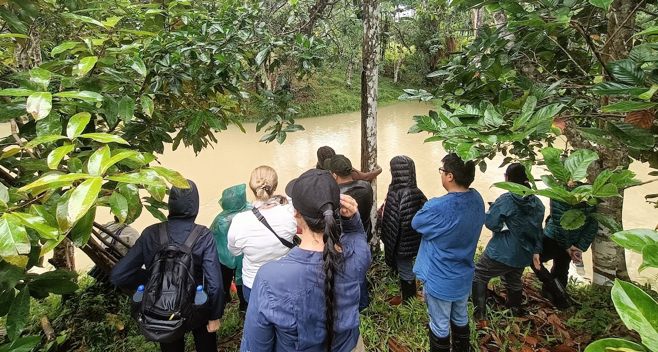
Figure 5: Discussing the Arara community’s aquaculture project.

Relationships with broader society
Participants highlighted that a key vision for many IPLCs is that they and their knowledge and practices be supported by governments, and political, economic and education systems at all scales. Ways should be found for IPLCs and these systems to work together to be mutually supportive, rather than in conflict. Many IPLCs wish to make positive contributions to their countries, but they wish to do so through their own systems.
Tied to this, many participants explained their desire for broader society to be inclusive, and to value and respect diversity. In this vision, broader society would be more open to work with IPLCs, to build a genuine and trusting intercultural dialogue for the benefit of all.
Participants highlighted that many IPLC visions may include changes in the ways they are perceived by broader society. For example, they may wish to be seen as hard working, peaceful and as enjoying a richness of spirit and nature. This is as opposed to persistent stereotypes in many countries about IPLCs as lazy, dangerous or disruptive, or poor.
Participants reported that a key vision for many IPLCs is a recognition that IPLCs are stewards of nature and that conservation cannot proceed without IPLCs, as opposed to being seen as environmentally destructive. They wish to be better supported in managing nature, with their own knowledge, values, management and governance systems. They noted that IPLCs usually manage nature for the wellbeing of nature, knowing that this will in return lead to human wellbeing, rather than managing nature only for humans.
Participants also highlighted that many communities wish to be open to the rest of the world, to new technology, pathways and opportunities, whilst maintaining their own strong roots in their knowledge and values. Communities are often perceived by outsiders as anti-development, but this is not necessarily the case; they are instead often against exploitation that damages nature and their communities. They often desire development opportunities, but these need to be controlled by communities and in keeping with their values and governance systems. They may wish to build strong, vibrant, dynamic communities that can engage with the outside world in an equal manner and that can provide opportunities for their youth. Many communities wish to be open to, and collaborate with, a world that treats them with respect and fairness.
Participants also explained a future vision in which ILK and science would work together in processes of mutual respect with no hierarchies of science over ILK, including recognition that ILK does not need to be validated by science. They highlighted that it is important that western science learns to learn from ILK, whilst accepting that not all ILK can be shared and understood by non-IPLCs. The transformative change assessment could open the door for more constructive processes of dialogue and innovation.
Participants also emphasized that to achieve good future visions, FPIC and consultation should be recognized as a right of Indigenous Peoples by governments, business and industry, and science and research. This will support conservation and culturally and environmentally appropriate development, as communities would be able to manage their own lands and wellbeing.

Chapter 3: How transformative change occurs
Participants at the dialogue workshop discussed and provided examples of the different ways that transformative change can occur, for their communities and for the world. Participants recommended that it would be beneficial to document and systematize current experiences of transformative change, including those of IPLCs. Participants noted that many IPLCs consider problems, their causes, impacts, benefits, solutions and adaptation holistically, rather than as discrete aspects of an issue.
Participants highlighted that for many IPLCs, transformative change should enable the continuity or revitalization of their ways of living and their value systems, cosmovisions, culture, knowledge, and practices, whilst also acknowledging that these are dynamic and adaptive. These systems are based on harmony among humans, and between humans, nature and spirits. However, these systems are currently under threat from many external pressures, so transformative change could entail removing these pressures and better supporting IPLCs to restore the balance between the cosmos, nature and human beings. Participants emphasized that this transformative change can only occur through profound changes in the systems, processes and practices that often cause the destruction of IPLCs and their ways of living, values, cultures, and knowledge, as discussed below.

Decolonization
Decolonization was highlighted by workshop participants as a key process for transformative change. This process should involve the recognition of the long history of colonization that has pushed many IPLCs into unsustainable practices or degraded environments, and the damage done to their cultures, knowledge, value systems and wellbeing. It also requires a recognition that the consequences of colonization processes are ongoing. Thus, transformative change should include changes in current systems of hierarchy in cultural, economic, social, political and knowledge systems that hinder IPLCs’ capacity to maintain their ways of life.
In general, participants highlighted the importance of changes in power dynamics and relationships at different levels: from personal to societal, from local to global, and from national to international. Colonial, developmental, economic, social and political structures have created unequal power dynamics at all levels. Transformative change requires challenging existing unequal power dynamics at all levels and establishing frameworks that nurture and enhance relationships based on reciprocity, equality and harmony.

Enhancing rights and justice systems
Workshop participants highlighted the importance of the recognition and guarantee of the rights of Indigenous Peoples, as enshrined in UNDRIP, as a key process that would be a transformative change.
Participants also highlighted that legal recognition and legal certainty of land ownership is a fundamental and crucial step in ensuring the effective management of lands, territories and human wellbeing, as this allows for planning and action in a space of legal clarity and certainty. The assessment could explore the different ways that national laws of different countries approach the recognition of Indigenous lands, territories and territoriality, as well as how this is considered for local communities.
Participants also noted the importance of transformations in the justice system to understand and support Indigenous rights and halt discrimination against IPLCs and criminalization of IPLC practices and struggles. They noted that Indigenous Peoples have their own laws, legal systems, and unwritten norms and guiding values, all of which consider ways of imparting and ensuring justice and are embedded in their knowledge and cultural systems. It would be beneficial to deepen the relationship between different justice systems, aiming for legal pluralism and an enhanced system of international governance of the law.
The workshop participants also highlighted the importance of recognizing the rights of nature and Mother Earth in existing regulatory frameworks, as a way of transforming global relationships between people and nature.

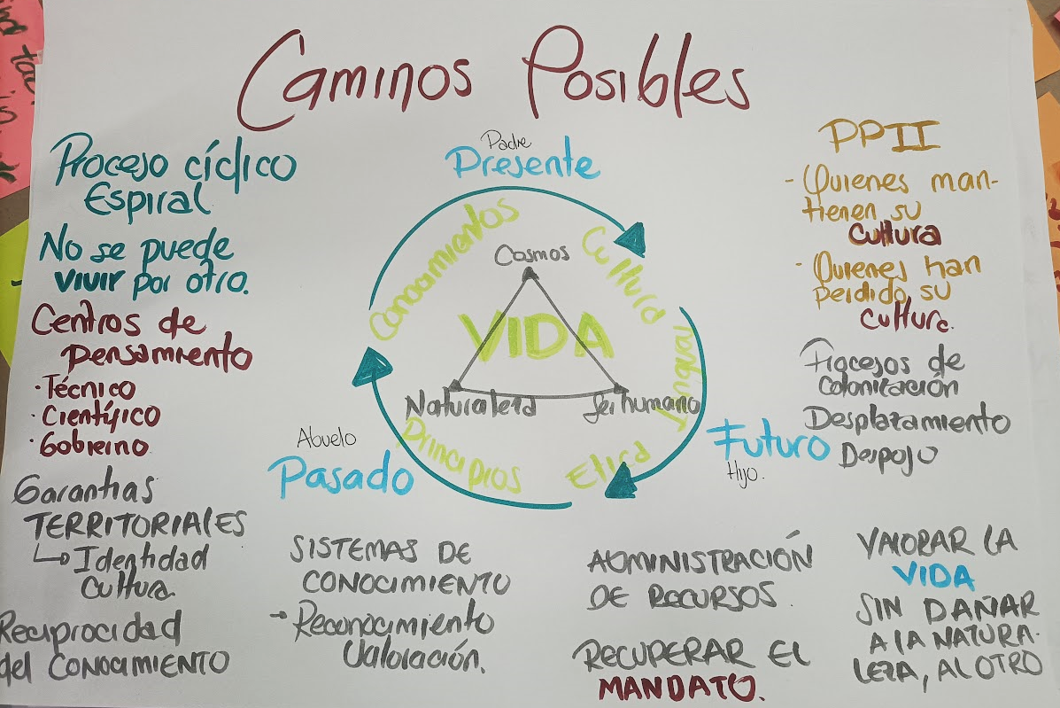
Figure 6: Building a picture of possible pathways, considering the cyclical nature of time and the interrelationship between nature, humans and the cosmos.

Transforming governance
The need for transformative changes in governance systems was highlighted by the participants. They noted the need for more local governance, with respect and support for IPLCs’ customary governance, rather than a focus only on national governance. They noted that national and international institutional adjustments may be needed to facilitate governance by IPLCs.
Participants reported the importance of recognizing IPLCs as stewards and guardians of nature, and as active decision-makers and actors around conservation and human wellbeing. In many cases, this could lead to the passing of control and management of communities and conservation areas to IPLCs. For this to occur, more participatory processes and spaces will be needed, keeping open the existing spaces of dialogue and negotiation with governments and international institutions, as well as creating new spaces for guaranteed active participation of IPLCs in decision-making.
Participants also reported that innovative use of existing legal and governance mechanisms (such as national parks systems) can in some cases strengthen IPLC management of lands and recognition of IPLC governance (see example below), whilst recognizing that in many cases protected areas can be a threat to IPLCs. To avoid this threat, protected areas that overlap with Indigenous territories and local community lands could be governed by IPLCs, to improve land management and community wellbeing.

Example
A participant from Russia shared that his community has already made a transformative change. As they are one of the smallest tribes in Russia, with 1,500 people in total, they were always forced to think about their future. They decided to stay isolated to preserve their identity, their forest and their traditional lifestyle. However, after many years, they came to the conclusion that they were losing out on development, and that they desired access to education, health care, and new technology. Five years ago, the community made the decision to accept the establishment of a national park within their territory. However, they demanded several conditions that the government accepted, including that they should have control over the park, with a council of Indigenous Peoples as part of the park’s management. The chair of that council is automatically the deputy director of the national park. In order to make this transformative change, strong political leadership was needed by the community to participate in high level negotiations, and to participate in the creation of written, legally binding documents reflecting the agreements. Now, 80% of the total park zone, around 2 million square kilometers, belong to community hunters and fishermen. Thus, the Indigenous community can continue its traditional lifestyle in the national park. They have now prevented poaching, illegal logging, overfishing and the threats of outside businesses that wanted to extract resources. The park has now been granted UNESCO world heritage status. While many national parks create problems for Indigenous Peoples, this example shows that if common understandings and compromises can be found between Indigenous Peoples and the government, there is scope for change.

Transforming relationships between knowledge systems
Participants highlighted changes in relationships between knowledge systems as a key process for transformative change. Respect for and recognition of ILK as a knowledge system on equal terms with scientific knowledge is crucial, including recognizing that it is not necessary or appropriate to validate ILK through scientific knowledge. Revaluation of knowledge systems and expertise is also needed, with a greater emphasis on knowledge that is lived and experienced, and increasing and reviving processes (cultural, environmental and educational) for learning knowledge in practice, with the recognition that these processes are dynamic and adaptive. Creation of spaces for knowledge exchange and ensuring effective inclusion of diverse systems of knowledge in the production of knowledge, including for environmental protection and human wellbeing, will be key. In all these processes, FPIC and recognition of intellectual property and benefit sharing will be essential.
Linked to changes in knowledge systems, participants highlighted the importance of changes in education systems. Recognizing that many formal education systems have their origins in times of colonialism, they recommended rethinking education systems through an examination of Indigenous ways of knowing and learning. This may include mainstreaming ILK into formal curricula and facilitating and valuing learning through experience outside of the classroom, recognizing the expertise of elders and other ILK holders, and revaluing different forms of knowledge, as described above. Participants emphasized that formal education is often focused on theory, rather than on Indigenous ways of learning that apply to practical real-life experiences. They noted that for many IPLCs, a person is considered to be what they do, not what they say, and that education systems need to reflect this. Many IPLCs desire an education system that teaches both ways of knowing, and that provides practical knowledge and skills to solve real-life challenges.
They also highlighted the importance of Indigenous and local languages, as many concepts, value systems and most ILK cannot be translated into other languages or understood by other ways of thinking. Education in Indigenous and local languages, and efforts to revitalize languages through education, will be key.

Example
A participant from Belize explained that they have a community school where food is grown by students that aims to combine practical and theoretical learning, for a more relevant, responsive education. For example, food is grown by the students. This kind of community school is however hard to replicate, and it faces many challenges. Often, it is not recognized as providing actual education, and it is seen as a less prestigious option than other schools. In spite of this, the Belize community school has a vision of creating a space that is competitive and prestigious, where the expertise of elders and the benefits of land-based learning are embraced. For this to occur the school needs funding, support and allyship, including from more formalized educational systems which could provide more recognition and visibility.

Participants also noted that opportunities and support for Indigenous scholarship in higher education are increasing in many countries of the world. On the other hand, they also noted that many challenges remain, as higher education often functions within the strictures of western models of research, learning and knowing. Creating IPLC institutions and increased recognition of IPLC frameworks, methodologies and scholarship would be a transformative change.

Mobilization of IPLCs
Participants highlighted that mobilization and organization by IPLCs themselves can be a key feature of transformative change, recognizing the different ways that IPLCs have been able to push for transformative change in their communities and their relationships with broader society and governments. Strategies used by IPLCs have included advocacy and lobbying, negotiation and legal recourse, and direct action and protest. Some IPLCs have also made strategic alliances with various actors, including lawyers, scientists and researchers, and intergovernmental UN mechanisms. They have also carried out training and capacity building within the judicial system and local and national governments, so that IPLC rights and issues can be better considered in legal and governmental processes.
Workshop participants also highlighted that there is a need to challenge the stereotypes that all IPLCs are marginalized, objects of change, passive actors and other stereotypes that serve to consolidate unequal power dynamics. There is a need to recognize the agency of IPLCs, and the impressive contributions that they make to sustaining biodiversity. Elders, youth and women are crucial actors in carrying and maintaining IPLC ways of living and ILK, and creating new visions based on IPLC value and knowledge systems. There is a need for the creation of mechanisms that will reconnect youth with values, knowledge systems, community pride, and ways of life that are based on harmony. Empowering and supporting IPLC women within communities is also important.

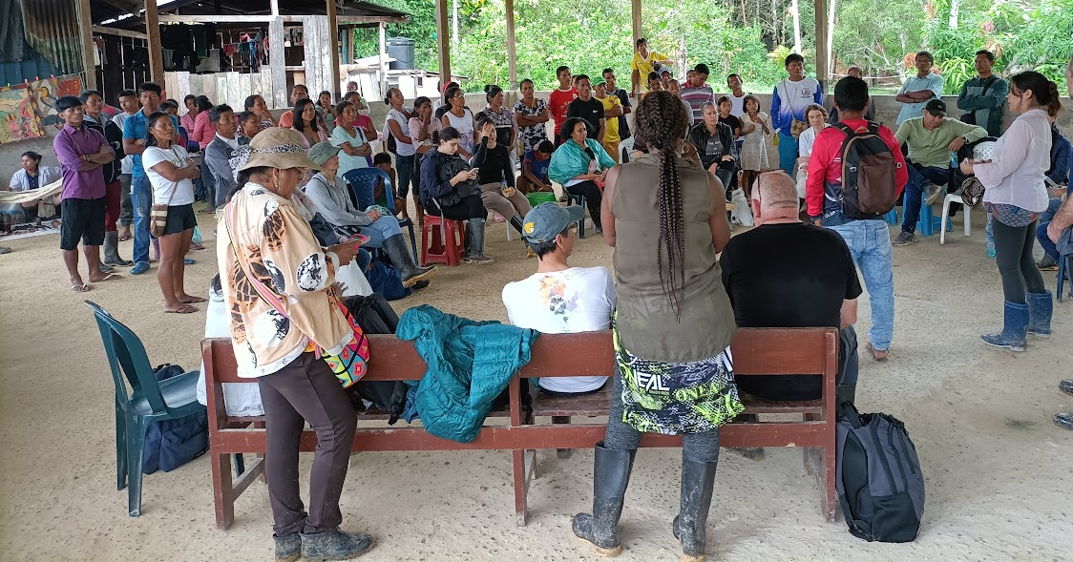
Figure 7: Discussions with the Arara community about their visions for community wellbeing and development

Transformative changes in global systems
At a more global scale, the need for changes in value systems were also highlighted by participants, with the need for global society to move away from ideas of progress and profit, towards balance and harmony, and from seeing nature as a resource to extract, to instead valuing relationships, responsibility, respect and reciprocity.
The need for transformative changes in global and national economic systems were also highlighted by workshop participants, including through rethinking capitalist systems, and reorganization of the economy and production systems in a way that recognizes the richness of relationships between people and nature rather than only valuing profit. Systems of production should be organized in ways that no longer assume the maximum possible exploitation of nature, and they should instead center around taking only what is necessary for human livelihoods without harming nature or causing human conflicts. Participants noted that many IPLCs have always been involved in sustainable economic systems, including barter-trading, and examples of these systems could provide models for transformative change.

Implementation of transformative changes
Participants also noted the need for the creation of mechanisms that will ensure effective implementation of international assessments and commitments (e.g., IPBES assessments and targets under the Convention on Biological Diversity) into policies and action. Participants noted that IPBES assessments and other mechanisms could be used to monitor whether governments are realizing the commitments they have made as a way of holding governments accountable.
Participants also noted that to generate transformative change, there may need to be high-level negotiations to generate common understandings and binding agreements so that concerted action can be taken.

Chapter 4: Overcoming the challenges of achieving transformative change
Participants at the dialogue highlighted the following challenges, which are obstacles to transformative change.

Broader society’s values and perceptions
Participants highlighted that many key challenges are rooted in the value systems and assumptions that exist in broader society, including:
- Broader societal values that focus on capitalism, ownership, transactions, extraction and competition and viewing the land as property rather than as a relationship with a mother or a spiritual entity;
- Lack of understanding and knowledge in broader society and governments about IPLCs, their livelihoods, their governance systems and their contributions to biodiversity and global human wellbeing;
- Disparities in blame assigned for environmental damage. For example, Indigenous Peoples performing rotational farming may be persecuted, while people who drive cars or big industrial polluters are not penalized; and
- Lack of recognition and valuation of ILK systems by broader society and education systems.

Governance
Participants highlighted that key challenges come from existing systems of governance, including:
- Structural hierarchical relationships and power imbalances between IPLCs and states;
- Colonialism, patriarchy and suppression of women and gender diverse people;
- The introduction into communities of governance and decision-making processes that exclude women and youth; and
- A lack of recognition of customary governance systems and rights to self-determination.

Rights and justice
Participants highlighted that key challenges relate to rights and justice, including:
- Lack of enforcement and guarantees of Indigenous Peoples’ rights;
- Injustice, and justice systems that seem to benefit the state and industry rather than communities;
- Lack of land tenure and lack of recognition of land rights, which can lead to evictions, displacements or loss of access and use (for example evictions or access and use restrictions in protected areas, or pastoralist rangelands taken for wheat cropping). Overcrowding and conflicts from immigration of non-IPLCs can also occur due to lack of land tenure. These issues can lead to loss of livelihoods, food insecurity, impacts on spiritual connections to lands and loss of ILK, which is mostly learnt through activities on the land; and
- Damaged human relationships and historical harms and grievances that prevent progress.

Economic systems
Participants highlighted that many key challenges have their roots in global economic systems, including:
- IPLCs are often drawn or forced into capitalist economic systems, as their existing sustainable systems are criminalized or prevented due to access restrictions and degraded environments;
- IPLCs are often caught between extractive industries on one side and strict conservation measures on the other; and
- The current global economic crisis, which trickles down to impact IPLCs, often especially women, and which diverts attention and resources away from environmental and social issues.

Environmental degradation, criminalization and conflict
Participants highlighted that environmental degradation, criminalization and conflict are key challenges, including:
- Environmental degradation, habitat loss, biodiversity decline and climate change increasingly hinder or destroy IPLC culture, knowledge systems and livelihoods;
- Unmet basic needs in communities (e.g., clean drinking water);
- Territorial conflicts around the territories of Indigenous Peoples and the lands of local communities;
- Groups using the label of “local community” to obtain land rights and using them to destroy nature (e.g., livestock farmers in the Amazon);
- Criminalization of IPLC practices such as hunting or gathering, as well as clashes with law enforcement and governments when IPLCs try to protect their lands, waters or communities;
- Violence and persecution of IPLCs, especially land and rights defenders; and
- Militarization, crime, and war around the lands and territories of Indigenous Peoples and the lands of local communities.

Social change in communities
Participants highlighted that social changes within their communities are key challenges for many IPLCs, including:
- Loss of values, language and knowledge within IPLC communities due to external pressures;
- Migration of youth away from communities to urban centers, especially due to lack of opportunities for work or study in their communities and regions of origin; and
- New divisions between rich and poor both within and between communities.

Chapter 5: Realizing a sustainable world for nature and people: transformative strategies, actions and roles for all
Workshop participants highlighted that there is a global crisis that is affecting IPLCs. They highlighted the urgency of changing current pathways to ensure that global society does not continue to further endanger the planet.
As discussed above, participants also emphasized that careful thought is needed when talking about transformative change, especially regarding who is being asked to change, and why. In the views of many IPLCs, they are the guardians and stewards of nature, and it is broader systems of governance, economics, finance, industry and colonialism that need to change. These systems are seen as the major threat to nature, to IPLC territories, lands and waters, and to IPLC wellbeing, as well as to the wellbeing of global humanity.
Participants highlighted the urgency of acting now, instead of only discussing possible actions. They noted that governments take many actions without waiting for assessments, if these are economically beneficial in the short-term. Meanwhile, for important long-term actions for biodiversity and human wellbeing, governments often wish to wait for more information. Participants noted that although the 2050 Vision and 2030 targets are action oriented, these need to happen faster. Many IPLCs cannot wait until 2050 for action to happen, as it will be too late. They also had grave concerns that the findings of the transformative change assessment will not lead to real changes seen at the local level, and they urged the authors, IPBES and governments to focus on implementation.

Overarching actions
Participants noted that actions must be contextualized according to place, culture, knowledge and values systems. As much as possible, these actions should also reinforce the connection of these four elements.
Workshop participants identified many important actions to achieve transformative change, including:
  - Strengthening local governance: Different decision-making processes impact nature in different ways. “Good governance” should be based on relationships – with a focus on small scale interpersonal governance, rather than large national governments. Relationships (human-human and human-nature) and trust were highlighted as key factors to build alliances and fulfil commitments.
  - Implementing Indigenous Peoples rights: Especially rights over their lands, territories, waters and resources, particularly through the legal recognition of land tenure. Not having tenure, legal certainty or access to land can have serious consequences, including not being able to meet the basic needs of families, as well as broader conflicts and environmental damage.
  - Recognizing diverse value systems beyond only economic values: Recognizing that “money” should not be the predominant value, as in many cases it fails to resolve problems and causes conflicts.
  - Recognition of Indigenous and local knowledge by other knowledge systems: It is important to recognize and value IPLC expert knowledge as equivalent to the expertise of other professions of social and natural science. ILK can be shared if appropriate protections and benefits are in place.
  - Recognizing the importance of spirituality as a factor that guides actions for most IPLCs. For many IPLCs, spirituality, along with respect and reciprocity between life in all its forms – human, animals, plants, landscapes, and spirits – should guide any actions.
  - Undoing the extensive history of colonialism, which continues in different forms, and has generated power imbalances, mistrust and dividing discourses. Participants highlighted that it will be impossible to make alliances and progress without explicit recognition of the impacts of colonialism and other forms of subjugation of IPLCs, and without steps to undo these impacts.

Roles, responsibilities and actions
Workshop participants noted that everybody has the potential to be an agent of change – including governments, NGOs, Indigenous Peoples, local communities, civil society, media, lawyers, academia, and international agencies. Each of these actors has their own role, responsibilities and commitments, some of which are described below. All individuals were recognized as key agents of change, and the collective sum of individual efforts as a lever to make a difference. Participants also noted that even daily actions and ways of living can be deliberate actions for change. The basic common interest in nature and its continuity across different actors can be a leverage point to build and catalyze alliances.
However, participants also noted that a focus on individual roles and responsibilities can deflect attention away from the bigger systems and power imbalances that currently hinder global transformative change. Determining who needs to change, and an analysis of where key challenges and leverage points lie, will be a crucial aspect of the assessment.

Governments
Governments were identified as important actors by participants. However, some IPLCs see changes and actions for nature as deeply dependent on person-to-person interactions and relationships, and that there is a need to identify basic common principles across actors to build trust and leadership. Therefore, large or central governments are currently not perceived by some IPLCs as effective agents for change.
Key actions for transformative change by governments highlighted by participants include:
  - Recognizing that the current global and national governance systems have led to an environmental crisis, and taking concerted action to understand and change these systems;
  - Recognizing IPLCs as partners and “transformative change agents”;
  - Recognizing Indigenous Peoples and their rights in countries that do not currently give them recognition;
  - Recognizing rights of Indigenous Peoples over their territories, lands and waters, and the rights of local communities over their lands, to ensure legal security of land tenure, including through consultations and mapping and exploring different models of management to enhance governance;
  - Recognizing the right of Indigenous Peoples to FPIC for developments and any possible harmful initiative taking place on Indigenous territories, lands, and waters;
  - Increasing spaces for dialogue with IPLCs within national decision-making processes, aiming for full and effective participation, recognizing that participation in processes with pre-determined outcomes is not appropriate or positive;
  - Forging connections and dialogue with communities, recognizing that relationships are key;
  - Recognition of IPLC governance and justice systems as positive systems that could be supported to enhance overall good national governance;
  - Implementing training and capacity-building for governments, ministries and departments on international instruments relating to the rights of Indigenous Peoples e.g., UNDRIP, FPIC, and CBD instruments;
  - Implementing processes to include different value systems in decision-making processes;
  - Forging holistic governance for nature, people, food, water, health, wellbeing, spirituality, education and justice; and
  - Introducing intercultural approaches in many policies and laws (e.g., medicine, justice, education).

Business and industry
Workshop participants highlighted business and industry as key actors for transformative change, with roles and actions including:
  - Recognizing that the current global environmental crises are largely the result of large-scale business and economic systems, and that therefore much of the responsibility for change lies within this sector;
  - Recognizing the right to FPIC and consultation for developments taking place on Indigenous lands and territories;
  - Enhancing the frameworks and mechanisms for fair trade and sharing of benefits with IPLCs;
  - Implementing training and capacity-building for business and industry on international instruments relating to the rights of Indigenous peoples e.g., UNDRIP, FPIC, and CBD instruments;
  - Enhancing and implementing mechanisms for responsible production and consumption, with the aim of reducing environmental and social destruction; and
  - Enhancing and implementing mechanisms for mitigation, restoration and compensation for environmental damage, including financing.

Education sector
In discussions of roles and responsibilities for transformative change, workshop participants highlighted the education sector as both a challenge and as a key actor for transformative change.
Key actions within the education sector highlighted by participants include:
- Recognizing that formal education systems are often teaching value systems and aspirations that are causing social change and contributing to the global environmental crisis;
- Changing the emphasis on values taught to youth, and particularly IPLC youth, away from progress, profit, competition and capitalist views of “owning” land and extracting resources, to maintaining relationships, harmony and balance with nature and among people and promoting spiritual connections and ethics;
- Developing education curricula, methods and institutions that are holistic and oriented towards the maintenance of ways of life and culture, and proactively protecting ILK, practices and traditions;
- Developing intercultural education curricula and methods that allow youth to understand both ways of knowing and learning – “western” education and ILK systems;
- Developing education curricula, methods and institutions that are a practical preparation for the challenges that IPLCs face in their lives, rather than only the transmission of theoretical knowledge;
- Encouraging and providing space and time for learning on the land with knowledgeable community members, rather than only encouraging learning in the classroom. Teaching directly through experience, with practice and in action, is important for transmitting Indigenous and local knowledge. Many IPLCs wish to develop a living curriculum based on “the school of life” where IPLC language, culture and spirituality are key components;
- Practicing reciprocity and respect between different knowledge systems and shifting perceptions of “knowledge” and “experts” to include experiential wisdom and knowledge learnt in practice that is relevant to livelihoods;
- Recognizing and supporting IPLC schools that focus on ILK and IPLC livelihoods as centers of excellence, including providing infrastructure, human resources, scholarships and financial support;
- Adjusting systems for certifying schools and teachers based on different ways of knowing and learning, so that IPLC schools can be better recognized and supported; and
- Teaching in IPLC languages and working to revitalize and maintain IPLC languages.

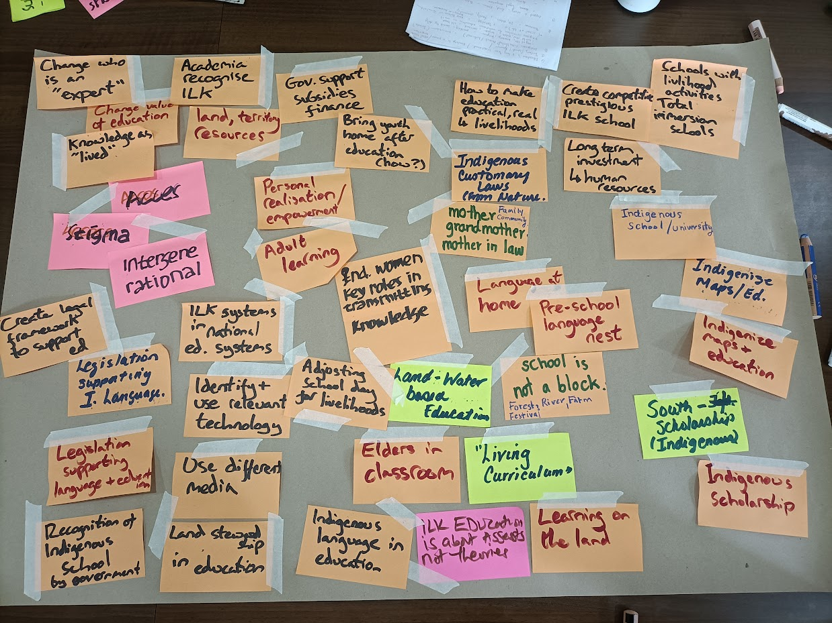
Figure 8: Building a picture of pathways, roles and actions for transformative change.

Research and higher education
Workshop participants highlighted research and higher education as a key sector for transformative change, with roles and responsibilities including:
- Recognizing power imbalances between science and ILK and the impacts of colonial history on research, which can:
  - Hinder or overlook research by IPLCs;
  - Hinder or overlook research from the global south;
  - Hinder or overlook research in languages other than English;
  - Impose western scientific methods and assumptions onto IPLCs and their ways of learning, knowing and representing ILK;
- Recognizing, supporting and implementing research and methods from IPLCs, and Indigenous scholarship by Indigenous Peoples working in academia, that center culture, language and ways of life;
- Striving for true co-production of knowledge;
- Basing research on building relationships rather than briefly documenting knowledge;
- Developing projects and funding for communities that are tied to preserving or revitalizing the transmission of dynamic knowledge in practice (e.g., through protecting environments and supporting land-based activities with elders), rather than only documenting ILK, as much ILK is lost in documentation processes, and it is the dynamism of the knowledge that must be preserved;
- Developing research that actively supports community aspirations, rights and goals, and that produces materials and results of relevance to IPLCs, for example materials that can support land claims or other key issues. Academics and researchers could actively support IPLC causes and goals, rather than only performing research;
- Enhancing frameworks, mechanisms and methods for ensuring FPIC and for recognizing and respecting intellectual property rights, crediting and citing knowledge holders, and sharing benefits from research;
- Developing partnerships and research with communities that are often not visible in research, including afro-descendent communities; and
- Recognizing the need for moral principles to underpin modern science.

Funders and Non-Governmental Organizations
Workshop participants highlighted funders and non-governmental organizations (NGOs) as key actors for transformative change, with roles and responsibilities including:
  - In discussion with IPLCs, developing strategies for funding and action that support community goals, or support them in their struggles for recognition of rights or against intimidation and violence;
  - As much as possible, directing funding directly to communities rather than mediating funding through larger organizations, which tend to take significant proportions of the available funds so that little is left for communities; and
  - Simplifying funding applications and reporting processes to reflect community needs.

United Nations and International Organizations
Workshop participants highlighted that the United Nations and international organizations are key actors for transformative change, with roles and responsibilities including:
- In collaboration with IPLCs and with their full participation, continue to develop assessments, frameworks, agreements and targets that support the recognition of IPLCs and Indigenous and local community rights, and support IPLCs in their struggles to protect their environments and communities;
- Outreach and capacity-building for national governments regarding relevant commitments, instruments, decisions and targets that support IPLCs and Indigenous rights and local community rights;
- Monitoring the implementation of commitments and progress towards targets that are relevant to IPLCs and Indigenous rights and local community rights;
- Continue to build spaces for intercultural dialogue and knowledge sharing between global IPLCs, and between IPLCs, policymakers, scientists and other actors; and
- Support and spread critical information regarding the importance of IPLCs for nature conservation, and relationships between nature and culture.

Legal and justice system
“Justice” emerged as a common theme across most discussions at the workshop, and workshop participants highlighted the legal and justice system as a key actor for transformative change, with the following suggested roles and responsibilities:
- Recognizing that the current legal and justice framework often supports governments and industry rather than small-scale producers, IPLC rights and human rights, and that this enhances the current global environmental crisis and negative impacts on human wellbeing;
- Implementing training and capacity-building throughout the legal and justice system on international instruments relating to the rights of Indigenous Peoples e.g., the UNDRIP, FPIC, and CBD instruments, and local community rights;
- Development of frameworks to support and enhance customary laws, justice systems and governance, including developing Indigenous jurisdictions and legal pluralism;
- Training and capacity building to understand and support customary governance, law, and justice systems;
- Developing and enhancing legal frameworks around FPIC, access and benefit sharing, intellectual property rights, bio-cultural community protocols, etc. to better protect and support ILK practices, traditions and community intellectual property, enterprises and development; and
- Education and training of Indigenous and non-Indigenous lawyers and legal experts who can support the processes and needs of IPLCs, e.g., around collecting and collating evidence on traditional use and occupation of territories.
Examples
A participant from Asia explained that during a judicial review for national forest regulations, communities were able to prove that customary forests belong to them, and they won in court. Part of this work involved training for the judge, and UNDRIP and CBD instruments were referenced and linked to the specific situation of the communities.
A participant from Latin America also explained how communities partnered with universities that would send law students to collect evidence, affidavits, documents, pictures and videos and then consolidate this evidence so that it could support communities in court. Capacity-building and training for legal experts was key.

Conservation sector
Workshop participants also highlighted the conservation sector as a key actor for transformative change, with roles and responsibilities including:
- Recognizing the important contributions of IPLCs to biodiversity conservation, as IPLCs have protected many of the last tracts of healthy, biodiverse lands and waters;
- Recognizing that the concept of “wilderness” is incorrect, as people have always been a part of nature;
- Advocating for a halt to criminalization of customary sustainable use;
- Building respectful partnerships with IPLCs as key actors, collaborators and managers of biodiversity;
- National parks and protected areas should work with IPLCs to change their aims and governance systems, so that they enhance IPLC ownership and governance over the areas, with benefits for communities and biodiversity;
- Supporting communities in their struggles against industrial activities and resource extraction on their lands and waters; and
- Recognizing the full diversity of actor and their contributions to biodiversity conservation, including for example afro-descendants in the Americas.

Media
Workshop participants also highlighted the media as an important actor for transformative change, with roles and responsibilities including:
- Reporting on IPLC issues and particularly on human rights violations, so that global awareness is raised;
- Promoting concepts of cultural diversity, tolerance and care, including caring for nature and relationships with IPLCs; and
- Disseminating culturally relevant information to communities, including in Indigenous and local languages.

Example
A participant from Latin America highlighted the important role that the international media played in supporting community struggles and raising international awareness about persecution and violence, which ultimately played a part in resolution of the problems faced by communities.

Indigenous Peoples and local communities
Workshop participants highlighted that Indigenous Peoples and local communities are key actors for transformative change. They noted that it will be important for all the actors listed above to collaborate with IPLCs and value their knowledge, as IPLCs collectively manage and own a large proportion of the global land area, so they are crucial actors for transformative change on the ground. They can also be important actors in developing, implementing and monitoring policy and action, including collectively at subnational, national and international levels. Women, youth, and elders were highlighted as key actors.
Key actions for IPLCs identified by workshop participants include:
  - Mobilizing, organizing and helping to advocate for and create a strong legal framework to protect Indigenous rights, as well as local community rights in many cases;
  - Building and enhancing broad leadership and capacity for action within communities, including among women and youth, and within local, national, regional and global organizations;
  - Building and strengthening national and international networks of IPLCs to recognize and build on collective strengths and to share knowledge;
  - Working with key allies (if possible, including national and local governments) and building new connections, fostering solidarity, creating networks and offering capacity-building where possible. For example, in some countries, community organizations have worked with local government to develop regulations that recognize IPLCs;
  - Protecting communities, children, lands, nature and spiritual beings;
  - During long struggles and conflicts, focusing on building and maintaining community unity and motivation;
  - Remembering the power of ceremony for protection and support;
  - Remembering also the power of ceremony, rituals, and spirituality also for the broader wellbeing of the planet;
  - Maintaining continuity with ancestors and being a bridge for future generations;
  - Educating IPLC youth and transmitting connections with nature and IPLC values to them, including through supporting and participating in land and water-based activities;
  - Maintaining, protecting and revitalizing traditional knowledge, culture, language and identity;
  - Developing and maintaining IPLC economies, livelihoods and enterprises that maintain community values;
  - Collectively developing and highlighting practical visions of economic, natural and human wellbeing that maintain community values, including through biocultural protocols or other formal processes, so that community members and outside actors can understand the community’s aspirations and value system;
  - Where possible, educating broader society on connections with nature and IPLC values;
  - Participating in assessments (including the transformative change assessment) and other international processes, including as part of expert panels, to provide collective contributions for guiding policies, where conditions of meaningful participation, including funding, are guaranteed;
  - Following the rules and guidance given by ancestors and spirits.
Example
During struggles against resource extraction in Canada, protestors were protected from harm, the land healed itself and roads were blocked by fallen trees due to ceremonies performed by the community.

Next steps
- A series of comments for the assessment’s review period were developed from the dialogue. These were sent to participants for editing and approval, and following this they were submitted into the formal assessment review process for the attention of authors;
- Development of a report from the dialogue workshop (this report). The draft report was sent to all participants for them to edit, make additions, and/or approve prior to finalization and publication of the report;
- Using the comments and report as resources, the authors continued to develop the draft chapters of the assessment;
- A call for contributions on ILK was released in the first half of 2023 to encourage the submission of materials that could inform the assessment;
- Author teams reached out to IPLC participants to invite them to be contributing authors; and
- Another dialogue will be organised in late 2023 during the second external review period for the first draft of the SPM and the second draft of the assessment chapters.

Annexes

Annex 1: Draft Agenda
Acronyms:
IPLCs = Indigenous Peoples and local communities
ILK = Indigenous and local knowledge

Monday 13 February
8h30-09h00 | Registration
9h00-9h45 | Opening, introductions
9h45-10h15 | - Introduction to IPBES and its work on ILK  - Introduction to the transformative change assessment  - Introduction to scenarios
10h15-10h30 | Introduction to the local context
10h30-10h45 | - Aims, methods and agenda of the dialogue  - Free Prior and Informed Consent
10h45-11h00 | Refreshment break
11h00-11h45 | IPLC caucus
11h45-12h30 | Caucus report back and discussion: How can the assessment, IPBES scenarios work and this workshop be most useful for all participants? What methods and approaches should be used?
12h30-14h00 | Lunch
14h00-15h30 | Visioning activity – Plenary: how does your community think and talk about the future?
15h00-15h30 | Discussion of framework for visioning
15h30-16h00 | Refreshment break
16h00-17h30 | Visioning activity – Break out: community visions
17h30-18h00 | Closing of day – Report back to plenary

Tuesday 14 February
9h00-9h15 | Updates, review of day 1, plan for day 2
9h15-10h30 | Visioning activity – Break out: community visions
10h30-11h00 | Refreshment break
11h00-12h30 | Visioning activity – Break out: Challenges and strengths
12h30-14h00 | Lunch
14h00-16h00 | Visioning activity – Breakouts: ways forward / pathways
16h00-16h15 | Refreshment break
16h15-17h45 | Visioning activity – Breakouts: ways forward / pathways
17h45-18h00 | Closing of day
19h00 | Visit to maloca

Wednesday 15 February
9h00-9h15 | Updates, review of day 2, plan for day 3
9h15-10h30 | Visioning activity – Plenary: Roles for all and global good futures
10h30-11h00 | Refreshment break
11h00-12h30 | Visioning activity – Plenary: Roles for all and global good futures
12h30-14h00 | Lunch
14h00-16h00 | Reflections on the transformative change assessment
16h00-16h15 | Refreshment break
16h15-17h45 | Reflections on the transformative change assessment
17h45-18h00 | Closing of day

Thursday 16 February
9h00-12h30 | Community visit
12h30-14h00 | Lunch
14h00-15h00 | IPLC caucus
15h00-16h00 | Report back from the IPLC caucus and discussion
16h00-16h15 | Refreshment break
16h15-17h00 | Discussion: overarching messages and themes, key approaches and participants, how can the assessment and scenarios work be useful for IPLCs?
17h00-17h30 | Ways forward and participation in the assessment and scenarios work: Timelines for collaboration, communication and dialogue throughout the processes, identifying key experts, resources
17h30-18h00 | Next steps and closing

Annex 2: FPIC document
Global Indigenous and local knowledge dialogue on scenarios of the future and the IPBES assessment of transformative change
13-16 February 2023
Leticia, Colombia
The individuals whose names are listed at the end of this document agreed during the dialogue workshop to follow the principles and steps laid out in this document.
Background
Within the framework of the UN Declaration on the Rights of Indigenous Peoples (UNDRIP), principles of Free, Prior and Informed Consent (FPIC) apply to research or knowledge-related interactions between Indigenous peoples and outsiders (including researchers, scientists, journalists, etc.). Given that the dialogue process includes discussion of Indigenous knowledge of biodiversity and ecosystems, there may be information which the knowledge holders or their organizations or respective communities consider sensitive, private, or holding value for themselves which they do not want to share in the public domain through publications or other media without formal consent.
Principles
The dialogue will be built on equal sharing and joint learning across knowledge systems and cultures. The aim is to create an environment where people feel comfortable and able to speak on equal terms, which is an important precondition for true dialogue.
To achieve these aims, the following goals are emphasized:
- Equality of all participants and absence of coercive influence
- Listening with empathy and seeking to understand each other’s viewpoints
- Accurate and empathetic communication
- Bringing assumptions into the open
If participants feel that the above goals are not being achieved at any point during IPBES activities, participants are asked to bring this to the attention of the organizers of the activity, or the IPBES technical support unit on ILK, at: ilk.tsu.ipbes@unesco.org.
Sharing knowledge and respecting FPIC
To ensure that knowledge is shared in appropriate ways during dialogue workshops and other IPBES activities, and that information and materials produced after these activities are used in ways that respect FPIC, we propose the following:
- Guardianship – participants who represent organizations and communities
- Principles of guardianship will be discussed with IPLC participants at the beginning of IPBES activities.
- Participants who represent organizations or communities will act as the guardians of the use of the knowledge and materials from their respective organizations or communities that is shared before, during or after the workshop. Any use of their organizations’ or communities’ knowledge will be discussed and approved by the guardians, as legitimate representatives of their organizations or communities. Guardians are expected to contact their respective organizations and communities when they need advice. Guardians are also expected to seek consent from their organizations or communities when they consider that this is required, keeping in mind that sharing details of their community’s knowledge can potentially have negative consequences, for example sharing the locations and uses of medicinal plants.
- FPIC rights during dialogue workshops and other activities
- The FPIC rights of the Indigenous Peoples participating in dialogue workshops or other activities will be discussed prior to the beginning of the activity, until participants feel comfortable and well informed about their rights and the process, including the eventual planned use and distribution of information. This discussion may be revisited during the activity, and will be revisited at the end of dialogue workshops once participants have engaged in the dialogue process.
- Participants do not have to answer any questions that they do not want to answer, and do not need to participate in any part of an activity in which they do not wish to participate;
- At any point, any participant can decide that they do not want particular information to be documented or shared outside of the activity. Participants will inform organizers and other participants of this. Organizers and participants will ensure that the information is not recorded. Participants can also request that the information is only recorded as a general statement attributed to a region or country, rather than to a specific community.
- Permission for photographs must be agreed prior to photos being taken and participants have the right not to be photographed. Organizers will take note of this.
- After the activity
- Permission will be obtained before any photograph of a participant is used or distributed in any form.
- Permission will be obtained before any list of participants is used or distributed in any form.
- Participants maintain intellectual property rights over all information collected from them about themselves or their communities, including photographs. Their intellectual property rights should be protected, pursuant to applicable laws.
- Copies of all information collected will be provided to the participants for approval.
- Any materials developed for IPBES assessments or other products using information provided by participants will be shared with the participants for prior approval and consent.
- The information collected during the activity will not be used for any purposes other than those for which consent has been granted, unless permission is sought and given by participants.
- Participants can decline to consent or withdraw their knowledge or information from the process at any time, and records of that information will be deleted if requested by the participant. Participants should however be aware that once an assessment is published it cannot be changed, and information incorporated into the assessment cannot therefore be withdrawn from the assessment after this point.
- Participants have the opportunity of reviewing and commenting upon the final product during the second draft review period, and a dialogue workshop will be organized ot support this, bearing in mind that responsibility for the final product rests exclusively with the authors.

Annex 3: Participants of the dialogue workshop
Indigenous Peoples and local communities
Devi Anggraini | Indonesia | Chair of PEREMPUAN AMAN (Indigenous women’s organization)
Edith Magnolia Bastidas Calderon | Colombia | Indigenous women's Network on Biodiversity in Latin America and the Caribbean
Ramiro Batzin | Guatemala | Co-chair, International Indigenous Forum on Biodiversity
Julio Bombare | Colombia | Indigenous representative from Amazonas
Cristina Coc | Belize | Q'eqchi Mayan community leader
Q”apaj Conde | Bolivia | Secretariat of the Convention on Biological Diversity
Mateo Estrada Cordoba | Colombia | Environmental climate change advisor of the National Organization of Indigenous Peoples of the Colombian Amazon (OPIAC)
Julio César Estrada | Colombia | President of the National Organization of Indigenous Peoples of the Colombian Amazon OPIAC
Viviana Figueroa | Argentina | Indigenous Women Network on Biodiversity (also IPBES ILK task force)
Yesenia Hernandez | Mexico | ILK focal point for IPBES in Mexico
Hannah Longole | Uganda | Executive director of Ateker Cultural Center
Onel Masardule | Panama | Executive Director, Foundation for the Promotion of Indigenous Knowledge (FPCI)
Hénry Negedeka | Colombia | Indigenous representative from Amazonas
Sherry Pictou | Canada | Schulich School of Law, Dalhousie University (also IPBES ILK task force)
Diana Quintero Rodríguez | Colombia | General Coordinator of the National Organization of Indigenous Peoples of the Colombian Amazon (OPIAC)
Donald Rojas | Costa Rica | President of the National Indigenous Bureau, Costa Rica
Martha Rosero | Colombia | University of Florida
Nick Roskruge | Aotearoa -New Zealand | Te Atiawa / Ngati Porou / Ngati Tama, Professor in Ethnobotany & Horticulture, Massey University
Darío Silva | Colombia | Indigenous representative from Amazonas
Rodion Sulyandziga | Russia | Director of the Centre for the Support of Indigenous Peoples of the North
Pirawan Wongnithisathaporn | Thailand | Environment Program Officer, Asia Indigenous Peoples Pact, AIPP

SINCHI Institute
Jessika Carvajal González | Colombia | International Affairs Advisor for the Sinchi Institute
Juan Felipe Guhl Samudio | Colombia | Coordinator of the Socio-environmental and Cultural Dynamics Programme of the SINCHI Institute

IPBES task force on Indigenous and local knowledge
Viviana Figueroa | Argentina | Indigenous Women Network on Biodiversity
Sherry Pictou | Canada | Schulich School of Law, Dalhousie University / IPBES ILK task force
Peter Bates | United Kingdom | Technical support unit

IPBES transformative change assessment
Karen O'Brien | Norway | Co-chair
Teresia Olemako | Tanzania | Chapter 1
Sebastian Villasante | Spain | Chapter 2
Zühre Askoy | Turkey | Chapter 3
Nicholas Roskruge | Aotearoa-New Zealand | Chapter 3
Martha Bonilla | Mexico | Chapter 5
Camille Guibal | France | Technical support unit
Anouk Renard | France | Technical support unit

IPBES task force on scenarios and models
Sylvia Karlsson-Vinkhuyzen | Netherlands | Task force member
Claudia Munera | Colombia | Task force member
Laura Pereira | South Africa | Task force member

IPBES (2019) Global assessment report on biodiversity and ecosystem services of the Intergovernmental Science-Policy Platform on Biodiversity and Ecosystem Services. E. S. Brondizio, J. Settele, S. Díaz, and H. T. Ngo (editors). IPBES secretariat, Bonn, Germany. ISBN: ​978-3-947851-20-1.
The report from the first ILK dialogue workshop for the transformative change and nexus assessments (29 June – 1 July, Bonn, Germany) is available here.
The report of the previous ILK dialogue on scenarios (online, 28 - 30 September and 19 October 2021) is available here.
Disclaimer: The text in section 3 represents an attempt to reflect solely the views and contributions of the participants in the dialogue. As such, it does not represent the views of IPBES or UNESCO or reflect upon their official positions.
The text of the UN Declaration on the Rights of Peasants is available here: https://digitallibrary.un.org/record/1650694?ln=en.
Available at: https://bristoluniversitypress.co.uk/asset/10297/the-future-we-dream-report.pdf
Martha Stiegman and Sherry Pictou. 2016. Co-Directors. We Story the Land. https://www.youtube.com/watch?v=zKaceG_FuM8.
Please see: Robert A. Williams Jr. 1990. Encounters on the Frontiers of International Human Rights Law: Redefining the Terms of Indigenous Peoples’ Survival in the World, Duke Law Journal 660-704 (1990): https://scholarship.law.duke.edu/dlj/vol39/iss4/2.

