Report

Third Indigenous and local knowledge dialogue workshop

on the

IPBES assessment of transformative change
Reviewing the first draft of the summary for policymakers and the second drafts of the chapters
13-15 December 2023, Agadir, Morocco

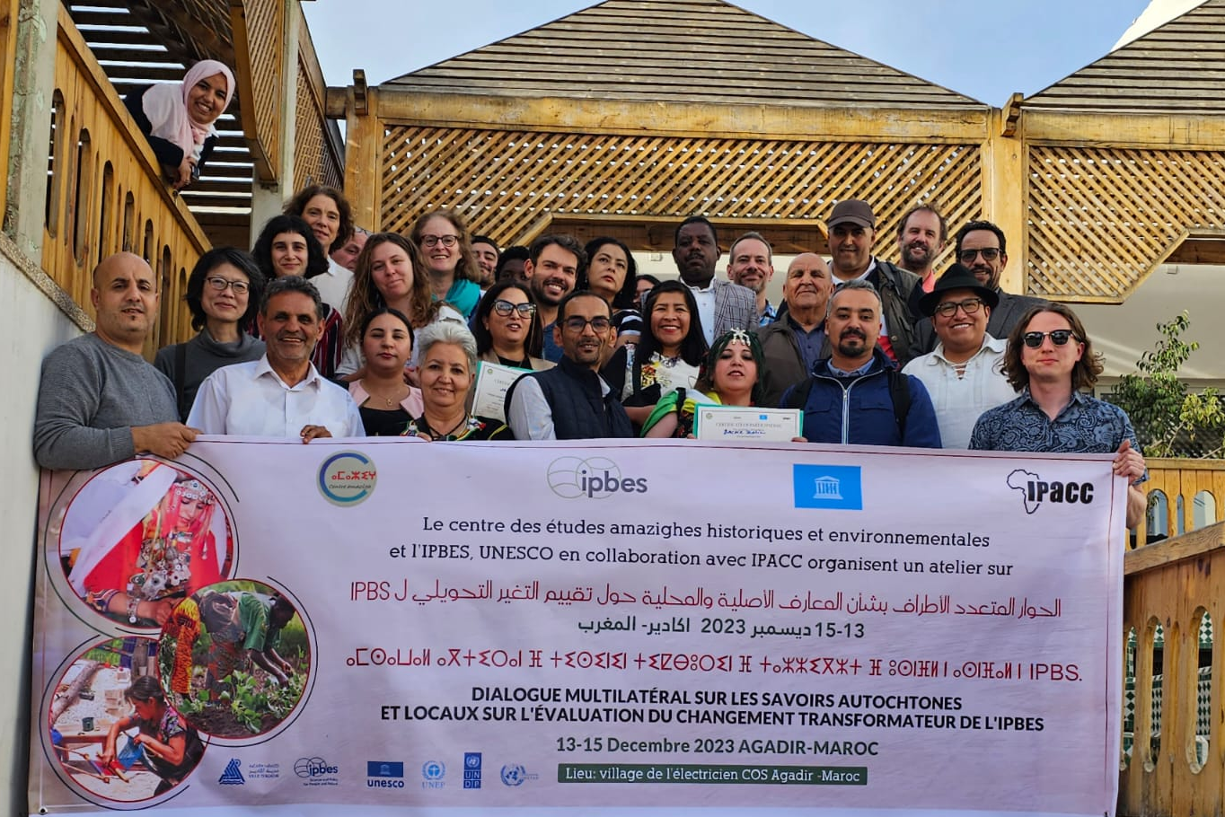

Suggested citation
IPBES (2023). Khalid Aayoud, Sabri Abdhallah, Yacine Abdelaziz, Ayoub Achbaro, Ijjou Arjdal, Zahia Bachir, Vital Bambaze, Malika Boutaleb, Lahcen Boukerdi, Kaoutar Caidi, Q”apaj Conde, Hicham El-Mastouri Guadalupe Yesenia Hernandez Marquez, Mariaelena Huambachano, Aslat Holmberg, Jamila Id Bourous, Lekishon Kanyinke, Boujid Khadija, Benbihi Lobna, Akounad Mohamed, Handaine Mohamed, Ouhmou Mohamed, Madbouhi Mustapha, Youba Ouberka, Jamila Raissi, Rachida Rachid and Nick Roskruge. Report of the third Indigenous and local knowledge dialogue workshop on the IPBES assessment of transformative change: reviewing the first draft of the summary for policymakers and second drafts of the chapters. 13-15 December 2023, Agadir, Morocco.

Disclaimer
The text in section 3, represents an attempt to reflect solely the views and contributions of the participants in the dialogue. As such, it does not represent the views of IPBES or UNESCO or reflect upon their official positions.

Acknowledgements
We are very grateful to Mohamed Handaine and his team from the Centre des Etudes Amazighes Historiques et Environnementales for their support in organizing and coordinating the workshop, in collaboration with the Indigenous Peoples of Africa Coordinating Committee (IPACC). We also wish to thank Khalid Alayoud for leading the community visits and sharing his knowledge with the group, and the women’s cooperative in Ait Baha for welcoming us and discussing the cooperative with us. We also want to thank all of the local participants and the Agadir municipal council for making everyone feel so welcome in Morocco, and for sharing their knowledge and enthusiasm for Amazigh culture and knowledge.

Table of Contents
1. Introduction 4
2. Background 5
2.1. The IPBES transformative change assessment 5
2.2. Context for the dialogue workshop 6
2.2.1. IPBES and ILK 6
2.2.2. ILK in the assessment process 7
2.3. Objectives of the ILK dialogue workshop 8
2.4. Methods for the dialogue workshop 9
2.5. Free, prior and informed consent 10
2.6. Benefits to IPLCs of participating in the assessments and other activities 11
3. Key recommendations and learning from the dialogue workshop 12
3.1. Overall comments on the assessment and transformative change 12
3.2. Representing IPLCs and ILK in the assessment 13
3.3. Conceptualizing and describing “transformative change” 14
3.4. Transformative change for broader society 15
3.5. Change and IPLCs 16
3.6. Indigenous and local knowledge, values, worldviews and governance 18
3.6.1. The importance of ILK systems 18
3.6.2. Threats to ILK systems 20
3.6.3. Actions to understand, support and revitalize ILK systems 21
3.7. Power imbalances and decolonization 24
3.7.1. Defining / exploring decolonization 24
3.7.2. Governance and decision-making 25
3.7.3. Legal and justice systems 26
3.7.4. Education 27
3.7.5. Gender 27
3.7.6. Recognition and rights 27
3.8. Capitalism and economic systems 28
3.9. The international system 29
3.10. Argan cooperative discussions 30
3.10.1. Introduction 30
3.10.2. The cultural importance of argan trees 30
3.10.3. Historical threats and protection 30
3.10.4. The development of cooperatives 31
3.10.5. Challenges 32
3.10.6. Ways forward 34
4. Next steps 36
Annexes 37
Annex 1: Draft Agenda 37
Annex 2: FPIC document 39
Annex 3: Participants of the dialogue workshop 42

Introduction
This is the report of the third Indigenous and local knowledge (ILK) dialogue workshop for the thematic assessment of the underlying causes of biodiversity loss, determinants of transformative change and options for achieving the 2050 Vision for Biodiversity (the transformative change assessment), which is being developed by the Intergovernmental Science-Policy Platform on Biodiversity and Ecosystems Services (IPBES). The workshop was held in Agadir, Morocco from 13 to 15 December 2023. The workshop took place within the second external review period of the assessment, which ran from 8 December 2023 until 2 February 2024, and provided a platform for Indigenous Peoples and local communities (IPLCs) to discuss the first draft of the summary for policymakers (SPM) and second drafts of the assessment chapters with the assessment authors.
This report aims to provide a written record of the dialogue workshop, which can be used by assessment authors to inform their work on the assessment. It is also intended as a resource for all dialogue participants who may wish to review and contribute to the work of the assessment moving forward.
The report is not intended to be comprehensive or give final resolution to the many interesting discussions and debates that took place during the workshop. Instead, it is intended as a written record of the discussions, and this conversation will continue to evolve over the coming months. For this reason, both clear points of agreement and diverging views among participants are presented for further attention and discussion.
The text in section 3 represents an attempt to reflect solely the views and contributions of the participants in the dialogue. As such, it does not represent the views of IPBES or UNESCO or reflect upon their official positions.
The agenda and participants’ list for the dialogue are provided in annexes 1 and 3.

Background

The IPBES transformative change assessment
The transformative change assessment commenced in 2021 and will be completed in 2024. It will consist of five chapters and an SPM, and is being drafted by almost 100 authors from all regions across the world. The chapters are as follows:
- Chapter 1: Transformative change and a sustainable world
- Chapter 2: Visions of a sustainable world – for nature and people
- Chapter 3: How transformative change occurs
- Chapter 4: Overcoming the challenges of achieving transformative change
- Chapter 5: Realizing a sustainable world for nature and people: transformative strategies, actions, and roles for all
“Transformative change” was defined by the IPBES Global Assessment of Biodiversity and Ecosystem Services (2019) as “a fundamental, system-wide reorganization across technological, economic and social factors, including paradigms, goals and values, needed for the conservation and sustainable use of biodiversity, long-term human wellbeing and sustainable development”.
The IPBES Global Assessment concluded that the 2050 Vision for Biodiversity cannot be achieved without transformative change, and that measures necessary to enable transformative change will require fundamental changes in social, economic and technological structures within and across nations. These changes will include achieving a sustainable economy by tackling poverty and inequality, enabling integrative, inclusive, informed and adaptive governance, enhancing the conservation and sustainable use of nature, and promoting sustainable production, consumption, and food systems. The transformative change assessment aims to inform decision-makers on options to implement transformative change.
The transformative change assessment report will assess and compare different visions, scenarios, and pathways for a sustainable world, including visions of IPLCs. Further, the report will assess the determinants of transformative change, how it occurs, and which obstacles it may face.
Finally, the report will assess which practical options for concrete action to foster, accelerate and maintain transformative change toward visions of a sustainable world exist, which practical steps are required to achieve these visions, and how progress towards transformative change can be identified and tracked.
Previous IPBES assessments have recognized that IPLCs hold knowledge, practices, worldviews, and values that can inform and provide examples of efforts to conceptualize, understand and create transformative change. This knowledge includes culturally specific visions of the future and strategies, pathways, and frameworks for achieving those visions. IPLCs also stand to be directly impacted – either positively or negatively – by transformative changes taking place in society as a whole. Participation of IPLCs is therefore crucial to the assessment.
More can be read about the transformative change assessment, including its scoping report, here: https://ipbes.net/transformative-change.

Context for the dialogue workshop

IPBES and ILK
IPBES is an independent intergovernmental body established to strengthen the science-policy interface for biodiversity and ecosystem services for the conservation and sustainable use of biodiversity, long-term human well-being and sustainable development.
Since its inception in 2012, IPBES has recognized that IPLCs possess detailed knowledge of biodiversity and ecosystem trends. In its first work programme (2014-2018), IPBES built on this recognition through deliverable 1 (c), Procedures, approaches, and participatory processes for working with Indigenous and local knowledge systems. The IPBES rolling work programme up to 2030 includes objective 3 (b), Enhanced recognition of and work with Indigenous and local knowledge systems, which aims to further this work.
Recognizing the importance of ILK to the conservation and sustainable use of biodiversity as a cross-cutting issue relevant to all of its activities, and noting also that approaches and methods for working with ILK and IPLCs in global and regional scale assessments would need to be developed, the IPBES Plenary established a task force on Indigenous and local knowledge systems and agreed on terms of reference guiding its operations towards implementing this deliverable. IPBES’ work with IPLCs and on ILK is supported by a technical support unit for ILK, hosted by UNESCO.
Key activities and deliverables of the task force and technical support unit on ILK so far include:
- Progress in the development of approaches and methodologies for working with ILK was made during previous IPBES assessments (Pollination, Pollinators and Food Production, Land Degradation and Restoration, four Regional Assessments and a Global Assessment of Biodiversity and Ecosystem Services, Sustainable Use of Wild Species, Diverse Values and Valuation of Nature and Invasive Alien Species and their Control);
- The development and implementation of the “approach to recognizing and working with ILK in IPBES”, which was formally approved by the Plenary at its fifth session in 2017 in decision IPBES-5/1, which sets out principles and approaches for IPBES’s work with ILK;
- Development and implementation of methodological guidance for recognizing and working with ILK in IPBES, which aims to provide further detail and guidelines on how to work with ILK within the IPBES context; and
- Development and implementation of a “participatory mechanism”, a series of activities and pathways to facilitate the participation of IPLCs in IPBES assessments and other activities.

ILK in the assessment process
Following the IPBES approach to ILK and as part of the participatory mechanism, dialogue workshops are being held during the cycle of the transformative change assessment, as follows:
- Reviewing the scoping report (online, 16 July 2020);
- Discussing key ILK themes and framing of the assessment (with the nexus assessment, 29 June to 1 July 2022, Bonn, Germany);
- Reviewing the first draft of the chapters (with the task force on scenarios and models, 13-16 February 2023, Leticia, Colombia); and
- Reviewing the first draft of the SPM and the second drafts of the chapters (13 to 15 December 2023, Agadir, Morocco – the subject of this report).
These workshops bring together IPLCs and authors of the assessments to discuss key themes relating to the assessments. They are part of a series of complementary activities for working with ILK and enhancing participation by IPLCs throughout the assessment process.
Other activities during an assessment include an online call for contributions, invitations to contributing authors and review of diverse literature and materials (see figure 1).
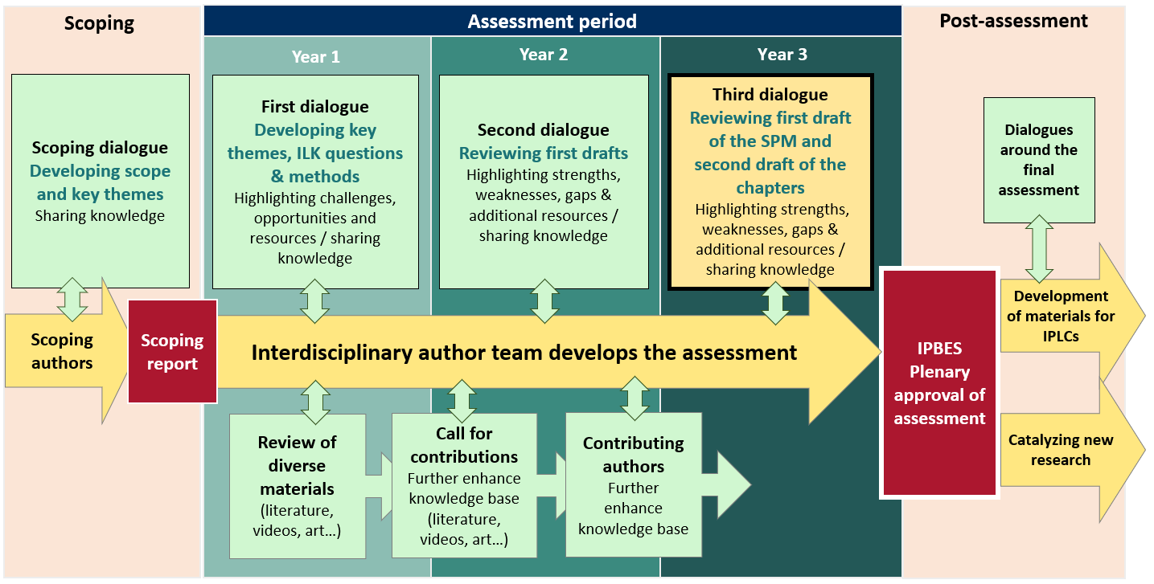
Figure 1: Timeline of work with ILK in IPBES assessments, following the IPBES approach to ILK.

Objectives of the ILK dialogue workshop
The objectives of the ILK dialogue workshop were as follows:
- Reviewing the first draft of the SPM and the second draft of the chapters of the transformative change assessment, for strengths, weaknesses, gaps and ways forward to reflect ILK and the visions, strengths and challenges of IPLCs;
- Developing a series of comments from IPLCs that can be entered into the assessment’s formal external review process;
- Exploring how IPLCs understand transformative change, including the changes they wish to see for their communities and the world, their visions for the future, and pathways, challenges and opportunities for achieving these visions;
- Further developing case studies of relevance to the assessment; and
- Identifying resources and sources of information that could be included in the assessments.

Methods for the dialogue workshop
The dialogue took place over three days, and the agenda is presented in annex 1 of this report. Methods for the dialogue workshop included:
- Presentations and discussions on IPBES and its goals, methods, and free, prior and informed consent;
- Presentations and discussions on the draft SPM and chapters of the assessment;
- Discussions around the following questions:
  - Is the concept of “transformative change” used by IPLCs? Is it a useful concept?
  - How could you discuss this, or express “change” and/or “transformative change” in your languages and communities?
  - How does your community think, talk about, and represent the future?
  - What would a “good future” look like?
    - What do you want your community and lands to look like in the future? (e.g., culture, livelihoods, economy, knowledge, education, infrastructure, rights, governance... or anything else).
    - What are the most important values that should support that good future? (e.g., justice, equity, sense of community… or anything else).
  - What would need to happen to create this good future? What are the current challenges and opportunities?
  - How would these changes contribute to a global good future? What visions do IPLCs have of a good future for the world as a whole?
- Visits and discussions in the local area, including:
- Arganeraie Biosphere Reserve to discuss the cultural importance of the argan trees and harvesting their fruits;
- A visit to the Agadir (traditional grain store) in Ighil Ifrane (in the commune Ida Ougnidif) to discuss the cultural importance of the Agadir and the related values;
- A visit to Ait Baha and the women’s argan oil cooperative to discuss how the cooperatives have transformed local economies and gender dynamics, whilst maintaining core community values.
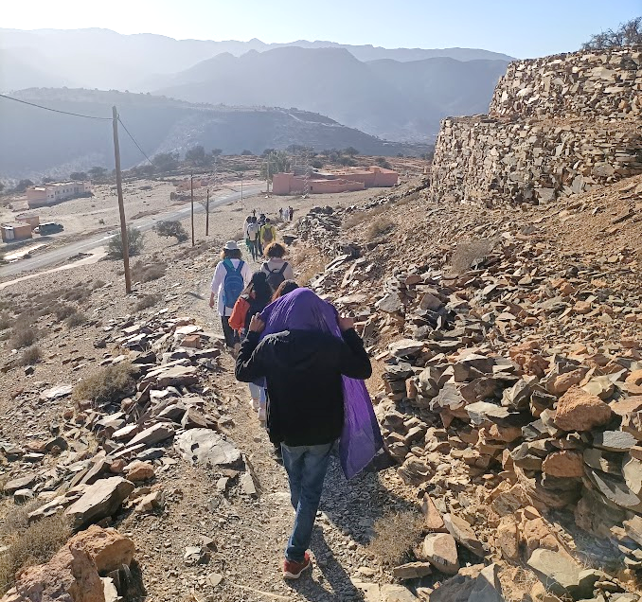
Visiting Ighil Ifrane during the workshop.

Free, prior and informed consent
Free, prior and informed consent (FPIC) principles are central to IPBES work with IPLCs, and a series of ethical principles have been developed to ensure that FPIC is followed in IPBES activities. These principles were agreed upon by the participants of the dialogue, and will be followed by IPLC participants, the assessment authors group and the technical support unit. The full agreed-upon text and the names of those agreeing to these principles are provided in annexes 2 and 3 to this report.

Benefits to IPLCs of participating in the assessments and other activities
During previous workshops, participants noted that there need to be clear benefits to IPLCs if they are to participate in an assessment process. It was noted that IPBES does not benefit financially from its processes or products, and that the main products of IPBES are publicly available resources, including the assessments, which aim to provide free and reliable information for policymakers, decision-makers and actors at all levels, including IPLCs. Key benefits of participating in dialogue workshops, and the assessment process as a whole, for IPLCs that were discussed included:
- The opportunity for IPLCs to share experiences with other IPLCs around the world;
- The opportunity for IPLCs to share and exchange experiences and knowledge with IPBES assessment authors;
- The opportunity to bring ILK and IPLC concerns to the attention of policymakers and decision-makers; and
- Use of the final assessments as a tool when IPLCs are working with policymakers, decision-makers and scientists, noting that part of the planning for the final assessment includes the development of an accessible summary for IPLCs and webinars that present the results to IPLCs.

Key recommendations and learning from the dialogue workshop
Over the course of the workshop, IPLC participants made a series of comments and recommendations for the transformative change assessment. From this process, a series of comments were entered into the assessment’s formal online review process for the consideration and action by assessment authors. The section below builds on these comments provided by the participants, providing added detail and examples that were shared during the workshop. As much as possible, the text reflects what was said during the workshop by participants, with only minimal editing.

Overall comments on the assessment and transformative change
Participants noted that the transformative change assessment is a critical assessment for IPLCs, as for a long time many IPLCs have been calling for a new world and changes in terms of power imbalances, colonization, domination, and the operation of economic systems which exploit cultures, peoples and the planet.
They highlighted that there is hope that this assessment will give strong and ambitious messages, recognizing that this is the IPBES assessment where ambition and vision is really needed.
A participant noted that many of the issues that IPLCs see as important are reflected in the assessment, and that hopefully this can support the considerations by the Plenary, as there is a clear basis of knowledge.
Participants noted that the summary for policymakers could have stronger messages on the need to change policies and governance, to tackle power imbalances and to reform the business sector.
Another participant noted that it is very important to clearly convey to IPBES members that the current environmental crises have shown that business as usual is not working, and that national governments and the international system have many weaknesses that hinder them from addressing these problems. He noted that the SPM addresses challenges and barriers to transformative change, but that there is room for improvement on more concrete actions on how to address these challenges. The assessment could therefore aim to provide more concrete options and solutions. For example, transformative change is needed in economics, which has an important role for a liveable future, and this should be clearly explored in the summary for policymakers. Articulating decolonization will also be very important, as will providing options to create decolonial modernity (discussed further below).
Overall, participants emphasized a strong desire for governments to use the assessment to build concrete actions for their countries and the international system that they will commit to implementing.

Representing IPLCs and ILK in the assessment
Participants agreed that the assessment should highlight that there is a great diversity of IPLCs, including in terms of their cultures, unique sets of ancestral knowledge passed from one generation to another, their experiences with colonization, and the current challenges that they face. There are however often shared values and philosophies across many IPLCs which bring them together. For example, comparing the Quechua People of South America and the Māoris of New Zealand, these groups have unique knowledge and value systems, but they share some traditions and values. Many IPLCs may also share a close relationship with nature, founded on a direct dependence on the natural environment. The assessment therefore needs to recognize this diversity and focus on elevating the unique set of skills, methods and values of different groups, as well as drawing overall conclusions.
In order to address these specific contexts and realities, different discussions of local examples will be needed, as well as more global-scale analyses and messages. It will also be important to review the balance between regions considered in case studies and examples in the assessment, to ensure that representations of diversity are balanced. Overall, creating options for a diverse world and recognition and acceptance of complexity will be key to the assessment and actions by governments and others following the assessment.
Participants also noted that ILK is constantly evolving, and that terms and knowledge presented in the assessment are always changing. It will be important to highlight that ILK is best understood through lived experience, rather than through abstract concepts.
Participants also recommended that throughout the SPM and assessment, it would be important to use the term “rights holders”, rather than stakeholders, to refer to Indigenous Peoples. While in terms of human rights, every human is a rights holder, Indigenous Peoples have a specific collective rights framework at the international level under the United Nations Declaration on the Rights of Indigenous Peoples (UNDRIP). The term “rights holders” therefore becomes particularly significant for Indigenous Peoples, including in the framework of efforts to actualise the right to self-determination. Meanwhile “stakeholders” can refer to other impacted groups: stakeholders have interest, but Indigenous Peoples as rights holders have the right to be consulted and consent to (or withhold consent from) any proposal in their territories. Both rights holders and stakeholders need to be considered in the assessment and SPM.
A participant also welcomed the capitalization of the word Indigenous in the assessment, and suggested that the assessment could provide a footnote explaining why it is capitalized.
Another participant highlighted that the assessment should make sure that it correctly references and highlights where the knowledge used in the assessment comes from, including the individuals or communities in question, or if it came from participants in different activities relating to the assessment, e.g., the dialogue workshops.

Conceptualizing and describing “transformative change”
Participants agreed that an important first consideration is whether the words and terms used in the assessment are those that would be used by IPLCs themselves. For example, “transformative change” may not be a term that is used by IPLCs, and it may not translate directly into IPLC languages, partly because “transformation” and “change” are similar concepts. Participants suggested that terms such as “fundamental change” may be better to translate into IPLC languages. They also noted that while many IPLCs are actively speaking about the changes they want to see in the world, they may not be using the term “transformative change” to frame those discussions or practices. This is similar to the concept of “sustainable development”, which was a new term, but in many ways reflected values and practices that IPLCs had held for far longer. There may also need to be more clarity as to whether “transformative change” only refers to positive changes, or also negative changes that are transformative.
Participants therefore recommended that the term should be further clarified, illustrated or explained. As such, it will also be important to be creative with language and visuals in the assessment, including by using synonyms and terms and concepts in other languages. In the assessment’s glossary, it will be important to reflect terms in the original languages and to explain them.
Example
To show concepts from other cultures, terms like “tiwizi” (ⵜⵉⵡⵉⵣⵉ) in Amazigh could be included both in the glossary and in the assessment text. Tiwizi means group work or mutual aid or assistance, which is done within the tribe, to work together to benefit everyone, for example building an Agadir (a traditional grain store) or a road. Such terms and examples could also be expressed in the tifinaghe alphabet, for example Agadir ⴰⴳⴰⴷⵉⵔ, Igoudar (plural of Agadir) ⵉⴳⵓⴷⴰⵔ and Tiwizi ⵜⵉⵡⵉⵣⵉ
Once the assessment is completed, there could be national and local processes of conceptualising, simplifying and explaining what is intended by transformative change, for example through local meetings and education programmes designed in collaboration with IPLCs. Once the assessment is published, efforts to translate it into IPLC languages would also be beneficial.

Transformative change for broader society
As discussed above, participants agreed that many IPLCs are dreaming of ambitious change for the wellbeing of humanity and nature. They noted that the current biodiversity and other crises are coming from the modern approach to biodiversity, and that now it is necessary to think about transformative change to shift paradigms and systems at all scales. This can include an important shift from people being the dominant component in relation to natural resources, to approaches that centre around nature, and examples and case studies in the assessment could use this nature-centric approach. Finding a balance between development and environmental degradation was also highlighted, as were transformations in industries that benefit from the exploitation of nature. Moving away from globalization that centres around gaining more goods and money, and moving towards ethics, sharing and mutual aid, was also highlighted as crucially important.
Participants also agreed that transformative change is complex and needs to take place throughout systems. When issues are tackled in isolation, there is a risk of negative impacts and not finding the desired results.
Example
In one community in Morocco, wild boar were reintroduced, which was positive for biodiversity. With the ongoing drought, however, the wild boar cannot find enough to eat in the forests, so they eat the food crops of the local people. This was a one-off change, which was not transformative because it was good for biodiversity but negative for local people, who now have to deal with the animals.
Participants also noted that there are different levels of change, from personal to global. Transformation can start with small changes.
Participants also discussed some barriers to achieving transformative change, including ongoing colonization, capitalism, industrialization, power imbalances between countries and social groups, pollution, wars and natural disasters.

Change and IPLCs
Participants highlighted that when discussing transformative change, it is important to be clear about where changes are needed (which could include governments, businesses and broader society) and where not (which could include many IPLCs who are already practicing sustainable livelihoods). As such, IPLCs may wish for broader society, policy and economics to change, as these often place unsustainable pressures onto IPLCs, rather than IPLCs wishing to change themselves. Decolonization and Indigenization (discussed below) were also highlighted as key processes for transformative change, which would transform the relationship between governments and Indigenous Peoples, but which would also mostly involve changes in how governments and others approach IPLCs.
However, participants also noted that there are risks from calls for IPLCs to remain the same or maintain their traditions, as this can enforce a “museum approach” that assumes that IPLCs must remain static and unchanged in their traditions. Participants explained that many IPLCs do want change, and that many communities recognise that change has always happened, including in the spiritual, social and physical worlds. This can be circular changes e.g., planning cycles during the year, but also permanent changes. As such, IPLCs are not necessarily opposed to change, but they wish to control and choose for themselves which changes they make. IPLC knowledge, values and customary governance also provide an important basis and guidance for this consciously chosen change. Considering and learning from the past is very important for IPLCs when making these decisions about who they want to be in the future, and preparing the world for future generations. Often a key consideration is that such changes should maintain and be underpinned by core IPLC values and ethics, and maintain a good relationship between humans and nature.
Example
Agadir/igoudar (ⴰⴳⴰⴷⵉⵔ / ⵉⴳⵓⴷⴰⵔ) are collective granaries built and managed collectively by the Amazigh Indigenous Peoples in Morocco (igoudar is the plural of agadir in Amazigh). Each family has a room in the granary where they store precious objects and the year’s harvest. The community takes care of the Agadir’s security, with guards taking turns. The term agadir also sums up a customary, communal management spirit, shaped for centuries and put into practice by the local people. As seen on the workshop’s field visit, some igoudar are now being restored by their communities after periods of disuse. However, a participant noted that there is not a suggestion that the Amazigh should return to using the igoudar and this system of banking. However, there are important cultural values and meanings embedded in the concept of agadir, including solidarity, sharing and trust, that the people wish to maintain, and these could be integrated into today’s banks and economies. A participant suggested that a comparative research study could be launched looking at the similarities and differences between the global and national banking system and Indigenous values as expressed around the igoudar. A key question could be whether the current banking and economic systems respects these values.
During the workshop’s field visit, participants also noted that the argan oil cooperatives near the city of Agadir, Morocco involve significant change that is nonetheless based on maintaining and enhancing core values, and returning to traditions, as discussed below in section 3.10.
Participants also noted that for many communities, there are significant current challenges with loss of knowledge, language and connections to culture, especially among the youth. In this context, returning to traditions and value systems would also be a conscious change. It will therefore be very important for IPLCs to consider what they want to continue or revitalize as part of transformative change (e.g., governance, customs, values, languages) and what they wish to change.
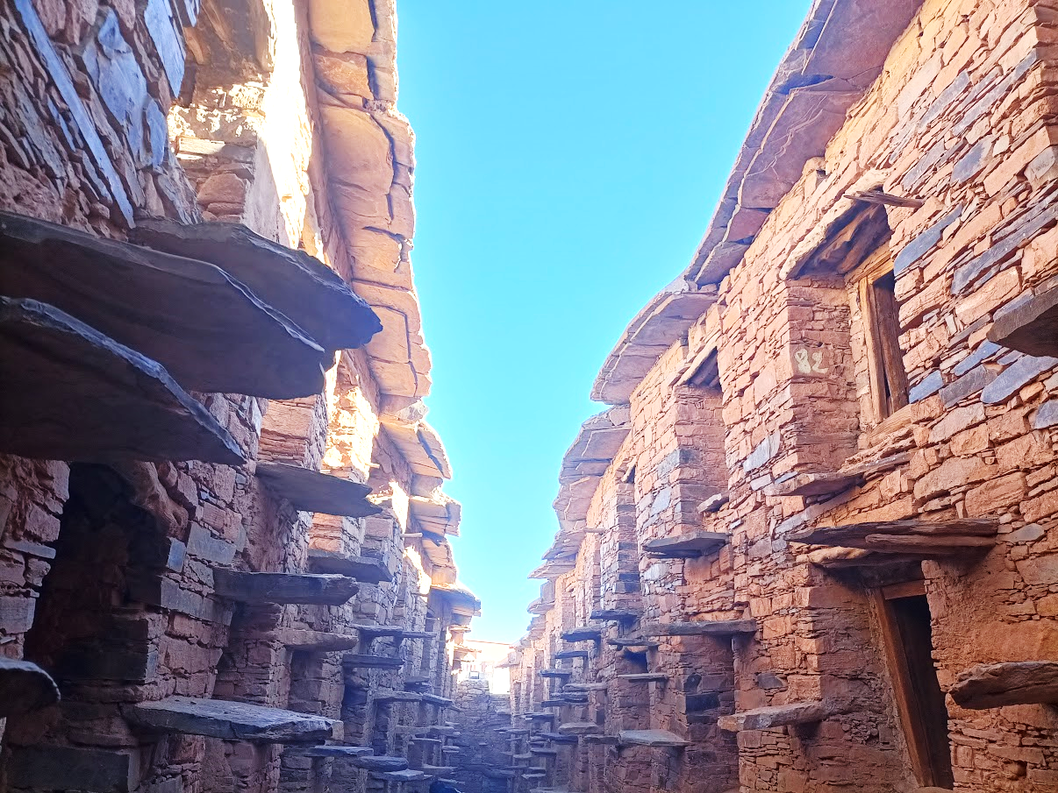
A restored Agadir in Ighil Ifrane, Morocco, visited during the workshop.

Indigenous and local knowledge, values, worldviews and governance

The importance of ILK systems
Participants agreed that ILK systems, which include values, philosophies, worldviews, management and governance, represent a vital contribution to meeting the current biodiversity crisis.

Knowledge
Participants noted that IPLCs have been able to preserve biodiversity in many territories, so it is necessary to learn from this ancestral knowledge in these regions. They also noted that in many cases, IPLCs have solutions long before the most technologically advanced countries, for example they have been conserving biodiversity and combatting the changing climate, and they have solutions to offer.
Example
Communities are taking actions to preserve local birds in the region around Agadir, Morocco, without knowing about the concept of transformative change. These types of actions and ethics could be brought and adapted to the global scale.

Values, worldviews and philosophies
Participants also emphasized that IPLC values, worldviews and philosophies offer important pathways to go beyond existing dominant philosophies, to build love, trust, community, sharing, solidarity (between people and people and nature) and democracy. For example, many IPLCs are deeply connected to their land, which they may call "Mother Earth". They have knowledge systems and values for feeding their children without damaging this land, for they consider it as their mother. For a transformative change, this notion of land could be integrated into international and national policies, with the aim of creating economies that do not damage the Earth and which correct injustices. This would entail moving away from values of dominating and oppressing nature. Within this, natural resources would not only be valued financially, and spiritual and other values should be central. For example, water should be considered a richness in itself, or as sacred, and to embed this respect into modern science and thought would potentially transform how this resource is managed.
Example
Participants noted that democracies often work within short-term timescales, as they are focused on delivery tied to election cycles. In contrast, Indigenous worldviews often consider future generations, for example the “Seven Generations” concepts, which consider how decisions and actions today will impact seven generations in the future. This is part of a recognition that people are not only here today, but that they are also here to safeguard the planet for future generations. In the Saami cosmovision people do not own the land – they are instead borrowing it from future generations. As a result, Saami do not modify their surroundings. There are often barely any signs of human inhabitation on the land because it should not be modified and should be left in the same condition, if not in a better condition, than before it is used. Meanwhile, a primary driver of biodiversity loss is land use change. A transformative change would therefore be to stop changing the land, or to reverse this process.
Participants highlighted that IPLCs have been embracing these values and worldviews since time immemorial. However, these values and worldviews can also offer important insights beyond only “traditional” situations and phenomenon, to include new environmental challenges, and issues such as industrial developments, and modern technologies, weapons and wars. They could also be fundamental to efforts to create transformative change at broader scales and globally, as embracing such values would be key to changing relationships between people and people and the natural world.

Languages
Participants also emphasized that IPLC languages are a crucial underpinning for ILK systems. Much of IPLC knowledge, values, worldviews, management practices and governance are encoded in IPLC languages and cannot be translated. Examples given for Morocco include water management, argan tree planting and traditional medicine, all of which impact relationships between nature and people in the region. Other examples include IPLC conceptualisations of time and the future, which are also encoded in IPLC languages. As such, biodiversity and ecosystems cannot be preserved by IPLCs without communication in IPLC languages.

Management and governance
They also noted that IPLC governance is sometimes more effective at nature conservation than regulations and protected areas created by national governments, as found by the IPBES Global Assessment.
Examples
Participants from Morocco shared examples of their ancestral systems of governance, which also embody knowledge, values, management and adaptation:
1. The system of Tanast: a system for distributing water to irrigate the community’s fields. Each family has its share, which is calculated. Using this system, the Amazigh community has been able to adapt to and manage water scarcity. All disputes between people benefiting from the system are settled by referring to customary law.
2. The system of Agadir: as described above in section 3.5, these are collective granaries built and managed by Indigenous Peoples using their ILK. They have several functions, and overall allow adaption to and management of food scarcity and climate change. Each family has a room in the granary where they store precious objects and the year’s harvest. The community takes care of the Agadir’s security, with guards taking turns. Cats or serpents guard the granary against mice, depending on the region, and are “paid” and respected for their work.
3. The system of Agdal: a system for preserving common areas of natural resources. Protected common areas are managed by the community, with respect for customary law. These areas are cultivated in common and are well managed. Grazing takes place after the harvest has been gathered. The Agdal is an area of balanced biodiversity. Everything has the right to receive respect, including birds and reptiles, and sometimes the sacred trees are used to impose respect for nature (for example several argan trees are sacred).
Participants agreed that if ILK and customary governance systems were recognized and supported by governments and other actors, this would represent a transformative change for people and biodiversity. Moreover, policy and action can be guided by ILK systems, providing solutions that are founded on transformative values and worldviews. This is particularly important because IPLCs stand to be the most impacted by the destruction of nature.
Examples
Since 1994, villagers in the Souss of Morocco have been organizing themselves for self-management, particularly with regard to water management. In each village, there is a legal association (which was formerly a council of elders). This builds on the ancestral systems and their working philosophies: they live in an area which, for centuries, has been based on the management of scarce water, land and other resources, and they practised communal management system based on sharing and solidarity, and on oral and written customary law. The government authorities are now asking how to practice and reinforce this type of management.
Similarly, in Algeria, some Amazigh villages voted for internal village laws around water, organized by the village committee and a president of environmental associations. This was done to preserve water, due to the natural disasters that took place the previous year. Water meters are installed by the village committees, not by the government water authority: they are self-managed and the community invested in the meters. Each person is entitled to 80 litres per day, calculated with consideration of the amount of water in local dams. If a household uses more, they must pay a fine to the village committee. If guests come to the village, the hosts need to declare to the committee that they are staying, and for how many days, and they will be entitled to 80 litres per day for the duration of their stay. Allowed amounts also vary for some groups of people (e.g., widows or old people are entitled to 130 litres per day). During events (e.g., festivals or ceremonies, including weddings or deaths), or during forest fires, water is free for three days. For agriculture, a portion of water is reserved free of charge, and troughs have been installed in every village.

Threats to ILK systems
Participants also highlighted that in spite of their strengths and contributions, ILK systems are declining rapidly in many cases. It is no longer possible to live self-sufficiently, as many IPLC older generations did, in many regions. Acculturation and changes in values are also related threats, as many IPLC youth pick up cultural influences from outside without seeing the risks. IPLC languages are also threatened and declining in many areas, and this represents a further fundamental threat to ILK systems. Participants emphasized that these threats should be highlighted and addressed as part of transformative change, as there is a need to revitalize and recognize IPLC knowledge, language, practices and governance and to enhance capacity to continue knowledge and culture among the youth.
Example
In the Atlas Mountains of Morocco, many people left the countryside to settle in the cities to work, and after material gain, they return home, which causes a societal and family change. To show off their wealth, people may build big, multi-story houses, even when they do not need to. However, over time, some people have realized that their parents’ houses were more beautiful than the ones they built, and they have gone back to building with traditional materials and methods, at least for the exterior (they often use a reinforced concrete interior). They are realizing that trying to move towards the West does not make things better, and that their local culture has a place in the universe.

Actions to understand, support and revitalize ILK systems

Enhancing understanding and research
Participants highlighted that governments could be encouraged to recognise and respect the wealth of ILK, values, worldviews and management and governance practices in their countries, and to see such ILK systems and cultural diversity as a richness rather than a challenge. The assessment could explore the steps and actions that could be taken by governments and others to understand, support and revitalise the diversity of knowledge, language, values and governance systems in their countries.
Participants also noted that there is often not enough research on IPLC societies, e.g., Amazigh societies. Enhanced research by and with IPLCs could document knowledge, language and practices relating to biodiversity or other practices, for example water management. This would help to communicate and explain IPLC cultures and their contributions more broadly, including through education programmes for non-IPLCs as well as IPLC youth. A repository of information about best practices of IPLCs could also help to inform other communities, decision makers and other actors of possible solutions to environmental and social challenges.

Co-production of knowledge
A participant noted that studies have shown that there are many synergies between ILK systems and science, in spite of their history of conflict.
Participants also noted that care must however be taken when working with ILK systems, and when attempting to find synergies or develop co-production with western science. The example was given of ILK related to health. This is ancestral knowledge that comes through theories and value systems that do not have the same origins, structures and assumptions as modern science. When ILK is brought into “modern” health systems, it is often examined using the frameworks and assumptions of modern science. This makes it difficult to accept the ILK, even when it has visible, positive and concrete results.

Education and youth
Overall, participants highlighted the crucial role of education, both for IPLC youth to learn about ILK systems, and for non-IPLCs, who could learn about the importance of IPLCs and their knowledge and value systems. In both cases, this could also include the creation of clubs, extracurricular activities and trainings, including educational outings that introduce children, students and adults to IPLCs and their concept, practices and knowledge systems. Shifting assumptions about IPLCs and ILK as inferior or as static and unchanging could be key goals in many contexts.
Other actions to protect and revitalise ILK among youth include enhancing dialogue between IPLC generations, and innovative methods such as social media and comics.
Participants recommended that the assessment could also highlight examples where youth have been brought into positive experiences of transformative change.
Example
In Algeria, Indigenous groups have implemented environmental education in different villages, including, around climate change and forest fires, particularly in view of the fires in 2001, which destroyed the fig and olive trees of a village whose livelihood depended on them. Children are also also being encouraged to plant trees and take responsibility for watering them.

Language revitalization
Participants also noted that great efforts are needed to revitalise languages, including by increasing pride in language and culture, and through education programmes that are taught in IPLC languages and which include IPLC values and concepts. A participant also noted that purely oral languages may need to be written down during this process. Participants noted that this is the International Decade of Indigenous Languages (2022-2032), and that the assessment could build synergies with this framework in relation to efforts to revitalise and continue Indigenous languages.
Example
Participants explained that the Amazigh People of Morocco have made great progress in enhancing the value given to the Amazigh language and culture, through a coherent strategy. In the past this language and culture were marginalized. After 30 years of effort, the Amazigh language has now been recognized as an official language in Morocco. Now, people proudly say they are Berbers or Amazigh, whereas before they felt that this was seen as inferior. Since 2009, 260 books have been written in Amazigh, and there are writers who received awards in Morocco and abroad. They have also translated the UNDRIP into Tamazight (the alphabet of Amazigh), as well as the International Labor Organization Convention 169 and the Nagoya Protocol. Overall, this was an ambitious project, which continues today, as they continue to push for revitalization and recognition of their language. Participants noted that this example could be shared to inspire and inform others.
A workshop participant also shared her personal experiences of the revitalisation of language, culture and identity. She grew up speaking Amazigh, but believed herself to be an Arab. She would draw and sew traditional clothing out of wool which was part of the bride’s dowry (which does not exist anymore and is only shown in museums) believing it was Arabic clothing, and only later learnt that this was Amazigh traditional clothing. Amazigh was not taught in school, so she studied the Amazigh language as an adult. Thus, the Amazigh identity came late to her. There is now legislation recommending that the Amazigh language is taught in schools, but its implementation has been slow. This should be enhanced in order to save this linguistic heritage and identity, and Amazigh should be prioritized in teaching and learning contexts. However, she noted that often majority languages such as Arabic are still prioritized in schools.
Participants also highlighted that Indigenous and local languages are very important in the global processes for a world living in harmony with nature by 2050. For IPLCs, it is impossible to imagine preserving and promoting ILK without promoting Indigenous and local languages. However, they noted that the Paris Agreement (2011) and the Global Biodiversity Framework (2022) make no mention of Indigenous languages, even though they are of prime importance. They noted that UNESCO’s International Decade of Indigenous Languages (2022-2032) could be a historic opportunity to remedy these shortcomings, but interest in this decade appears low.

Donors and funding
Participants also highlighted the role of donor organizations in supporting the revitalization of ILK knowledge systems and related practices. They however noted that donor organizations are often not receptive to what communities want, as they are focused on reports or other measurable indicators of results, rather than reconnection to lands, culture and spirituality. A better understanding by donors could be generated by building relationships and visiting places with IPLCs, to co-experience IPLC culture and knowledge in order to generate understanding.

Land tenure
Land tenure rights were also highlighted as key for IPLCs, as this gives IPLCs the legal certainty to plan, manage and take care of their lands, as well as their communities. This recognizes that in many cases IPLCs have been living on the land for centuries or thousands of years.

Technology
Participants agreed that while technology can be a threat to ILK systems, it can also provide tools for connecting with and educating youth, as well as forming connections and networks across and between communities. They noted that technology itself is not a problem, as long as its use is underpinned by IPLC values and ethics.

Intellectual property
Participants also highlighted that recognizing collective intellectual property would protect ILK from appropriation. They recommended that international processes supporting intellectual property could be adapted to local realities and implemented.

Leadership
A participants noted that the assessment could highlight the importance of leadership by IPLCs for transformative change, including for community and communal change (as was demonstrated by the women’s argan oil cooperatives discussed in section 3.10), and also the ability to respond to change. For IPLCs, leadership is sometimes an inherited responsibility, or it comes through educational roles and experience. Climate change is a good example – it may not be possible to predict what the climate might be like next year, but IPLCs need to be able to respond to it, and leadership is key.

Power imbalances and decolonization

Defining / exploring decolonization
Participants agreed that decolonization is a key process that should be explored in the assessment. They also noted however that colonial processes were very different from one country to another, and continue in different forms. IPLCs in the same country may also have had different experiences in different areas and communities. This means that “decolonization” could mean very different things in different contexts. Participants advised that it is important to explore this complexity, including through practical examples and case studies, rather than trying to standardise or simplify the terms. It may also be necessary to define decolonization in the glossary while recognizing this complexity.
Example
A participant noted that in Africa, even after the withdrawal of European powers, many Indigenous Peoples still existed under different forms of colonization. In some cases, they were also the victims of the struggles and genocides that followed, but atrocities against them were often obscured or underreported. Discrimination and power imbalances continue today in many different forms. Moreover, in some African countries, regions are facing armed conflicts linked to natural resources. Indigenous territories are often highly exposed to these conflicts. In these complex situations it is important to think about how to create a context in which all human beings are treated in accordance with the minimum international and national standards for human rights. Regulations and laws against discrimination (especially towards Indigenous Peoples) are very important, and need to continue to evolve in the context of UNDRIP.
Participants also agreed that “decolonization” could involve addressing the great power imbalances that exist in most countries, especially around political and economic power.

Governance and decision-making
Participants highlighted that governance and decision-making are key aspects of power imbalances and decolonization. Currently, IPLCs often do not have decision-making power over their communities, and policymakers make decisions without consulting them. Also, multinational or international organizations can make decisions with governments and then impose projects on IPLCs that are not in line with their reality on the ground. There is often no consultation on projects implemented on IPLC lands.
A participant noted that the assessment should explore IPLC aspirations, beyond only visions. Many IPLCs hope that governments can work with them to understand their philosophies of life, and their ethics.
A participant also noted that biocultural community protocols created by IPLCs are proven as a way for communities to establish rules for a more equal relationships between communities, governments, businesses and other actors. The clearing house mechanism of the Nagoya Protocol has many examples of these community protocols. She suggested that the assessment, particularly chapter 5, could examine biocultural community protocols to consider their transformative potential.
A participant also highlighted that there are examples of how civil society movements can check or influence the power of multinationals and governments, and these could be explored in the assessment.
Participants highlighted a vision that there should be participation by IPLCs at all levels of governance. They recommended that the assessment could explore what effective participation by IPLCs could mean at different levels of governance and in different processes.
Moreover, in terms of their own communities and lands, participants noted that for many IPLCs, self-determination is a goal, where they would have control over their own communities, lands, resources, decisions and futures, as laid out in the UNDRIP. A vision of many IPLCs is to have their own governance systems recognized by their national governments, to create sovereignty to sovereignty approaches, where diverse governance systems work together in synergy. They noted that the transformative change assessment is an appropriate place to explore such ambitious concepts and visions.
Participants also noted that it will be important to explore different cases and examples from around the world, as IPLCs seek to establish their identities, visions and decision-making capabilities in different ways and within different contexts and national frameworks.
Examples
In the case of the Plurinational State of Bolivia, the State now recognizes different nations within the country. This then needs to be reflected in institutions, ministries and laws.
The Kanak people of New Caledonia made a declaration – a statement that they had organized themselves, determined their priorities and their identity. This was also done by the Māori in New Zealand, but it has been less impactful.
The Amazigh cultural movement in Morocco had a strategy based on three elements (Awal-Afgan-Akal (language, human rights, the land):
      - the Amazigh language, with a focus on restoring the language, which has been highly successful, as described above in section 3.6.3.4.
      - human rights in general, including translating key documents (e.g., UNDRIP into Tamazight, the International Labor Organization Convention 169 and the Nagoya Protocol into Amazigh using the Tamazight alphabet); and
      - the land and land rights, which has been more challenging, though they continue to work with the government on this.
This can be seen to contrast with Indigenous movements in Latin America, where there is a clear focus on territory and land tenure, but it can seem that less explicit attention is given to language and culture.
Participants also noted that in many cases an important step may be for governments to formally recognise the Indigenous Peoples in their countries, so they can begin to work together on implementing the UNDRIP.

Legal and justice systems
Participants highlighted that legal systems are also key when discussing governance and power imbalances. They noted that the law can be a challenge and threat to IPLCs, or a tool that supports their rights and aspirations. For example, in the past, the law was used to take away the lands of Indigenous Peoples in many countries. Now, in some cases, Indigenous Peoples are able to use the law to reclaim their lands.
Participants noted that state legislation could be inspired by and changed to be supportive of customary law, to create an overarching legal framework for the country where diverse legal and governance systems can work together, rather than the current situation where customary law may be seen to be in conflict with state legislation, or is not accounted for within it.
Example
In Bolivia, when studying law, students learn about a system based on Western philosophy, and how to use Latin and Greek terms. However, customary law is used by over 60% of the population in Bolivia, so it is highly important, but this is not being taught in most law schools.
Participants recommended that the relationships and value systems behind legal systems could also be explored in the assessment. For example, in conflict resolution for many Indigenous Peoples, conciliation is prioritized over punitive actions. This could be considered at broader scales.
Participants also emphasized that access to justice for environmental defenders, many of whom are intimidated, injured or killed, is of crucial importance for IPLCs. This is also highlighted in the new Kunming-Montreal Global Biodiversity Framework.

Education
Participants also emphasized that education is a crucial pathway for decolonization on a more personal level, which could involve moving away from teaching western concepts, values and philosophies, and back towards IPLC ways of knowing and learning. Education is also discussed above in section 3.6.3.3.
Overall, participants emphasized that passing on ILK from generation to generation should be a national priority for all countries, to preserve this essential knowledge for the preservation of nature.

Gender
Participants agreed that striving for gender balance and equity should also be key goals of transformative change. They noted that impacts on women from environmental changes or hazards are often different from impacts on men, for example from climate change. They also noted that often the role of women in transformative change is not recognized. For example, over the past years, in many summits, meetings and dialogues, women have played a key role in passing on knowledge.
Participants also noted that attention to youth and elders, including those living in cities, will also be key in the context of IPLCs and broader society.

Recognition and rights
Participants also expressed their concern that many countries, especially in Africa and Asia, do not recognize Indigenous Peoples, and seem reluctant to use the term “Indigenous”, which participants described as a significant barrier to the full and effective participation of Indigenous Peoples in national environmental projects or in the development of national plans required by the United Nations Framework Convention on Climate Change (UNFCCC) and the Convention on Biological Diversity (CBD), as well as limiting participation in international fora and benefiting from rights frameworks such as the UNDRIP.

Capitalism and economic systems
Participants also agreed that capitalism and dominant economic systems are a key challenge for the world, and often especially for IPLCs, as within these systems nature and social issues tend to be ignored as rapidly making profit and acquiring wealth are prioritized.
Participants noted that capitalism cannot be changed rapidly, but first steps include finding a balance between production, consumption and conservation. Within this, the assessment could highlight the need to move away from the idea that environmental and social values somehow hinder development, and instead explore how they can work together.
Example
The example was given of the personal computer and cell phone, which are widely used by many IPLCs, including to continue culture and connections between elders and youth. However, the extraction of the materials needed, for example lithium, is often done in remote areas, and negatively impacts the quality of life of the local peoples. The participant noted that such extraction should be based on the FPIC of the concerned Indigenous Peoples, and that they should be involved in the production chain. Overall, the balance between production, consumption and the preservation of nature should be a central concern.
Participants noted that the relationships between IPLCs, conservation and multinationals could be further explored, including in relation to the Nagoya Protocol and how benefits from business are shared with IPLCs.
A participant also noted that there is a need to build recognition that some corporations and multinationals are more powerful than governments. It will be important to acknowledge in the assessment not only the political issue but also the corporate multinational issue, as their influence and power are growing.
Participants agreed that overall, a change in values is needed, to move away from production based on profits, gain and wealth, and towards valuing healthy environments and communities, where basic needs are fulfilled. Participants noted that IPLC values and economies could provide inspiration and frameworks to support this process. The case study on argan oil cooperatives may be useful to explore in this context, see section 3.10. Participants recommended that the assessment could review and compare capitalism with IPLC economies and production systems, or the assessment could recommend that more such research projects take place. Within this, it will be important to assess as many good practices from IPLCs as possible. Participants noted that the assessment could also explore different conceptions of development and progress and different ways of measuring success in a country, for example Bhutan, which has a happiness index.

The international system
Participants noted that the international system has a crucial role to play for transformative change. They noted, however, that this is currently limited in many ways, for example, only at the most recent session of the UNFCCC COP fossil fuels were recognized as an issue. However, in other cases many agreements and mechanisms are highly ambitious, for example the Paris Agreement. Participants also highlighted that even where ambitious targets or agreements are set, implementation at the national level is often lacking. It is therefore important to find a way to ensure that states implement their commitments.
Participants also noted that there is a need for more synergy between various UN organizations, processes and mechanisms: there are many different programs and processes with positive ideas and goals, but synergies need to be built between them, and between them and all relevant actors. As part of this, participants noted that it would be beneficial to enhance the synergies between the transformative change assessment and other UN instruments, e.g., mechanisms on Indigenous Peoples rights and laws, the Permanent Forum on Indigenous Issues, Indigenous rapporteurs, and other aspects of international laws and agreements.
Overall, participants agreed that the ILK dialogue workshop was very optimistic about the transformative change assessment, but in the end, it will be important to ensure commitments for action from the governments. Participants recommended that the CBD and IPBES could look to ways to ensure or enhance implementation. They noted that a first stage will be to provide an assessment with clear actionable steps towards transformative change for diverse actors.

Argan cooperative discussions

Introduction
Local participants explained that the Souss region of Morocco is the only area in the world that produces argan, an exceptional treasure that produces argan oil. Argan trees and the women’s cooperatives around them are a strong case study for transformative change.
During the workshop, participants visited a women’s argan oil cooperative in Ait Baha to learn about and discuss the transformative nature of the cooperatives, the challenges they face, and lessons that can be drawn from their experiences.

The cultural importance of argan trees
A participant explained that argan trees have great cultural significance, and that they demonstrate the intertwining of culture and nature in the region. In the poetry and stories of the local people, the argan tree has agency and spiritual significance, speaking to and with women, about the flow of water and other environmental phenomena. Some individual trees also have particular significance, e.g., some old argan trees were used as sites for court decisions, or for women’s collective feasts. These trees are often large as the women would water them. They are also seen as sacred trees, and so the scared trees grow to be even larger and more beautiful due to this reverence from the people. The tree and the customary land governance systems that developed around it have been key to the sustainable living of the Amazigh peoples, underpinned by ethics of solidarity between people and people and the trees.
Due to the law enacted in 1925, the people now do not own the trees and cannot cut them down, but they still have a right to harvest from them – there are rights of enjoyment for beneficiaries. Argan fruits are collected from the ground by women and children (they cannot be picked from the tree). There are specific songs around collecting the fruits. The fruits are then dried in the sun and processed into argan oil, through a process that involves the women cracking open the nuts before they are processed into oil.

Historical threats and protection
A participant explained that the argan tree area has been greatly reduced by waves of land use change. First, land was converted land for sugar cane, and then later for olives and oranges, and then during the second World War the trees were taken for charcoal. There are also more recent citrus fruit farms, which have taken hundreds of hectares, and intensive urbanisation at the expense of the argan forest. Climate change and ongoing drought are new threats to the trees, as the length of the drought is beginning to push the trees beyond their limits.
In response, the Argan tree, its lands, products and practices around them have now gone through different stages of protection and recognition:
1998: The Arganeraie was recognized by UNESCO as a Biosphere Reserve;
2014: UNESCO recognized the knowledge associated with argan oil as intangible heritage; and
2021: The First International Day of the Argan Tree was proclaimed by the United Nations General Assembly.

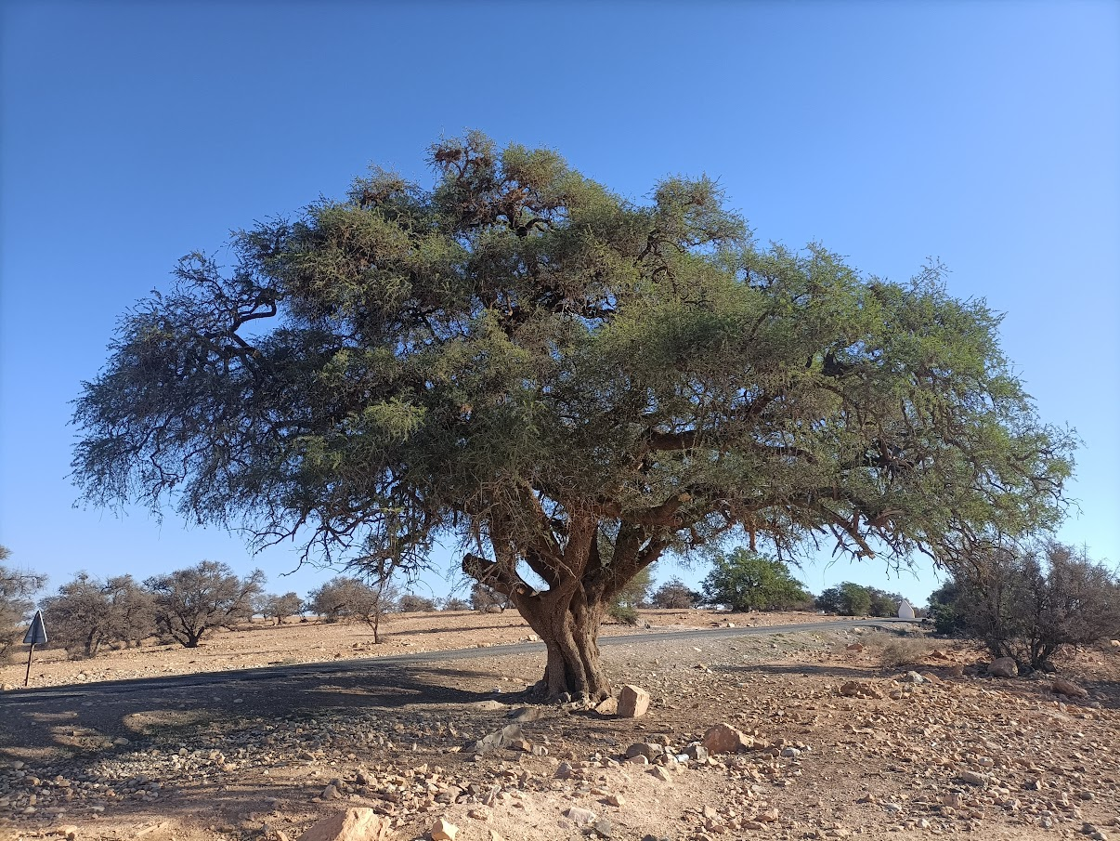
An Argan tree in the Arganeraie Biosphere Reserve, visited during the workshop.

The development of cooperatives
Participants explained that today, there are over 500 women’s cooperatives producing argan oil and related products, and the women are also traveling across the globe to promote their work with these cooperatives. This is a significant transformative change – before 1996 there were no cooperatives and in general it was often considered that women should not work. While cooperatives have some mechanization for some processes, they have also chosen to prioritise work by hand, as this provides jobs and income for the women.
Participants explained that this cooperative model has created economic activity that is not only about production and commercialization but is also based on a social and solidarity economy, that aims to protect the environment, fairly distribute benefits and create jobs whilst also bringing recognition for women and revitalizing their best practices and preserving them for the future generations. This has shown that it is crucial to protect and recognize rural women as a treasure of humanity.
Participants reflected that the cooperatives show how strong leadership and a conscious decision and vision to focus more on social goals rather than capitalism and profit can generate transformative change. The cooperatives also demonstrate that when culture and cultural practices are restored, cultural values are also revitalized.

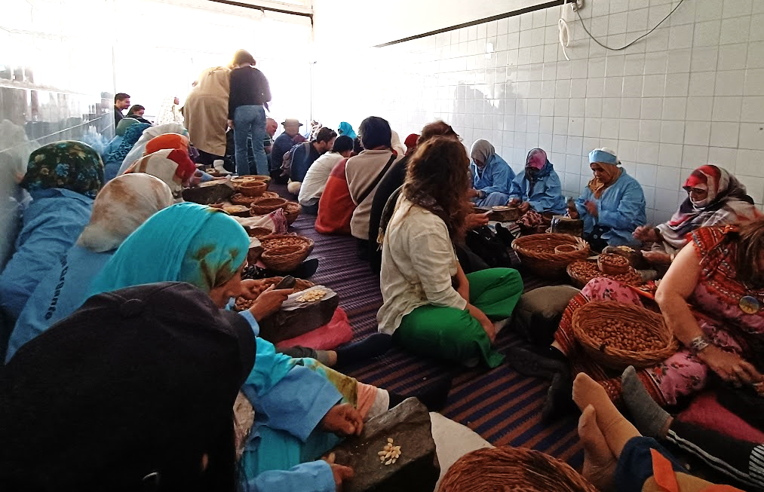
The woman’s argan oil cooperative in Ait Baha, visited during the workshop.

Challenges

Competition and exploitation
Participants highlighted that in spite of their successes, Argan cooperatives are facing challenges, as their success drew the attention of multinational corporations to argan. The initial dream of cooperatives was to improve the situation of women, which worked well for 7-8 years before multinationals entered the system. This changed the argan market, creating an imbalance in the sector. Argan oil is now an international commodity. Multinational cooperations build on Indigenous knowledge of the argan tree and the ways to produce and use its oil, but now profit more than the Indigenous Peoples who discovered these techniques and genetic properties.
This has reduced the economic benefits that accrue to the workers. When the first cooperative was set up, argan was sold at 40 dirham a litre. It is now sold at much higher prices and is often exported in whole litres, but then sold in very small quantities and diluted. Yet the situation of women has not changed with these rising prices, with some multinationals paying women much lower wages than they would receive from the cooperatives. A participant noted that there is a risk of creating a situation of severe exploitation with women working hard for minimal gain.
Participants explained that multinationals monopolize the raw materials and some cooperatives and local people now struggle to harvest or buy these raw materials, because companies buy in bulk at prices that the cooperatives cannot provide.
A participant noted that there are also economic and governance problems that occur due to a lack of capital, as many small business or communities do not have enough money, so they invite outside investments, which then brings challenges for governance and for the protection of the social and solidarity economy linked to rural women. Multinationals also bring different value systems, which influence the local population.
A participant also explained that there have also been challenges around intellectual property registration, with multinationals registering argan as intellectual property which presented challenges for cooperatives.

Ongoing gender challenges
While recognising that the argan cooperatives have been transformative for women, some participants noted that there are still many ways that this could continue and improve.
Participants noted that in spite of the success of the cooperatives, some social perceptions around gender persist in the region. There may also be complicated dynamics around gender roles. At the argan cooperatives, only women are working, and men are now often dependent on these women. However, participants noted that the aim should not be for one gender to be dependent on another, with one person working hard. Gender equality should be the goal, with cooperation within the family and mutual support.
Participants also noted that while women may be engaged at the initial production stages, they could be more involved at every stage of the production and marketing process. The eventual goal should be for the women to be better paid, with job security, and social and health issues need to be taken into account.

Ways forward
Participants discussed ways that the transformative nature of the argan cooperatives could be further enhanced.

Governance, regulation and protection
Participants noted that in the face of competition from multinational corporations, there was a need to protect and regulate the sector and the cycle of the social and solidarity economy around argan, in order to protect the rights of Indigenous women. Governance is also key: in cooperatives, communities, societies, and States.
A national strategy is therefore being implemented that aims to address the issues facing the women’s cooperatives, including regulating bulk argan sales to 5 litres maximum, with exports of larger quantities not permitted, unless a license is granted. This license implies the application of a tax that finances social actions for the local population (access to water, social coverage, and links with sustainable development). This strategy will officially begin in 2024 (2023 is a transitional period for exporters). The strategy also calls for each kilo produced by women to be paid at 65 dirhams by all buyers. All customers have been informed about the initiative and its objectives. The national strategy will give an important role back to women, with the integration of women and men (who harvest trees, for example).
Participants also noted that local people to exploit need to be able to exploit the added value and related products from the argan tree. Banning the export of raw argan oil could mean that processing and production of related products could take place locally, where the local people could be involved and benefit further, including from support to education and improved living conditions.
A participant also noted that to protect their intellectual property, the people of Morocco could make use of the World Intellectual Property Organization, which has supported other Indigenous groups in other countries. Other UN mechanisms around human rights and the Convention on Biological Diversity could also be explored.
A participant also highlighted that customary law and governance could be explored, revived and followed to help support the system, for example by changing the provision that people only have the right to harvest from the argan trees, but not own them. There is also a need to explore and revitalize traditions around harvesting, production and management, to derive best practices from them.
Participants also noted that collaboration and dialogue with multinational companies is needed, to find ways to collaborate and support rural women.
Participants noted that in the future it will also be important to protect other sectors and economic activities, for example there is also a problem with overexploitation of other forest resources. It is important to protect rare resources for local benefit.

Education and research
Education was also highlighted as crucial for further transformation. A participant highlighted that the women working in the cooperatives have a good command of the Amazigh language orally, as it is their mother tongue, but they also urgently need to learn how to read and write. The Amazigh language is officially recognised by the Moroccan constitution and the organic law (a type of Institutional Act) says that this language should be taught to everyone. Learning to read and write would enhance their ability to participate at different stages of the argan oil production and marketing chain. They also need to be made aware of their rights and the need for gender equality, to try to avoid exploitation and gender imbalances.
Participants also noted that building the future needs to be done with the youth. School curriculums are important in this, including to introduce children to the importance of preserving the biosphere reserve in which the argan trees grow, which would also benefit other species in the ecosystem.
Participants also emphasized that exploration is needed of how to stop degradation of the argan tree areas and how to restore this important relationship between land, culture and economy with the argan trees.
Education for all on the importance of the women’s cooperatives for culture, economy and environment, including visits to the cooperatives where possible, could also improve understanding and the value placed on products which are handmade and created through sustainable social and cultural systems.
More education and awareness of such cooperative models could also help to demonstrate how small islands of transformative changes at the local level are creating more sustainable futures, and the difficulties they face. This then invites discussions of how to protect and scale up these models and the values that accompany them.

Next steps
A series of steps took place after the workshop:
- A series of comments for the assessment’s review period were developed from the dialogue. These were sent to participants for editing and approval, and following this they were submitted into the formal assessment review process for the attention of authors;
- A report from the dialogue workshop (this report) was developed. The draft report was sent to all participants for them to edit, make additions, and/or approve prior to finalization and publication online;
- Using the comments and report as resources, the authors continued to develop the draft chapters of the assessment;
- The assessment will be considered by the IPBES Plenary in December 2024.

Annexes

Annex 1: Draft Agenda

Wednesday 13 December
8h30-09h00 | Registration | All
9h00-9h15 | Opening | Kaidi Khalid, Mohamed Handaine, Karen O’Brien
9h15-9h45 | Introductions | All
9h45-10h15 | Introduction to IPBES and its work on ILK  Introduction to the transformative change assessment | Peter Bates / Karen O’Brien
10h15-10h30 | Introduction to the local context | Mohamed Handaine
10h30-10h45 | Aims, methods and agenda of the dialogue / Free Prior and Informed Consent | Peter Bates
10h45-11h00 | Refreshment break
11h00-11h45 | IPLC caucus | IPLC participants
11h45-12h30 | Caucus report back and discussion: How can the assessment and this workshop be most useful for all participants? What methods and approaches should be used? | IPLC participants
12h30-14h00 | Lunch
14h00-15h30 | Discussions on IPLC visions and transformative change | All
15h30-16h00 | Refreshment break
16h00-17h45 | Discussions on the assessment and its summary for policymakers:  - Why is transformative change necessary and urgent?  - What is transformative change? | All
17h45-18h00 | Closing of day | Karen O’Brien /  Mohamed Handaine

Thursday 14 December
8h00-11h00 | Visits to the Biosphere Reserve of Argan, to Ighil Ifrane and guided tour of Agadir
11h00-12h30 | Lunch in Ifri’s cave
12h30-15h00 | Visits of the Argan Women Cooperative and the Babouche market of Ait Baha
15h00-16h00 | Back to Agadir: closing of the day

Friday 15 December
9h00-9h15 | Reflections on days 1 and 2, Plan for day 3 | All
9h15-10h30 | Discussions on the assessment and its summary for policymakers  - How does transformative change happen?  - Strategies and options for transformative change | All
10h30-11h00 | Refreshment break
11h00-12h30 | Discussions on the assessment and its summary for policymakers:  - How does transformative change happen?  - Strategies and options for transformative change | All
12h30-14h00 | Lunch
14h00-15h00 | IPLC caucus | IPLC participants
15h00-16h00 | Report back from the IPLC caucus and discussion | IPLC participants
16h00-16h15 | Refreshment break
16h15-17h00 | Discussion: overarching messages and themes, key approaches and participants, how can the assessment be useful for IPLCs? | All
17h00-17h30 | Ways forward and participation in the assessment work:  Timelines for collaboration, communication and dialogue throughout the processes, identifying key experts, resources | Karen O’Brien / Peter Bates
17h30-17h45 | Next steps | Karen O’Brien / Peter Bates
17h45-18h00 | Closing | Mohamed Handaine / Karen O’Brien

Annex 2: FPIC document
Third Indigenous and local knowledge dialogue on the IPBES assessment of transformative change
13-15 December 2023
Agadir, Morocco
The individuals whose names are listed at the end of this document agreed during the dialogue workshop to follow the principles and steps laid out in this document.
Background
Within the framework of the UN Declaration on the Rights of Indigenous Peoples (UNDRIP), principles of Free, Prior and Informed Consent (FPIC) apply to research or knowledge-related interactions between Indigenous peoples and outsiders (including researchers, scientists, journalists, etc.). Given that the dialogue process includes discussion of Indigenous knowledge of biodiversity and ecosystems, there may be information which the knowledge holders or their organizations or respective communities consider sensitive, private, or holding value for themselves which they do not want to share in the public domain through publications or other media without formal consent.
Principles
The dialogue will be built on equal sharing and joint learning across knowledge systems and cultures. The aim is to create an environment where people feel comfortable and able to speak on equal terms, which is an important precondition for true dialogue.
To achieve these aims, the following goals are emphasized:
- Equality of all participants and absence of coercive influence
- Listening with empathy and seeking to understand each other’s viewpoints
- Accurate and empathetic communication
- Bringing assumptions into the open
If participants feel that the above goals are not being achieved at any point during IPBES activities, participants are asked to bring this to the attention of the organizers of the activity, or the IPBES technical support unit on ILK, at: ilk.tsu.ipbes@unesco.org.

Sharing knowledge and respecting FPIC
To ensure that knowledge is shared in appropriate ways during dialogue workshops and other IPBES activities, and that information and materials produced after these activities are used in ways that respect FPIC, we propose the following:
- Guardianship – participants who represent organizations and communities
- Principles of guardianship will be discussed with IPLC participants at the beginning of IPBES activities.
- Participants who represent organizations or communities will act as the guardians of the use of the knowledge and materials from their respective organizations or communities that is shared before, during or after the workshop. Any use of their organizations’ or communities’ knowledge will be discussed and approved by the guardians, as legitimate representatives of their organizations or communities. Guardians are expected to contact their respective organizations and communities when they need advice. Guardians are also expected to seek consent from their organizations or communities when they consider that this is required, keeping in mind that sharing details of their community’s knowledge can potentially have negative consequences, for example sharing the locations and uses of medicinal plants.
- FPIC rights during dialogue workshops and other activities
- The FPIC rights of the Indigenous Peoples participating in dialogue workshops or other activities will be discussed prior to the beginning of the activity, until participants feel comfortable and well informed about their rights and the process, including the eventual planned use and distribution of information. This discussion may be revisited during the activity, and will be revisited at the end of dialogue workshops once participants have engaged in the dialogue process.
- Participants do not have to answer any questions that they do not want to answer, and do not need to participate in any part of an activity in which they do not wish to participate;
- At any point, any participant can decide that they do not want particular information to be documented or shared outside of the activity. Participants will inform organizers and other participants of this. Organizers and participants will ensure that the information is not recorded. Participants can also request that the information is only recorded as a general statement attributed to a region or country, rather than to a specific community.
- Permission for photographs must be agreed prior to photos being taken and participants have the right not to be photographed. Organizers will take note of this.
- After the activity
- Permission will be obtained before any photograph of a participant is used or distributed in any form.
- Permission will be obtained before any list of participants is used or distributed in any form.
- Participants maintain intellectual property rights over all information collected from them about themselves or their communities, including photographs. Their intellectual property rights should be protected, pursuant to applicable laws.
- Copies of all information collected will be provided to the participants for approval.
- Any materials developed for IPBES assessments or other products using information provided by participants will be shared with the participants for prior approval and consent.
- The information collected during the activity will not be used by IPBES for any purposes other than those for which consent has been granted, unless permission is sought and given by participants, noting that IPBES does not have control of how other parties use its publicly available materials.
- Participants can decline to consent or withdraw their knowledge or information from the process at any time, and records of that information will be deleted if requested by the participant. Participants should however be aware that once an assessment is published it cannot be changed, and information incorporated into the assessment cannot therefore be withdrawn from the assessment after this point.
- Participants had the opportunity of reviewing and commenting upon the final product during the second draft review period, and a dialogue workshop was organized to support this, bearing in mind that responsibility for the final product rests exclusively with the authors.

Annex 3: Participants of the dialogue workshop

Indigenous Peoples and local communities
Khalid Aayoud | Morocco | Researcher and expert in heritage and immigration
Sabri Abdhallah | Morocco | TAMAYNUT Organization
Yacine Abdelaziz | Morocco | Researcher on Amazigh history and culture
Ayoub Achbaro | Morocco | Junior Project Manager "Ocean Decade", Mohammed VI Foundation for the Protection of the Environment
Ijjou Arjdal | Morocco | Doctoral candidate in Amazigh heritage
Zahia Bachir | Algeria | IPACC women's representative - North Africa
Vital Bambaze | Burundi | UNIPROBA
Malika Boutaleb | Morocco | Summer University – Agadir
Lahcen Boukerdi | Morocco | Confederation of Amazigh Associations of Southern Morocco
Kaoutar Caidi | Morocco | Junior Project Manager, Programme to safeguard and develop the Marrakech palm grove, Fondation Mohammed VI Pour La Protection De L'Environnement
Q”apaj Conde | Bolivia | Convention on Biological Diversity Secretariat
Hicham El-Mastouri | Morocco | TAMAYNUT Organization
Guadalupe Yesenia Hernandez Marquez | Mexico | ILK focal point for IPBES in Mexico
Mariaelena Huambachano | Peru | Indigenous researcher, Syracuse University
Aslat Holmberg | Finland | Saami Council
Jamila Id Bourous | Morocco | Director of the Argan women's cooperative - Agadir
Lekishon Kanyinke | Kenya | Indigenous Peoples of Africa Co-ordinating Committee (IPACC)
Boujid Khadija | Morocco | Center for Amazigh Historical and Environmental Studies
Benbihi Lobna | Morocco | TAMAYNUT-INERGANE Organization
Jane Meriwas | Kenya | Samburu Women Trust
Akounad Mohamed | Morocco | TAMUNT N IFFUS Confederation
Handaine Mohamed | Morocco | Center for Amazigh Historical and Environmental Studies
Ouhmou Mohamed | Morocco | IGHBOULA Organization
Madbouhi Mustapha | Morocco | Ministry of Energy and Sustainable Development
Youba Ouberka | Morocco | Filmmaker – Amazigh heritage
Jamila Raissi | Morocco | Cooperative Manager – Aqqayn
Rachida Rachid | Morocco | Center for Amazigh Historical and Environmental Studies

IPBES transformative change assessment
Karen O’Brien | Norway | Co-chair
Juan Martin Dabiezies | Uruguay | Chapter 1
Nick Roskruge | New Zealand | Chapter 3
Maiko Nishi | Japan | Chapter 3
Valerie Nelson | United Kingdom | Chapter 4
Rafael Magris | Brazil | Chapter 5
Camille Guibal | France | Transformative change assessment technical support unit

IPBES task force on Indigenous and local knowledge
Peter Bates | United Kingdom | Technical support unit on ILK
Julie Vivier | New Caledonia | Technical support unit on ILK

IPBES (2019) Global assessment report on biodiversity and ecosystem services of the Intergovernmental Science-Policy Platform on Biodiversity and Ecosystem Services. E. S. Brondizio, J. Settele, S. Díaz, and H. T. Ngo (editors). IPBES secretariat, Bonn, Germany. ISBN: ​978-3-947851-20-1.
The report from the first ILK dialogue workshop for the transformative change and nexus assessments is available here.
The report for the second ILK dialogue workshop for the transformative change assessment is available here.
Disclaimer: The text in section 3 represents an attempt to reflect solely the views and contributions of the participants in the dialogue. As such, it does not represent the views of IPBES or UNESCO or reflect upon their official positions.
Please see the following for some references to “rights holders”: https://www.unescwa.org/sd-glossary/rights-holders; https://opil.ouplaw.com/display/10.1093/law/9780199683734.001.0001/law-9780199683734-chapter-7; https://data.unaids.org/topics/human-rights/hrissuepaper_rbadefinitions_en.pdf

