MBARARA UNIVERSITY OF SCIENCE AND TECHNOLOGY

NAME; ABAASA PRINCE KABAMBA

REG NO; 2021/ BIT/136/PS

**Web Design and Development Project Report**

**Loan Management System**

**1. Project Overview**

**a. Purpose and Target Audience**

The **Loan Management System** is a web-based platform designed to manage and automate the process of loan application, approval, repayment tracking, and customer communication. It is aimed at financial institutions, microfinance organizations, and SACCOs. The primary users include loan officers, financial administrators, and system admins.

**b. Key Functionalities and Features**

* User registration and login with role-based access (Admin, Loan Officer)
* Loan application, approval, and rejection workflow
* Repayment schedule generation and tracking
* Equated Monthly Installment calculator
* Customer profile management
* Dashboard with real-time loan statistics and performance metrics

**c. Early Wireframes and Mockups**

* Admin dashboard layout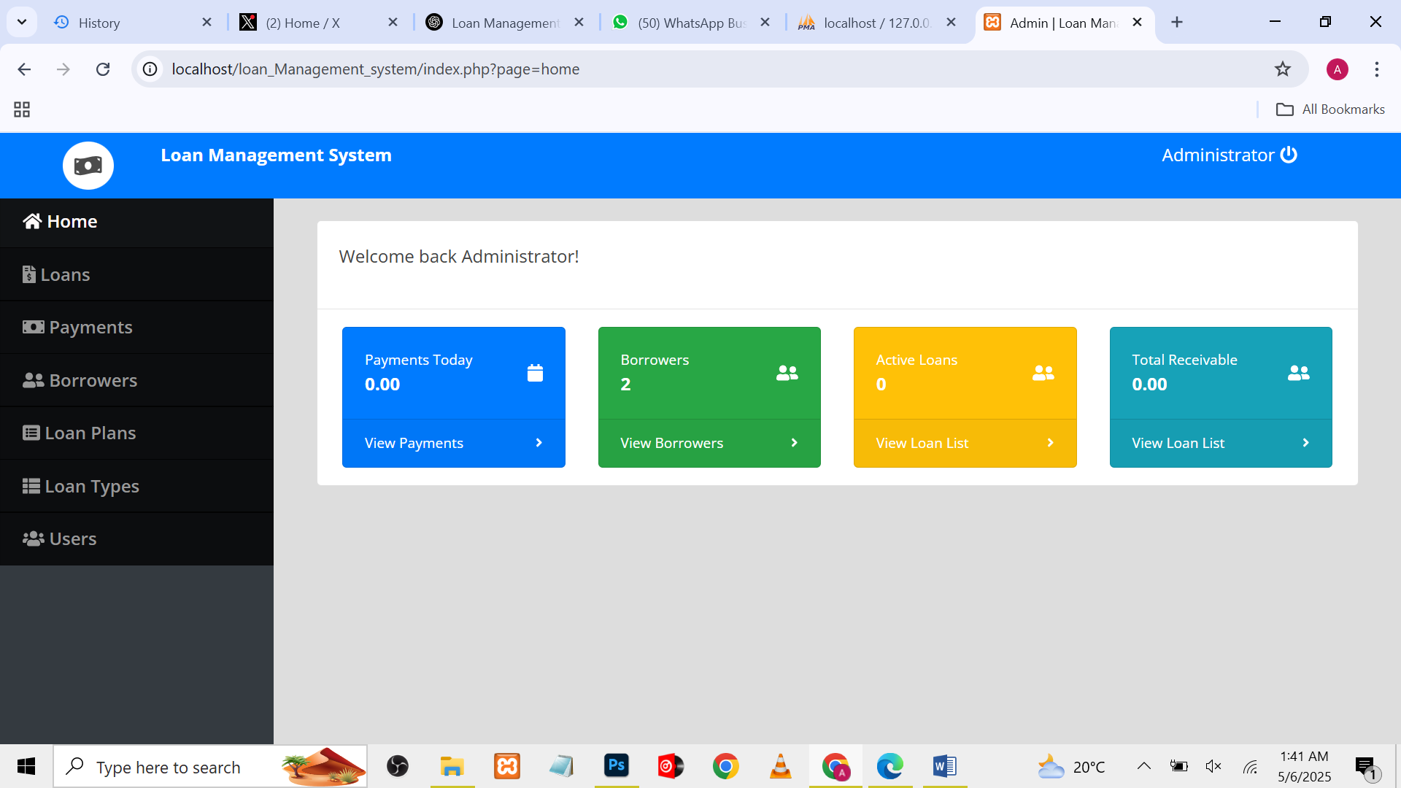
* 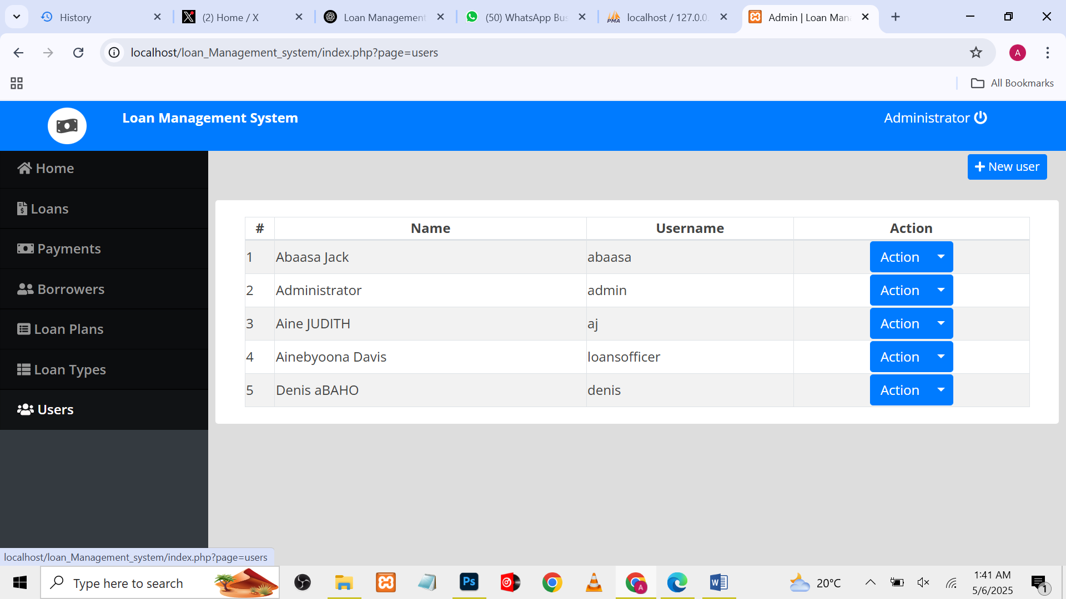
* Loan officer review and approval interface
* 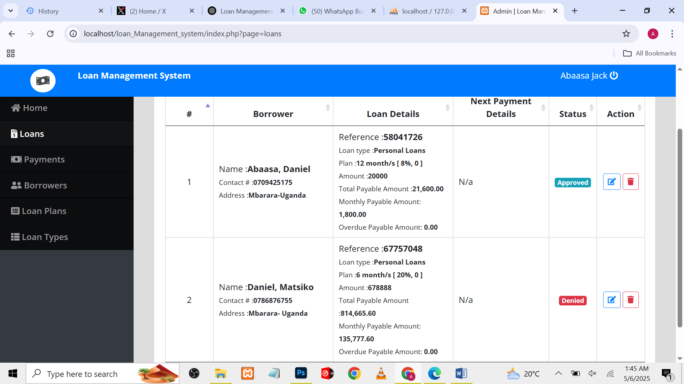
* 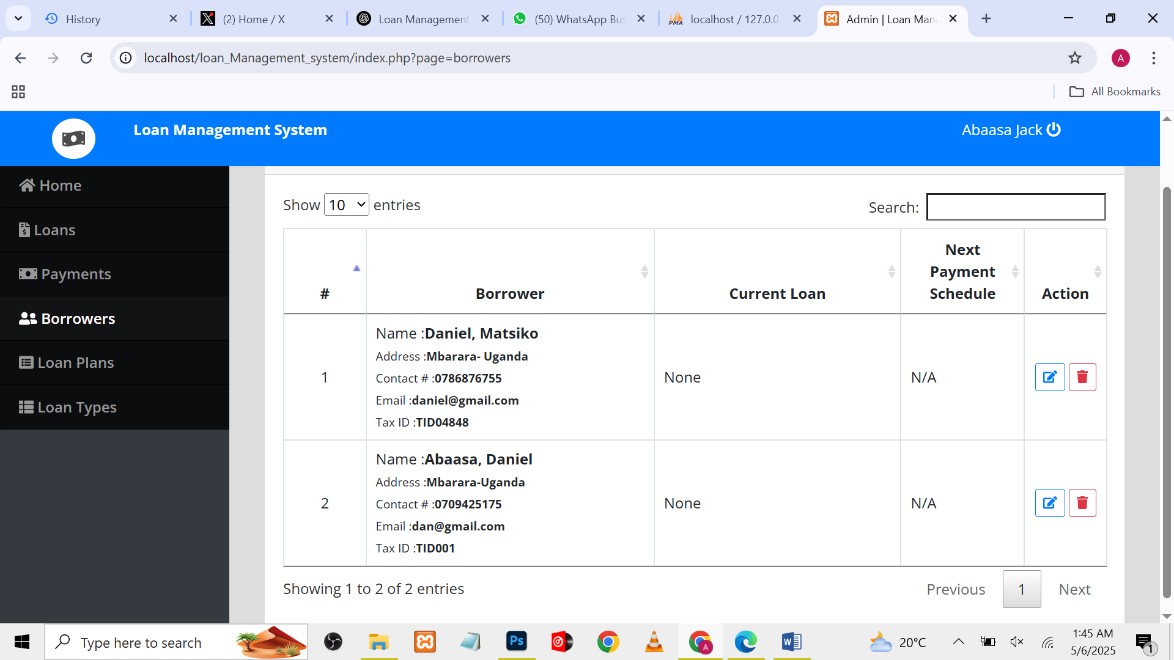

**2. Design Decisions**

**a. Design Principles Considered**

* **User Interface (UI):** Emphasized simplicity and clarity to allow users to quickly access key functionalities.
* **Color Theory:** Adopted a green and white theme symbolizing financial growth and trust, with accent colors for status indicators (e.g., red for overdue, blue for pending).

**b. Rationale Behind Design Choices**

The LMS interface was designed for efficiency and trust. A responsive layout ensures ease of use across desktops and mobile devices, while consistent iconography and color codes support rapid task execution and status recognition.

**c. Design Illustrations**

* User login page

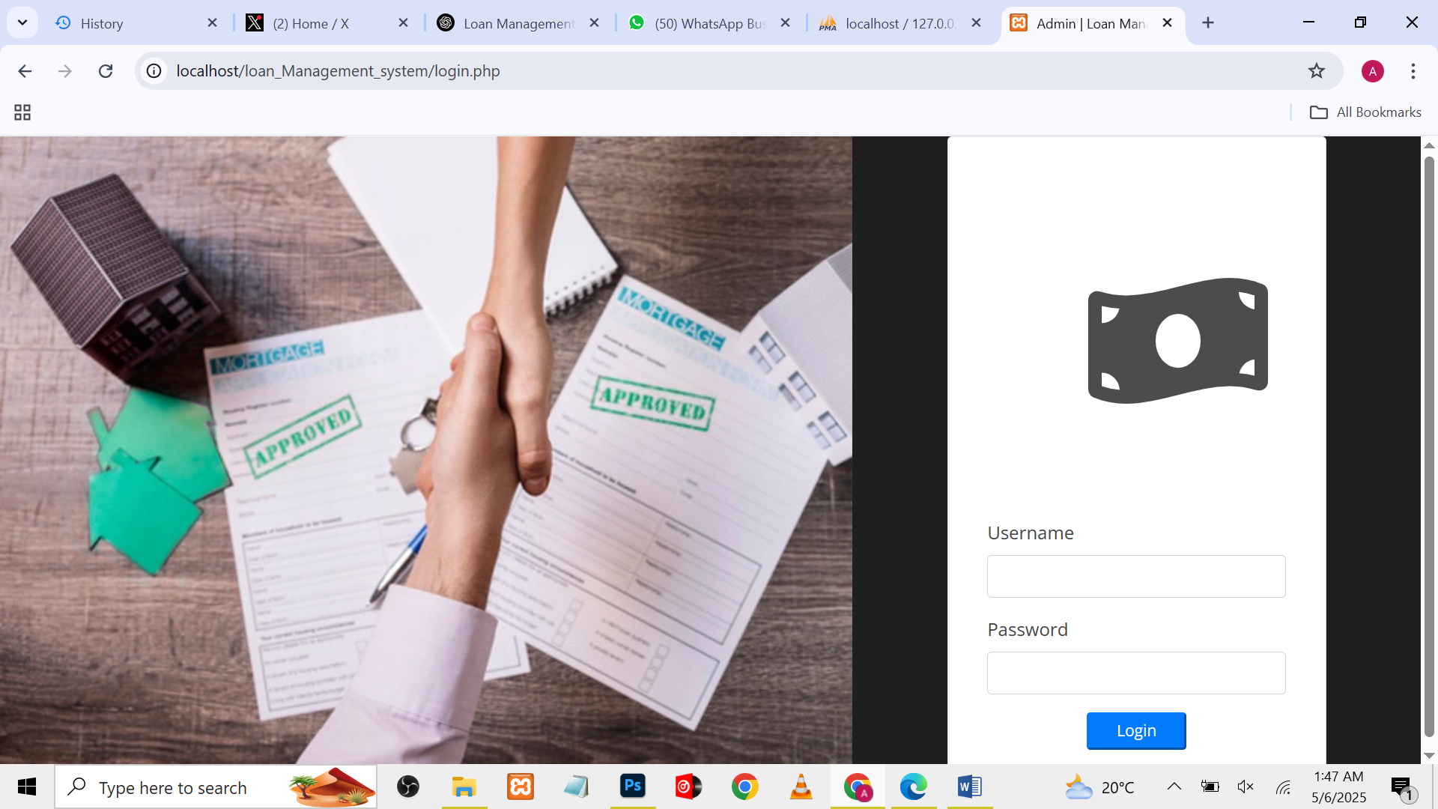

* Loan application form mockup

**3. Development Process**

**a. Technologies and Frameworks**

* **Frontend:** HTML5, CSS3, JavaScript
* **Frameworks:** Bootstrap for responsiveness, Font Awesome for icons
* **Backend:** PHP
* **Database:** MySQL

**b. Development Stages & Challenges**

1. Requirement Gathering – Identified primary user roles and workflows
2. Database Design – Normalized tables for users, loans, repayments, and transactions
3. Frontend Development – Created reusable UI components for forms, lists, and dashboards
4. Backend Integration – Handled form submissions, validations, and database operations
5. Testing and Iteration – Addressed bugs, security, and UI responsiveness

**Challenges Faced:**

* Designing a flexible repayment model to support various loan types
* Preventing duplicate entries during concurrent submissions
* Managing real-time loan status updates

**c. Solutions Implemented**

* Used AJAX for asynchronous form validation
* Applied foreign key constraints and unique indexes in MySQL
* Created cron job logic to update overdue loan statuses daily

**4. Testing and Deployment**

**a. Testing Strategies**

* Cross-browser testing (Chrome, Firefox, Safari)
* Mobile responsiveness testing using Chrome DevTools
* Loan calculation and date validation tests
* Role-based access tests to ensure permissions are respected

**b. Deployment Strategy**

* Developed and tested on XAMPP (local server environment)
* Prepared for future deployment on a public.
* Version-controlled using Git for team collaboration and rollback capabilities

**c. Visuals**

* Loan types

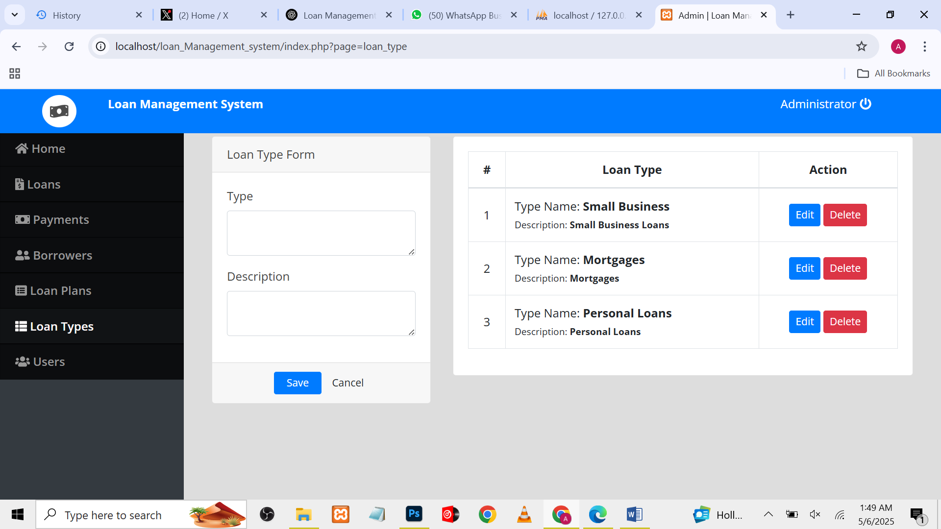

**5. Key Takeaways from the Project**

The Loan Management System project provided hands-on experience with end-to-end web development—from wireframing and UI design to implementing backend workflows and database integration. It underscored how digital systems can greatly simplify and automate loan management processes, improving efficiency and transparency for both staff and clients.

**b. Reflection on the Learning Experience**

**What went well?**

* Role-based access control functioned correctly and securely
* Dashboard effectively displayed key loan insights
* EMI calculation and loan status updates performed accurately

**What could be improved?**

* Validation logic can be enhanced for edge cases like floating interest rates
* Need for better error messages during form submission
* Limited time constrained the implementation of SMS/email reminders

**6. Future Considerations for the Project's Development**

* Cloud Hosting: Deploy the system on a cloud platform for remote access and scalability
* Security Enhancements: Use password hashing, HTTPS, and audit logs
* Automation: Add automated reminders for due EMIs via email or SMS
* Advanced Features: Include loan performance graphs, credit scoring integration, and mobile money APIs
* Mobile Optimization: Develop a progressive web app (PWA) or native Android app for field agents
* Reporting Module: Generate downloadable reports for loans, repayments, and defaulters