**Deployment Guide by Team Nymbus**

**For local development**

1. **Install visual studio 2019**

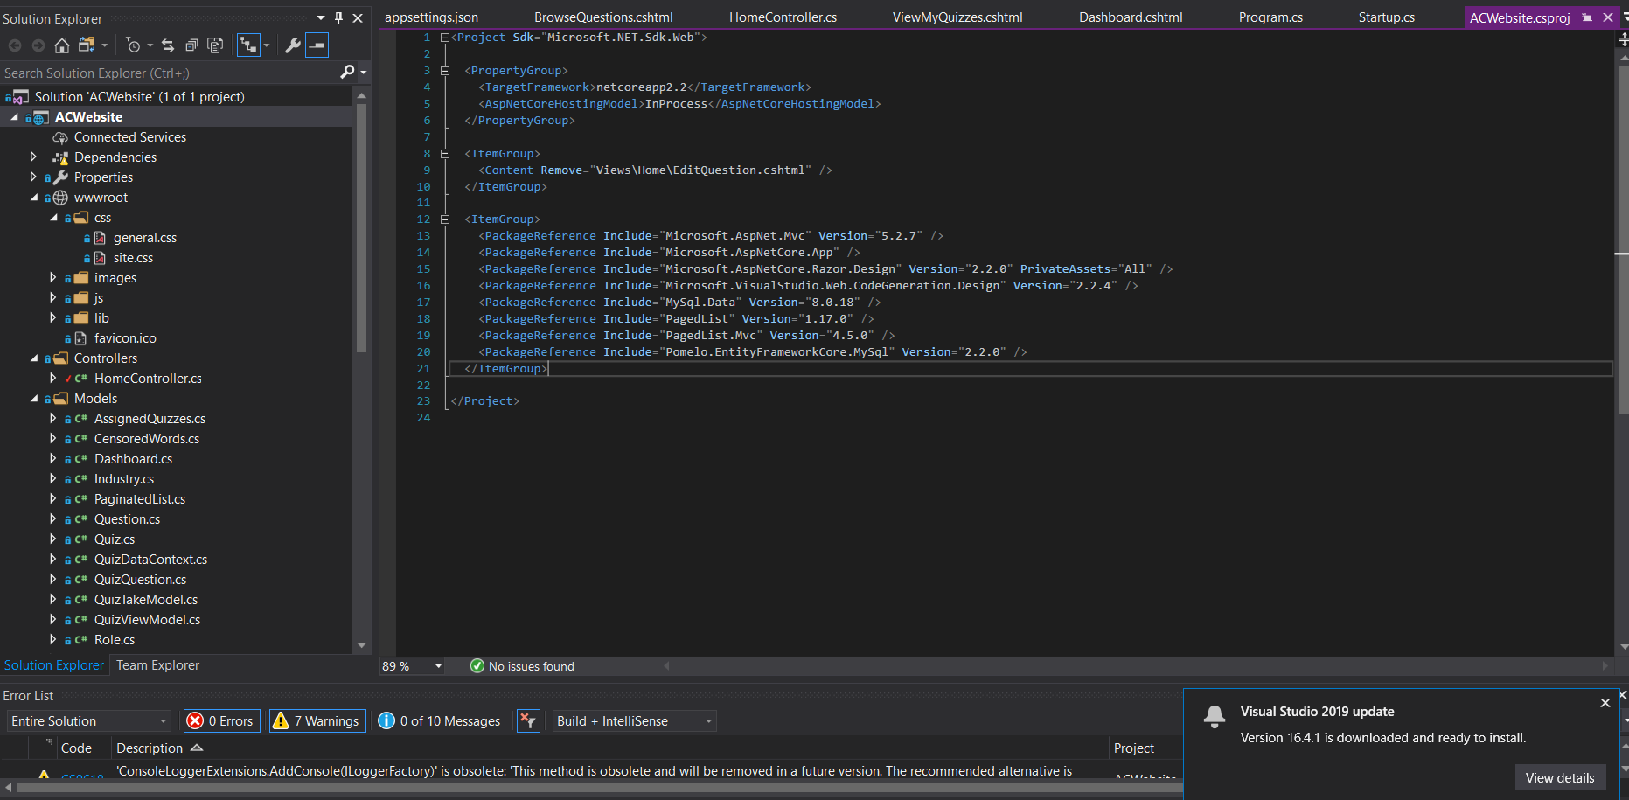

1. **Install Xampp ( it comes with Mysql preinstalled and database manager phpMyAdmin )**

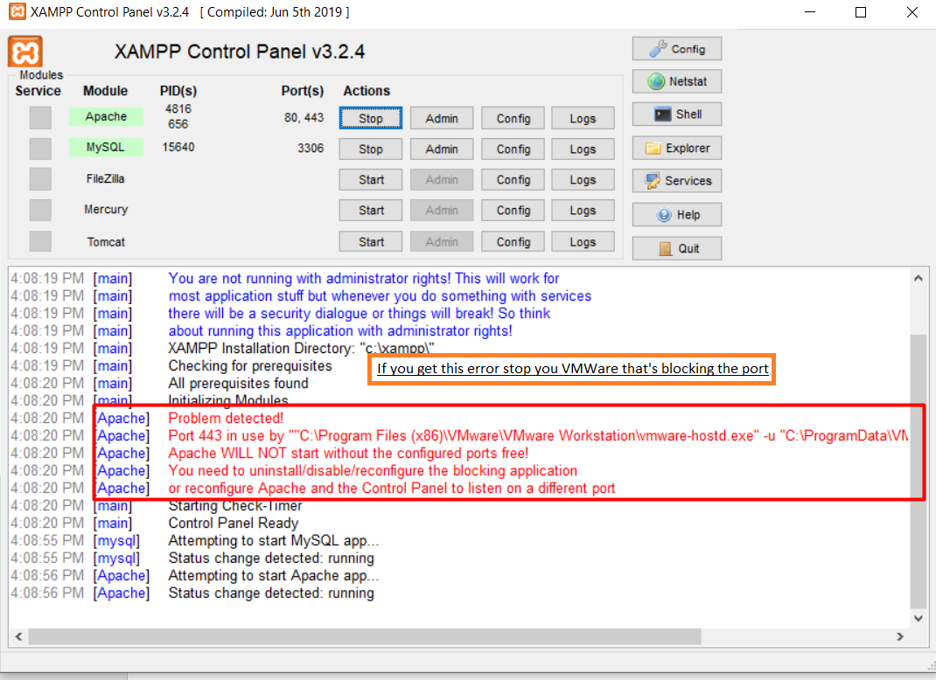

1. **Add your database credentials in Startup.cs. By default: database = acsite, port=3306, user=root, password=<none>.**

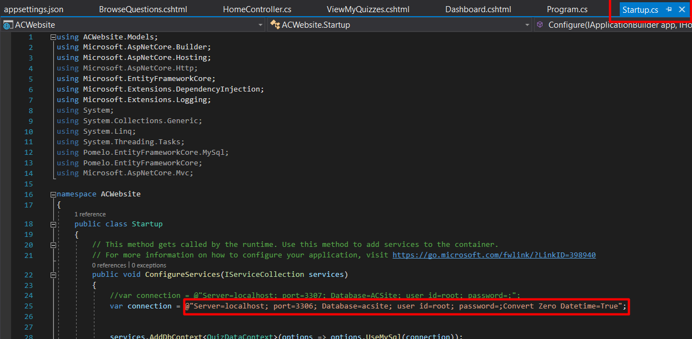

1. **Run mysql and import acsite.sql. Make sure the port is not taken.**

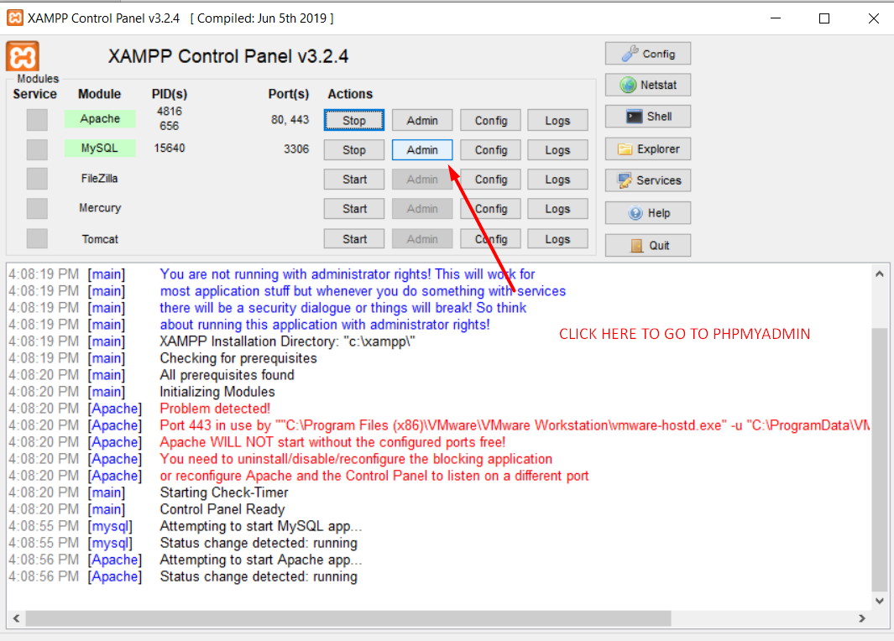

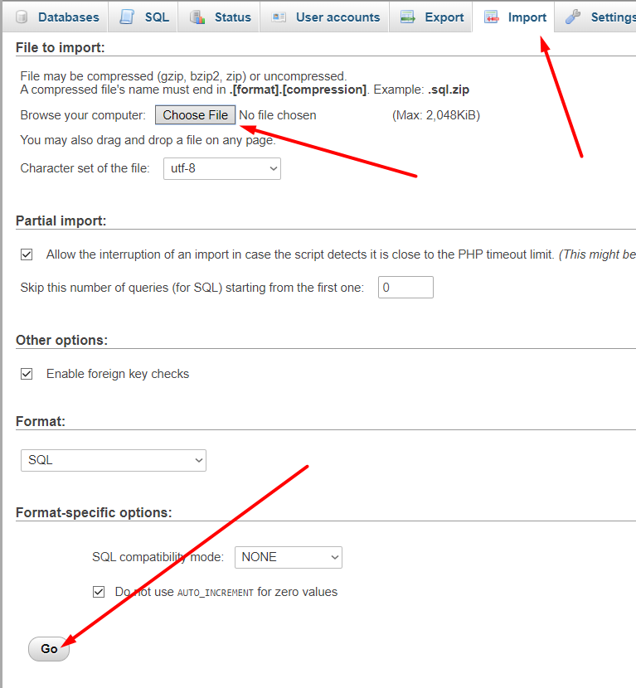

1. **Run project!**

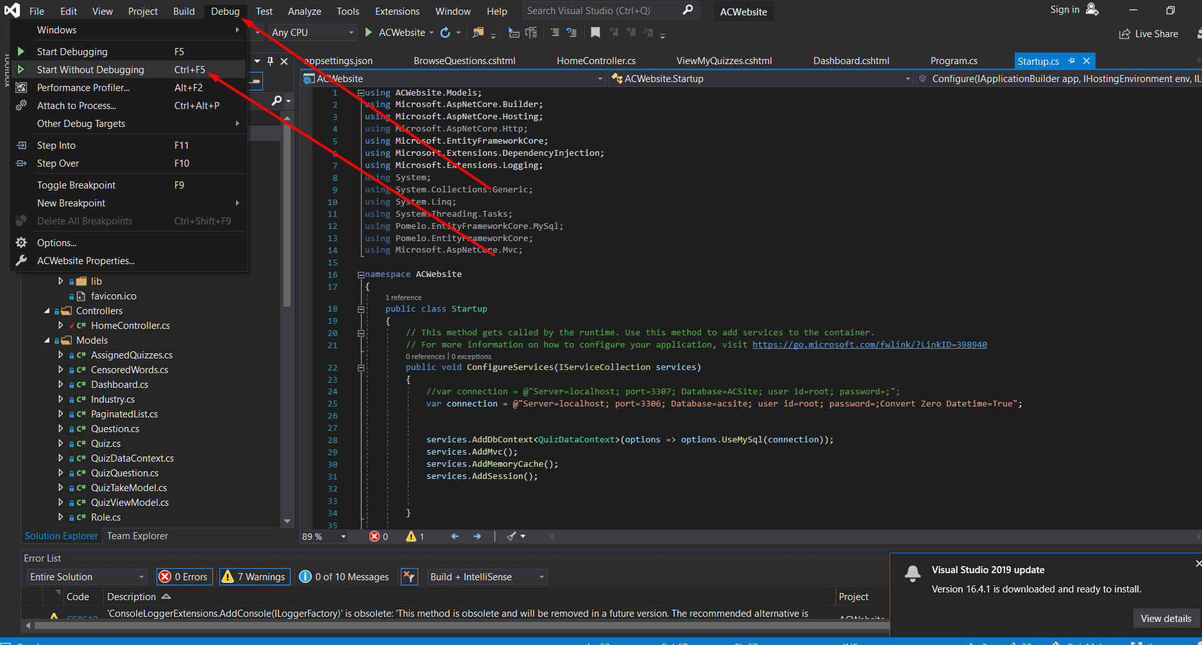

1. **Voila!**

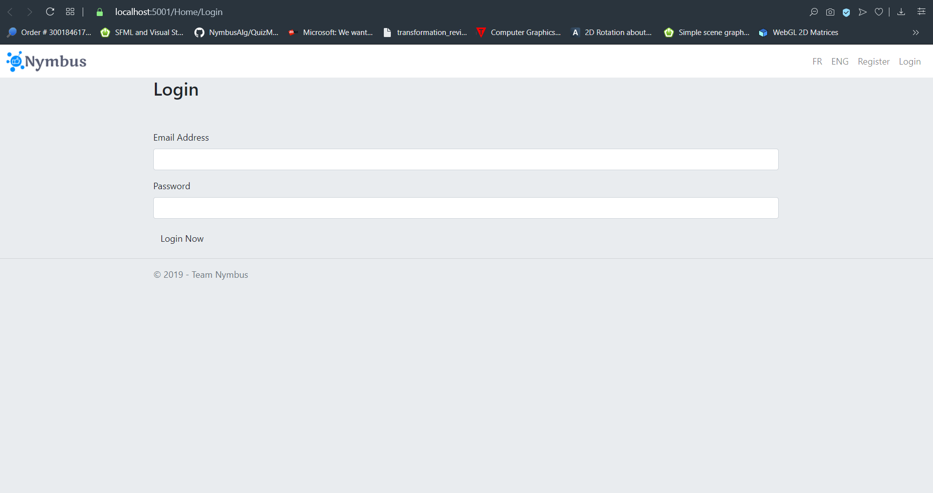

**For production**

1. **Get Azure account.**
2. **Create and import MySQL database**
3. **Change database connection string to work with Azure**
4. **Add azure account into your VS 2019**
5. **Publish application.**

**Features that are not finished**

1. **Taking quiz page saves answers individually, but doesn’t submit quiz**
2. **Quizzes assigned to me not fully finished**
3. **Implement moderator profile**
4. **Email notifications**