Odoo Installation Report

Part 1: Installation Process

1. Research and Document Hardware and Software Requirements

Hardware Requirements:
- Processor:
  - Minimum: Dual-core processor
  - Recommended: Quad-core processor or higher for better performance.
- Memory (RAM):
  - Minimum: 2 GB RAM
  - Recommended: 4 GB RAM or higher for better responsiveness, especially when handling multiple users or modules.
- Disk Space:
  - Minimum: 10 GB of available disk space for Odoo installation.
  - Recommended: 20 GB or higher, especially if using a database with large amounts of data or multiple add-ons.
- Network:
  - A stable internet connection is required for downloading packages and updates.

Software Requirements:
- Operating System:
  - Ubuntu 22.04 (recommended)
  - Other Linux distributions, Windows, and macOS are supported but may require additional steps.
- Python:
  - Minimum required version: Python 3.10 or higher.
  - Recommended: Python 3.11 to work with Odoo 17 seamlessly.
- PostgreSQL:
  - Minimum required version: PostgreSQL 13 or higher.
  - PostgreSQL is the database system used by Odoo, so its installation and proper configuration are essential.
- Node.js and npm:
  - Node.js: Version 14.x or higher.
  - npm (Node Package Manager) is required for managing frontend dependencies.
- Libraries and Dependencies:
  - Python libraries such as pip, wheel, setup tools, and others specific to Odoo( automatically installed during the process).
  - Additional system dependencies may include:
    - libxml2-dev
    - libxslt1-dev
    - libevent-dev
    - libsass-dev
    - libldap2-dev
    - libjpeg-dev
    - libpq-dev
    - libpng-dev
    - python-dev
- Git:
  - Required for downloading and managing Odoo source code from the repository.
  - Git version 2.x or higher.
- Web Server:
  - Nginx or Apache (optional, for production environments where Odoo is exposed to the web).
- Browsers:
  - Any modern web browser such as Google Chrome, Mozilla Firefox, or Microsoft Edge for accessing the Odoo web interface.

2. Install Git
Command: sudo apt install git
Verify Installation: After installing, verify by running:
git --version
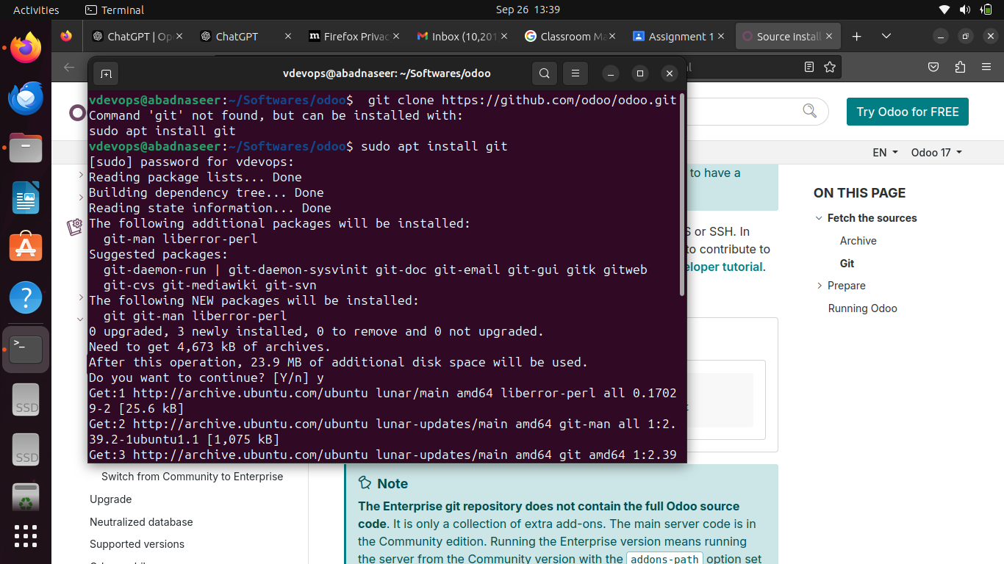

3. Clone Odoo Enterprise Code from GitHub
Task: Normally, I would clone the repository using:
git clone https://github.com/odoo/odoo.git
Issue Encountered: Due to GitHub security restrictions, the terminal did not allow me to clone the repository using Git. This issue typically arises due to credential restrictions (token-based authentication required).
Workaround: Downloaded Odoo 17 source code via browser from GitHub directly. You manually searched for the Odoo repository, browsed the available versions, and selected Odoo 17.

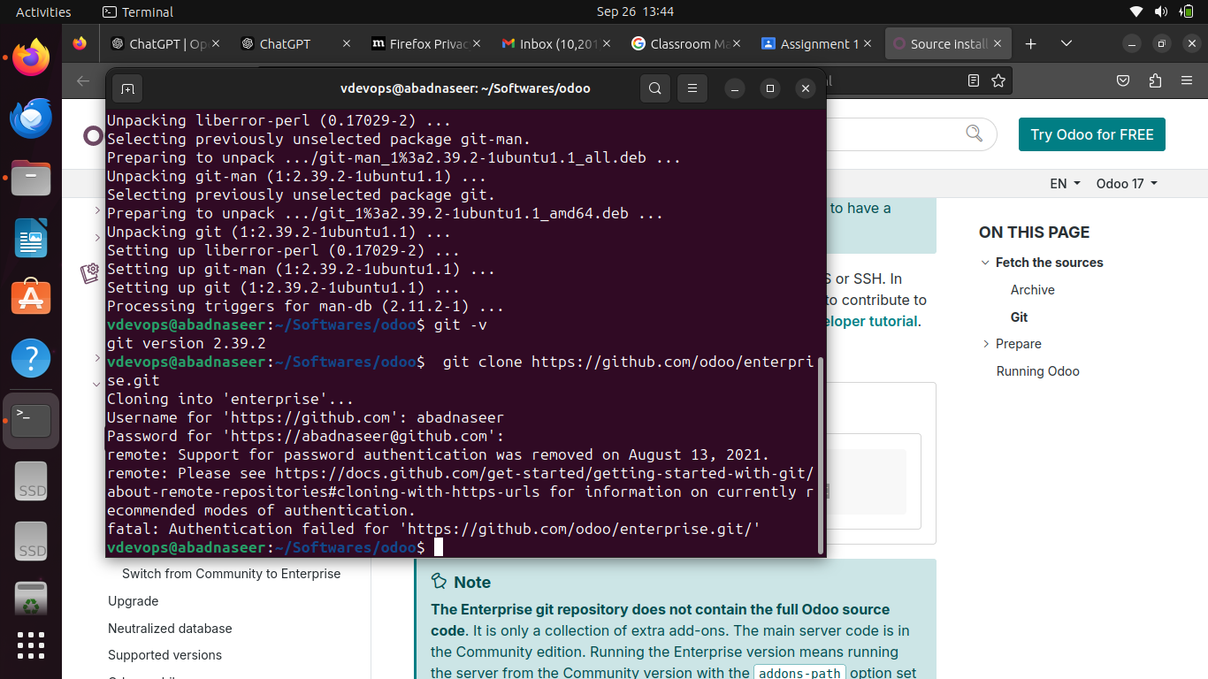
After I search for the odoo on google.com and found source code on github, I downloaded it.

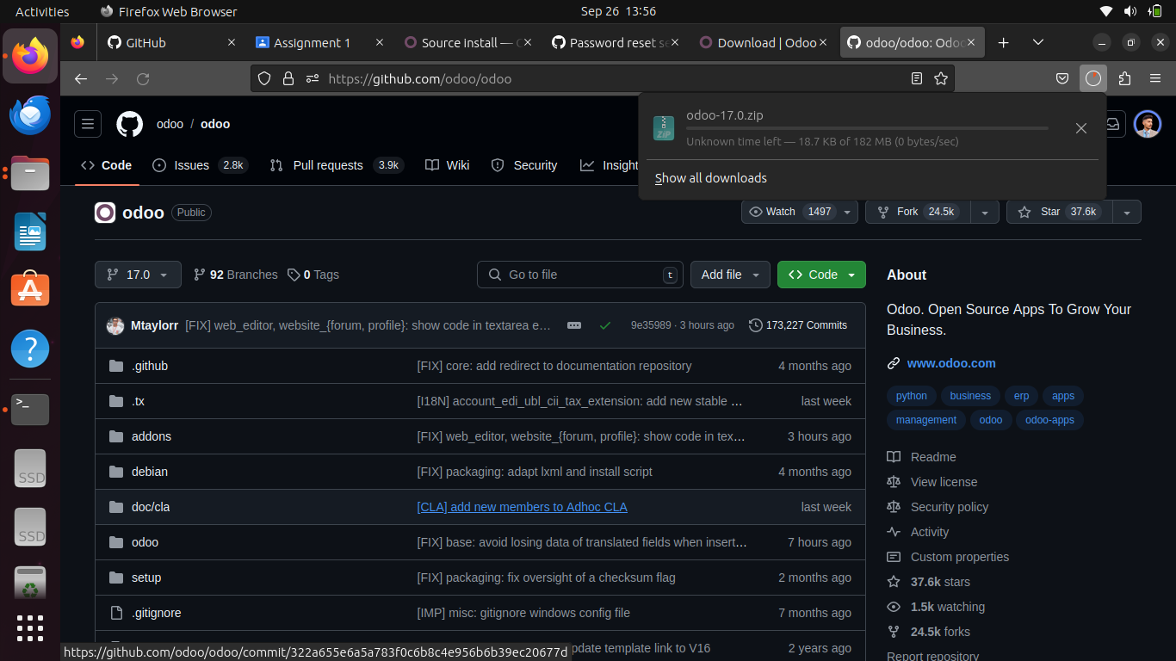

4. Python Version Check
Command: python3 --version
Odoo 17 requires Python version 3.10 or above. I verified the Python version on your system and found it to be 3.11.
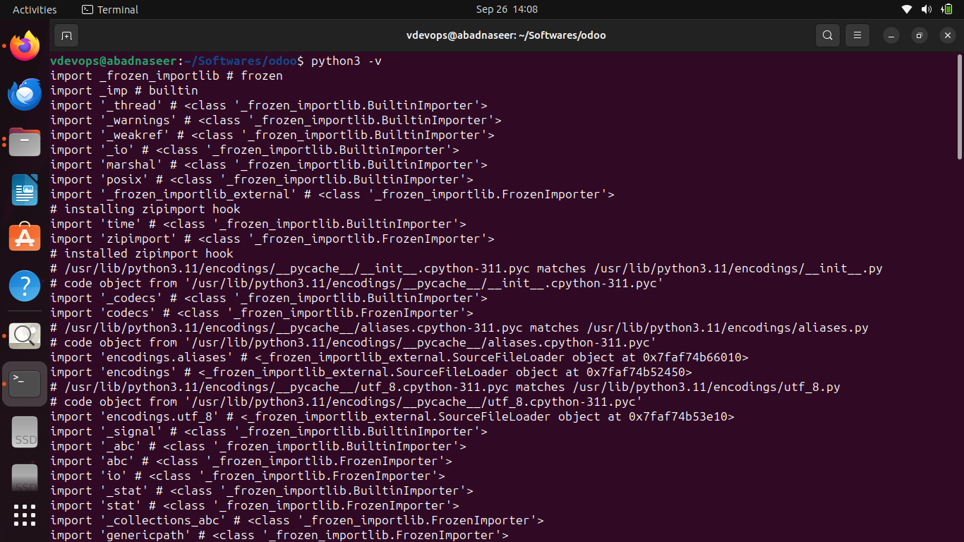

5. Verify and Install Pip
Command:
pip3 --version
In my case, Pip was not installed, so I installed it using:
sudo apt install python3-pip
Verified the version before installation gave me information that pip was not installed. But, Verified the version after installation.

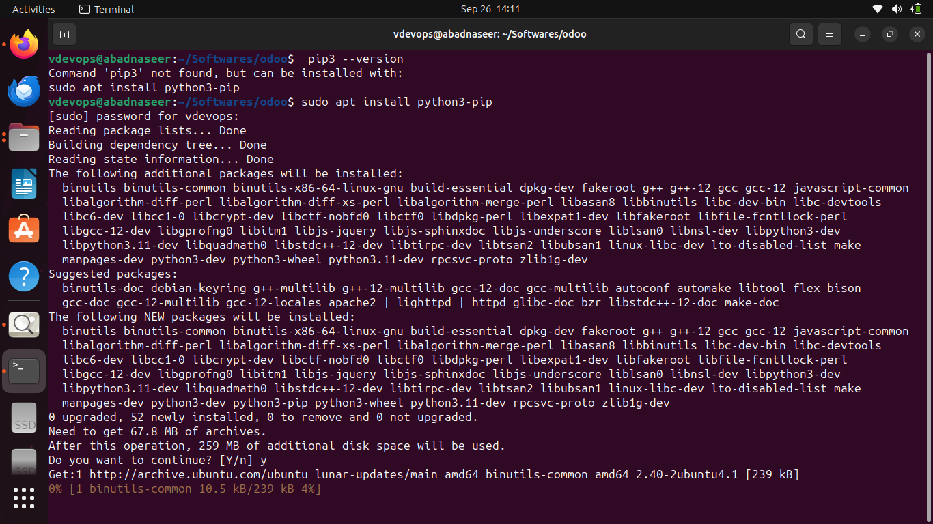

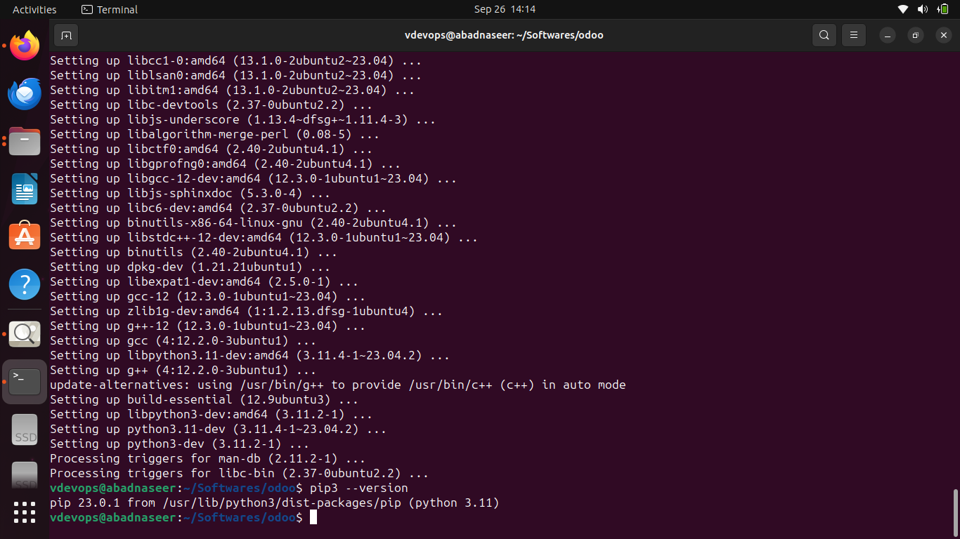

6. Install PostgreSQL
Command:
sudo apt install postgresql postgresql-client

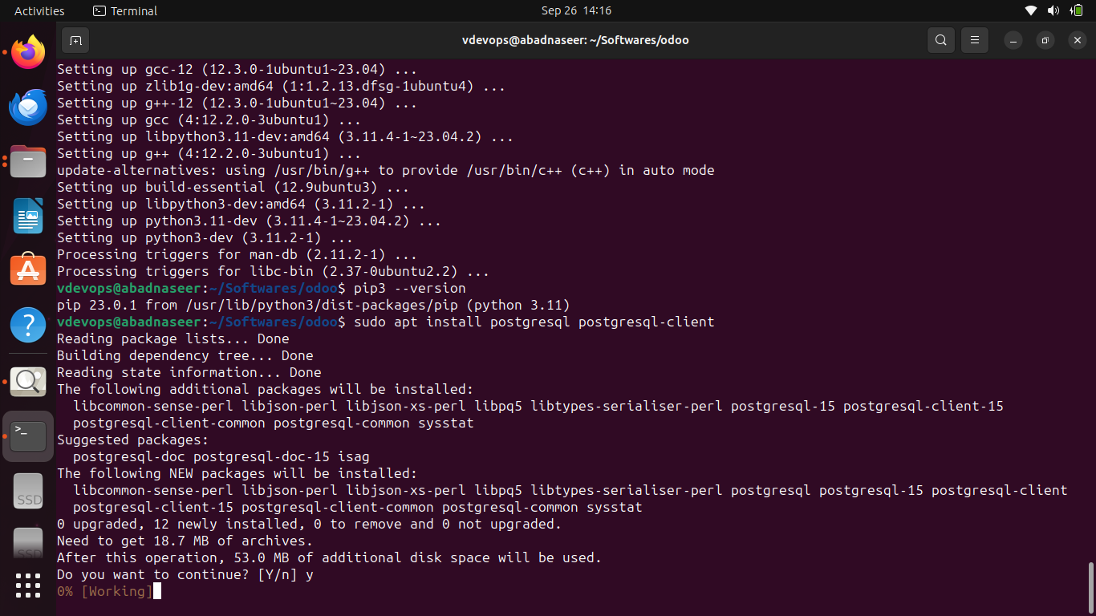
PostgreSQL Configuration:
While creating a new PostgreSQL user, I encountered a permission issue related to accessing the home directory. After troubleshooting, I removed the existing postgres user and created a new postgres role with superuser privileges for managing databases in Odoo.

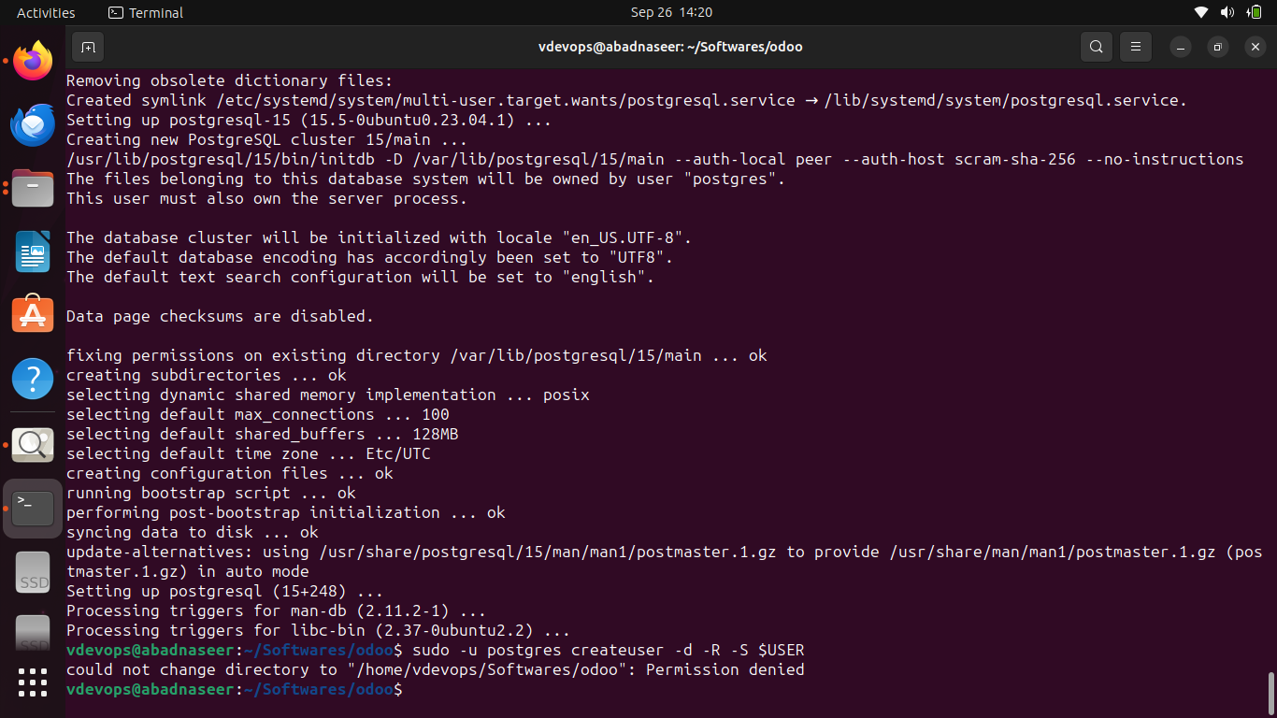

Command to create a user and role:
sudo -u postgres psql

Command to check the user list under the system user ( postgres).
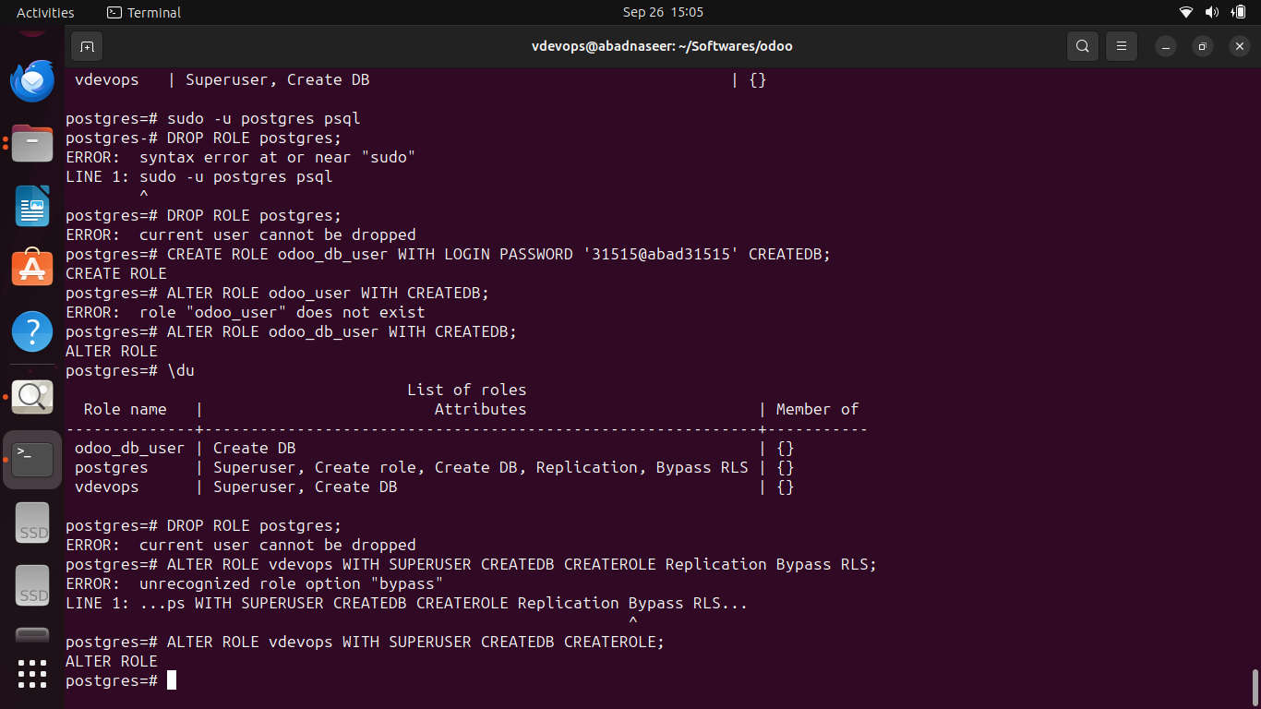

Here I have to delete “vdevops” user, but I was trying to remove postgres because I got confused. I learnt that postgres should be kept as system ( DBMS) user for odoo ( with all permissions related to managing database creation roles, assigning db to users).

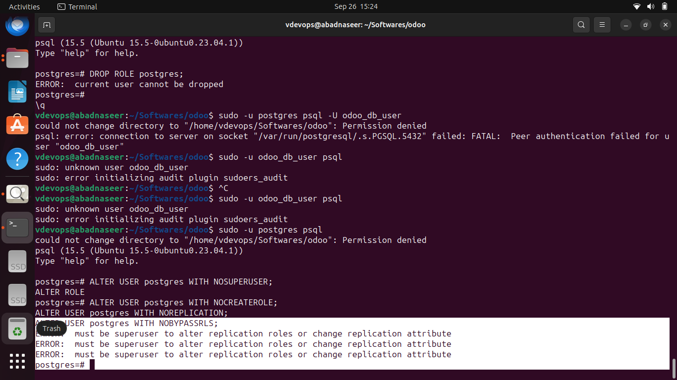

7. Install Odoo Dependencies
To install Odoo dependencies, I navigated to the Odoo community path and ran the following script:
sudo ./setup/debinstall.sh
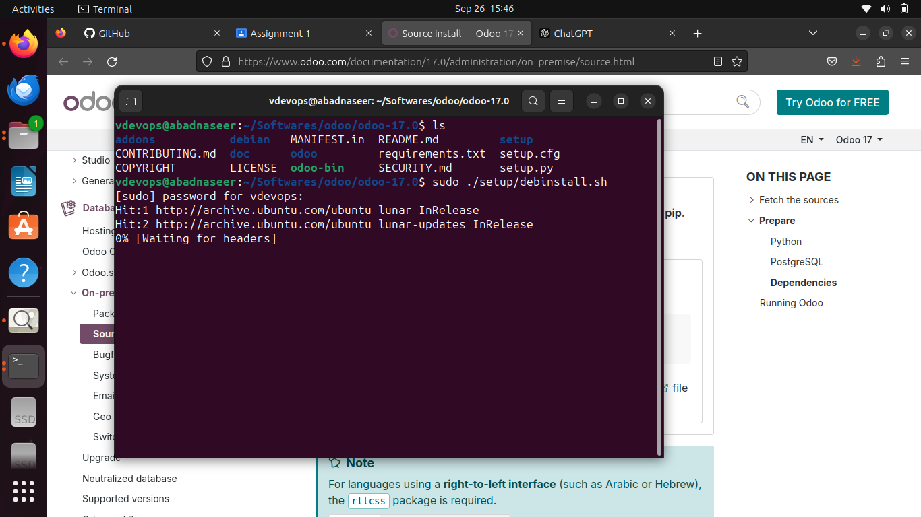

8. Running Odoo
Command:
python3 odoo-bin --addons-path=addons -d mydb --db_user=odoo_user –db_password=<your-password>
I initially encountered an error when switching back to PostgreSQL. To resolve this, I changed the PostgreSQL authentication method in the pg_hba.conf file, reset the user password, and reverted the file.

9. Accessing Odoo on the Browser
After completing the installation, I accessed Odoo by navigating to:
http://localhost:8069

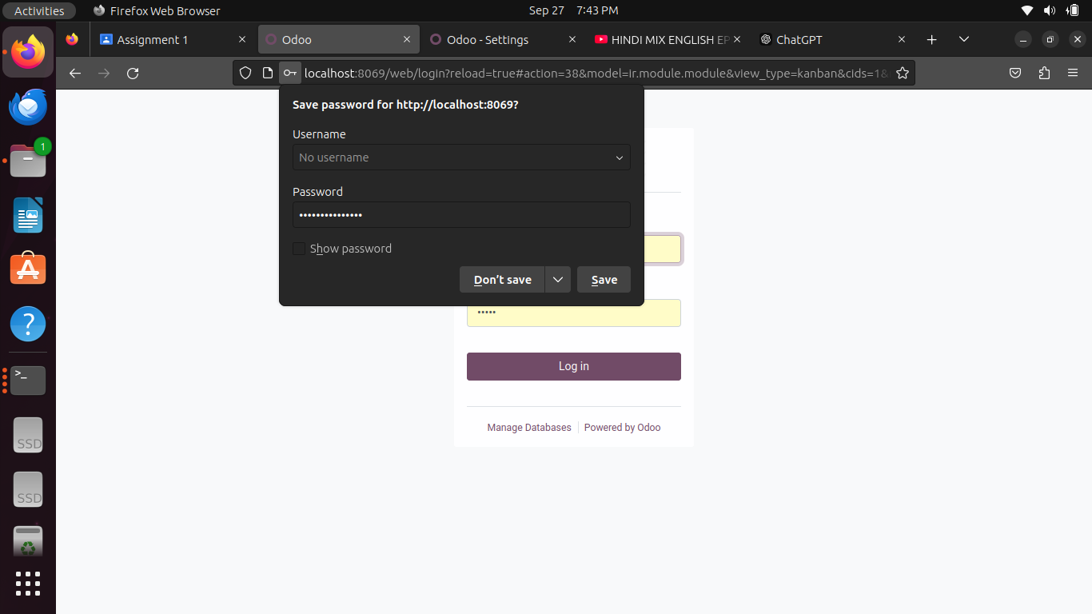

Part 2: Initial Configuration of Odoo

1. Access Odoo Web Interface
After successfully accessing Odoo, I logged in using the default credentials.

2. Change Default Password and Create a New Admin User
I changed the default password for security purposes and created a new admin user with full privileges.

3. Explore Odoo Dashboard
Explored the dashboard and modules such as Sales, Inventory, and Accounting.
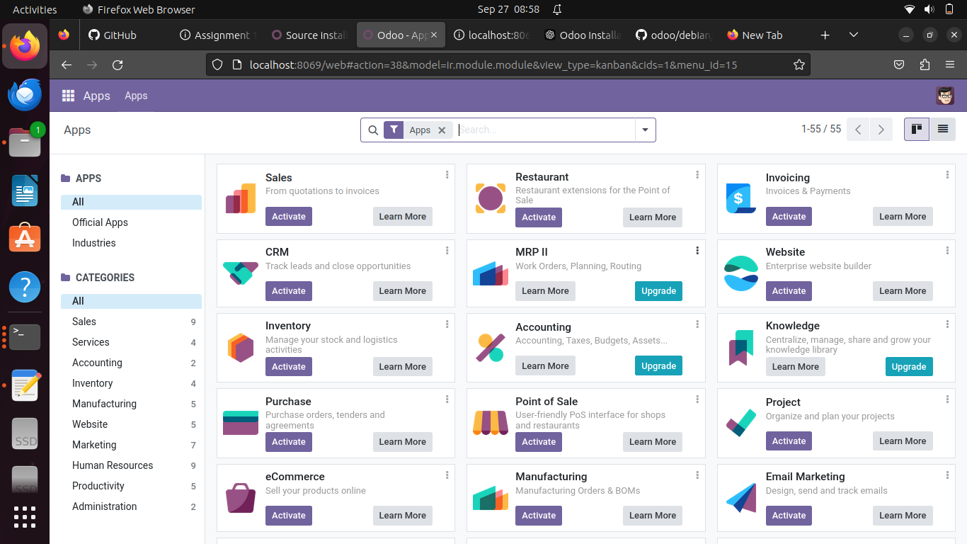

4. Configure Basic Settings
Configured essential settings, including:
- Company information
- Currency
- Language
- Timezone
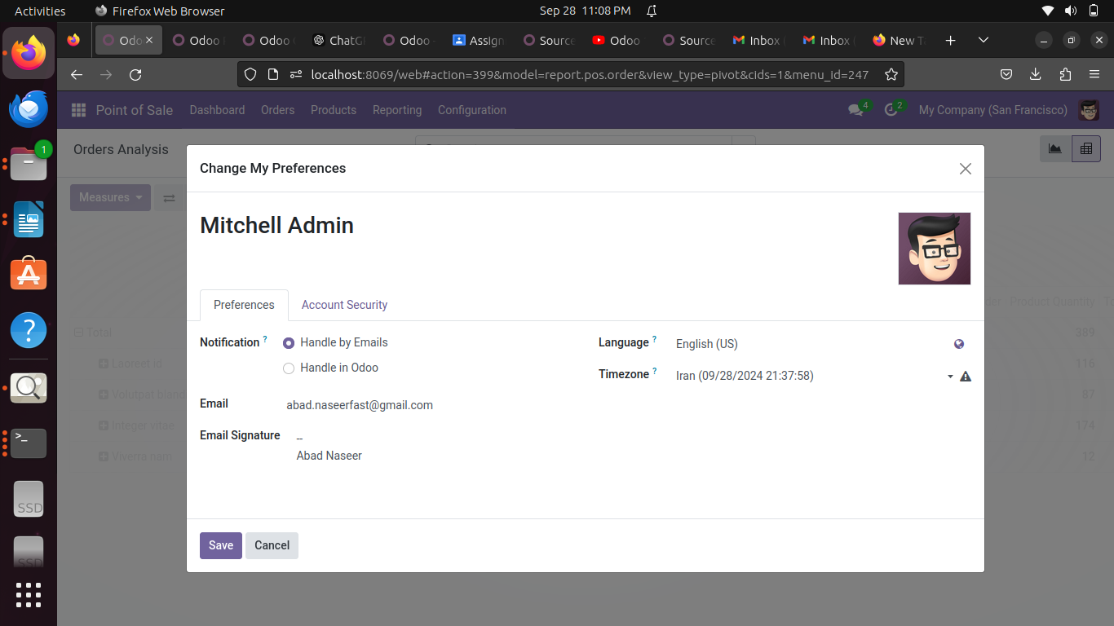

5. Install Additional Modules
Installed a few essential modules as per my requirement, such as Point of sale, Invoicing, and Inventory Management.
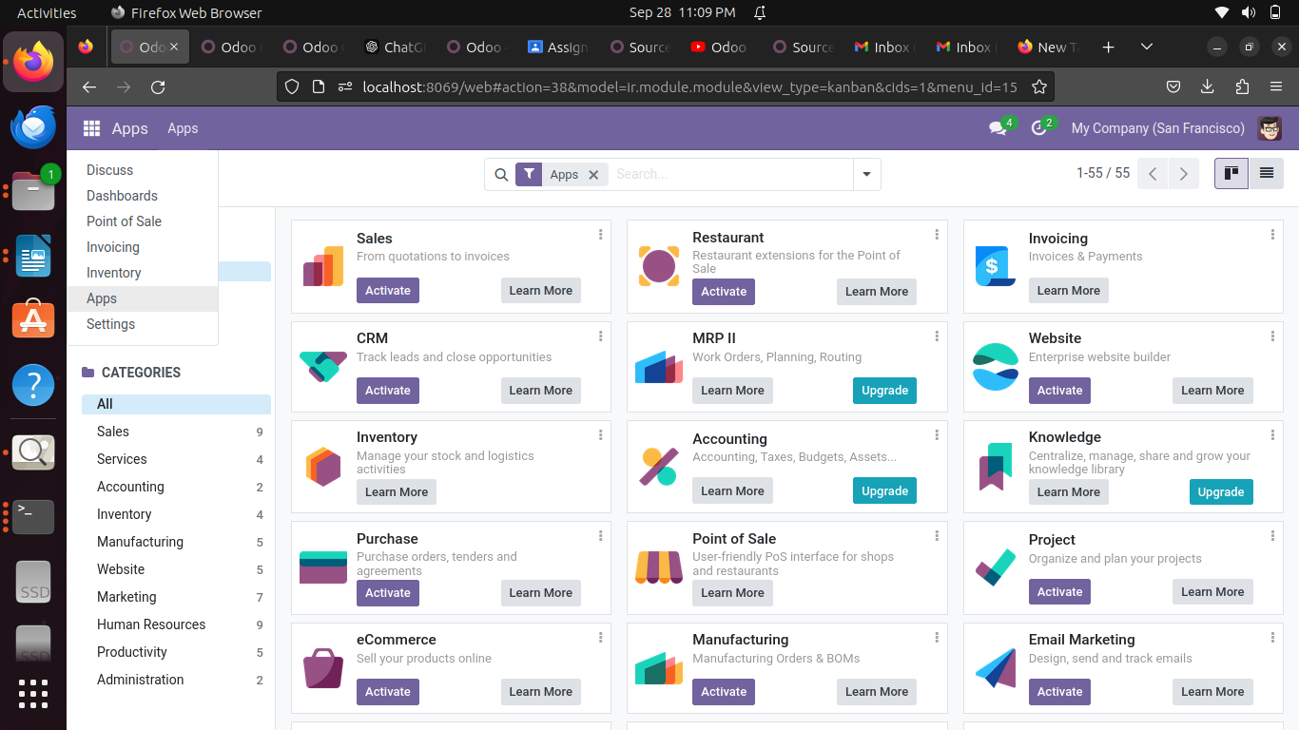

Part 3: Customization Documentation

POS Module:

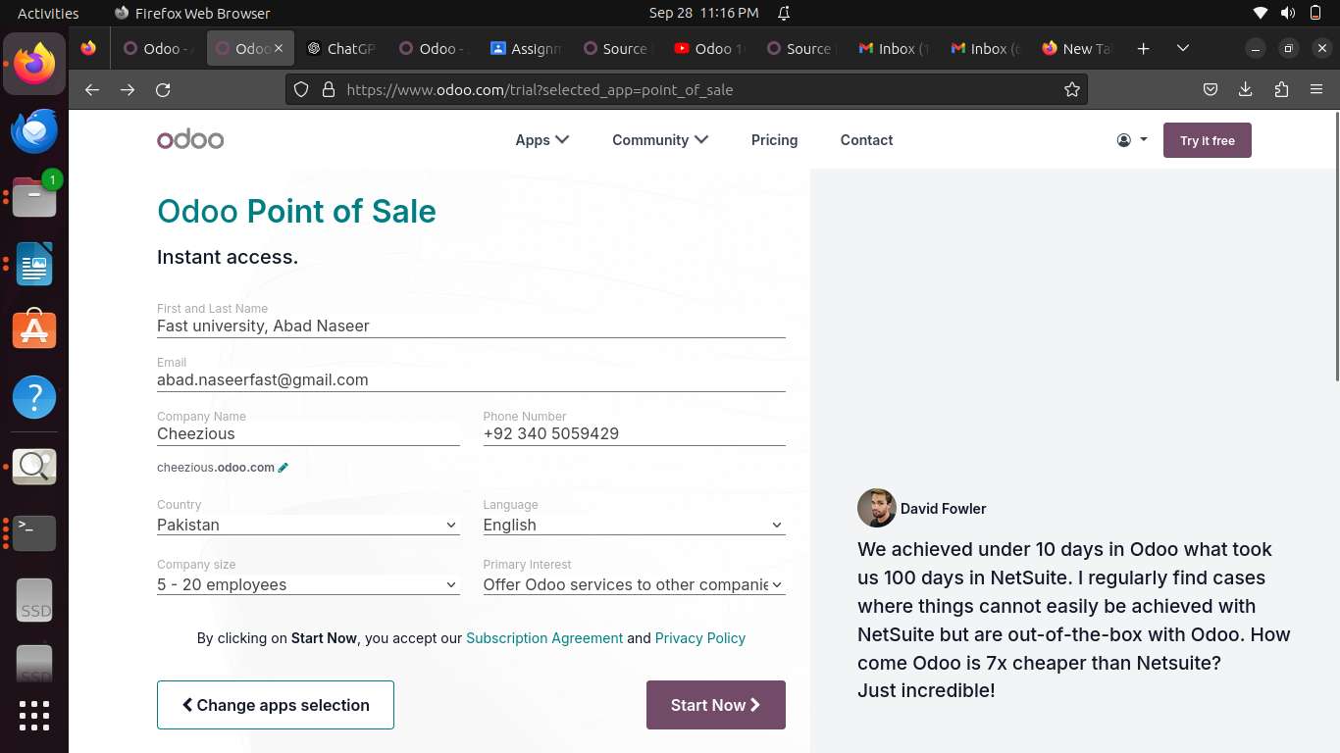
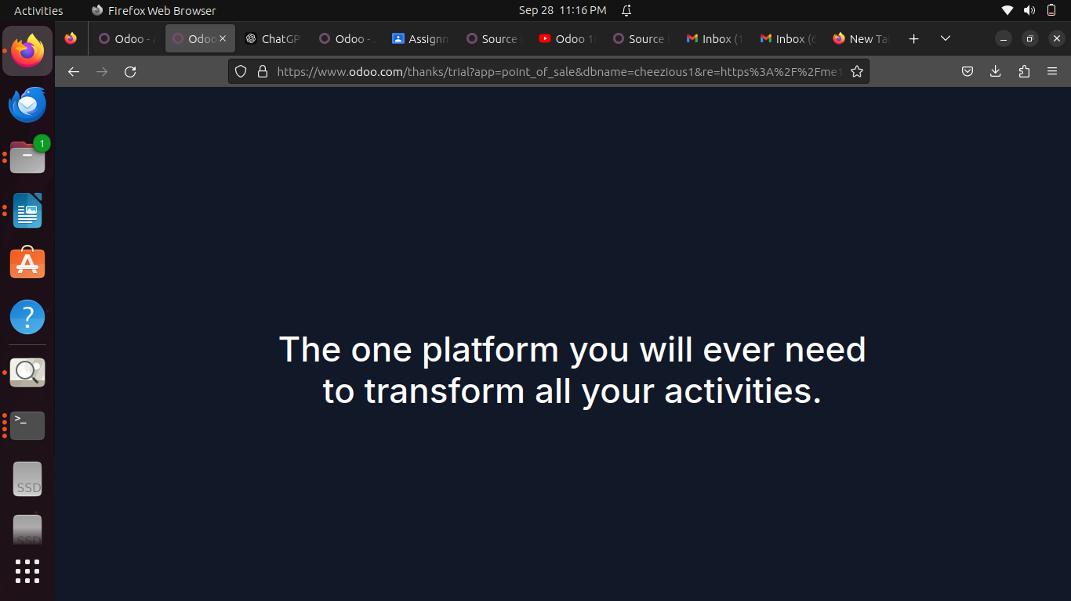
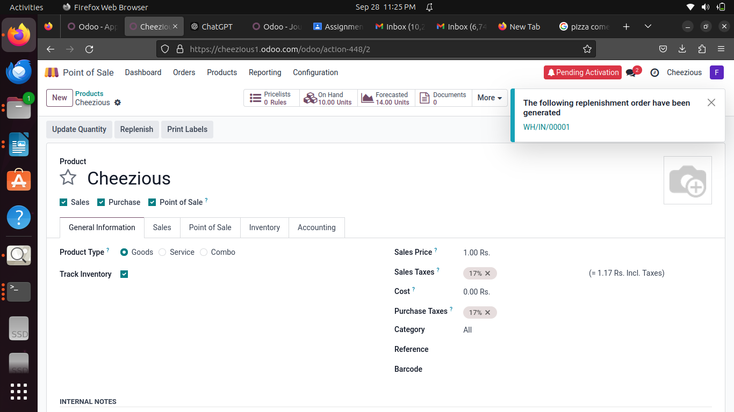
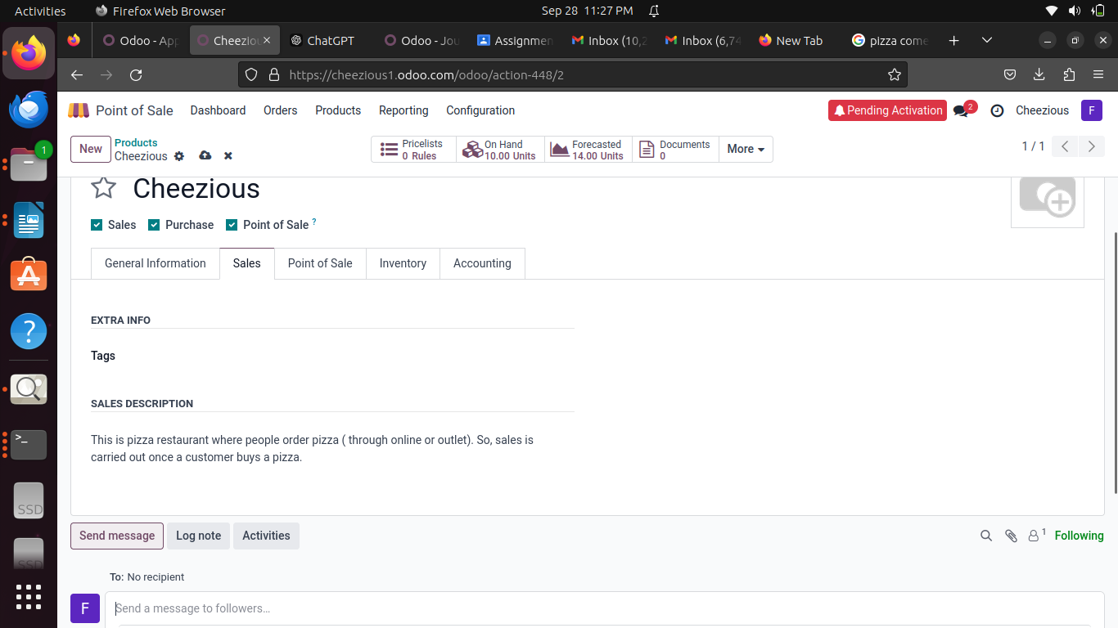
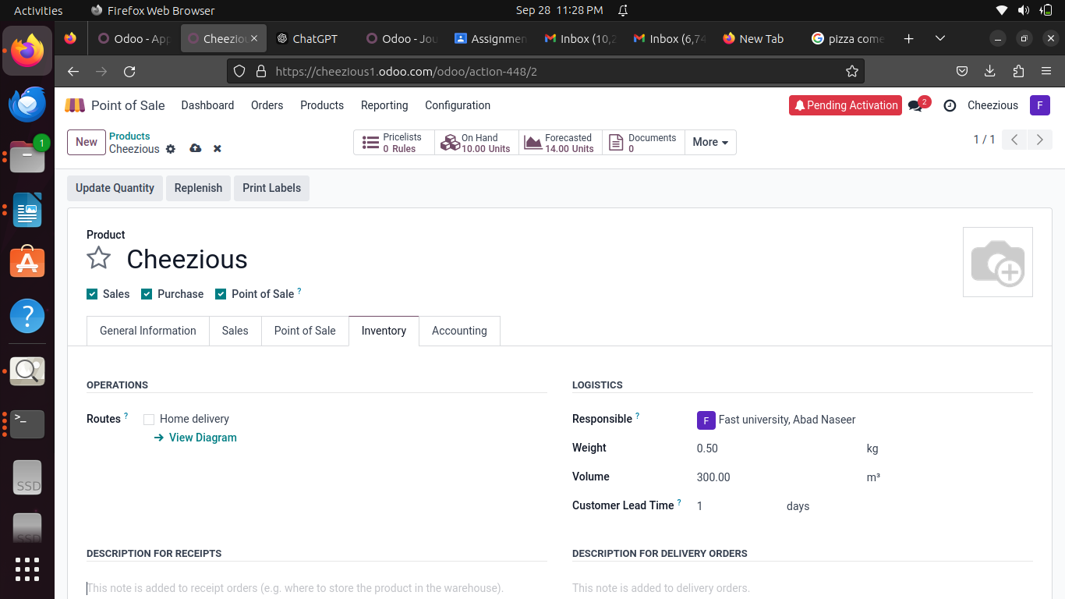

Invoicing Module:

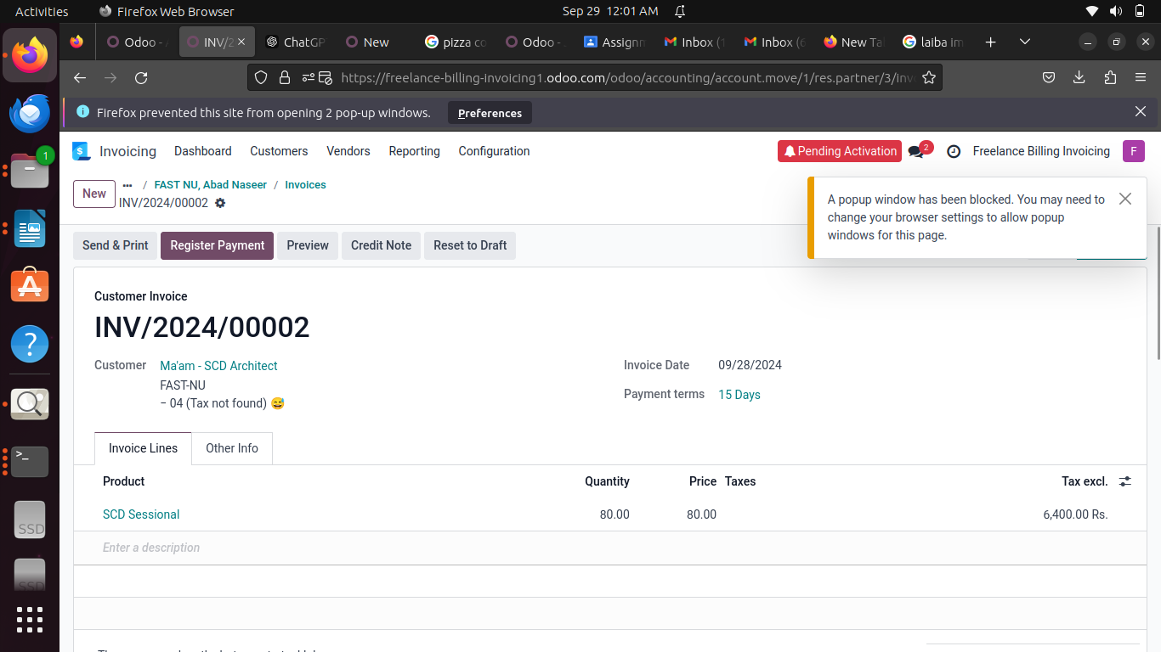
Point Of Sale:

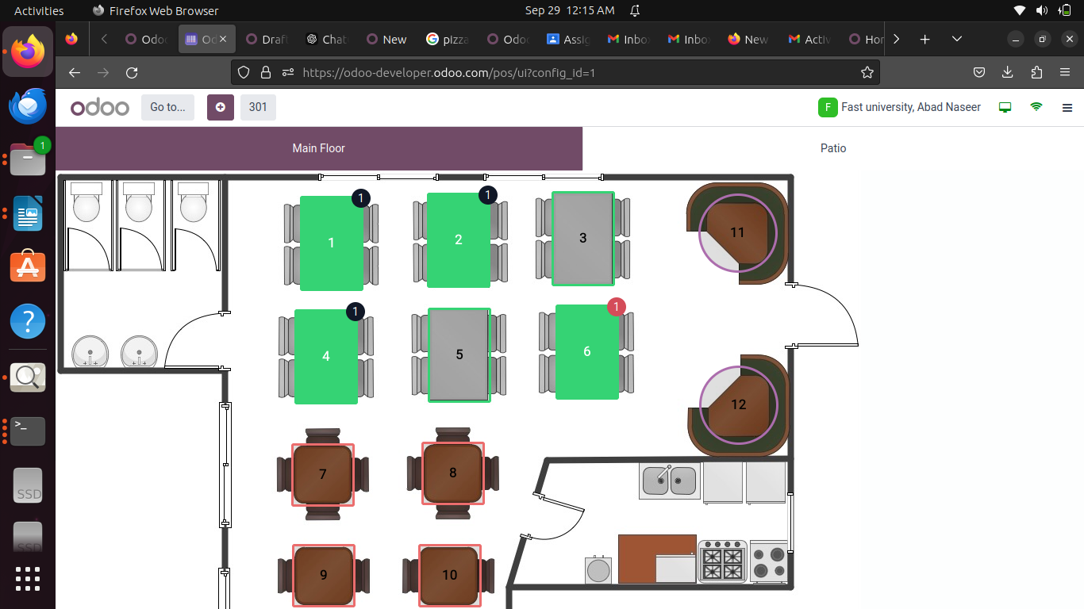

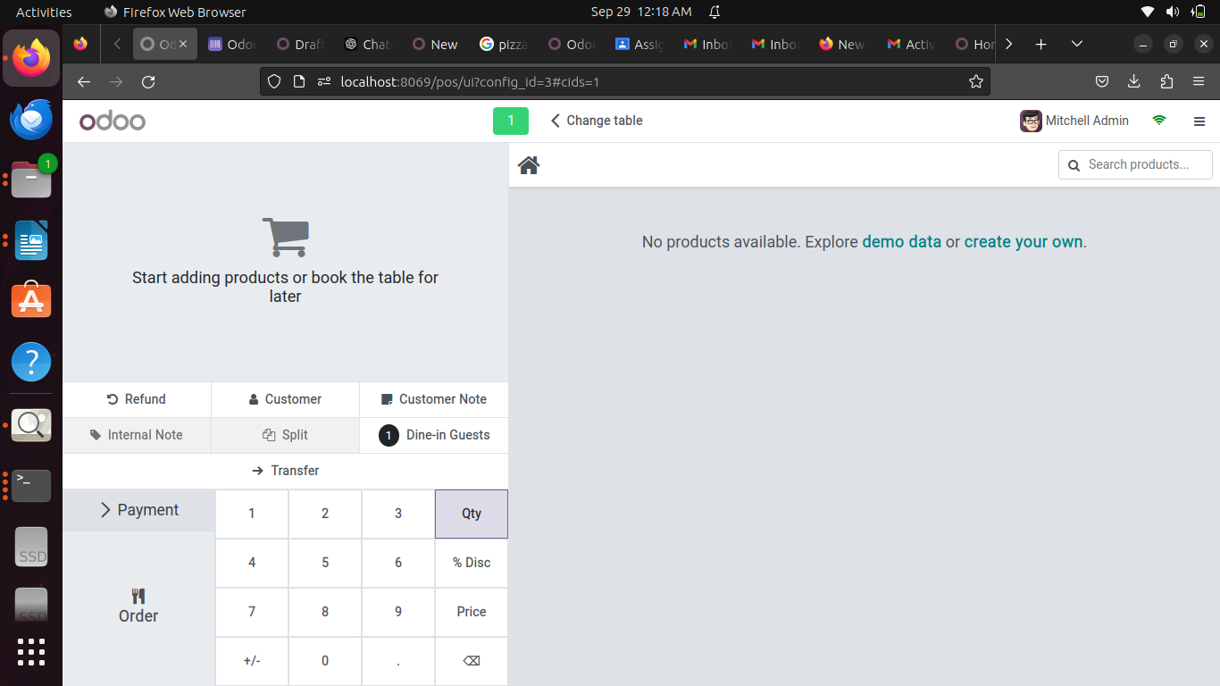

Deliverables
1. Installation Documentation: A comprehensive guide documenting the installation steps, issues encountered, and how you resolved them.
2. Configuration Report: A summary of the configuration steps, including the addition of admin users and the exploration of essential features in Odoo.
3. Customization Documentation: Detailing any future customization efforts in Odoo modules.

Evaluation Criteria
1. Accuracy of Installation: Odoo was successfully installed following the steps described.
2. Completeness of Configuration: Basic settings were configured, and essential modules were explored.
3. Creativity in Customization: No customizations were made yet.
4. Documentation Clarity: The report is well-organized with clear instructions, explanations, and screenshots for each step.

