SCD-Lab_Exam

Prepared by: Abad Naseer

Submission Date

12 Novemeber, 2024

This is the docker container for this specific service an that is parking slot management service:

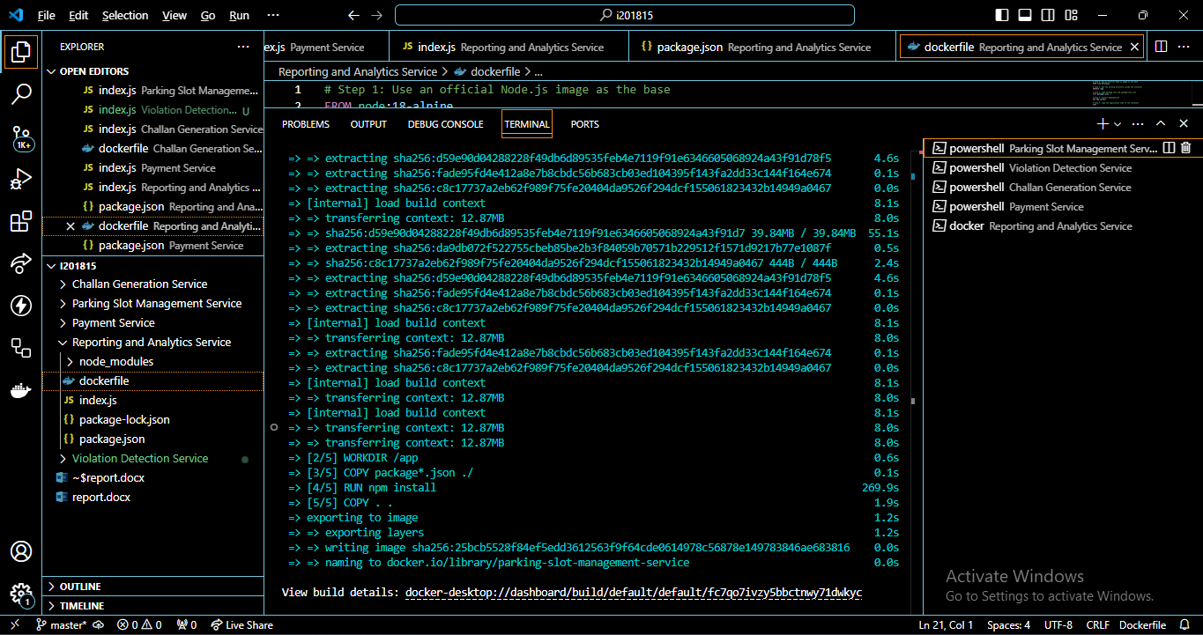

And this is violation detection service:

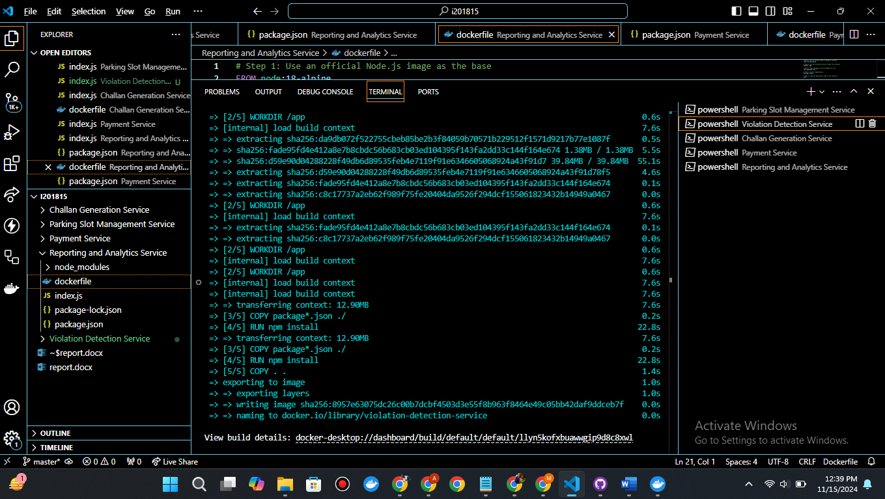

Now this is the image created for challen generation service

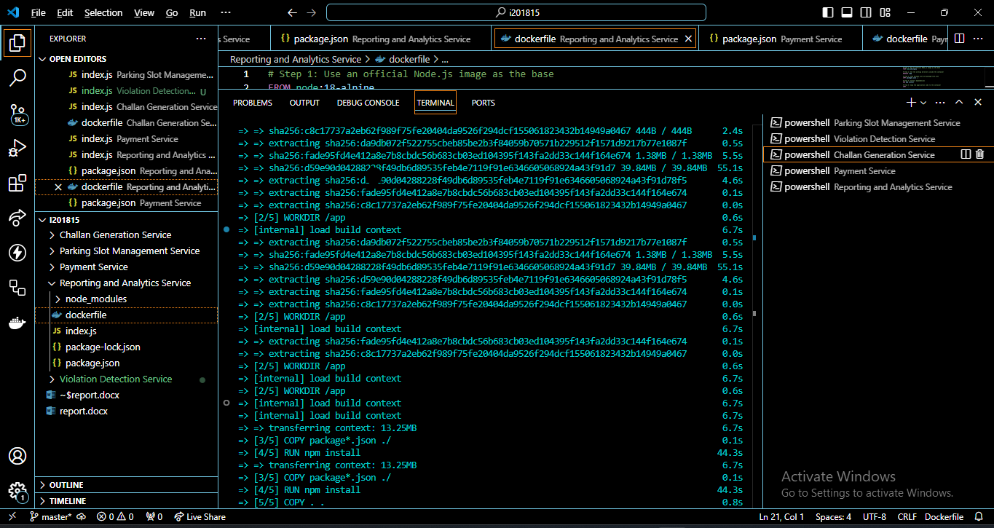

And this the service for payment service docker image created for the whole application:

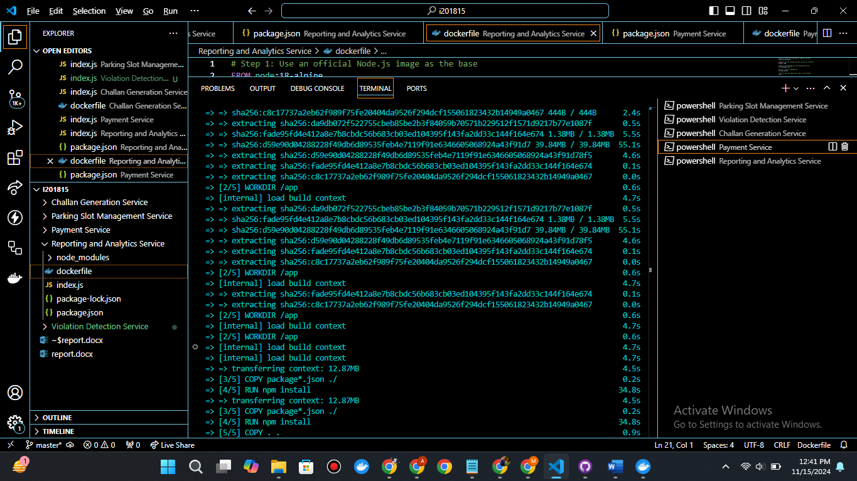

Here is the created images for each service:

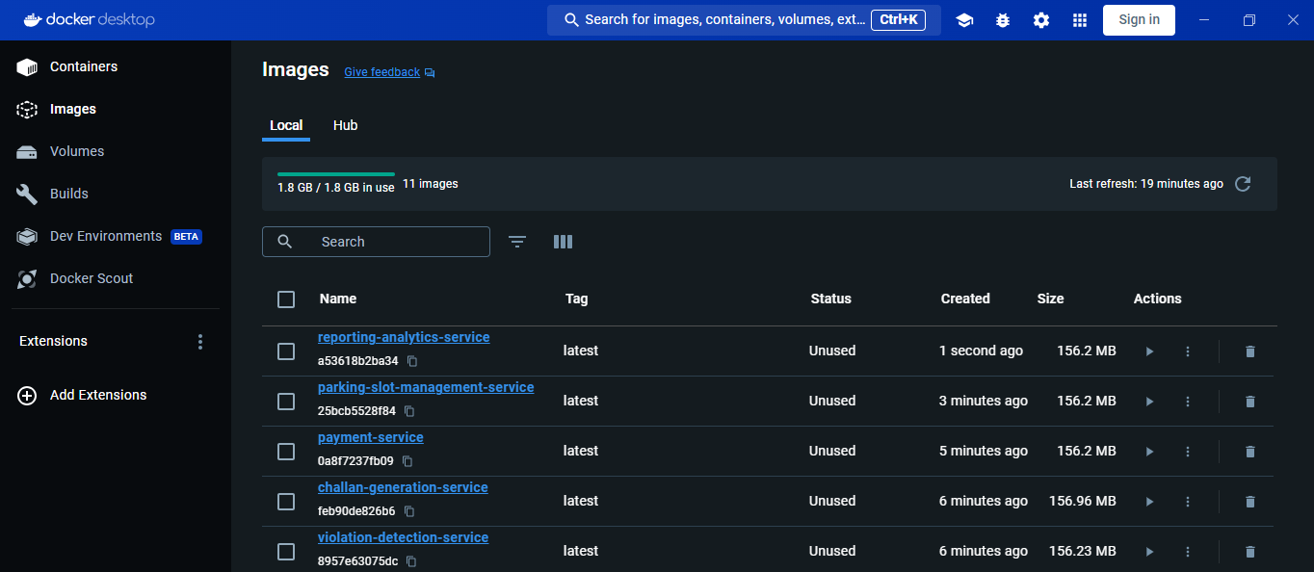

And this is the last service of reporting and analytics service docker image created for this.

And here is the container running for whole application and yml docker-compose file is written for this:

Since internet is not fast so still processing and containerizing whole application

