**Software Design and Architecture**

Project Assignment 1



Saim Alam 21I-1210

Sami Irshad 21I-1103

Abad Naseer 20I-1815

|  |  |  |  |
| --- | --- | --- | --- |
| **Name** | **Date** | **Reason For Changes** | **Version** |
|  |  |  |  |
|  |  |  |  |
| CafeConnect | 04-03-2023 | - | 1.0 |

Contents

Work Division Table 3

Project Scope 3

Actor-Goal List 4

Use Case Diagram 5

High Level Use Cases 6

## Work Division Table

|  |  |
| --- | --- |
| **Name** | **Contribution** |
| Saim Alam | Scope, Actor-Goal List, Use Cases for Processing Returns, Placing Orders, Account Handling, Returning Food, Analyzing Sales, Generating Daily Receipt, Handling Student Information, Managing the Administrators, |
| Sami Irshad | Scope, Use Cases for Processing Sales, Tax Deduction, and Paying for Food |
| Abad Naseer | Use Cases for Paying Employees, Updating Inventory, and Paying Rent |

## Project Scope

The scope of the proposed cafeteria management project is to develop a Java/JavaFX-based GUI system that will allow students, guests, cashiers, administrators, and a manager to interact with the system. The system will enable students and guests to order food, manage their accounts, pay for food, and return food items. The cashier will be able to process sales, handle returns, and manage cash in and cash out. The administrator will be able to manage the cashiers, analyze sales, generate daily sales receipts, and view inventory. The manager will be able to manage the inventory, the administrators' information, pay rent, and pay both the cashiers and the administrators. The system's key use cases will include managing cashiers, processing sales and returns, analyzing sales, updating inventory, generating daily receipts, handling student information, managing administrators, paying rent, and paying employees. The system will be developed to provide an efficient, reliable, and user-friendly interface that will meet the needs of all the actors involved in the cafeteria management process.

## Actor-Goal List

|  |  |
| --- | --- |
| Actor | Goal |
| Student | Place an order for food  Manage their account/profile  Return food item  Pay for food |
| Guest | Place an order for food  Pay for food  Return food item |
| Cashier | Process sales  Handle returns  Cash in and cash out |
| Administrator | Manage cashiers (add/modify/delete)  Manage student details (add/modify/delete)  Analyze sale(s)  Generate daily sale receipt  View inventory |
| Manager | Manage inventory  Manage administrator information (add/modify/delete)  Pay rent  Pay employees |
| Landlord | Receive rent |
| Government | Collect tax on sale of items |

Each actor has their own specific goals they want to achieve using the system, which highlights the importance of having a comprehensive cafeteria management system that caters to the needs of all stakeholders. By identifying and addressing these needs, the cafeteria management system can improve overall efficiency, accuracy, and customer satisfaction.

## Use Case Diagram

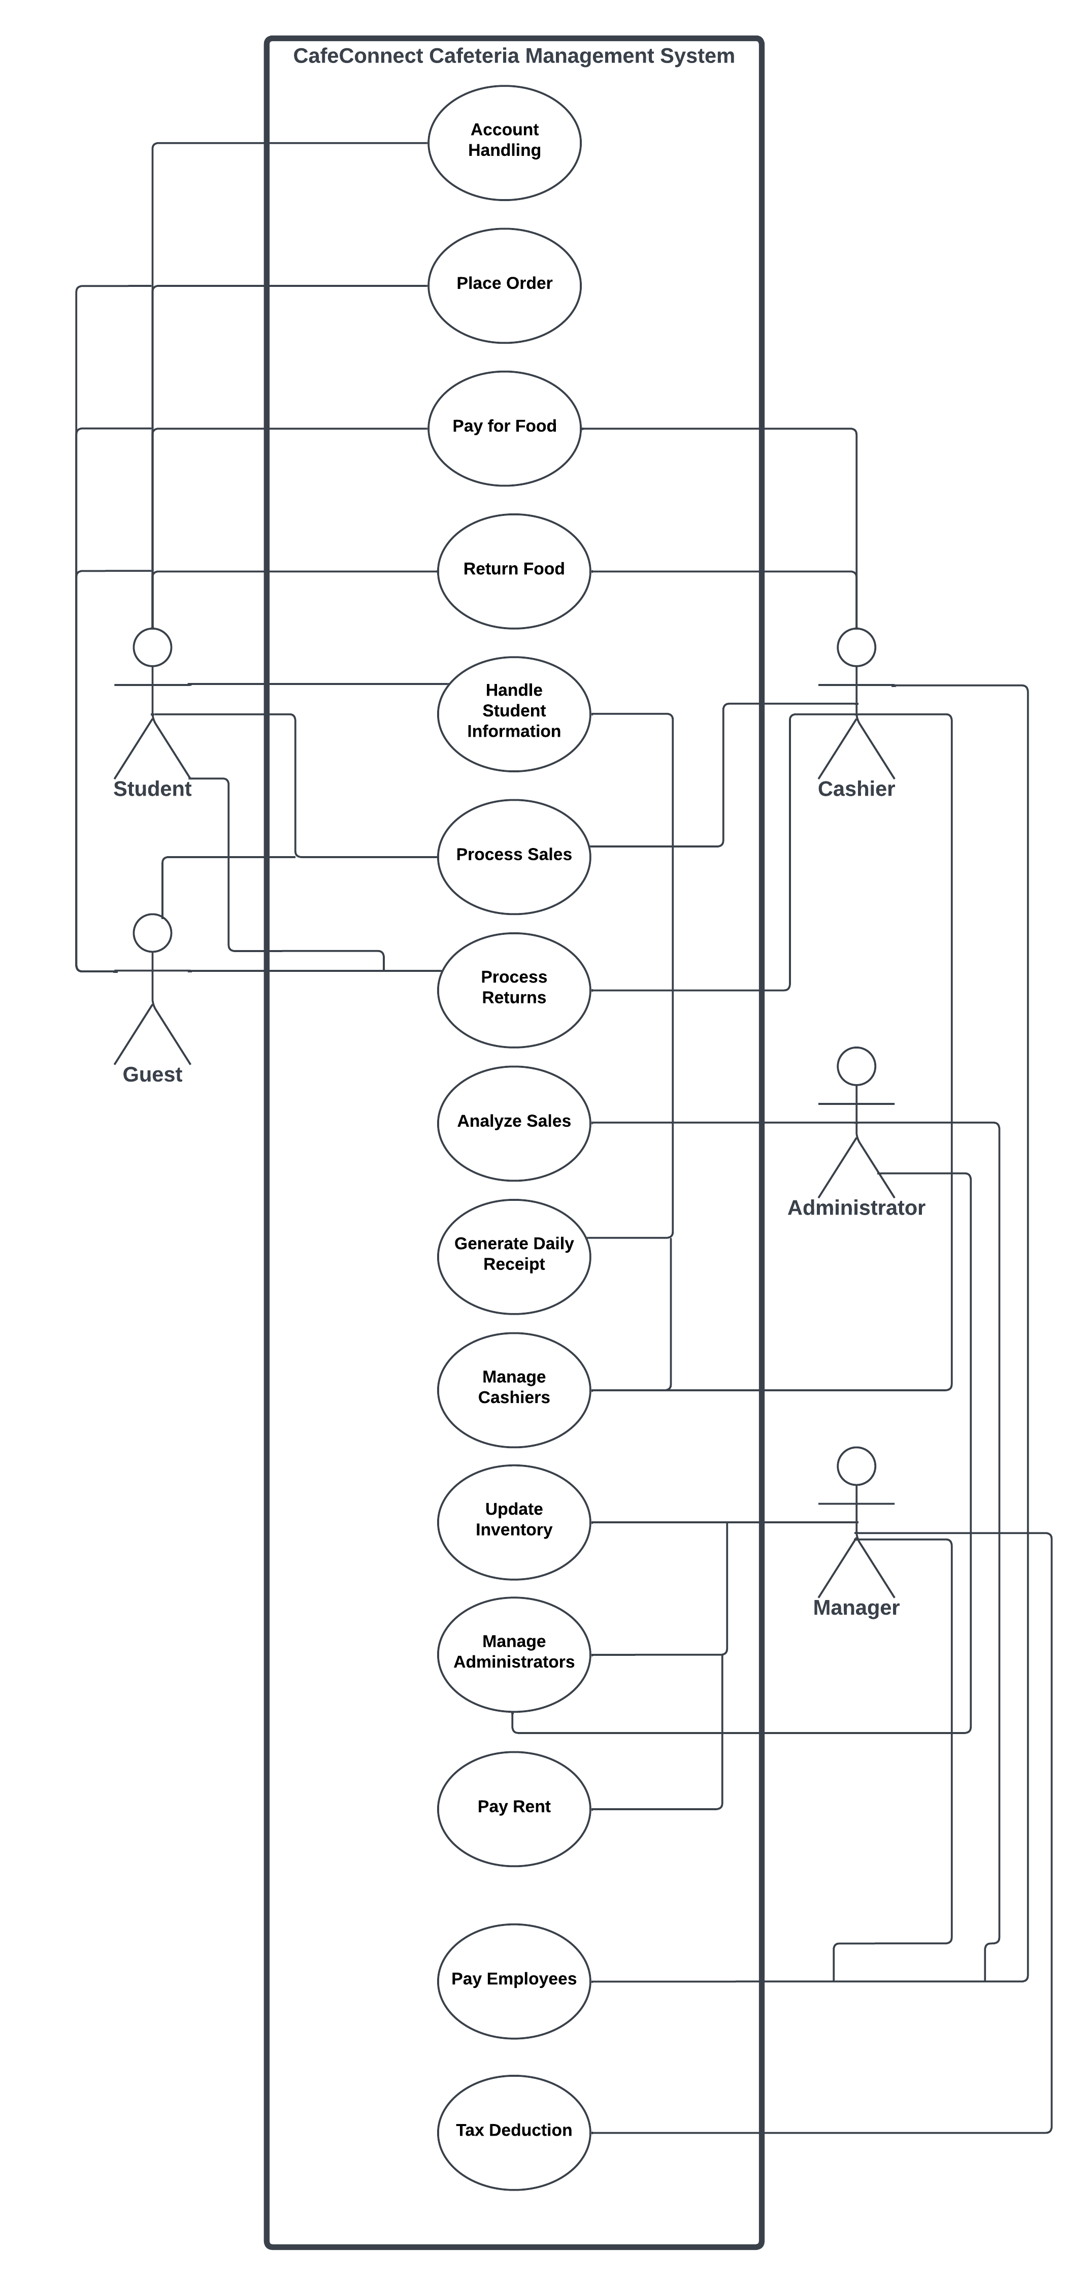

## High Level Use Cases

|  |  |
| --- | --- |
| High Level Use case: Manage Cashiers | |
| Use Case | Manage Cashiers |
| Actors | Administrator, Cashier |
| Type | Secondary |
| Description | The Administrator manages the Cashiers by adding, modifying, or deleting their information in the system based on their performance. |

|  |  |
| --- | --- |
| High Level Use case: Process Sales | |
| Use Case | Process Sales |
| Actors | Student, Guest, Cashier |
| Type | Primary, Primary, Secondary |
| Description | The Cashier processes a sale by recording the items purchased by a Student or Guest and calculating the total cost, then accepting payment and providing change. |
| High Level Use case: Process Returns | |
| Use Case | Process Returns |
| Actors | Student, Guest, Cashier |
| Type | Primary, Primary, Secondary |
| Description | The Cashier processes a return by accepting returned items, verifying the reason for the return, and issuing a refund or credit. |
| High Level Use case: Place Order | |
| Use Case | Place Order |
| Actors | Student, Guest |
| Type | Primary |
| Description | The Student or Guest places an order for food by selecting items from the menu, specifying quantities, and providing payment. |
| High Level Use case: Account Handling | |
| Use Case | Account Handling |
| Actors | Student |
| Type | Primary |
| Description | The Student organizes and handles their account by updating their personal details, viewing their purchase history, and checking their account balance. |
| High Level Use case: Pay for Food | |
| Use Case | Pay for Food |
| Actors | Student, Guest |
| Type | Primary |
| Description | The Student or Guest pays for their food to the cashier by providing payment in the form of cash or other accepted payment methods. |
| High Level Use case: Return Food | |
| Use Case | Return Food |
| Actors | Student, Guest |
| Type | Primary |
| Description | The Student or Guest returns food to the cashier by providing a reason for the return, verifying the purchase details, and receiving a refund or credit. |
| High Level Use case: Analyze Sales | |
| Use Case | Analyze Sales |
| Actors | Administrator |
| Type | Secondary |
| Description | The Administrator analyzes sales by generating reports that summarize the total sales, individual sales, and sales by item, student, or guest. |
| High Level Use case: Update Inventory | |
| Use Case | Update Inventory |
| Actors | Manager |
| Type | Secondary |
| Description | The Manager updates the inventory by adding or removing items, updating quantities, and checking inventory levels to ensure adequate stock. |
| High Level Use case: Generate Daily Receipt | |
| Use Case | Generate Daily Receipt |
| Actors | Administrator |
| Type | Secondary |
| Description | The Administrator generates a daily receipt by compiling a summary of all the sales made in the day, including item descriptions, quantities, and total cost. |
| High Level Use case: Handle Student Information | |
| Use Case | Handle Student Information |
| Actors | Administrator, Student |
| Type | Secondary, Primary |
| Description | The Administrator handles student information by adding, modifying, or deleting their details, such as name, ID number, and contact information. |
| High Level Use case: Manage Administrators | |
| Use Case | Manage Administrators |
| Actors | Manager, Administrator |
| Type | Secondary |
| Description | The Manager manages Administrators by adding, modifying, or deleting their information in the system. |
| High Level Use case: Pay Rent | |
| Use Case | Pay Rent |
| Actors | Manager, Landlord |
| Type | Secondary, Offstage |
| Description | The Manager pays rent by making the necessary payments to the landlord or property owner according to the terms of the rental agreement. |
| High Level Use case: Pay Employees | |
| Use Case | Pay Employees |
| Actors | Manager, Cashier, Administrator |
| Type | Secondary |
| Description | The Manager pays employees by making the necessary payments to the Cashiers and Administrators according to their salaries and payment schedules. |
| High Level Use case: Tax Deduction | |
| Use Case | Tax Deduction |
| Actors | Manager, Government |
| Type | Secondary, Offstage |
| Description | The government of Pakistan has decided to tax a specific percentage of the cost of a product. The Manager pays the government with the tax amount accumulated from the products over the month. |